Sources Fuels and Energy Paths
  - Grade 5 Unit 2 • Chapter 1
Learning goal I can trace energy transformations and explain why fossil fuels are nonrenewable.
An electric bus and a fuel-powered bus can both move people, but their energy paths differ.

Follow the source
A motor transforms electrical energy into motion and other forms. A combustion engine transforms chemical energy from fuel into thermal energy and motion, with some energy spreading into the surroundings.
Coal, petroleum and natural gas are fossil fuels. Their formation takes far longer than human use, so they are nonrenewable. They are not replaced each year like a crop.
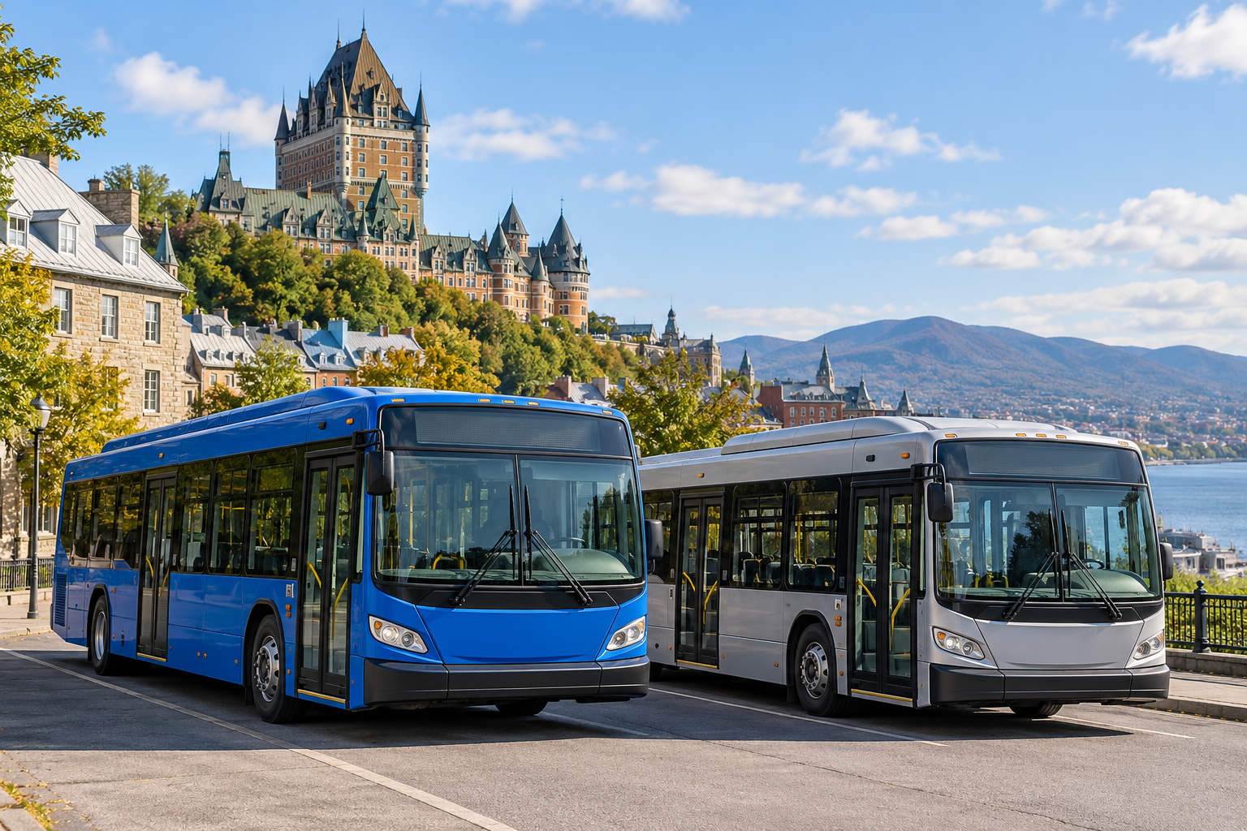
Two modern city buses parked in a Québec city setting. Fossil fuels form much more slowly than people use them. Generated contextual illustration; not a scale model.

Identify fuels accurately
Petroleum can be processed into gasoline and fuel oil. Propane and butane can come from petroleum processing or natural-gas processing. Natural gas is a fossil fuel in its own right, not simply a product made from petroleum.
Sources and devices have different environmental effects. Burning fossil fuels releases carbon dioxide; electricity’s effects depend partly on how it is generated.
Trace the actual system rather than assuming every electric device or every renewable source has identical impacts. Conserving unnecessary use can reduce demands on either system.

What to remember
- Fossil fuels form much more slowly than people use them.
- An energy path includes sources, transformations and effects beyond the final device.

Check your understanding
Explain aloud, sketch, or write. Use evidence from the chapter.
1 Why is natural gas nonrenewable even though it is called natural?
My thinking
2 Why must we ask how electricity is generated when comparing vehicles?
My thinking

Practise the words
Cover the meanings and explain the words. Then cover the words and name the meanings. Give an example.
fossil fuel fuel formed from ancient organic matter over very long times
nonrenewable not replenished as fast as people use it
transformation a change from one energy form to another

Lesson connection
Lesson 1 · Sources and transformations / Lesson 8 · Fossil fuels
Original adaptation informed by Core Knowledge Foundation science materials including Energy Transfer and Transformation, Thermal Energy, Electricity and Magnetism, Light and Matter. Shared under CC BY NC SA 4.0. Generated contextual illustration.

