Insulation Slows Energy Transfer
  - Grade 5 Unit 2 • Chapter 3
Learning goal I can explain why insulating materials reduce thermal energy transfer.
A winter coat helps retain energy supplied by the body’s processes.

A coat does not make warmth
Many insulating materials trap still air. Air is a poor thermal conductor, and keeping it from circulating reduces convection. A metal can transfer thermal energy more readily than many fabrics.
Insulation slows transfer in either direction. It can help keep a warm drink warm or reduce warming of a cold drink. It does not create energy.
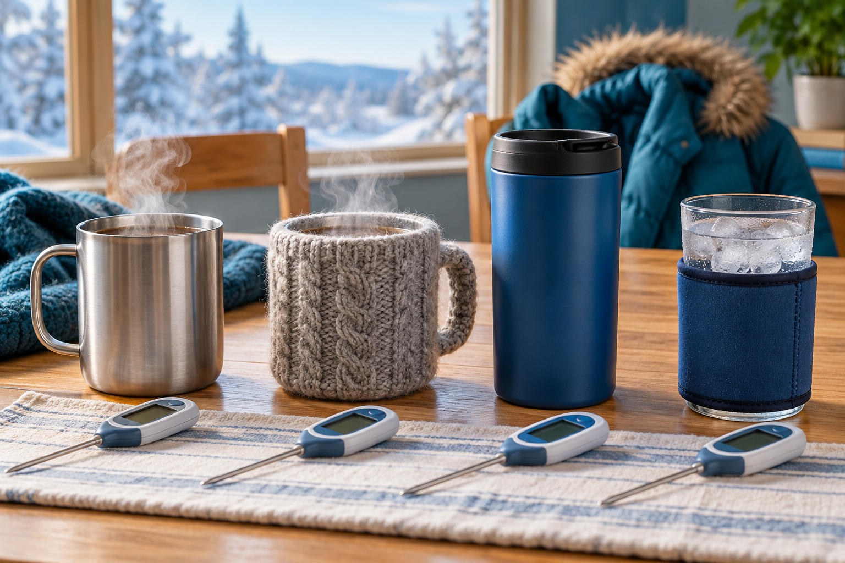
Metal and insulated drink containers with thermometers arranged for discussion. Insulation reduces the rate of thermal energy transfer rather than creating energy. Generated contextual illustration; not a scale model.

Test the complete arrangement
Compare matching covered containers starting at the same temperature, with equal liquid amounts and observation times. Record temperature changes rather than judging by touch.
A material’s thickness, trapped air, moisture and gaps all affect performance. A wet or compressed layer may behave differently from a dry fluffy one.
Eventually temperatures may approach the surroundings even with insulation. Explain a reduced rate of transfer, not a guarantee that temperature never changes. Use only safe liquid temperatures.

What to remember
- Insulation reduces the rate of thermal energy transfer rather than creating energy.
- The whole arrangement, including gaps and moisture, affects performance.

Check your understanding
Explain aloud, sketch, or write. Use evidence from the chapter.
1 Why can the same insulation help a cold drink remain cool?
My thinking
2 Why should insulation tests use equal amounts of liquid?
My thinking

Practise the words
Cover the meanings and explain the words. Then cover the words and name the meanings. Give an example.
insulator a material or arrangement that slows a transfer
conductor a material that allows a transfer relatively readily
thermal equilibrium a condition in which interacting objects have the same temperature

Lesson connection
Lesson 4 · Insulation
Original adaptation informed by Core Knowledge Foundation science materials including Energy Transfer and Transformation, Thermal Energy, Electricity and Magnetism, Light and Matter. Shared under CC BY NC SA 4.0. Generated contextual illustration.

