Electrical Conductors and Insulators
  - Grade 5 Unit 2 • Chapter 4
Learning goal I can explain how electrical materials support a safe complete circuit.
A wire often has a metal core and a plastic covering because its parts have different functions.

Different jobs in one wire
Metals such as copper conduct electric current. Plastic covering is an electrical insulator that limits unintended contact with the conductor. Thermal and electrical properties are related in some materials but are not the same property.
A complete low-voltage circuit can help test whether a material conducts under its test conditions. A nonlit lamp can also mean a loose connection or drained cell.
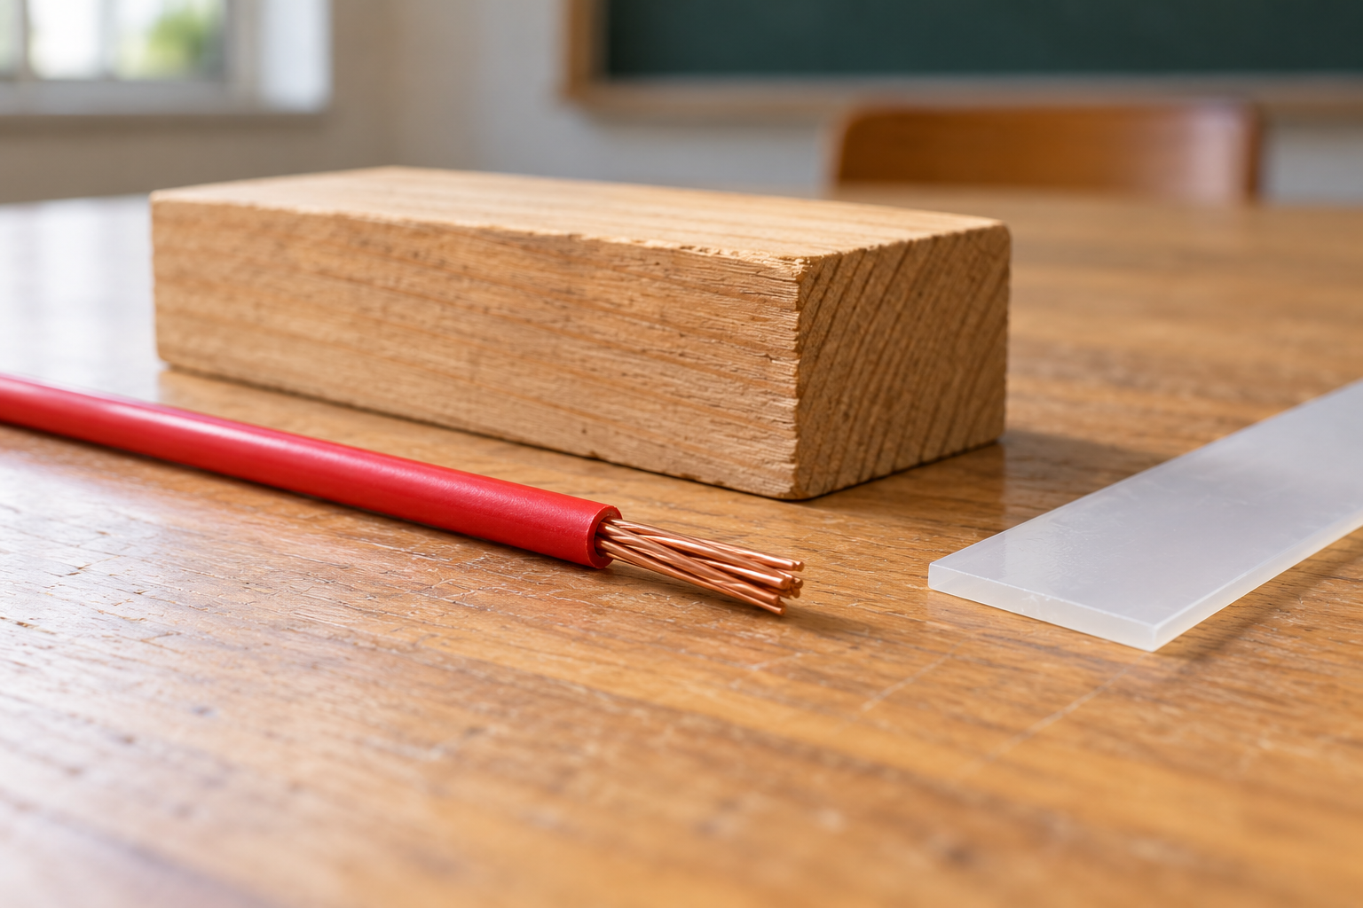
A copper wire with red plastic covering beside separate wood and plastic samples. Electrical conductors and insulators support different functions. Generated contextual illustration; not a scale model.

Check the explanation
First test that the circuit works with a known conductor. Then change only the test material. This control helps separate material properties from equipment problems.
Water is not one simple case: dissolved substances strongly affect conductivity. Do not use water in electrical tests or assume it makes equipment safe.
Use only teacher-approved cells and components. Never test wall outlets, damaged wires or household power. An insulator in a classroom test is not proof of safety under every voltage or condition.

What to remember
- Electrical conductors and insulators support different functions.
- A working control circuit helps separate material properties from equipment failures.

Check your understanding
Explain aloud, sketch, or write. Use evidence from the chapter.
1 Why does a lamp staying dark not always prove the tested material is an insulator?
My thinking
2 Why are a wire’s core and covering made from different materials?
My thinking

Practise the words
Cover the meanings and explain the words. Then cover the words and name the meanings. Give an example.
electric current movement of electric charge
electrical conductor a material through which charge can move readily
electrical insulator a material that resists charge movement

Lesson connection
Lesson 5 · Electrical materials
Original adaptation informed by Core Knowledge Foundation science materials including Energy Transfer and Transformation, Thermal Energy, Electricity and Magnetism, Light and Matter. Shared under CC BY NC SA 4.0. Generated contextual illustration.

