A Circuit Needs a Complete Path
  - Grade 5 Unit 2 • Chapter 5
Learning goal I can explain the functions of a cell, wires, switch and load.
A small lamp can remain dark even when a fresh cell is nearby.

Every component has a role
The cell supplies energy; wires connect components; the load transforms electrical energy. A switch controls whether the path is open or closed. A gap prevents steady current in a simple circuit.
Both terminals of the cell must connect through the load. Current is not simply used up in the lamp; energy is transferred and transformed as charges move around the circuit.
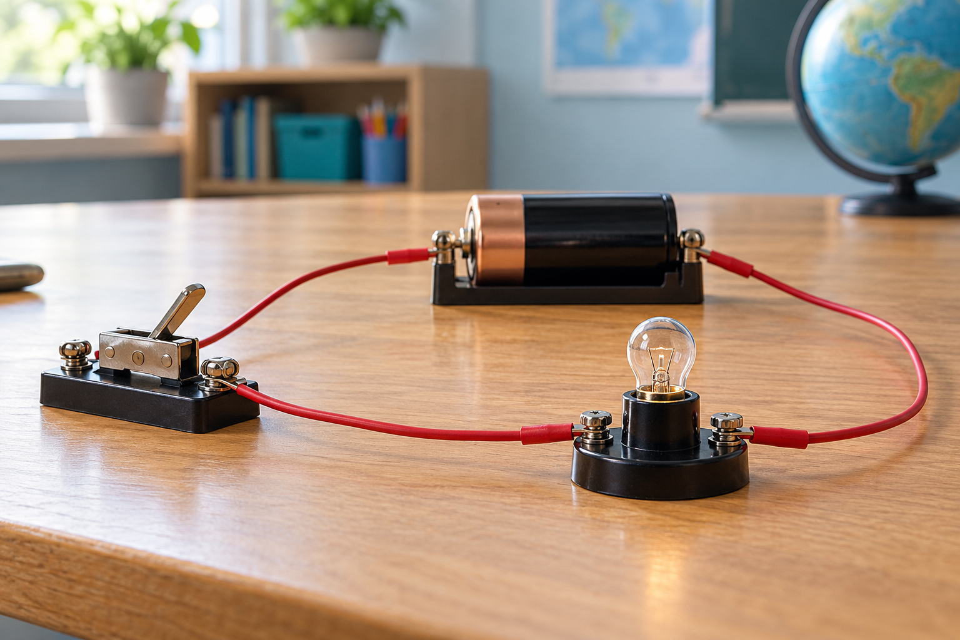
A low-voltage cell, switch, lamp and wires arranged in a simple circuit. A simple circuit requires a complete path through its components. Generated contextual illustration; not a scale model.

Trace and troubleshoot
Follow the path from one terminal through each component and back to the other. Check connections systematically rather than changing everything at once.
In a simple series circuit, one break can stop current throughout. Several loads can share a path; their behaviour depends on the whole arrangement.
Do not join cell terminals directly with a wire. This short circuit can heat wires and cells. Use teacher-approved low-voltage setups and disconnect them after use.

What to remember
- A simple circuit requires a complete path through its components.
- Loads transform energy while switches open or close the path.

Check your understanding
Explain aloud, sketch, or write. Use evidence from the chapter.
1 Why does touching only one cell terminal to a lamp usually not light it?
My thinking
2 What does opening a switch do to the rest of a simple series circuit?
My thinking

Practise the words
Cover the meanings and explain the words. Then cover the words and name the meanings. Give an example.
circuit a connected path for electric current
switch a component that opens or closes a path
load a component that transforms electrical energy
cell a source that supplies electrical energy from chemical energy

Lesson connection
Lesson 6 · Circuits
Original adaptation informed by Core Knowledge Foundation science materials including Energy Transfer and Transformation, Thermal Energy, Electricity and Magnetism, Light and Matter. Shared under CC BY NC SA 4.0. Generated contextual illustration.

