Light Reflects and Refracts
  - Grade 5 Unit 2 • Chapter 6
Learning goal I can distinguish reflection from refraction using a light path.
A pond can show a reflection of trees, while a submerged stick can appear bent.

Light reaching our eyes
Reflection occurs when light returns from a surface. Smooth surfaces can form clear images; rough surfaces scatter reflected light in many directions. We see most objects because reflected light reaches our eyes.
Refraction happens when light changes speed between materials, such as air and water. At many crossing angles, its direction changes too.
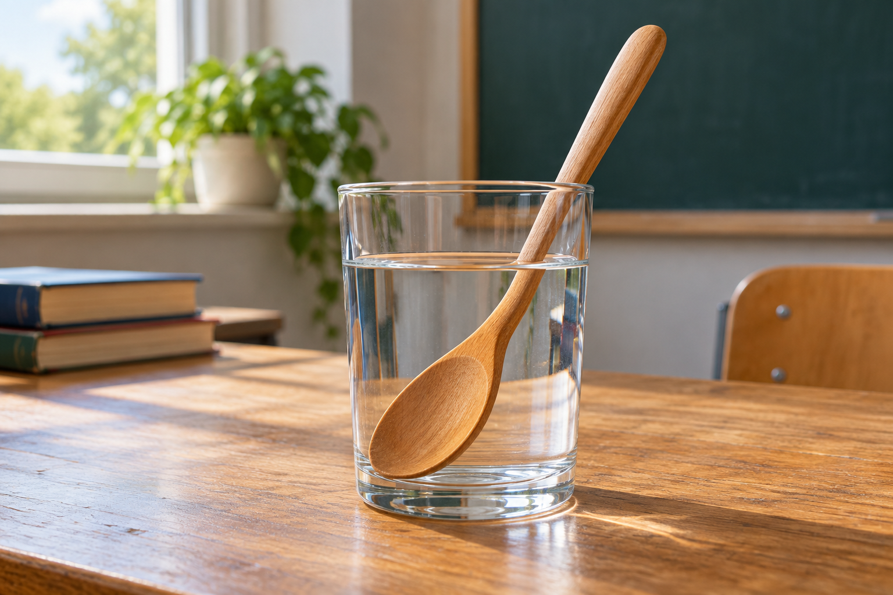
A straight wooden spoon partly immersed in a clear glass of water. Reflection returns light from a surface; refraction changes its path between media. Generated contextual illustration; not a scale model.

Use a path model
The stick is not necessarily physically bent. Light from its submerged part changes direction at the water-air boundary, affecting where it appears to be.
A lens uses refraction to change light paths. Mirrors use reflection. Draw where light starts, which boundary it reaches and how it reaches an observer.
Never direct bright lights or lasers into eyes or look at the Sun. Classroom models can use safe lights and pictures without exposing anyone to harmful brightness.

What to remember
- Reflection returns light from a surface; refraction changes its path between media.
- Light-path models explain apparent images and positions.

Check your understanding
Explain aloud, sketch, or write. Use evidence from the chapter.
1 Why can a straight stick appear bent in water?
My thinking
2 How do mirrors and lenses change light differently?
My thinking

Practise the words
Cover the meanings and explain the words. Then cover the words and name the meanings. Give an example.
reflection light returning from a surface
refraction a change in light direction when passing between media at an angle
medium material through which light travels

Lesson connection
Lesson 7 · Light
Original adaptation informed by Core Knowledge Foundation science materials including Energy Transfer and Transformation, Thermal Energy, Electricity and Magnetism, Light and Matter. Shared under CC BY NC SA 4.0. Generated contextual illustration.

