Design an Energy System
  - Grade 5 Unit 2 • Chapter 7
Learning goal I can justify a design using energy transfer and material properties.
A school project might need a low-voltage alarm or an insulated container. The right design depends on the job.

Name the job first
For an alarm, specify what should trigger it and how sound or light signals a change. Trace the circuit and energy transformations. For insulation, specify the starting conditions and how long a temperature should be maintained.
Choose materials using the relevant properties. A good thermal insulator is not automatically a suitable electrical component.
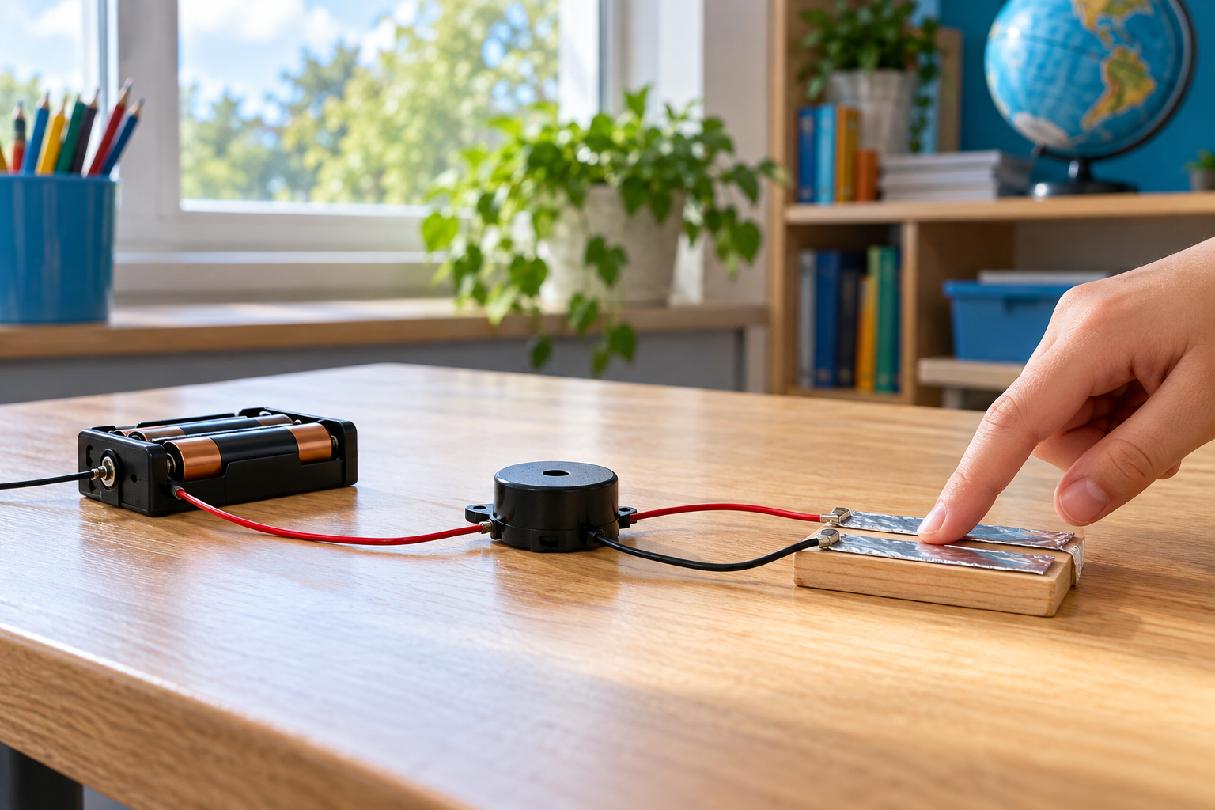
A finger operating a simple low-voltage contact switch connected to a buzzer. A design’s criteria and constraints should be defined before testing. Generated contextual illustration; not a scale model.

Make evidence useful
Define success before testing. Keep comparison conditions alike and record observations with units where appropriate. Change one feature so you can explain its effect.
A working model can still have weaknesses. Consider energy use, durability, safe operation and who must use it. Do not add complex parts without explaining their purpose.
Use approved classroom equipment and safe temperatures. A clear diagram and a careful test are stronger evidence than a confident claim that a design is best.

What to remember
- A design’s criteria and constraints should be defined before testing.
- Controlled comparisons connect changes to evidence of improvement.

Check your understanding
Explain aloud, sketch, or write. Use evidence from the chapter.
1 Why should design criteria be written before testing?
My thinking
2 Why is changing several features at once a weak way to improve a prototype?
My thinking

Practise the words
Cover the meanings and explain the words. Then cover the words and name the meanings. Give an example.
criterion a feature used to judge whether a design succeeds
constraint a limit the design must meet
prototype a test model of a proposed solution

Lesson connection
Lesson 9 · Energy-system design
Original adaptation informed by Core Knowledge Foundation science materials including Energy Transfer and Transformation, Thermal Energy, Electricity and Magnetism, Light and Matter. Shared under CC BY NC SA 4.0. Generated contextual illustration.

