What Plants Take In
  - Grade 5 Unit 3 • Chapter 1
Learning goal I can explain the different roles of water, light, carbon dioxide and mineral nutrients.
A greenhouse tomato plant depends on several inputs with different jobs.

Food is made not absorbed as soil
Water and carbon dioxide provide materials for making sugars. Light supplies energy. Mineral nutrients help growth and other processes but are not an energy source or the plant’s food.
Roots obtain water and dissolved minerals. Carbon dioxide enters leaves mainly through tiny openings. Suitable temperature, air and space also influence growth.
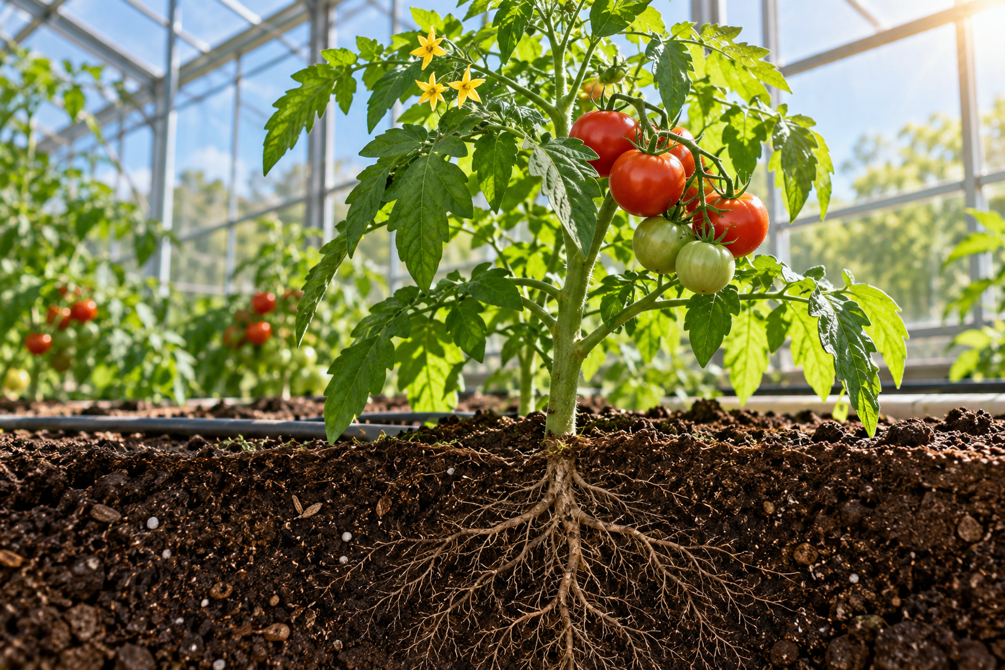
A greenhouse tomato plant with leaves, fruit and roots shown in a soil cutaway. Light supplies energy while water, carbon dioxide and minerals supply different materials. Generated contextual illustration; not a scale model.

Separate cause from coincidence
To investigate light, compare similar plants with the same water, soil, temperature and observation period. A plant receiving less light might still use stored food briefly, so one day is not a complete test.
More is not always better. Excess water can reduce air around roots, and excessive mineral additions can damage plants.
Connect each input to its role instead of listing needs without an explanation. Plants make food but still depend on their environment for materials and energy.

What to remember
- Light supplies energy while water, carbon dioxide and minerals supply different materials.
- Plant inputs have distinct roles and need suitable conditions.

Check your understanding
Explain aloud, sketch, or write. Use evidence from the chapter.
1 Why are light and minerals not interchangeable plant needs?
My thinking
2 Why might a plant survive briefly in darkness but not keep growing normally?
My thinking

Practise the words
Cover the meanings and explain the words. Then cover the words and name the meanings. Give an example.
carbon dioxide a gas plants use in photosynthesis
mineral nutrient an inorganic substance needed for plant processes
photosynthesis using light energy to make sugars from water and carbon dioxide

Lesson connection
Lesson 1 · Plant needs
Original adaptation informed by Core Knowledge Foundation science materials including Energy and Matter in Ecosystems, Structure and Functions. Shared under CC BY NC SA 4.0. Generated contextual illustration.

