Photosynthesis Stores Energy in Food
  - Grade 5 Unit 3 • Chapter 2
Learning goal I can describe photosynthesis as a transformation of light energy into chemical energy.
Sunlight reaching a maple leaf can become part of an energy path through a forest.

A leaf is part of a system
During photosynthesis, green plants use light energy to make sugars from water and carbon dioxide. Oxygen is released. Chlorophyll helps absorb light; other structures and processes are also involved.
The sugars can be used, transported or stored. Light energy becomes chemical energy in food, rather than simply making the leaf warm.
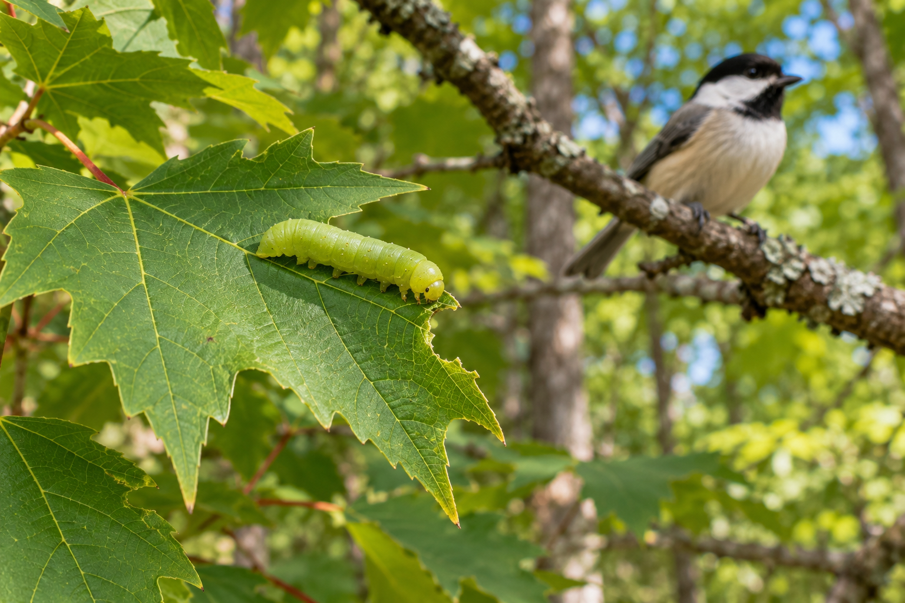
A green caterpillar at a maple leaf with a chickadee on a separate branch. Photosynthesis transforms light energy into chemical energy stored in sugars. Generated contextual illustration; not a scale model.

Plants support other organisms
A caterpillar eating a leaf receives materials and chemical energy the plant made. A bird eating the caterpillar connects indirectly to that plant process.
Plants also use the sugars for their own growth and maintenance. They do not make food only for animals.
A simplified word model shows inputs and outputs but not every reaction inside a leaf. It helps us explain why light, water and carbon dioxide are connected needs.

What to remember
- Photosynthesis transforms light energy into chemical energy stored in sugars.
- Plant food connects producers to many consumers.

Check your understanding
Explain aloud, sketch, or write. Use evidence from the chapter.
1 Why is photosynthesis called an energy transformation?
My thinking
2 How can a bird depend on photosynthesis without eating leaves?
My thinking

Practise the words
Cover the meanings and explain the words. Then cover the words and name the meanings. Give an example.
photosynthesis using light energy to make sugars from water and carbon dioxide
chlorophyll a pigment that absorbs light for photosynthesis
chemical energy energy stored in chemical substances

Lesson connection
Lesson 2 · Photosynthesis
Original adaptation informed by Core Knowledge Foundation science materials including Energy and Matter in Ecosystems, Structure and Functions. Shared under CC BY NC SA 4.0. Generated contextual illustration.

