Plants Respire Too
  - Grade 5 Unit 3 • Chapter 3
Learning goal I can distinguish photosynthesis from cellular respiration.
A plant does not stop needing energy when darkness falls.

Making food and using food differ
Photosynthesis makes sugars using light energy. Respiration releases usable energy from sugars for cell activities. Most familiar plant cells use oxygen in respiration and release carbon dioxide and water.
Plants respire during both day and night. Green tissues can photosynthesize when conditions allow, but roots and many other tissues cannot make food through photosynthesis.
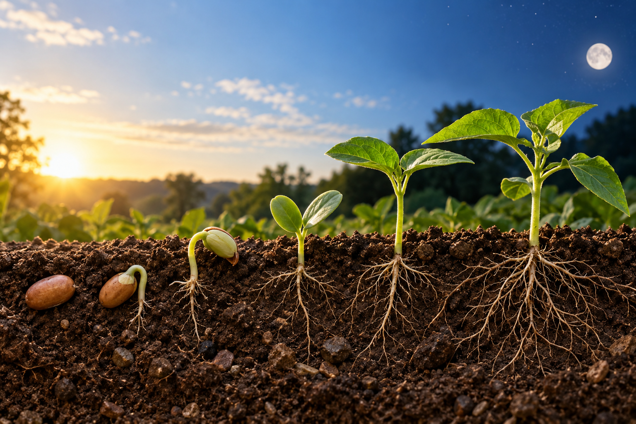
A composite seed-to-seedling scene beneath a sky representing day and night. Photosynthesis makes food; respiration releases usable energy from food. Generated contextual illustration; not a scale model.

Connect rather than cancel
These processes have different roles even when both happen in a leaf. Gas exchange measured during daylight reflects their combined effects, not proof that respiration has stopped.
A germinating seed uses stored food through respiration before it has effective leaves. It needs oxygen as well as suitable water and temperature.
Explain the plant as an organism with energy needs of its own. Making food is one part of that system, not a replacement for using energy in cells.

What to remember
- Photosynthesis makes food; respiration releases usable energy from food.
- Plants respire during day and night.

Check your understanding
Explain aloud, sketch, or write. Use evidence from the chapter.
1 Why do roots need food from other plant parts?
My thinking
2 Can a plant release oxygen in daylight and still be respiring?
My thinking

Practise the words
Cover the meanings and explain the words. Then cover the words and name the meanings. Give an example.
respiration a cellular process releasing usable energy from food
photosynthesis using light energy to make sugars
oxygen a gas used in many organisms’ respiration

Lesson connection
Lesson 3 · Respiration comparison
Original adaptation informed by Core Knowledge Foundation science materials including Energy and Matter in Ecosystems, Structure and Functions. Shared under CC BY NC SA 4.0. Generated contextual illustration.

