Growth Responds to Conditions
  - Grade 5 Unit 3 • Chapter 5
Learning goal I can distinguish phototropism, gravitropism and hydrotropism.
A seedling near a window may bend as it grows, but it is not walking toward the light.

Growth can have a direction
Phototropism is directional growth in response to light. Gravitropism, also called geotropism, is a response to gravity. Shoots often grow against gravity while roots usually grow with it.
Hydrotropism is growth influenced by water availability. These responses help plants obtain resources and position structures appropriately.
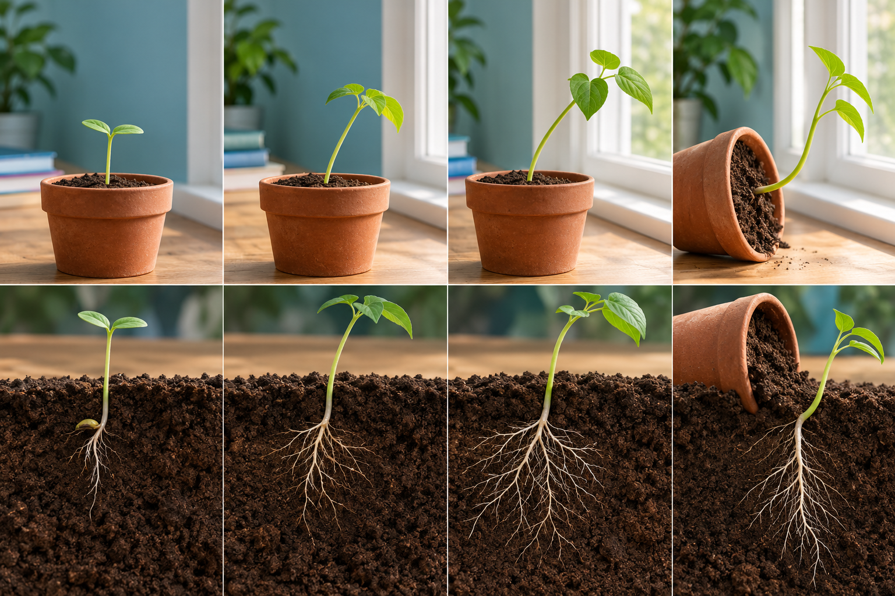
A composite of seedlings growing beside a window and a pot placed on its side. Tropisms are directional growth responses rather than deliberate movement. Generated contextual illustration; not a scale model.

Investigate the stimulus
Turn a pot or change the direction of light and observe growth over several days. Keep other conditions alike. Different responses can act together, so roots and shoots may not follow one simple rule.
A tropism is growth, not an immediate deliberate choice. Do not explain it as the plant thinking about where to go.
Use diagrams showing starting position, stimulus and later growth. Record time, because existing parts may remain while new growth changes direction.

What to remember
- Tropisms are directional growth responses rather than deliberate movement.
- Light, gravity and water conditions can influence different parts of a plant.

Check your understanding
Explain aloud, sketch, or write. Use evidence from the chapter.
1 Why is a bent seedling not evidence that a plant walked?
My thinking
2 Why might gravity and water both matter when predicting root growth?
My thinking

Practise the words
Cover the meanings and explain the words. Then cover the words and name the meanings. Give an example.
tropism a directional growth response to a stimulus
phototropism growth response to light
gravitropism growth response to gravity
hydrotropism growth response to water conditions

Lesson connection
Lesson 5 · Tropisms
Original adaptation informed by Core Knowledge Foundation science materials including Energy and Matter in Ecosystems, Structure and Functions. Shared under CC BY NC SA 4.0. Generated contextual illustration.

