Plant Energy Supports Ecosystems and Farms
  - Grade 5 Unit 3 • Chapter 6
Learning goal I can explain an ecological pyramid and justify a plant-growing technology.
A field supports many plants but far fewer large predators.

Energy becomes less available along a path
An energy pyramid shows producers at its base, followed by consumers. Organisms use food energy for their own processes, and much becomes thermal energy in the surroundings. Only some energy is available to the next level. This type of ecological pyramid compares available energy at each trophic level.
An energy pyramid is not simply a count of organisms. A few large trees can support many small insects, so population numbers need a different kind of model.
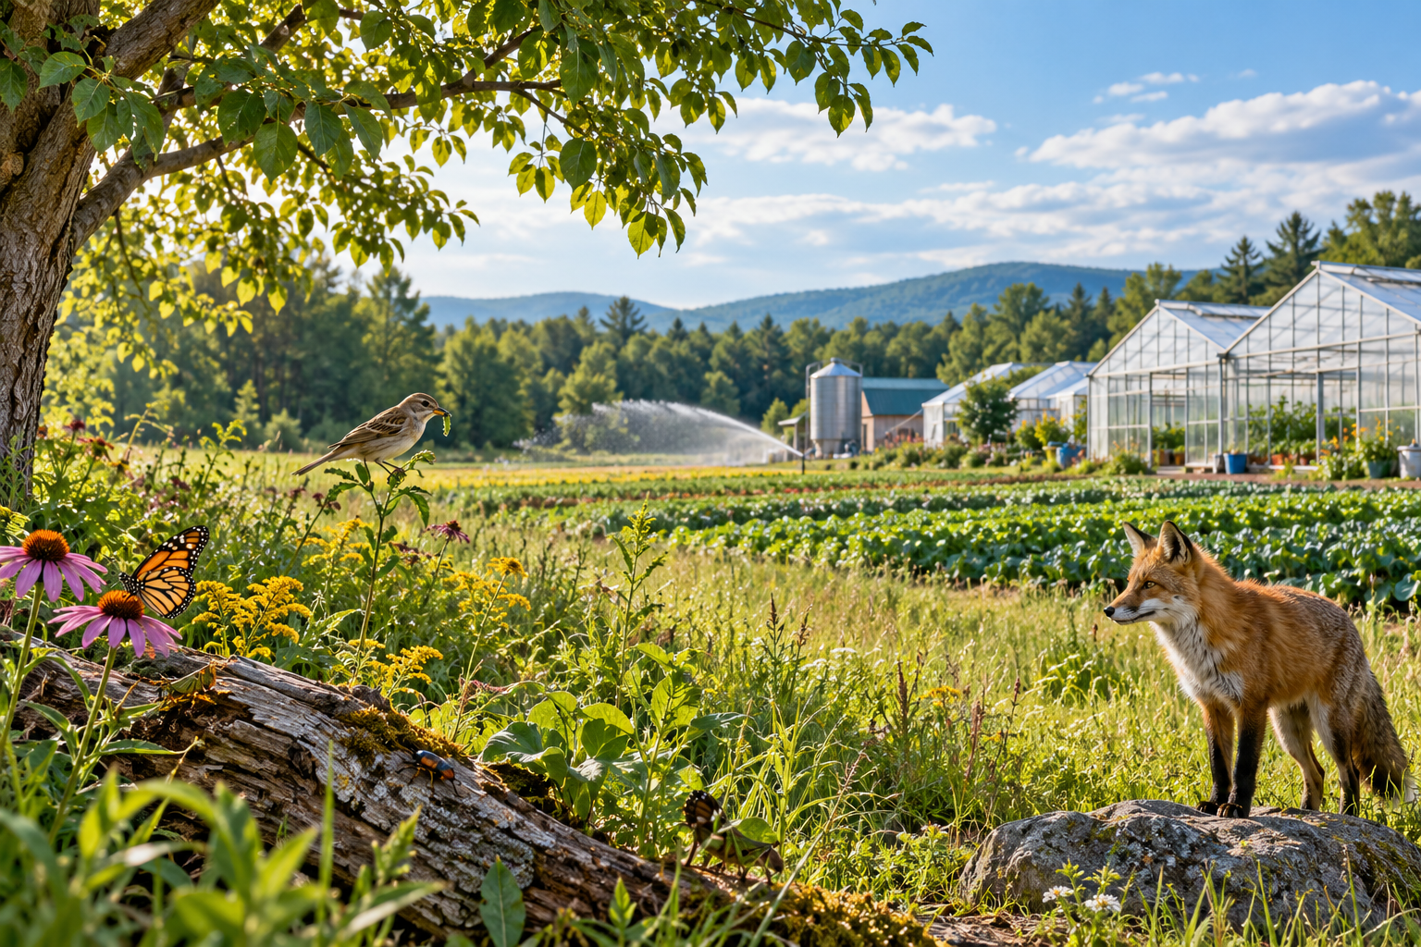
Wild plants and animals beside a cultivated field, irrigation system and greenhouse. Energy pyramids show reduced energy available at higher feeding levels. Generated contextual illustration; not a scale model.

Apply plantsystem knowledge
Irrigation, greenhouses, crop storage and food processing are technologies that meet particular needs. A growing system must supply suitable light, water, nutrients and conditions without assuming that more of each is always better. Agriculture applies this knowledge when growing crops.
Compare designs using evidence and defined criteria. A greenhouse may extend growing conditions in Québec but can require heating energy and materials.
Explain the ecological connection as well: agricultural decisions affect soil, water and habitats as well as the crop itself.

What to remember
- Energy pyramids show reduced energy available at higher feeding levels.
- Agricultural technologies must meet plant needs while considering resource use and effects.

Check your understanding
Explain aloud, sketch, or write. Use evidence from the chapter.
1 Why is less energy available to higher feeding levels?
My thinking
2 Why might greenhouse heating improve one outcome but create a tradeoff?
My thinking

Practise the words
Cover the meanings and explain the words. Then cover the words and name the meanings. Give an example.
ecological pyramid a model comparing feeding levels such as their available energy
trophic level a position in a feeding pathway
agriculture growing crops or raising organisms for human use

Lesson connection
Lesson 6 · Ecological pyramids / Lesson 7 · Agriculture and design
Original adaptation informed by Core Knowledge Foundation science materials including Energy and Matter in Ecosystems, Structure and Functions. Shared under CC BY NC SA 4.0. Generated contextual illustration.

