Life Cycles and Metamorphosis
  - Grade 5 Unit 4 • Chapter 2
Learning goal I can compare human development with an animal life cycle involving metamorphosis.
A caterpillar and an adult butterfly belong to one life cycle but live differently.

Stages can have different jobs
A butterfly develops through egg, larva, pupa and adult. The larva eats and grows. During the pupal stage, major changes produce adult structures. The adult can reproduce.
A frog also undergoes metamorphosis, changing from a tadpole to an adult. Its pattern is not identical to a butterfly’s; there is no frog pupa.
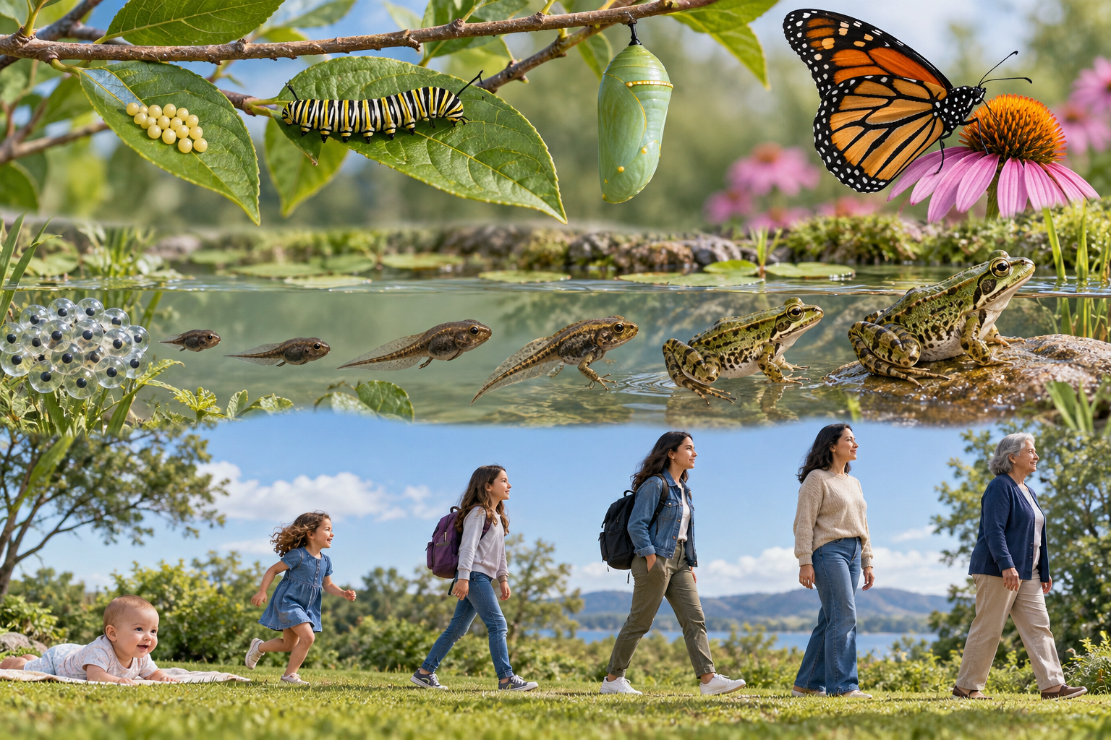
A composite illustration comparing butterfly, frog and human developmental stages. Different organisms have different developmental stages. Generated contextual illustration; not a scale model.

Compare without forcing a pattern
Human development includes infancy, childhood, adolescence and adulthood, followed by later life. Humans grow and change but do not undergo a butterfly-like metamorphosis.
Stages describe general patterns rather than exact deadlines for every individual. An organism’s needs and abilities change through development.
A cycle connects generations. Adults may produce offspring; the same adult does not turn into its own earlier stage. Identify both shared processes and genuine differences between examples.

What to remember
- Different organisms have different developmental stages.
- Life cycles connect growth and reproduction across successive generations.

Check your understanding
Explain aloud, sketch, or write. Use evidence from the chapter.
1 Why should a frog’s cycle not include a pupa just because a butterfly’s does?
My thinking
2 What do human and butterfly life cycles share despite different body changes?
My thinking

Practise the words
Cover the meanings and explain the words. Then cover the words and name the meanings. Give an example.
life cycle stages of an organism’s life
metamorphosis a major change of body form during development
larva an immature stage with a form different from the adult

Lesson connection
Lesson 2 · Life cycles / Lesson 3 · Metamorphosis
Original adaptation informed by Core Knowledge Foundation science materials including Life Cycles, Human Hormones and Reproduction, Natural Selection and Common Ancestry. Shared under CC BY NC SA 4.0. Generated contextual illustration.

