Sexual Reproduction in Animals
  - Grade 5 Unit 4 • Chapter 3
Learning goal I can explain the roles of sperm, egg cells and fertilization.
A fertilized bird egg and a developing mammal begin through a shared cellular event.

A new organism begins
Sexual reproduction involves sperm and an egg cell. Fertilization joins these cells and begins development of a new organism. Offspring inherit information from both contributing parents.
In some animals, fertilization occurs outside bodies; in others it occurs inside. Embryos may develop in laid eggs or inside a parent. These are different ways to support development after fertilization.
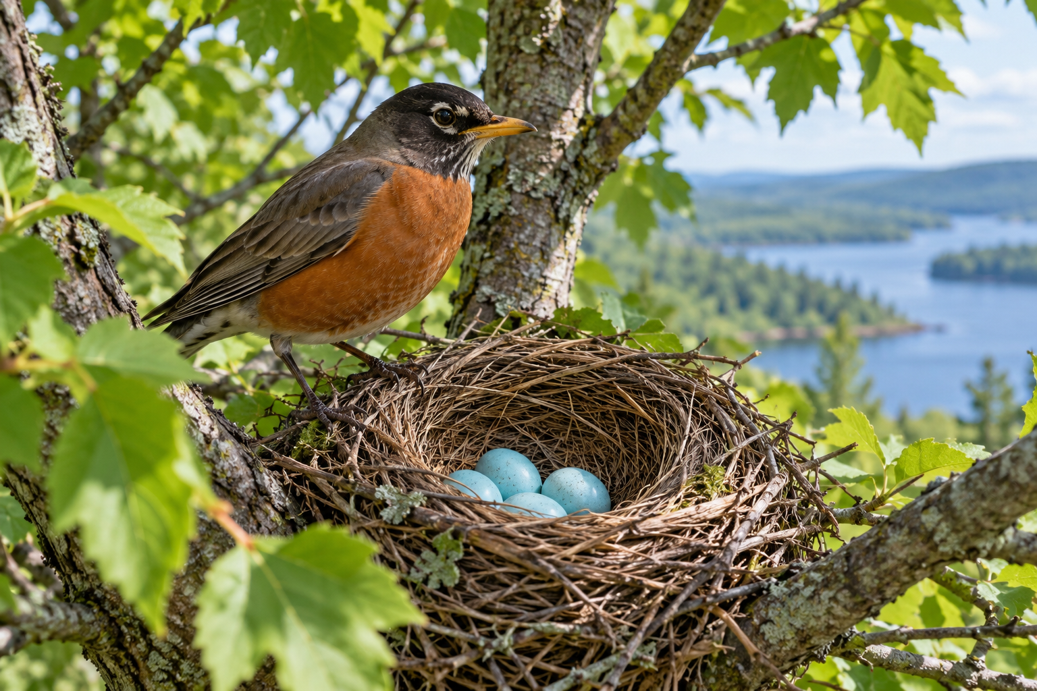
A robin beside intact pale blue eggs in its nest. Sexual reproduction begins through joining sperm and an egg cell. Generated contextual illustration; not a scale model.

Roles and stages differ
Producing reproductive cells, fertilization, embryo development and caring for young are different parts of reproduction. Not every animal provides the same care.
Inherited variation means offspring are not exact copies of their parents. Appearance alone does not reveal every inherited feature.
Use scientific vocabulary and appropriate diagrams. Questions about human experiences belong in respectful classroom discussions following school guidance; no one needs to share private information.

What to remember
- Sexual reproduction begins through joining sperm and an egg cell.
- Fertilization, embryo development and parental care are distinct processes.

Check your understanding
Explain aloud, sketch, or write. Use evidence from the chapter.
1 Why are fertilization and caring for young different processes?
My thinking
2 Why can offspring resemble both parents without being identical to either?
My thinking

Practise the words
Cover the meanings and explain the words. Then cover the words and name the meanings. Give an example.
sexual reproduction reproduction involving the joining of reproductive cells
sperm a male reproductive cell
egg cell a female reproductive cell
fertilization joining of sperm and an egg cell

Lesson connection
Lesson 4 · Sexual reproduction
Original adaptation informed by Core Knowledge Foundation science materials including Life Cycles, Human Hormones and Reproduction, Natural Selection and Common Ancestry. Shared under CC BY NC SA 4.0. Generated contextual illustration.

