Plants Can Reproduce Without Seeds
  - Grade 5 Unit 4 • Chapter 4
Learning goal I can explain asexual reproduction and compare it with sexual reproduction.
A garden strawberry plant can form a new plant at the end of a runner.

A strawberry sends out runners
Asexual reproduction can produce offspring from one parent without fertilization. Runners, bulbs and suitable cuttings are examples in plants. New growth can develop roots and become a separate organism.
These offspring usually have genetic information very similar to their parent. Growing a cutting is not the same as joining sperm and an egg cell.
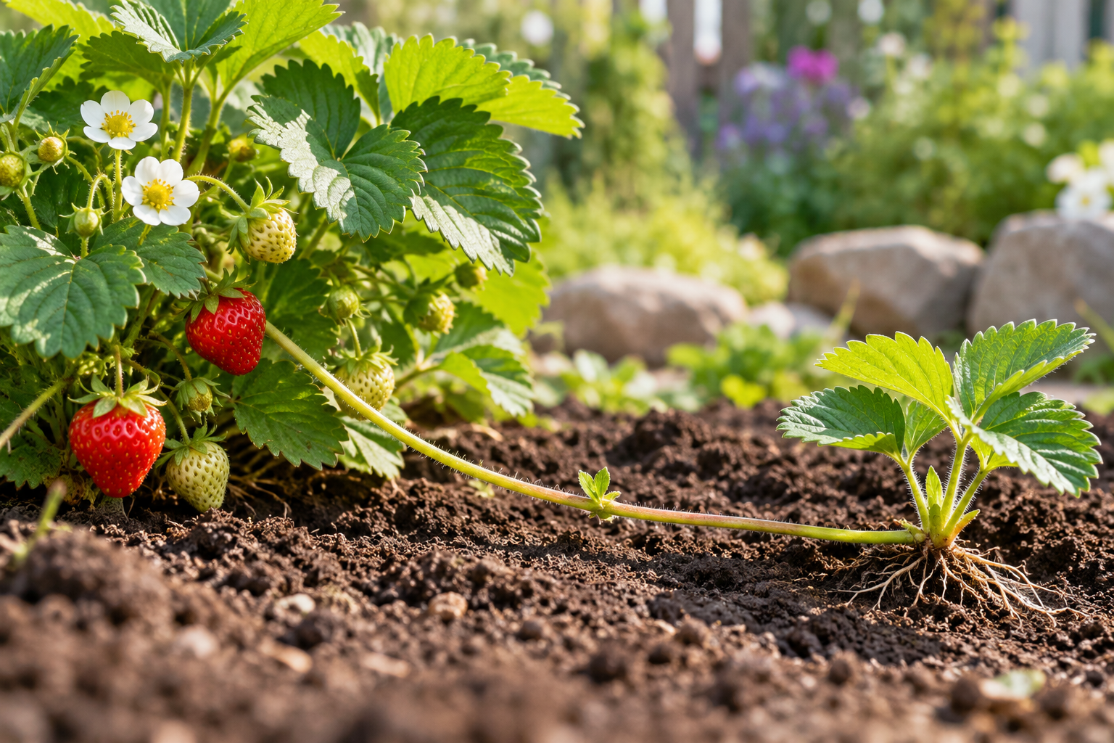
A strawberry parent plant connected by a runner to a rooted young plant. Asexual reproduction can produce a new plant without fertilization. Generated contextual illustration; not a scale model.

Compare advantages and limits
Asexual reproduction can maintain useful traits in cultivated plants. Sexual reproduction usually combines information from two reproductive cells and can create greater variation.
Similar plants may share susceptibility to the same disease or conditions. Variation can matter when surroundings change.
Not every broken plant part can grow independently. A cutting needs suitable tissue and conditions. In a classroom test, compare similar cuttings and document roots and new growth over time.

What to remember
- Asexual reproduction can produce a new plant without fertilization.
- Genetic similarity can preserve traits and also share vulnerabilities.

Check your understanding
Explain aloud, sketch, or write. Use evidence from the chapter.
1 Why does growing a new plant from a runner count as reproduction?
My thinking
2 Why might many genetically similar crop plants share a vulnerability?
My thinking

Practise the words
Cover the meanings and explain the words. Then cover the words and name the meanings. Give an example.
asexual reproduction producing offspring without joining reproductive cells
runner a horizontal stem that can form a new plant
cutting a plant piece used to grow a new plant

Lesson connection
Lesson 5 · Asexual reproduction
Original adaptation informed by Core Knowledge Foundation science materials including Life Cycles, Human Hormones and Reproduction, Natural Selection and Common Ancestry. Shared under CC BY NC SA 4.0. Generated contextual illustration.

