Life Has Changed Over Time
  - Grade 5 Unit 4 • Chapter 6
Learning goal I can place major developments in life’s history and explain what fossils can show.
Fossils in rocks show that living things have not always been the same as those around us today.

Evidence across long times
The earliest life was microscopic. Multicellular organisms later developed. Over long periods, life diversified in water and on land, including plants, invertebrates and different vertebrate groups.
Humans appeared very late in this long history. Organisms alive today are not arranged from unfinished to finished; they have different evolutionary histories.
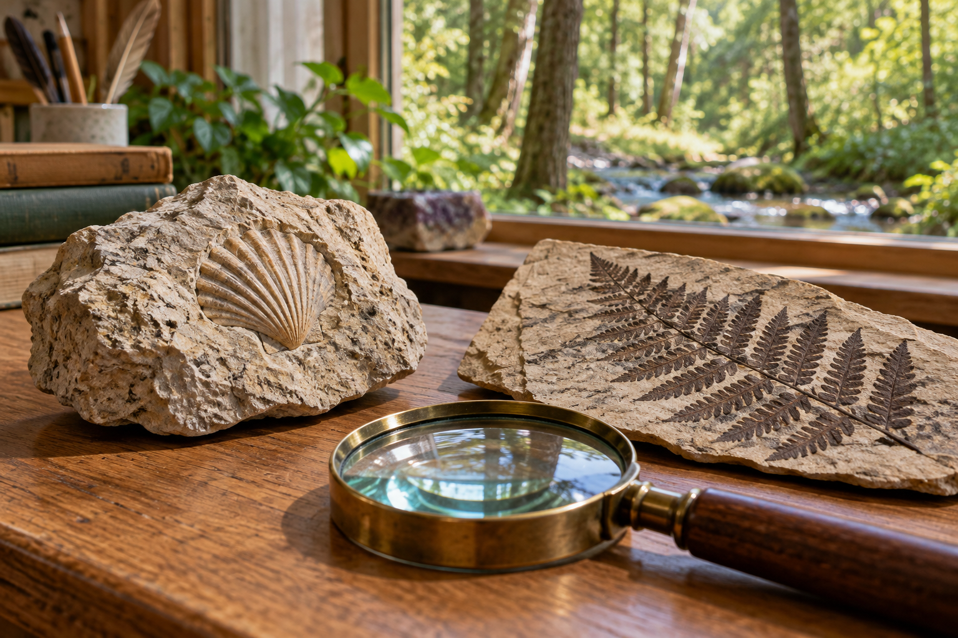
A fossil-bearing rock, fern specimen and magnifying lens on a classroom display. Evolution changes inherited features of populations across generations. Generated contextual illustration; not a scale model.

A branching history
Evolution involves populations across generations, not an individual deciding to change during its life. Variation and changing environments help explain why some inherited features become more common.
Extinctions remove branches of life’s history. Fossils and other evidence help scientists reconstruct patterns, but the fossil record is incomplete.
Use a branching diagram or timeline rather than a ladder with humans at its goal. Many groups coexist, and evolution does not move toward a predetermined best organism.

What to remember
- Evolution changes inherited features of populations across generations.
- Life’s history branches and does not form a ladder toward a predetermined goal.

Check your understanding
Explain aloud, sketch, or write. Use evidence from the chapter.
1 Why is growth of one caterpillar not the same as evolution?
My thinking
2 Why is a ladder ending in humans a misleading model of life’s history?
My thinking

Practise the words
Cover the meanings and explain the words. Then cover the words and name the meanings. Give an example.
evolution change in inherited features of populations across generations
fossil preserved remains or traces of past life
extinction the end of a species

Lesson connection
Lesson 7 · Life through time
Original adaptation informed by Core Knowledge Foundation science materials including Life Cycles, Human Hormones and Reproduction, Natural Selection and Common Ancestry. Shared under CC BY NC SA 4.0. Generated contextual illustration.

