Permanent Magnets and Magnetic Fields
  - Grade 6 Unit 1 • Chapter 2
Learning goal I can describe magnetic poles and test how a permanent magnet acts.
A classroom bar magnet can pull some objects without touching them, but it does not attract all metals.

Poles affect the interaction
Iron and some iron-containing alloys respond strongly. Aluminium and copper are not attracted like iron in ordinary classroom tests. A magnet has north and south poles; unlike poles attract and like poles repel.
The effect often changes with distance and is strongest near the poles of a simple bar magnet. A permanent magnet maintains magnetism without a powered circuit.
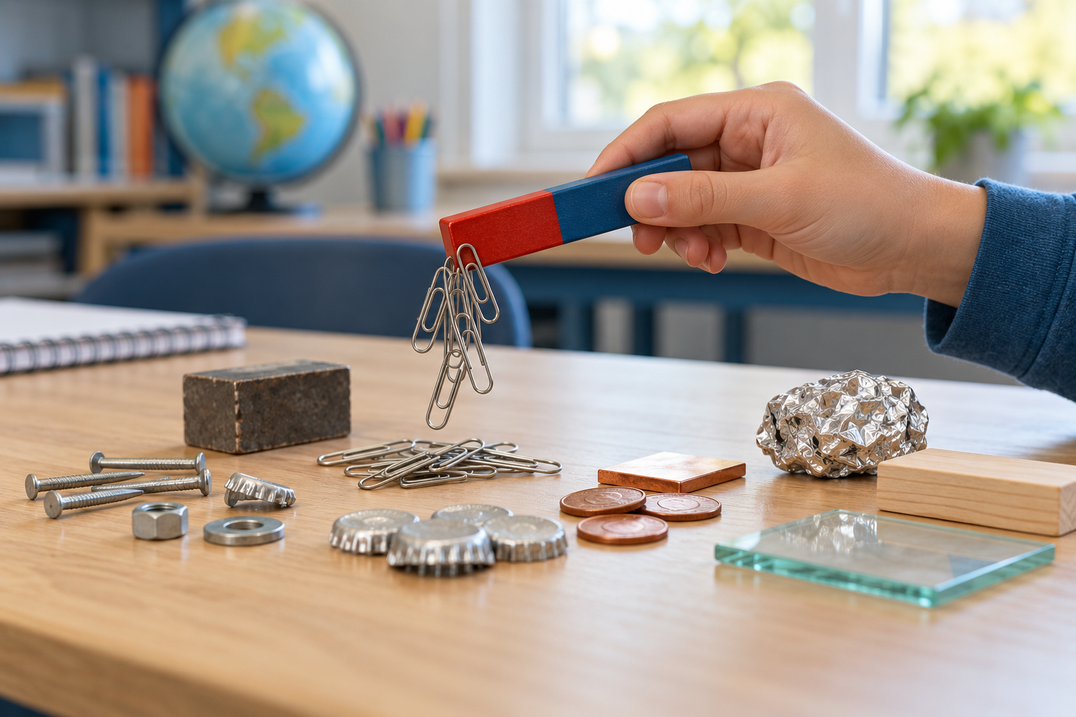
A bar magnet attracting steel clips beside several other material samples. Permanent magnets retain magnetic effects without a powered circuit. Generated contextual illustration; not a scale model.

Use a model and a comparison
A compass needle is a small magnet that aligns with the local magnetic field. Several compass observations can help map its direction. Drawn lines summarize observations; they do not fill space as solid objects.
Compare equal distances and the same object when testing strength. Magnetic forces can pass through some nonmagnetic materials, but increased separation still matters.
Keep magnets away from sensitive equipment and follow classroom guidance. Small strong magnets are not toys and must not be swallowed.

What to remember
- Permanent magnets retain magnetic effects without a powered circuit.
- Pole arrangement, distance and material affect magnetic interactions.

Check your understanding
Explain aloud, sketch, or write. Use evidence from the chapter.
1 Why is metal not a sufficient prediction rule for magnetic attraction?
My thinking
2 Why can paper between a magnet and a steel clip still allow attraction?
My thinking

Practise the words
Cover the meanings and explain the words. Then cover the words and name the meanings. Give an example.
magnetic field a region described by magnetic influence
pole one of a magnet’s north or south ends
attract pull toward
repel push away

Lesson connection
Lesson 2 · Magnetism
Original adaptation informed by Core Knowledge Foundation science materials including Forces at a Distance, Electricity and Magnetism, Astronomy. Shared under CC BY NC SA 4.0. Generated contextual illustration.

