Gravity and the Ebb and Flow of Tides
  - Grade 6 Unit 1 • Chapter 7
Learning goal I can explain tides using gravitational differences and local coastline conditions.
Along the St. Lawrence estuary, the same shoreline can look different as water levels rise and fall.

Coasts have repeating water levels
The Moon’s gravitational attraction differs across Earth, creating tidal effects in oceans. The Sun contributes too. Earth’s rotation carries coasts through changing tidal conditions.
Tides are not simply waves pushed toward shore. High and low water levels arise from large-scale patterns that are shaped by basin depth and coastlines.
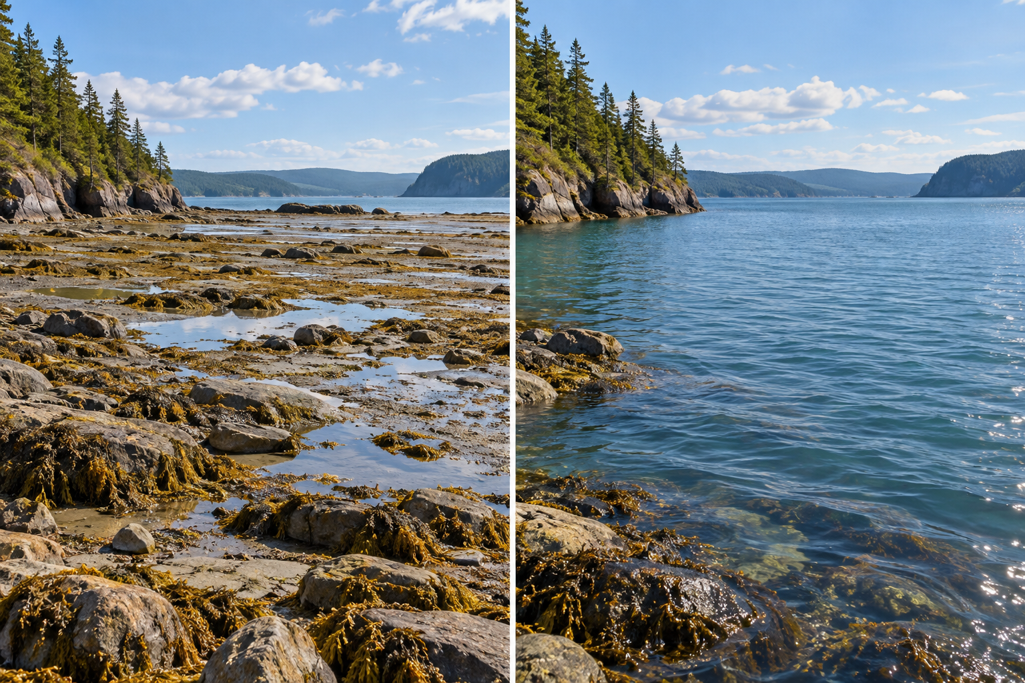
A paired view of a coastal shore at lower and higher water levels. Tides arise from gravitational differences and include solar contributions. Generated contextual illustration; not a scale model.

Local conditions matter
Many places have roughly two high and two low tides in a lunar day, but patterns and timing vary. The St. Lawrence’s channels and estuary alter the response.
When the Sun, Earth and Moon align, their tidal effects can reinforce, producing a larger tidal range. At other alignments, the range can be smaller.
Use local tide tables and adult guidance for shore visits. A general model does not provide safe access times, and a lunar phase alone cannot specify a local water level.

What to remember
- Tides arise from gravitational differences and include solar contributions.
- Coastline and basin conditions affect local tidal patterns.

Check your understanding
Explain aloud, sketch, or write. Use evidence from the chapter.
1 Why can two coasts have different tidal ranges under the same Moon?
My thinking
2 Why is an ordinary surface wave not the same as a tide?
My thinking

Practise the words
Cover the meanings and explain the words. Then cover the words and name the meanings. Give an example.
tide a regular rise and fall in coastal water level
ebb the falling stage of a tide
flood the rising stage of a tide

Lesson connection
Lesson 7 · Earth, Moon and tides
Original adaptation informed by Core Knowledge Foundation science materials including Forces at a Distance, Electricity and Magnetism, Astronomy. Shared under CC BY NC SA 4.0. Generated contextual illustration.

