Complex Machines Have Connected Jobs
  - Grade 6 Unit 2 • Chapter 1
Learning goal I can identify a machine’s main function and the simple machines within it.
A cart transports a load, while a waterwheel transfers energy from moving water to rotation.

Begin with the main function
A complex machine combines working parts. A cart may include wheels and axles, levers and screw fasteners. A wind turbine includes blades, rotating shafts and components that transmit motion.
Name the main function before listing parts. Input and output help explain why the parts are connected. A component may support, join, guide or move rather than directly supply energy.
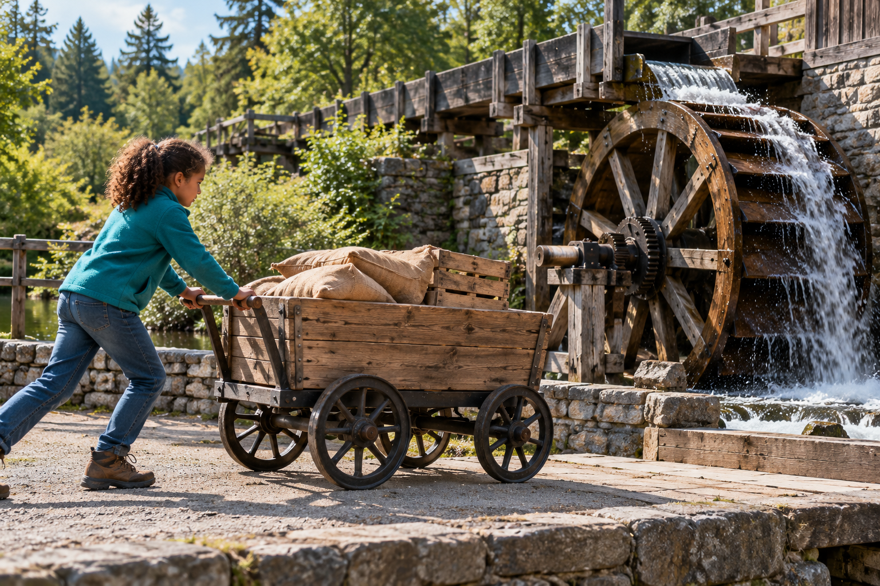
A person pushing a wheeled cart beside a turning waterwheel. Complex machines connect components to perform a main function. Generated contextual illustration; not a scale model.

Trace a useful path
Follow a cart from the user’s push to the handle, frame, axles and wheels. Explain how forces and motion pass between parts.
A technology can include more than the machine itself: users, energy supplies and maintenance are also part of the working system. A device that performs well in one setting may not suit another.
Inspect only safe stopped equipment. A clear system explanation identifies connections instead of treating the machine as a collection of unrelated pieces.

What to remember
- Complex machines connect components to perform a main function.
- An explanation traces input, connected actions and output.

Check your understanding
Explain aloud, sketch, or write. Use evidence from the chapter.
1 Why is listing a cart’s parts not enough to explain its function?
My thinking
2 How can two devices both contain wheels but have different functions?
My thinking

Practise the words
Cover the meanings and explain the words. Then cover the words and name the meanings. Give an example.
complex machine a device combining components to perform a task
input what enters or drives a system
output the resulting action or effect

Lesson connection
Lesson 1 · Complex machines
Original adaptation informed by Core Knowledge Foundation science materials including Simple Machines, HelpfulComputers, ProblemSolvingAndComputers. Shared under CC BY NC SA 4.0. Generated contextual illustration.

