Rotation Translation and Transmission
  - Grade 6 Unit 2 • Chapter 2
Learning goal I can trace different motion types through a mechanism.
A rotating crank can move a slider back and forth even though the slider does not rotate.

Describe the part you mean
Rotation and translation describe different motions. A rolling wheel combines rotation about its axle with movement of its centre. Saying the machine moves is not precise enough to describe each part.
Links and guides constrain possible motion. A slider’s guide allows translation along a path, while an axle permits a wheel to rotate.
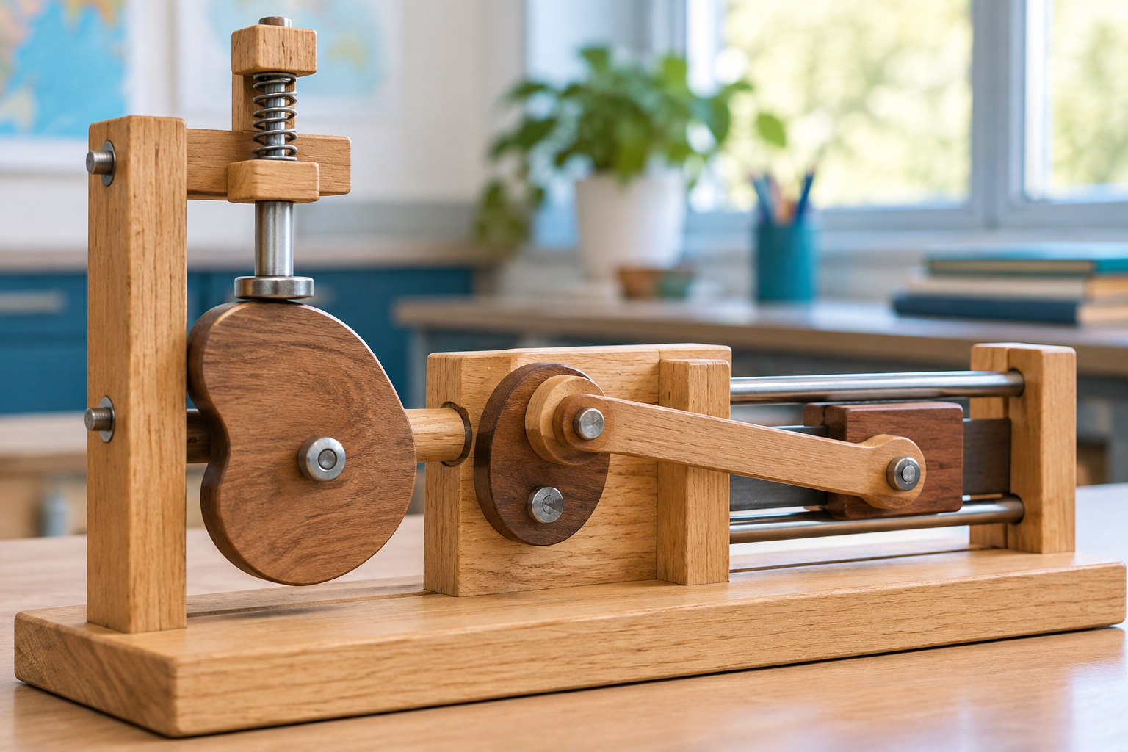
A classroom mechanism with an offset crank and guided slider on the right, beside a cam and follower on the left. Mechanisms can transmit motion or transform its type. Generated contextual illustration; not a scale model.

Connections determine the sequence
Begin at the input, identify each connection and trace the output. Contact, belts, chains or rods can transmit motion differently.
A part may change motion type or direction. A mechanism can also transmit motion without changing its type. The explanation must state what remains and what changes.
Draw arrows for each component with labels describing its movement. Stop equipment before checking a connection, and do not put fingers near moving parts.

What to remember
- Mechanisms can transmit motion or transform its type.
- Guides and connections constrain how individual parts move.

Check your understanding
Explain aloud, sketch, or write. Use evidence from the chapter.
1 Why does a rotating input not guarantee a rotating output?
My thinking
2 Why is a guide important in a slider mechanism?
My thinking

Practise the words
Cover the meanings and explain the words. Then cover the words and name the meanings. Give an example.
rotation turning about an axis
translation movement without turning
transmission passing motion between connected parts

Lesson connection
Lesson 2 · Motion types
Original adaptation informed by Core Knowledge Foundation science materials including Simple Machines, HelpfulComputers, ProblemSolvingAndComputers. Shared under CC BY NC SA 4.0. Generated contextual illustration.

