Cams Cranks and Connecting Rods
  - Grade 6 Unit 2 • Chapter 4
Learning goal I can explain how rotating parts produce repeated movement.
An uneven cam can make a follower rise and fall as the cam turns.

Shape changes the output
The distance from the cam’s axis to its surface changes around its outline. The follower’s position changes accordingly. A spring or gravity can help keep the follower against the cam.
A crank and connecting rod can produce back-and-forth slider movement. These mechanisms transform rotation into a repeating output.
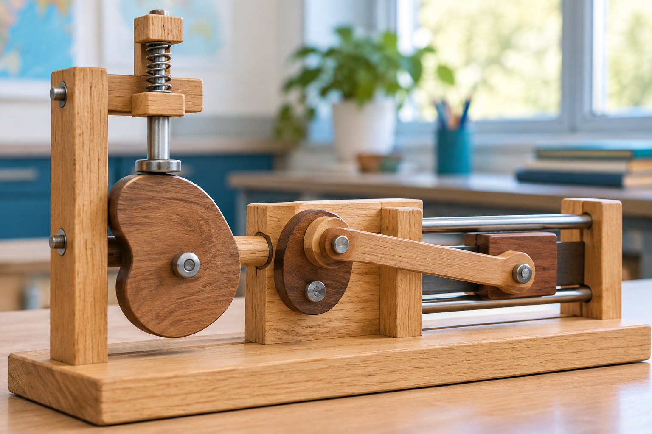
A cam and spring-loaded follower beside a crank-slider model. Cam shape and link arrangement determine repeated output motion. Generated contextual illustration; not a scale model.

Different shapes serve different jobs
A cam can be designed to lift gradually, drop quickly or pause near one position. The output depends on both cam shape and the follower arrangement.
A connecting rod transmits force and motion through its joints. If a joint or guide is missing, the intended sequence may fail.
Compare input rotation with output position at several points in a cycle. A single photograph cannot show the whole repeated pattern. Keep safe models slow and fingers clear of pinch points.

What to remember
- Cam shape and link arrangement determine repeated output motion.
- Observations across a cycle reveal more than one fixed position.

Check your understanding
Explain aloud, sketch, or write. Use evidence from the chapter.
1 Why can two differently shaped cams produce different movements from the same input speed?
My thinking
2 Why is observing one position insufficient to describe a crank-slider mechanism?
My thinking

Practise the words
Cover the meanings and explain the words. Then cover the words and name the meanings. Give an example.
cam a shaped rotating part that moves a follower
follower a part moved by a cam
crank an offset rotating arm
connecting rod a rigid link transmitting motion

Lesson connection
Lesson 4 · Cams and connecting rods
Original adaptation informed by Core Knowledge Foundation science materials including Simple Machines, HelpfulComputers, ProblemSolvingAndComputers. Shared under CC BY NC SA 4.0. Generated contextual illustration.

