Springs Store and Release Energy
  - Grade 6 Unit 2 • Chapter 5
Learning goal I can explain a spring’s role in a mechanism and compare its response.
A spring in a mechanism can return a follower or push a part after release.

Stored energy can drive a return
Stretching or compressing a suitable spring stores elastic energy. Releasing it lets the spring transfer energy as it returns toward its original form. A spring is not a continuing energy source without being loaded again.
The response depends on material, shape and deformation. Too much deformation can permanently change or damage a spring.
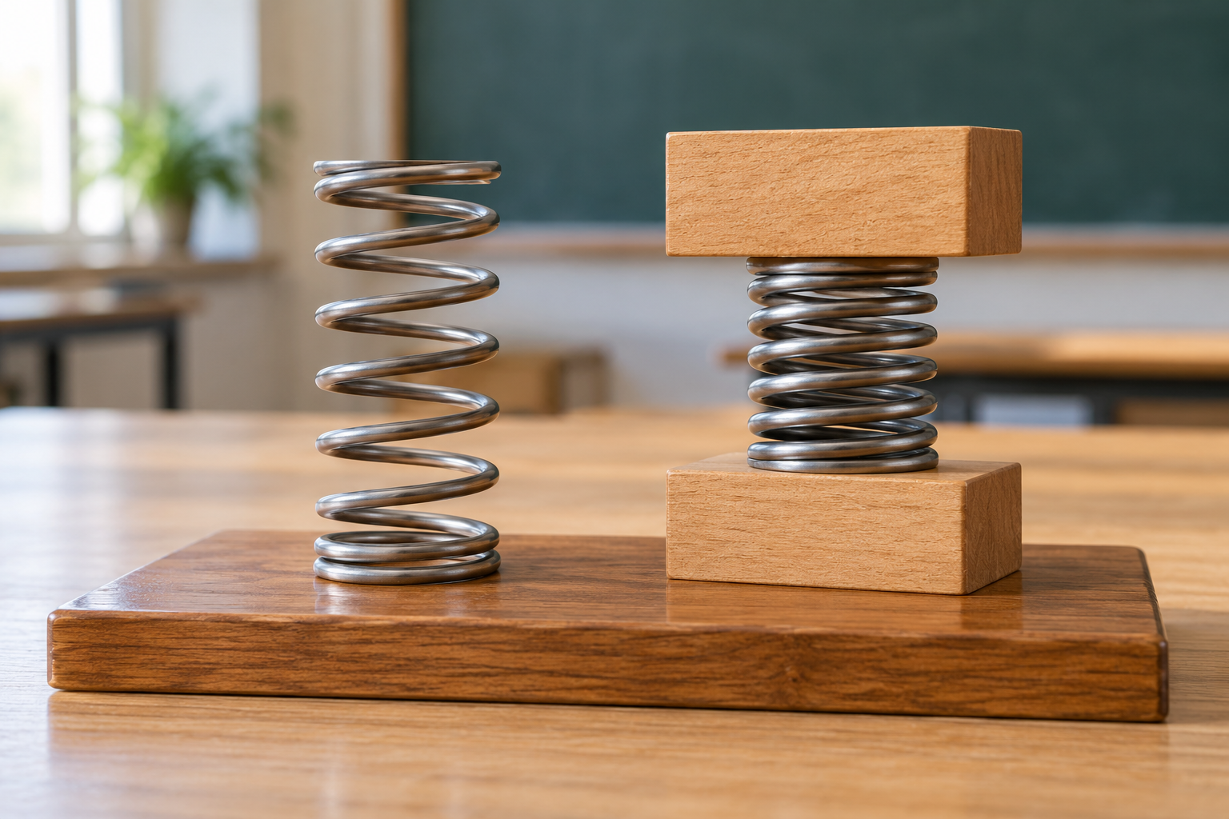
A loose steel coil spring and a similar spring held between wooden blocks. Deformed springs store energy and provide restoring forces. Generated contextual illustration; not a scale model.

Compare within safe limits
A stronger restoring force at a given extension may be useful for one task but unsuitable for another. A delicate follower may not need a very stiff spring.
Test approved springs with controlled small loads and eye protection where required. Keep starting lengths, measurements and load conditions consistent.
Real mechanisms also involve friction and damping, so stored energy may become motion, sound and thermal energy. Explain the energy path and the purpose of the return movement.

What to remember
- Deformed springs store energy and provide restoring forces.
- A suitable spring must match the task and remain within safe limits.

Check your understanding
Explain aloud, sketch, or write. Use evidence from the chapter.
1 Why does a spring-driven toy need winding or compression again?
My thinking
2 Why is the stiffest spring not automatically the best for a mechanism?
My thinking

Practise the words
Cover the meanings and explain the words. Then cover the words and name the meanings. Give an example.
spring a component that can store energy when deformed
elastic energy stored energy from reversible deformation
restoring force a force tending to return an object toward its original form

Lesson connection
Lesson 5 · Springs and stored energy
Original adaptation informed by Core Knowledge Foundation science materials including Simple Machines, HelpfulComputers, ProblemSolvingAndComputers. Shared under CC BY NC SA 4.0. Generated contextual illustration.

