Feedback Helps Robots Act
  - Grade 6 Unit 2 • Chapter 6
Learning goal I can explain a servomechanism and evaluate a robotic technology.
A robot arm must do more than start turning; it may need to reach a particular position.

Control needs information
A servomechanism compares a desired output with feedback about the actual output. A controller adjusts an actuator such as a motor to reduce the difference. Feedback distinguishes this from simply running a motor for a fixed time.
Gears, links and joints carry controlled motion through a robotic structure. A sensor’s information matters only when the system uses it appropriately.
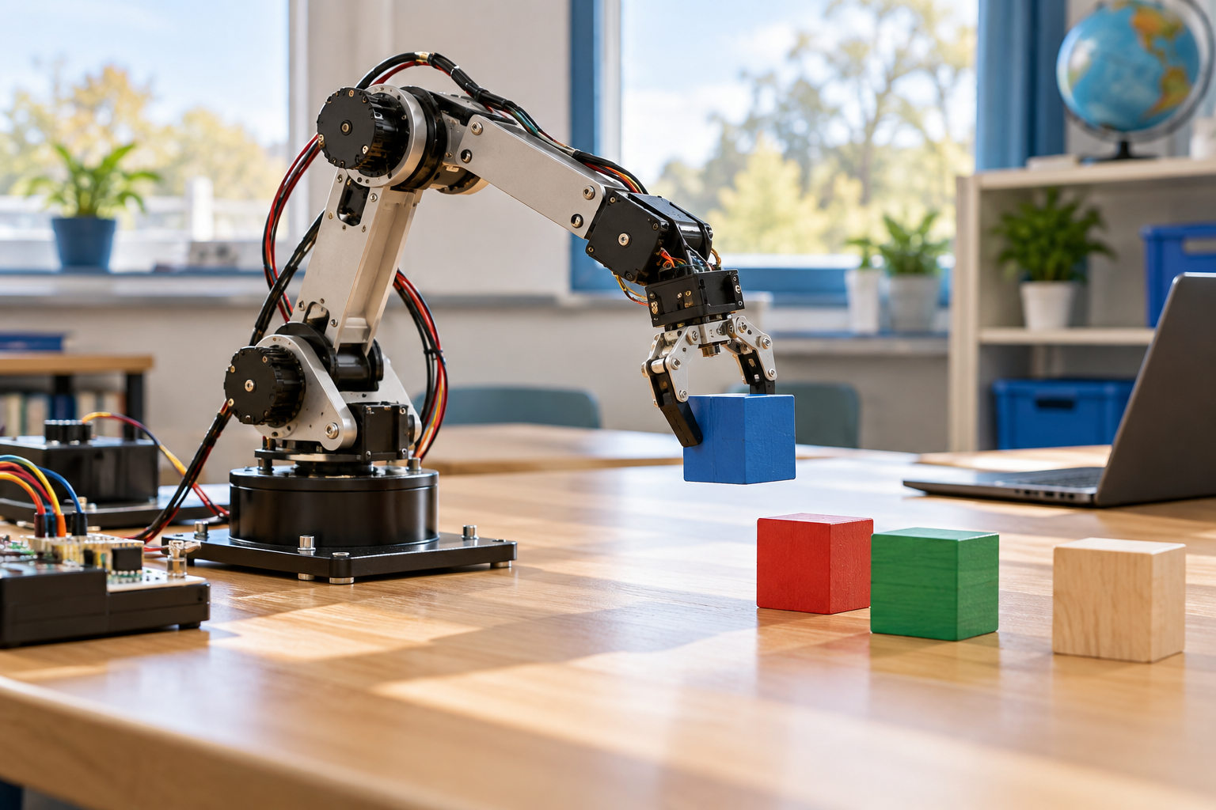
A small robotic arm holding a block above a table of coloured blocks. Servomechanisms use feedback to adjust actual output toward a desired result. Generated contextual illustration; not a scale model.

Evaluate the whole technology
Robotic and electronic technologies can improve precision, support accessibility or reduce some dangerous work. They also use materials, energy and maintenance and can change work roles.
Transportation systems similarly affect mobility, land use and surroundings. Consider which people benefit, who faces costs and which evidence supports your judgement.
Use a safe classroom model or simulation. Trace input, sensing, control and motion rather than calling every moving toy a robot with feedback.

What to remember
- Servomechanisms use feedback to adjust actual output toward a desired result.
- Technology evaluation includes users, resources and social effects as well as performance.

Check your understanding
Explain aloud, sketch, or write. Use evidence from the chapter.
1 Why does running a motor for two seconds not guarantee a particular position?
My thinking
2 Why should a robot evaluation consider more than precision?
My thinking

Practise the words
Cover the meanings and explain the words. Then cover the words and name the meanings. Give an example.
servomechanism a control system using feedback to regulate motion
feedback information about a system’s output used to adjust it
sensor a component detecting a condition

Lesson connection
Lesson 6 · Servos and robots / Lesson 7 · Technology and design
Original adaptation informed by Core Knowledge Foundation science materials including Simple Machines, HelpfulComputers, ProblemSolvingAndComputers. Shared under CC BY NC SA 4.0. Generated contextual illustration.

