Earths Address in Space
  - Grade 6 Unit 3 • Chapter 1
Learning goal I can locate Earth within the solar system and distinguish a galaxy from a constellation.
Earth is a planet in the solar system, which is part of the Milky Way galaxy.

Different scales different groups
The Sun is a star. Planets orbit it, and natural satellites such as the Moon orbit planets. Asteroids and comets are also solar-system bodies. The solar system is only a tiny part of the Milky Way.
A constellation is a pattern or named region seen from Earth, not the same kind of physical system as a galaxy. Its apparently neighbouring stars may be far apart.
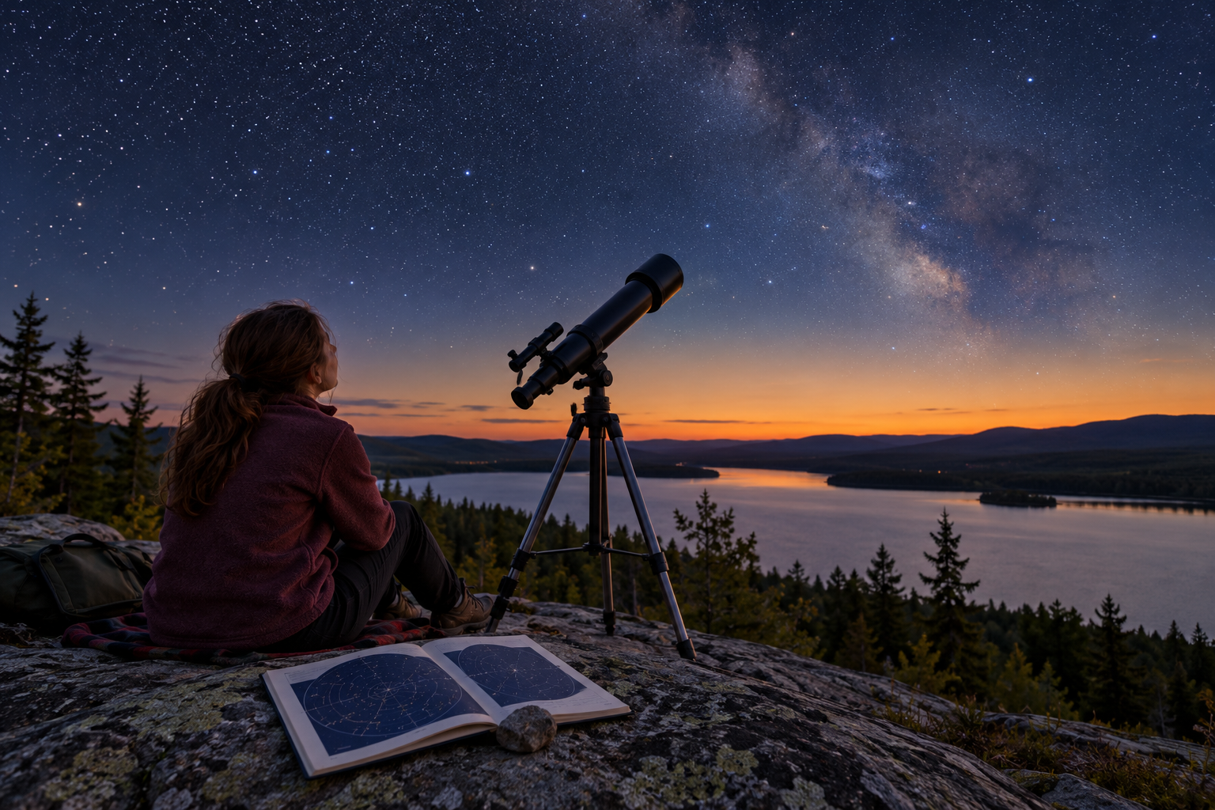
A student with a telescope and star chart at a Québec lakeside lookout at twilight. Earth belongs to the solar system within the Milky Way galaxy. Generated contextual illustration; not a scale model.

Use models with scale awareness
A classroom picture can show bodies together but cannot easily show both realistic sizes and distances. State whether a diagram is scaled or schematic.
Earth’s address helps organize observations from local to much larger scales. Do not confuse the solar system with the universe, which includes many galaxies.
The night sky changes with observer position and Earth’s movements. A useful explanation separates what an object is from where it appears on a map.

What to remember
- Earth belongs to the solar system within the Milky Way galaxy.
- Solar systems, galaxies and constellation patterns describe different kinds of organization.

Check your understanding
Explain aloud, sketch, or write. Use evidence from the chapter.
1 Why is the Milky Way not simply another constellation?
My thinking
2 Why do solar-system pictures need scale warnings?
My thinking

Practise the words
Cover the meanings and explain the words. Then cover the words and name the meanings. Give an example.
solar system the Sun and bodies gravitationally linked to it
galaxy a vast system of stars gas dust and other matter
constellation a named sky region associated with a pattern

Lesson connection
Lesson 1 · Earth's address / Lesson 2 · Solar-system components
Original adaptation informed by Core Knowledge Foundation science materials including Astronomy, Weather Climate and Water Cycling. Shared under CC BY NC SA 4.0. Generated contextual illustration.

