Compare SolarSystem Bodies
  - Grade 6 Unit 3 • Chapter 2
Learning goal I can compare planets and natural satellites using more than apparent size.
Earth has a rocky surface, but not every planet has a solid ground like Earth’s.

Composition matters
Mercury, Venus, Earth and Mars are terrestrial planets. Jupiter and Saturn are gas giants. Uranus and Neptune are ice giants with different compositions, not simply frozen balls with familiar surfaces.
The Moon is a natural satellite of Earth, not a star. It reflects sunlight rather than producing visible light through stellar processes.
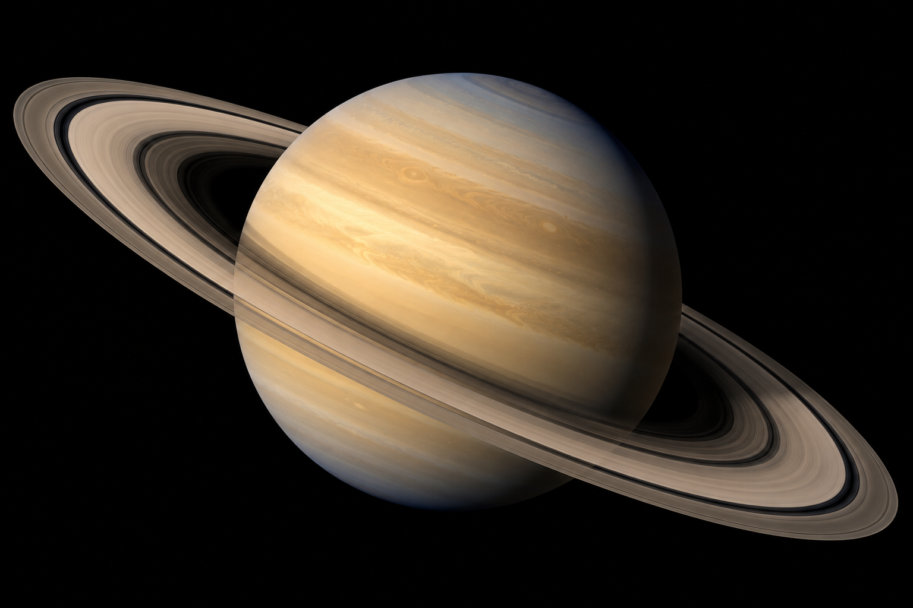
Saturn alone against dark space, with its rings and atmospheric bands visible. Solar-system bodies differ in composition, orbit, size and conditions. Generated contextual illustration; not a scale model.

Compare conditions not just distance
Planets differ in diameter, mass, orbit, atmosphere and temperature. Greater distance from the Sun usually reduces received solar energy, but atmosphere also strongly affects temperature.
Venus is hotter at its surface than Mercury because its dense atmosphere produces a strong greenhouse effect. Distance alone is therefore not a complete temperature explanation.
Use a table of trustworthy measurements with units and clear categories. Apparent size in a drawing can be misleading unless scale is specified.

What to remember
- Solar-system bodies differ in composition, orbit, size and conditions.
- Atmosphere affects temperature as well as distance from the Sun.

Check your understanding
Explain aloud, sketch, or write. Use evidence from the chapter.
1 Why is distance from the Sun insufficient to predict every planet’s temperature?
My thinking
2 Why is a bright Moon not evidence that it is a star?
My thinking

Practise the words
Cover the meanings and explain the words. Then cover the words and name the meanings. Give an example.
terrestrial planet a rocky planet such as Earth
gas giant a large planet dominated by hydrogen and helium
natural satellite a naturally occurring body orbiting another body

Lesson connection
Lesson 3 · Planet comparisons
Original adaptation informed by Core Knowledge Foundation science materials including Astronomy, Weather Climate and Water Cycling. Shared under CC BY NC SA 4.0. Generated contextual illustration.

