Why Québec Has Seasons
  - Grade 6 Unit 3 • Chapter 4
Learning goal I can explain seasons using daylight duration and sunlight angle.
Québec’s winter is not mainly caused by Earth moving farther from the Sun.

Tilt changes received energy
When the Northern Hemisphere tilts toward the Sun, days are longer and sunlight reaches the surface more directly. More solar energy reaches a given area during a day. These conditions support summer warming.
When it tilts away, days are shorter and sunlight is less direct, spreading energy over more area. These conditions support winter cooling.
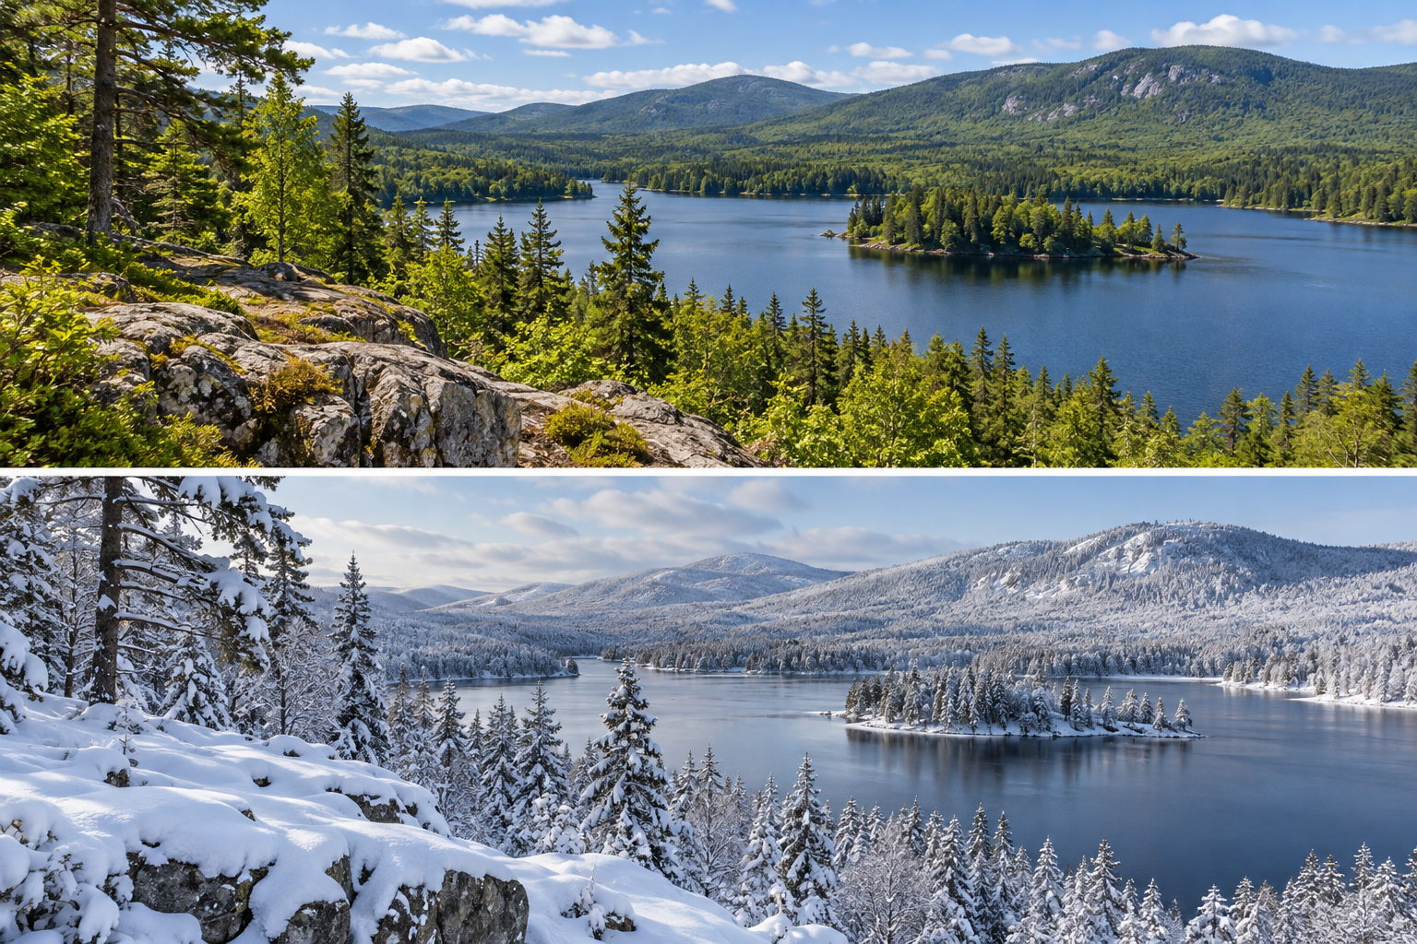
A paired landscape view of the same Québec woodland and lake in summer and winter. Seasonal sunlight varies in angle and daylight duration. Generated contextual illustration; not a scale model.

Compare the hemispheres
Northern and Southern Hemisphere seasons are opposite because of the same tilted axis. Earth-Sun distance affects received energy somewhat but does not explain this opposite pattern.
Temperature does not instantly follow a date because land, water and air store and transfer energy. Local weather can also differ from typical seasonal conditions.
Explain the combined roles of angle and day length. A tilted globe is a useful model, provided distances and sizes are not mistaken for real scale.

What to remember
- Seasonal sunlight varies in angle and daylight duration.
- Axial tilt explains opposite seasonal patterns between hemispheres.

Check your understanding
Explain aloud, sketch, or write. Use evidence from the chapter.
1 Why is Earth-Sun distance not the main explanation for Québec’s winter?
My thinking
2 Why can summer temperatures differ among places with long days?
My thinking

Practise the words
Cover the meanings and explain the words. Then cover the words and name the meanings. Give an example.
season a recurring part of a yearly climate cycle
hemisphere half of Earth divided by the equator
sunlight angle the angle at which sunlight reaches a surface

Lesson connection
Lesson 5 · Seasons
Original adaptation informed by Core Knowledge Foundation science materials including Astronomy, Weather Climate and Water Cycling. Shared under CC BY NC SA 4.0. Generated contextual illustration.

