Stars Galaxies and Apparent Patterns
  - Grade 6 Unit 3 • Chapter 5
Learning goal I can distinguish stars, constellations and galaxies and explain apparent brightness.
The Sun seems much brighter than other stars mainly because it is so much closer to Earth.

A dot can hide a vast object
Stars differ in their true light output as well as distance. A faint-looking star can be intrinsically very luminous but far away. Apparent brightness alone does not give a star’s size or energy output.
Galaxies contain enormous numbers of stars plus gas, dust and other matter. Our solar system belongs to one galaxy; it is not a separate galaxy itself.
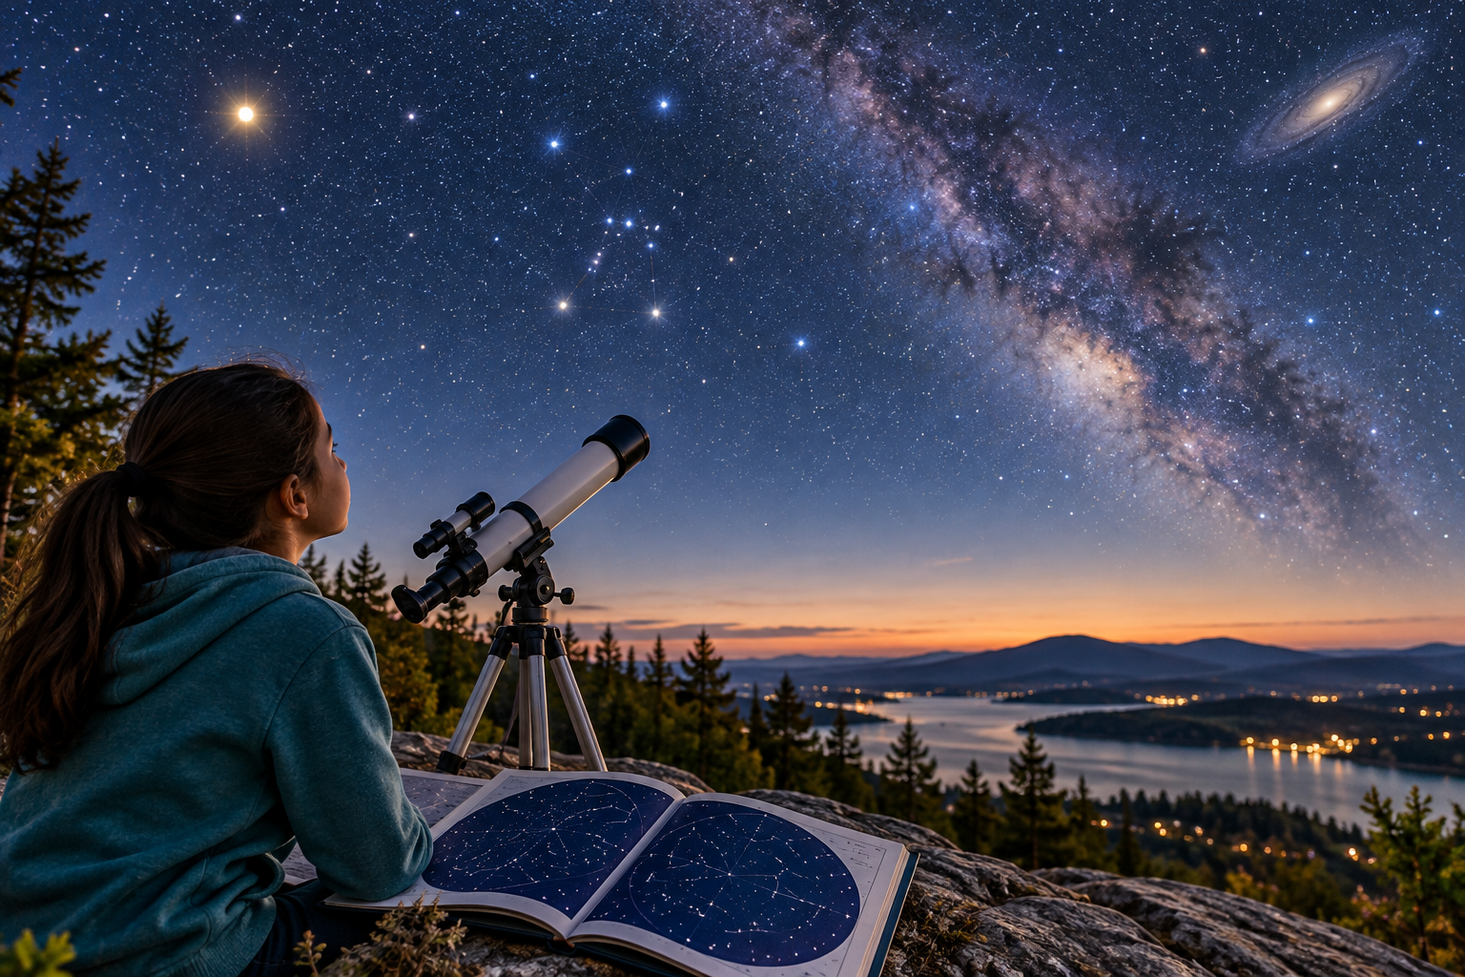
A student with a telescope and star chart beneath a composite night-sky illustration. Apparent brightness depends on distance as well as actual light output. Generated contextual illustration; not a scale model.

A map shows directions
Constellations organize the sky into named regions associated with patterns. The stars making a pattern are not necessarily near one another in three-dimensional space.
A sky map can show apparent positions without distances. Telescopes and other measurements help scientists investigate properties that unaided viewing cannot reveal.
The sky’s changing appearance reflects both observer location and Earth’s movements. Explain what the evidence directly shows and what requires additional measurement.

What to remember
- Apparent brightness depends on distance as well as actual light output.
- Sky maps show directions rather than full three-dimensional distances.

Check your understanding
Explain aloud, sketch, or write. Use evidence from the chapter.
1 Why can a distant luminous star appear fainter than a less luminous nearby star?
My thinking
2 Why does a constellation map not prove its stars form a close physical group?
My thinking

Practise the words
Cover the meanings and explain the words. Then cover the words and name the meanings. Give an example.
star a body producing energy and light through nuclear fusion
galaxy a vast gravitational system containing stars and other matter
apparent brightness how bright a source looks to an observer

Lesson connection
Lesson 6 · Stars and galaxies
Original adaptation informed by Core Knowledge Foundation science materials including Astronomy, Weather Climate and Water Cycling. Shared under CC BY NC SA 4.0. Generated contextual illustration.

