Technology Extends Observation
  - Grade 6 Unit 3 • Chapter 7
Learning goal I can explain how Earth and space technologies provide useful evidence and tradeoffs.
A weather satellite observes broad cloud patterns that one school weather station cannot see.

Measurements beyond our reach
Satellites, telescopes, radar and ground instruments collect different evidence. Some monitor weather, land cover or ocean conditions; others study space. Their measurements support models and predictions.
Canadian space technologies include robotic systems used to handle equipment in orbit. Such devices extend what people can do without being evidence that space work has no risks or costs.
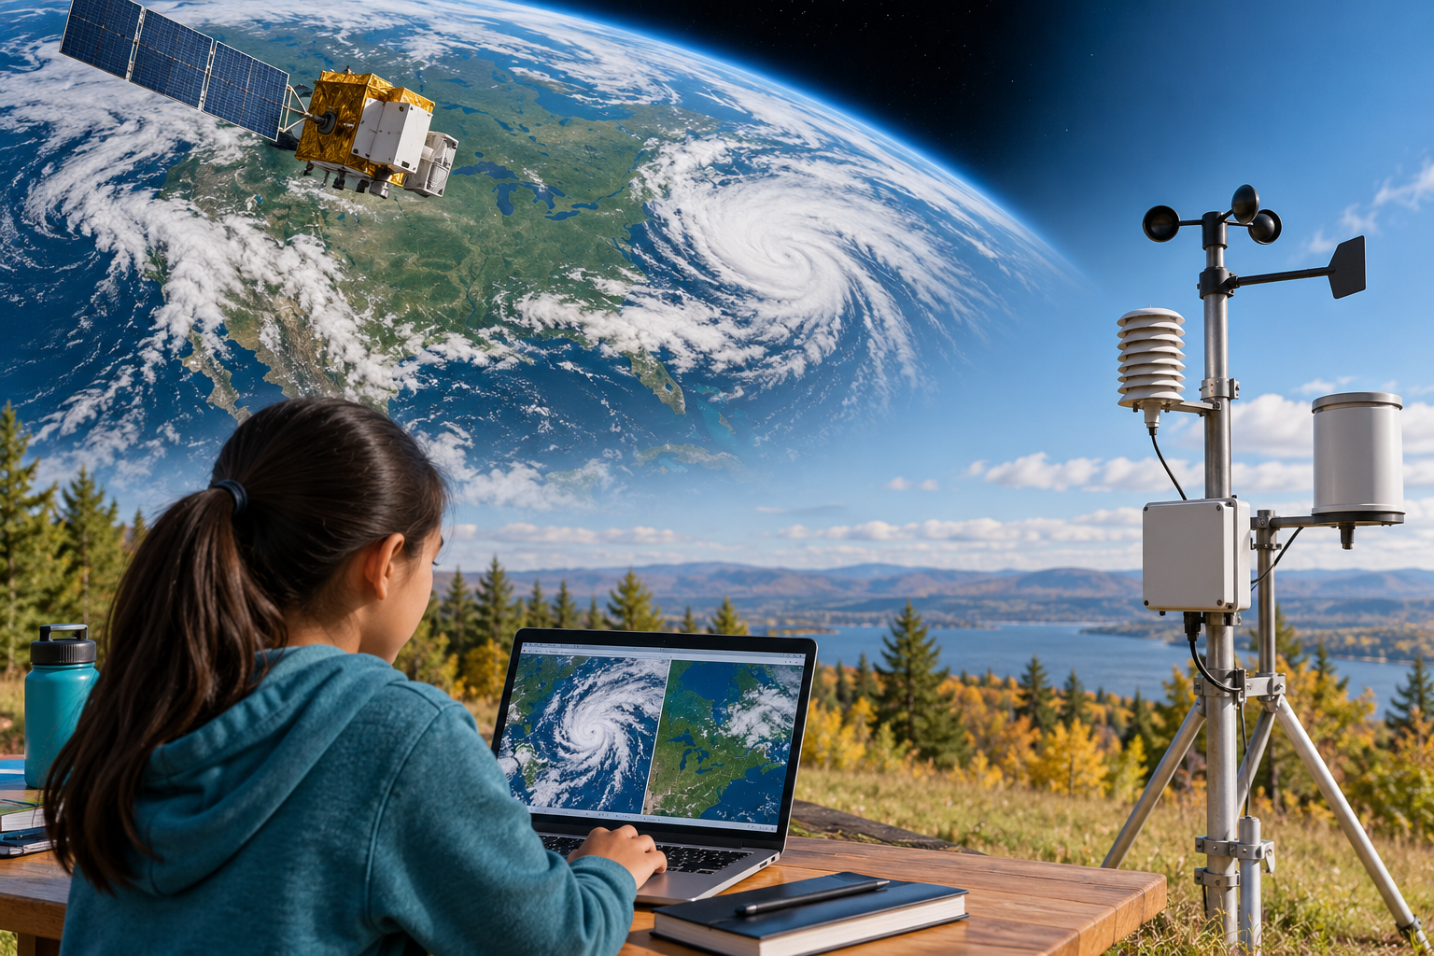
A composite of a satellite, broad Earth imagery, local weather instruments and a student using a computer. Different observation technologies supply different kinds and scales of evidence. Generated contextual illustration; not a scale model.

Choose evidence for the question
A sensor’s location, resolution and measurement type affect what it can show. A broad image may miss local details; a local station may miss regional patterns.
Technology can support navigation, communication and environmental planning. It also requires materials, energy, maintenance and responsible decisions about waste and use.
Describe the question first, then choose tools. A colourful image is not enough; explain what is measured and how the result supports a conclusion.

What to remember
- Different observation technologies supply different kinds and scales of evidence.
- A useful conclusion connects measurements and their limits to a specific question.

Check your understanding
Explain aloud, sketch, or write. Use evidence from the chapter.
1 Why do satellites not make local weather stations unnecessary?
My thinking
2 Why should an environmental image include information about its measurement method?
My thinking

Practise the words
Cover the meanings and explain the words. Then cover the words and name the meanings. Give an example.
satellite an object orbiting another body
remote sensing collecting information without direct contact
model a representation used to explain or predict

Lesson connection
Lesson 8 · Earth and space technology
Original adaptation informed by Core Knowledge Foundation science materials including Astronomy, Weather Climate and Water Cycling. Shared under CC BY NC SA 4.0. Generated contextual illustration.

