Minerals and Rocks Are Different
  - Grade 6 Unit 4 • Chapter 1
Learning goal I can distinguish a mineral from a rock using several observable properties.
A granite sample may show several differently coloured crystals rather than one uniform material.

A rock can contain several minerals
A mineral has characteristic composition and structure. A rock is usually an aggregate of one or more minerals. Some rocks contain nonmineral material, so the distinction is more precise than saying every rock is one mineral.
Mineral identification uses colour, texture, lustre, hardness and other evidence. Colour alone is unreliable because impurities and surface changes can alter it.
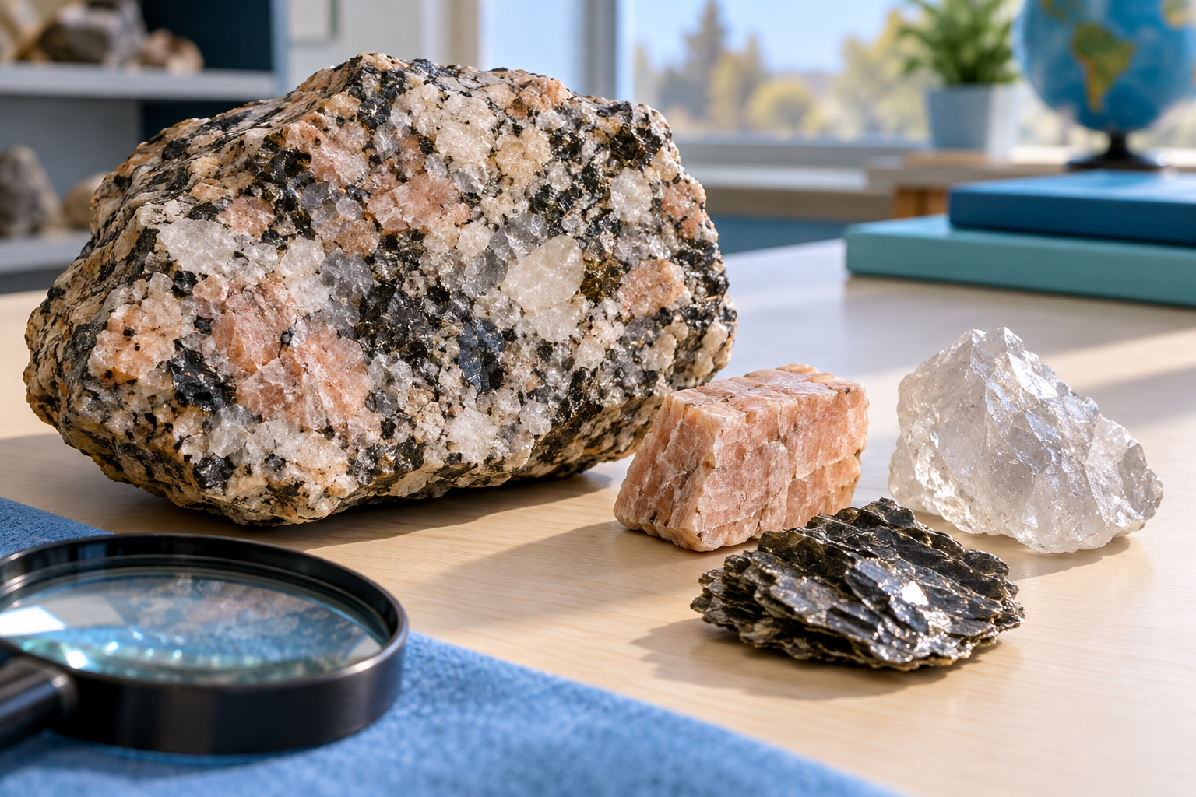
A granite sample beside several individual mineral samples and a hand lens. Minerals have characteristic composition and structure; rocks usually combine minerals. Generated contextual illustration; not a scale model.

Build a supported identification
Use several safe observations and a reference. Hardness tests compare resistance to scratching, not a material’s mass or resistance to breaking.
A shiny surface may reflect light strongly without proving a specific mineral. Look for consistent combinations of properties.
Handle only approved specimens and wash hands afterwards. Do not taste minerals or use unknown samples in chemical tests. Report uncertainty when evidence fits more than one identification.

What to remember
- Minerals have characteristic composition and structure; rocks usually combine minerals.
- Identification requires several properties rather than colour alone.

Check your understanding
Explain aloud, sketch, or write. Use evidence from the chapter.
1 Why is a multicoloured granite sample not necessarily one mineral?
My thinking
2 Why is colour alone a weak identification method?
My thinking

Practise the words
Cover the meanings and explain the words. Then cover the words and name the meanings. Give an example.
mineral a naturally occurring solid with characteristic composition and internal structure
rock a natural solid usually made of minerals
lustre how a surface reflects light
hardness resistance to scratching

Lesson connection
Lesson 1 · Minerals
Original adaptation informed by Core Knowledge Foundation science materials including Plate Tectonics and Rock Cycling, Processes That Shape Earth, Natural Hazards, Protecting Earths Resources. Shared under CC BY NC SA 4.0. Generated contextual illustration.

