Rocks Record Different Processes
  - Grade 6 Unit 4 • Chapter 2
Learning goal I can relate strata and crystal size to rock-forming processes.
Large crystals and visible layers can provide evidence about how a rock formed.

Features are clues to a history
Igneous rocks form as molten material cools. Slower cooling often allows larger crystals; rapid cooling can produce tiny crystals or glassy textures. Sedimentary rocks can form from sediments that are deposited, compacted and cemented.
Metamorphic rocks result when existing rocks change under heat, pressure and other conditions without fully melting. They can develop new textures or mineral arrangements.
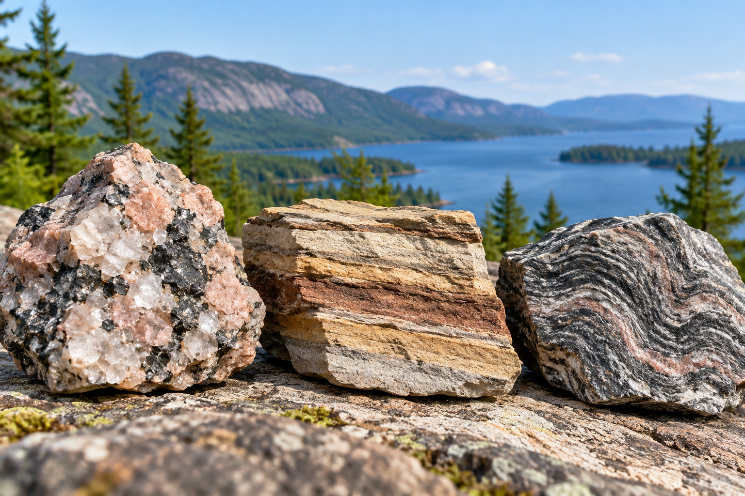
Rock samples with visible crystals, layers and bands beside a lake. Crystal size and layering provide clues to rock-forming processes. Generated contextual illustration; not a scale model.

Interpret rather than guess
Strata often record successive deposits. Fossils or grains can provide additional clues. A layered appearance alone is not proof of one history because metamorphic rocks can also show bands.
The rock cycle connects processes, but every sample does not follow one fixed circular route. Uplift, weathering, burial, melting and cooling can occur in different sequences.
Compare crystal size and layering with other evidence and acknowledge limits. A hand sample records features, not a complete direct video of its past.

What to remember
- Crystal size and layering provide clues to rock-forming processes.
- Rock histories can follow different paths, and one visible feature is not conclusive.

Check your understanding
Explain aloud, sketch, or write. Use evidence from the chapter.
1 Why can larger crystals suggest slower cooling in an igneous rock?
My thinking
2 Why should all visible bands not automatically be called sedimentary strata?
My thinking

Practise the words
Cover the meanings and explain the words. Then cover the words and name the meanings. Give an example.
igneous rock formed from cooled molten material
sedimentary rock formed from deposited material or related processes
metamorphic rock changed by heat pressure and related processes
strata layers of deposited material

Lesson connection
Lesson 2 · Rocks
Original adaptation informed by Core Knowledge Foundation science materials including Plate Tectonics and Rock Cycling, Processes That Shape Earth, Natural Hazards, Protecting Earths Resources. Shared under CC BY NC SA 4.0. Generated contextual illustration.

