Earths Surface Has Connected Features
  - Grade 6 Unit 4 • Chapter 3
Learning goal I can describe continents, oceans, ice caps, mountains and volcanoes as parts of Earth’s surface.
A world map includes land, oceans and ice, but its flat form changes shapes or areas in different ways.

Maps show more than borders
Continents are large land regions. Ocean basins hold interconnected salty water. Mountains rise above surrounding land through several geological processes. Glaciers and ice caps store water as ice on land.
Volcanoes allow molten material and gases to reach the surface. They occur in particular geological settings; not every mountain is a volcano.
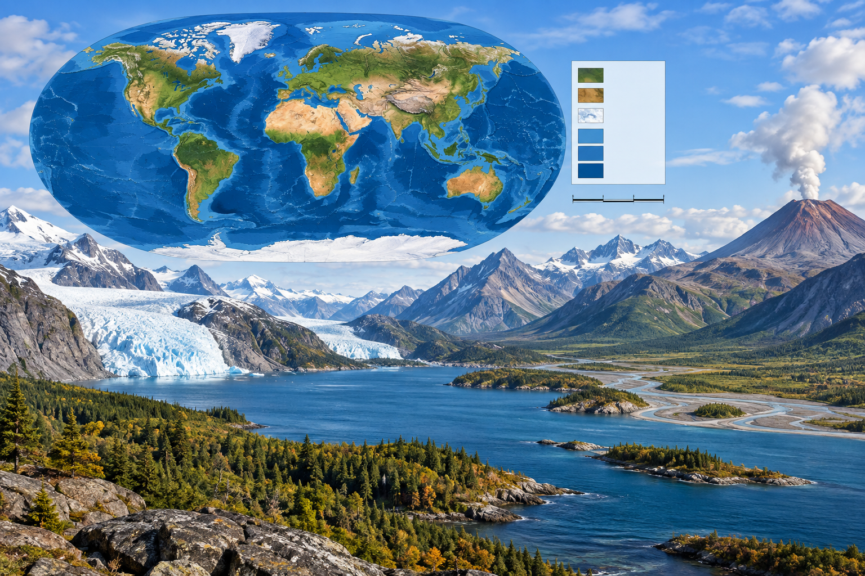
A composite illustration of a world map, ice-covered land, water, mountains and a volcano. Internal and external processes shape Earth’s connected surface features. Generated contextual illustration; not a scale model.

Patterns have causes
Earth’s surface is shaped by internal processes such as plate movement and external processes such as flowing water and ice. A mountain’s rock can later weather and erode.
Ice on land differs from sea ice floating on ocean water. Their formation, movement and effects are not interchangeable.
Use maps with clear legends and scale. Locate Québec within the wider system without assuming every surface feature occurs nearby or has the same age.

What to remember
- Internal and external processes shape Earth’s connected surface features.
- Not all mountains are volcanoes, and land ice differs from sea ice.

Check your understanding
Explain aloud, sketch, or write. Use evidence from the chapter.
1 Why is every mountain not a volcano?
My thinking
2 Why should an ice-covered place be identified as land ice or sea ice?
My thinking

Practise the words
Cover the meanings and explain the words. Then cover the words and name the meanings. Give an example.
continent a large region of land
ice cap a body of ice covering land over a region
volcano a place where molten material and gases reach the surface

Lesson connection
Lesson 3 · Earth's surface
Original adaptation informed by Core Knowledge Foundation science materials including Plate Tectonics and Rock Cycling, Processes That Shape Earth, Natural Hazards, Protecting Earths Resources. Shared under CC BY NC SA 4.0. Generated contextual illustration.

