Weathering Erosion and Deposition
  - Grade 6 Unit 4 • Chapter 4
Learning goal I can distinguish rock breakdown from transport and explain a local effect.
A cracked rock beside a river and sediment carried downstream show different processes.

Breakdown and movement differ
Weathering breaks down or alters rock in place. Freezing water can widen cracks, and chemical processes can change minerals. Erosion transports material through water, wind, ice or gravity.
Deposition occurs when transported material settles or accumulates. A stream can erode one bank and deposit sediment somewhere else.
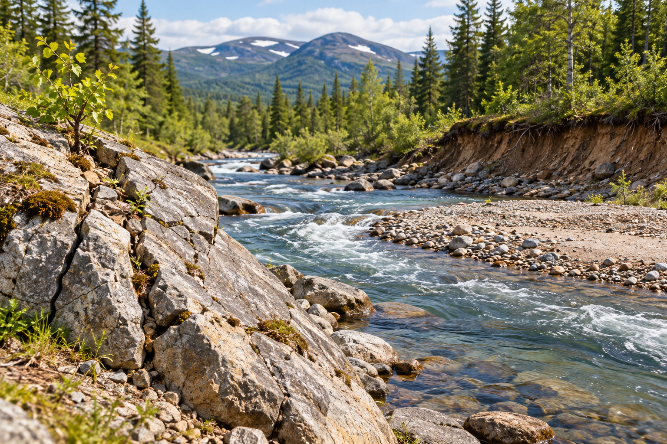
A flowing stream beside a rocky, eroded bank. Weathering changes material in place; erosion transports it; deposition accumulates it. Generated contextual illustration; not a scale model.

Conditions affect the rate
Snowmelt and heavy rain can increase flowing water in Québec. Vegetation, slope and soil properties affect how much material moves. An event may accelerate a process usually described as slow.
A model stream can compare bare and protected surfaces, but small-scale flows do not reproduce every river condition. Record input water, slope and material amounts.
Erosion can affect habitats, land and infrastructure. Explain a specific pathway, such as loss of soil or added sediment, rather than treating all land change as equally harmful.

What to remember
- Weathering changes material in place; erosion transports it; deposition accumulates it.
- Flow conditions and vegetation influence surface change.

Check your understanding
Explain aloud, sketch, or write. Use evidence from the chapter.
1 Why is a rock breaking apart not automatically erosion?
My thinking
2 How can one river both erode and deposit material?
My thinking

Practise the words
Cover the meanings and explain the words. Then cover the words and name the meanings. Give an example.
weathering breakdown or alteration of rock where it is
erosion removal and transport of material
deposition settling or accumulation of transported material

Lesson connection
Lesson 4 · Slow change and erosion
Original adaptation informed by Core Knowledge Foundation science materials including Plate Tectonics and Rock Cycling, Processes That Shape Earth, Natural Hazards, Protecting Earths Resources. Shared under CC BY NC SA 4.0. Generated contextual illustration.

