Rapid Hazards and Reducing Risk
  - Grade 6 Unit 4 • Chapter 5
Learning goal I can explain natural hazards and distinguish prediction from prevention.
Lightning, tornadoes and hurricanes are not different sizes of the same event.

Different events different causes
Lightning is an electrical discharge. A tornado is a violently rotating air column connected to a thunderstorm and the ground. A hurricane is a large tropical storm system. Their causes, scales and patterns differ.
Floods, earthquakes and eruptions can also cause rapid change. A hazard’s effects depend on location, structures, ecosystems and people’s preparedness.
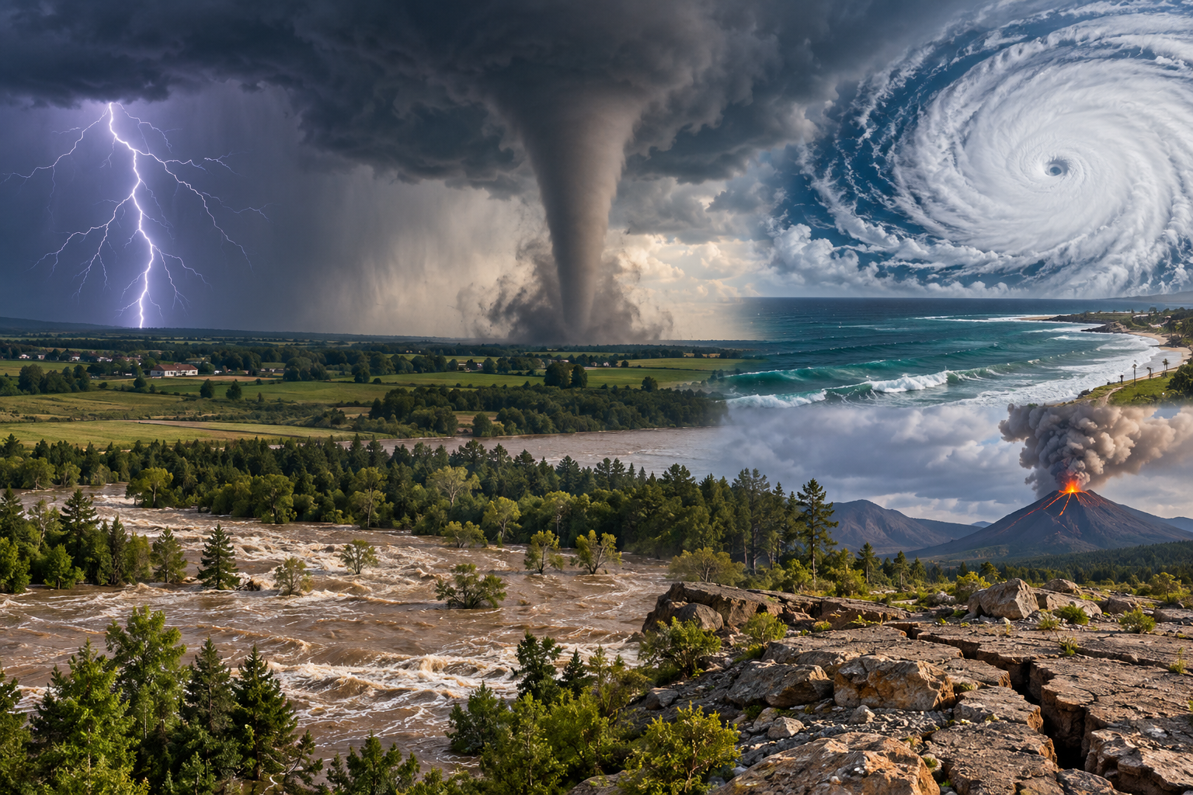
A composite showing separate examples of lightning, a tornado, a hurricane, flooding and a volcano. Natural hazards differ in cause, scale and effects. Generated contextual illustration; not a scale model.

Reduce harm using evidence
Monitoring can improve forecasts for some events, but exact prediction is not always possible. A warning does not stop the natural process.
Land-use choices, stronger structures, evacuation plans and communication can reduce risk. These measures require reliable information and coordination.
Use recorded cases and follow school emergency instructions. Do not approach storms or floodwater for observations. A scientific investigation can compare causes and effects safely from data, models and reports.

What to remember
- Natural hazards differ in cause, scale and effects.
- Forecasting and preparedness can reduce risk without stopping the natural event.

Check your understanding
Explain aloud, sketch, or write. Use evidence from the chapter.
1 Why can the same hazard cause different damage in two communities?
My thinking
2 Why is forecasting a storm not the same as preventing it?
My thinking

Practise the words
Cover the meanings and explain the words. Then cover the words and name the meanings. Give an example.
hazard a natural event or process capable of causing harm
risk the possibility of harm given exposure and vulnerability
forecast an evidence based prediction

Lesson connection
Lesson 5 · Rapid hazards
Original adaptation informed by Core Knowledge Foundation science materials including Plate Tectonics and Rock Cycling, Processes That Shape Earth, Natural Hazards, Protecting Earths Resources. Shared under CC BY NC SA 4.0. Generated contextual illustration.

