Sustainable Responses Need WholeSystem Thinking
  - Grade 6 Unit 4 • Chapter 6
Learning goal I can justify a response to human pressures using matter and energy concepts.
Resource extraction, farming and urban growth supply needs while changing land, water and living systems.

Human decisions change systems
Pollution can move across boundaries. Waste management changes where matter goes rather than making it cease to exist. Recycling recovers some materials through sorting and processing; composting uses organisms to transform organic matter.
Both processes need suitable conditions and can use or release energy. They are responses within a larger product and resource system, not complete solutions to every impact.
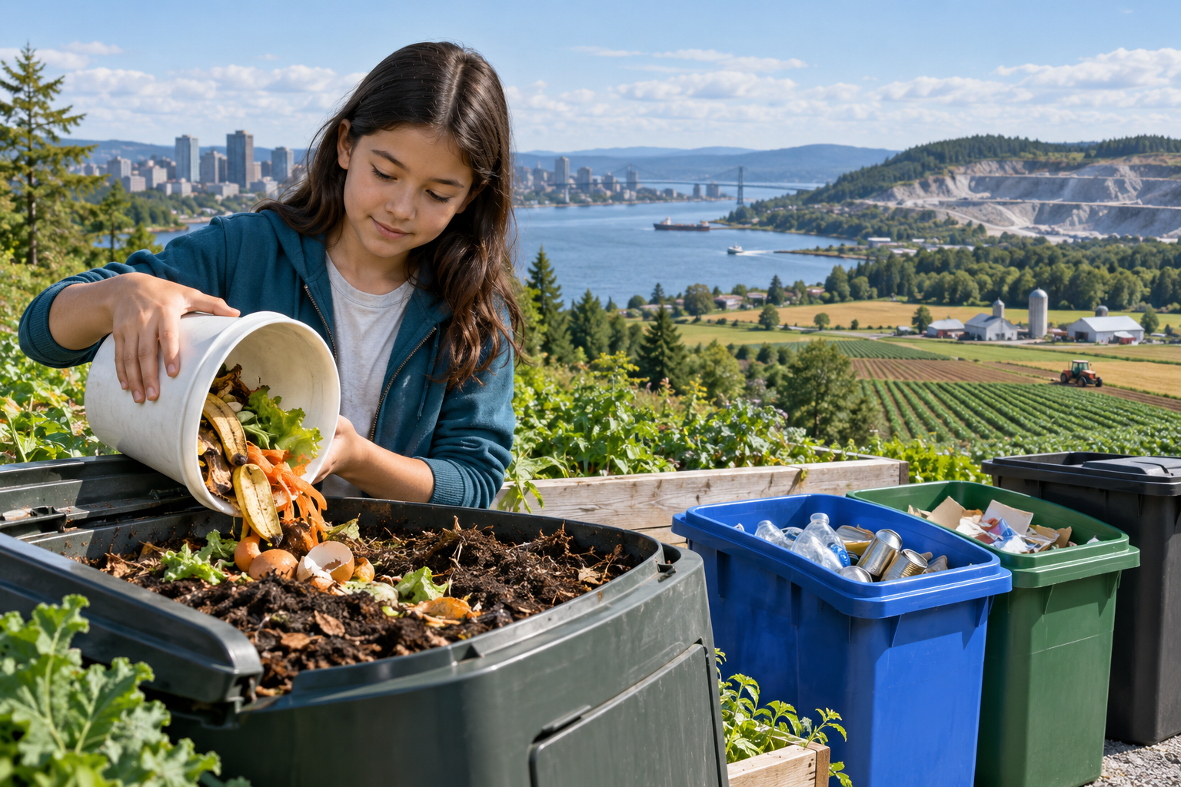
A student placing organic scraps in compost beside material collection bins. Human pressures move and transform matter through connected systems. Generated contextual illustration; not a scale model.

Compare proposed responses
Start with a specific need and evidence about the problem. Reducing unnecessary use, repairing, reusing, recycling or composting may address different causes.
Choose criteria such as waste prevented, resource demands, usefulness and effects on people. Check accepted materials with the school’s current system rather than assuming labels tell the whole story.
A sustainable design explains tradeoffs and uncertainty. Propose what to measure after implementation so a claim of improvement can be tested.

What to remember
- Human pressures move and transform matter through connected systems.
- Sustainable responses need specific criteria, tradeoff analysis and evidence of results.

Check your understanding
Explain aloud, sketch, or write. Use evidence from the chapter.
1 Why does waste not disappear when it is recycled or composted?
My thinking
2 Why should a recycling proposal also consider reduction and reuse?
My thinking

Practise the words
Cover the meanings and explain the words. Then cover the words and name the meanings. Give an example.
sustainability meeting needs while considering long-term environmental and social effects
recycling processing used material for further use
composting managed decomposition of suitable organic matter

Lesson connection
Lesson 6 · Human pressures / Lesson 7 · Sustainable responses
Original adaptation informed by Core Knowledge Foundation science materials including Plate Tectonics and Rock Cycling, Processes That Shape Earth, Natural Hazards, Protecting Earths Resources. Shared under CC BY NC SA 4.0. Generated contextual illustration.

