Project Report

Video Link: <https://www.youtube.com/watch?v=M2fVOOl73Ow>

1. Testing the login page with wrong account to see what kind of massage will be released.

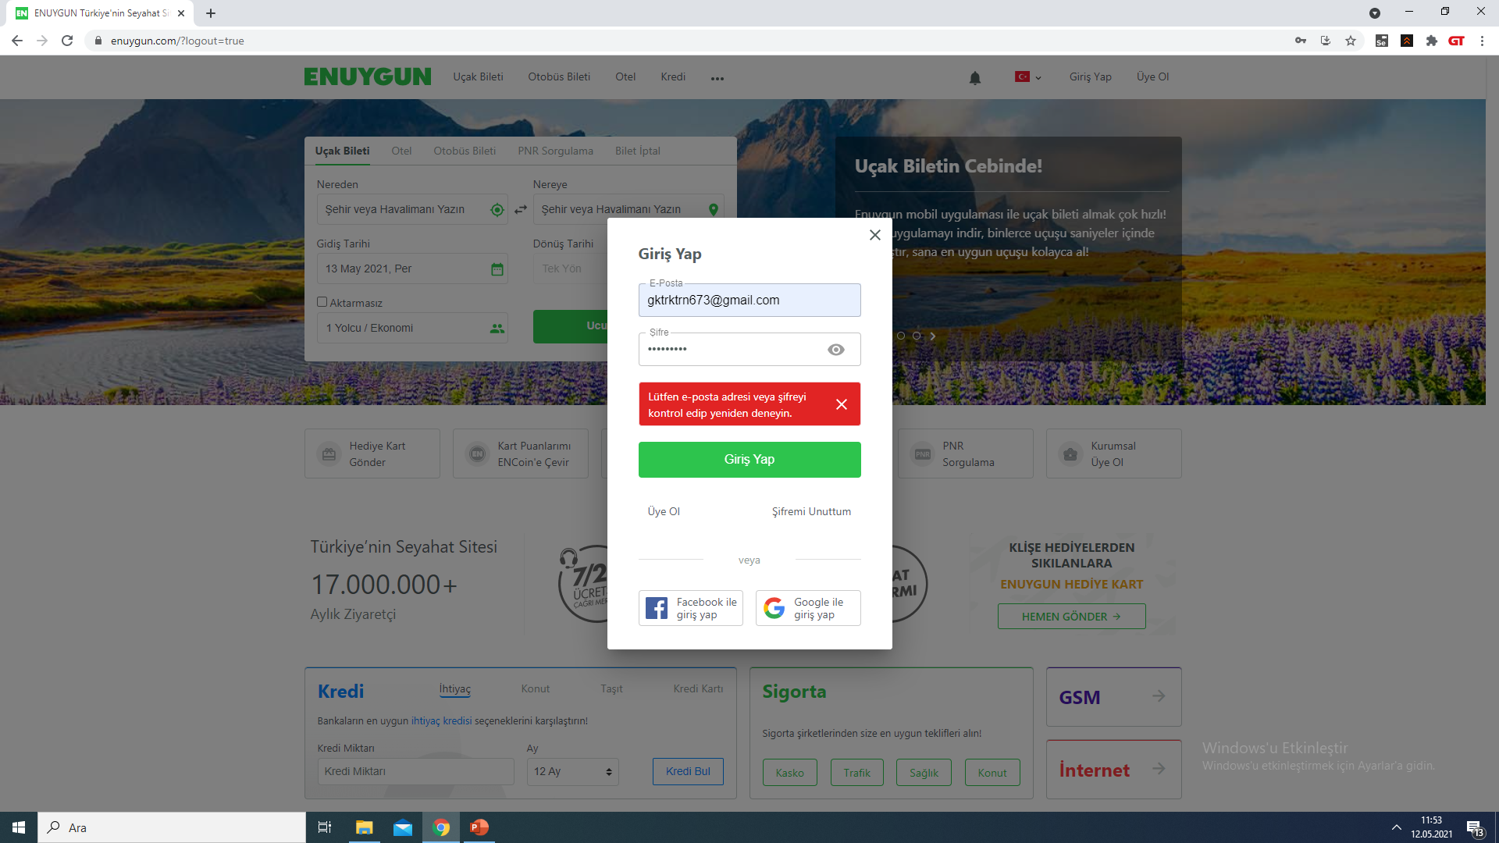

1. In the flight ticket section, cities are tested in the take-off and landing sections. In this case, by entering the same cities, it has been tested whether the site gives the error it should give.

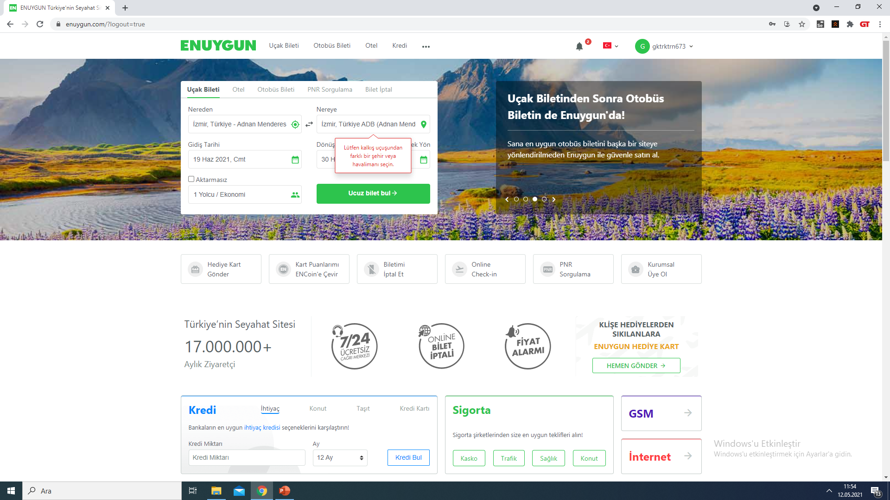

1. In this section, we tested the filtering options in different combinations to see if the hotel filters from the hotels section of the site will deliver the expected results. In addition, we tested the ranges we created in the price range section and tested whether the expected hotels will come out.

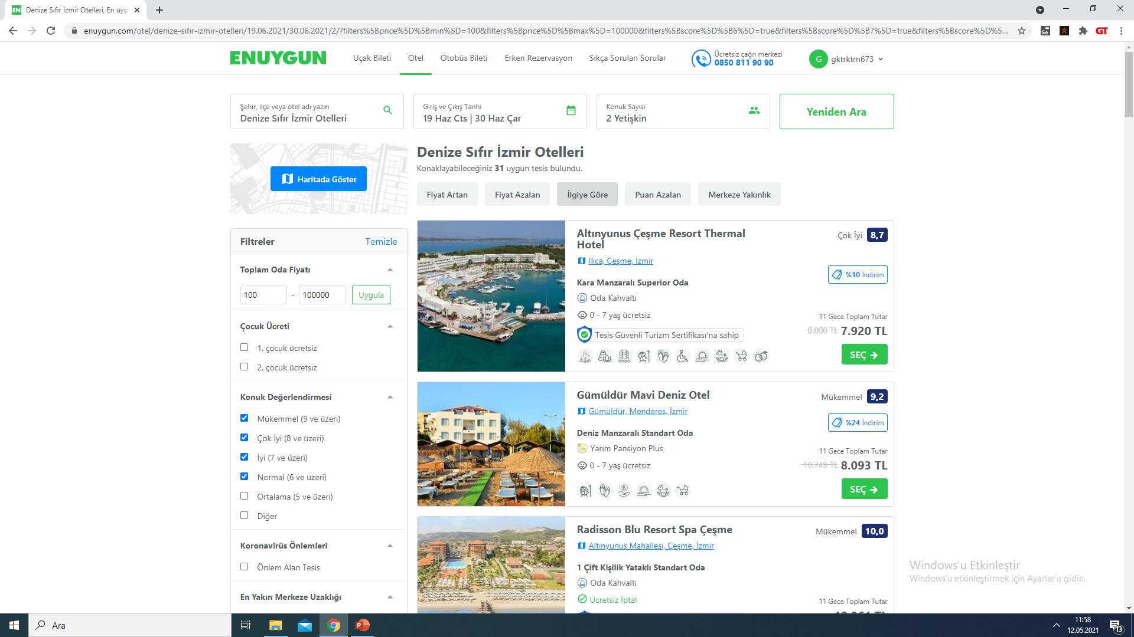

1. From account settings, we tested to save a credit card with wrong numbers. As you down below, it gave an error.

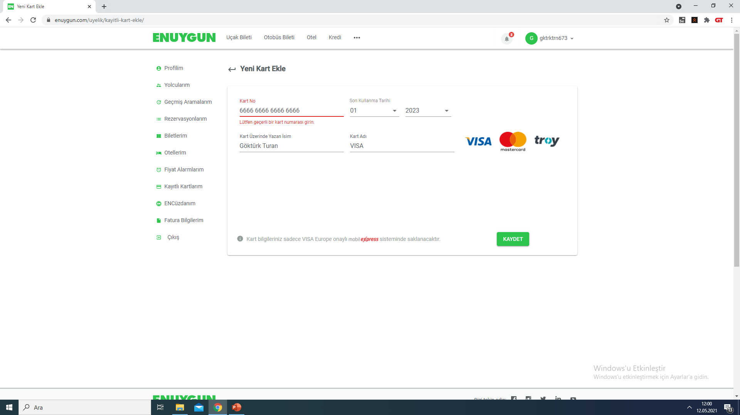

1. In equivalence class, we determined the ranges we use for testing and entered a number for each range. When testing with Selenium, we used these ranges and checked whether it gave the expected result.

tablo içeren bir resim

Açıklama otomatik olarak oluşturuldu

1. With using the boundary value analysis method, we wrote the room types between in whole ranges. Also, we determine the Test input values.

tablo içeren bir resim

Açıklama otomatik olarak oluşturuldu

1. At the decision table stage, we applied the information’s according to the type of reservation and the discount relationship.

tablo içeren bir resim

Açıklama otomatik olarak oluşturuldu

1. In use case testing table, we identified suitable scenarios for testing and wrote down which results should be given in which situations. 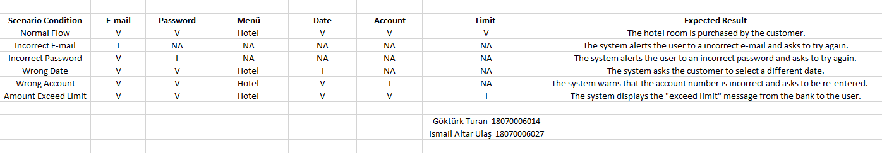
2. According to the use case testing table, it is the table that we are testing real inputs. In general, the information that the user enters the site, the expected message will be given according to what information is entered correctly or incorrectly.

