Stroke Classification and SHAP Explanation
  - Assignment report
Exploratory data analysis, local and global explanations, audience communication, and a second black box model.
Student name: [Student: enter name]
Student ID: [Student: enter ID]
Course and programme: [Student: enter details]
Lecturer: [Student: enter name]
Submission date: [Student: enter date]
Repository URL and commit: [Student: enter URL and commit]

Abstract
This report classifies recorded stroke status in the Kaggle stroke prediction dataset and explains the predictions with SHAP. The data hold 5110 patients, of whom 249 (4.87%) have stroke = 1. After a stratified 80/20 split, bmi was imputed with the training median, categories were one-hot encoded on training data, and only the training set was oversampled. The Task 2 RandomForest, explained with TreeExplainer, reached ROC AUC 0.827, average precision 0.145 and balanced accuracy 0.513, but recall for stroke = 1 was only 0.040 at threshold 0.5. For the selected held-out true positive, the predicted probability rose from a base value of 0.500 to 0.72, mainly through heart disease and glucose, while bmi pushed it down. Globally, age, average glucose and bmi had the largest mean absolute SHAP values. An MLP explained with Kernel SHAP ranked cases less well (ROC AUC 0.725) but had higher recall (0.200), and agreed on age as the top feature while differing on several others. The main limitation is that a retrospective, imbalanced dataset with uncalibrated scores supports explanation of model behaviour only, not clinical use.

Report map
Assignment component | Report location
Task 1 Exploratory data analysis | Sections 1 and 2
Task 2 Create a SHAP explainer | Section 3
Task 3 Local force plot | Section 4
Task 4 Global summary plot | Section 5
Task 5 Three audience slides | Section 6
Task 6 Deep SHAP or Kernel SHAP | Sections 7 and 8

1 Study Context and Dataset

1 1 Background and objective
Stroke is a serious medical event, and a model that flags patients with a recorded stroke from routine health data is only useful if people can see what drives its output. A score alone gives a clinician little to question. SHAP [2] breaks one prediction into feature contributions, which makes it possible to check whether a model relies on sensible information. The WHO statistic in the brief is not repeated here because its reference year could not be verified from the supplied files.
Objective: Evaluate a classifier for stroke = 1 on an untouched held-out test set, using metrics that suit a rare class, and explain its predictions with SHAP at the level of one case and of the whole test set. A second, different model is then explained in the same way for comparison.
Outcome definition: stroke = 1 indicates a recorded history of stroke; stroke = 0 indicates no recorded stroke. The supplied files only link to the dataset page and give no follow-up period, so the output is not described as a validated future stroke risk anywhere in this report.

1 2 Data source and variables
Dataset URL and access date: https://www.kaggle.com/fedesoriano/stroke-prediction-dataset [1]; the CSV was supplied with the course code, so no separate download date was recorded. File name and version: healthcare-dataset-stroke-data.csv, SHA-256 644d473b05d27970... (full value in Section 9.2). Population, collection period and provenance: not stated in the supplied files, so treated as unavailable.
Attribute | Meaning or values | Analytical role
id | Unique identifier | Exclude from predictors
gender | Male, Female, Other | Categorical predictor
age | Patient age. Treated as years; range 0.08 to 82, with fractional values for infants | Numeric predictor
hypertension | 0 = no; 1 = yes | Binary predictor
heart_disease | 0 = no; 1 = yes | Binary predictor
ever_married | No, Yes | Categorical predictor
work_type | children, Govt_job, Never_worked, Private, Self-employed | Categorical predictor
Residence_type | Rural, Urban | Categorical predictor
avg_glucose_level | Average blood glucose; unit not stated in the supplied files | Numeric predictor
bmi | Body mass index; unit not stated in the supplied files (kg/m² by the usual definition of BMI) | Numeric predictor
smoking_status | formerly smoked, never smoked, smokes, Unknown | Categorical predictor
stroke | 0 = no recorded stroke; 1 = recorded stroke | Target variable

Data checks: All 12 column names were confirmed in the CSV. The real spelling is Govt_job, not Govt_jov as written in the brief. Unknown smoking status means unavailable information, so it was kept as its own category and not merged with never smoked.

2 Task 1 Exploratory Data Analysis

2 1 Code download and execution
GitHub download method: [Student: confirm clone or ZIP; the folder name xai-series-master suggests a ZIP of the master branch]. Commit or release: [Student: enter if known; no commit is recorded in the supplied files]. Python environment and dependencies: Python 3.13.0 on Windows 11 in a project virtual environment; shap 0.54.1, scikit-learn 1.9.1, imbalanced-learn 0.14.2, pandas 3.1.1, numpy 2.5.4, matplotlib 3.11.2. Full list in requirements.txt.
Execution command: python 00_data_exploration.py, no arguments, run from the project root. MPLBACKEND=Agg was set in the environment so that plt.show() would not wait for a window. Date, output directory and execution status: 2026-11-07, console output saved to outputs/eda/00_data_exploration_stdout.txt, exit code 0. Modifications or errors resolved: none; the script ran unchanged and no errors occurred.

2 2 Data quality and descriptive results
Check or statistic | Observed result | Action or interpretation
Rows and columns | 5110 rows; 12 columns | Imported dimensions confirmed. After removing id and stroke, 10 original predictors remain
Duplicate records or IDs | 0 duplicate rows; 0 duplicate ids | Nothing to remove. Also no duplicates when id is ignored
Missing values by variable | bmi: 201 (3.93%) blank. smoking_status Unknown: 1544 (30.22%). All other columns: 0 | bmi imputed with the training median. Blank bmi is uneven: 19.9% of those rows have stroke = 1 vs 4.26% with bmi recorded. Unknown smoking kept as a category
Stroke class counts | 4861; 249; 4.87% positive | Strong imbalance. Always predicting 0 would give about 95% accuracy, so accuracy alone is not reported. Training set oversampled
Age glucose and BMI | age: 43.23 ± 22.61; median 45.0, IQR 36.0 (25.0 to 61.0); range 0.08 to 82.0; avg_glucose_level: 106.15 ± 45.28; median 91.88, IQR 36.84 (77.24 to 114.09); range 55.12 to 271.74; bmi: 28.89 ± 7.85; median 28.1, IQR 9.6 (23.5 to 33.1); range 10.3 to 97.6 | 43 ages under 1 year and 856 under 18. bmi extremes: 3 rows under 12, 13 over 60. Unusual values were kept and flagged
Categorical distributions | gender: Female 2994 (58.59%), Male 2115 (41.39%), Other 1 (0.02%); ever_married: Yes 3353 (65.62%), No 1757 (34.38%); work_type: Private 2925 (57.24%), Self-employed 819 (16.03%), children 687 (13.44%), Govt_job 657 (12.86%), Never_worked 22 (0.43%); Residence_type: Urban 2596 (50.8%), Rural 2514 (49.2%); smoking_status: never smoked 1892 (37.03%), Unknown 1544 (30.22%), formerly smoked 885 (17.32%), smokes 789 (15.44%); hypertension: 0: 4612 (90.25%), 1: 498 (9.75%); heart_disease: 0: 4834 (94.6%), 1: 276 (5.4%) | Rare levels: gender Other (1 row) and Never_worked. These have too few rows for any conclusion. Categories are one-hot encoded and the code size has no clinical meaning

Figure 1 EDA panel
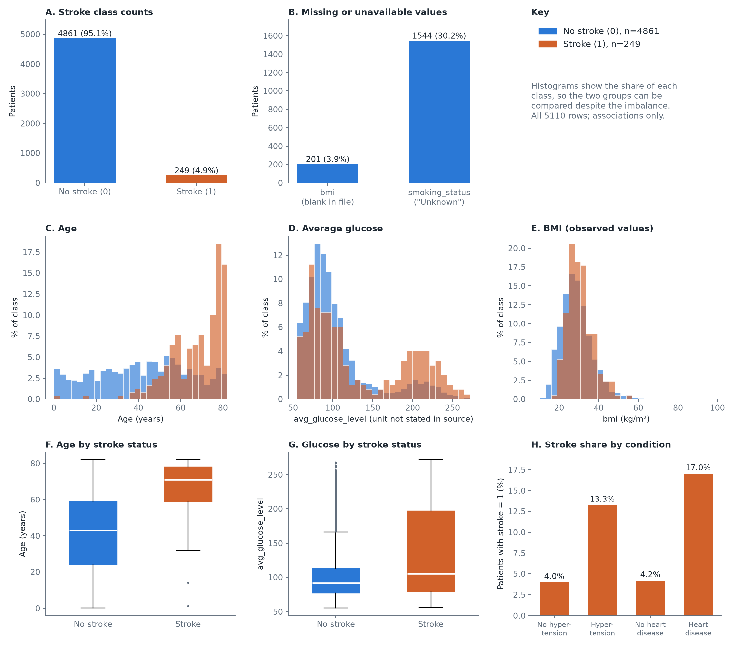
Figure 1. EDA panel for all 5110 rows, before any modelling. A and B show patient counts; C to E show the percentage within each stroke class; F and G show box plots by class; H shows the share of patients with stroke = 1 by condition. Stroke = 1 rows are rare and tend to be older, as an association.

2 3 Interpretation and preprocessing decisions
Three observations follow. First, the classes are imbalanced: 249 of 5110 rows (4.87%) have stroke = 1 (Figure 1A). Second, information is missing unevenly: bmi is blank in 201 rows and smoking is Unknown in 1544 (Figure 1B), and rows with blank bmi have a stroke share of 19.9% against 4.26% for the rest. Third, age is associated with stroke status: median age is 71 with stroke = 1 and 43 without (Figure 1C and 1F). Hypertension and heart disease show a similar association (Figure 1H). These are associations in a retrospective dataset and do not show causes. They shaped the plan: test metrics focus on the positive class, the training set is oversampled, bmi is imputed from training data only, and unusual values are kept because no rule in the source says they are errors.
Training safeguards: The data were split before imputation, encoding or resampling. Each of these steps was fitted on training data only, and the test set was left untouched apart from applying the fitted steps. id and stroke are excluded from the predictors. The script stops if these checks fail.

3 Task 2 Model and SHAP Explainer

3 1 Model development
Task 2 classifier and rationale: RandomForestClassifier with random_state=2021 and default hyperparameters, as in the course script. A tree ensemble handles mixed binary and numeric inputs without scaling and can be explained exactly by TreeExplainer. Predictors retained and excluded: all columns except id and stroke. Preprocessing pipeline: bmi imputed with the training median (28.1); gender, ever_married, work_type, Residence_type and smoking_status one-hot encoded with an encoder fitted on training data; no scaling. This gives 21 encoded features, for example ever_married_Yes and smoking_status_Unknown. The course utils.py was not used for preprocessing because it fills bmi with 0 and preprocesses before the split.
Train validation test sizes: 4088 train (80%, 199 positive) and 1022 test (20%, 50 positive); no separate validation set. Stratification, seed and any group separation: stratified on stroke, random_state=2021; no group separation was needed because all ids are unique. Hyperparameter tuning and imbalance strategy: no tuning; RandomOverSampler on the training set only, giving 7778 rows with 3889 positive. Decision threshold and selection rule: 0.5, the default. No threshold was tuned because no validation data were set aside for it.
Test metric | Result | Evaluation detail
Accuracy and balanced accuracy | 0.940 and 0.513 | Threshold 0.5
Precision recall and F1 for stroke = 1 | Precision 0.133, recall 0.040, F1 0.062 | Positive class support: 50 of 1022 test rows
ROC AUC and average precision | 0.827 and 0.145 | Both use predicted probabilities. PR metric is average precision; test prevalence is 4.89%
Confusion matrix TN FP FN TP | TN 959, FP 13, FN 48, TP 2 | The model missed 48 of 50 recorded strokes at this threshold. High accuracy here mostly reflects the majority class

3 2 Explainer specification
Explainer class and suitability: shap.TreeExplainer, a compatible exact explainer for tree ensembles. SHAP version and model library version: shap 0.54.1, scikit-learn 1.9.1. The explainer works on the fitted RandomForest and takes the transformed input directly: the 21 encoded columns after imputation, in the order given in Section 9.2.
Output explained: predicted probability of stroke = 1, with no link function. Class label and output index: model.classes_ is [0, 1], so stroke = 1 is index 1. Installed shap returns one array of shape (1022, 21, 2) (rows, features, classes), not the list assumed by 03_shap.py, so the class was selected on the last axis. Background source, size and sampling seed: none passed; feature_perturbation is tree_path_dependent, which uses training coverage stored in the trees. Explanation sample source and size: all 1022 held-out test rows.

3 3 Verification and interpretation
For an additive explanation, the base value plus the sum of feature contributions reconstructs the explained output on its stated scale. Here the output is already a probability, so no link function or transformation applies.
Verification item | Recorded evidence
Input feature names order and dimensions match | Model feature_names_in_ equals the test columns in the same order: True. Test matrix 1022 × 21; SHAP array (1022, 21, 2)
Correct class and output scale selected | classes_ = [0, 1]; index 1 is stroke = 1. Units: predicted probability, model_output = raw
Base value + sum of SHAP values | Row 0 of the test set: 0.5005 + sum of SHAP = 0.0100
Model output and reconstruction residual | Row 0 model output 0.0100. Over all 1022 rows, max absolute residual 3.28e-15, tolerance 1e-06: passed

A positive SHAP value means that the feature value moved this model's predicted probability of stroke = 1 above the base value; a negative value moved it below. The base value is 0.500, not close to the test prevalence of 4.89%, because the trees were fitted on balanced oversampled data. Most test rows therefore have many negative contributions. SHAP describes this model relative to that reference; it does not establish that a feature causes stroke.

4 Task 3 Local Explanation Using a Force Plot

4 1 Selected held out case
Anonymous row reference: test_row 413 (position in the held-out test set, not id). Selection rule: the true-positive test case with the highest predicted probability. This is a favourable choice: only 2 true positives exist, so the case does not represent the 48 missed cases. It was used because a true positive shows the model at its clearest. Actual class: 1. Predicted stroke class: 1. Threshold: 0.5.
Model score or probability: 0.72. Explained output and units: predicted probability of stroke = 1. Base value in those units: 0.500. Case type: true positive.

Figure 2 Local SHAP force plot
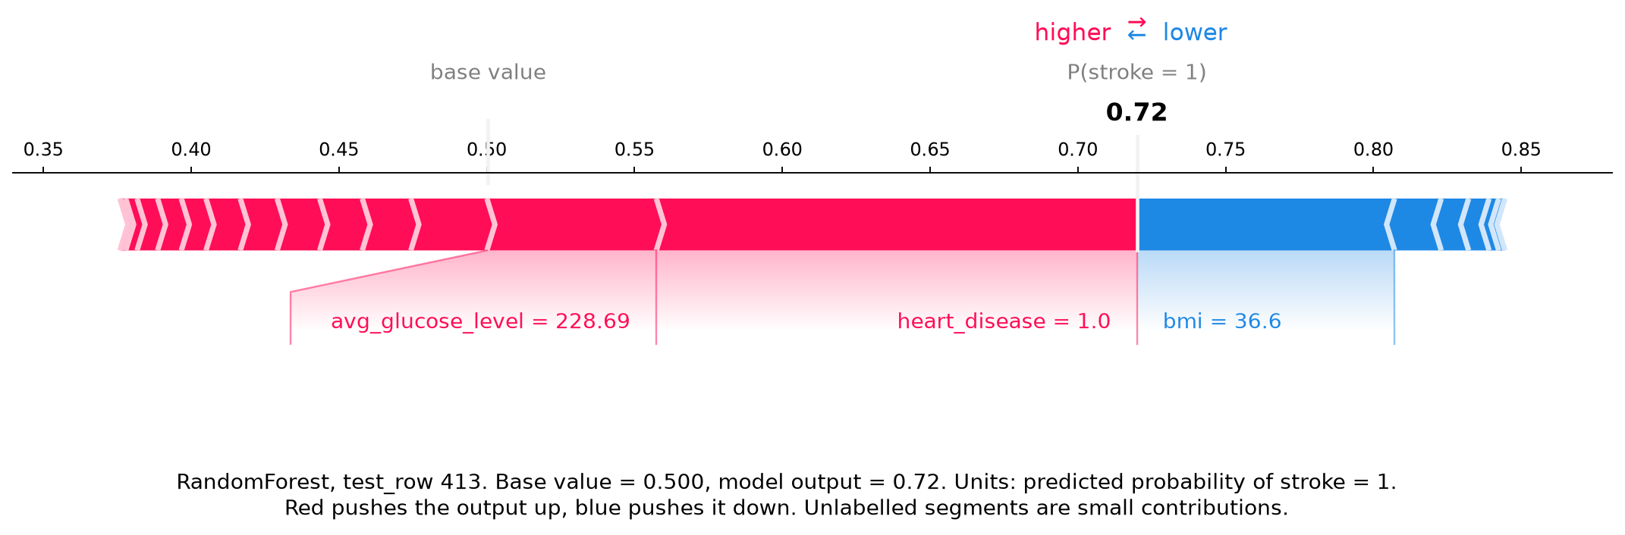
Figure 2. SHAP force plot for RandomForest, held-out test_row 413. The axis is predicted probability of stroke = 1, from base value 0.500 to output 0.72. Red segments push up and blue push down. Only the largest are labelled for readability; every value is in outputs/task3/. Heart disease is the largest push.

4 2 Feature contributions
Feature | Patient value | SHAP value | Direction for stroke output
heart_disease | 1 | +0.163 | Increases
bmi | 36.6 | -0.087 | Decreases
avg_glucose_level | 228.69 | +0.057 | Increases
Remaining features combined | — | +0.087 | Net increase

4 3 Interpretation of this prediction
Starting from the base value of 0.500, the model output moved to 0.72 on the probability scale. The largest upward contributions were heart_disease = 1 (+0.163) and avg_glucose_level = 228.69 (+0.057). The largest downward contribution was bmi = 36.6 (-0.087). The other 18 features together added +0.087, so no single small feature decides the result. These contributions add up to +0.220, with a residual of 5.6e-16.
The upward pushes are plausible as model behaviour, because heart disease and high glucose are also linked with stroke = 1 in Figure 1. The downward push from bmi = 36.6 needs care. It should not be read as higher bmi being protective: Section 5 shows that bmi has no simple direction in this model. Age 67 contributes only -0.007 here even though it is the top feature globally. No data were missing for this case: bmi was recorded and smoking status was formerly smoked. A false positive would flag someone with no recorded stroke and could lead to needless worry or checks. A false negative would leave a recorded stroke unflagged, which is the common error here (48 of 50). This describes a model prediction on a retrospective dataset. It is not a diagnosis or a recommendation for treatment.

5 Task 4 Global Explanation Using a Summary Plot

5 1 Population and plotting settings
Model and output explained: Task 2 RandomForest, predicted probability of stroke = 1. Held-out explanation sample and positive class count: all 1022 test rows, 50 with stroke = 1. Number of displayed features: 15 of 21. Sampling rule and seed: no sampling, so no seed applies.
Feature representation: encoded columns as they are, with no grouping. Each category of a one-hot variable has its own row, so a single original variable can appear more than once.

Figure 3 Global SHAP summary plot
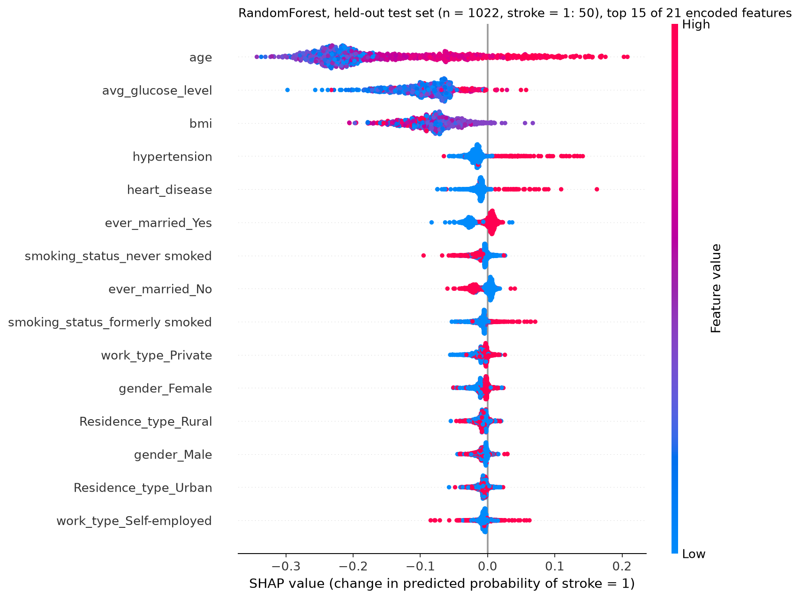
Figure 3. SHAP summary plot for RandomForest on all 1022 held-out rows (50 with stroke = 1). The x axis is the change in predicted probability of stroke = 1. Each dot is one patient, coloured from low (blue) to high (red) feature value. Older age tends to push the output up, and age has the widest spread.

5 2 Global importance and patterns
Rank | Feature | Mean absolute SHAP | Observed pattern
1 | age | 0.165 | Higher values push up. Lowest quarter mean -0.226, highest quarter +0.008; Spearman value vs SHAP +0.80
2 | avg_glucose_level | 0.093 | Weak upward link. Lowest quarter mean -0.096, highest quarter -0.070; only the highest values reach above zero
3 | bmi | 0.082 | No simple direction. Lowest quarter mean -0.089, highest quarter -0.108; Spearman -0.19, and middle values sit closest to zero
4 | hypertension | 0.021 | Value 1 pushes up (mean +0.042); value 0 pushes slightly down (mean -0.018)
5 | heart_disease | 0.014 | Value 1 pushes up (mean +0.036); value 0 pushes slightly down (mean -0.012)

Age is the most influential feature (mean absolute SHAP 0.165), followed by avg_glucose_level (0.093) and bmi (0.082). The next two features are much smaller. Effects vary across patients: age contributions range from -0.343 to +0.208. Read with the colour legend, higher age and a value of 1 for hypertension or heart disease generally increase the output, while bmi has no consistent direction. Many SHAP values are negative because most test rows score well below the balanced base value of 0.500. For one-hot columns, red only means that the category is present; the code size says nothing about clinical severity.
The bmi result needs a closer look. Only 12 test rows have a positive bmi SHAP value, all with bmi between 27.9 and 28.1, next to the imputed value of 28.1, and 8 of them are imputed rows. The 41 imputed test rows have a mean bmi SHAP of -0.016, against -0.084 for the others. The imputation used training data only, so this is not leakage from the test set, but the model may be treating the imputed value as a sign that bmi was blank, and blank bmi is linked with stroke = 1 in Section 2.

5 3 Link local and global findings
The Task 3 case only partly follows the global pattern. Its glucose and bmi contributions come from globally important features, but age ranks 1st globally and only 15th for this case, while heart_disease ranks 5th globally and 1st for the case. Its heart_disease value of +0.163 and glucose value of +0.057 are the largest for those features in the test set, so this is an unusual case and not a typical one. Global importance summarises the size of contributions across patients, while a local value gives the direction for one person. Correlated predictors can share attribution: age correlates with ever_married_Yes (r = 0.70) and work_type_children (r = -0.62) in the test set, and ever_married_Yes and ever_married_No hold the same information in two columns. A small value for one of them may not mean that the information is unimportant.

6 Task 5 Plan for Three Audience Slides
Three slides were made, one per audience, using the same RandomForest, the same case and the same numbers as this report. The file is outputs/slides/Stroke_SHAP_Slides.pptx.

Slide 1 Explanation as a data scientist
Title: Model performance and explanation of stroke classification
Visual: Global summary plot (Figure 3), with the main numbers as short bullets.
The slide gives the model, the stratified 80/20 split with training-only oversampling, and stroke = 1 as the positive class. It reports ROC AUC 0.827, average precision 0.145, recall 0.040 and precision 0.133, with outputs on the probability scale. Top features are age, avg_glucose_level and bmi. The explainer is TreeExplainer with path-dependent settings, so no background data were passed. The limitation shown is that the scores come from oversampled training data and calibration was not checked.
Accuracy is not shown alone. The evidence is one held-out test set, and the additivity check passed. External validation, a tuned threshold and a calibration check would be needed before relying on the model.

Slide 2 Explanation as a doctor
Title: Interpreting one patient prediction in clinical context
Visual: Force plot for the same anonymous case, test_row 413 (Figure 2).
The slide gives the predicted probability of 0.72 against a base value of 0.500, with heart disease and glucose pushing up and bmi pushing down. It explains that 48 of 50 recorded strokes were missed at threshold 0.5, so a low score does not rule out a stroke history. It states the need for calibration and external validation, and that SHAP explains model behaviour and is not a diagnosis.
A clinician could use the plot to check whether the drivers look sensible against the patient record. The dataset is retrospective and educational, so the slide does not suggest any clinical use.

Slide 3 Explanation as a patient
Title: What the computer prediction means for this example
Visual: A simple chart built from the same SHAP values, showing what pushed the prediction up or down, in words and without feature codes or numbers.
The slide addresses the patient directly. It says that the computer looked at recorded information such as age, health conditions and blood sugar, names the factors that pushed this example up and down, and says that the prediction can be wrong. No score is given as a risk percentage.
Uncertainty is explained in simple words: the computer learned from past records and misses many cases. The slide makes no causal claims, gives no blame and no medication advice, and says that a clinician would read the result alongside other information.

Slide consistency check
All three slides use the RandomForest and the same case, predicted value, output units and top features as this report. A source note credits the Kaggle dataset, and the text was checked at presentation size.

7 Task 6 Explain a Different Black Box Model

7 1 Alternative model and rationale
Task 2 model: RandomForestClassifier. Task 6 model: MLPClassifier, a neural network with one hidden layer of 100 units, default settings and max_iter=500, after a StandardScaler. Reason for choosing it: it is a different model type that learns smooth functions, not axis-aligned splits, and its predictions are fast enough for Kernel SHAP. The split, encoded predictors, bmi imputation and training oversampling are the same as Task 2. The only addition is the scaler, needed by the network and fitted on training data as part of the model.

7 2 Choose and document one explainer
Record | Kernel SHAP route | Deep SHAP route
Suitable explained model | A prediction function for the chosen model | Not used
Output and class | predict_proba for stroke = 1; class index 1; identity link; probability scale | Not used
Background | 100 rows from the oversampled training set, shap.sample, seed 2021 | Not used
Computation settings | nsamples 2048; l1_reg False; numpy seed 2021 | Not used
Input consistency | Wrapper function passes the 21 encoded columns to the fitted pipeline | Not used

Chosen route and implementation: Kernel SHAP using shap.KernelExplainer (shap 0.54.1) on a wrapper around the fitted pipeline. Background selection: 100 rows sampled from the oversampled training set, seed 2021. Held-out sample size: 200 rows, being the Task 3 case plus a seeded random sample of other test rows (14 with stroke = 1). Computational settings: nsamples 2048, no L1 regularisation. Deep SHAP was not used.
Compatibility and checks: output shape (200, 21); selected class stroke = 1 (index 1, classes_ [0, 1]); reconstruction residual 3.33e-15 against tolerance 1e-06, passed; runtime 41 seconds; no warnings from the explainer. For the model, the optimiser reached 500 iterations and raised a ConvergenceWarning during fitting, so training had not fully converged. This is reported as found, and iterations were not raised because no tuning was done. The same preprocessing objects were used for training, prediction and explanation. Kernel SHAP estimates SHAP values by sampling, so the values are approximate, although additivity holds by construction.

7 3 Required evidence for the chosen model
Held-out performance on the same 1022 test rows at threshold 0.5: accuracy 0.876, balanced accuracy 0.555, precision 0.103, recall 0.200, F1 0.136 (support 50), ROC AUC 0.725, average precision 0.124. Confusion matrix: TN 885, FP 87, FN 40, TP 10. Both plots below are in units of predicted probability of stroke = 1.
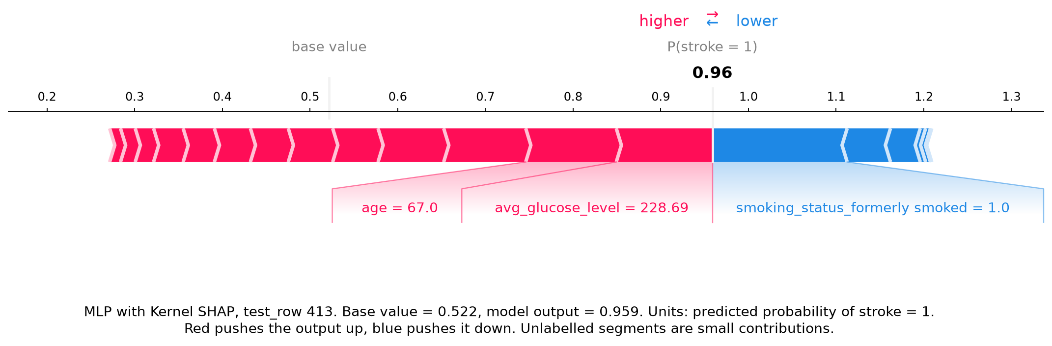
Figure 4. Kernel SHAP force plot for the MLP, same case as Figure 2 (test_row 413). Base value 0.522, output 0.959, in predicted probability of stroke = 1. The axis runs past 1 only because the up and down pushes are drawn side by side.
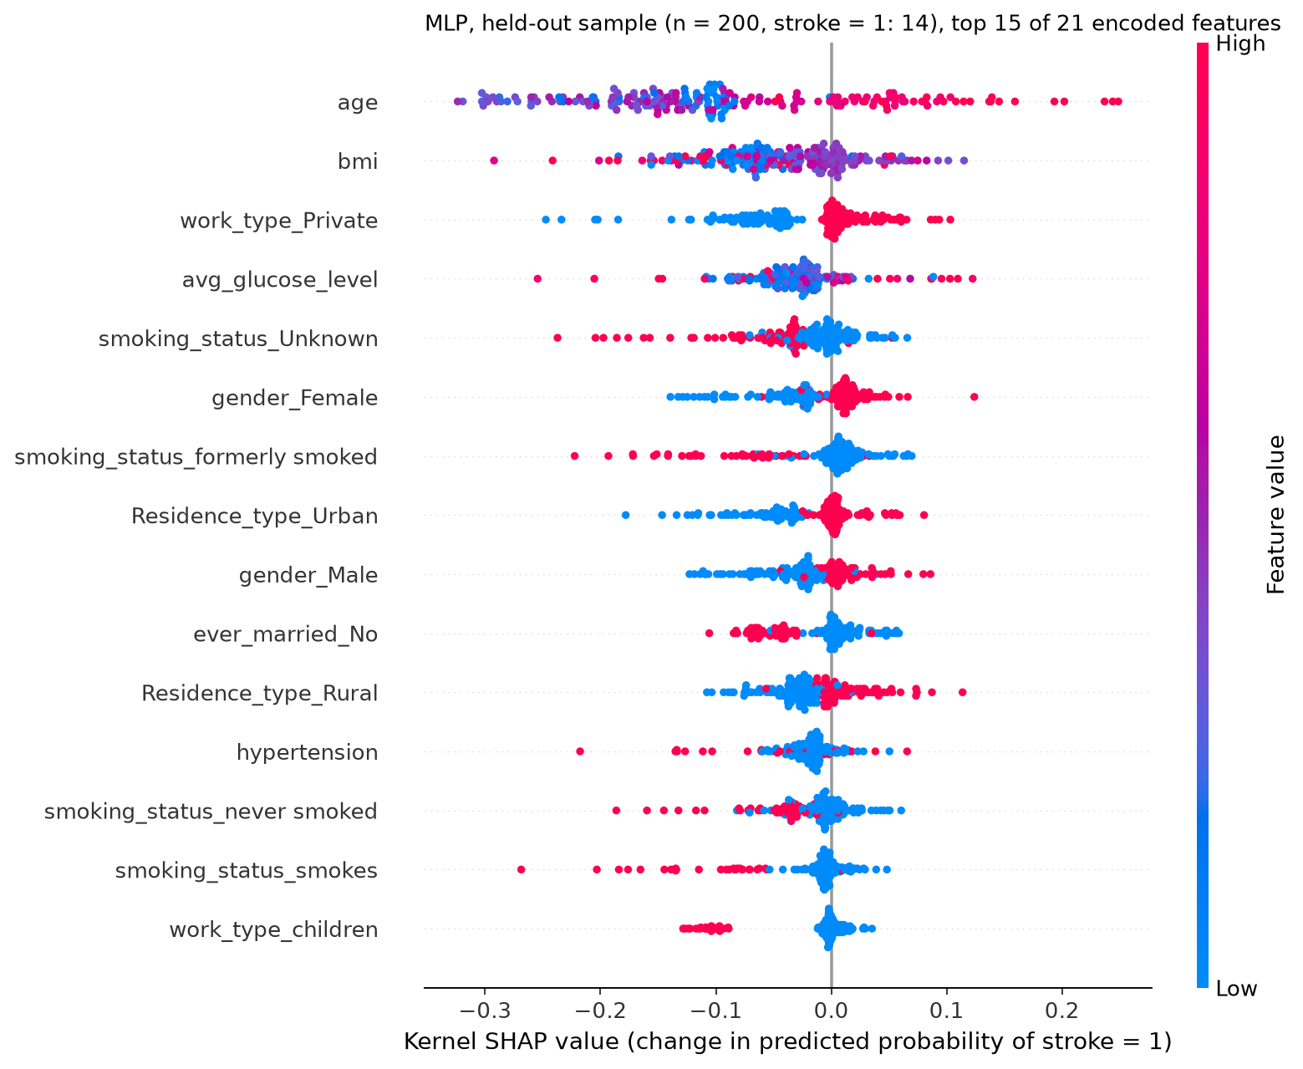
Figure 5. Kernel SHAP summary plot for the MLP on 200 held-out rows (14 with stroke = 1). The x axis is the change in predicted probability of stroke = 1. Age again has the widest spread.
The MLP also predicts stroke = 1 for this case, with a higher probability of 0.959. Its largest contribution is smoking_status_formerly smoked = 1 (-0.154), followed by avg_glucose_level (+0.110) and age (+0.103). Agreement with Task 2 is partial. Both models push the case up through glucose, but heart_disease is much smaller in the MLP (+0.036 vs +0.163), and bmi changes sign (+0.075 vs -0.087). Over all 21 features, the signs match for 11. Globally, age is first for both models, but the MLP gives more weight to work_type_Private and smoking_status_Unknown. Its summary plot also spreads hypertension to the negative side, unlike the RandomForest. That disagreement should be read with care, given the MLP's weaker ranking and non-converged training.

8 Comparison Discussion and Conclusion

8 1 Compare the two models
Comparison item | Task 2 model | Task 6 model
Model and explainer | RandomForest; shap.TreeExplainer | StandardScaler + MLPClassifier; shap.KernelExplainer
Positive class recall and precision | Recall 0.040; precision 0.133 | Recall 0.200; precision 0.103
F1 balanced accuracy ROC AUC | F1 0.062; balanced accuracy 0.513; ROC AUC 0.827 | F1 0.136; balanced accuracy 0.555; ROC AUC 0.725
Average precision and prevalence | Average precision 0.145; prevalence 4.89% | Average precision 0.124; prevalence 4.89%
Case score and explained scale | 0.72; predicted probability of stroke = 1 | 0.959; predicted probability of stroke = 1
Top three global features | age, avg_glucose_level, bmi (same three on the Task 6 rows) | age, bmi, work_type_Private
Explanation sample and runtime | All 1022 test rows; 26 s | 200 test rows; 41 s
Reconstruction residual | Max 3.28e-15 | Max 3.33e-15

The models agree on most hard predictions (92.0% of test rows), mainly because both predict 0 for most rows, and their scores have a Spearman correlation of 0.73. On the same 200 rows, the Spearman correlation of mean absolute SHAP across features is 0.63, so importance rankings agree only moderately. The magnitudes can be compared because both are on the probability scale and the same encoded features, but the explained samples differ in the table (Task 2 used all test rows), the reference differs (tree-path coverage vs a 100-row background), and the base values are 0.500 and 0.522. Differences may therefore reflect the models, the explainers or the background. No model should be favoured because its explanation looks more familiar.

8 2 Limitations and responsible interpretation
Provenance and representativeness are unknown: the supplied files give no population, sites or collection period, so results may not carry over to any real clinical group. The dataset is retrospective and there was no prospective validation. Classes are imbalanced (4.87% positive), and oversampling repeats minority rows, which can encourage overfitting. Missingness also matters: bmi is blank for 201 rows with a higher stroke share, and Section 5 suggests that the imputed value may carry that pattern into the model, while smoking is Unknown for 1544 rows. Probability calibration was not assessed. Scores come from models trained on balanced data, so they should be treated as uncalibrated. Subgroup performance was not assessed; with only 50 positive test rows, the subgroups would be very small. The recorded stroke may also precede the measured values, so the data cannot support a temporal reading. Correlated features share attribution, as shown by age and ever_married, and background selection affects attribution, as shown next.
The repeat was quick, so Kernel SHAP was run again with a second background of 100 training rows (seed 2022), using the same MLP and the same 200 rows. The top five global features overlapped on 5 of 5, and the Spearman correlation of mean absolute SHAP was 0.94. For the Task 3 case, the five largest contributions all kept their sign, and 2 of 21 features changed sign overall. Magnitudes did move: the age contribution went from +0.103 to +0.055, and the base value went from 0.522 to 0.623. The ranking was stable in this one repeat, but local values depended on the background. The RandomForest was not repeated because its path-dependent TreeExplainer takes no background.

8 3 Conclusion
On threshold-free ranking the RandomForest performed better than the MLP (ROC AUC 0.827 vs 0.725, average precision 0.145 vs 0.124), and this criterion is used because neither model's threshold was tuned. At 0.5, neither model works well as a detector: recall was 0.040 and 0.200. Local SHAP showed that the selected case reached 0.72 mainly through heart disease and glucose. Global SHAP ranked age, glucose and bmi highest. With the MLP, age stayed first, but the same case scored 0.959 and its bmi contribution changed sign. The main constraint is that both explanations describe models trained on balanced, retrospective data with uncalibrated probabilities, so they describe model behaviour and not stroke mechanisms or individual risk.

8 4 Work contributions
Individual or group contributions: [Student: enter names and tasks]. Assistance and tools used: [Student: confirm final wording under course policy. Suggested: Claude Code was used to run the analysis, write the code and draft this report, and all reported results come from code that was actually run].

9 References and Submission Checklist

9 1 References
References are numbered. [Student: change the style if the course requires another one.]
[1] fedesoriano. Stroke Prediction Dataset. Kaggle. https://www.kaggle.com/fedesoriano/stroke-prediction-dataset
[2] Lundberg, S. M. and Lee, S.-I. (2017). A unified approach to interpreting model predictions. In Advances in Neural Information Processing Systems 30, pp. 4765-4774.

9 2 Reproducibility appendix
Environment: Python 3.13.0, Windows 11, shap 0.54.1, scikit-learn 1.9.1, imbalanced-learn 0.14.2, pandas 3.1.1, numpy 2.5.4, matplotlib 3.11.2; full list in requirements.txt. Seeds: random_state=2021 for the split, oversampling, both models, background and explained sample; 2022 for the second background only. Data fingerprint or version: SHA-256 644d473b05d2797006bd94865e4f8bb057f0c721617911613c82c8fcfc707420. Configuration: RandomForest defaults with random_state=2021; StandardScaler + MLPClassifier defaults with max_iter=500; bmi median 28.1; threshold 0.5; TreeExplainer with tree_path_dependent; KernelExplainer with 100 background rows and nsamples 2048. Split indices are reproduced by train_test_split with test_size=0.20, stratified, seed 2021. Encoded feature order: age, hypertension, heart_disease, avg_glucose_level, bmi, gender_Female, gender_Male, gender_Other, ever_married_No, ever_married_Yes, work_type_Govt_job, work_type_Never_worked, work_type_Private, work_type_Self-employed, work_type_children, Residence_type_Rural, Residence_type_Urban, smoking_status_Unknown, smoking_status_formerly smoked, smoking_status_never smoked, smoking_status_smokes.
Evidence files: EDA outputs in outputs/eda/; trained pipeline in outputs/task2/rf_model.joblib, outputs/task2/preprocessing.joblib and outputs/task6/mlp_model.joblib; metrics in outputs/task2/metrics.json and outputs/task6/metrics.json; confusion matrix in outputs/task2/confusion_matrix.png; force plot in outputs/task3/force_plot_case.png and .html; summary plot in outputs/task4/summary_plot.png; alternative model plots in outputs/task6/; explanation arrays in outputs/task2/shap_values_test.npz and outputs/task6/kernel_shap_values.npz; three-slide file in outputs/slides/Stroke_SHAP_Slides.pptx; environment in requirements.txt; scripts in work/; log in outputs/progress_log.md.

9 3 Final submission check
☐ Task 1 Repository recorded and 00_data_exploration.py executed; EDA results interpreted.
☑ Task 2 Model evaluated and SHAP explainer specified with class, background and output scale.
☑ Task 3 Readable force plot included and linked to one held-out case.
☑ Task 4 Readable summary plot included and global patterns explained.
☑ Task 5 Three slides prepared for the data scientist, doctor and patient audiences.
☑ Task 6 Different black box model explained using Deep SHAP or Kernel SHAP.
☐ All placeholders replaced; figures captioned; sources cited; code and versions supplied.
☑ No invented results, data leakage, unsupported causal claims or unvalidated future risk claims.

