**DSWD DROMIC Report #27 on the Coronavirus Disease (COVID19)**

as of 02 April 2020, 6PM

**Situation Overview**

The coronavirus disease (COVID19) is an infectious disease that was unknown before the outbreak began in Wuhan, China. On 16 March 2020, a Memorandum from the Executive Secretary was issued regarding Community Quarantine over the entire Luzon and Further Guidelines for the Management of the Coronavirus Disease 2019 (COVID19) Situation.

As of 01 April 2020 4PM, the Department of Health (DOH) has conducted **4,726 COVID19 tests;** of which, **2,633** are **confirmed cases**. Out of these infected, **51** have **recovered** while **107 deaths** were recorded.

*Source: DOH through NDRRMC*

1. **Assistance Provided**

A total of **₱2,194,994,678.37** worth of assistance was provided to the affected families of COVID19; of which, **₱65,994,577.37** was provided by **DSWD**, **₱2,109,510,617.97** from **LGUs**, **₱5,001,302.03** from **NGOs** and **₱14,488,181.00** from **Private Partners** (see Table 1).

***Table 1. Cost of Assistance Provided to Affected Families / Persons***

| **REGION / PROVINCE / MUNICIPALITY** | | **COST OF ASSISTANCE** | | | | |
| --- | --- | --- | --- | --- | --- | --- |
| **DSWD** | **LGU** | **NGOs** | **OTHERS** | **GRAND TOTAL** |
| **GRAND TOTAL** | | **65,994,577.37** | **2,109,510,617.97** | **5,001,302.03** | **14,488,181.00** | **2,194,994,678.37** |
| **NCR** | | **32,610,980.00** | **621,778,650.00** | **3,400,000.00** | **-** | **657,789,630.00** |
| *Caloocan City* | | 1,850,000.00 | 50,000,000.00 | 850,000.00 | - | 52,700,000.00 |
| *Las Pinas* | | 702,000.00 | 29,815,500.00 | - | - | 30,517,500.00 |
| *Makati City* | | 720,000.00 | - | - | - | 720,000.00 |
| *Malabon City* | | 2,009,000.00 | - | - | - | 2,009,000.00 |
| *Mandaluyong City* | | 1,984,000.00 | - | - | - | 1,984,000.00 |
| *Manila City* | | 5,898,000.00 | - | 850,000.00 | - | 6,748,000.00 |
| *Marikina city* | | 1,934,000.00 | - | - | - | 1,934,000.00 |
| *Muntinlupa City* | | 1,801,000.00 | 42,189,750.00 | - | - | 43,990,750.00 |
| *Navotas* | | 864,000.00 | - | - | - | 864,000.00 |
| *Paranaque City* | | 1,830,000.00 | 30,000,000.00 | - | - | 31,830,000.00 |
| *Pasay City* | | 1,810,000.00 | - | 850,000.00 | - | 2,660,000.00 |
| *Pasig City* | | 1,644,000.00 | 260,000,000.00 | - | - | 261,644,000.00 |
| *Pateros* | | 830,000.00 | 11,816,400.00 | - | - | 12,646,400.00 |
| *Taguig City* | | 2,691,480.00 | 165,000,000.00 | - | - | 167,691,480.00 |
| *Quezon City* | | 3,240,000.00 | - | 850,000.00 | - | 4,090,000.00 |
| *San Juan City* | | 723,000.00 | - | - | - | 723,000.00 |
| *Valenzuela City* | | 2,080,500.00 | 32,957,000.00 | - | - | 35,037,500.00 |
| **REGION I** | | **377,140.00** | **152,780,914.16** | **120,400.03** | **9,301,693.00** | **162,580,147.19** |
| **Ilocos Norte** | | **-** | **18,853,531.50** | **-** | **-** | **18,853,531.50** |
|  | *Adams* | *-* | *705,230.00* | *-* | *-* | *705,230.00* |
|  | *Bacarra* | *-* | *1,499,000.00* | *-* | *-* | *1,499,000.00* |
|  | *Badoc* | *-* | *2,116,500.00* | *-* | *-* | *2,116,500.00* |
|  | *Bangui* | *-* | *1,230,402.00* | *-* | *-* | *1,230,402.00* |
|  | *Banna (Espiritu)* | *-* | *1,500,000.00* | *-* | *-* | *1,500,000.00* |
|  | *CITY OF BATAC* | *-* | *1,935,000.00* | *-* | *-* | *1,935,000.00* |
|  | *Burgos* | *-* | *587,229.00* | *-* | *-* | *587,229.00* |
|  | *Carasi* | *-* | *179,620.00* | *-* | *-* | *179,620.00* |
|  | *Dumalneg* | *-* | *663,706.75* | *-* | *-* | *663,706.75* |
|  | *LAOAG CITY (Capital)* | *-* | *280,800.00* | *-* | *-* | *280,800.00* |
|  | *Marcos* | *-* | *121,510.00* | *-* | *-* | *121,510.00* |
|  | *Nueva Era* | *-* | *292,305.75* | *-* | *-* | *292,305.75* |
|  | *Pasuquin* | *-* | *469,000.00* | *-* | *-* | *469,000.00* |
|  | *Piddig* | *-* | *4,724,500.00* | *-* | *-* | *4,724,500.00* |
|  | *Pinili* | *-* | *653,000.00* | *-* | *-* | *653,000.00* |
|  | *San Nicolas* | *-* | *1,070,300.00* | *-* | *-* | *1,070,300.00* |
|  | *Sarrat* | *-* | *819,788.00* | *-* | *-* | *819,788.00* |
|  | *Solsona* | *-* | *5,640.00* | *-* | *-* | *5,640.00* |
| **Ilocos Sur** | | **-** | **34,257,367.72** | **-** | **-** | **34,257,367.72** |
|  | *Alilem* | *-* | *320,070.00* | *-* | *-* | *320,070.00* |
|  | *Bantay* | *-* | *471,200.00* | *-* | *-* | *471,200.00* |
|  | *Burgos* | *-* | *1,577,419.96* | *-* | *-* | *1,577,419.96* |
|  | *CITY OF CANDON* | *-* | *3,894,099.29* | *-* | *-* | *3,894,099.29* |
|  | *Caoayan* | *-* | *990,052.00* | *-* | *-* | *990,052.00* |
|  | *Cervantes* | *-* | *407,400.00* | *-* | *-* | *407,400.00* |
|  | *Galimuyod* | *-* | *1,108,849.10* | *-* | *-* | *1,108,849.10* |
|  | *Gregorio del Pilar (Concepcion)* | *-* | *463,482.00* | *-* | *-* | *463,482.00* |
|  | *Magsingal* | *-* | *1,240,155.00* | *-* | *-* | *1,240,155.00* |
|  | *Nagbukel* | *-* | *651,700.00* | *-* | *-* | *651,700.00* |
|  | *Salcedo (Baugen)* | *-* | *605,542.08* | *-* | *-* | *605,542.08* |
|  | *San Emilio* | *-* | *428,419.00* | *-* | *-* | *428,419.00* |
|  | *San Esteban* | *-* | *400,000.04* | *-* | *-* | *400,000.04* |
|  | *San Ildefonso* | *-* | *1,834.01* | *-* | *-* | *1,834.01* |
|  | *San Juan (Lapog)* | *-* | *877,798.50* | *-* | *-* | *877,798.50* |
|  | *San Vicente* | *-* | *1,076,500.00* | *-* | *-* | *1,076,500.00* |
|  | *Santa* | *-* | *1,907,233.20* | *-* | *-* | *1,907,233.20* |
|  | *Santa Catalina* | *-* | *837,000.00* | *-* | *-* | *837,000.00* |
|  | *Santa Lucia* | *-* | *1,321,400.00* | *-* | *-* | *1,321,400.00* |
|  | *Santa Maria* | *-* | *666,276.48* | *-* | *-* | *666,276.48* |
|  | *Santiago* | *-* | *1,393,707.80* | *-* | *-* | *1,393,707.80* |
|  | *Sigay* | *-* | *478,271.02* | *-* | *-* | *478,271.02* |
|  | *Sinait* | *-* | *3,395,324.31* | *-* | *-* | *3,395,324.31* |
|  | *Tagudin* | *-* | *1,815,570.00* | *-* | *-* | *1,815,570.00* |
|  | *CITY OF VIGAN (Capital)* | *-* | *7,928,063.93* | *-* | *-* | *7,928,063.93* |
| **La Union** | | **-** | **42,629,857.50** | **104,200.00** | **-** | **42,734,057.50** |
|  | *Agoo* | *-* | *2,450,000.00* | *-* | *-* | *2,450,000.00* |
|  | *Bacnotan* | *-* | *1,568,867.54* | *-* | *-* | *1,568,867.54* |
|  | *Balaoan* | *-* | *2,044,875.00* | *-* | *-* | *2,044,875.00* |
|  | *Bauang* | *-* | *2,748,346.00* | *-* | *-* | *2,748,346.00* |
|  | *Caba* | *-* | *1,780,800.00* | *-* | *-* | *1,780,800.00* |
|  | *Luna* | *-* | *4,948,530.00* | *-* | *-* | *4,948,530.00* |
|  | *Rosario* | *-* | *5,378,847.60* | *104,200.00* | *-* | *5,483,047.60* |
|  | *CITY OF SAN FERNANDO (Capital)* | *-* | *9,780,888.00* | *-* | *-* | *9,780,888.00* |
|  | *San Juan* | *-* | *2,515,376.00* | *-* | *-* | *2,515,376.00* |
|  | *Santo Tomas* | *-* | *6,138,631.36* | *-* | *-* | *6,138,631.36* |
|  | *Santol* | *-* | *2,038,281.00* | *-* | *-* | *2,038,281.00* |
|  | *Sudipen* | *-* | *1,236,415.00* | *-* | *-* | *1,236,415.00* |
| **Pangasinan** | | **377,140.00** | **57,040,157.44** | **16,200.03** | **9,301,693.00** | **66,735,190.47** |
|  | *Agno* | *-* | *147,579.00* | *-* | *-* | *147,579.00* |
|  | *Aguilar* | *-* | *2,221,600.00* | *-* | *-* | *2,221,600.00* |
|  | *Alcala* | *-* | *517,500.00* | *-* | *-* | *517,500.00* |
|  | *Asingan* | *-* | *787,423.21* | *-* | *-* | *787,423.21* |
|  | *Balungao* | *-* | *790,605.75* | *-* | *-* | *790,605.75* |
|  | *Bani* | *-* | *5,500,000.00* | *-* | *-* | *5,500,000.00* |
|  | *Bautista* | *-* | *2,484,300.00* | *-* | *-* | *2,484,300.00* |
|  | *Bayambang* | *-* | *2,466,800.00* | *-* | *-* | *2,466,800.00* |
|  | *Binmaley* | *-* | *-* | *-* | *2,370,800.00* | *2,370,800.00* |
|  | *Bugallon* | *-* | *6,624,860.00* | *-* | *216,500.00* | *6,841,360.00* |
|  | *Calasiao* | *-* | *6,307,500.00* | *-* | *4,584,260.00* | *10,891,760.00* |
|  | *Labrador* | *-* | *460,000.00* | *-* | *-* | *460,000.00* |
|  | *LINGAYEN (Capital)* | *377,140.00* | *5,635,020.00* | *-* | *-* | *6,012,160.00* |
|  | *Mabini* | *-* | *1,373,600.00* | *-* | *-* | *1,373,600.00* |
|  | *Malasiqui* | *-* | *373,320.00* | *-* | *-* | *373,320.00* |
|  | *Mangatarem* | *-* | *9,450.00* | *-* | *-* | *9,450.00* |
|  | *Pozzorubio* | *-* | *1,324,600.00* | *-* | *-* | *1,324,600.00* |
|  | *Rosales* | *-* | *1,983,503.42* | *-* | *-* | *1,983,503.42* |
|  | *San Fabian* | *-* | *1,122,180.00* | *-* | *-* | *1,122,180.00* |
|  | *San Manuel* | *-* | *792,000.00* | *-* | *850,043.00* | *1,642,043.00* |
|  | *San Quintin* | *-* | *600,000.00* | *-* | *-* | *600,000.00* |
|  | *Santa Barbara* | *-* | *2,114,750.00* | *-* | *-* | *2,114,750.00* |
|  | *Sison* | *-* | *500.00* | *-* | *-* | *500.00* |
|  | *Tayug* | *-* | *1,500,001.06* | *16,200.03* | *-* | *1,516,201.09* |
|  | *Umingan* | *-* | *974,785.00* | *-* | *347,400.00* | *1,322,185.00* |
|  | *Urbiztondo* | *-* | *1,750,000.00* | *-* | *-* | *1,750,000.00* |
|  | *CITY OF URDANETA* | *-* | *7,178,280.00* | *-* | *-* | *7,178,280.00* |
|  | *Villasis* | *-* | *2,000,000.00* | *-* | *932,690.00* | *2,932,690.00* |
| **REGION II** | | **234,636.50** | **51,736,957.68** | **-** | **-** | **51,971,594.18** |
| **Batanes** | | **5,897.98** | **-** | **-** | **-** | **5,897.98** |
|  | *Basco* | *4,966.72* | *-* | *-* | *-* | *4,966.72* |
|  | *Uyugan* | *931.26* | *-* | *-* | *-* | *931.26* |
| **Cagayan** | | **228,428.10** | **2,856,496.36** | **-** | **-** | **3,084,924.46** |
|  | *Alcala* | *133,750.00* | *2,006,320.00* | *-* | *-* | *2,140,070.00* |
|  | *Baggao* | *310.42* | *-* | *-* | *-* | *310.42* |
|  | *Ballesteros* | *310.42* | *-* | *-* | *-* | *310.42* |
|  | *Calayan* | *94,057.26* | *-* | *-* | *-* | *94,057.26* |
|  | *Iguig* | *-* | *850,176.36* | *-* | *-* | *850,176.36* |
| **Isabela** | | **310.42** | **19,967,567.00** | **-** | **-** | **19,967,877.42** |
|  | *Alicia* | *-* | *2,251,200.00* | *-* | *-* | *2,251,200.00* |
|  | *Angadanan* | *-* | *3,445,000.00* | *-* | *-* | *3,445,000.00* |
|  | *Benito Soliven* | *-* | *120,575.00* | *-* | *-* | *120,575.00* |
|  | *Burgos* | *-* | *1,404,000.00* | *-* | *-* | *1,404,000.00* |
|  | *City of Cauayan* | *310.42* | *-* | *-* | *-* | *310.42* |
|  | *Cordon* | *-* | *96,876.00* | *-* | *-* | *96,876.00* |
|  | *Delfin Albano (Magsaysay)* | *-* | *2,602,600.00* | *-* | *-* | *2,602,600.00* |
|  | *Dinapigue* | *-* | *343,706.00* | *-* | *-* | *343,706.00* |
|  | *Luna* | *-* | *397,565.00* | *-* | *-* | *397,565.00* |
|  | *Maconacon* | *-* | *1,017,552.00* | *-* | *-* | *1,017,552.00* |
|  | *Mallig* | *-* | *214,360.00* | *-* | *-* | *214,360.00* |
|  | *Naguilian* | *-* | *419,185.00* | *-* | *-* | *419,185.00* |
|  | *Reina Mercedes* | *-* | *1,327,105.00* | *-* | *-* | *1,327,105.00* |
|  | *City of Santiago* | *-* | *3,985,104.00* | *-* | *-* | *3,985,104.00* |
|  | *Santo Tomas* | *-* | *2,342,739.00* | *-* | *-* | *2,342,739.00* |
| **Nueva Vizcaya** | | **-** | **21,362,210.32** | **-** | **-** | **21,362,210.32** |
|  | *Alfonso Castaneda* | *-* | *262,240.16* | *-* | *-* | *262,240.16* |
|  | *Ambaguio* | *-* | *338,500.00* | *-* | *-* | *338,500.00* |
|  | *Aritao* | *-* | *940,000.00* | *-* | *-* | *940,000.00* |
|  | *Bagabag* | *-* | *2,059,397.00* | *-* | *-* | *2,059,397.00* |
|  | *Bambang* | *-* | *3,073,719.00* | *-* | *-* | *3,073,719.00* |
|  | *Bayombong (capital)* | *-* | *1,252,000.00* | *-* | *-* | *1,252,000.00* |
|  | *Diadi* | *-* | *2,995,705.00* | *-* | *-* | *2,995,705.00* |
|  | *Dupax del Norte* | *-* | *3,770,962.00* | *-* | *-* | *3,770,962.00* |
|  | *Dupax del Sur* | *-* | *1,137,600.00* | *-* | *-* | *1,137,600.00* |
|  | *Kayapa* | *-* | *1,250,603.00* | *-* | *-* | *1,250,603.00* |
|  | *Quezon* | *-* | *500.00* | *-* | *-* | *500.00* |
|  | *Santa Fe* | *-* | *961,232.50* | *-* | *-* | *961,232.50* |
|  | *Solano* | *-* | *955,000.00* | *-* | *-* | *955,000.00* |
|  | *Villaverde* | *-* | *2,364,751.66* | *-* | *-* | *2,364,751.66* |
| **Quirino** | | **-** | **7,550,684.00** | **-** | **-** | **7,550,684.00** |
|  | *Aglipay* | *-* | *2,260,500.00* | *-* | *-* | *2,260,500.00* |
|  | *Cabarroguis (capital)* | *-* | *2,846,700.00* | *-* | *-* | *2,846,700.00* |
|  | *Nagtipunan* | *-* | *2,443,484.00* | *-* | *-* | *2,443,484.00* |
| **REGION III** | | **5,472,077.30** | **311,659,582.43** | **-** | **-** | **317,131,659.73** |
| **Aurora** | | **343,750.00** | **22,226,093.10** | **- .00** | **- .00** | **22,569,843.10** |
|  | *PLGU Aurora* | *-* | *57,590.52* | *-* | *-* | *57,590.52* |
|  | *Baler (capital)* | *150,750.00* | *3,278,650.00* | *-* | *-* | *3,429,400.00* |
|  | *Casiguran* | *-* | *1,987,490.00* | *-* | *-* | *1,987,490.00* |
|  | *Dilasag* | *-* | *1,692,143.00* | *-* | *-* | *1,692,143.00* |
|  | *Dinalungan* | *-* | *1,099,964.00* | *-* | *-* | *1,099,964.00* |
|  | *Dingalan* | *193,000.00* | *3,732,082.69* | *-* | *-* | *3,925,082.69* |
|  | *Dipaculao* | *-* | *4,085,712.04* | *-* | *-* | *4,085,712.04* |
|  | *Maria Aurora* | *-* | *2,728,355.00* | *-* | *-* | *2,728,355.00* |
|  | *San Luis* | *-* | *3,564,105.85* | *-* | *-* | *3,564,105.85* |
| **Bataan** | | **142,434.00** | **12,600,272.00** | **-** | **-** | **12,742,706.00** |
|  | *Bagac* | *-* | *2,631,375.00* | *-* | *-* | *2,631,375.00* |
|  | *City of Balanga (capital)* | *-* | *8,606,000.00* | *-* | *-* | *8,606,000.00* |
|  | *Hermosa* | *-* | *1,362,897.00* | *-* | *-* | *1,362,897.00* |
|  | *Orani* | *142,434.00* | *-* | *-* | *-* | *142,434.00* |
| **Bulacan** | | **2,490,895.80** | **92,437,815.68** | **-** | **-** | **94,928,711.48** |
|  | *Angat* | *-* | *5,285,280.00* | *-* | *-* | *5,285,280.00* |
|  | *Balagtas (Bigaa)* | *-* | *9,543,750.00* | *-* | *-* | *9,543,750.00* |
|  | *Baliuag* | *291,353.60* | *9,238,000.00* | *-* | *-* | *9,529,353.60* |
|  | *Bulacan* | *-* | *10,251,500.00* | *-* | *-* | *10,251,500.00* |
|  | *Bustos* | *-* | *6,250,885.68* | *-* | *-* | *6,250,885.68* |
|  | *Calumpit* | *-* | *1,256,000.00* | *-* | *-* | *1,256,000.00* |
|  | *Doña Remedios Trinidad* | *-* | *727,400.00* | *-* | *-* | *727,400.00* |
|  | *Guiguinto* | *-* | *1,500,000.00* | *-* | *-* | *1,500,000.00* |
|  | *City of Malolos (capital)* | *235,074.00* | *-* | *-* | *-* | *235,074.00* |
|  | *Marilao* | *-* | *14,061,600.00* | *-* | *-* | *14,061,600.00* |
|  | *City of Meycauayan* | *298,182.20* | *-* | *-* | *-* | *298,182.20* |
|  | *Norzagaray* | *-* | *1,749,440.00* | *-* | *-* | *1,749,440.00* |
|  | *Obando* | *136,572.00* | *5,000,000.00* | *-* | *-* | *5,136,572.00* |
|  | *Pandi* | *154,400.00* | *10,826,250.00* | *-* | *-* | *10,980,650.00* |
|  | *Plaridel* | *-* | *7,730,910.00* | *-* | *-* | *7,730,910.00* |
|  | *City of San Jose del Monte* | *736,242.00* | *-* | *-* | *-* | *736,242.00* |
|  | *San Miguel* | *639,072.00* | *-* | *-* | *-* | *639,072.00* |
|  | *San Rafael* | *-* | *6,998,000.00* | *-* | *-* | *6,998,000.00* |
|  | *Santa Maria* | *-* | *2,018,800.00* | *-* | *-* | *2,018,800.00* |
| **Nueva Ecija** | | **1,167,407.50** | **71,465,515.00** | **-** | **-** | **72,632,922.50** |
|  | *Bongabon* | *-* | *4,200,000.00* | *-* | *-* | *4,200,000.00* |
|  | *Cabanatuan City* | *-* | *47,997,200.00* | *-* | *-* | *47,997,200.00* |
|  | *Cabiao* | *343,207.50* | *-* | *-* | *-* | *343,207.50* |
|  | *Gabaldon (Bitulok & Sabani)* | *-* | *2,104,830.00* | *-* | *-* | *2,104,830.00* |
|  | *General Mamerto Natividad* | *-* | *2,419,550.00* | *-* | *-* | *2,419,550.00* |
|  | *General Tinio (Papaya)* | *289,500.00* | *-* | *-* | *-* | *289,500.00* |
|  | *Laur* | *-* | *2,500,000.00* | *-* | *-* | *2,500,000.00* |
|  | *Palayan City (capital)* | *-* | *1,617,736.00* | *-* | *-* | *1,617,736.00* |
|  | *Rizal* | *341,700.00* | *-* | *-* | *-* | *341,700.00* |
|  | *Santa Rosa* | *-* | *1,222,000.00* | *-* | *-* | *1,222,000.00* |
|  | *Science City of Muñoz* | *-* | *9,404,199.00* | *-* | *-* | *9,404,199.00* |
|  | *Zaragoza* | *193,000.00* | *-* | *-* | *-* | *193,000.00* |
| **Pampanga** | | **1,025,400.00** | **72,243,066.65** | **-** | **-** | **73,268,466.65** |
|  | *Floridablanca* | *1,025,400.00* | *596,070.00* | *-* | *-* | *1,621,470.00* |
|  | *Masantol* | *-* | *5,346,260.00* | *-* | *-* | *5,346,260.00* |
|  | *Mexico* | *-* | *5,392,223.00* | *-* | *-* | *5,392,223.00* |
|  | *Minalin* | *-* | *4,815,700.00* | *-* | *-* | *4,815,700.00* |
|  | *Porac* | *-* | *15,529,050.00* | *-* | *-* | *15,529,050.00* |
|  | *City of San Fernando (capital)* | *-* | *26,869,000.00* | *-* | *-* | *26,869,000.00* |
|  | *San Simon* | *-* | *9,653,289.59* | *-* | *-* | *9,653,289.59* |
|  | *Santa Ana* | *-* | *2,400,000.00* | *-* | *-* | *2,400,000.00* |
|  | *Santo Tomas* | *-* | *1,641,474.06* | *-* | *-* | *1,641,474.06* |
| **Tarlac** | | **-** | **31,549,700.00** | **-** | **-** | **31,549,700.00** |
|  | *Anao* | *-* | *1,032,500.00* | *-* | *-* | *1,032,500.00* |
|  | *Bamban* | *-* | *2,253,500.00* | *-* | *-* | *2,253,500.00* |
|  | *Capas* | *-* | *9,136,000.00* | *-* | *-* | *9,136,000.00* |
|  | *Concepcion* | *-* | *16,000,000.00* | *-* | *-* | *16,000,000.00* |
|  | *Pura* | *-* | *1,052,000.00* | *-* | *-* | *1,052,000.00* |
|  | *Ramos* | *-* | *1,670,700.00* | *-* | *-* | *1,670,700.00* |
|  | *Victoria* | *-* | *405,000.00* | *-* | *-* | *405,000.00* |
| **Zambales** | | **302,190.00** | **9,137,120.00** | **-** | **-** | **9,439,310.00** |
|  | *Candelaria* | *-* | *1,537,120.00* | *-* | *-* | *1,537,120.00* |
|  | *Castillejos* | *-* | *2,800,000.00* | *-* | *-* | *2,800,000.00* |
|  | *Olongapo City* | *302,190.00* | *2,000,000.00* | *-* | *-* | *2,302,190.00* |
|  | *San Felipe* | *-* | *500,000.00* | *-* | *-* | *500,000.00* |
|  | *San Marcelino* | *-* | *2,300,000.00* | *-* | *-* | *2,300,000.00* |
| **CALABARZON** | | **5,332,360.00** | **595,460,463.49** | **-** | **-** | **600,792,823.49** |
| **Batangas** | | **563,860.00** | **174,753,769.79** | **-** | **-** | **175,317,629.79** |
| PLGU Batangas | | *-* | *21,560,000.00* | *-* | *-* | *21,560,000.00* |
|  | Agoncillo | *-* | *5,434,240.00* | *-* | *-* | *5,434,240.00* |
|  | Alitagtag | *-* | *2,300,000.00* | *-* | *-* | *2,300,000.00* |
|  | *Balete* | *-* | *750,000.00* | *-* | *-* | *750,000.00* |
|  | *Batangas City (capital)* | *511,500.00* | *59,089,129.00* | *-* | *-* | *59,600,629.00* |
|  | *Cuenca* | *-* | *4,126,080.00* | *-* | *-* | *4,126,080.00* |
|  | *Ibaan* | *-* | *3,612,250.00* | *-* | *-* | *3,612,250.00* |
|  | *Lian* | *-* | *7,800,000.00* | *-* | *-* | *7,800,000.00* |
|  | *Lipa City* | *52,360.00* | *10,525,000.00* | *-* | *-* | *10,577,360.00* |
|  | *Malvar* | *-* | *2,883,954.00* | *-* | *-* | *2,883,954.00* |
|  | *Nasugbu* | *-* | *1,456,687.67* | *-* | *-* | *1,456,687.67* |
|  | *Rosario* | *-* | *2,065,000.00* | *-* | *-* | *2,065,000.00* |
|  | *San Juan* | *-* | *765,405.00* | *-* | *-* | *765,405.00* |
|  | *San Luis* | *-* | *2,161,250.00* | *-* | *-* | *2,161,250.00* |
|  | *San Nicolas* | *-* | *6,099,200.00* | *-* | *-* | *6,099,200.00* |
|  | *San Pascual* | *-* | *2,626,890.00* | *-* | *-* | *2,626,890.00* |
|  | *Santo Tomas* | *-* | *14,038,650.00* | *-* | *-* | *14,038,650.00* |
|  | *Talisay* | *-* | *4,860,500.00* | *-* | *-* | *4,860,500.00* |
|  | *City of Tanauan* | *-* | *16,997,555.12* | *-* | *-* | *16,997,555.12* |
|  | *Taysan* | *-* | *2,172,375.00* | *-* | *-* | *2,172,375.00* |
|  | *Tingloy* | *-* | *1,121,000.00* | *-* | *-* | *1,121,000.00* |
|  | *Tuy* | *-* | *2,308,604.00* | *-* | *-* | *2,308,604.00* |
| **Cavite** | | **2,842,400.00** | **144,455,828.13** | **-** | **-** | **147,298,228.13** |
| PLGU Cavite | | *-* | *31,873,950.00* | *-* | *-* | *31,873,950.00* |
|  | *Alfonso* | *-* | *5,671,611.00* | *-* | *-* | *5,671,611.00* |
|  | *Amadeo* | *-* | *114,000.00* | *-* | *-* | *114,000.00* |
|  | *Bacoor* | *-* | *12,230,160.00* | *-* | *-* | *12,230,160.00* |
|  | *Carmona* | *-* | *4,422,400.00* | *-* | *-* | *4,422,400.00* |
|  | *Cavite City* | *-* | *7,876,000.00* | *-* | *-* | *7,876,000.00* |
|  | *Dasmariñas* | *-* | *4,500,000.00* | *-* | *-* | *4,500,000.00* |
|  | *Gen. Mariano Alvarez* | *-* | *17,100,000.00* | *-* | *-* | *17,100,000.00* |
|  | *General Emilio Aguinaldo* | *374,000.00* | *1,609,996.13* | *-* | *-* | *1,983,996.13* |
|  | *General Trias* | *224,400.00* | *11,450,400.00* | *-* | *-* | *11,674,800.00* |
|  | *Imus* | *-* | *20,000,000.00* | *-* | *-* | *20,000,000.00* |
|  | *Indang* | *374,000.00* | *744,244.00* | *-* | *-* | *1,118,244.00* |
|  | *Kawit* | *-* | *1,250,000.00* | *-* | *-* | *1,250,000.00* |
|  | *Maragondon* | *374,000.00* | *1,129,717.00* | *-* | *-* | *1,503,717.00* |
|  | *Mendez (MENDEZ-NUÑEZ)* | *374,000.00* | *-* | *-* | *-* | *374,000.00* |
|  | *Naic* | *374,000.00* | *-* | *-* | *-* | *374,000.00* |
|  | *Noveleta* | *374,000.00* | *200,000.00* | *-* | *-* | *574,000.00* |
|  | *Silang* | *-* | *87,200.00* | *-* | *-* | *87,200.00* |
|  | *Tagaytay City* | *-* | *696,150.00* | *-* | *-* | *696,150.00* |
|  | *Tanza* | *-* | *9,600,000.00* | *-* | *-* | *9,600,000.00* |
|  | *Ternate* | *374,000.00* | *2,500,000.00* | *-* | *-* | *2,874,000.00* |
|  | *Trece Martires City (capital)* | *-* | *11,400,000.00* | *-* | *-* | *11,400,000.00* |
| **Laguna** | | **56,100.00** | **142,874,481.78** | **-** | **-** | **142,930,581.78** |
|  | *Alaminos* | *-* | *1,263,000.00* | *-* | *-* | *1,263,000.00* |
|  | *Bay* | *-* | *1,517,508.00* | *-* | *-* | *1,517,508.00* |
|  | *Biñan* | *-* | *27,000,000.00* | *-* | *-* | *27,000,000.00* |
|  | *Cabuyao* | *-* | *17,244,000.00* | *-* | *-* | *17,244,000.00* |
|  | *Calauan* | *-* | *13,251,750.00* | *-* | *-* | *13,251,750.00* |
|  | *Cavinti* | *-* | *54,000.00* | *-* | *-* | *54,000.00* |
|  | *Famy* | *-* | *1,200,000.00* | *-* | *-* | *1,200,000.00* |
|  | *Kalayaan* | *-* | *4,356,524.83* | *-* | *-* | *4,356,524.83* |
|  | *Liliw* | *-* | *4,558,600.00* | *-* | *-* | *4,558,600.00* |
|  | *Los Baños* | *56,100.00* | *675,600.00* | *-* | *-* | *731,700.00* |
|  | *Luisiana* | *-* | *18,004.00* | *-* | *-* | *18,004.00* |
|  | *Lumban* | *-* | *692,000.00* | *-* | *-* | *692,000.00* |
|  | *Mabitac* | *-* | *680,000.00* | *-* | *-* | *680,000.00* |
|  | *Magdalena* | *-* | *419,237.00* | *-* | *-* | *419,237.00* |
|  | *Majayjay* | *-* | *494,649.00* | *-* | *-* | *494,649.00* |
|  | *Nagcarlan* | *-* | *1,750,000.00* | *-* | *-* | *1,750,000.00* |
|  | *Paete* | *-* | *1,092,800.00* | *-* | *-* | *1,092,800.00* |
|  | *Pagsanjan* | *-* | *2,334,283.00* | *-* | *-* | *2,334,283.00* |
|  | *Pakil* | *-* | *3,900,000.00* | *-* | *-* | *3,900,000.00* |
|  | *Pangil* | *-* | *2,107,100.00* | *-* | *-* | *2,107,100.00* |
|  | *Pila* | *-* | *400,000.00* | *-* | *-* | *400,000.00* |
|  | *Rizal* | *-* | *300,000.00* | *-* | *-* | *300,000.00* |
|  | *San Pablo City* | *-* | *11,550,000.00* | *-* | *-* | *11,550,000.00* |
|  | *Santa Cruz (capital)* | *-* | *9,617,832.00* | *-* | *-* | *9,617,832.00* |
|  | *City of Santa Rosa* | *-* | *32,136,000.00* | *-* | *-* | *32,136,000.00* |
|  | *Siniloan* | *-* | *2,624,225.00* | *-* | *-* | *2,624,225.00* |
|  | *Victoria* | *-* | *1,637,368.95* | *-* | *-* | *1,637,368.95* |
| **Quezon** | | **1,870,000.00** | **56,906,193.19** | **-** | **-** | **58,776,193.19** |
| PLGU Quezon | | *-* | *12,500,000.00* | *-* | *-* | *12,500,000.00* |
|  | *Burdeos* | *374,000.00* | *-* | *-* | *-* | *374,000.00* |
|  | *Calauag* | *-* | *1,500,000.00* | *-* | *-* | *1,500,000.00* |
|  | *Candelaria* | *-* | *3,769,272.00* | *-* | *-* | *3,769,272.00* |
|  | *Catanauan* | *-* | *5,334,000.00* | *-* | *-* | *5,334,000.00* |
|  | *Dolores* | *-* | *1,149,150.00* | *-* | *-* | *1,149,150.00* |
|  | *General Nakar* | *-* | *317,204.69* | *-* | *-* | *317,204.69* |
|  | *Guinayangan* | *-* | *162,500.00* | *-* | *-* | *162,500.00* |
|  | *Jomalig* | *374,000.00* | *-* | *-* | *-* | *374,000.00* |
|  | *Lucban* | *-* | *1,900,000.00* | *-* | *-* | *1,900,000.00* |
|  | *Mauban* | *-* | *4,022,801.00* | *-* | *-* | *4,022,801.00* |
|  | *Mulanay* | *-* | *3,295,000.00* | *-* | *-* | *3,295,000.00* |
|  | *Pagbilao* | *-* | *249,400.00* | *-* | *-* | *249,400.00* |
|  | *Panukulan* | *374,000.00* | *31,750.00* | *-* | *-* | *405,750.00* |
|  | *Patnanungan* | *374,000.00* | *312,370.00* | *-* | *-* | *686,370.00* |
|  | *Polillo* | *374,000.00* | *1,426,304.00* | *-* | *-* | *1,800,304.00* |
|  | *Quezon* | *-* | *100,000.00* | *-* | *-* | *100,000.00* |
|  | *Real* | *-* | *3,821,250.00* | *-* | *-* | *3,821,250.00* |
|  | *Sampaloc* | *-* | *646,540.00* | *-* | *-* | *646,540.00* |
|  | *San Antonio* | *-* | *500,000.00* | *-* | *-* | *500,000.00* |
|  | *San Narciso* | *-* | *2,009,200.00* | *-* | *-* | *2,009,200.00* |
|  | *Sariaya* | *-* | *15,000.00* | *-* | *-* | *15,000.00* |
|  | *City of Tayabas* | *-* | *5,500,000.00* | *-* | *-* | *5,500,000.00* |
|  | *Tiaong* | *-* | *8,344,451.50* | *-* | *-* | *8,344,451.50* |
| **Rizal** | | **-** | **76,470,190.60** | **-** | **-** | **76,470,190.60** |
|  | *Angono* | *-* | *3,000,000.00* | *-* | *-* | *3,000,000.00* |
|  | *City of Antipolo* | *-* | *6,220,000.00* | *-* | *-* | *6,220,000.00* |
|  | *Baras* | *-* | *5,701,576.00* | *-* | *-* | *5,701,576.00* |
|  | *Binangonan* | *-* | *10,467,716.00* | *-* | *-* | *10,467,716.00* |
|  | *Cainta* | *-* | *1,785,000.00* | *-* | *-* | *1,785,000.00* |
|  | *Cardona* | *-* | *2,011,800.00* | *-* | *-* | *2,011,800.00* |
|  | *Jala-Jala* | *-* | *2,480,880.00* | *-* | *-* | *2,480,880.00* |
|  | *Morong* | *-* | *2,044,400.00* | *-* | *-* | *2,044,400.00* |
|  | *Pililla* | *-* | *5,700,000.00* | *-* | *-* | *5,700,000.00* |
|  | *Rodriguez (Montalban)* | *-* | *24,016,102.00* | *-* | *-* | *24,016,102.00* |
|  | *Tanay* | *-* | *11,042,716.60* | *-* | *-* | *11,042,716.60* |
|  | *Teresa* | *-* | *2,000,000.00* | *-* | *-* | *2,000,000.00* |
| **MIMAROPA** | | **-** | **14,463,196.20** | **-** | **-** | **14,463,196.20** |
| **Marinduque** | | **-** | **11,141,196.20** | **-** | **-** | **11,141,196.20** |
| PLGU Marinduque | | *-* | *2,628,771.20* | *-* | *-* | *2,628,771.20* |
|  | *Boac (capital)* | *-* | *2,545,000.00* | *-* | *-* | *2,545,000.00* |
|  | *Gasan* | *-* | *1,906,800.00* | *-* | *-* | *1,906,800.00* |
|  | *Santa Cruz* | *-* | *2,000,000.00* | *-* | *-* | *2,000,000.00* |
|  | *Torrijos* | *-* | *2,060,625.00* | *-* | *-* | *2,060,625.00* |
| **Occidental Mindoro** | | **-** | **2,000,000.00** | **-** | **-** | **2,000,000.00** |
|  | *Santa Cruz* | *-* | *2,000,000.00* | *-* | *-* | *2,000,000.00* |
| **Oriental Mindoro** | | **-** | **1,322,000.00** | **-** | **-** | **1,322,000.00** |
|  | *Baco* | *-* | *1,322,000.00* | *-* | *-* | *1,322,000.00* |
| **REGION V** | | **9,502,507.61** | **183,064,332.55** | **1,406,400.00** | **-** | **193,973,240.16** |
| **Albay** | | **2,861,142.68** | **55,798,645.00** | **1,356,400.00** | **-** | **60,016,187.68** |
|  | *Bacacay* | *339,865.16* | *-* | *-* | *-* | *339,865.16* |
|  | *Camalig* | *308,781.72* | *623,500.00* | *-* | *-* | *932,281.72* |
|  | *Daraga (Locsin)* | *379,452.56* | *1,800,000.00* | *1,356,400.00* | *-* | *3,535,852.56* |
|  | *Guinobatan* | *388,836.24* | *1,719,650.00* | *-* | *-* | *2,108,486.24* |
|  | *Legazpi City (capital)* | *-* | *26,501,073.00* | *-* | *-* | *26,501,073.00* |
|  | *Libon* | *490,297.28* | *-* | *-* | *-* | *490,297.28* |
|  | *Malilipot* | *-* | *273,000.00* | *-* | *-* | *273,000.00* |
|  | *Malinao* | *-* | *7,000,000.00* | *-* | *-* | *7,000,000.00* |
|  | *Oas* | *-* | *1,253,262.00* | *-* | *-* | *1,253,262.00* |
|  | *Polangui* | *397,926.68* | *-* | *-* | *-* | *397,926.68* |
|  | *Rapu-Rapu* | *262,743.04* | *-* | *-* | *-* | *262,743.04* |
|  | *Santo Domingo (Libog)* | *-* | *4,075,000.00* | *-* | *-* | *4,075,000.00* |
|  | *City of Tabaco* | *293,240.00* | *9,711,460.00* | *-* | *-* | *10,004,700.00* |
|  | *Tiwi* | *-* | *2,841,700.00* | *-* | *-* | *2,841,700.00* |
| **Camarines Norte** | | **284,823.62** | **-** | **-** | **-** | **284,823.62** |
|  | *San Lorenzo Ruiz (Imelda)* | *92,430.00* | *-* | *-* | *-* | *92,430.00* |
|  | *San Vicente* | *64,490.94* | *-* | *-* | *-* | *64,490.94* |
|  | *Talisay* | *127,902.68* | *-* | *-* | *-* | *127,902.68* |
| **Camarines Sur** | | **2,855,673.14** | **79,937,132.40** | **50,000.00** | **-** | **82,842,805.54** |
|  | *Baao* | *302,623.68* | *-* | *-* | *-* | *302,623.68* |
|  | *Bombon* | *-* | *374,528.00* | *-* | *-* | *374,528.00* |
|  | *Bula* | *-* | *7,408,809.70* | *-* | *-* | *7,408,809.70* |
|  | *Cabusao* | *-* | *1,850,040.00* | *-* | *-* | *1,850,040.00* |
|  | *Calabanga* | *-* | *7,336,000.00* | *-* | *-* | *7,336,000.00* |
|  | *Camaligan* | *-* | *1,048,400.00* | *-* | *-* | *1,048,400.00* |
|  | *Canaman* | *159,522.56* | *2,086,900.00* | *-* | *-* | *2,246,422.56* |
|  | *Caramoan* | *-* | *4,212,750.00* | *-* | *-* | *4,212,750.00* |
|  | *Del Gallego* | *338,749.00* | *500,000.00* | *-* | *-* | *838,749.00* |
|  | *Gainza* | *-* | *530,000.00* | *-* | *-* | *530,000.00* |
|  | *Garchitorena* | *-* | *1,375,000.00* | *-* | *-* | *1,375,000.00* |
|  | *Goa* | *-* | *1,875,000.00* | *-* | *-* | *1,875,000.00* |
|  | *Iriga City* | *-* | *7,408,809.70* | *-* | *-* | *7,408,809.70* |
|  | *Lagonoy* | *560,430.04* | *4,519,200.00* | *-* | *-* | *5,079,630.04* |
|  | *Libmanan* | *-* | *237,500.00* | *50,000.00* | *-* | *287,500.00* |
|  | *Lupi* | *-* | *1,162,625.00* | *-* | *-* | *1,162,625.00* |
|  | *Magarao* | *-* | *625,000.00* | *-* | *-* | *625,000.00* |
|  | *Milaor* | *-* | *971,700.00* | *-* | *-* | *971,700.00* |
|  | *Minalabac* | *-* | *3,345,000.00* | *-* | *-* | *3,345,000.00* |
|  | *Nabua* | *429,371.53* | *1,200,000.00* | *-* | *-* | *1,629,371.53* |
|  | *Naga City* | *-* | *5,000,000.00* | *-* | *-* | *5,000,000.00* |
|  | *Ocampo* | *-* | *4,621,000.00* | *-* | *-* | *4,621,000.00* |
|  | *Pamplona* | *-* | *1,600,000.00* | *-* | *-* | *1,600,000.00* |
|  | *Pasacao* | *447,955.69* | *1,500,000.00* | *-* | *-* | *1,947,955.69* |
|  | *Pili (capital)* | *32,842.88* | *6,400,000.00* | *-* | *-* | *6,432,842.88* |
|  | *Presentacion (Parubcan)* | *177,703.44* | *-* | *-* | *-* | *177,703.44* |
|  | *Ragay* | *-* | *642,160.00* | *-* | *-* | *642,160.00* |
|  | *San fernando* | *-* | *5,161,280.00* | *-* | *-* | *5,161,280.00* |
|  | *Siruma* | *-* | *939,430.00* | *-* | *-* | *939,430.00* |
|  | *Tigaon* | *406,474.32* | *-* | *-* | *-* | *406,474.32* |
|  | *Tinambac* | *-* | *6,006,000.00* | *-* | *-* | *6,006,000.00* |
| **Catanduanes** | | **351,888.00** | **2,525,800.00** | **-** | **-** | **2,877,688.00** |
|  | *PLGU Catanduanes* | *351,888.00* | *-* | *-* | *-* | *351,888.00* |
|  | *Baras* | *-* | *2,250,000.00* | *-* | *-* | *2,250,000.00* |
|  | *San Miguel* | *-* | *275,800.00* | *-* | *-* | *275,800.00* |
| **Masbate** | | **1,121,362.57** | **18,258,773.85** | **-** | **-** | **19,380,136.42** |
|  | *Aroroy* | *-* | *485,000.00* | *-* | *-* | *485,000.00* |
|  | *Baleno* | *316,000.00* | *301,150.00* | *-* | *-* | *617,150.00* |
|  | *Balud* | *-* | *625,215.00* | *-* | *-* | *625,215.00* |
|  | *Batuan* | *-* | *230,000.00* | *-* | *-* | *230,000.00* |
|  | *Cataingan* | *-* | *341,800.00* | *-* | *-* | *341,800.00* |
|  | *Cawayan* | *174,226.50* | *1,599,680.00* | *-* | *-* | *1,773,906.50* |
|  | *Claveria* | *-* | *111,370.00* | *-* | *-* | *111,370.00* |
|  | *Dimasalang* | *136,500.00* | *690,387.00* | *-* | *-* | *826,887.00* |
|  | *Esperanza* | *96,792.25* | *365,514.00* | *-* | *-* | *462,306.25* |
|  | *City of Masbate (capital)* | *154,420.00* | *4,613,730.00* | *-* | *-* | *4,768,150.00* |
|  | *Mobo* | *102,634.00* | *2,099,643.00* | *-* | *-* | *2,202,277.00* |
|  | *Palanas* | *-* | *2,792,773.85* | *-* | *-* | *2,792,773.85* |
|  | *Pio V. Corpuz (Limbuhan)* | *-* | *924,449.00* | *-* | *-* | *924,449.00* |
|  | *Placer* | *-* | *700,000.00* | *-* | *-* | *700,000.00* |
|  | *San Fernando* | *-* | *1,618,180.00* | *-* | *-* | *1,618,180.00* |
|  | *San Jacinto* | *-* | *139,348.00* | *-* | *-* | *139,348.00* |
|  | *Uson* | *140,789.82* | *620,534.00* | *-* | *-* | *761,323.82* |
| **Sorsogon** | | **2,027,617.60** | **26,543,981.30** | **-** | **-** | **28,571,598.90** |
|  | *Barcelona* | *-* | *167,500.00* | *-* | *-* | *167,500.00* |
|  | *Bulan* | *531,057.64* | *2,327,650.00* | *-* | *-* | *2,858,707.64* |
|  | *Bulusan* | *-* | *1,312,170.00* | *-* | *-* | *1,312,170.00* |
|  | *Casiguran* | *206,672.72* | *2,581,544.00* | *-* | *-* | *2,788,216.72* |
|  | *Castilla* | *25,143.12* | *2,343,000.00* | *-* | *-* | *2,368,143.12* |
|  | *Donsol* | *286,202.24* | *2,185,300.00* | *-* | *-* | *2,471,502.24* |
|  | *Gubat* | *-* | *945,000.00* | *-* | *-* | *945,000.00* |
|  | *Irosin* | *282,096.88* | *913,150.00* | *-* | *-* | *1,195,246.88* |
|  | *Juban* | *200,282.92* | *1,250,000.00* | *-* | *-* | *1,450,282.92* |
|  | *Matnog* | *-* | *1,189,200.00* | *-* | *-* | *1,189,200.00* |
|  | *Pilar* | *496,162.08* | *2,500,000.00* | *-* | *-* | *2,996,162.08* |
|  | *Prieto Diaz* | *-* | *51,288.00* | *-* | *-* | *51,288.00* |
|  | *City of Sorsogon (capital)* | *-* | *8,778,179.30* | *-* | *-* | *8,778,179.30* |
| **REGION VI** | | **643,068.00** | **4,415,250.00** | **50,000.00** | **-** | **5,108,318.00** |
| **Antique** | | **226,908.00** | **-** | **-** | **-** | **226,908.00** |
|  | *Pandan* | *226,908.00* | *-* | *-* | *-* | *226,908.00* |
| **Iloilo** | | **294,840.00** | **4,415,250.00** | **50,000.00** | **-** | **4,760,090.00** |
|  | *Concepcion* | *294,840.00* | *200,000.00* | *50,000.00* | *-* | *544,840.00* |
|  | *Iloilo City (capital)* | *-* | *4,215,250.00* | *-* | *-* | *4,215,250.00* |
| **Negros Occidental** | | **121,320.00** | **-** | **-** | **-** | **121,320.00** |
|  | *Bacolod City (capital)* | *1,440.00* | *-* | *-* | *-* | *1,440.00* |
|  | *City of Himamaylan* | *119,880.00* | *-* | *-* | *-* | *119,880.00* |
| **REGION VII** | | **1,071,610.00** | **-** | **-** | **-** | **1,071,610.00** |
| **Bohol** | | **128,770.00** | **-** | **-** | **-** | **128,770.00** |
| PLGU Bohol | | *128,770.00* | *-* | *-* | *-* | *128,770.00* |
| **Cebu** | | **942,840.00** | **-** | **-** | **-** | **942,840.00** |
|  | *Lapu-Lapu City (Opon)* | *942,840.00* | *-* | *-* | *-* | *942,840.00* |
| **REGION VIII** | | **-** | **77,237,042.64** | **-** | **655,070.00** | **77,892,112.64** |
| **Eastern Samar** | | **-** | **10,670,447.30** | **-** | **-** | **10,670,447.30** |
|  | *Arteche* | *-* | *1,790,333.00* | *-* | *-* | *1,790,333.00* |
|  | *Can-Avid* | *-* | *1,616,738.50* | *-* | *-* | *1,616,738.50* |
|  | *Oras* | *-* | *1,252,729.80* | *-* | *-* | *1,252,729.80* |
|  | *San Julian* | *-* | *178,340.00* | *-* | *-* | *178,340.00* |
|  | *Balangiga* | *-* | *674,444.00* | *-* | *-* | *674,444.00* |
|  | *Balangkayan* | *-* | *134,310.00* | *-* | *-* | *134,310.00* |
|  | *Guiuan* | *-* | *229,390.00* | *-* | *-* | *229,390.00* |
|  | *Hernani* | *-* | *62,525.00* | *-* | *-* | *62,525.00* |
|  | *Llorente* | *-* | *2,594,817.00* | *-* | *-* | *2,594,817.00* |
|  | *Mercedes* | *-* | *1,125,000.00* | *-* | *-* | *1,125,000.00* |
|  | *Quinapondan* | *-* | *770,000.00* | *-* | *-* | *770,000.00* |
|  | *Salcedo* | *-* | *241,820.00* | *-* | *-* | *241,820.00* |
| **Leyte** | | **-** | **32,787,476.17** | **-** | **105,070.00** | **32,892,546.17** |
|  | *San Miguel* | *-* | *1,622,925.00* | *-* | *-* | *1,622,925.00* |
|  | *Barugo* | *-* | *1,284,918.00* | *-* | *-* | *1,284,918.00* |
|  | *Carigara* | *-* | *5,302,125.00* | *-* | *-* | *5,302,125.00* |
|  | *Dagami* | *-* | *839,077.40* | *-* | *-* | *839,077.40* |
|  | *Jaro* | *-* | *383,460.00* | *-* | *-* | *383,460.00* |
|  | *MacArthur* | *-* | *3,565,190.00* | *-* | *-* | *3,565,190.00* |
|  | *Tunga* | *-* | *228,240.79* | *-* | *45,380.00* | *273,620.79* |
|  | *Leyte* | *-* | *873,000.00* | *-* | *-* | *873,000.00* |
|  | *Tabango* | *-* | *1,556,499.00* | *-* | *-* | *1,556,499.00* |
|  | *Albuera* | *-* | *4,549,883.70* | *-* | *40,000.00* | *4,589,883.70* |
|  | *City of Baybay* | *-* | *3,370,456.00* | *-* | *-* | *3,370,456.00* |
|  | *Hilongos* | *-* | *5,342,454.98* | *-* | *-* | *5,342,454.98* |
|  | *Hindang* | *-* | *119,246.30* | *-* | *-* | *119,246.30* |
|  | *Inopacan* | *-* | *2,500,000.00* | *-* | *19,690.00* | *2,519,690.00* |
|  | *Matalom* | *-* | *1,250,000.00* | *-* | *-* | *1,250,000.00* |
| **Western Samar** | | **-** | **26,715,389.41** | **-** | **-** | **26,715,389.41** |
|  | *Almagro* | *-* | *960,297.91* | *-* | *-* | *960,297.91* |
|  | *Gandara* | *-* | *792,200.00* | *-* | *-* | *792,200.00* |
|  | *Matuguinao* | *-* | *432,000.00* | *-* | *-* | *432,000.00* |
|  | *Pagsanghan* | *-* | *300,000.00* | *-* | *-* | *300,000.00* |
|  | *San Jorge* | *-* | *1,043,985.50* | *-* | *-* | *1,043,985.50* |
|  | *Santa Margarita* | *-* | *500,000.00* | *-* | *-* | *500,000.00* |
|  | *Santo Nino* | *-* | *236,000.00* | *-* | *-* | *236,000.00* |
|  | *Tagapul-an* | *-* | *529,500.00* | *-* | *-* | *529,500.00* |
|  | *Tarangnan* | *-* | *1,250,000.00* | *-* | *-* | *1,250,000.00* |
|  | *Calbiga* | *-* | *6,451,006.00* | *-* | *-* | *6,451,006.00* |
|  | *City of Catbalogan (capital)* | *-* | *10,558,900.00* | *-* | *-* | *10,558,900.00* |
|  | *San Sebastian* | *-* | *1,117,500.00* | *-* | *-* | *1,117,500.00* |
|  | *Santa Rita* | *-* | *2,544,000.00* | *-* | *-* | *2,544,000.00* |
| **Southern Leyte** | | **-** | **7,063,729.76** | **-** | **550,000.00** | **7,613,729.76** |
|  | *Limasawa* | *-* | *468,000.00* | *-* | *-* | *468,000.00* |
|  | *Malitbog* | *-* | *2,401,740.60* | *-* | *-* | *2,401,740.60* |
|  | *Padre Burgos* | *-* | *500,000.00* | *-* | *550,000.00* | *1,050,000.00* |
|  | *Libagon* | *-* | *2,275,000.00* | *-* | *-* | *2,275,000.00* |
|  | *Silago* | *-* | *1,418,989.16* | *-* | *-* | *1,418,989.16* |
| **REGION IX** | | **-** | **781,000.00** | **-** | **-** | **781,000.00** |
| **Zamboanga Sibugay** | | **-** | **75,000.00** | **-** | **-** | **75,000.00** |
|  | *Mabuhay* | *-* | *75,000.00* | *-* | *-* | *75,000.00* |
| **Basilan (Isabela City)** | | **-** | **706,000.00** | **-** | **-** | **706,000.00** |
|  | *City of Isabela (capital)* | *-* | *706,000.00* | *-* | *-* | *706,000.00* |
| **REGION X** | | **12,536.90** | **-** | **-** | **-** | **12,536.90** |
| **Misamis Oriental** | | **12,536.90** | **-** | **-** | **-** | **12,536.90** |
|  | *Cagayan De Oro City (capital)* | *12,536.90* | *-* | *-* | *-* | *12,536.90* |
| **REGION XI** | | **8,497,380.06** | **34,369,600.00** | **-** | **-** | **42,866,980.06** |
| **Davao de Oro** | | **1,670,303.18** | **-** | **-** | **-** | **1,670,303.18** |
| PLGU Davao de Oro | | *1,670,303.18* | *-* | *-* | *-* | *1,670,303.18* |
| **Davao del Norte** | | **2,658,057.22** | **-** | **-** | **-** | **2,658,057.22** |
| PLGU Davao del Norte | | *2,658,057.22* | *-* | *-* | *-* | *2,658,057.22* |
| **Davao del Sur** | | **1,724,209.50** | **-** | **-** | **-** | **1,724,209.50** |
| PLGU Davao del Sur | | *396,370.00* | *-* | *-* | *-* | *396,370.00* |
|  | *Davao City* | *1,327,839.50* | *-* | *-* | *-* | *1,327,839.50* |
| **Davao Oriental** | | **1,387,295.00** | **34,369,600.00** | **-** | **-** | **35,756,895.00** |
| PLGU Davao Oriental | | *1,387,295* | *34,369,600* | *-* | *-* | *35,756,895* |
| **Davao Occidental** | | **1,057,515.16** | **-** | **-** | **-** | **1,057,515.16** |
| PLGU Davao Occidental | | *1,057,515.16* | *-* | *-* | *-* | *1,057,515.16* |
| **REGION XII** | | **709,213.00** | **-** | **-** | **-** | **709,213.00** |
| **South Cotabato** | | **709,213.00** | **-** | **-** | **-** | **709,213.00** |
|  | *City of Koronadal (capital)* | *320,000.00* | *-* | *-* | *-* | *320,000.00* |
|  | *Tantangan* | *389,213.00* | *-* | *-* | *-* | *389,213.00* |
| **CARAGA** | | **-** | **14,463,171.82** | **-** | **-** | **14,463,171.82** |
| **Agusan del Norte** | | **-** | **630,126.83** | **-** | **-** | **630,126.83** |
|  | *Jabonga* | *-* | *62,124.57* | *-* | *-* | *62,124.57* |
|  | *Las Nieves* | *-* | *208,170.48* | *-* | *-* | *208,170.48* |
|  | *Magallanes* | *-* | *47,820.78* | *-* | *-* | *47,820.78* |
|  | *Nasipit* | *-* | *312,011.00* | *-* | *-* | *312,011.00* |
| **Agusan del Sur** | | **-** | **364,000.00** | **-** | **-** | **364,000.00** |
|  | *Bunawan* | *-* | *338,000.00* | *-* | *-* | *338,000.00* |
|  | *Sibagat* | *-* | *26,000.00* | *-* | *-* | *26,000.00* |
| **Surigao del Norte** | | **-** | **9,868,178.09** | **-** | **-** | **9,868,178.09** |
|  | *General Luna* | *-* | *893,642.09* | *-* | *-* | *893,642.09* |
|  | *Mainit* | *-* | *1,374,424.00* | *-* | *-* | *1,374,424.00* |
|  | *Malimono* | *-* | *1,050,000.00* | *-* | *-* | *1,050,000.00* |
|  | *Pilar* | *-* | *884,079.00* | *-* | *-* | *884,079.00* |
|  | *Placer* | *-* | *1,200,000.00* | *-* | *-* | *1,200,000.00* |
|  | *San Benito* | *-* | *919,720.00* | *-* | *-* | *919,720.00* |
|  | *San Isidro* | *-* | *134,810.00* | *-* | *-* | *134,810.00* |
|  | *Santa Monica (Sapao)* | *-* | *411,503.00* | *-* | *-* | *411,503.00* |
|  | *Sison* | *-* | *1,500,000.00* | *-* | *-* | *1,500,000.00* |
|  | *Socorro* | *-* | *1,500,000.00* | *-* | *-* | *1,500,000.00* |
| **Surigao del Sur** | | **-** | **3,600,866.90** | **-** | **-** | **3,600,866.90** |
|  | *Barobo* | *-* | *70,140.00* | *-* | *-* | *70,140.00* |
|  | *Bayabas* | *-* | *215,933.00* | *-* | *-* | *215,933.00* |
|  | *Carmen* | *-* | *27,500.00* | *-* | *-* | *27,500.00* |
|  | *Lianga* | *-* | *185,000.00* | *-* | *-* | *185,000.00* |
|  | *Marihatag* | *-* | *1,437,313.20* | *-* | *-* | *1,437,313.20* |
|  | *San Agustin* | *-* | *69,222.50* | *-* | *-* | *69,222.50* |
|  | *San Miguel* | *-* | *45,000.00* | *-* | *-* | *45,000.00* |
|  | *Tago* | *-* | *980,057.50* | *-* | *-* | *980,057.50* |
|  | *City of Tandag (capital)* | *-* | *570,700.70* | *-* | *-* | *570,700.70* |
| **CAR** | | **1,309,068.00** | **47,300,457.00** | **24,502.00** | **4,531,418.00** | **53,165,445.00** |
| **Abra** | | **-** | **13,247,650.00** | **24,502.00** | **475,370.00** | **13,747,522.00** |
| *PLGU Abra* | | *-* | *13,247,650.00* | *24,502.00* | *475,370.00* | *13,747,522.00* |
| **Apayao** | | **-** | **2,214,448.00** | **-** | **-** | **2,214,448.00** |
| *PLGU Apayao* | | *-* | *2,214,448.00* | *-* | *-* | *2,214,448.00* |
| **Benguet** | | **1,309,068.00** | **30,246,250.00** | **-** | **4,056,048.00** | **35,611,366.00** |
| *PLGU Benguet* | | *-* | *23,007,550.00* | *-* | *-* | *23,007,550.00* |
|  | *Baguio City* | *1,309,068.00* | *7,238,700.00* | *-* | *4,056,048.00* | *12,603,816.00* |
| **Ifugao** | | **-** | **1,036,509.00** | **-** | **-** | **1,036,509.00** |
| *PLGU Ifugao* | | *-* | *1,036,509.00* | *-* | *-* | *1,036,509.00* |
| **Mountain Province** | | **-** | **555,600.00** | **-** | **-** | **555,600.00** |
| *PLGU Mountain Province* | | *-* | *555,600.00* | *-* | *-* | *555,600.00* |
| **ARMM** | | **222,000.00** | **-** | **-** | **-** | **222,000.00** |
| **Lanao del Sur** | | **222,000.00** | **-** | **-** | **-** | **222,000.00** |
|  | *Marawi City (capital)* | *222,000.00* | *-* | *-* | *-* | *222,000.00* |

*Source: DSWD-Field Offices*

**Status of Prepositioned Resources: Stockpile and Standby Funds**

The DSWD Central Office (CO), Field Offices (FOs), and National Resource Operations Center (NROC) have stockpiles and standby funds amounting to **₱1,352,339,618.55** with breakdown as follows (see Table 2):

1. **Standby Funds**

A total of **₱614,983,983.83 standby funds** in the CO and FOs. Of the said amount, **₱586,224,333.03** is the available Quick Response Fund (QRF) in the CO.

1. **Stockpiles**

A total of **357,394 family food packs (FFPs)** amounting to **₱133,995,438.07**, **other food items** amounting to **₱217,542,680.19** and **non-food items (FNIs)** amounting to **₱385,817,516.46** are available.

***Table 2. Available Standby Funds and Stockpiles***

|  |  |  |  |  |  |  |
| --- | --- | --- | --- | --- | --- | --- |
| **OFFICE** | **STANDBY FUNDS** | **FAMILY FOOD PACKS** | | **OTHER FOOD ITEMS** | **NON-FOOD RELIEF ITEMS** | **TOTAL STANDBY FUNDS & STOCKPILE** |
| **Quantity** | **Total Cost** |
| **TOTAL** | **614,983,983.83** | **357,394** | **133,995,438.07** | **217,542,680.19** | **385,817,516.46** | **1,352,339,618.55** |
| Central Office | 586,224,333.03 |  |  |  |  | 586,224,333.03 |
| NRLMB - NROC |  | 45,767 | 16,587,120.00 | 56,645,969.76 | 196,072,739.15 | 269,305,828.91 |
| NRLMB - VDRC |  | 10,967 | 4,002,955.00 | 31,188,618.00 | 6,001,177.50 | 41,192,750.50 |
| I |  | 28,215 | 10,617,725.10 | 11,820,206.00 | 22,513,861.00 | 44,951,792.10 |
| II | 2,340,967.84 | 36,652 | 13,629,136.18 | 3,951,674.80 | 5,976,470.95 | 25,898,249.77 |
| III | 690,397.64 | 1,592 | 673,770.08 | 555,784.06 | 4,553,859.90 | 6,473,811.68 |
| CALABARZON | 3,000,000.00 | 12,050 | 3,929,189.60 |  |  | 6,929,189.60 |
| MIMAROPA | 197,867.19 | 23,376 | 10,519,200.00 | 2,896,952.00 | 5,464,805.75 | 19,078,824.94 |
| V | 3,000,000.00 | 5,807 | 1,838,957.49 | 996,912.00 | 31,704,239.16 | 37,540,108.65 |
| VI | 3,000,699.50 | 21,253 | 7,563,960.00 | 36,853,893.80 | 7,067,684.37 | 54,486,237.67 |
| VII | 569,800.00 | 31,594 | 11,373,840.00 | 6,671,753.14 | 7,792,720.35 | 26,408,113.49 |
| VIII | 3,000,550.00 | 2,084 | 780,812.28 | 2,111,884.58 | 11,706,642.08 | 17,599,888.94 |
| IX | 1,251,360.00 | 38,582 | 13,889,520.00 | 7,781,860.00 | 13,570,698.09 | 36,493,438.09 |
| X | 3,106,997.00 | 23,109 | 8,615,320.31 | 28,261,028.83 | 19,741,365.19 | 59,724,711.33 |
| XI | 2,506,000.00 | 31,744 | 12,582,369.28 | 2,706,882.00 | 23,839,069.26 | 41,634,320.54 |
| XII | 3,000,701.68 | 10,609 | 4,784,659.00 | 17,009,106.62 | 12,987,748.72 | 37,782,216.02 |
| CARAGA | 0 | 22,441 | 8,130,636.30 | 2,461,623.60 | 3,550,399.34 | 14,142,659.24 |
| NCR | 84,300.00 | 142 | 53,553.88 |  |  | 137,853.88 |
| CAR | 3,010,009.95 | 11,410 | 4,422,713.57 | 5,628,531.00 | 13,274,035.65 | 26,335,290.17 |

*Note: The Inventory Summary is as of 02 April 2020, 12:00PM.*

*Source: DSWD-NRLMB*

**Situational Reports**

**DSWD-DRMB**

|  |  |
| --- | --- |
| **DATE** | **SITUATIONS / ACTIONS UNDERTAKEN** |
| 02 April 2020 | * The Disaster Response Management Bureau (DRMB) is on **BLUE** alert status. * The DRMB Operations Center (OpCen) is in 24/7 virtual operation to closely monitor and coordinate with the National Resource and Logistics Management Bureau (NRLMB) and DSWD Field Offices for significant updates on response operations relative to COVID19. * DRMB processed the following Sub-Allotment Allocation (SAA) for the requested Admin Cost amounting to ₱350,000.00 for FO CALABARZON and ₱3,000,000.00 to replenish the Standby Funds of FO MIMAROPA. |

**DSWD-NRLMB**

|  |  |
| --- | --- |
| **DATE** | **SITUATIONS / ACTIONS UNDERTAKEN** |
| 30 March 2020 | * DSWD-NRLMB is continuously repacking goods for possible augmentation. * Provision of logistical augmentation to Field Offices on delivering FFPs to LGUs. * The total augmentation request of **80,000 FFPs** from DSWD-FO NCR have been received by DSWD-NRLMB. Out of this, a total of **67,150 FFPs** have already been delivered. |

**DSWD-FO NCR**

|  |  |
| --- | --- |
| **DATE** | **SITUATIONS / ACTIONS UNDERTAKEN** |
| 01 April 2020 | * DSWD-FO NCR coordinated with the 17 Local Government Units (LGUs) in Metro Manila through its respective Local Social Welfare and Development Offices (LSWDOs) regarding the initial wave of DSWD-FO NCR’s food augmentation for stockpiling purposes. On 02 April 2020, the following family food packs were delivered to the LGUs:  |  |  |  | | --- | --- | --- | | LGUs | Quantity | Amount | | Quezon City | 830 FFPs | 1,550,000.00 | | Mandaluyong CIty | 360 FFPs | 504,000.00 |  * The Asian Development Bank (ADB) donated five (5) million dollars or approximately PhP 250,000,000.00 worth of goods for augmentation to the Local Government Units in Metro Manila. The NRLMB, Philippine Army, and the FO-NCR are working together in facilitating the delivery of said goods in the form of bags of rice (50 Kilograms per bag) to the 17 LGUs in Manila. As of reporting time, the following were delivered:  |  |  |  | | --- | --- | --- | | LGUs | Number of Bags (50Kgs per Bag) | Total | | Caloocan | 500 | 850,000.00 | | Manila | 500 | 850,000.00 | | Pasay | 500 | 850,000.00 | | Quezon | 500 | 850,000.00 | | **TOTAL** | **2,000** | **3,400,000.00** |  * The hauling, delivery, and unloading of relief goods were monitored by DSWD-FO NCR personnel composed of Disaster Response Management Division (DRMD) staff, the FO Motorcycle Riders’ Group and Quick Response Team (QRT) members. * As to the number of the family food packs per LGU, the DSWD-FO NCR is continuously assessing and in close coordination with the LGUs with regard to the capacity of their respective warehouses. Logistics requirement particularly trucks or other vehicles for hauling and transporting of goods is also a major consideration. Thus, DSWD-FO NCR is continuously coordinating with Joint Task Force-National Capital Region (JTR-NCR) for possible provision of trucks/vehicles for hauling and transporting of goods. In the meantime, some of the LGUs have also committed to provide their trucks/vehicles for the same purpose. * To ensure the safety and security during the hauling, transport, and unloading of the goods, the DSWD-FO NCR is continuously coordinating with Philippine National Police (PNP) for their assistance. |

**DSWD-FO CAR**

|  |  |
| --- | --- |
| **DATE** | **SITUATIONS / ACTIONS UNDERTAKEN** |
| 01 April 2020 | * DSWD-FO CAR was able to provide a total **of ₱52,930.00** to its clients under the **Aid to Individuals in Crisis Situation (AICS) program** from 30 March – 1 April 2020. * DSWD-FO CAR spearheaded and attended the Response Cluster Hub Meeting at the Training Center. * The Provincial and Regional QRTs are still activated to continuously monitor the situation on ground level. * The Rapid Emergency Telecommunications Team (RETT) including the International Maritime/Marine Satellite (INMARSAT) equipment are on standby. * DSWD-FO CAR Delta Team 1 is still on duty at the Emergency Operations Center (EOC) with ARDO Amelyn Cabrera as the Action Officer. * DSWD-FO CAR staff rendered duty at the CRDRRMC EOC and Incident Command Post (ICP). * DSWD-FO CAR DRMD staff on duty is continuously coordinating with partner agencies for logistical concerns. * DSWD-FO CAR is in close coordination with PDO II DRR focal in the provinces and the QRT on duty for the submission of reports. * Social Welfare and Development (SWAD) QRT on duty is continuously coordinating with LGUs and health workers on the updates regarding COVID19. * Joined the teleconference meeting with DSWD EXECOM and other FO MANCOM. * Continuous coordination with DRMB and NRLMB on the disaster operations concerns such as technical assistance, guidance and facilitation of logistical concerns and needs. |

**DSWD-FO I**

|  |  |
| --- | --- |
| **DATE** | **SITUATIONS / ACTIONS UNDERTAKEN** |
| 01 April 2020 | * Video conference with the Branch Directors assigned in Provincial Operations Offices was conducted at the Panlipunan Hall, DSWD Field Office 1, San Fernando, La Union. Memorandum Circular No. 04 series of 2020 or the Special Guidelines on the Provision of Social Amelioration Measures by the Department of Social Welfare and Development to the Most Affected Residents of the Areas Under Community Quarantine and Continuation of the Implementation of the Social Pension for Indigent Senior Citizens and the Supplementary Feeding Programs was discussed. * As part of the RDRRMC1 and Inter-Agency Task Force on Management of Emerging Infectious Diseases (IATF – EID) operations against COVID-19, Mr. Gerald M. Castillo and Mr. Joshua John G. Jimenez are continuously rendering duty as Regional Incident Management Team (RIMT) members at 2F, OCD RO 1 Bldg., Aguila Road, Sevilla, City of San Fernando, La Union while Mr. Angel R. Austria Jr. rendered duty at the RDRRMC1 – EOC. Continuous monitoring on the updates of COVID-19 and provision of logistical support is being conducted. * IMT members assigned in different divisions coordinated with the LGUs for updates on COVID19 response operations from their respective areas. * Hauled 700 NFA rice from NFA to Laoag International Airport, Laoag City, Ilocos Norte. * Unloading of 350 NFA rice and continuous repacking of raw materials for the production of FFPs at DSWD-FO I Warehouse B. * DSWD-FO is in close coordination with the LGUs relative to relief augmentation as well as the Social Amelioration Program (SAP). * DSWD-FO I is closely monitoring the areas affected by COVID-19 in coordination with the DOH, Provincial/ City/ Municipal Disaster Risk Reduction and Management Councils (P/C/MDRRMCs), and Provincial/ City/ Municipal Social Welfare and Development Offices (P/C/MSWDOs). Likewise, City/Municipality Operations Office (C/MOO) staff render duty in their respective cities/municipalities. * DSWD-FO I received requests from 58 LGUs for FFPs and other support services to be provided to affected families due to the declaration of enhanced community quarantine in Luzon. Per coordination, the LGUs continuously procure and repack goods to be distributed to affected families. |

**DSWD-FO II**

|  |  |
| --- | --- |
| **DATE** | **SITUATIONS / ACTIONS UNDERTAKEN** |
| 02 April 2020 | * DSWD-FO II Regional Director conducted a strategic planning with the MANCOM on the revised guidelines of Social Amelioration Package. * DSWD FO II Regional Information Officer and secretariat had a meeting with Congressman Joseph L. Lara on the implementation of social amelioration 2020 package for the district three of the province *of* Cagayan. * Regional Information Officer addressed queries on the implementation of social amelioration from different radio programs. * Packed two thousand six hundred thirty four (2,634) family food packs at the Field Office by the FO staff that are on skeletal work force. |

**DSWD-FO III**

|  |  |
| --- | --- |
| **DATE** | **SITUATIONS / ACTIONS UNDERTAKEN** |
| 01 April 2020 | **Relief Augmentation Support**   * Ongoing repacking of family food packs. * Requested augmentation of 20,000 FFPs to NRLMB. * Provision of 12,633 FFPs to 16 LGUs in the Region.   **Financial Assistance**   * Total provision of ₱216,000.00 (₱3,000.00 each) worth of cash assistance for the 54 stranded passengers at Clark International Airport (19 March 2020) and 18 stranded passengers in Angeles City and Porac, Pampanga. * Served 571 walk-in clients requesting for assistance through AICS from 16-31 March 2020 amounting to ₱1,387,000.00. * Received Sub-Allotment Advise amounting to ₱20,0000,000.00 for the procurement of welfare goods for the on-going disaster response operations for the fight against COVID-19.   **Safety Measures:**   * Provision of Personal Protective Equipment (PPEs) such as masks, gloves and alcohol to DSWD-FO III frontliners. * The PNP provided two (2) security personnel to ensure safety and security of the relief items inside the regional warehouse with a 12-hour shifting schedule since 20 March 2020.   **Coordination:**   * Continuous monitoring on the status of affected families due to COVID19 and assistance provided among the DSWD Provincial Extension Offices. * Convened the RDRRMC 3 Response Cluster to ensure timely delivery of government’s response efforts. * Activation of EOC and establishment of Incident Management Team (IMT). * Coordination with Armed Forces of the Philippines (AFP) and PNP for the delivery and hauling of relief goods. * Ongoing monitoring of the IMT on the situation and for other updates. * Attended IRTF meeting at Camp Olivas. * Coordinated with Office of Civil Defense (OCD) Region III for additional personnel for repacking of FFPs. OCD tapped Bureau of Jail Management and Penology (BJMP). They assigned 5 personnel for each shift (morning and evening). * Requested from 7th Infantry “Kaugnay” Division of the Philippine Army in Fort Ramon Magsaysay, Palayan City, Nueva Ecija for the establishment of DSWD-FO III Operation Hub in their warehouse for the repacking of relief goods. The said request was approved and waiting for the procurement of food items that will be repacked. * Consultation Meeting with DSWD Assistant Secretary Rhea Peñaflor for the Guidance in the Response Operations. * Attended the Inter-Agency Task Force Meeting on COVID-19 response. * Convened the Inter-Agency Task Force Meeting on Social Amelioration Measures due to Enhanced Community Quarantine on COVID-19. |

**DSWD-FO CALABARZON**

|  |  |
| --- | --- |
| **DATE** | **SITUATIONS / ACTIONS UNDERTAKEN** |
| 01 April 2020 | * DSWD-FO CALABARZON was able to provide a total of **₱1, 843,300.00** to **464** clients under **the Aid to Individuals in Crisis Situation (AICS) program**. * DSWD-FO CALABARZON OIC Regional Director conducted a video conference meeting with the implementing agencies of the Social Amelioration Program (SAP) to identify areas of collaboration and coordination. * Facilitated a video conference meeting among Provincial Social Welfare and Development Officers (PSWDOs), and ALWSDOPI Provincial Presidents to discuss the salient features of the SAP. * Coordinated to the Anti-Cybercrime Group of Police Regional Office (PRO) IV-A to take countermeasures and to track down posting and sharing unreliable as well as unverified information about the implementation of SAP. * Maintains close coordination with the Local Social Welfare and Development Office (LWSDOs) of CALABARZON to ensure updates are transmitted to the Field Office. * Conducted a meeting in Dasmariñas Warehouse regarding the updates on procurement of Personal Protective Equipment (PPE), rice sealer, plastic pallets and other supplies; as well as scheduling of FO staff, reporting time and target FFP production daily. * Provided Technical Assistance to the LGUs on managing relief distribution in their respective AOR. |

**DSWD-MIMAROPA**

|  |  |
| --- | --- |
| **DATE** | **SITUATIONS / ACTIONS UNDERTAKEN** |
| 2 April 2020 | * DSWD MIMAROPA has directed all SWADT Leaders to ensure that food packs are properly packed and labeled. * Continuously coordinating with Regional and Provincial PNP/AFP for the hauling of family food packs to affected LGUs; * Closely coordination with Provincial and Local DILG Officer as to the strict implementation of DILG MC No. 2020-065; * Conducted orientation to the C/MSWDOs on their accountabilities (as certifying officers) to ensure that the services are delivered to qualified beneficiaries. * The C/MAT, on a skeletal workforce arrangement, will closely coordinate with the Barangay Council and C/MSWDOs particularly in identifying the list of beneficiaries; * DSWD MIMAROPA created a Regional Technical Working Group (RTWG) for the review of all documents and reports submitted by LGUs (particularly name matching); * Directed Field Staff to ensure the completeness of attachment/ documents i.e. SAC, masterlist of beneficiaries and other attachment to the payroll; * Conducted regular consultation-meeting of ManCom with SWADT Leaders through video conferencing; * All ManCom members are on an “On-Call” basis (24/7). * On the Implementation of Social Amelioration Program:   a. Orientation with the SWADT Leaders in five provinces through video conferencing.  b. Orientation of SWADT Leaders to LGUs (Mayors and C/MSWDOs) on SAP guidelines (Memorandum Circular Nos. 4; MOA; and, processes);  c. Sent communications to all Local Chief Executives (LCEs) attention C/MSWDOs with attached copy of templates for MOA, template List of Beneficiaries; Project Proposal; SAC Form. Further requesting for the submission of SB Resolution and signed MOA; initial list of beneficiaries on or before April 3, 2020; |

**DSWD-FO V**

|  |  |
| --- | --- |
| **DATE** | **SITUATIONS / ACTIONS UNDERTAKEN** |
| 01 April 2020 | * DSWD-FO V is continuously delivering FFPs to LGUs with request for augmentation. * Provided FFPs to 15 families of former rebels taking temporary shelter at Camp Boni Serrano, Masbate City. * Provided 385 FFPs and 272 sleeping kits to the stranded passengers in Del Gallego, Camarines Norte. * Distributed FFPs to the standees in Castilla, Sorsogon and Pili, Camarines Sur. * PAT/MAT members of the 6 provinces augments in the repacking of goods in their respective areas of assignment. * DSWD-FO V DRMD is continuously monitoring and coordinating with LGUs for food ration requirements. * The Resource Operation Section (RROS) ensures the availability of FFPs and non-food items as need arises. * DSWD-FO V DRMD is continuously monitoring and coordinating relative to COVID19 operation updates. |

**DSWD-FO VI**

|  |  |
| --- | --- |
| **DATE** | **SITUATIONS / ACTIONS UNDERTAKEN** |
| 01 April 2020 | * DSWD-FO VI with its continued operation was able to provide a total of **₱5,776,560.00** to **755 individuals** under AICS program from 9 March – 1 April 2020. * Executive Order released by the LGU on community quarantine:  |  |  |  | | --- | --- | --- | | **LGU** | **EO No.** | **EO Name** | | Province of Capiz | EO No. 12 Series of 2020 | An order declaring the province of Capiz under enhanced community quarantine pursuant to DIL Circular No. 2020-062 issued on March 21, 2020 and RDRRMC memorandum order No. 51 series of 2020, issued on March 19, 2020 | | Province of Negros Occidental | EO No. 20 Series of 2020 | An executive order placing the entire province of Negros Occidental under enhanced community quarantine |  * Meeting on the implementation of Social Amelioration Program with the Regional Director and Division Chiefs. * DSWD-FO VI, through teleconference, started the orientation to the LGUs on SAP, Joint Memorandum Circular (JMC) 1 and Memorandum Circular (MC) 4; the distribution of master list template, SAP Forms, video on how to fill out SAP forms and MOA to the LGU. * Distributed 333 Family Food Packs (FFPs) to Himamaylan, Negros Occidental and four (4) FFPs in Bacolod City. * DSWD-FO VI Facebook account posted 13 updates on social media in relation to COVID19, the following are the updates/status in relation to COVID-19: * The Department of Social Welfare and Development (DSWD) Field Office VI released a total of **₱**6,692,308.00 assistance as part of its response for the COVID19 pandemic * How to correctly fill out the Social Amelioration Card (SAC); and guide on how to avail the Social Amelioration Package * Information dissemination on how to Donate to DSWD |

**DSWD-FO VII**

|  |  |
| --- | --- |
| **DATE** | **SITUATIONS / ACTIONS UNDERTAKEN** |
| 30 March 2020 | * Regional warehouse personnel are extensively looking for other possible areas for the location of the repacking of goods while procurement of raw materials is ongoing. Nearby schools, gymnasiums and covered courts are currently being negotiated. * Coordination and continued negotiations with other National Government Agencies (NGAs) for logistics support and assistance through the EOC: * DPWH/ Philippine Coast Guard (PCG)/Central Command - for the transportation/hauling of relief goods * AFP/PNP - for volunteers in the repacking * NFA through Office of the Presidential Assistant to the Visayas (OPAV) - for the free use of a warehouse located at Pier 6, Cebu City as storage area for FFPs ready for distribution * Department of Education (DepEd) - for use of facilities/areas/ground as production and/or repacking sites * DSWD-FO VII personnel continue to man the Joint IATF-MEID and RDRRMC 7 EOC for COVID19. The EOC was established at the DOH Regional Office and became operationalized on 21 March 2020. * A total of ₱18,000 financial assistance was extended by DSWD-FO VII Crisis Intervention Section (CIS) for at least 6 apprentices of the Lite Shipping Company who are currently stranded at Cebu City Port. They are residents of the Province of Bohol and are requesting for assistance, so that they will be given entry in Bohol. CIS head has already coordinated with Bohol PSWDO, and the MSWDOs of the LGU residents of the crew. * DSWD-FO VII Regional Director directed the Division Chiefs to revisit work arrangements and requested some staff to help in the repacking of goods at the warehouses on a rotation basis. Due to the Enhanced Community Quarantine, transportation was suspended; thus, coaster services were arranged by the Regional Office to ferry staff. At least 6 different routes were provided. Pick-up and drop off points were identified. * Summary of declarations over the provinces:  |  |  |  |  |  | | --- | --- | --- | --- | --- | | **Province** | **State of Calamity** | **General Community Quarantine** | **Enhanced Community Quarantine** | **Effectivity** | | Bohol |  | ✔ |  | 30 March | | Cebu | ✔ |  | ✔ | 30 March | | Cebu City | ✔ |  | ✔ | 28 March | | Mandaue City |  |  | ✔ | 30 March | | Lapu-Lapu City |  |  | ✔ | 29 March | | Negros Oriental | ✔ | ✔ | ✔ | 3 April | | Siquijor |  | ✔ |  | 24 March |  * DSWD-FO VII received request from 19 LGUs re augmentation of FFPs; at least 140,000 FFPs requests from the Provinces of Bohol (2), Cebu (10), Negros Oriental (6) and Siquijor (1). LGUs were also requested to submit documents to help the FO assess and prioritize given the magnitude/volume of the needs of the LGUs. * Coordinated with PCG the transportation/hauling of packing materials and relief items for Bohol on 29 March 2020. * In Negros Oriental, packing materials for the continuous production of FFPs arrived on 28 March 2020. This was in coordination with Maayo Shipping Corporation and Martin Matiao Transport Services who provided for the free transport from Cebu to Negros. * Continuous repacking of FFPs at the 3 warehouses in Cebu, Bohol and Negros Oriental. Aside from the 35 Pantawid beneficiaries under the Cash-for-Work Program, at least 50 DSWD-FO VII staff volunteered/were mobilized to help in the repacking of goods at the warehouses. * More than 6,000 pieces of washable and reusable face masks, with prices ranging from ₱20-30 each, were produced by Sustainable Livelihood Program associations (SLPAs), and delivered to Cebu, Bohol and Negros Oriental. The masks were produced by SLPA skills training graduates, and were fashioned out of rags, old dresses, and other clothing materials. DSWD-FO VII, Department of Agrarian Reform (DAR) Negros Oriental and other government agencies, Barangay LGUs, Non-Government Organizations (NGOs), and Mactan Cebu International Airport (MCIA), including resellers are some of their clients. |

**DSWD-FO VIII**

|  |  |
| --- | --- |
| **DATE** | **SITUATIONS / ACTIONS UNDERTAKEN** |
| 02 April 2020 | * OIC Division Chief of DRMD is assisting the Provincial Action Team of Leyte 2 in the conduct of Orientation on Social Amelioration Program to the 21 LGUs of District 3-5 in Leyte Province. * DSWD staffs from the four (4) Provincial Action Teams are already conducting orientation on Social Amelioration Program to LGUs under their AOR. * All Divisions under Operations Cluster are in collaboration efforts to ensure services for the clients will continue and will promptly address. * DRIMS are still consolidating all response efforts and activities of the Operations Cluster related to COVID-19. Also, continuously consolidating reports of LGUs on COVID-19 and closely coordinating with the DRMD-PDOs as to status of their activities. |

**DSWD-FO IX**

|  |  |
| --- | --- |
| **DATE** | **SITUATIONS / ACTIONS UNDERTAKEN** |
| 31 March 2020 | * DSWD FO IX provided 70 Family Food Packs and 6 cases of bottled water to 35 persons who were stranded in Boundary of Barangay Licomo, Zambaonga City and municipality of Tungawan due to the implementation of Enhanced Community Quarantine in relation to COVID-19. These 35 individuals are TABLIGH, an Islamic missionary. * 10 Armed Forces of the Philippines, 12 Army of 54th Engineering Brigade and 18 Pantawid personnel assisted in the repacking of goods in Mampang Warehouse, Zambaonga City. |

**DSWD-FO X**

|  |  |
| --- | --- |
| **DATE** | **SITUATIONS / ACTIONS UNDERTAKEN** |
| 01 April 2020 | * Summary of declarations over the provinces:  |  |  |  |  |  | | --- | --- | --- | --- | --- | | **Province** | **State of Calamity** | **General Community Quarantine** | **Enhanced Community Quarantine** | **Effectivity** | | Bukidnon |  | ✔ |  | March 17, 2020 | | Camiguin |  | ✔ |  | March 23, 2020 | | Lanao Del Norte |  | ✔ |  | March 16, 2020 | | Iligan City |  |  | ✔ | March 20, 2020 | | Misamis Occidental |  | ✔ |  | March 16, 2020 | | Misamis Oriental |  | ✔ |  | March 24, 2020 | | Cagayan de Oro City |  | ✔ |  | March 19, 2020 |  * Continued coordination with the LGUs regarding preparation, guidelines and protocol for possible relief distribution. * DSWD-FO X augmented staff along with Cash-for-Work beneficiaries to continuously work together in repacking FFPs in preparation for possible relief distribution. * Regular coordination and attendance to the NorMin COVID-19 Response Inter–agency Task Force Press Conference every Monday, Wednesday and Friday of the week. * On-going procurement of additional supplies for production of family food packs. * DSWD-FO X Division Chief attended a meeting with the Regional Director to further discuss the guidelines on the Amelioration Program. |

**DSWD-FO XI**

|  |  |
| --- | --- |
| **DATE** | **SITUATIONS / ACTIONS UNDERTAKEN** |
| 01 April 2020 | * DSWD-FO XI conducted a series of meetings for the orientation on Social Amelioration Program, pursuant to RA 11469, to different LGUs of Davao Region. |
| 31 March 2020 | * DSWD-FO XI facilitated the withdrawal of family food by the LGUs for relief distribution. * Activation of the Field Office’s and RPMO’s (SWADTs, PATs, MATs, CATs) Quick Response Team as “On-Call Duty” during the observance of the Holy Week. * An Interoffice memorandum was issued to guide all staff and contribute to the prevention, control and mitigation of the spread of covid-19. * Advisory to external partners and service providers was also issued to conduct their * transaction online. * Close coordination with all SWADOs as well as with PSWDOs/CSWDO/MSWDOs for monitoring of the situations in the different parts of Davao Region.Personnel in the warehouse are also on alert mood to ensure the readiness to dispatch relief goods (food and non-food items) at any given time. * Availability of Disaster Wing Van, Vehicles and Drivers in the event of a Relief Operation. * Close coordination with the Office of Civil Defense (OCD) XI for monitoring purposes and response mechanisms. * Coordination with staff rendering skeletal duty in the DRMD office for any incident that requires to be reported. |

**DSWD-FO XII**

|  |  |
| --- | --- |
| **DATE** | **SITUATIONS / ACTIONS UNDERTAKEN** |
| 29 March 2020 | * DSWD-FO XII conducted a meeting on the implementation of Social Amelioration Card (SAC). * DSWD-FO XII closely coordinated with the concerned LGU for possible provision of technical assistance and resource augmentation (TARA). |

**DSWD-FO Caraga**

|  |  |
| --- | --- |
| **DATE** | **SITUATIONS / ACTIONS UNDERTAKEN** |
| 2 April 2020 | * Continuous coordination and monitoring with LGUs on their response and relief operations. * Conducted orientation to the local government units in the province of Agusan del Norte, Agusan del Sur, Surigao del Norte and Province of Dinagat Islands thru teleconferencing regarding the implementation of the Social Amelioration Program. * Ensure readiness of warehouse personnel for dispatching and hauling of welfare goods of possible augmentation. * Establishment of skeletal and work from home duty for continuous monitoring and coordination with LGUs. |

***\*\*\*\*\****

*The Disaster Response Operations Monitoring and Information Center (DROMIC) of the DSWD-DRMB is closely coordinating with the concerned DSWD Field Offices for any significant updates and actions taken relative to COVID19 pandemic.*

Prepared by:

**JEM ERIC F. FAMORCAN**

**JAN ERWIN ANDREW I. ONTANILLAS**

**LESLIE R. JAWILI**

Releasing Officer

**Photo Documentation**

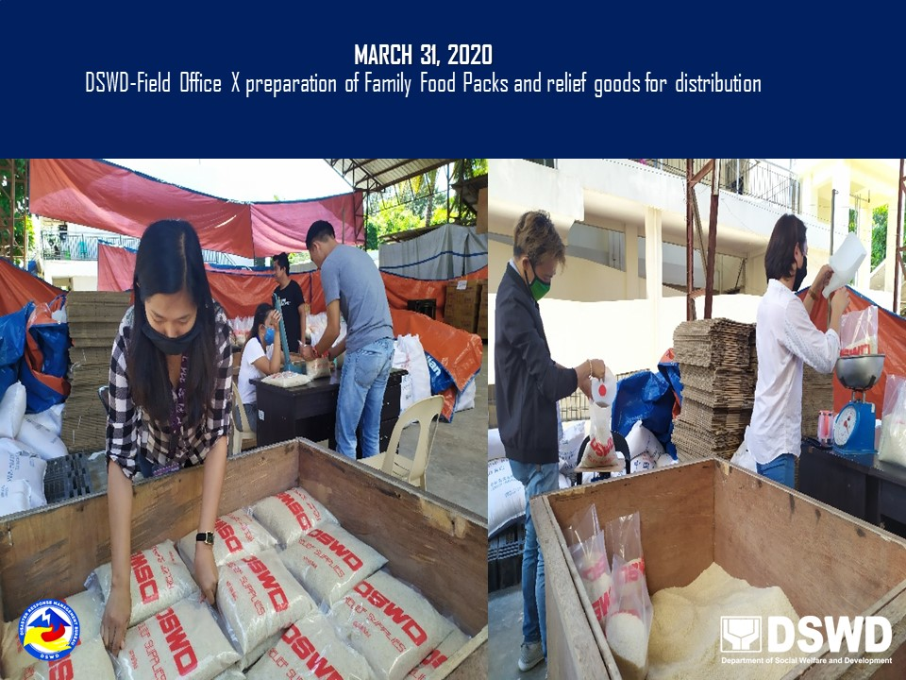

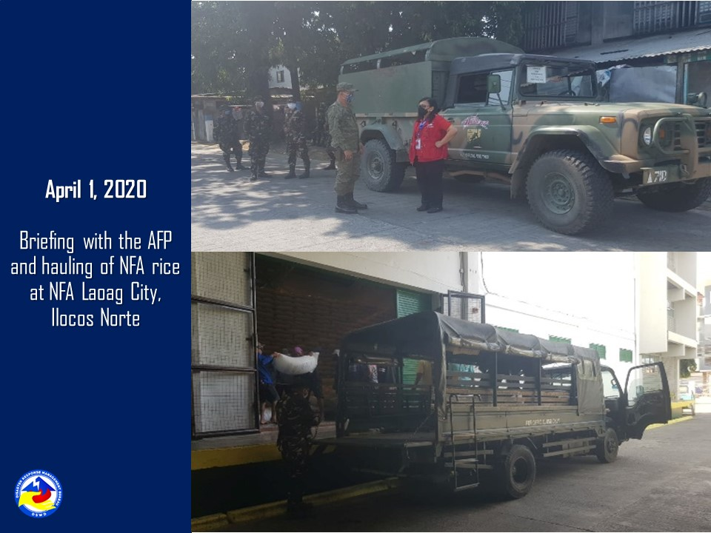

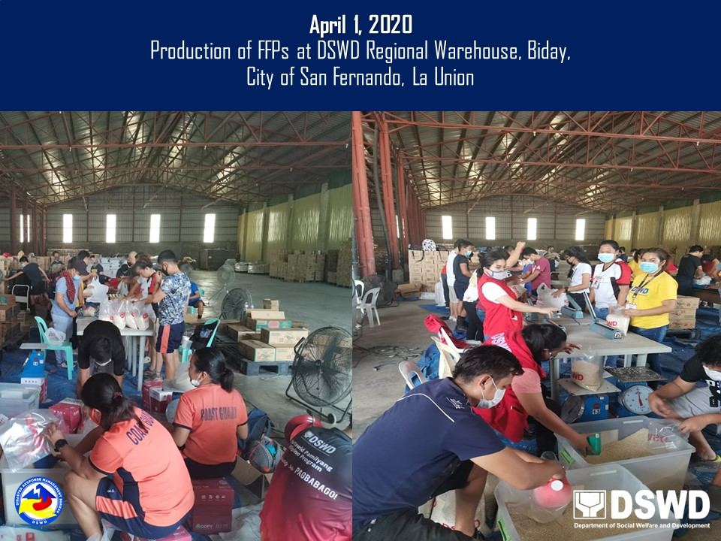

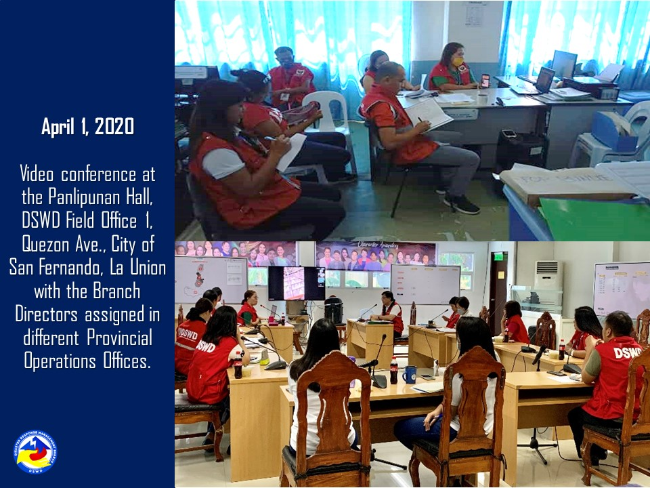

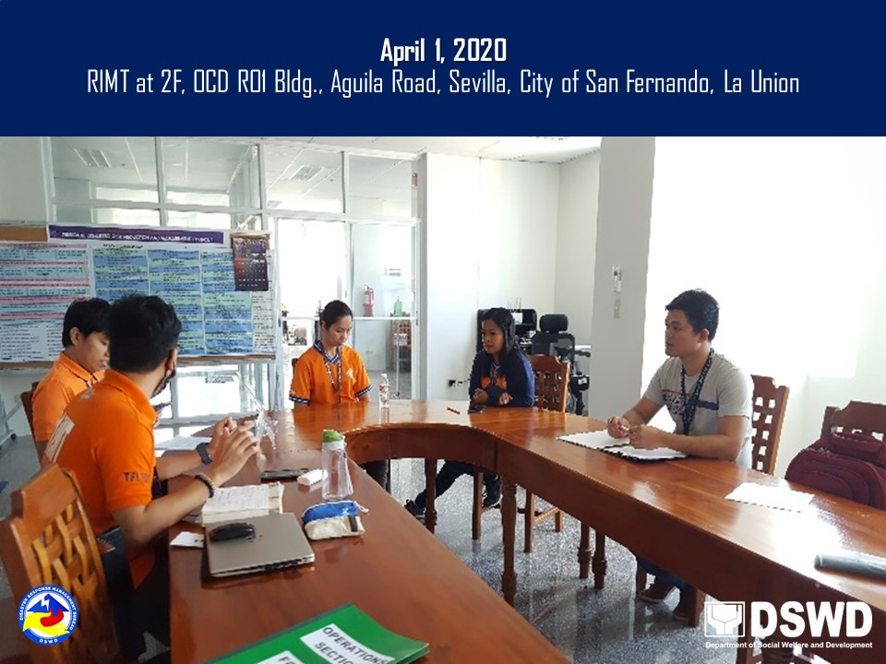

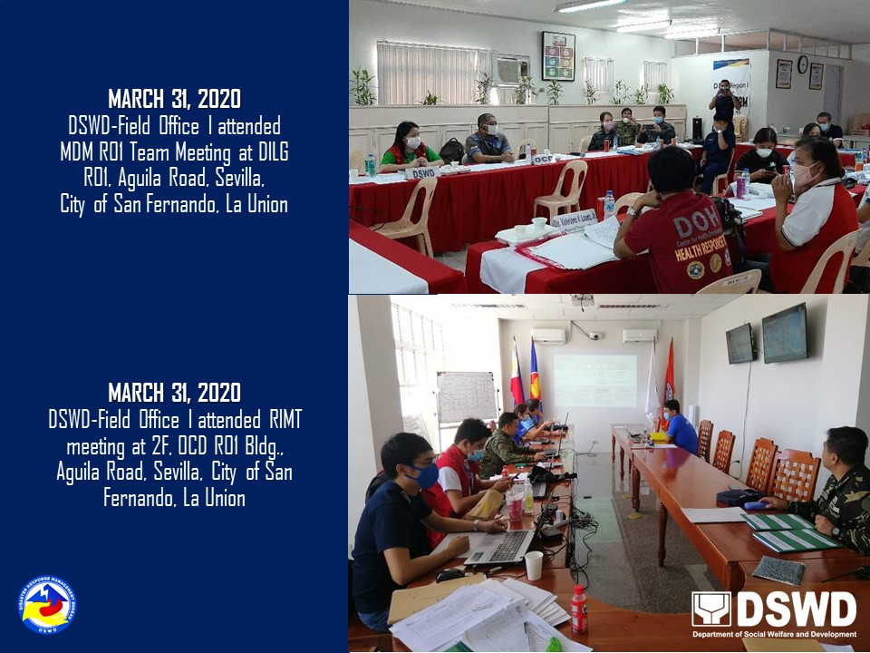

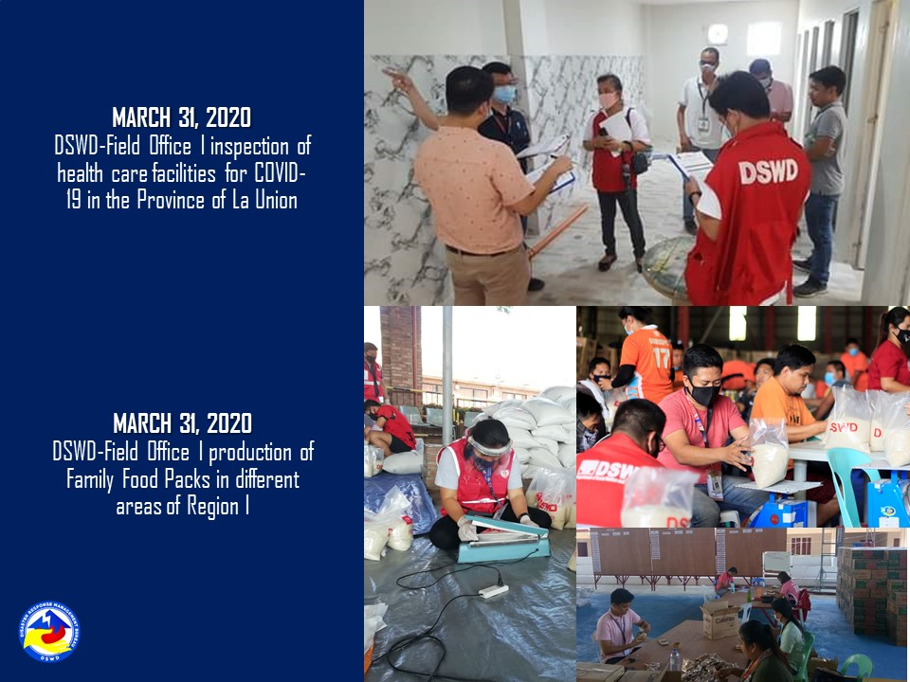

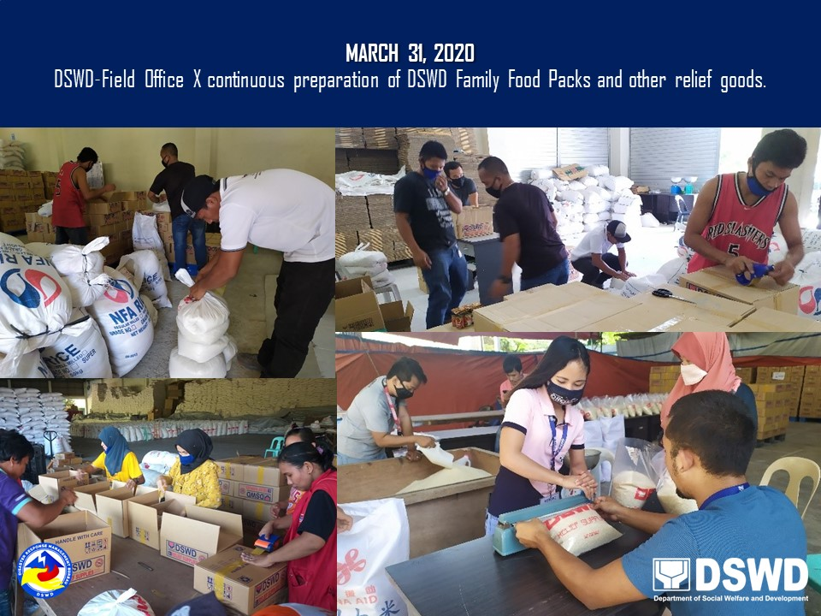

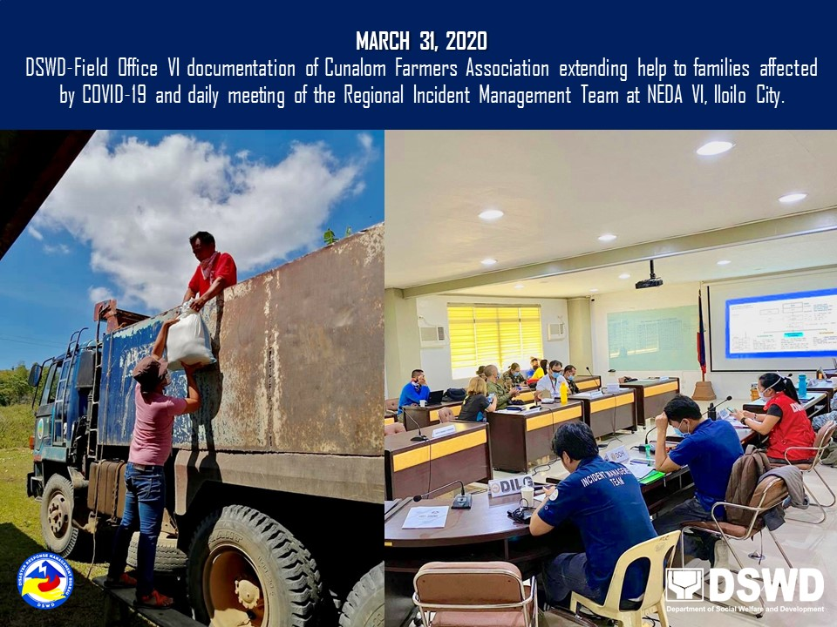

**APRIL2, 2020**

DSWD staffs from four (4) Provincial Action Teams are already conducting orientation on Social Amelioration Program to different LGUs.

