**DSWD DROMIC Report #65 on the Coronavirus Disease (COVID19)**

as of 21 April 2020, 6PM

**Situation Overview**

The coronavirus disease (COVID19) is an infectious disease that was unknown before the outbreak began in Wuhan, China. On 16 March 2020, a Memorandum from the Executive Secretary was issued regarding Community Quarantine over the entire Luzon and Further Guidelines for the Management of the Coronavirus Disease 2019 (COVID19) Situation.

As of **21 April 2020, 4PM**, the Department of Health (DOH) has **confirmed 6,599 COVID19 cases**. Out of these infected, **654** have **recovered** while **437 deaths** were recorded.

*Source: https://ncovtracker.doh.gov.ph/*

1. **Assistance Provided**

A total of **₱7,182,839,426.82** worth of assistance was provided to the families and individuals including strandees affected by community quarantine being implemented due to COVID19; of which, **₱185,459,612.08** was provided by **DSWD**, **₱6,850,036,084.93** from **LGUs**, **₱ 120,297,176.81** from **NGOs** and **₱27,046,553.00** from **Private Partners** (see Table 1).

***Table 1. Cost of Assistance Provided to Affected Families / Persons***

| **REGION / PROVINCE / MUNICIPALITY** | | **COST OF ASSISTANCE** | | | | |
| --- | --- | --- | --- | --- | --- | --- |
| **DSWD** | **LGUs** | **NGOs** | **OTHERS** | **GRAND TOTAL** |
| **GRAND TOTAL** | | **185,459,612.08** | **6,850,036,084.93** | **120,297,176.81** | **27,046,553.00** | **7,182,839,426.82** |
| **NCR** | | **53,963,120.00** | **1,243,851,942.97** | **104,085,000.00** | **-** | **1,401,900,062.97** |
| *Caloocan City* | | 3,788,000.00 | 200,000,000.00 | 42,100,000.00 | - | 245,888,000.00 |
| *Las Pinas* | | 1,800,000.00 | 41,838,500.00 | - | - | 43,638,500.00 |
| *Makati City* | | 1,440,000.00 | 30,306,750.00 | 6,250,000.00 | - | 37,996,750.00 |
| *Malabon City* | | 3,271,500.00 | 1,543,580.00 | 15,000,000.00 | - | 19,815,080.00 |
| *Mandaluyong City* | | 3,072,000.00 | 67,512,250.00 | - | - | 70,584,250.00 |
| *Manila City* | | 6,258,000.00 | - | 13,370,000.00 | - | 19,628,000.00 |
| *Marikina city* | | 3,194,000.00 | 1,032,500.00 | - | - | 4,226,500.00 |
| *Muntinlupa City* | | 2,881,000.00 | 108,868,510.00 | - | - | 111,749,510.00 |
| *Navotas* | | 2,700,000.00 | 44,000,000.00 | 11,915,000.00 | - | 58,615,000.00 |
| *Paranaque City* | | 3,270,000.00 | 260,976,452.97 | - | - | 264,246,452.97 |
| *Pasay City* | | 2,890,000.00 | - | 850,000.00 | - | 3,740,000.00 |
| *Pasig City* | | 2,220,000.00 | 260,000,000.00 | - | - | 262,220,000.00 |
| *Pateros* | | 1,868,000.00 | 11,816,400.00 | - | - | 13,684,400.00 |
| *Taguig City* | | 4,654,120.00 | 165,000,000.00 | 13,750,000.00 | - | 183,404,120.00 |
| *Quezon City* | | 5,150,500.00 | - | 850,000.00 | - | 6,000,500.00 |
| *San Juan City* | | 1,443,000.00 | 18,000,000.00 | - | - | 19,443,000.00 |
| *Valenzuela City* | | 4,063,000.00 | 32,957,000.00 | - | - | 37,020,000.00 |
| **REGION I** | | **13,930,900.00** | **395,007,773.72** | **231,740.03** | **20,808,156.56** | **429,978,570.31** |
| **Ilocos Norte** | | **3,771,400.00** | **59,598,973.00** | **4,000.00** | **-** | **63,374,373.00** |
|  | *Adams* | *143,313.20* | *705,230.00* | *-* | *-* | *848,543.20* |
|  | *Bacarra* | *143,313.20* | *7,264,250.00* | *-* | *-* | *7,407,563.20* |
|  | *Badoc* | *143,313.20* | *7,820,000.00* | *-* | *-* | *7,963,313.20* |
|  | *Bangui* | *143,313.20* | *1,830,600.00* | *-* | *-* | *1,973,913.20* |
|  | *Banna (Espiritu)* | *143,313.20* | *1,823,550.00* | *-* | *-* | *1,966,863.20* |
|  | *CITY OF BATAC* | *377,140.00* | *4,700,250.00* | *-* | *-* | *5,077,390.00* |
|  | *Burgos* | *143,313.20* | *971,160.00* | *-* | *-* | *1,114,473.20* |
|  | *Carasi* | *143,313.20* | *318,288.00* | *4000* | *-* | *465,601.20* |
|  | *Currimao* | *143,313.20* | *630000* | *-* | *-* | *773313* |
|  | *Dingras* | *143,313.20* | *4,709,100.00* | *-* | *-* | *4,852,413.20* |
|  | *Dumalneg* | *143,313.20* | *995,918.00* | *-* | *-* | *1,139,231.20* |
|  | *LAOAG CITY (Capital)* | *150,856.00* | *2,168,100.00* | *-* | *-* | *2,318,956.00* |
|  | *Marcos* | *143,313.20* | *398,260.00* | *-* | *-* | *541,573.20* |
|  | *Nueva Era* | *143,313.20* | *2,398,750.00* | *-* | *-* | *2,542,063.20* |
|  | *Pagudpud* | *143,313.20* | *2,432,192.50* | *-* | *-* | *2,575,505.70* |
|  | *Paoay* | *377,140.00* | *1104219* | *-* | *-* | *1,481,359.00* |
|  | *Pasuquin* | *143,313.20* | *2,265,500.00* | *-* | *-* | *2,408,813.20* |
|  | *Piddig* | *143,313.20* | *6,450,460.00* | *-* | *-* | *6,593,773.20* |
|  | *Pinili* | *143,313.20* | *3,516,497.50* | *-* | *-* | *3,659,810.70* |
|  | *San Nicolas* | *143,313.20* | *2,706,360.00* | *-* | *-* | *2,849,673.20* |
|  | *Sarrat* | *143,313.20* | *2,007,788.00* | *-* | *-* | *2,151,101.20* |
|  | *Solsona* | *143,313.20* | *1,842,500.00* | *-* | *-* | *1,985,813.20* |
|  | *Vintar* | *143,313.20* | *540000* | *-* | *-* | *683313* |
| **Ilocos Sur** | | **377,140.00** | **45,011,819.14** | **-** | **-** | **45,388,959.14** |
|  | *Alilem* | *-* | *320,070.00* | *-* | *-* | *320,070.00* |
|  | *Banayoyo* | *-* | *660,901.25* | *-* | *-* | *660,901.25* |
|  | *Bantay* | *-* | *471,200.00* | *-* | *-* | *471,200.00* |
|  | *Burgos* | *-* | *1,577,419.96* | *-* | *-* | *1,577,419.96* |
|  | *Cabugao* | *-* | *2,732,400.00* | *-* | *-* | *2,732,400.00* |
|  | *CITY OF CANDON* | *-* | *3,894,099.29* | *-* | *-* | *3,894,099.29* |
|  | *Caoayan* | *-* | *990,052.00* | *-* | *-* | *990,052.00* |
|  | *Cervantes* | *-* | *407,400.00* | *-* | *-* | *407,400.00* |
|  | *Galimuyod* | *-* | *1,108,849.10* | *-* | *-* | *1,108,849.10* |
|  | *Gregorio del Pilar (Concepcion)* | *-* | *463,482.00* | *-* | *-* | *463,482.00* |
|  | *Lidlidda* | *-* | *293,581.16* | *-* | *-* | *293,581.16* |
|  | *Magsingal* | *-* | *1,240,155.00* | *-* | *-* | *1,240,155.00* |
|  | *Nagbukel* | *-* | *651,700.00* | *-* | *-* | *651,700.00* |
|  | *Narvacan* | *-* | *1,654,668.00* | *-* | *-* | *1,654,668.00* |
|  | *Quirino (Angkaki)* | *-* | *294,114.00* | *-* | *-* | *294,114.00* |
|  | *Salcedo (Baugen)* | *-* | *605,542.08* | *-* | *-* | *605,542.08* |
|  | *San Emilio* | *-* | *428,419.00* | *-* | *-* | *428,419.00* |
|  | *San Esteban* | *-* | *400,000.04* | *-* | *-* | *400,000.04* |
|  | *San Ildefonso* | *-* | *2,536,523.50* | *-* | *-* | *2,536,523.50* |
|  | *San Juan (Lapog)* | *-* | *877,798.50* | *-* | *-* | *877,798.50* |
|  | *San Vicente* | *-* | *1,076,500.00* | *-* | *-* | *1,076,500.00* |
|  | *Santa* | *-* | *1,907,233.20* | *-* | *-* | *1,907,233.20* |
|  | *Santa Catalina* | *-* | *837,000.00* | *-* | *-* | *837,000.00* |
|  | *Santa Cruz* | *-* | *789,210.00* | *-* | *-* | *789,210.00* |
|  | *Santa Lucia* | *-* | *1,399,813.06* | *-* | *-* | *1,399,813.06* |
|  | *Santa Maria* | *-* | *666,276.48* | *-* | *-* | *666,276.48* |
|  | *Santiago* | *-* | *1,393,707.80* | *-* | *-* | *1,393,707.80* |
|  | *Sigay* | *-* | *480,369.48* | *-* | *-* | *480,369.48* |
|  | *Sinait* | *-* | *3,395,324.31* | *-* | *-* | *3,395,324.31* |
|  | *Sugpon* | *-* | *34,736.00* | *-* | *-* | *34,736.00* |
|  | *Suyo* | *-* | *1,680,000.00* | *-* | *-* | *1,680,000.00* |
|  | *Tagudin* | *377,140.00* | *1,815,210.00* | *-* | *-* | *2,192,350.00* |
|  | *CITY OF VIGAN (Capital)* | *-* | *7,928,063.93* | *-* | *-* | *7,928,063.93* |
| **La Union** | | **3,017,120.00** | **92,402,648.36** | **211,540.00** | **782,235.64** | **96,413,544.00** |
|  | *Agoo* | *377,140.00* | *6,887,410.00* | *-* | *-* | *7,264,550.00* |
|  | *Bacnotan* | *-* | *7,473,058.53* | *-* | *-* | *7,473,058.53* |
|  | *Balaoan* | *-* | *2,044,875.00* | *-* | *-* | *2,044,875.00* |
|  | *Bangar* | *-* | *5,629,101.51* | *-* | *-* | *5,629,101.51* |
|  | *Bauang* | *377,140.00* | *2,748,346.00* | *-* | *-* | *3,125,486.00* |
|  | *Burgos* | *-* | *564,060.00* | *-* | *78,135.00* | *642,195.00* |
|  | *Caba* | *377,140.00* | *1,780,800.00* | *-* | *-* | *2,157,940.00* |
|  | *Luna* | *-* | *4,948,530.00* | *-* | *-* | *4,948,530.00* |
|  | *Naguilian* | *377,140.00* | *-* | *-* | *-* | *377,140.00* |
|  | *Pugo* | *377,140.00* | *138,821.00* | *-* | *-* | *515,961.00* |
|  | *Rosario* | *-* | *12,000,731.60* | *104,200.00* | *-* | *12,104,931.60* |
|  | *CITY OF SAN FERNANDO (Capital)* | *377,140.00* | *36,248,440.00* | *-* | *-* | *36,625,580.00* |
|  | *San Juan* | *377,140.00* | *2,515,376.00* | *-* | *-* | *2,892,516.00* |
|  | *Santo Tomas* | *377,140.00* | *5,563,402.72* | *-* | *704,100.64* | *6,644,643.36* |
|  | *Santol* | *-* | *2,038,281.00* | *-* | *-* | *2,038,281.00* |
|  | *Sudipen* | *-* | *1,236,415.00* | *-* | *-* | *1,236,415.00* |
|  | *Tubao* | *-* | *585,000.00* | *107,340.00* | *-* | *692,340.00* |
| **Pangasinan** | | **6,765,240.00** | **197,994,333.22** | **16,200.03** | **20,025,920.92** | **224,801,694.17** |
|  | *Agno* | *-* | *147,579.00* | *-* | *-* | *147,579.00* |
|  | *Aguilar* | *-* | *2,221,600.00* | *-* | *-* | *2,221,600.00* |
|  | *CITY OF ALAMINOS* | *377,140.00* | *7,421,400.00* | *-* | *-* | *7,798,540.00* |
|  | *Alcala* | *-* | *11,405,000.00* | *-* | *-* | *11,405,000.00* |
|  | *Asingan* | *377,140.00* | *2,934,414.49* | *-* | *1,231,488.72* | *4,543,043.21* |
|  | *Balungao* | *-* | *3,358,873.25* | *-* | *-* | *3,358,873.25* |
|  | *Bani* | *-* | *5,500,000.00* | *-* | *-* | *5,500,000.00* |
|  | *Basista* | *377,140.00* | *3,728,603.99* | *-* | *-* | *4,105,743.99* |
|  | *Bautista* | *-* | *2,484,300.00* | *-* | *-* | *2,484,300.00* |
|  | *Bayambang* | *377,140.00* | *2,466,800.00* | *-* | *-* | *2,843,940.00* |
|  | *Binalonan* | *377,140.00* | *872,915.00* | *-* | *-* | *1,250,055.00* |
|  | *Binmaley* | *-* | *4,775,812.00* | *-* | *2,412,800.00* | *7,188,612.00* |
|  | *Bugallon* | *377,140.00* | *6,624,860.00* | *-* | *216,500.00* | *7,218,500.00* |
|  | *Burgos* | *-* | *1,226,600.00* | *-* | *1,194,840.00* | *2,421,440.00* |
|  | *Calasiao* | *361,000.00* | *6,307,500.00* | *-* | *9,168,520.00* | *15,837,020.00* |
|  | *Dagupan City* | *377,140.00* | *26,117,000.00* | *-* | *-* | *26,494,140.00* |
|  | *Infanta* | *377,140.00* | *-* | *-* | *-* | *377,140.00* |
|  | *Labrador* | *-* | *460,000.00* | *-* | *-* | *460,000.00* |
|  | *Laoac* | *377,140.00* | *2,634,428.90* | *-* | *-* | *3,011,568.90* |
|  | *LINGAYEN (Capital)* | *370,000.00* | *5,635,020.00* | *-* | *-* | *6,005,020.00* |
|  | *Mabini* | *-* | *1,373,600.00* | *-* | *-* | *1,373,600.00* |
|  | *Malasiqui* | *377,140.00* | *373,320.00* | *-* | *-* | *750,460.00* |
|  | *Manaoag* | *-* | *6,256,800.00* | *-* | *-* | *6,256,800.00* |
|  | *Mangaldan* | *-* | *18,340,000.00* | *-* | *-* | *18,340,000.00* |
|  | *Mangatarem* | *-* | *9,450.00* | *-* | *-* | *9,450.00* |
|  | *Mapandan* | *-* | *2,345,400.00* | *-* | *-* | *2,345,400.00* |
|  | *Natividad* | *-* | *584,500.00* | *-* | *-* | *584,500.00* |
|  | *Pozzorubio* | *377,140.00* | *1,324,600.00* | *-* | *-* | *1,701,740.00* |
|  | *Rosales* | *377,140.00* | *6,418,314.57* | *-* | *-* | *6,795,454.57* |
|  | *San Fabian* | *377,140.00* | *1,122,180.00* | *-* | *-* | *1,499,320.00* |
|  | *San Manuel* | *-* | *5,295,671.80* | *-* | *1,861,675.20* | *7,157,347.00* |
|  | *San Nicolas* | *-* | *3,841,200.00* | *-* | *-* | *3,841,200.00* |
|  | *San Quintin* | *-* | *2,028,000.00* | *-* | *-* | *2,028,000.00* |
|  | *Santa Barbara* | *-* | *4,048,000.00* | *-* | *-* | *4,048,000.00* |
|  | *Santa Maria* | *-* | *2,278,900.00* | *-* | *745,000.00* | *3,023,900.00* |
|  | *Santo Tomas* | *377,140.00* | *-* | *-* | *-* | *377,140.00* |
|  | *Sison* | *-* | *500.00* | *-* | *-* | *500.00* |
|  | *Tayug* | *-* | *4,670,833.22* | *16,200.03* | *-* | *4,687,033.25* |
|  | *Umingan* | *-* | *4,876,187.00* | *-* | *2,495,097.00* | *7,371,284.00* |
|  | *Urbiztondo* | *377,140.00* | *1,750,000.00* | *-* | *-* | *2,127,140.00* |
|  | *CITY OF URDANETA* | *377,140.00* | *31,775,750.00* | *-* | *700,000.00* | *32,852,890.00* |
|  | *Villasis* | *-* | *2,958,420.00* | *-* | *-* | *2,958,420.00* |
| **REGION II** | | **3,328,322.06** | **392,675,001.53** | **-** | **-** | **396,003,323.59** |
| **Batanes** | | **6,518.82** | **-** | **-** | **-** | **6,518.82** |
|  | *Basco* | *5,587.56* | *-* | *-* | *-* | *5,587.56* |
|  | *Uyugan* | *931.26* | *-* | *-* | *-* | *931.26* |
| **Cagayan** | | **2,157,163.34** | **75,884,258.01** | **-** | **-** | **78,041,421.35** |
|  | *Abulug* | *1,862.52* | *3,749,302.00* | *-* | *-* | *3,751,164.52* |
|  | *Alcala* | *133,750.00* | *3,047,906.00* | *-* | *-* | *3,181,656.00* |
|  | *Allacapan* | *-* | *1,674,278.00* | *-* | *-* | *1,674,278.00* |
|  | *Amulung* | *1,241.68* | *2,969,125.00* | *-* | *-* | *2,970,366.68* |
|  | *Aparri* | *228,432.80* | *14,693,978.00* | *-* | *-* | *14,922,410.80* |
|  | *Baggao* | *931.26* | *4,532,656.00* | *-* | *-* | *4,533,587.26* |
|  | *Ballesteros* | *931.26* | *865,896.00* | *-* | *-* | *866,827.26* |
|  | *Buguey* | *-* | *911,796.00* | *-* | *-* | *911,796.00* |
|  | *Calayan* | *1,618,661.98* | *1,057,264.00* | *-* | *-* | *2,675,925.98* |
|  | *Camalaniugan* | *-* | *741,510.00* | *-* | *-* | *741,510.00* |
|  | *Claveria* | *-* | *979,206.00* | *-* | *-* | *979,206.00* |
|  | *Enrile* | *-* | *2,114,432.72* | *-* | *-* | *2,114,432.72* |
|  | *Gattaran* | *-* | *5,722,998.00* | *-* | *-* | *5,722,998.00* |
|  | *Gonzaga* | *-* | *2,376,742.00* | *-* | *-* | *2,376,742.00* |
|  | *Iguig* | *-* | *1,236,426.36* | *-* | *-* | *1,236,426.36* |
|  | *Lal-lo* | *-* | *1,319,248.00* | *-* | *-* | *1,319,248.00* |
|  | *Lasam* | *-* | *2,772,318.00* | *-* | *-* | *2,772,318.00* |
|  | *Pamplona* | *-* | *708,706.00* | *-* | *-* | *708,706.00* |
|  | *Peñablanca* | *-* | *4,549,527.64* | *-* | *-* | *4,549,527.64* |
|  | *Piat* | *-* | *4,837,430.60* | *-* | *-* | *4,837,430.60* |
|  | *Rizal* | *-* | *1,315,628.02* | *-* | *-* | *1,315,628.02* |
|  | *Sanchez-Mira* | *-* | *760,144.00* | *-* | *-* | *760,144.00* |
|  | *Santa Ana* | *-* | *1,057,264.00* | *-* | *-* | *1,057,264.00* |
|  | *Santa Praxedes* | *155,210.00* | *132,158.00* | *-* | *-* | *287,368.00* |
|  | *Santa Teresita* | *-* | *445,050.00* | *-* | *-* | *445,050.00* |
|  | *Santo Niño (Faire)* | *-* | *4,607,122.50* | *-* | *-* | *4,607,122.50* |
|  | *Solana* | *-* | *2,157,506.46* | *-* | *-* | *2,157,506.46* |
|  | *Tuao* | *620.84* | *847,501.00* | *-* | *-* | *848,121.84* |
|  | *Tuguegarao City (capital)* | *15,521.00* | *3,701,137.71* | *-* | *-* | *3,716,658.71* |
| **Isabela** | | **390,197.94** | **239,682,281.26** | **-** | **-** | **240,072,479.20** |
|  | *Alicia* | *-* | *4,488,690.00* | *-* | *-* | *4,488,690.00* |
|  | *Angadanan* | *-* | *4,870,990.00* | *-* | *-* | *4,870,990.00* |
|  | *Aurora* | *-* | *970,490.00* | *-* | *-* | *970,490.00* |
|  | *Benito Soliven* | *-* | *1,014,065.00* | *-* | *-* | *1,014,065.00* |
|  | *Burgos* | *-* | *5,646,790.00* | *-* | *-* | *5,646,790.00* |
|  | *Cabagan* | *-* | *6,610,384.00* | *-* | *-* | *6,610,384.00* |
|  | *Cabatuan* | *-* | *2,520,372.67* | *-* | *-* | *2,520,372.67* |
|  | *City of Cauayan* | *310.42* | *72,423,584.00* | *-* | *-* | *72,423,894.42* |
|  | *Cordon* | *-* | *2,919,944.00* | *-* | *-* | *2,919,944.00* |
|  | *Delfin Albano (Magsaysay)* | *-* | *3,430,090.00* | *-* | *-* | *3,430,090.00* |
|  | *Dinapigue* | *-* | *613,696.00* | *-* | *-* | *613,696.00* |
|  | *Divilacan* | *-* | *936,413.16* | *-* | *-* | *936,413.16* |
|  | *Echague* | *-* | *4,272,662.00* | *-* | *-* | *4,272,662.00* |
|  | *Gamu* | *-* | *3,784,460.60* | *-* | *-* | *3,784,460.60* |
|  | *Ilagan (capital)* | *-* | *43,395,550.00* | *-* | *-* | *43,395,550.00* |
|  | *Jones* | *-* | *8,247,662.00* | *-* | *-* | *8,247,662.00* |
|  | *Luna* | *-* | *1,377,555.00* | *-* | *-* | *1,377,555.00* |
|  | *Maconacon* | *388,645.84* | *1,256,542.00* | *-* | *-* | *1,645,187.84* |
|  | *Mallig* | *-* | *4,873,780.00* | *-* | *-* | *4,873,780.00* |
|  | *Naguilian* | *-* | *1,366,859.92* | *-* | *-* | *1,366,859.92* |
|  | *Palanan* | *-* | *515,990.00* | *-* | *-* | *515,990.00* |
|  | *Quezon* | *-* | *774,690.00* | *-* | *-* | *774,690.00* |
|  | *Quirino* | *-* | *761,990.00* | *-* | *-* | *761,990.00* |
|  | *Ramon* | *-* | *7,839,880.00* | *-* | *-* | *7,839,880.00* |
|  | *Reina Mercedes* | *-* | *2,204,079.00* | *-* | *-* | *2,204,079.00* |
|  | *Roxas* | *-* | *1,831,490.00* | *-* | *-* | *1,831,490.00* |
|  | *San Agustin* | *620.84* | *2,813,017.92* | *-* | *-* | *2,813,638.76* |
|  | *San Guillermo* | *-* | *22,644,174.00* | *-* | *-* | *22,644,174.00* |
|  | *San Isidro* | *-* | *4,025,490.00* | *-* | *-* | *4,025,490.00* |
|  | *San Manuel* | *-* | *817,500.00* | *-* | *-* | *817,500.00* |
|  | *San Mariano* | *-* | *1,448,490.00* | *-* | *-* | *1,448,490.00* |
|  | *San Mateo* | *-* | *1,582,990.00* | *-* | *-* | *1,582,990.00* |
|  | *San Pablo* | *620.84* | *737,490.00* | *-* | *-* | *738,110.84* |
|  | *Santa Maria* | *-* | *618,490.00* | *-* | *-* | *618,490.00* |
|  | *City of Santiago* | *-* | *6,546,636.99* | *-* | *-* | *6,546,636.99* |
|  | *Santo Tomas* | *-* | *3,139,529.00* | *-* | *-* | *3,139,529.00* |
|  | *Tumauini* | *-* | *6,359,774.00* | *-* | *-* | *6,359,774.00* |
| **Nueva Vizcaya** | | **-** | **56,703,040.26** | **-** | **-** | **56,703,040.26** |
|  | *Alfonso Castaneda* | *-* | *633,568.16* | *-* | *-* | *633,568.16* |
|  | *Ambaguio* | *-* | *1,209,284.00* | *-* | *-* | *1,209,284.00* |
|  | *Aritao* | *-* | *4,451,225.00* | *-* | *-* | *4,451,225.00* |
|  | *Bagabag* | *-* | *3,111,493.00* | *-* | *-* | *3,111,493.00* |
|  | *Bambang* | *-* | *7,207,244.00* | *-* | *-* | *7,207,244.00* |
|  | *Bayombong (capital)* | *-* | *7,758,400.00* | *-* | *-* | *7,758,400.00* |
|  | *Diadi* | *-* | *3,653,282.00* | *-* | *-* | *3,653,282.00* |
|  | *Dupax del Norte* | *-* | *4,699,282.00* | *-* | *-* | *4,699,282.00* |
|  | *Dupax del Sur* | *-* | *4,033,372.00* | *-* | *-* | *4,033,372.00* |
|  | *Kasibu* | *-* | *4,811,740.78* | *-* | *-* | *4,811,740.78* |
|  | *Kayapa* | *-* | *3,107,243.00* | *-* | *-* | *3,107,243.00* |
|  | *Quezon* | *-* | *2,248,584.06* | *-* | *-* | *2,248,584.06* |
|  | *Santa Fe* | *-* | *2,573,924.50* | *-* | *-* | *2,573,924.50* |
|  | *Solano* | *-* | *3,929,529.10* | *-* | *-* | *3,929,529.10* |
|  | *Villaverde* | *-* | *3,274,868.66* | *-* | *-* | *3,274,868.66* |
| **Quirino** | | **774,441.96** | **20,405,422.00** | **-** | **-** | **21,179,863.96** |
|  | *PLGU Quirino* | *774,441.96* | *-* | *-* | *-* | *774,441.96* |
|  | *Aglipay* | *-* | *4,852,771.00* | *-* | *-* | *4,852,771.00* |
|  | *Cabarroguis (capital)* | *-* | *4,647,577.50* | *-* | *-* | *4,647,577.50* |
|  | *Diffun* | *-* | *3,032,197.50* | *-* | *-* | *3,032,197.50* |
|  | *Maddela* | *-* | *2,071,680.00* | *-* | *-* | *2,071,680.00* |
|  | *Nagtipunan* | *-* | *3,990,996.00* | *-* | *-* | *3,990,996.00* |
|  | *Saguday* | *-* | *1,810,200.00* | *-* | *-* | *1,810,200.00* |
| **REGION III** | | **8,224,671.30** | **689,427,317.36** | **-** | **-** | **697,651,988.66** |
| **Aurora** | | **343,750.00** | **25,073,148.48** | **-** | **-** | **25,416,898.48** |
|  | *PLGU Aurora* | *-* | *210,111.50* | *-* | *-* | *210,111.50* |
|  | *Baler (capital)* | *150,750.00* | *3,885,400.00* | *-* | *-* | *4,036,150.00* |
|  | *Casiguran* | *-* | *2,372,490.00* | *-* | *-* | *2,372,490.00* |
|  | *Dilasag* | *-* | *1,867,427.40* | *-* | *-* | *1,867,427.40* |
|  | *Dinalungan* | *-* | *1,319,964.00* | *-* | *-* | *1,319,964.00* |
|  | *Dingalan* | *193,000.00* | *4,187,082.69* | *-* | *-* | *4,380,082.69* |
|  | *Dipaculao* | *-* | *4,346,962.04* | *-* | *-* | *4,346,962.04* |
|  | *Maria Aurora* | *-* | *3,058,355.00* | *-* | *-* | *3,058,355.00* |
|  | *San Luis* | *-* | *3,825,355.85* | *-* | *-* | *3,825,355.85* |
| **Bataan** | | **785,925.20** | **14,783,762.30** | **-** | **-** | **15,569,687.50** |
|  | *Abucay* | *74,504.00* | *-* | *-* | *-* | *74,504.00* |
|  | *Bagac* | *-* | *2,631,375.00* | *-* | *-* | *2,631,375.00* |
|  | *City of Balanga (capital)* | *-* | *8,606,000.00* | *-* | *-* | *8,606,000.00* |
|  | *Dinalupihan* | *250,768.00* | *-* | *-* | *-* | *250,768.00* |
|  | *Hermosa* | *-* | *1,362,897.30* | *-* | *-* | *1,362,897.30* |
|  | *Limay* | *118,219.20* | *-* | *-* | *-* | *118,219.20* |
|  | *Morong* | *-* | *2,183,490.00* | *-* | *-* | *2,183,490.00* |
|  | *Orani* | *142,434.00* | *-* | *-* | *-* | *142,434.00* |
|  | *Orion* | *200,000.00* | *-* | *-* | *-* | *200,000.00* |
| **Bulacan** | | **2,794,972.60** | **261,894,782.68** | **-** | **-** | **264,689,755.28** |
|  | *Angat* | *-* | *5,285,280.00* | *-* | *-* | *5,285,280.00* |
|  | *Balagtas (Bigaa)* | *-* | *9,543,750.00* | *-* | *-* | *9,543,750.00* |
|  | *Baliuag* | *291,353.60* | *23,043,000.00* | *-* | *-* | *23,334,353.60* |
|  | *Bocaue* | *-* | *5,572,000.00* | *-* | *-* | *5,572,000.00* |
|  | *Bulacan* | *-* | *10,251,500.00* | *-* | *-* | *10,251,500.00* |
|  | *Bustos* | *-* | *6,250,885.68* | *-* | *-* | *6,250,885.68* |
|  | *Calumpit* | *153,616.00* | *14,743,000.00* | *-* | *-* | *14,896,616.00* |
|  | *Doña Remedios Trinidad* | *-* | *1,749,440.00* | *-* | *-* | *1,749,440.00* |
|  | *Guiguinto* | *-* | *10,240,000.00* | *-* | *-* | *10,240,000.00* |
|  | *Hagonoy* | *-* | *22,249,826.00* | *-* | *-* | *22,249,826.00* |
|  | *City of Malolos (capital)* | *235,074.00* | *7,700,000.00* | *-* | *-* | *7,935,074.00* |
|  | *Marilao* | *-* | *14,061,600.00* | *-* | *-* | *14,061,600.00* |
|  | *City of Meycauayan* | *298,182.20* | *19,242,800.00* | *-* | *-* | *19,540,982.20* |
|  | *Norzagaray* | *-* | *1,549,219.00* | *-* | *-* | *1,549,219.00* |
|  | *Obando* | *136,572.00* | *5,000,000.00* | *-* | *-* | *5,136,572.00* |
|  | *Pandi* | *154,400.00* | *21,861,000.00* | *-* | *-* | *22,015,400.00* |
|  | *Paombong* | *-* | *2,550,000.00* | *-* | *-* | *2,550,000.00* |
|  | *Plaridel* | *-* | *15,461,820.00* | *-* | *-* | *15,461,820.00* |
|  | *Pulilan* | *150,460.80* | *10,826,000.00* | *-* | *-* | *10,976,460.80* |
|  | *San Ildefonso* | *-* | *19,984,181.00* | *-* | *-* | *19,984,181.00* |
|  | *City of San Jose del Monte* | *736,242.00* | *18,897,120.00* | *-* | *-* | *19,633,362.00* |
|  | *San Miguel* | *639,072.00* | *199,361.00* | *-* | *-* | *838,433.00* |
|  | *San Rafael* | *-* | *11,111,000.00* | *-* | *-* | *11,111,000.00* |
|  | *Santa Maria* | *-* | *4,522,000.00* | *-* | *-* | *4,522,000.00* |
| **Nueva Ecija** | | **1,571,027.50** | **147,549,437.25** | **-** | **-** | **149,120,464.75** |
|  | *Aliaga* | *249,860.00* | *-* | *-* | *-* | *249,860.00* |
|  | *Bongabon* | *-* | *4,409,575.25* | *-* | *-* | *4,409,575.25* |
|  | *Cabanatuan City* | *-* | *47,997,200.00* | *-* | *-* | *47,997,200.00* |
|  | *Cabiao* | *343,207.50* | *17,647,200.00* | *-* | *-* | *17,990,407.50* |
|  | *Carranglan* | *-* | *100,000.00* | *-* | *-* | *100,000.00* |
|  | *Cuyapo* | *-* | *4,434,740.00* | *-* | *-* | *4,434,740.00* |
|  | *Gabaldon (Bitulok & Sabani)* | *-* | *2,738,270.00* | *-* | *-* | *2,738,270.00* |
|  | *General Mamerto Natividad* | *-* | *2,419,550.00* | *-* | *-* | *2,419,550.00* |
|  | *General Tinio (Papaya)* | *289,500.00* | *1,299,550.00* | *-* | *-* | *1,589,050.00* |
|  | *Jaen* | *-* | *2,803,200.00* | *-* | *-* | *2,803,200.00* |
|  | *Laur* | *-* | *2,500,000.00* | *-* | *-* | *2,500,000.00* |
|  | *Licab* | *153,760.00* | *-* | *-* | *-* | *153,760.00* |
|  | *Palayan City (capital)* | *-* | *4,200,000.00* | *-* | *-* | *4,200,000.00* |
|  | *Pantabangan* | *-* | *463,750.00* | *-* | *-* | *463,750.00* |
|  | *Peñaranda* | *-* | *8,646,456.00* | *-* | *-* | *8,646,456.00* |
|  | *Rizal* | *341,700.00* | *-* | *-* | *-* | *341,700.00* |
|  | *San Antonio* | *-* | *4,054,380.00* | *-* | *-* | *4,054,380.00* |
|  | *San Isidro* | *-* | *912,800.00* | *-* | *-* | *912,800.00* |
|  | *San Jose City* | *-* | *1,209,222.00* | *-* | *-* | *1,209,222.00* |
|  | *San Leonardo* | *-* | *3,450,000.00* | *-* | *-* | *3,450,000.00* |
|  | *Santa Rosa* | *-* | *10,404,240.00* | *-* | *-* | *10,404,240.00* |
|  | *Science City of Muñoz* | *-* | *9,404,199.00* | *-* | *-* | *9,404,199.00* |
|  | *Talavera* | *-* | *17,190,000.00* | *-* | *-* | *17,190,000.00* |
|  | *Talugtug* | *-* | *72,225.00* | *-* | *-* | *72,225.00* |
|  | *Zaragoza* | *193,000.00* | *1,192,880.00* | *-* | *-* | *1,385,880.00* |
| **Pampanga** | | **1,506,614.00** | **78,125,216.65** | **-** | **-** | **79,631,830.65** |
|  | *Apalit* | *-* | *1,958,100.00* | *-* | *-* | *1,958,100.00* |
|  | *Floridablanca* | *1,025,400.00* | *596,070.00* | *-* | *-* | *1,621,470.00* |
|  | *Guagua* | *-* | *948,000.00* | *-* | *-* | *948,000.00* |
|  | *Masantol* | *230,640.00* | *5,346,260.00* | *-* | *-* | *5,576,900.00* |
|  | *Mexico* | *-* | *5,392,223.00* | *-* | *-* | *5,392,223.00* |
|  | *Minalin* | *-* | *4,815,700.00* | *-* | *-* | *4,815,700.00* |
|  | *Porac* | *-* | *15,529,050.00* | *-* | *-* | *15,529,050.00* |
|  | *City of San Fernando (capital)* | *-* | *26,869,000.00* | *-* | *-* | *26,869,000.00* |
|  | *San Simon* | *159,526.00* | *9,653,289.59* | *-* | *-* | *9,812,815.59* |
|  | *Santa Ana* | *-* | *2,400,000.00* | *-* | *-* | *2,400,000.00* |
|  | *Santa Rita* | *-* | *2,976,050.00* | *-* | *-* | *2,976,050.00* |
|  | *Santo Tomas* | *91,048.00* | *1,641,474.06* | *-* | *-* | *1,732,522.06* |
| **Tarlac** | | **920,192.00** | **152,863,850.00** | **-** | **-** | **153,784,042.00** |
|  | *Anao* | *86,048.00* | *1,032,500.00* | *-* | *-* | *1,118,548.00* |
|  | *Bamban* | *172,096.00* | *2,253,500.00* | *-* | *-* | *2,425,596.00* |
|  | *Camiling* | *288,000.00* | *13,800,000.00* | *-* | *-* | *14,088,000.00* |
|  | *Capas* | *-* | *9,281,000.00* | *-* | *-* | *9,281,000.00* |
|  | *Concepcion* | *-* | *23,382,000.00* | *-* | *-* | *23,382,000.00* |
|  | *Gerona* | *288,000.00* | *25,276,250.00* | *-* | *-* | *25,564,250.00* |
|  | *La Paz* | *-* | *3,320,000.00* | *-* | *-* | *3,320,000.00* |
|  | *Mayantoc* | *-* | *2,506,000.00* | *-* | *-* | *2,506,000.00* |
|  | *Moncada* | *-* | *1,610,500.00* | *-* | *-* | *1,610,500.00* |
|  | *Paniqui* | *-* | *7,200,000.00* | *-* | *-* | *7,200,000.00* |
|  | *Pura* | *-* | *1,052,000.00* | *-* | *-* | *1,052,000.00* |
|  | *Ramos* | *86,048.00* | *1,670,700.00* | *-* | *-* | *1,756,748.00* |
|  | *San Clemente* | *-* | *621,300.00* | *-* | *-* | *621,300.00* |
|  | *San Manuel* | *-* | *1,952,500.00* | *-* | *-* | *1,952,500.00* |
|  | *Santa Ignacia* | *-* | *7,500,600.00* | *-* | *-* | *7,500,600.00* |
|  | *City of Tarlac (capital)* | *-* | *50,000,000.00* | *-* | *-* | *50,000,000.00* |
|  | *Victoria* | *-* | *405,000.00* | *-* | *-* | *405,000.00* |
| **Zambales** | | **302,190.00** | **9,137,120.00** | **-** | **-** | **9,439,310.00** |
|  | *Candelaria* | *-* | *1,537,120.00* | *-* | *-* | *1,537,120.00* |
|  | *Castillejos* | *-* | *2,800,000.00* | *-* | *-* | *2,800,000.00* |
|  | *Olongapo City* | *302,190.00* | *2,000,000.00* | *-* | *-* | *2,302,190.00* |
|  | *San Felipe* | *-* | *500,000.00* | *-* | *-* | *500,000.00* |
|  | *San Marcelino* | *-* | *2,300,000.00* | *-* | *-* | *2,300,000.00* |
| **CALABARZON** | | **13,265,700.00** | **3,167,949,131.36** | **12,507,076.80** | **-** | **3,193,721,908.16** |
| **Batangas** | | **885,460.00** | **961,981,621.88** | **4,753,000.00** | **-** | **967,620,081.88** |
| PLGU Batangas | | *-* | *262,101,336.82* | *-* | *-* | *262,101,336.82* |
|  | Agoncillo | *-* | *6,835,190.00* | *-* | *-* | *6,835,190.00* |
|  | Alitagtag | *-* | *3,300,000.00* | *-* | *-* | *3,300,000.00* |
|  | *Balayan* | *-* | *13,522,960.00* | *-* | *-* | *13,522,960.00* |
|  | *Balete* | *321,600.00* | *6,674,266.68* | *1,533,000.00* | *-* | *8,528,866.68* |
|  | *Batangas City (capital)* | *511,500.00* | *186,254,060.00* | *-* | *-* | *186,765,560.00* |
|  | *Bauan* | *-* | *11,500,000.00* | *-* | *-* | *11,500,000.00* |
|  | *Calaca* | *-* | *40,998,861.17* | *-* | *-* | *40,998,861.17* |
|  | *Calatagan* | *-* | *4,551,915.00* | *-* | *-* | *4,551,915.00* |
|  | *Cuenca* | *-* | *10,129,803.99* | *-* | *-* | *10,129,803.99* |
|  | *Ibaan* | *-* | *3,637,250.00* | *-* | *-* | *3,637,250.00* |
|  | *Laurel* | *-* | *3,220,000.00* | *3,220,000.00* | *-* | *6,440,000.00* |
|  | *Lemery* | *-* | *19,175,614.30* | *-* | *-* | *19,175,614.30* |
|  | *Lian* | *-* | *7,981,879.43* | *-* | *-* | *7,981,879.43* |
|  | *Lipa City* | *52,360.00* | *92,837,549.00* | *-* | *-* | *92,889,909.00* |
|  | *Lobo* | *-* | *1,232,695.00* | *-* | *-* | *1,232,695.00* |
|  | *Mabini* | *-* | *14,462,754.00* | *-* | *-* | *14,462,754.00* |
|  | *Malvar* | *-* | *7,683,954.00* | *-* | *-* | *7,683,954.00* |
|  | *Mataas Na Kahoy* | *-* | *7,282,516.74* | *-* | *-* | *7,282,516.74* |
|  | *Nasugbu* | *-* | *2,353,176.72* | *-* | *-* | *2,353,176.72* |
|  | *Padre Garcia* | *-* | *4,664,100.00* | *-* | *-* | *4,664,100.00* |
|  | *Rosario* | *-* | *2,808,500.00* | *-* | *-* | *2,808,500.00* |
|  | *San Jose* | *-* | *5,889,018.20* | *-* | *-* | *5,889,018.20* |
|  | *San Juan* | *-* | *11,952,801.17* | *-* | *-* | *11,952,801.17* |
|  | *San Luis* | *-* | *2,161,250.00* | *-* | *-* | *2,161,250.00* |
|  | *San Nicolas* | *-* | *8,113,466.54* | *-* | *-* | *8,113,466.54* |
|  | *San Pascual* | *-* | *3,484,855.13* | *-* | *-* | *3,484,855.13* |
|  | *Santa Teresita* | *-* | *4,155,178.18* | *-* | *-* | *4,155,178.18* |
|  | *Santo Tomas* | *-* | *74,987,750.00* | *-* | *-* | *74,987,750.00* |
|  | *Taal* | *-* | *8,289,041.25* | *-* | *-* | *8,289,041.25* |
|  | *Talisay* | *-* | *10,753,000.00* | *-* | *-* | *10,753,000.00* |
|  | *City of Tanauan* | *-* | *95,930,820.00* | *-* | *-* | *95,930,820.00* |
|  | *Taysan* | *-* | *7,147,215.13* | *-* | *-* | *7,147,215.13* |
|  | *Tingloy* | *-* | *3,856,066.01* | *-* | *-* | *3,856,066.01* |
|  | *Tuy* | *-* | *12,052,777.42* | *-* | *-* | *12,052,777.42* |
| **Cavite** | | **8,602,000.00** | **946,332,895.49** | **7,754,076.80** | **-** | **962,688,972.29** |
| PLGU Cavite | | *-* | *129,183,840.80* | *7,754,076.80* | *-* | *136,937,917.60* |
|  | *Alfonso* | *374,000.00* | *11,580,157.09* | *-* | *-* | *11,954,157.09* |
|  | *Amadeo* | *374,000.00* | *12,654,927.93* | *-* | *-* | *13,028,927.93* |
|  | *Bacoor* | *374,000.00* | *92,894,705.35* | *-* | *-* | *93,268,705.35* |
|  | *Carmona* | *374,000.00* | *39,704,592.44* | *-* | *-* | *40,078,592.44* |
|  | *Cavite City* | *374,000.00* | *19,281,917.41* | *-* | *-* | *19,655,917.41* |
|  | *Dasmariñas* | *374,000.00* | *180,871,000.00* | *-* | *-* | *181,245,000.00* |
|  | *Gen. Mariano Alvarez* | *374,000.00* | *22,700,000.00* | *-* | *-* | *23,074,000.00* |
|  | *General Emilio Aguinaldo* | *374,000.00* | *1,609,996.13* | *-* | *-* | *1,983,996.13* |
|  | *General Trias* | *374,000.00* | *56,919,960.00* | *-* | *-* | *57,293,960.00* |
|  | *Imus* | *374,000.00* | *111,228,088.37* | *-* | *-* | *111,602,088.37* |
|  | *Indang* | *374,000.00* | *16,706,355.00* | *-* | *-* | *17,080,355.00* |
|  | *Kawit* | *374,000.00* | *29,546,761.34* | *-* | *-* | *29,920,761.34* |
|  | *Magallanes* | *374,000.00* | *2,881,612.93* | *-* | *-* | *3,255,612.93* |
|  | *Maragondon* | *374,000.00* | *2,011,936.18* | *-* | *-* | *2,385,936.18* |
|  | *Mendez (MENDEZ-NUÑEZ)* | *374,000.00* | *8,000,000.00* | *-* | *-* | *8,374,000.00* |
|  | *Naic* | *374,000.00* | *17,724,000.00* | *-* | *-* | *18,098,000.00* |
|  | *Noveleta* | *374,000.00* | *7,489,888.37* | *-* | *-* | *7,863,888.37* |
|  | *Rosario* | *374,000.00* | *9,544,238.00* | *-* | *-* | *9,918,238.00* |
|  | *Silang* | *374,000.00* | *12,625,780.00* | *-* | *-* | *12,999,780.00* |
|  | *Tagaytay City* | *374,000.00* | *108,886,300.00* | *-* | *-* | *109,260,300.00* |
|  | *Tanza* | *374,000.00* | *10,256,167.15* | *-* | *-* | *10,630,167.15* |
|  | *Ternate* | *374,000.00* | *4,958,117.60* | *-* | *-* | *5,332,117.60* |
|  | *Trece Martires City (capital)* | *374,000.00* | *37,072,553.40* | *-* | *-* | *37,446,553.40* |
| **Laguna** | | **1,143,360.00** | **534,333,445.55** | **-** | **-** | **535,476,805.55** |
| PLGU Laguna | | *-* | *123,479,297.56* | *-* | *-* | *123,479,297.56* |
|  | *Alaminos* | *-* | *4,015,243.10* | *-* | *-* | *4,015,243.10* |
|  | *Bay* | *-* | *14,408,372.72* | *-* | *-* | *14,408,372.72* |
|  | *Biñan* | *181,210.00* | *27,000,000.00* | *-* | *-* | *27,181,210.00* |
|  | *Cabuyao* | *-* | *17,244,000.00* | *-* | *-* | *17,244,000.00* |
|  | *City of Calamba* | *-* | *89,997,321.00* | *-* | *-* | *89,997,321.00* |
|  | *Calauan* | *-* | *15,174,208.25* | *-* | *-* | *15,174,208.25* |
|  | *Cavinti* | *-* | *95,000.00* | *-* | *-* | *95,000.00* |
|  | *Famy* | *-* | *2,162,005.86* | *-* | *-* | *2,162,005.86* |
|  | *Kalayaan* | *-* | *6,705,743.21* | *-* | *-* | *6,705,743.21* |
|  | *Liliw* | *-* | *5,126,151.06* | *-* | *-* | *5,126,151.06* |
|  | *Los Baños* | *56,100.00* | *675,600.00* | *-* | *-* | *731,700.00* |
|  | *Luisiana* | *-* | *2,667,550.80* | *-* | *-* | *2,667,550.80* |
|  | *Lumban* | *-* | *4,634,009.31* | *-* | *-* | *4,634,009.31* |
|  | *Mabitac* | *-* | *1,026,693.79* | *-* | *-* | *1,026,693.79* |
|  | *Magdalena* | *-* | *4,718,826.34* | *-* | *-* | *4,718,826.34* |
|  | *Majayjay* | *-* | *3,672,848.78* | *-* | *-* | *3,672,848.78* |
|  | *Nagcarlan* | *-* | *7,769,000.00* | *-* | *-* | *7,769,000.00* |
|  | *Paete* | *181,210.00* | *1,646,785.50* | *-* | *-* | *1,827,995.50* |
|  | *Pagsanjan* | *-* | *12,579,749.82* | *-* | *-* | *12,579,749.82* |
|  | *Pakil* | *-* | *3,900,000.00* | *-* | *-* | *3,900,000.00* |
|  | *Pangil* | *-* | *2,256,076.00* | *-* | *-* | *2,256,076.00* |
|  | *Pila* | *362,420.00* | *3,856,876.50* | *-* | *-* | *4,219,296.50* |
|  | *Rizal* | *181,210.00* | *3,256,353.22* | *-* | *-* | *3,437,563.22* |
|  | *San Pablo City* | *-* | *23,093,060.11* | *-* | *-* | *23,093,060.11* |
|  | *San Pedro* | *-* | *56,439,800.00* | *-* | *-* | *56,439,800.00* |
|  | *Santa Cruz (capital)* | *-* | *20,077,217.00* | *-* | *-* | *20,077,217.00* |
|  | *Santa Maria* | *-* | *4,992,341.00* | *-* | *-* | *4,992,341.00* |
|  | *City of Santa Rosa* | *181,210.00* | *59,859,000.00* | *-* | *-* | *60,040,210.00* |
|  | *Siniloan* | *-* | *8,122,740.78* | *-* | *-* | *8,122,740.78* |
|  | *Victoria* | *-* | *3,681,573.84* | *-* | *-* | *3,681,573.84* |
| **Quezon** | | **1,914,880.00** | **372,015,375.36** | **-** | **-** | **373,930,255.36** |
| PLGU Quezon | | *-* | *32,611,638.34* | *-* | *-* | *32,611,638.34* |
|  | *Agdangan* | *-* | *2,508,295.33* | *-* | *-* | *2,508,295.33* |
|  | *Alabat* | *-* | *3,200,000.00* | *-* | *-* | *3,200,000.00* |
|  | *Atimonan* | *-* | *10,824,930.65* | *-* | *-* | *10,824,930.65* |
|  | *Buenavista* | *-* | *3,265,879.19* | *-* | *-* | *3,265,879.19* |
|  | *Burdeos* | *374,000.00* | *1,240,658.28* | *-* | *-* | *1,614,658.28* |
|  | *Calauag* | *-* | *13,823,251.30* | *-* | *-* | *13,823,251.30* |
|  | *Candelaria* | *-* | *8,550,980.70* | *-* | *-* | *8,550,980.70* |
|  | *Catanauan* | *-* | *7,000,000.00* | *-* | *-* | *7,000,000.00* |
|  | *Dolores* | *-* | *13,305,450.20* | *-* | *-* | *13,305,450.20* |
|  | *General Luna* | *-* | *19,300,000.00* | *-* | *-* | *19,300,000.00* |
|  | *General Nakar* | *-* | *6,270,199.81* | *-* | *-* | *6,270,199.81* |
|  | *Guinayangan* | *-* | *2,547,830.68* | *-* | *-* | *2,547,830.68* |
|  | *Gumaca* | *-* | *10,284,623.00* | *-* | *-* | *10,284,623.00* |
|  | *Infanta* | *-* | *7,750,981.06* | *-* | *-* | *7,750,981.06* |
|  | *Jomalig* | *374,000.00* | *854,866.50* | *-* | *-* | *1,228,866.50* |
|  | *Lopez* | *-* | *26,674,999.57* | *-* | *-* | *26,674,999.57* |
|  | *Lucban* | *-* | *10,114,882.92* | *-* | *-* | *10,114,882.92* |
|  | *Lucena City (capital)* | *44,880.00* | *30,977,600.00* | *-* | *-* | *31,022,480.00* |
|  | *Macalelon* | *-* | *2,357,259.12* | *-* | *-* | *2,357,259.12* |
|  | *Mauban* | *-* | *7,431,555.00* | *-* | *-* | *7,431,555.00* |
|  | *Mulanay* | *-* | *5,504,725.44* | *-* | *-* | *5,504,725.44* |
|  | *Padre Burgos* | *-* | *6,999,273.24* | *-* | *-* | *6,999,273.24* |
|  | *Pagbilao* | *-* | *9,180,144.61* | *-* | *-* | *9,180,144.61* |
|  | *Panukulan* | *374,000.00* | *3,232,996.92* | *-* | *-* | *3,606,996.92* |
|  | *Patnanungan* | *374,000.00* | *1,498,140.30* | *-* | *-* | *1,872,140.30* |
|  | *Perez* | *-* | *5,539,786.82* | *-* | *-* | *5,539,786.82* |
|  | *Pitogo* | *-* | *4,548,433.62* | *-* | *-* | *4,548,433.62* |
|  | *Plaridel* | *-* | *4,701,454.16* | *-* | *-* | *4,701,454.16* |
|  | *Polillo* | *374,000.00* | *2,426,615.00* | *-* | *-* | *2,800,615.00* |
|  | *Quezon* | *-* | *4,161,423.77* | *-* | *-* | *4,161,423.77* |
|  | *Real* | *-* | *3,821,250.00* | *-* | *-* | *3,821,250.00* |
|  | *Sampaloc* | *-* | *14,248,040.00* | *-* | *-* | *14,248,040.00* |
|  | *San Andres* | *-* | *7,092,398.61* | *-* | *-* | *7,092,398.61* |
|  | *San Antonio* | *-* | *8,128,425.00* | *-* | *-* | *8,128,425.00* |
|  | *San Francisco (Aurora)* | *-* | *3,058,941.74* | *-* | *-* | *3,058,941.74* |
|  | *San Narciso* | *-* | *7,219,516.13* | *-* | *-* | *7,219,516.13* |
|  | *Sariaya* | *-* | *20,583,000.00* | *-* | *-* | *20,583,000.00* |
|  | *Tagkawayan* | *-* | *8,348,475.20* | *-* | *-* | *8,348,475.20* |
|  | *City of Tayabas* | *-* | *14,608,843.00* | *-* | *-* | *14,608,843.00* |
|  | *Tiaong* | *-* | *10,000,000.00* | *-* | *-* | *10,000,000.00* |
|  | *Unisan* | *-* | *6,217,610.15* | *-* | *-* | *6,217,610.15* |
| **Rizal** | | **720,000.00** | **353,285,793.08** | **-** | **-** | **354,005,793.08** |
| PLGU Rizal | | *-* | *62,574,350.00* | *-* | *-* | *62,574,350.00* |
|  | *Angono* | *-* | *15,509,770.00* | *-* | *-* | *15,509,770.00* |
|  | *City of Antipolo* | *-* | *47,784,000.00* | *-* | *-* | *47,784,000.00* |
|  | *Baras* | *-* | *15,931,270.70* | *-* | *-* | *15,931,270.70* |
|  | *Binangonan* | *-* | *10,467,716.00* | *-* | *-* | *10,467,716.00* |
|  | *Cainta* | *180,000.00* | *67,548,582.42* | *-* | *-* | *67,728,582.42* |
|  | *Cardona* | *-* | *8,957,100.00* | *-* | *-* | *8,957,100.00* |
|  | *Jala-Jala* | *-* | *5,311,989.00* | *-* | *-* | *5,311,989.00* |
|  | *Morong* | *-* | *11,229,997.09* | *-* | *-* | *11,229,997.09* |
|  | *Pililla* | *180,000.00* | *13,478,296.87* | *-* | *-* | *13,658,296.87* |
|  | *Rodriguez (Montalban)* | *-* | *45,079,530.84* | *-* | *-* | *45,079,530.84* |
|  | *San Mateo* | *180,000.00* | *11,620,391.08* | *-* | *-* | *11,800,391.08* |
|  | *Tanay* | *180,000.00* | *13,016,111.60* | *-* | *-* | *13,196,111.60* |
|  | *Taytay* | *-* | *19,524,520.00* | *-* | *-* | *19,524,520.00* |
|  | *Teresa* | *-* | *5,252,167.48* | *-* | *-* | *5,252,167.48* |
| **MIMAROPA** | | **1,548,450.00** | **25,069,914.27** | **-** | **-** | **26,618,364.27** |
| **Marinduque** | | **-** | **18,910,414.27** | **-** | **-** | **18,910,414.27** |
| PLGU Marinduque | | *-* | *6,378,771.20* | *-* | *-* | *6,378,771.20* |
|  | *Boac (capital)* | *-* | *4,259,188.00* | *-* | *-* | *4,259,188.00* |
|  | *Buenavista* | *-* | *1,266,714.96* | *-* | *-* | *1,266,714.96* |
|  | *Gasan* | *-* | *2,945,115.11* | *-* | *-* | *2,945,115.11* |
|  | *Santa Cruz* | *-* | *2,000,000.00* | *-* | *-* | *2,000,000.00* |
|  | *Torrijos* | *-* | *2,060,625.00* | *-* | *-* | *2,060,625.00* |
| **Occidental Mindoro** | | **27,000.00** | **-** | **-** | **-** | **27,000.00** |
|  | *San Jose* | *27,000.00* | *-* | *-* | *-* | *27,000.00* |
| **Oriental Mindoro** | | **-** | **1,322,000.00** | **-** | **-** | **1,322,000.00** |
|  | *Baco* | *-* | *1,322,000.00* | *-* | *-* | *1,322,000.00* |
| **Romblon** | | **1,521,450.00** | **4,837,500.00** | **-** | **-** | **6,358,950.00** |
| PLGU Romblon | | *-* | *4,837,500.00* | *-* | *-* | *4,837,500.00* |
|  | *Cajidiocan* | *148,950.00* | *-* | *-* | *-* | *148,950.00* |
|  | *Calatrava* | *94,050.00* | *-* | *-* | *-* | *94,050.00* |
|  | *Concepcion* | *29,250.00* | *-* | *-* | *-* | *29,250.00* |
|  | *Corcuera* | *69,300.00* | *-* | *-* | *-* | *69,300.00* |
|  | *Ferrol* | *53,550.00* | *-* | *-* | *-* | *53,550.00* |
|  | *Looc* | *192,150.00* | *-* | *-* | *-* | *192,150.00* |
|  | *Magdiwang* | *136,800.00* | *-* | *-* | *-* | *136,800.00* |
|  | *Odiongan* | *183,150.00* | *-* | *-* | *-* | *183,150.00* |
|  | *San Agustin* | *161,550.00* | *-* | *-* | *-* | *161,550.00* |
|  | *San Andres* | *111,600.00* | *-* | *-* | *-* | *111,600.00* |
|  | *San Fernando* | *135,000.00* | *-* | *-* | *-* | *135,000.00* |
|  | *San Jose* | *79,200.00* | *-* | *-* | *-* | *79,200.00* |
|  | *Santa Fe* | *126,900.00* | *-* | *-* | *-* | *126,900.00* |
| **REGION V** | | **16,142,227.08** | **250,435,308.31** | **3,076,950.00** | **-** | **269,654,485.39** |
| **Albay** | | **3,976,334.40** | **60,803,281.10** | **1,445,750.00** | **-** | **66,225,365.50** |
|  | *Bacacay* | *339,865.16* | *-* | *-* | *-* | *339,865.16* |
|  | *Camalig* | *308,781.72* | *623,500.00* | *-* | *-* | *932,281.72* |
|  | *Daraga (Locsin)* | *379,452.56* | *1,800,000.00* | *1,356,400.00* | *-* | *3,535,852.56* |
|  | *Guinobatan* | *388,836.24* | *1,515,400.00* | *89,350.00* | *-* | *1,993,586.24* |
|  | *Legazpi City (capital)* | *-* | *26,501,073.00* | *-* | *-* | *26,501,073.00* |
|  | *Libon* | *490,297.28* | *4,150,736.10* | *-* | *-* | *4,641,033.38* |
|  | *Malilipot* | *146,033.52* | *-* | *-* | *-* | *146,033.52* |
|  | *Malinao* | *268,021.36* | *8,009,400.00* | *-* | *-* | *8,277,421.36* |
|  | *Manito* | *142,221.40* | *-* | *-* | *-* | *142,221.40* |
|  | *Oas* | *-* | *1,253,262.00* | *-* | *-* | *1,253,262.00* |
|  | *Pio Duran* | *296,465.64* | *-* | *-* | *-* | *296,465.64* |
|  | *Polangui* | *397,926.68* | *321,750.00* | *-* | *-* | *719,676.68* |
|  | *Rapu-Rapu* | *262,743.04* | *-* | *-* | *-* | *262,743.04* |
|  | *Santo Domingo (Libog)* | *-* | *4,075,000.00* | *-* | *-* | *4,075,000.00* |
|  | *City of Tabaco* | *555,689.80* | *9,711,460.00* | *-* | *-* | *10,267,149.80* |
|  | *Tiwi* | *-* | *2,841,700.00* | *-* | *-* | *2,841,700.00* |
| **Camarines Norte** | | **1,009,940.77** | **43,072,021.05** | **-** | **-** | **44,081,961.82** |
|  | *PLGU Camarines Norte* | *188,846.56* | *-* | *-* | *-* | *188,846.56* |
|  | *Basud* | *178,583.16* | *8,798,387.80* | *-* | *-* | *8,976,970.96* |
|  | *Daet (capital)* | *-* | *11,250,000.00* | *-* | *-* | *11,250,000.00* |
|  | *Labo* | *-* | *7,972,120.00* | *-* | *-* | *7,972,120.00* |
|  | *Mercedes* | *357,687.43* | *-* | *-* | *-* | *357,687.43* |
|  | *Paracale* | *-* | *1,475,000.00* | *-* | *-* | *1,475,000.00* |
|  | *San Lorenzo Ruiz (Imelda)* | *92,430.00* | *7,422,439.50* | *-* | *-* | *7,514,869.50* |
|  | *San Vicente* | *64,490.94* | *1,574,765.00* | *-* | *-* | *1,639,255.94* |
|  | *Santa Elena* | *-* | *1,820,000.00* | *-* | *-* | *1,820,000.00* |
|  | *Talisay* | *127,902.68* | *2,759,308.75* | *-* | *-* | *2,887,211.43* |
| **Camarines Sur** | | **6,577,749.58** | **80,703,713.01** | **50,000.00** | **-** | **87,331,462.59** |
|  | *PLGU Cam Sur* | *97,923.28* | *-* | *-* | *-* | *97,923.28* |
|  | *Baao* | *302,623.68* | *1,250,000.00* | *-* | *-* | *1,552,623.68* |
|  | *Balatan* | *-* | *916,600.00* | *-* | *-* | *916,600.00* |
|  | *Bato* | *293,240.00* | *1,812,942.00* | *-* | *-* | *2,106,182.00* |
|  | *Bombon* | *-* | *374,528.00* | *-* | *-* | *374,528.00* |
|  | *Buhi* | *-* | *6,080,000.00* | *-* | *-* | *6,080,000.00* |
|  | *Bula* | *-* | *7,408,809.70* | *-* | *-* | *7,408,809.70* |
|  | *Cabusao* | *-* | *1,850,040.00* | *-* | *-* | *1,850,040.00* |
|  | *Calabanga* | *514,342.96* | *7,336,000.00* | *-* | *-* | *7,850,342.96* |
|  | *Camaligan* | *74,482.96* | *1,048,400.00* | *-* | *-* | *1,122,882.96* |
|  | *Canaman* | *159,522.56* | *2,086,900.00* | *-* | *-* | *2,246,422.56* |
|  | *Caramoan* | *-* | *4,212,750.00* | *-* | *-* | *4,212,750.00* |
|  | *Del Gallego* | *509,414.68* | *500,000.00* | *-* | *-* | *1,009,414.68* |
|  | *Gainza* | *-* | *530,000.00* | *-* | *-* | *530,000.00* |
|  | *Garchitorena* | *222,569.16* | *1,375,000.00* | *-* | *-* | *1,597,569.16* |
|  | *Goa* | *-* | *1,875,000.00* | *-* | *-* | *1,875,000.00* |
|  | *Lagonoy* | *560,430.04* | *4,519,200.00* | *-* | *-* | *5,079,630.04* |
|  | *Libmanan* | *-* | *237,500.00* | *50,000.00* | *-* | *287,500.00* |
|  | *Lupi* | *-* | *1,162,625.00* | *-* | *-* | *1,162,625.00* |
|  | *Magarao* | *120,814.88* | *625,000.00* | *-* | *-* | *745,814.88* |
|  | *Milaor* | *142,807.88* | *971,700.00* | *-* | *-* | *1,114,507.88* |
|  | *Minalabac* | *-* | *3,345,000.00* | *-* | *-* | *3,345,000.00* |
|  | *Nabua* | *429,371.53* | *1,200,000.00* | *-* | *-* | *1,629,371.53* |
|  | *Naga City* | *-* | *5,000,000.00* | *-* | *-* | *5,000,000.00* |
|  | *Ocampo* | *-* | *4,621,000.00* | *-* | *-* | *4,621,000.00* |
|  | *Pamplona* | *-* | *1,600,000.00* | *-* | *-* | *1,600,000.00* |
|  | *Pasacao* | *447,955.69* | *221,848.31* | *-* | *-* | *669,804.00* |
|  | *Pili (capital)* | *384,730.88* | *5,800,000.00* | *-* | *-* | *6,184,730.88* |
|  | *Presentacion (Parubcan)* | *177,703.44* | *-* | *-* | *-* | *177,703.44* |
|  | *Ragay* | *380,918.76* | *642,160.00* | *-* | *-* | *1,023,078.76* |
|  | *San fernando* | *197,057.28* | *5,161,280.00* | *-* | *-* | *5,358,337.28* |
|  | *Sipocot* | *388,249.76* | *-* | *-* | *-* | *388,249.76* |
|  | *Siruma* | *169,492.72* | *939,430.00* | *-* | *-* | *1,108,922.72* |
|  | *Tigaon* | *406,474.32* | *-* | *-* | *-* | *406,474.32* |
|  | *Tinambac* | *597,623.12* | *6,000,000.00* | *-* | *-* | *6,597,623.12* |
| **Catanduanes** | | **351,888.00** | **2,525,800.00** | **-** | **-** | **2,877,688.00** |
|  | *PLGU Catanduanes* | *351,888.00* | *-* | *-* | *-* | *351,888.00* |
|  | *Baras* | *-* | *2,250,000.00* | *-* | *-* | *2,250,000.00* |
|  | *San Miguel* | *-* | *275,800.00* | *-* | *-* | *275,800.00* |
| **Masbate** | | **1,213,841.32** | **22,607,248.85** | **-** | **-** | **23,821,090.17** |
|  | *PLGU Masbate* | *-* | *4,437,500.00* | *-* | *-* | *4,437,500.00* |
|  | *Aroroy* | *-* | *485,000.00* | *-* | *-* | *485,000.00* |
|  | *Baleno* | *116,151.00* | *212,125.00* | *-* | *-* | *328,276.00* |
|  | *Balud* | *-* | *625,215.00* | *-* | *-* | *625,215.00* |
|  | *Batuan* | *-* | *230,000.00* | *-* | *-* | *230,000.00* |
|  | *Cataingan* | *-* | *341,800.00* | *-* | *-* | *341,800.00* |
|  | *Cawayan* | *174,226.50* | *1,599,680.00* | *-* | *-* | *1,773,906.50* |
|  | *Claveria* | *-* | *111,370.00* | *-* | *-* | *111,370.00* |
|  | *Dimasalang* | *136,500.00* | *690,387.00* | *-* | *-* | *826,887.00* |
|  | *Esperanza* | *96,792.50* | *365,514.00* | *-* | *-* | *462,306.50* |
|  | *City of Masbate (capital)* | *154,420.00* | *4,613,730.00* | *-* | *-* | *4,768,150.00* |
|  | *Mobo* | *102,634.00* | *2,099,643.00* | *-* | *-* | *2,202,277.00* |
|  | *Monreal* | *96,792.50* | *-* | *-* | *-* | *96,792.50* |
|  | *Palanas* | *-* | *2,792,773.85* | *-* | *-* | *2,792,773.85* |
|  | *Pio V. Corpuz (Limbuhan)* | *-* | *924,449.00* | *-* | *-* | *924,449.00* |
|  | *Placer* | *-* | *700,000.00* | *-* | *-* | *700,000.00* |
|  | *San Fernando* | *195,535.00* | *1,618,180.00* | *-* | *-* | *1,813,715.00* |
|  | *San Jacinto* | *-* | *139,348.00* | *-* | *-* | *139,348.00* |
|  | *Uson* | *140,789.82* | *620,534.00* | *-* | *-* | *761,323.82* |
| **Sorsogon** | | **3,012,473.01** | **40,723,244.30** | **1,581,200.00** | **-** | **45,316,917.31** |
| PLGU Sorsogon | | *722,405.61* | *-* | *-* | *-* | *722,405.61* |
|  | *Barcelona* | *-* | *167,500.00* | *-* | *-* | *167,500.00* |
|  | *Bulan* | *531,057.64* | *2,327,650.00* | *-* | *-* | *2,858,707.64* |
|  | *Bulusan* | *125,213.48* | *1,312,170.00* | *-* | *-* | *1,437,383.48* |
|  | *Casiguran* | *206,672.72* | *2,581,544.00* | *-* | *-* | *2,788,216.72* |
|  | *Castilla* | *25,143.12* | *7,649,825.00* | *350,000.00* | *-* | *8,024,968.12* |
|  | *Donsol* | *286,202.24* | *2,185,300.00* | *513,750.00* | *-* | *2,985,252.24* |
|  | *Gubat* | *-* | *5,495,950.00* | *252,000.00* | *-* | *5,747,950.00* |
|  | *Irosin* | *282,096.88* | *3,152,700.00* | *-* | *-* | *3,434,796.88* |
|  | *Juban* | *200,282.92* | *1,295,000.00* | *169,250.00* | *-* | *1,664,532.92* |
|  | *Magallanes* | *-* | *270,000.00* | *-* | *-* | *270,000.00* |
|  | *Matnog* | *-* | *2,769,200.00* | *296,200.00* | *-* | *3,065,400.00* |
|  | *Pilar* | *496,162.08* | *2,500,000.00* | *-* | *-* | *2,996,162.08* |
|  | *Prieto Diaz* | *137,236.32* | *188,166.00* | *-* | *-* | *325,402.32* |
|  | *Santa Magdalena* | *-* | *50,000.00* | *-* | *-* | *50,000.00* |
|  | *City of Sorsogon (capital)* | *-* | *8,778,239.30* | *-* | *-* | *8,778,239.30* |
| **REGION VI** | | **8,109,468.00** | **10,806,293.90** | **50,000.00** | **-** | **18,965,761.90** |
| **Aklan** | | **792,000.00** | **3,085,993.90** | **-** | **-** | **3,877,993.90** |
|  | *Kalibo (capital)* | *180,000.00* | *-* | *-* | *-* | *180,000.00* |
|  | *Buruanga* | *216,000.00* | *3,085,993.90* | *-* | *-* | *3,301,993.90* |
|  | *Makato* | *216,000.00* | *-* | *-* | *-* | *216,000.00* |
|  | *Nabas* | *180,000.00* | *-* | *-* | *-* | *180,000.00* |
| **Antique** | | **1,342,908.00** | **-** | **-** | **-** | **1,342,908.00** |
|  | *Anini-y* | *72,000.00* | *-* | *-* | *-* | *72,000.00* |
|  | *Hamtic* | *90,000.00* | *-* | *-* | *-* | *90,000.00* |
|  | *San Remigio* | *270,000.00* | *-* | *-* | *-* | *270,000.00* |
|  | *Tobias Fornier (Dao)* | *126,000.00* | *-* | *-* | *-* | *126,000.00* |
|  | *Valderrama* | *90,000.00* | *-* | *-* | *-* | *90,000.00* |
|  | *Barbaza* | *90,000.00* | *-* | *-* | *-* | *90,000.00* |
|  | *Bugasong* | *90,000.00* | *-* | *-* | *-* | *90,000.00* |
|  | *Culasi* | *90,000.00* | *-* | *-* | *-* | *90,000.00* |
|  | *Libertad* | *90,000.00* | *-* | *-* | *-* | *90,000.00* |
|  | *Pandan* | *226,908.00* | *-* | *-* | *-* | *226,908.00* |
|  | *Patnongon* | *108,000.00* | *-* | *-* | *-* | *108,000.00* |
| **Capiz** | | **1,440,000.00** | **3,338,250.00** | **-** | **-** | **4,778,250.00** |
|  | *Cuartero* | *180,000.00* | *1,400,000.00* | *-* | *-* | *1,580,000.00* |
|  | *Dumarao* | *180,000.00* | *1,938,250.00* | *-* | *-* | *2,118,250.00* |
|  | *Jamindan* | *360,000.00* | *-* | *-* | *-* | *360,000.00* |
|  | *Ma-ayon* | *360,000.00* | *-* | *-* | *-* | *360,000.00* |
|  | *Panitan* | *360,000.00* | *-* | *-* | *-* | *360,000.00* |
| **Guimaras** | | **555,840.00** | **-** | **-** | **-** | **555,840.00** |
|  | *Buenavista* | *208,080.00* | *-* | *-* | *-* | *208,080.00* |
|  | *San Lorenzo* | *107,640.00* | *-* | *-* | *-* | *107,640.00* |
|  | *Jordan (capital)* | *148,680.00* | *-* | *-* | *-* | *148,680.00* |
|  | *Sibunag* | *91,440.00* | *-* | *-* | *-* | *91,440.00* |
| **Iloilo** | | **2,634,840.00** | **4,382,050.00** | **50,000.00** | **-** | **7,066,890.00** |
|  | *Carles* | *360,000.00* | *-* | *-* | *-* | *360,000.00* |
|  | *Concepcion* | *294,840.00* | *166,800.00* | *50,000.00* | *-* | *511,640.00* |
|  | *Guimbal* | *540,000.00* | *-* | *-* | *-* | *540,000.00* |
|  | *Iloilo City (capital)* | *720,000.00* | *4,215,250.00* | *-* | *-* | *4,935,250.00* |
|  | *Lambunao* | *360,000.00* | *-* | *-* | *-* | *360,000.00* |
|  | *Miagao* | *180,000.00* | *-* | *-* | *-* | *180,000.00* |
|  | *San Joaquin* | *180,000.00* | *-* | *-* | *-* | *180,000.00* |
| **Negros Occidental** | | **1,343,880.00** | **-** | **-** | **-** | **1,343,880.00** |
|  | *Bacolod City (capital)* | *1,440.00* | *-* | *-* | *-* | *1,440.00* |
|  | *Cauayan* | *430,560.00* | *-* | *-* | *-* | *430,560.00* |
|  | *City of Himamaylan* | *119,880.00* | *-* | *-* | *-* | *119,880.00* |
|  | *Ilog* | *432,000.00* | *-* | *-* | *-* | *432,000.00* |
|  | *Murcia* | *360,000.00* | *-* | *-* | *-* | *360,000.00* |
| **REGION VII** | | **8,137,044.47** | **-** | **-** | **-** | **8,137,044.47** |
| **Bohol** | | **128,770.00** | **-** | **-** | **-** | **128,770.00** |
| PLGU Bohol | | *128,770.00* | *-* | *-* | *-* | *128,770.00* |
| **Cebu** | | **8,008,274.47** | **-** | **-** | **-** | **8,008,274.47** |
|  | *PLGU Cebu* | *2,923,298.47* | *-* | *-* | *-* | *2,923,298.47* |
|  | *Alcantara* | *95,040.00* | *-* | *-* | *-* | *95,040.00* |
|  | *Argao* | *319,680.00* | *-* | *-* | *-* | *319,680.00* |
|  | *Asturias* | *187,560.00* | *-* | *-* | *-* | *187,560.00* |
|  | *Balamban* | *276,840.00* | *-* | *-* | *-* | *276,840.00* |
|  | *Borbon* | *72,000.00* | *-* | *-* | *-* | *72,000.00* |
|  | *Danao City* | *364,680.00* | *-* | *-* | *-* | *364,680.00* |
|  | *Dumanjug* | *288,000.00* | *-* | *-* | *-* | *288,000.00* |
|  | *Ginatilan* | *93,960.00* | *-* | *-* | *-* | *93,960.00* |
|  | *Lapu-Lapu City (Opon)* | *942,840.00* | *-* | *-* | *-* | *942,840.00* |
|  | *Malabuyoc* | *133,920.00* | *-* | *-* | *-* | *133,920.00* |
|  | *Medellin* | *171,000.00* | *-* | *-* | *-* | *171,000.00* |
|  | *Moalboal* | *121,680.00* | *-* | *-* | *-* | *121,680.00* |
|  | *City of Naga* | *338,400.00* | *-* | *-* | *-* | *338,400.00* |
|  | *Oslob* | *119,160.00* | *-* | *-* | *-* | *119,160.00* |
|  | *Poro* | *168,480.00* | *-* | *-* | *-* | *168,480.00* |
|  | *Ronda* | *108,000.00* | *-* | *-* | *-* | *108,000.00* |
|  | *Samboan* | *392,376.00* | *-* | *-* | *-* | *392,376.00* |
|  | *San Francisco* | *267,840.00* | *-* | *-* | *-* | *267,840.00* |
|  | *San Remigio* | *289,080.00* | *-* | *-* | *-* | *289,080.00* |
|  | *Santander* | *50,040.00* | *-* | *-* | *-* | *50,040.00* |
|  | *Sibonga* | *67,320.00* | *-* | *-* | *-* | *67,320.00* |
|  | *Tabogon* | *217,080.00* | *-* | *-* | *-* | *217,080.00* |
| **REGION VIII** | | **43,412.39** | **147,568,156.80** | **-** | **2,119,770.00** | **149,731,339.19** |
| **Biliran** | | **-** | **4,830,239.47** | **-** | **-** | **4,830,239.47** |
|  | *Naval (capital)* | *-* | *3,742,239.47* | *-* | *-* | *3,742,239.47* |
|  | *Culaba* | *-* | *1,088,000.00* | *-* | *-* | *1,088,000.00* |
| **Eastern Samar** | | **-** | **17,932,451.69** | **-** | **12,900.00** | **17,945,351.69** |
|  | *Arteche* | *-* | *1,790,333.00* | *-* | *-* | *1,790,333.00* |
|  | *City of Borongan (capital)* | *-* | *7,133,204.39* | *-* | *-* | *7,133,204.39* |
|  | *Can-Avid* | *-* | *1,616,738.50* | *-* | *-* | *1,616,738.50* |
|  | *Jipapad* | *-* | *128,800.00* | *-* | *12,900.00* | *141,700.00* |
|  | *Oras* | *-* | *1,252,729.80* | *-* | *-* | *1,252,729.80* |
|  | *San Julian* | *-* | *178,340.00* | *-* | *-* | *178,340.00* |
|  | *Balangiga* | *-* | *674,444.00* | *-* | *-* | *674,444.00* |
|  | *Balangkayan* | *-* | *134,310.00* | *-* | *-* | *134,310.00* |
|  | *Guiuan* | *-* | *229,390.00* | *-* | *-* | *229,390.00* |
|  | *Hernani* | *-* | *62,525.00* | *-* | *-* | *62,525.00* |
|  | *Llorente* | *-* | *2,594,817.00* | *-* | *-* | *2,594,817.00* |
|  | *Mercedes* | *-* | *1,125,000.00* | *-* | *-* | *1,125,000.00* |
|  | *Quinapondan* | *-* | *770,000.00* | *-* | *-* | *770,000.00* |
|  | *Salcedo* | *-* | *241,820.00* | *-* | *-* | *241,820.00* |
| **Leyte** | | **43,412.39** | **77,493,386.72** | **-** | **148,370.00** | **77,685,169.11** |
|  | *Palo* | *-* | *18,657,997.50* | *-* | *-* | *18,657,997.50* |
|  | *San Miguel* | *-* | *1,622,925.00* | *-* | *-* | *1,622,925.00* |
|  | *Tacloban City (capital)* | *43,412.39* | *-* | *-* | *-* | *43,412.39* |
|  | *Tolosa* | *-* | *6,000,000.00* | *-* | *-* | *6,000,000.00* |
|  | *Barugo* | *-* | *1,284,918.00* | *-* | *-* | *1,284,918.00* |
|  | *Carigara* | *-* | *5,302,125.00* | *-* | *-* | *5,302,125.00* |
|  | *Dagami* | *-* | *839,077.40* | *-* | *-* | *839,077.40* |
|  | *Dulag* | *-* | *8,377,983.85* | *-* | *-* | *8,377,983.85* |
|  | *Jaro* | *-* | *383,460.00* | *-* | *-* | *383,460.00* |
|  | *MacArthur* | *-* | *3,565,190.00* | *-* | *-* | *3,565,190.00* |
|  | *Mayorga* | *-* | *3,058,055.00* | *-* | *-* | *3,058,055.00* |
|  | *Pastrana* | *-* | *1,368,738.79* | *-* | *-* | *1,368,738.79* |
|  | *Tunga* | *-* | *228,240.79* | *-* | *45,380.00* | *273,620.79* |
|  | *Leyte* | *-* | *873,000.00* | *-* | *-* | *873,000.00* |
|  | *Tabango* | *-* | *1,556,499.00* | *-* | *-* | *1,556,499.00* |
|  | *Albuera* | *-* | *6,094,303.70* | *-* | *40,000.00* | *6,134,303.70* |
|  | *Matag-ob* | *-* | *150,000.00* | *-* | *-* | *150,000.00* |
|  | *City of Baybay* | *-* | *3,370,456.00* | *-* | *-* | *3,370,456.00* |
|  | *Hilongos* | *-* | *5,342,454.98* | *-* | *-* | *5,342,454.98* |
|  | *Hindang* | *-* | *1,699,821.71* | *-* | *43,300.00* | *1,743,121.71* |
|  | *Inopacan* | *-* | *2,500,000.00* | *-* | *19,690.00* | *2,519,690.00* |
|  | *Javier (Bugho)* | *-* | *2,738,940.00* | *-* | *-* | *2,738,940.00* |
|  | *Mahaplag* | *-* | *1,229,200.00* | *-* | *-* | *1,229,200.00* |
|  | *Matalom* | *-* | *1,250,000.00* | *-* | *-* | *1,250,000.00* |
| **Northern Samar** | | **-** | **10,103,548.16** | **-** | **300,000.00** | **10,403,548.16** |
|  | *Bobon* | *-* | *2,637,112.73* | *-* | *300,000.00* | *2,937,112.73* |
|  | *Lavezares* | *-* | *299,400.00* | *-* | *-* | *299,400.00* |
|  | *San Vicente* | *-* | *2,844,200.43* | *-* | *-* | *2,844,200.43* |
|  | *Mapanas* | *-* | *4,322,835.00* | *-* | *-* | *4,322,835.00* |
| **Western Samar** | | **-** | **30,144,801.00** | **-** | **1,108,500.00** | **31,253,301.00** |
|  | *Almagro* | *-* | *797,142.50* | *-* | *-* | *797,142.50* |
|  | *Gandara* | *-* | *792,200.00* | *-* | *-* | *792,200.00* |
|  | *Matuguinao* | *-* | *432,000.00* | *-* | *-* | *432,000.00* |
|  | *Pagsanghan* | *-* | *300,000.00* | *-* | *-* | *300,000.00* |
|  | *San Jorge* | *-* | *1,043,985.50* | *-* | *-* | *1,043,985.50* |
|  | *Santa Margarita* | *-* | *2,771,250.00* | *-* | *1,108,500.00* | *3,879,750.00* |
|  | *Santo Nino* | *-* | *236,000.00* | *-* | *-* | *236,000.00* |
|  | *Tagapul-an* | *-* | *529,500.00* | *-* | *-* | *529,500.00* |
|  | *Tarangnan* | *-* | *2,045,317.00* | *-* | *-* | *2,045,317.00* |
|  | *Calbiga* | *-* | *6,977,006.00* | *-* | *-* | *6,977,006.00* |
|  | *City of Catbalogan (capital)* | *-* | *10,558,900.00* | *-* | *-* | *10,558,900.00* |
|  | *San Sebastian* | *-* | *1,117,500.00* | *-* | *-* | *1,117,500.00* |
|  | *Santa Rita* | *-* | *2,544,000.00* | *-* | *-* | *2,544,000.00* |
| **Southern Leyte** | | **-** | **7,063,729.76** | **-** | **550,000.00** | **7,613,729.76** |
|  | *Limasawa* | *-* | *468,000.00* | *-* | *-* | *468,000.00* |
|  | *Malitbog* | *-* | *2,401,740.60* | *-* | *-* | *2,401,740.60* |
|  | *Padre Burgos* | *-* | *500,000.00* | *-* | *550,000.00* | *1,050,000.00* |
|  | *Libagon* | *-* | *2,275,000.00* | *-* | *-* | *2,275,000.00* |
|  | *Silago* | *-* | *1,418,989.16* | *-* | *-* | *1,418,989.16* |
| **REGION IX** | | **12,543,960.00** | **781,000.00** | **-** | **-** | **13,324,960.00** |
| **Zamboanga del Norte** | | **2,950,040.00** | **-** | **-** | **-** | **2,950,040.00** |
|  | *Dapitan City* | *485,680.00* | *-* | *-* | *-* | *485,680.00* |
|  | *Dipolog City (capital)* | *770,120.00* | *-* | *-* | *-* | *770,120.00* |
|  | *Kalawit* | *96,480.00* | *-* | *-* | *-* | *96,480.00* |
|  | *Manukan* | *215,280.00* | *-* | *-* | *-* | *215,280.00* |
|  | *PINAN (NEW PINAN)* | *119,080.00* | *-* | *-* | *-* | *119,080.00* |
|  | *Polanco* | *231,920.00* | *-* | *-* | *-* | *231,920.00* |
|  | *Pres. Manuel A. Roxas* | *231,920.00* | *-* | *-* | *-* | *231,920.00* |
|  | *SERGIO OSMENA SR.* | *177,840.00* | *-* | *-* | *-* | *177,840.00* |
|  | *Sindangan* | *405,360.00* | *-* | *-* | *-* | *405,360.00* |
|  | *Sirawai* | *117,360.00* | *-* | *-* | *-* | *117,360.00* |
|  | *Tampilisan* | *99,000.00* | *-* | *-* | *-* | *99,000.00* |
| **Zamboanga del Sur** | | **6,359,880.00** | **-** | **-** | **-** | **6,359,880.00** |
|  | *Bayog* | *232,200.00* | *-* | *-* | *-* | *232,200.00* |
|  | *Dimataling* | *208,080.00* | *-* | *-* | *-* | *208,080.00* |
|  | *Dinas* | *241,920.00* | *-* | *-* | *-* | *241,920.00* |
|  | *Dumalinao* | *319,800.00* | *-* | *-* | *-* | *319,800.00* |
|  | *Dumingag* | *474,240.00* | *-* | *-* | *-* | *474,240.00* |
|  | *Guipos* | *206,960.00* | *-* | *-* | *-* | *206,960.00* |
|  | *Josefina* | *118,040.00* | *-* | *-* | *-* | *118,040.00* |
|  | *Kumalarang* | *196,920.00* | *-* | *-* | *-* | *196,920.00* |
|  | *Lakewood* | *140,760.00* | *-* | *-* | *-* | *140,760.00* |
|  | *Lapuyan* | *188,640.00* | *-* | *-* | *-* | *188,640.00* |
|  | *Mahayag* | *204,360.00* | *-* | *-* | *-* | *204,360.00* |
|  | *Margosatubig* | *261,720.00* | *-* | *-* | *-* | *261,720.00* |
|  | *Molave* | *207,480.00* | *-* | *-* | *-* | *207,480.00* |
|  | *Pitogo* | *187,200.00* | *-* | *-* | *-* | *187,200.00* |
|  | *San Miguel* | *132,840.00* | *-* | *-* | *-* | *132,840.00* |
|  | *San Pablo* | *260,520.00* | *-* | *-* | *-* | *260,520.00* |
|  | *Tabina* | *173,160.00* | *-* | *-* | *-* | *173,160.00* |
|  | *Tambulig* | *361,400.00* | *-* | *-* | *-* | *361,400.00* |
|  | *Tigbao* | *145,080.00* | *-* | *-* | *-* | *145,080.00* |
|  | *Vincenzo A. Sagun* | *164,160.00* | *-* | *-* | *-* | *164,160.00* |
|  | *Zamboanga City* | *1,934,400.00* | *-* | *-* | *-* | *1,934,400.00* |
| **Zamboanga Sibugay** | | **2,569,480.00** | **75,000.00** | **-** | **-** | **2,644,480.00** |
|  | *Alicia* | *220,680.00* | *-* | *-* | *-* | *220,680.00* |
|  | *Buug* | *224,280.00* | *-* | *-* | *-* | *224,280.00* |
|  | *Ipil (capital)* | *660,400.00* | *-* | *-* | *-* | *660,400.00* |
|  | *Mabuhay* | *-* | *75,000.00* | *-* | *-* | *75,000.00* |
|  | *Naga* | *235,800.00* | *-* | *-* | *-* | *235,800.00* |
|  | *Olutanga* | *205,920.00* | *-* | *-* | *-* | *205,920.00* |
|  | *Payao* | *194,040.00* | *-* | *-* | *-* | *194,040.00* |
|  | *Roseller Lim* | *267,120.00* | *-* | *-* | *-* | *267,120.00* |
|  | *Titay* | *303,840.00* | *-* | *-* | *-* | *303,840.00* |
|  | *Tungawan* | *257,400.00* | *-* | *-* | *-* | *257,400.00* |
| **Basilan (Isabela City)** | | **664,560.00** | **706,000.00** | **-** | **-** | **1,370,560.00** |
|  | *City of Isabela (capital)* | *664,560.00* | *706,000.00* | *-* | *-* | *1,370,560.00* |
| **REGION X** | | **12,536.90** | **-** | **-** | **-** | **12,536.90** |
| **Misamis Oriental** | | **12,536.90** | **-** | **-** | **-** | **12,536.90** |
|  | *Cagayan De Oro City (capital)* | *12,536.90* | *-* | *-* | *-* | *12,536.90* |
| **REGION XI** | | **29,134,137.61** | **279,888,138.00** | **-** | **-** | **309,022,275.61** |
| **Davao de Oro** | | **7,530,306.63** | **14,974,196.00** | **-** | **-** | **22,504,502.63** |
|  | *Compostela* | *549,630.00* | *1,527,200.00* | *-* | *-* | *2,076,830.00* |
|  | *Laak (San Vicente)* | *1,256,096.53* | *1,331,652.00* | *-* | *-* | *2,587,748.53* |
|  | *Mabini (Doña Alicia)* | *414,206.65* | *-* | *-* | *-* | *414,206.65* |
|  | *Maco* | *1,236,482.59* | *-* | *-* | *-* | *1,236,482.59* |
|  | *Maragusan (San Mariano)* | *746,364.71* | *-* | *-* | *-* | *746,364.71* |
|  | *Mawab* | *396,370.00* | *1,850,236.00* | *-* | *-* | *2,246,606.00* |
|  | *Monkayo* | *1,148,283.89* | *-* | *-* | *-* | *1,148,283.89* |
|  | *Montevista* | *-* | *7,347,824.00* | *-* | *-* | *7,347,824.00* |
|  | *Nabunturan (capital)* | *1,203,379.32* | *1,549,444.00* | *-* | *-* | *2,752,823.32* |
|  | *New Bataan* | *579,492.94* | *-* | *-* | *-* | *579,492.94* |
|  | *Pantukan* | *-* | *1,367,840.00* | *-* | *-* | *1,367,840.00* |
| **Davao del Norte** | | **7,029,621.95** | **4,237,734.00** | **-** | **-** | **11,267,355.95** |
|  | *Asuncion (Saug)* | *620,715.42* | *-* | *-* | *-* | *620,715.42* |
|  | *Braulio E. Dujali* | *925,523.95* | *-* | *-* | *-* | *925,523.95* |
|  | *Carmen* | *520,830.18* | *-* | *-* | *-* | *520,830.18* |
|  | *Island Garden City of Samal* | *1,086,846.54* | *-* | *-* | *-* | *1,086,846.54* |
|  | *Kapalong* | *807,009.32* | *-* | *-* | *-* | *807,009.32* |
|  | *New Corella* | *549,368.82* | *-* | *-* | *-* | *549,368.82* |
|  | *San Isidro* | *414,206.65* | *-* | *-* | *-* | *414,206.65* |
|  | *Santo Tomas* | *667,487.08* | *-* | *-* | *-* | *667,487.08* |
|  | *City of Tagum (capital)* | *849,024.54* | *-* | *-* | *-* | *849,024.54* |
|  | *Talaingod* | *588,609.45* | *4,237,734.00* | *-* | *-* | *4,826,343.45* |
| **Davao del Sur** | | **4,866,314.99** | **226,306,608.00** | **-** | **-** | **231,172,922.99** |
|  | *Bansalan* | *565,619.99* | *-* | *-* | *-* | *565,619.99* |
|  | *Davao City* | *2,065,960.94* | *226,306,608.00* | *-* | *-* | *228,372,568.94* |
|  | *City of Digos (capital)* | *916,803.81* | *-* | *-* | *-* | *916,803.81* |
|  | *Malalag* | *600,104.18* | *-* | *-* | *-* | *600,104.18* |
|  | *Matanao* | *717,826.07* | *-* | *-* | *-* | *717,826.07* |
| **Davao Oriental** | | **6,203,190.50** | **34,369,600.00** | **-** | **-** | **40,572,790.50** |
|  | *Baganga* | *1,146,698.41* | *3,723,200.00* | *-* | *-* | *4,869,898.41* |
|  | *Banaybanay* | *-* | *2,466,800.00* | *-* | *-* | *2,466,800.00* |
|  | *Boston* | *-* | *898,400.00* | *-* | *-* | *898,400.00* |
|  | *Caraga* | *-* | *2,438,800.00* | *-* | *-* | *2,438,800.00* |
|  | *Cateel* | *-* | *3,200,000.00* | *-* | *-* | *3,200,000.00* |
|  | *Governor Generoso* | *-* | *2,835,200.00* | *-* | *-* | *2,835,200.00* |
|  | *Lupon* | *-* | *3,527,600.00* | *-* | *-* | *3,527,600.00* |
|  | *Manay* | *-* | *2,740,000.00* | *-* | *-* | *2,740,000.00* |
|  | *City of Mati (capital)* | *5,056,492.09* | *8,800,000.00* | *-* | *-* | *13,856,492.09* |
|  | *San Isidro* | *-* | *1,792,400.00* | *-* | *-* | *1,792,400.00* |
|  | *Tarragona* | *-* | *1,947,200.00* | *-* | *-* | *1,947,200.00* |
| **Davao Occidental** | | **3,504,703.54** | **-** | **-** | **-** | **3,504,703.54** |
|  | *Malita* | *2,447,188.38* | *-* | *-* | *-* | *2,447,188.38* |
|  | *Santa Maria* | *1,057,515.16* | *-* | *-* | *-* | *1,057,515.16* |
| **REGION XII** | | **4,824,113.00** | **-** | **-** | **-** | **4,824,113.00** |
| **North Cotabato** | | **541,200.00** | **-** | **-** | **-** | **541,200.00** |
|  | *Alamada* | *270,600.00* | *-* | *-* | *-* | *270,600.00* |
|  | *Makilala* | *270,600.00* | *-* | *-* | *-* | *270,600.00* |
| **Sarangani** | | **947,100.00** | **-** | **-** | **-** | **947,100.00** |
|  | *Kiamba* | *135,300.00* | *-* | *-* | *-* | *135,300.00* |
|  | *Maasim* | *135,300.00* | *-* | *-* | *-* | *135,300.00* |
|  | *Maitum* | *135,300.00* | *-* | *-* | *-* | *135,300.00* |
|  | *Alabel (capital)* | *135,300.00* | *-* | *-* | *-* | *135,300.00* |
|  | *Glan* | *135,300.00* | *-* | *-* | *-* | *135,300.00* |
|  | *Malapatan* | *135,300.00* | *-* | *-* | *-* | *135,300.00* |
|  | *Malungon* | *135,300.00* | *-* | *-* | *-* | *135,300.00* |
| **South Cotabato** | | **2,368,713.00** | **-** | **-** | **-** | **2,368,713.00** |
|  | *PLGU South Cotabato* | *800,000.00* | *-* | *-* | *-* | *800,000.00* |
|  | *Banga* | *135,300.00* | *-* | *-* | *-* | *135,300.00* |
|  | *City of Koronadal (capital)* | *335,900.00* | *-* | *-* | *-* | *335,900.00* |
|  | *Norala* | *135,300.00* | *-* | *-* | *-* | *135,300.00* |
|  | *Santo Niño* | *135,300.00* | *-* | *-* | *-* | *135,300.00* |
|  | *Surallah* | *135,300.00* | *-* | *-* | *-* | *135,300.00* |
|  | *Tampakan* | *135,300.00* | *-* | *-* | *-* | *135,300.00* |
|  | *Tantangan* | *389,213.00* | *-* | *-* | *-* | *389,213.00* |
|  | *Tupi* | *167,100.00* | *-* | *-* | *-* | *167,100.00* |
| **Sultan Kudarat** | | **167,100.00** | **-** | **-** | **-** | **167,100.00** |
|  | *City of Tacurong* | *167,100.00* | *-* | *-* | *-* | *167,100.00* |
|  | *Cotabato City* | *800,000.00* | *-* | *-* | *-* | *800,000.00* |
| **CARAGA** | | **-** | **109,125,479.70** | **-** | **-** | **109,125,479.70** |
| **Agusan del Norte** | | **-** | **2,329,657.26** | **-** | **-** | **2,329,657.26** |
|  | *Jabonga* | *-* | *1,761,655.00* | *-* | *-* | *1,761,655.00* |
|  | *Las Nieves* | *-* | *208,170.48* | *-* | *-* | *208,170.48* |
|  | *Magallanes* | *-* | *47,820.78* | *-* | *-* | *47,820.78* |
|  | *Nasipit* | *-* | *312,011.00* | *-* | *-* | *312,011.00* |
| **Agusan del Sur** | | **-** | **66,232,000.00** | **-** | **-** | **66,232,000.00** |
|  | *City of Bayugan* | *-* | *65,868,000.00* | *-* | *-* | *65,868,000.00* |
|  | *Bunawan* | *-* | *338,000.00* | *-* | *-* | *338,000.00* |
|  | *Sibagat* | *-* | *26,000.00* | *-* | *-* | *26,000.00* |
| **Surigao del Norte** | | **-** | **24,465,551.69** | **-** | **-** | **24,465,551.69** |
|  | *Bacuag* | *-* | *1,952,842.60* | *-* | *-* | *1,952,842.60* |
|  | *Del Carmen* | *-* | *3,200,000.00* | *-* | *-* | *3,200,000.00* |
|  | *General Luna* | *-* | *893,642.09* | *-* | *-* | *893,642.09* |
|  | *Mainit* | *-* | *1,374,424.00* | *-* | *-* | *1,374,424.00* |
|  | *Malimono* | *-* | *1,050,000.00* | *-* | *-* | *1,050,000.00* |
|  | *Pilar* | *-* | *2,123,520.00* | *-* | *-* | *2,123,520.00* |
|  | *Placer* | *-* | *1,200,000.00* | *-* | *-* | *1,200,000.00* |
|  | *San Benito* | *-* | *919,720.00* | *-* | *-* | *919,720.00* |
|  | *San Isidro* | *-* | *134,810.00* | *-* | *-* | *134,810.00* |
|  | *Santa Monica (Sapao)* | *-* | *411,503.00* | *-* | *-* | *411,503.00* |
|  | *Sison* | *-* | *2,605,090.00* | *-* | *-* | *2,605,090.00* |
|  | *Socorro* | *-* | *1,500,000.00* | *-* | *-* | *1,500,000.00* |
|  | *Surigao City (capital)* | *-* | *7,100,000.00* | *-* | *-* | *7,100,000.00* |
| **Surigao del Sur** | | **-** | **16,098,270.75** | **-** | **-** | **16,098,270.75** |
|  | *Barobo* | *-* | *70,140.00* | *-* | *-* | *70,140.00* |
|  | *Bayabas* | *-* | *215,933.00* | *-* | *-* | *215,933.00* |
|  | *Carmen* | *-* | *27,500.00* | *-* | *-* | *27,500.00* |
|  | *Lianga* | *-* | *185,000.00* | *-* | *-* | *185,000.00* |
|  | *Marihatag* | *-* | *1,437,313.20* | *-* | *-* | *1,437,313.20* |
|  | *San Agustin* | *-* | *69,222.50* | *-* | *-* | *69,222.50* |
|  | *San Miguel* | *-* | *7,536,390.00* | *-* | *-* | *7,536,390.00* |
|  | *Tago* | *-* | *980,057.50* | *-* | *-* | *980,057.50* |
|  | *City of Tandag (capital)* | *-* | *5,576,714.55* | *-* | *-* | *5,576,714.55* |
| **CAR** | | **12,029,549.27** | **137,450,627.01** | **346,409.98** | **4,118,626.44** | **153,945,212.70** |
| **Abra** | | **2,760,313.29** | **28,391,160.10** | **31,955.00** | **-** | **31,183,428.39** |
|  | *Bangued (capital)* | *151,751.52* | *2,703,616.00* | *-* | *-* | *2,855,367.52* |
|  | *Boliney* | *66,538.00* | *416,580.00* | *-* | *-* | *483,118.00* |
|  | *Bucay* | *231,177.28* | *864,948.00* | *-* | *-* | *1,096,125.28* |
|  | *Bucloc* | *26,265.00* | *21,930.00* | *-* | *-* | *48,195.00* |
|  | *Daguioman* | *32,831.25* | *2,680,866.00* | *-* | *-* | *2,713,697.25* |
|  | *Danglas* | *52,530.00* | *224,666.00* | *-* | *-* | *277,196.00* |
|  | *Dolores* | *100,423.80* | *955,639.00* | *-* | *-* | *1,056,062.80* |
|  | *La Paz* | *314,661.24* | *2,277,500.00* | *-* | *-* | *2,592,161.24* |
|  | *Lacub* | *-* | *236,041.00* | *-* | *-* | *236,041.00* |
|  | *Lagangilang* | *207,931.25* | *2,007,414.00* | *-* | *-* | *2,215,345.25* |
|  | *Lagayan* | *-* | *1,010,232.00* | *-* | *-* | *1,010,232.00* |
|  | *Langiden* | *87,550.00* | *804,459.95* | *-* | *-* | *892,009.95* |
|  | *Licuan-Baay (Licuan)* | *-* | *749,826.00* | *-* | *-* | *749,826.00* |
|  | *Luba* | *81,421.50* | *51,010.00* | *-* | *-* | *132,431.50* |
|  | *Malibcong* | *-* | *474,386.00* | *-* | *-* | *474,386.00* |
|  | *Manabo* | *163,718.50* | *898,667.95* | *-* | *-* | *1,062,386.45* |
|  | *Penarrubia* | *76,247.70* | *1,630,883.64* | *-* | *-* | *1,707,131.34* |
|  | *Pidigan* | *154,088.00* | *1,556,200.00* | *-* | *-* | *1,710,288.00* |
|  | *Pilar* | *150,586.00* | *1,137,177.17* | *-* | *-* | *1,287,763.17* |
|  | *Sallapadan* | *97,180.50* | *736,600.00* | *-* | *-* | *833,780.50* |
|  | *San Isidro* | *87,550.00* | *692,550.00* | *-* | *-* | *780,100.00* |
|  | *San Juan* | *174,412.00* | *1,049,583.00* | *11,955.00* | *-* | *1,235,950.00* |
|  | *San Quintin* | *140,517.75* | *1,889,012.39* | *20,000.00* | *-* | *2,049,530.14* |
|  | *Tayum* | *-* | *771,845.00* | *-* | *-* | *771,845.00* |
|  | *Tineg* | *111,582.00* | *1,116,795.00* | *-* | *-* | *1,228,377.00* |
|  | *Tubo* | *-* | *801,162.00* | *-* | *-* | *801,162.00* |
|  | *Villaviciosa* | *251,350.00* | *631,570.00* | *-* | *-* | *882,920.00* |
| **Apayao** | | **1,762,831.24** | **21,154,176.00** | **-** | **-** | **22,917,007.24** |
|  | *Calanasan (Bayag)* | *-* | *1,644,097.00* | *-* | *-* | *1,644,097.00* |
|  | *Conner* | *376,465.00* | *1,890,000.00* | *-* | *-* | *2,266,465.00* |
|  | *Flora* | *306,425.00* | *2,320,422.00* | *-* | *-* | *2,626,847.00* |
|  | *Kabugao (capital)* | *326,399.60* | *9,445,138.00* | *-* | *-* | *9,771,537.60* |
|  | *Luna* | *225,322.44* | *1,644,097.00* | *-* | *-* | *1,869,419.44* |
|  | *Pudtol* | *303,975.20* | *1,890,000.00* | *-* | *-* | *2,193,975.20* |
|  | *Santa Marcela* | *224,244.00* | *2,320,422.00* | *-* | *-* | *2,544,666.00* |
| **Benguet** | | **4,431,033.47** | **59,928,884.80** | **314,454.98** | **4,118,626.44** | **68,792,999.69** |
| *PLGU Benguet* | | *25,388.92* | *-* | *-* | *-* | *25,388.92* |
|  | *Atok* | *215,373.65* | *1,411,399.00* | *-* | *-* | *1,626,772.65* |
|  | *Baguio City* | *1,841,372.00* | *17,453,741.40* | *-* | *3,983,986.46* | *23,279,099.86* |
|  | *Bakun* | *221,063.75* | *6,837,300.00* | *-* | *-* | *7,058,363.75* |
|  | *Bokod* | *-* | *794,897.00* | *-* | *-* | *794,897.00* |
|  | *Buguias* | *312,991.25* | *592,800.00* | *-* | *-* | *905,791.25* |
|  | *Itogon* | *221,063.75* | *3,662,284.00* | *239,599.98* | *134,639.98* | *4,257,587.71* |
|  | *Kabayan* | *250,400.00* | *10,565,000.00* | *33,855.00* | *-* | *10,849,255.00* |
|  | *Kapangan* | *255,589.65* | *5,282,500.00* | *-* | *-* | *5,538,089.65* |
|  | *Kibungan* | *398,656.00* | *2,641,250.00* | *-* | *-* | *3,039,906.00* |
|  | *La Trinidad (capital)* | *210,120.00* | *1,842,960.00* | *-* | *-* | *2,053,080.00* |
|  | *Mankayan* | *-* | *1,941,400.00* | *-* | *-* | *1,941,400.00* |
|  | *Tuba* | *280,448.00* | *5,060,403.00* | *41,000.00* | *-* | *5,381,851.00* |
|  | *Tublay* | *198,566.50* | *1,842,950.40* | *-* | *-* | *2,041,516.90* |
| **Ifugao** | | **1,449,932.91** | **11,570,884.96** | **-** | **-** | **13,020,817.87** |
|  | *Aguinaldo* | *284,162.16* | *1,099,850.00* | *-* | *-* | *1,384,012.16* |
|  | *Alfonso Lista (Potia)* | *-* | *794,600.00* | *-* | *-* | *794,600.00* |
|  | *Asipulo* | *264,838.75* | *851,417.50* | *-* | *-* | *1,116,256.25* |
|  | *Banaue* | *185,970.00* | *4,124,115.00* | *-* | *-* | *4,310,085.00* |
|  | *Hingyon* | *111,582.00* | *683,653.50* | *-* | *-* | *795,235.50* |
|  | *Hungduan* | *105,060.00* | *186,900.00* | *-* | *-* | *291,960.00* |
|  | *Kiangan* | *-* | *218,466.00* | *-* | *-* | *218,466.00* |
|  | *Lagawe (capital)* | *174,412.00* | *1,811,140.00* | *-* | *-* | *1,985,552.00* |
|  | *Lamut* | *323,908.00* | *1,170,942.96* | *-* | *-* | *1,494,850.96* |
|  | *Mayoyao* | - | 506,800.00 | - | - | 506,800.00 |
|  | *Tinoc* | *-* | *123,000.00* | *-* | *-* | *123,000.00* |
| **Kalinga** | | **698,623.56** | **12,631,696.79** | **-** | **-** | **13,330,320.35** |
|  | *Balbalan* | *216,243.56* | *1,219,577.51* | *-* | *-* | *1,435,821.07* |
|  | *Lubuagan* | *130,179.00* | *1,030,499.54* | *-* | *-* | *1,160,678.54* |
|  | *Pasil* | *155,218.00* | *520,700.00* | *-* | *-* | *675,918.00* |
|  | *Pinukpuk* | *-* | *1,304,100.00* | *-* | *-* | *1,304,100.00* |
|  | *Tanudan* | *-* | *579,948.66* | *-* | *-* | *579,948.66* |
|  | *Tinglayan* | *196,983.00* | *2,097,245.00* | *-* | *-* | *2,294,228.00* |
|  | *Rizal (Liwan)* | *-* | *1,248,174.00* | *-* | *-* | *1,248,174.00* |
|  | *City of Tabuk (capital)* | *-* | *4,631,452.08* | *-* | *-* | *4,631,452.08* |
| **Mountain Province** | | **926,814.80** | **3,773,824.36** | **-** | **-** | **4,700,639.16** |
|  | *Barlig* | *-* | *23,130.00* | *-* | *-* | *23,130.00* |
|  | *Bontoc (capital)* | *92,895.00* | *180,600.00* | *-* | *-* | *273,495.00* |
|  | *Paracelis* | *540,235.00* | *1,018,000.40* | *-* | *-* | *1,558,235.40* |
|  | *Besao* | *-* | *768,460.00* | *-* | *-* | *768,460.00* |
|  | *Sabangan* | *66,949.20* | *689,234.00* | *-* | *-* | *756,183.20* |
|  | *Sagada* | *-* | *719,400.00* | *-* | *-* | *719,400.00* |
|  | *Tadian* | *226,735.60* | *374,999.96* | *-* | *-* | *601,735.56* |
| **BARMM** | | **222,000.00** | **-** | **-** | **-** | **222,000.00** |
| **Lanao del Sur** | | **222,000.00** | **-** | **-** | **-** | **222,000.00** |
|  | *Marawi City (capital)* | *222,000.00* | *-* | *-* | *-* | *222,000.00* |

*Note: Reflected cost of assistance under DSWD are FNIs provided and does not include other DSWD social services and Social Amelioration Program (SAP) for target beneficiaries.*

*\* The decrease in the DSWD cost of assistance for Pio Duran, Albay is based on the actual distribution.*

*\* FFPs assistance in Dumarao, Capiz was transferred to Cuarterto, Capiz based on actual distribution.*

*Source: DSWD-Field Offices*

**Status of Prepositioned Resources: Stockpile and Standby Funds**

The DSWD Central Office (CO), Field Offices (FOs), and National Resource Operations Center (NROC) have stockpiles and standby funds amounting to **₱1,833,116,525.18** with breakdown as follows (see Table 2):

1. **Standby Funds**

A total of **₱514,250,346.08 standby funds** in the CO and FOs. Of the said amount, **₱476,985,397.83** is the available Quick Response Fund (QRF) in the CO.

1. **Stockpiles**

A total of **398,018 family food packs (FFPs)** amounting to **₱158,667,601.00**, **other food items** amounting to **₱703,806,947.12** and **non-food items (FNIs)** amounting to **₱456,391,630.98** are available.

***Table 2. Available Standby Funds and Stockpiles***

| **Region / Office** | ***Standby Funds*** | ***FAMILY FOOD PACKS*** | | **Other Food Items** | **Non-Food Relief Items** | **Total Standby Funds & Stockpile** |
| --- | --- | --- | --- | --- | --- | --- |
| **Quantity** | **Total Cost** |
| **514,250,346.08** | **398,018** | **158,667,601.00** | 703,806,947.12 | 456,391,630.98 | 1,833,116,525.18 |
| **Central Office** | 476,985,397.83 | - | - | - | - | 476,985,397.83 |
| **NRLMB - NROC** | - | 20,981 | 7,628,160.00 | 54,545,118.48 | 241,830,773.72 | 304,004,052.20 |
| **NRLMB - VDRC** | - | 10,841 | 3,956,965.00 | 27,863,251.36 | 6,001,177.50 | 37,821,393.86 |
| **I** | 3,000,000.00 | 59,417 | 22,650,967.38 | 2,603,094.00 | 37,855,484.00 | 66,109,545.38 |
| **II** | 4,911,974.29 | 37,726 | 14,204,932.44 | 6,033,921.14 | 5,510,400.95 | 30,661,228.82 |
| **III** | 926,720.64 | 804 | 308,133.40 | 5,785,122.70 | 4,519,514.40 | 11,539,491.14 |
| **CALABARZON** | 3,000,000.00 | 8,014 | 2,997,236.00 | 7,777,722.00 | 5,331,082.66 | 19,106,040.66 |
| **MIMAROPA** | 3,000,367.19 | 22,077 | 9,934,650.00 | 4,367,041.00 | 5,464,805.75 | 22,766,863.94 |
| **V** | - | 2,273 | 667,561.84 | 8,246,299.08 | 31,081,241.91 | 39,995,102.83 |
| **VI** | 3,000,099.50 | 42,996 | 16,358,810.00 | 486,520,521.32 | 6,303,250.19 | 512,182,681.01 |
| **VII** | 3,000,015.14 | 42,615 | 15,341,400.00 | 16,177,722.72 | 5,409,693.22 | 39,928,831.08 |
| **VIII** | 3,001,454.16 | 6,567 | 3,081,457.89 | 2,625,510.58 | 11,669,599.08 | 20,378,021.71 |
| **IX** | 1,251,360.00 | 44,711 | 22,255,960.00 | 8,782,570.00 | 12,037,025.59 | 44,326,915.59 |
| **X** | 3,106,997.00 | 44,200 | 17,152,375.53 | 37,291,201.93 | 19,741,365.19 | 77,291,939.65 |
| **XI** | - | 9,388 | 3,439,950.96 | 4,305,175.00 | 23,839,069.26 | 31,584,195.22 |
| **XII** | 3,000,701.68 | 5,209 | 2,349,259.00 | 14,250,474.29 | 12,876,448.72 | 32,476,883.69 |
| **CARAGA** | 3,000,000.00 | 22,279 | 8,072,267.70 | 5,362,057.52 | 3,305,245.70 | 19,739,570.92 |
| **NCR** | 3,000,300.00 | 171 | 75,465.72 | 3,942,118.00 | 11,702,654.14 | 18,720,537.86 |
| **CAR** | 64,958.65 | 17,749 | 8,192,048.14 | 7,328,026.00 | 11,912,799.00 | 27,497,831.79 |

*Note: The Inventory Summary is as of 21 April 2020, 12NN.*

*Source: DRMB and NRLMB*

**Situational Reports**

**DSWD-DRMB**

| **DATE** | **SITUATIONS / ACTIONS UNDERTAKEN** |
| --- | --- |
| 21 April 2020 | * The Disaster Response Management Bureau (DRMB) is on **BLUE** alert status. * The DRMB Operations Center (OpCen) is in 24/7 virtual operation to closely monitor and coordinate with the National Resource and Logistics Management Bureau (NRLMB) and DSWD Field Offices for significant updates on response operations relative to COVID19. * Continuous provision of two (2) DRMB personnel to render duty at the DSWD-Agency Operations Center (AOC) in DSWD Central Office and at the Inter-Agency Task Force (IATF) in Camp, Aguinaldo, Quezon City for response monitoring. |

**DSWD-NRLMB**

| **DATE** | **SITUATIONS / ACTIONS UNDERTAKEN** |
| --- | --- |
| 20 April 2020 | * DSWD-NRLMB is continuously repacking goods for possible augmentation. * DSWD-NRLMB provides logistical augmentation to Field Offices on delivering FFPs to LGUs. |

**DSWD-FO NCR**

| **DATE** | **SITUATIONS / ACTIONS UNDERTAKEN** |
| --- | --- |
| 21 April 2020 | * Number of Staffs Deployed for Food and Non-Food Items (FNFI) Augmentation to LGUs and other partners for today, April 21, 2020:  |  |  | | --- | --- | | **Division/Section/Office/Group** | **Number of Deployed Staff** | | Disaster Response Management Division | 15 | | Administrative Division | 2 | | Total | 17 |  * DSWD-FO NCR provided relief assistance amounting to **₱1,092,063.81** to **1,868** individuals (i.e., stranded workers and students, frontliners, walk-in clients, residential care facilities, etc.) affected by the Enhanced Community Quarantine due to COVID-19 pandemic. * The Asian Development Bank (ADB) donated $5,000,000.00 or approximately ₱250,000,000.00 worth of goods for augmentation to LGUs in Metro Manila. The DSWD-NRLMB, Philippine Army, and the DSWD-FO NCR are working together in facilitating the delivery of said goods in the form of bags of rice (50kg per bag). As of reporting time, the following were delivered:  |  |  |  |  |  |  | | --- | --- | --- | --- | --- | --- | | **LGU** | **Number of Bags** | **Cost Per Bag** | **Number of Relief Goods** | **Cost Per Relief** | **Total** | | Caloocan | 500 | 1,700.00 | 16,500 | 2,500.00 | 42,100,000.00 | | Malabon |  |  | 6,000 | 2,500.00 | 15,000,000.00 | | Makati |  |  | 2,500 | 2,500.00 | 6,250,000.00 | | Manila | 500 | 1,700.00 |  |  | 850,000.00 | | Navotas |  |  | 4,766 | 2,500.00 | 11,915,000.00 | | Pasay | 500 | 1,700.00 |  |  | 850,000.00 | | Quezon | 500 | 1,700.00 |  |  | 850,000.00 | | Taguig |  |  | 5,500 | 2,500.00 | 13,750,000.00 | | **TOTAL** | **2,000** |  | **40,274** |  | **104,085,000.00** |  * DSWD-FO NCR is continuously coordinating with the Joint Task Force-National Capital Region (JTR-NCR) for possible provision of trucks/vehicles for hauling and transport the goods. In the meantime, some of the LGUs have committed to provide their own trucks/vehicles for the same purpose. * To ensure the safety and security during the hauling, transport, and unloading of the goods, the DSWD-FO NCR is continuously coordinating with Philippine National Police (PNP) for their assistance. |

**DSWD-FO CAR**

| **DATE** | **SITUATIONS / ACTIONS UNDERTAKEN** |
| --- | --- |
| 20 April 2020 | * Continuous coordination by the DRMD staff assigned in the PSWADTs with the LDRRMOs for updates. * Continuous repacking of Family Food Packs (FFPs) in the provinces. * The Operations Center is on **RED ALERT** in accordance to the alert level status of Cordillera Regional Disaster Risk Reduction and Management Council (CRDRRMC). * Rendered duty at the CRDRRMC Emergency Operations Center and Incident Command Post. * DRMD on duty is in continuous coordination with partner agencies for the logistical concerns. * Continuous coordination with PDO II DRR focal in the provinces and with the QRT on duty and submit initial report. * Continuous coordination with DRMB and NRLMB on the disaster operations concerns. * Rendered 24/7 duty at the DSWD-FO CAR Emergency Operations Center.   **Social Amelioration Program (SAP)**   * As of this reporting period, a total amount of **₱247,435,450.00** was provided with SAP Assistance to **59,623** 4Ps beneficiaries and **₱287,865,000.00** to **52,467** Non-4Ps beneficiaries. * With the ongoing review of proposals for the Social Amelioration Program, proposals were reviewed from 70 municipalities and two (2) cities as of 06:00 PM of 08 April 2020. * Continuous monitoring of the payout for the non-4Ps beneficiaries of the Social Amelioration Program (SAP) in the different barangays of Baguio City and other provinces. * Responded to grievances on SAP. |

**DSWD-FO I**

| **DATE** | **SITUATIONS / ACTIONS UNDERTAKEN** |
| --- | --- |
| 20 April 2020 | * Ms. Nicole Kasandra O. Lipawen, Information Officer (IO) 1, represented the DSWD FO 1 during the meeting of the Crisis Communication Cluster of the Regional Task Force1 (RTF1) for COVID-19 at 2F, OCD RO 1 Bldg., Aguila Road, Sevilla, City of San Fernando, La Union on 19 April 2020. Plans and activities to support the operations of the RTF were discussed and agreed. * DSWD FO 1 Responsible Official Marcelo Nicomedes J. Castillo together with Operations Section Chief Maricel S. Caleja attended the Response Cluster coordination meeting with the OCD R1, DOH CHD 1, DPWH R1, and La Union Chamber of Commerce relative to the use of government facility that may be temporary used as isolation and quarantine facility and possible support of the business sector on the needed resources amid the COVID-19 pandemic held at at 2F, OCD RO 1 Bldg., Aguila Road, Sevilla, City of San Fernando, La Union. * Turnover of responsibilities to the outgoing and incoming DSWD FO 1 representatives to the Regional Incident Management Team (RIMT) and Emergency Operations Center (EOC) was conducted at 2F, OCD RO 1 Bldg., Aguila Road, Sevilla, City of San Fernando, La Union. Likewise, monitoring and updating of Status of Regional Monitoring and Treatment Facilities, COVID-19 Daily Monitoring Report in the Region, and updating of Incident Action Plan are continually being conducted.   **Social Amelioration Program (SAP)**   * A total amount of **₱500,313,000.00** were paid to **90,966** SAP beneficiaries. Of that amount, **₱32,340,000.00** were fully paid to **5,880** SAP beneficiaries in the municipalities of Adams, Ilocos Norte; Alilem, Lidlidda, Nagbukel, San Emilio, and Sigay, Ilocos Sur; and Burgos, Pangasinan. The remaining amount of **₱467,973,000.00** were provided to **85,078** SAP beneficiaries in Banna, Carasi, Dingras, Laoag City, Nueva Era, Piddig, and Sarrat in Ilocos Norte; Banayoyo, Bantay, Cabugao, Caoayan, Cervantes, City of Candon, Galimuyod, Gregorio del Pilar, Magsingal, Quirino, San Esteban, San Ildefonso, San Vicente, Santa, Santa Catalina, Santa Maria, Sarrat, Sugpon, Suyo, and Tagudin in Ilocos Sur; Agoo, Bacnotan, Bagulin, Balaoan, Bauang, Caba, Luna, Pugo, Rosario, Santol, Sudipen, and Tubao in La Union; and Agno, Alaminos City, Alcala, Asingan, Balungao, Bani, Bolinao, Bugallon, Calasiao, Infanta, Lingayen, Mabini, Mangaldan, San Fabian, San Quintin, Santa Barbara, Santa Maria, Sison, Sual, Tayug, Umingan, Urbiztondo, and Urdaneta City in Pangasinan. * Continuous provision of right information and technical assistance to LGUs regarding the SAP implementation through phone calls and meetings, encoding of masterlist and payroll, cross matching of SAP target beneficiaries, preparing the distribution plan per barangay, and administration of SAC forms were conducted. * Likewise, house to house validation, coordination with LSWDOs and barangay officials relative to the submission of SAP documentary requirements, and verification of list of potential and target beneficiaries were also conducted. * Noted the observations, issues, queries, and concerns relative to SAP Implementation and provided appropriate actions and recommendations. |

**DSWD-FO II**

| **DATE** | **SITUATIONS / ACTIONS UNDERTAKEN** |
| --- | --- |
| 20 April 2020 | * A total of **₱3,110,607,500.00** for **85** out of **93** municipalities in the region has been processed for the joint implementation of SAP between DSWD FO II and LGUs. * There are **73,685** beneficiaries out of **586,675** target beneficiaries **(6.36%)** who have received their grants from SAP. * The municipalities of Alicia and Reina Mercedes in the province of Isabela have completely paid all their target beneficiaries. * On-going SAP payout for the following **38** municipalities:  | **PROVINCES** | **MUNICIPALITIES** | | | --- | --- | --- | | CAGAYAN | * Abulug * Amulung * Iguig * Penablanca | * Sta. Praxedes * Sta. Teresita * Tuguegarao City | | ISABELA | * Aurora * Cabatuan * Cauayan City * Delfin Albano * Divilacan * Echague * Gamu * Ilagan City * Luna | * Maconacon * Palanan * Roxas * San Agustin * San Mateo * San Pablo * Santiago City * Sto. Tomas * Tumauini | | QUIRINO | * Cabarroguis * Diffun | * Maddela * Saguday | | NUEVA VIZCAYA | * Ambaguio * Bayombong * Diadi * Dupax Del Norte * Dupax del Sur | * Quezon * Sta. Fe * Solano * Villaverde |  * DSWD FO II staff conducted monitoring in the implementation of SAP to the different LGUs in the region. * DSWD FO II staff went to Basco, Batanes in coordination with Philippine Air Force and Office of Civil Defense to assess the documentary requirements for the SAP implementation of the six municipalities of Batanes Province. |

**DSWD-FO III**

| **DATE** | **SITUATIONS / ACTIONS UNDERTAKEN** |
| --- | --- |
| 21 April 2020 | * Provision of **19,688 FFPs** to **32** Local Government Units in the region. * Served **1,324** walk-in clients requesting for assistance through AICS from **16 March to 20 April 2020** amounting to a total of **₱** **4,662,706.40.** * Continuous monitoring on the status of families affected by Enhanced Community Quarantine due to COVID19 and assistance provided by LGUs and other stakeholders.   **Social Amelioration Program**   * Released **₱** **9,570,542,000.00** for SAPintended for **125 LGUs** covering **1,465,073** families. |

**DSWD-FO CALABARZON**

| **DATE** | **SITUATIONS / ACTIONS UNDERTAKEN** |
| --- | --- |
| 20 April 2020 | * DSWD-FO CALABARZON Disaster Response Management Division (DRMD) Personnel rendered duty in the Agency Operations Center (AOC) to monitor the implementation of Social Amelioration Program and measures against COVID-19 in the Local Government Units (LGUs). * DRMD is continuously providing risk assessment and guidance to LGUs on the Social Amelioration Program and needs assessment on relief distribution especially in the provinces of Laguna, Batangas, Rizal and Quezon. * DRMD maintains close coordination with the Local Social Welfare and Development Offices (LSWDOs) in collaboration with the Local Disaster Risk Reduction Management Offices (LDRRMOs) for situational updates in their respective AORs. LSWDOs were also requested to provide updated situational reports. * Continuously monitoring the on-going humanitarian response activity thru news reports and social media. * DSWD-FO IV-A Emergency Operations Center is continuously monitoring the response activities of the LGUS, and will issue updates should there be any significant development.   **Social Amelioration Program**   * Assistance to Individuals in Crisis (AICS) - As of April 16, 2020 a total of **3,072** clients were served and provided with assistance amounting to **₱12,311,500.00.** |

**DSWD-MIMAROPA**

| **DATE** | **SITUATIONS / ACTIONS UNDERTAKEN** |
| --- | --- |
| 18 April 2020 | * A total of 107 family food packs amounting to ₱48,150.00 was provided to the Stranded and Informal Workers in the region. * Ongoing distribution of the family food packs to 3,381 families in 13 municipalities of Romblon. Delivery of goods to designated areas of Romblon started on 14 April 2020. Actual served families are reported once distribution of goods has been completed. * Coordination with suppliers re: delivery schedule of purchased additional goods for augmentation support to affected LGUs. * Coordination of Disaster Response Management Division with LGUs through SWADT in preparation for the implementation of SAP related activities including FFPs allocation and distribution. * DRMD staff are rendering 24/7 duty to Region’s Operation Center for SAP implementation monitoring. * Coordination with OCD MIMAROPA as to the availability of fleet vehicles and land assets for the delivery of goods. * Close coordination with concerned offices, divisions, sections and units to ensure robust communication on the disseminated and reported information. * Continuous monitoring of the R/P/C/M QRT of the situation in the whole MIMAROPA Region in coordination with the P/C/MSWDOs and concerned agencies. |

**DSWD-FO V**

| **DATE** | **SITUATIONS / ACTIONS UNDERTAKEN** |
| --- | --- |
| 21 April 2020 | * DSWD-FO V is continuously providing FFPs to LGUs with request for augmentation. * Provided a total of **49,453 family food packs** Region wide amounting **₱15,295,621.83**. * Requested LGUs to submit signed MOA the initial list of beneficiaries * The C/MATs is closely coordinating with the Barangay Council and C/MSWDOs particularly in identifying the list of beneficiaries. * P/C/MAT members of the 6 provinces are helping in the repacking of goods in their respective areas of assignment. * DSWD-FO V DRMD is continuously monitoring COVID19 updates and information. * The Regional Resource Operation Section (RROS) of DSWD-FO V ensures the availability of FFPs and NFIs as need arises. * P/C/MATS are continuously monitoring COVID19 related reports and updates in their respective areas of assignment.   **Social Amelioration Program**   * DSWD-FO V was able to pay **145,738** non-CCT SAP beneficiaries amounting to **₱728,690,000.00** and **315,544** CCT (4Ps) SAP beneficiaries amounting to **₱1,151,735,600.00.** * Grievance teams for SAP are working both skeletal and from home to handle grievances from different platforms. |

**DSWD-FO VI**

| **DATE** | **SITUATIONS / ACTIONS UNDERTAKEN** |
| --- | --- |
| 21 April 2020 | * DSWD-FO VI was able to provide **₱11,710,060.00** worth of assistance to **2,554** clients under the Aid to Individual Crisis Situation (AICS) from March 9 to April 20, 2020. * 24/7 Operation Center Hotline catered a total of 166 calls as today, in which99 were resolved and 67 was unresolved (cases are for referral and further validation at the LGU). * 5,000 family food packs for prepositioning were delivered to the Province of Antique. DSWD FO VI is in partnership with the Philippine Air Force, Philippine Navy, Armed Forces of the Philippines, Philippine National Police, National Irrigation Administration and Department of Public Works and Highways with the transportation and hauling of goods in coordination with the Office of Civil Defense. * Harrasment cases were reported to the Secretary, to USec Paje and to the DSWD Harrasment Viber Group.   **Social Amelioration Program**   * DSWD-FO VI has transferred funds to different LGUs in the Region amounting to a total of **₱6,922,704,000.00** intended to **1,153,784 SAP beneficiaries.** * 44 municipalities in region 6 has conducted its pay-out on Social Amelioration Program. * Provincial Coordinators meeting regarding the status and updates of Social Amelioration Program. * Sent letter to Himamaylan Mayor on the encounter of PA troops with the NPAs, results to the seath of 3 soldiers and wounding of 4 others, affecting SAP pay-out. * The following social media updates were posted at DSWD Western Visayas facebook page:   *DSWD staff are ready to answer calls 24/7 at the Regional Operation Center for any concerns about the Social Amelioration Program**.**  *DSWD distributes SAP cash grants to eligible beneficiaries in Laua-an, Antique. |

**DSWD-FO VII**

| **DATE** | **SITUATIONS / ACTIONS UNDERTAKEN** |
| --- | --- |
| 21 April 2020 | * Cebu LGUs continue to withdraw/pull-out food packs requested by the Cebu provincial government through the Provincial Health Office. A total of 29,497 FFPs were requested for the LGU front-liners. Of this number, at least 18,155 FFPs were already withdrawn by the 34 Cebu LGUs. To date, five more LGU requests for COVID-19 were approved. Total FFP request is 12,504 which came from Bohol, Negros Oriental and Cebu. * DSWD-FO VII delivered relief assistance to **827** individuals from Province of Bohol who are stranded in Cebu City. A total of **₱2,223,000.00** cash aid was provided from 3-16 April 2020. * At least 1,395 volunteers helped in the repacking at the different warehouses. Of this number, at least 501 individuals are from the PNP, PCG, AFP and ROTC students from BISU and Philippine Maritime Institute, both in Bohol. * A meeting was called on the repatriation of stranded OFWs in the Region. DSWD-7 was represented by the new Disaster Response Management Division. * Regular coordination meetings conducted every 9am at the AOC; video-conferencing amongst the field staff at the different provinces and LGUs, among others. Media interviews, teleconferencing with Central Office SAP TWG, etc. are continuously being done. * The DROMIC Siete Messenger group continues to link C/MATs and the Regional Office. Issues/concerns are forwarded and responded, memorandums and advisories sent and other information exchange are made through this medium.   **Social Amelioration Program**   |  |  | | --- | --- | | **REGION** | **VII – Central Visayas** | | No. of LGUs | 132 | | Total Targeted Beneficiaries | 1,058,075 | | Budget Requirement | ₱6,348,450,000.00 | |  |  | | No. of LGUs who received TOF | 127 of 132 (96%) | | Amount transferred to LGUs | ₱5,860,830,000.00 | |  |  | | Amount Paid | ₱643,440,000.00 | | # of Beneficiaries Paid | 107,240 | | % of SAC Forms Distributed | 91.67% |  * The team is expected to ensure among others compliance to SAP reportorial requirements through the centralized SAP tracker database in coordination with the Technical Assistance Resource Augmentation (TARA) Team Leaders assigned for the different provinces, monitor grievance desks, respond to other queries. * A centralized regional database tracker/system was created, in congruent with the AOC system established at the Central Office. This is to monitor the SAP implementation in the Region from LGU compliance of the MOA, SB Resolution and Proposal, to funds downloading, SAC distribution, payout beneficiaries and schedules, left-out data among others. Tracker is shared by all persons involved in the implementation at the Regional and SWAD/Provincial Offices, as well as the SWOs 3 and the City/Municipal Action Teams. * At least 2 viber groups were created – SAP FO7 and SAP Reporting Team for easier information dissemination and coordination especially on the report/status updating. |

**DSWD-FO VIII**

| **DATE** | **SITUATIONS / ACTIONS UNDERTAKEN** |
| --- | --- |
| 21 April 2020 | * The Crisis Intervention Unit (CIU) is continuously providing Assistance to Individuals in Crisis Situations (AICS). As of reporting period, **₱** **15,314,946.61** worth of financial assistance has been provided to **2,784** walk-in clients. * The Social Pension Unit is continuously providing assistance to 737 Senior Citizens amounting to **₱4,422,000.00.**   **Social Amelioration Program**   * To date, a total of **257,077 4Ps beneficiaries** (100% - Cash Card Holder) were already served and remaining are those 24,952 4Ps beneficiaries (0%-Non-Cash Card Holder). * A total **₱** **1,486,585,000.00** 5k SAP assistance has been provided to **297,317** Non-4Ps beneficiaries. Currently, five (5) LGUs have ongoing payout of 5k SAP assistance and other LGUs with fund transferred are scheduling the distribution of assistance. * 143 LGUs in Region VIII submitted their Project Proposals for the implementation of SAP which were reviewed by the composite team led by the DSWD-FO VIII Operations Cluster. 131 Project Proposals have already been obligated and with signed MOA. |

**DSWD-FO IX**

| **DATE** | **SITUATIONS / ACTIONS UNDERTAKEN** |
| --- | --- |
| 20 April 2020 | * DSWD-FO IX DRMD continues to facilitate the repacking of FFPs in order to maintain the required number of Family Food Packs (FFPs) at any given time considering the influx of requests from concerned LGUs for augmentation. * DSWD-FO IX DRMD through the Disaster Response Information Management Section (DRIMS) is constantly coordinating with SWAD Team Leaders in three (3) provinces on the number of families greatly affected by Enhanced Community Quarantine (ECQ) in Zamboanga Peninsula. * The number of FFPs and the NFIs prepositioned in the provinces are being monitored by the DSWD-FO IX through DRMD should there be a need to increase their existing supplies. The SWAD Offices continue to facilitate the withdrawal of FFPs. |

**DSWD-FO X**

| **DATE** | **SITUATIONS / ACTIONS UNDERTAKEN** |
| --- | --- |
| 21 April 2020 | * Repacking of Family Food Packs is simultaneously still in progress for both the Cagayan de Oro Regional Warehouse and Dalipuga, Iligan City Warehouse. * Augmentation of staff members along with Cash for Work beneficiaries for repacking of FFPs in preparation for possible relief distribution. * Regular coordination and attendance to the NorMin COVID-19 Response Inter-Agency Task Force Press Conference every Monday, Wednesday and Friday of the week. * Ongoing procurement of additional supplies for production of family food packs. * Regional Quick Response Team worked full force with the monitoring and reporting of the regional operational activities in line with the COVID-19 response. * Coordinated with the LGUs for the preparation of the COVID Intake Card (CIC) listing and submission. * Division Chief and Unit Heads attended the Health Task Group meeting via video conferencing led by DOH which focuses on organization and its updates taken by respective agencies in addressing the consequences of Covid-19   **Social Amelioration Program**   * Continuously coordinating with LGUs regarding preparation, guidelines and protocol for the implementation of Social Amelioration Program. |

**DSWD-FO XI**

| **DATE** | **SITUATIONS / ACTIONS UNDERTAKEN** |
| --- | --- |
| 21 April 2020 | **Social Amelioration Program**   * Status of Payout on SAP Beneficiaries:  |  |  | | --- | --- | | Name of Baragays | No. of Beneficiaries | | Davao City |  | | 31-D, Poblacion B | 967 | | Bantol, Marilog | 315 | | Dominga, Calinan | 251 | | Eden, Toril | 539 | | Langub, Talomo A | 697 | | Catalunan Pequeño,Talomo B | 761 | | Lampiano, Calinan | 134 | | Cadalian, Baguio District | 219 | | Carmen, Baguio District | 282 | | Fatima, Paquibato | 815 | | Mabuhay, Paquibato | 278 | | San Antonio, Agdao | 2,215 |   ● Ongoing simultaneous payouts in the municipalities of Davao del Sur and Davao de Oro.  ● Ongoing payout in the remaining barangays in Sta. Maria, Davao Occidental.  ● Panabo City and San Isidro is scheduled to conduct SAP payout on April 22, 2020.  ●Municipalities of Bangaga, Boston, Caraga, Cateel, San Isidro and Tarragona have already started the payouts for the SAP beneficiaries. Mati City will start the SAP payout on April 22, 2020. The subsidies shall be delivered to the beneficiaries house to house.  ● Ongoing validation and encoding of beneficiaries across Davao Region. |

**DSWD-FO XII**

| **DATE** | **SITUATIONS / ACTIONS UNDERTAKEN** |
| --- | --- |
| 20 April 2020 | * DSWD-FO XII released 600 FFPs each to LGUs of Almada and Makilala in North Cotabato. |

**DSWD-FO CARAGA**

| **DATE** | **SITUATIONS / ACTIONS UNDERTAKEN** |
| --- | --- |
| 21 April 2020 | **Social Amelioration Program**   * A total of **65** **LGUs** have already conducted SAP/ESP Payout which served a total of **160,437** beneficiaries amounting to **₱802,185,000.00.** * DSWD-FO Caraga Agency Operation Center is continuously coordinating and monitoring with LGUs on the SAP/ESP Implementation. * Grievance team for SAP are activated to handle grievances and queries from different platforms. |

***\*\*\*\*\****

*The Disaster Response Operations Monitoring and Information Center (DROMIC) of the DSWD-DRMB is closely coordinating with the concerned DSWD Field Offices for any significant updates and actions taken relative to COVID19 pandemic.*

Prepared by:

**DIANE C. PELEGRINO**

**MARIE JOYCE G. RAFANAN**

**LESLIE R. JAWILI**

Releasing Officer

**Photo Documentation**

**APRIL 20, 2020**

DSWD Field Office VRegional Director Arnel Garcia presented the agency's efforts in providing aid to quarantine-affected families in the Bicol Region during the 2nd Quarter Regional Peace and Order Council (RPOC) Meeting earlier today at Albay Astrodome, Legazpi City.

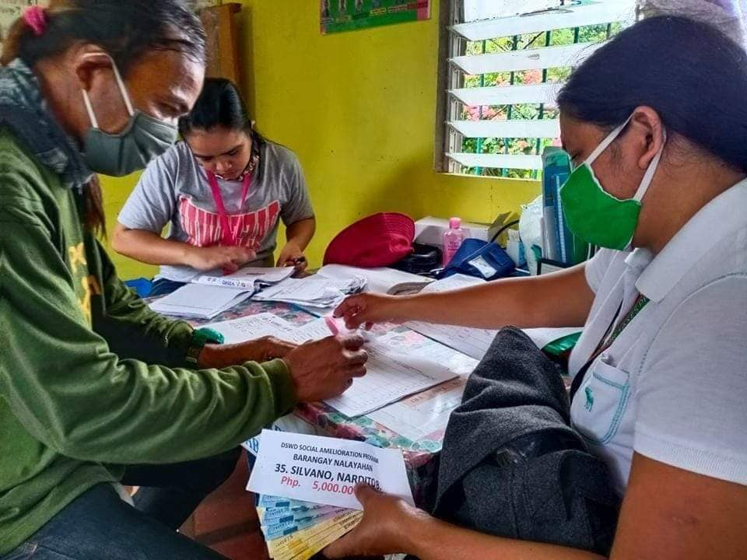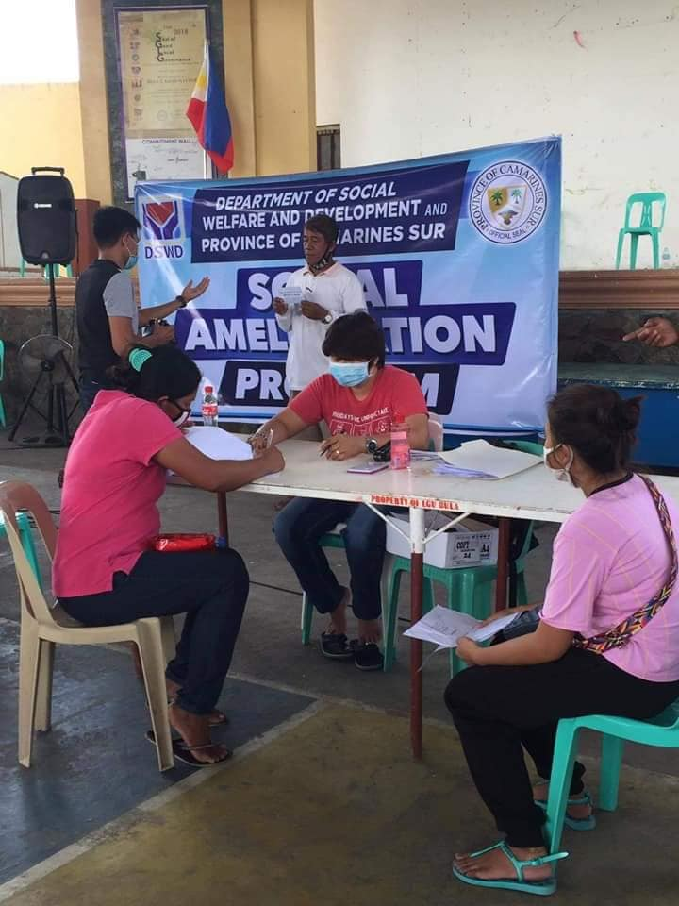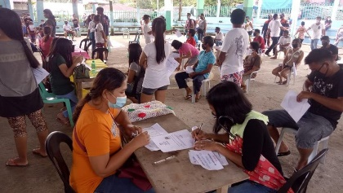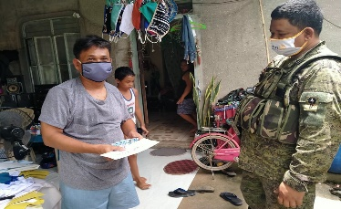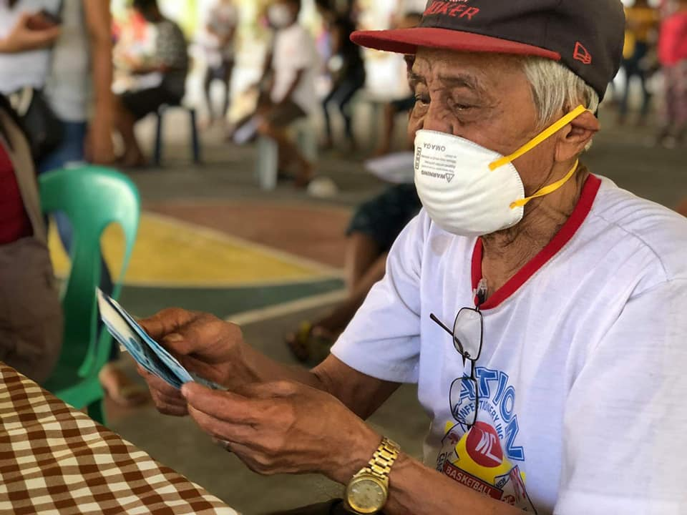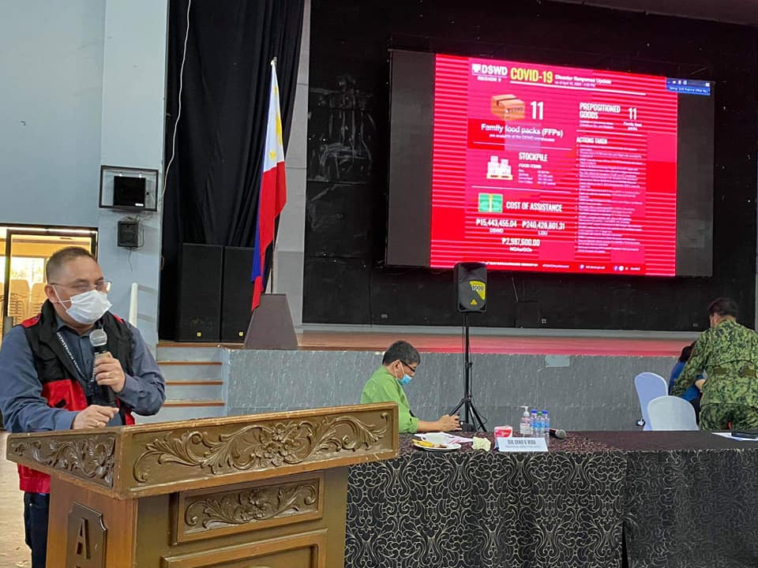****

**APRIL 20, 2020**

The Local Government Units in Bicol Region started releasing the emergency subsidy of P5,000.00 under the Social Amelioration Program (SAP) of the Department of Social Welfare and Development (DSWD).

**APRIL 20,2020** DSWD FO 10 Division Chief and Unit Heads attended the Health Task Group meeting via video conferencing led by DOH which focuses on organization and its updates taken by respective agencies in addressing the consequences of Covid-19

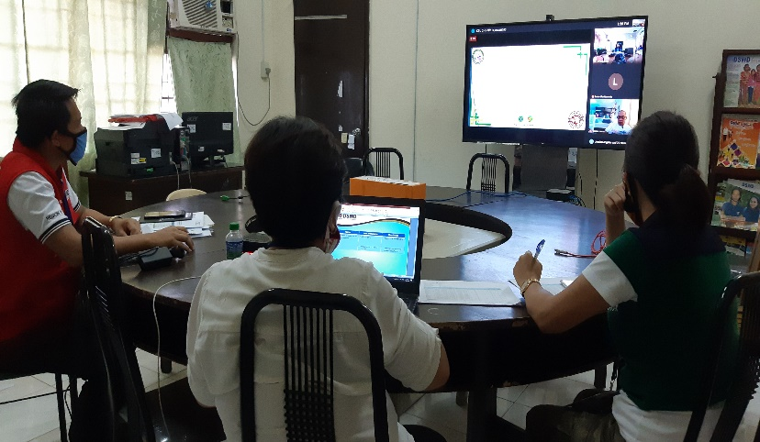

**APRIL 20,2020** DSWD Field Office II staff went to Basco, Batanes in coordination with Philippine Air Force and Office of Civil Defense to assess the documentary requirements for the SAP implementation of the six municipalities of Batanes Province.

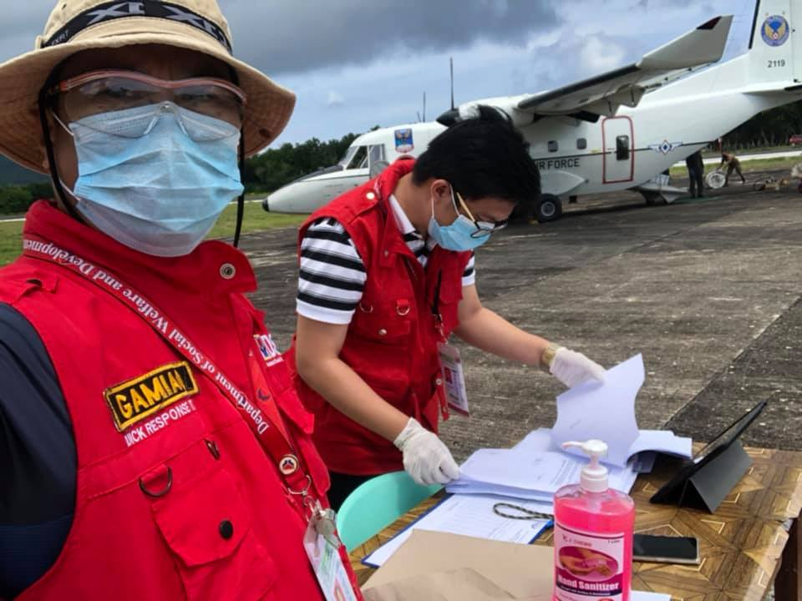

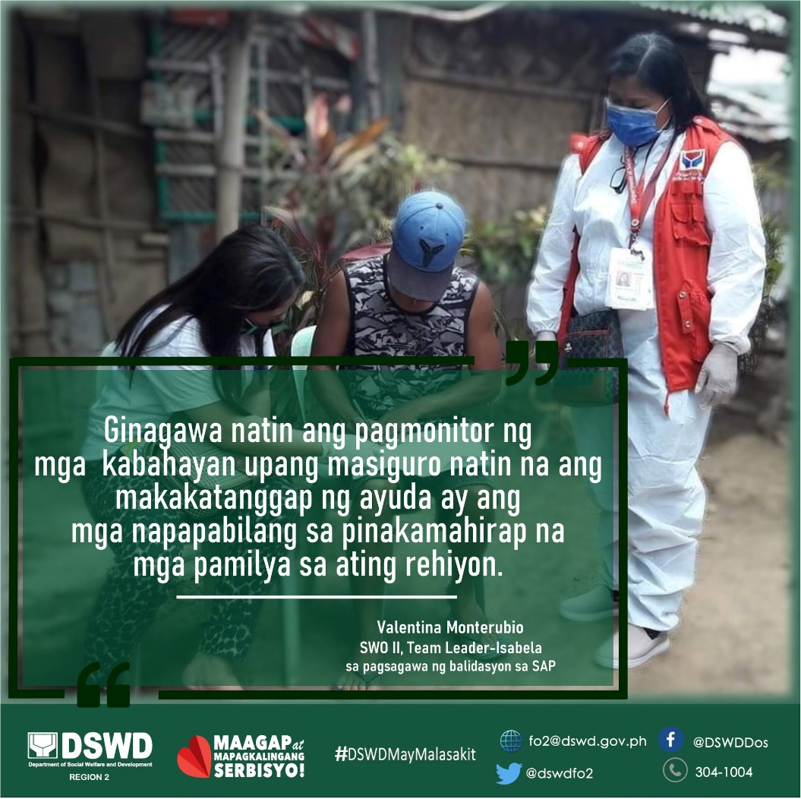

**APRIL 20,2020** DSWD Fielf Office 2 staff conducted monitoring in the implementation of SAP to the different LGUs in the region.

