# **Readme**

This file contains all the information needed in order to solve Martello’s **Murder on the 2nd Floor** Hackathon challenge.

# Challenge Description

It was a dark and dreary night at the Richcraft Hall Hotel. Unknown to the occupants of the hotel, one of the guests was murdered that night. The next morning, the body was found on the 2nd floor in room 210 by a hotel staff member. They immediately reported it to the local police station. You have been contacted by the forensic team requesting for assistance.

# **Problem Statement**

**The forensic team approached you to create a tool that displays the Richcraft Hall Hotel data that clearly measures, analyzes and correlates the association of the events and activities in the last 24-hour period before the victim's body was discovered.**

**It’s up to you to develop a forensic solution that can lead the team to the potential suspects.**

# **Extra information**

The hotel is equipped with 4 different sensors that have gathered information on the occupants of the hotel. You have been provided sensor data from the 4 different sensors (Wi-Fi access points, door sensors, motion sensors and phones) on 12 suspects. Data is provided in the 24-hour period before the victim’s body was discovered on Sunday, January 5, at 10 AM.

# **Judging Criteria**

Presentation, Ease of use, Quality of Code, Solution, and Bonus.

# **Prizes**

Gift Basket including a DJI drone, GIGABYTE graphics card, Bose Headset and Nintendo Switch Lite.

**Website**<https://martellotech.com/cuhacking/>

**Need Help?**Should you need help we have a team committed to help and guide you through solving our challenge. You can contact us on slack at **#Martello-Mystery** or you can find us at **RB 2211** in the mentor room.

# Challenge Information

# **The Data**

For this challenge Martello will be providing you with a file containing a simulated set of events that occurred at the hotel near the time of the murder. The file will be in JSON format and will be an ordered list of objects which have a timestamp as their key. The following is a sample of the file:

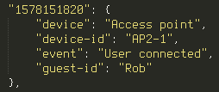

**“157815820”**, is the key to the json object and timestamp in epoch time (see below for more information on epoch time)

**“device”** is the type of device in the hotel that has reported an event, in this example it’s an “Access point” but there are other types of devices listed below.

**“device-id”** is the specific device that recorded the event, in this case its “AP2-1” an access point on the 2nd floor of the hotel.

**“event”** is the actual event that was recorded, in this case it’s “User connected”, a list of events is available below.

**“guest-id”** is the guest or person associated with the event if applicable, some hardware is unable to record a guest-id and it will respond with “n/a”

# Hotel Sensors

The hotel is equipped with the 4 sensors shown below with their corresponding events.

### **Access Points**

|  |  |  |
| --- | --- | --- |
| Description: | The hotel has 7 Wi-Fi access points spread out over both floors. Most of the guests carry smart phones connected to the hotel Wi-Fi. This data shows which access point each guest is connected to. | |
| Fields | Device-id | The id of the access point. This will correspond to one of the id’s on the floor plan. |
| Event | See the list of events below. |
| Guest-id | Name of the owner of the device. |
| Events: | New client | A device new to the network connects to an access point. |
| User connected | A device moves to a new access point. |
| User disconnected | A device leaves an access point. |

### **Door Sensors**

|  |  |  |
| --- | --- | --- |
| Description: | Most of the doors in the hotel are equipped with door sensors, except for the washrooms and the front door. | |
| Fields | Device-id | The room number that the door leads to. |
| Event | See the list of events below. |
| Guest-id | Name of the owner of the keycard used to open the door. If no keycard was used there will be no data here. |
| Events: | Successful keycard unlock | Door is unlocked from the outside. |
| Unlocked no keycard | Door is unlocked from the inside without the use of a keycard. |
| Door closed | The door was closed. |

### **Motion Sensors**

|  |  |  |
| --- | --- | --- |
| Description: | The hotel is also equipped with 3 motion sensors. These are in the elevator, the stairwell and in front of the ice machine. | |
| Fields | Device-id | The location of the sensor. This is either “Elevator”, “Stairwell” or “Ice machine”. |
| Event | This is always “Motion detected” |

### **Phones**

|  |  |  |
| --- | --- | --- |
| Description: | Every room in the hotel is equipped with a phone, and there is also a phone at the front desk | |
| Fields | Device-id | The location of the phone. This is either a room number or “reception” |
| Event | See the list of events below. |
| Events: | Off hook | A new call is started. |
| On hook | A call has ended. |

# Hotel Guests

This is a list of hotel guests and their corresponding room numbers below:

|  |  |
| --- | --- |
| Name | Room Number |
| Veronica | 210 |
| Jason | 241 |
| Thomas | 248 |
| Rob | 231 |
| Kristina | 235 |

# Hotel Staff

This is a list of hotel staff and their roles below:

|  |  |
| --- | --- |
| Name | Role |
| Marc-Andre | Cleaning Staff |
| Dave | Cooking Staff |
| Salina | Reception Staff |
| Harrison | Reception Late-night Staff |

# Hotel Floor Plan

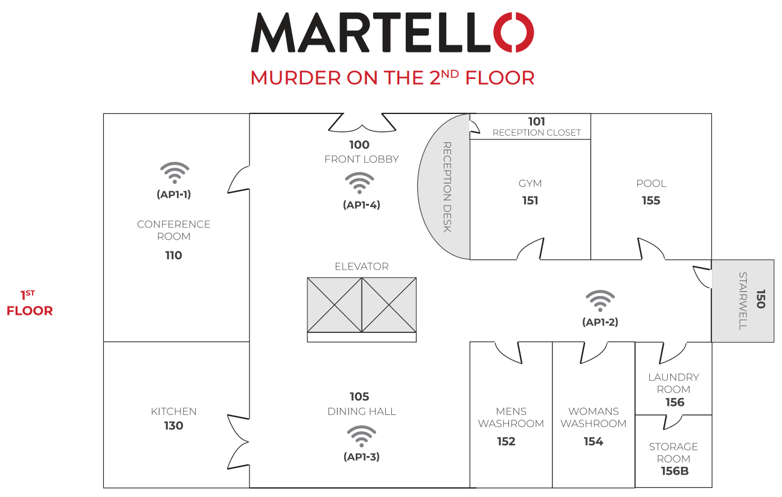

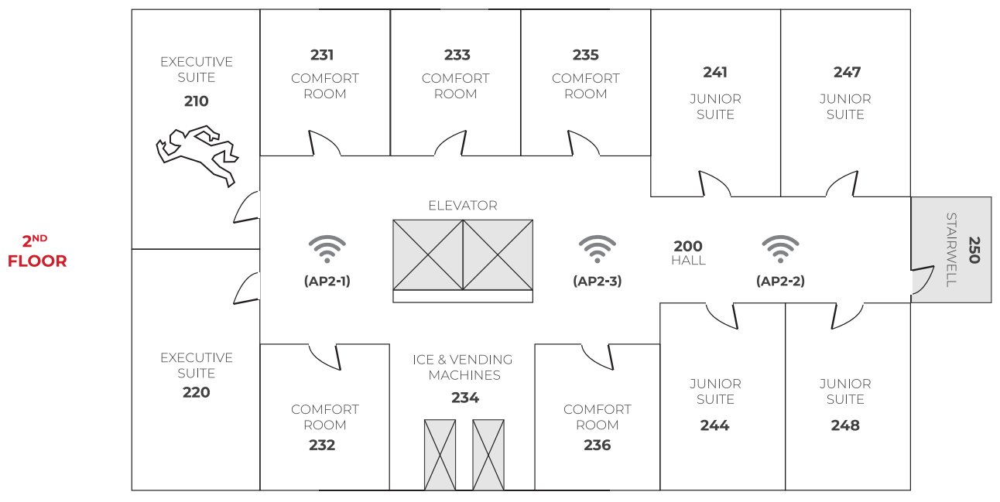

# References

**Epoch time**  
In our data format, we store times in Epoch time. Most programming languages have a method for converting from these to a human-readable DateTime format. The epoch for a given moment in time is the number of seconds which have passed since January 1st, 1970, in the UTC time zone.

References: <https://en.wikipedia.org/wiki/Unix_time>

<https://www.epochconverter.com/>