

SOFTWARE DEVELOPMENT PROJECT
Final Report

CivicLink: Municipal Incident Reporting and Community Alert Platform
Prepared by:
Nthoroane KP
202328762
Department of Computer Science & Information Technology
Sol Plaatje University
Submitted to:
Dr Silas Verkijika
Lecturer: Project (NPRJ740)
Department of Computer Science & Information Technology
Sol Plaatje University
24-26 Scanlan St, New Park, Kimberley, 8301
30 October 2026

EXECUTIVE SUMMARY
Sol Plaatje Local Municipality in Kimberley receives reports of burst pipes, power outages, potholes and illegal dumping by telephone, walk-in visits and community WhatsApp groups. Reports are logged by hand without a precise location. The same incident is reported many times. Field teams are dispatched by phone with no record of progress, and residents hear nothing back unless they call again. When municipal workers went on strike on 31 March 2026 and blocked roads across the city, there was no official way to warn commuters.
CivicLink is a web application that connects four groups in one workflow. Residents report incidents from their phones with a map location, photos and a severity, receive a reference number, and follow the report live until it is fixed. Municipal officials triage reports for their department, assign them to field workers, escalate overdue work and broadcast alerts to specific suburbs. Field workers receive tasks on their phones, record progress and close each task with completion notes and a proof photo. Administrators manage staff accounts, departments and incident categories.
The final release implements 28 of the 32 specified functional requirements, including all 14 Must-have requirements. The core lifecycle runs end to end: report, duplicate detection, triage, assignment, field completion, and resident confirmation or reopening. It is supported by real-time notifications, suburb-targeted alerts with read receipts, a privacy-safe community map, live service-delivery analytics, SLA-based automatic escalation, a complete audit trail, Google sign-in, and self-service account deletion that meets POPIA's right to erasure. Push notifications (Could-have), SMS alerts, offline drafting and scheduled alerts were deliberately deferred.
The system is built with React and TypeScript on Firebase Authentication and Cloud Firestore, with a Node.js command API. Every state-changing operation runs on the server inside a database transaction, and access is enforced by Security Rules. It runs entirely on free tiers: the deployed system uses Vercel and Firebase's free Spark plan, and a local configuration using the Firebase Emulator Suite can be reproduced with two commands and no cloud account. It is verified by 136 automated tests (unit, security-rule, API integration, end-to-end and non-functional) running in continuous integration. All five success criteria were achieved.

PROJECT CONTEXT
Application domain. Municipal service delivery: the reporting, dispatch and resolution of infrastructure and community incidents (water, electricity, roads, waste and public safety), and communication between a municipality and its residents.
Primary users and client. The intended client is Sol Plaatje Local Municipality, Northern Cape. Its users are residents of the municipal area (Kimberley, Galeshewe, Roodepan, Ritchie, Platfontein and surrounding areas), municipal officials in the five service departments, field workers who carry out repairs, and system administrators.
Basis of the project. The project is based on a real organisation and real events (the municipality, its departments and the 31 March 2026 strike). The requirements were gathered through a simulated stakeholder interview with a senior infrastructure official, an analysis of the municipality's daily reporting transactions, and published sources. CivicLink has not been commissioned or deployed by the municipality.

PROBLEM, PURPOSE AND SUCCESS CRITERIA

Problem Statement
Residents of Sol Plaatje have no dependable digital channel for reporting service failures, and the municipality has no single system for managing them. The Phase 1 investigation found the following:
- No precise capture. Calls are written on paper or in spreadsheets, without GPS coordinates or photos, so field teams are sent to the wrong place and repeat visits are common, especially for illegal dumping.
- Duplicate reports. The same burst pipe or outage is reported many times across channels, which wastes call-centre time and distorts priorities.
- No accountability for dispatch. Supervisors phone field workers directly, leaving no record of who was assigned, when work started, or whether it was finished.
- No feedback to residents. Residents are not told when a report is accepted or resolved, so they call back repeatedly. This adds to the call-centre load and erodes trust.
- No targeted public communication. During the 31 March 2026 strike, road closures were communicated only by radio and informal WhatsApp groups. Residents and taxi commuters received no official guidance.
- No management visibility. Without data, the municipality cannot measure response times, compare departments or identify hotspots.
The stakeholder questionnaire reported response times of 24–72 hours for burst pipes, mainly because reports were routed to the wrong team. These problems are structural rather than individual: they come from analogue, fragmented processes. A shared digital system that records every report, assignment and status change in one place, enforces routing and accountability rules, and pushes updates to the people affected directly addresses each of them.
These findings agree with published evidence that municipal service delivery in South Africa suffers from weak monitoring, poor record-keeping and slow responses to infrastructure failures (Auditor-General South Africa, 2024). They also agree with the municipality's own planning documents, which identify ageing water and electricity infrastructure as a priority (Sol Plaatje Local Municipality, 2022).
TO VERIFY BEFORE SUBMISSION: Before submission, confirm the Sol Plaatje IDP edition and add one sentence with a specific figure from it (e.g. water-loss percentage or backlog), and the Census 2022 population figure for Sol Plaatje (Statistics South Africa, 2023). Phase 1 quoted "approximately 250 000"; replace it with the census value.

Project Purpose
CivicLink is intended to replace the municipality's manual, fragmented incident reporting with one accountable digital workflow. Residents should be able to report a located, evidenced incident in under a minute and follow it to resolution. Officials should be able to route and dispatch work and warn affected suburbs immediately. Field workers should be able to close tasks with proof. Every action should leave an auditable record.

Success Criteria
Table 1: Success criteria
ID | Success criterion | How it is verified
SC-01 | The complete incident lifecycle runs end-to-end on the submitted system: a resident submits, an official triages and assigns, a field worker completes with proof, and the resident sees the report resolved with a full status history. | End-to-end test E2E-01; demonstration
SC-02 | The key business rules are enforced on the server, not only in the interface: duplicate detection, allowed status transitions, one active task per report, valid assignment and SLA escalation. | Unit and integration tests for BR-03 to BR-11
SC-03 | Role-based access control holds: each role can perform exactly the functions in the permission matrix and nothing else. | Security-rule tests RT-*, API authorisation tests, E2E-04
SC-04 | Residents receive timely, targeted information: a status change or a suburb alert appears in the resident's app within 5 seconds, without refreshing. | NFT-05, E2E-03
SC-05 | Officials have operational visibility from live data: dashboard metrics match the known dataset. | UT-ANL-01, IT-ANL-01

SOLUTION OVERVIEW AND SCOPE

Solution Overview
CivicLink is a responsive web application backed by Firebase. The system boundary contains the React single-page application (with separate resident, official, field-worker and administrator areas), a Node.js command API (served by Cloud Functions locally and by Vercel serverless functions when deployed), Cloud Firestore and Firebase Authentication. The external actors are the four user roles. The only external services are OpenStreetMap, which supplies map tiles, and the browser's geolocation service on the user's device.
Its major functional areas are:
- Incident reporting: a three-step report form with category, map location, suburb, landmark, description, severity and up to three photos; reference numbers; and duplicate detection within 100 m.
- Tracking and feedback: a live status lifecycle, an audit timeline, in-app notifications, confirmation or reopening by the resident, and automatic closure.
- Dispatch: a department-scoped report queue with triage, rejection, assignment, reassignment and escalation, plus internal staff notes.
- Field work: a mobile task list where the worker accepts, starts and completes tasks with notes and proof photos.
- Community communication: suburb-targeted alerts with delivery and read receipts, and a community incident map with approximate locations.
- Management and administration: live analytics on volumes, resolution time and SLA compliance; user, role, department and category management; and a system log.
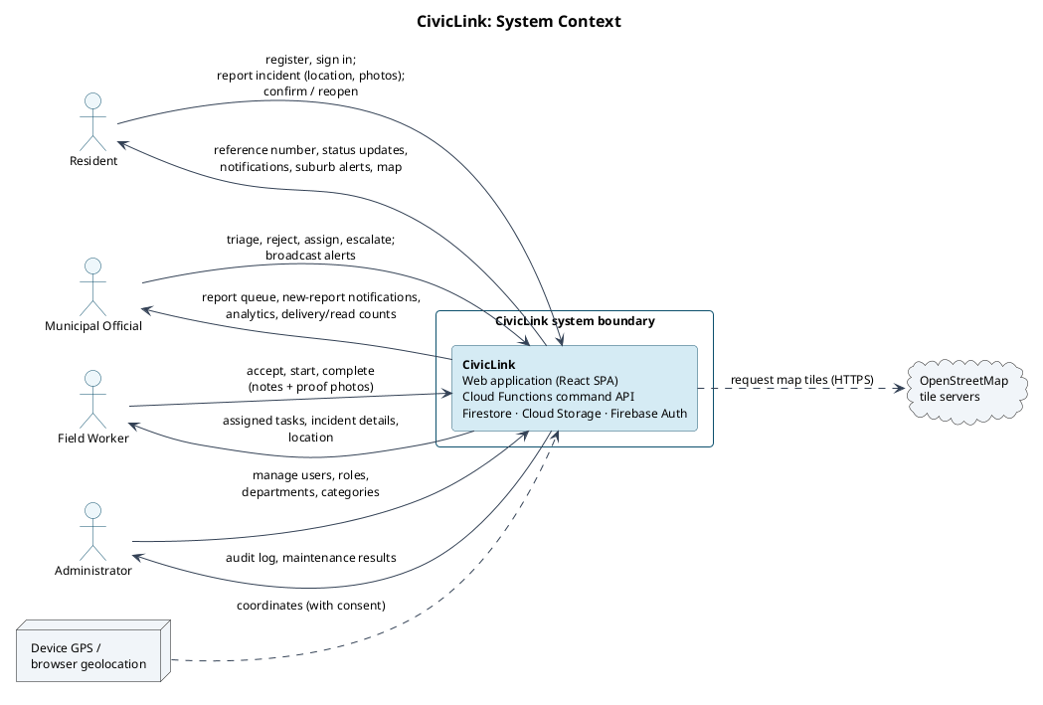
Figure 1: CivicLink system context diagram

Final Release Scope
The submitted release (tag v1.0.0) includes the following capabilities. Each one is traceable to its requirements in Section 4 and to its tests in Section 7.
Table 2: Final release scope
Capability | Requirements | Priority
Resident registration, sign-in and role-based routing; account deactivation | FR-01, FR-02, FR-20 | Must
Located incident report with photos; reference number; duplicate detection | FR-03, FR-04, FR-05 | Must
My reports with live status lifecycle and audit timeline | FR-06 | Must
Department report queue with filters, search and CSV export | FR-08, FR-26 | Must / Could
Triage, reject, assign field worker | FR-09, FR-10 | Must
Field-worker task list; accept, start, complete with proof | FR-11 | Must
Real-time in-app notifications | FR-15 | Must
Suburb-targeted alert broadcast and resident alerts feed | FR-16, FR-17 | Must
Reassignment; manual and SLA-based escalation; resident confirm/reopen; auto-close | FR-12, FR-13, FR-14 | Should
Community incident map (privacy-safe) | FR-07 | Should
Alert history with delivery and read counts | FR-18 | Should
Service-delivery analytics | FR-19 | Should
Department and category configuration | FR-21 | Should
Internal staff comments; system log | FR-22, FR-23 | Could
Google sign-in; password reset; profile editing; POPIA account deletion | FR-29–FR-32 | Should

Excluded and Deferred Capabilities
Table 3: Excluded and deferred capabilities
Capability | Status | Reason
Web push notifications via Firebase Cloud Messaging (FR-24) | Deferred | Could-have. Push delivery cannot be demonstrated in the emulator environment; in-app real-time notifications meet the feedback need
SMS alerts for residents without data (FR-25) | Deferred | Paid external service (e.g. Twilio); cannot be verified in the assessment environment
Offline report drafting with synchronisation (FR-27) | Deferred | Conflict handling for drafts and uploads exceeds the time available
Scheduled (future-dated) alerts (FR-28) | Deferred | Low value for the MVP; immediate alerts cover the strike scenario
Bulk assignment of reports | Deferred | Efficiency feature; single assignment covers the workflow
Native Android/iOS apps | Excluded | The responsive web app works on low-end phones without app-store distribution
Google Maps and reverse geocoding | Excluded (replaced) | Replaced by Leaflet and OpenStreetMap (decision D4)
99.5% availability, 10 000 concurrent users, multi-region failover | Excluded | Production targets from Phases 1–2 that cannot be verified in a student environment
AI/ML prediction | Excluded | Not part of the product

Known Limitations and Open Issues
All capabilities listed in Section 3.2 are complete and verified. The following limitations affect included functionality:
Table 4: Known limitations
Area | Limitation | Impact | Status / workaround
Notifications (FR-15) | Notifications are in-app only | A resident who does not open CivicLink is not alerted | Push (FR-24) and SMS (FR-25) deferred
Scheduled rules (FR-13, FR-14) | The local emulator does not fire scheduled functions | In the local demo, escalation and auto-close run when an administrator selects "Run SLA & auto-close now" | When deployed, Cloud Scheduler runs them hourly and daily
Alert broadcast (FR-16) | Delivery records are written in batches after the alert document, not in one transaction | A failure during a broadcast could leave the recipient count higher than the stored delivery records | Acceptable at municipal scale; records can be re-derived from the suburb query
Location (FR-03) | No street address; location is a map pin plus suburb and optional landmark | Officials rely on the pin and the landmark text | Deliberate (decision D4)

SYSTEM REQUIREMENTS SPECIFICATION
The requirements below are the consolidated baseline that controls the project. Changes from the Phase 1–3 documents (for example the added Administrator actor, the eight-state report lifecycle and the rewritten non-functional requirements) are recorded as change requests CR-01 to CR-28 in docs/baseline/change-log.md.

Functional Requirements
Table 5: Functional requirements
ID | Functional requirement | Priority | Release status
FR-01 | The system shall allow a member of the public to register as a Resident with name, email, password, suburb and optional phone number. | Must Have | Included
FR-02 | The system shall authenticate users by email and password and route each user to the interface for their role; deactivated accounts are refused. | Must Have | Included
FR-03 | The system shall allow an authenticated Resident to submit an incident report with category, description, map location, suburb, optional landmark, severity and 0–3 photos. | Must Have | Included
FR-04 | The system shall give each accepted report a unique reference (CL-YYYY-NNNN), status Submitted, a default department derived from its category, and a first history entry. | Must Have | Included
FR-05 | The system shall detect when a new report duplicates an open report, link it to the original and tell the resident the original's reference. | Must Have | Included
FR-06 | The system shall allow a Resident to list their reports (All / Active / Resolved) and view a report's details and full status timeline. | Must Have | Included
FR-07 | The system shall show a community map of open reports with category filtering, without revealing reporter identity or photos. | Should Have | Included
FR-08 | The system shall allow an Official to view the report queue with filters (status, category, department, severity, unassigned) and search by reference. | Must Have | Included
FR-09 | The system shall allow an Official to triage a Submitted report (to Under Review, confirming or changing the department) or reject it with a reason. | Must Have | Included
FR-10 | The system shall allow an Official to assign a report under review or escalated to an active field worker in its department, creating a task and moving the report to In Progress. | Must Have | Included
FR-11 | The system shall allow a Field Worker to view, accept, start and complete their tasks; completion requires notes and at least one proof photo and resolves the report. | Must Have | Included
FR-12 | The system shall allow an Official to reassign an active task to another eligible field worker. | Should Have | Included
FR-13 | The system shall escalate open reports that exceed their department's SLA hours automatically, and allow an Official to escalate manually with a reason. | Should Have | Included
FR-14 | The system shall allow the reporting Resident to confirm or reopen a resolved report within 7 days, and shall close resolved reports automatically after 7 days. | Should Have | Included
FR-15 | The system shall notify users in-app in real time: residents on every status change of their (or a followed) report, officials on new reports, and field workers on assignment. | Must Have | Included
FR-16 | The system shall allow an Official to broadcast an alert with type, title, message, target suburbs (or all) and expiry, recording a delivery record for each targeted resident. | Must Have | Included
FR-17 | The system shall show Residents the active, unexpired alerts for their suburb, emergencies first, with unread markers and read receipts. | Must Have | Included
FR-18 | The system shall allow an Official to view sent alerts with recipient and read counts and to end an alert early. | Should Have | Included
FR-19 | The system shall show Officials an analytics dashboard computed from live data: open reports, resolution time, SLA compliance per department and the daily trend. | Should Have | Included
FR-20 | The system shall allow an Administrator to create staff accounts, change roles and deactivate or reactivate accounts. | Must Have | Included
FR-21 | The system shall allow an Administrator to manage departments (name, SLA hours, active) and categories (name, default department, active). | Should Have | Included
FR-22 | The system shall allow Officials and Field Workers to add internal comments to a report that residents cannot see. | Could Have | Included
FR-23 | The system shall record significant system events and show them to Administrators. | Could Have | Included
FR-24 | The system shall send web push notifications for status changes and alerts. | Could Have | Deferred
FR-25 | The system shall send SMS alerts to residents without data access. | Won't Have (this release) | Deferred
FR-26 | The system shall allow an Official to export the filtered report queue as CSV. | Could Have | Included
FR-27 | The system shall let residents draft reports offline and submit them when connectivity returns. | Won't Have (this release) | Deferred
FR-28 | The system shall allow alerts to be scheduled for a future time. | Won't Have (this release) | Deferred
FR-29 | The system shall allow users to sign in with a Google account; on first sign-in a new user completes a resident profile. | Should Have | Included
FR-30 | The system shall allow users to request a password-reset email without revealing whether an account exists. | Should Have | Included
FR-31 | The system shall allow users to update their name and phone number, and residents their suburb. | Should Have | Included
FR-32 | The system shall allow a Resident to delete their account; personal data is erased and their reports are kept anonymised. | Should Have | Included

Non-Functional Requirements
All non-functional requirements are verified in the assessment environment: the local Firebase Emulator Suite with the seeded dataset (150 reports, 15 users) on the latest Chrome and Firefox.
Table 6: Non-functional requirements
ID | Quality attribute | Requirement | Verification
NFR-01 | Security: authorisation | Every role-restricted read or write is enforced server-side by Security Rules and Cloud Function role checks, independently of the user interface. | Security-rule tests, authorisation tests
NFR-02 | Security: authentication | Passwords are handled only by Firebase Authentication (minimum 8 characters); no credential is stored in Firestore or the repository; roles are carried as signed custom claims. | Code review, rule tests, secret scan
NFR-03 | Security: input validation | All commands validate input on the server against shared schemas; invalid input is rejected with field-level messages and no data change. | Integration tests
NFR-04 | Security: secrets | No secrets are kept in source control; configuration comes from environment variables with a committed .env.example. | Secret scan (gitleaks)
NFR-05 | Performance: propagation | A new report appears on the official's queue, and a status change appears on the resident's screen, within 5 seconds without a refresh. | Timing test NFT-05
NFR-06 | Performance: responsiveness | Key screens become interactive within 3 seconds; commands complete within 2 seconds (95th percentile of 50 calls). | Timing test NFT-06
NFR-07 | Usability: mobile | Resident and field-worker screens work at 360×640 with no horizontal scrolling; submitting a report takes at most 3 steps. | NFT-07
NFR-08 | Accessibility | Key pages have no serious or critical WCAG 2.1 A/AA violations in an automated axe-core audit. | NFT-08
NFR-09 | Compatibility | Core flows pass on the latest Chrome and Firefox. | End-to-end tests on both browsers
NFR-10 | Integrity | Multi-document operations are atomic; conflicting concurrent commands result in exactly one success; failures leave no partial data. | Concurrency tests
NFR-11 | Privacy (POPIA) | Residents' identity, contact details and photos are visible only to the reporter and staff; public map data contains no personal information. | Rule tests, data classification
NFR-12 | Maintainability | TypeScript strict mode, lint-clean, shared domain logic with at least 80% line coverage, and CI on every push. | CI, coverage report

Business Rules
Table 7: Business rules
ID | Rule
BR-01 | Only an authenticated, active user with role Resident may submit a report.
BR-02 | A report needs an active category, a description of 10–300 characters, a location inside the Sol Plaatje municipal bounds, a suburb from the configured list and a severity. It may carry 0–3 photos, each a real JPEG/PNG/WebP image (checked by its content) of at most 700 KB once compressed; residents may pick files of up to 15 MB, which the app compresses.
BR-03 | A new report is a duplicate if an open report with the same category exists within 100 m and was created in the last 72 hours. The duplicate is stored as Duplicate, linked to the original; the original's affected count is incremented and the resident follows it.
BR-04 | References are CL-<year>-<sequence>, allocated in a transaction, unique and never reused.
BR-05 | A report's status may change only along the transitions of the report state machine (Figure 7). Every change appends an immutable history entry recording the actor, role, note and time.
BR-06 | A report has at most one active task at any time.
BR-07 | A report may be assigned only to an active Field Worker of the report's department, and only while it is Under Review, Escalated or (for reassignment) In Progress.
BR-08 | Only the assigned Field Worker may act on a task, and only in the order Assigned → Accepted → In Progress → Completed.
BR-09 | Completion requires notes of at least 10 characters and 1–3 proof photos, and sets the report to Resolved in the same transaction.
BR-10 | An open report not resolved within its department's SLA hours is escalated automatically (once); officials may escalate manually with a reason.
BR-11 | Only the reporting Resident may confirm or reopen a resolved report, within 7 days of resolution; afterwards it closes automatically. Closed, Rejected and Duplicate are terminal.
BR-12 | Rejection requires a reason of 10–300 characters and is allowed only for Submitted or Under Review reports.
BR-13 | Only Officials and Administrators may create alerts; an alert needs a title (≤ 100), message (≤ 500), at least one target suburb or All, and an expiry in the future and within 30 days.
BR-14 | A resident sees an alert only while it is active and unexpired and targets their suburb or All.
BR-15 | Only Administrators manage accounts and configuration; an Administrator cannot demote or deactivate their own account.
BR-16 | Self-registration always creates a Resident; staff roles are granted only by an Administrator; a deactivated account cannot sign in or call any function.
BR-17 | Reporter identity, contact details and photos are visible only to the reporter and staff; other residents see category, status, approximate location (about 100 m) and age only.
BR-18 | Internal comments are visible only to staff.
BR-19 | Inactive departments and categories cannot be selected for new reports, triage or assignment.
BR-20 | Officials may act only on reports of their own department; Administrators may act on any.
BR-21 | A resident may submit at most N reports in any rolling hour; N is set by an Administrator (1–100, default 10).
BR-22 | When a resident deletes their account, their name, email, phone, photos, notifications, alert receipts, profile and sign-in are erased; their reports are kept for service records as "Former resident". Staff accounts are deactivated, never self-deleted.

Acceptance Criteria for Included Requirements
FR-01 Register. Valid details create a Resident account and profile. A duplicate email is refused with "Email already registered". A password shorter than 8 characters or a missing suburb is refused with a field message. A role sent by the client is ignored.
FR-02 Sign in. Valid credentials open the area for the user's role. Wrong credentials show a generic error. A deactivated account cannot sign in or call any function. Opening another role's page shows the access-denied page.
FR-03 Submit report. Every BR-02 rule is checked in the form and again on the server, with field-level messages. A location outside the municipality, a fourth photo, a file over 15 MB or a file that is not really an image is refused. On success the resident sees the reference number.
FR-04 Reference. Concurrent submissions receive distinct, sequential references. A new report is Submitted, routed to its category's department, and has one history entry.
FR-05 Duplicate. A report of the same category within 100 m of an open report from the last 72 hours is linked as a duplicate, and the resident is shown the original's reference. Beyond 100 m, a different category, or a closed original produces a new report.
FR-06 My reports. Only the resident's own (or followed) reports are shown. The tabs filter correctly. The timeline is chronological with actor role and note. Another resident's report cannot be opened. An empty state is shown when there are no reports.
FR-07 Map. Open reports appear as category-coloured markers with a working filter. Popups show category, status, suburb and age only. The public data contains no reporter, description or photos.
FR-08 Queue. Officials see only their department's reports (Administrators see all). Filters combine. Searching by reference finds the report. Unassigned reports are flagged. An empty result shows an empty state.
FR-09 Triage / reject. Triage moves Submitted to Under Review and records history. Rejection requires a reason. Triage from any other status, or by an official of another department, is refused.
FR-10 Assign. Only active workers of the report's department can be chosen. Assignment creates an Assigned task, moves the report to In Progress, and notifies the worker and resident. A report that already has an active task cannot be assigned again. Of two simultaneous assignments, exactly one succeeds.
FR-11 Field worker. Workers see only their own tasks. Steps must happen in order. Completion without notes or a proof photo is refused. Completion resolves the report and notifies the resident. Another worker cannot act on the task.
FR-12 Reassign. The old task becomes Reassigned and a new task is created. Reassigning to the same worker, or when there is no active task, is refused. A reassigned task can no longer be completed.
FR-13 Escalate. A report past its SLA is escalated by the next scheduled run, exactly once. Manual escalation requires a reason. An escalated report can still be assigned.
FR-14 Confirm / reopen. Within 7 days the reporter can confirm (Closed) or reopen with a reason (Under Review, officials notified). After 7 days both are refused and the schedule closes the report. Other residents cannot act on it.
FR-15 Notifications. Each lifecycle event creates notifications for the correct recipients. The unread badge updates live. Opening a notification marks it read and navigates to the record.
FR-16 Broadcast. BR-13 is enforced with field messages. A valid alert creates one delivery record per active resident in the target suburbs. Residents and field workers cannot broadcast.
FR-17 Alerts feed. Residents see only active, unexpired alerts for their suburb or All, emergencies first. Reading records a receipt once per resident.
FR-18 Alert history. Recipient and read counts match the delivery records. Ending an alert hides it from residents immediately.
FR-19 Analytics. The metrics match the dataset. Empty data shows "no data" rather than an invalid number. Residents cannot access analytics.
FR-20 User administration. Staff accounts are created with the correct role and department. Role changes and deactivation take effect immediately. Administrators cannot demote or deactivate themselves. Non-administrators are refused.
FR-21 Configuration. SLA hours must be a whole number from 1 to 720. Names are unique. A deactivated category disappears from the report form. The hourly report limit (BR-21) must be from 1 to 100.
FR-29 Google sign-in. A first-time Google user is taken to a profile step that needs a name and a suburb, and always becomes a Resident. An existing profile cannot be re-created.
FR-30 Password reset. The same confirmation is shown whether or not the email is registered.
FR-31 Profile. An invalid SA phone number is refused. A resident who changes suburb receives that suburb's alerts. Staff have no suburb.
FR-32 Account deletion. It requires typing DELETE. Afterwards the user cannot sign in. Their reports show "Former resident" without photos and generate no notifications. Staff cannot self-delete.

SYSTEM DESIGN SPECIFICATION
The design described here is the final implemented design. Every diagram is generated from PlantUML source kept in the repository (docs/diagrams/src) and uses the identifiers of the code and the requirements.

Use Cases and Workflows
The use-case diagram (Figure 2) shows the four human actors, plus the system scheduler that triggers SLA escalation and automatic closure. The Administrator inherits every Official capability.
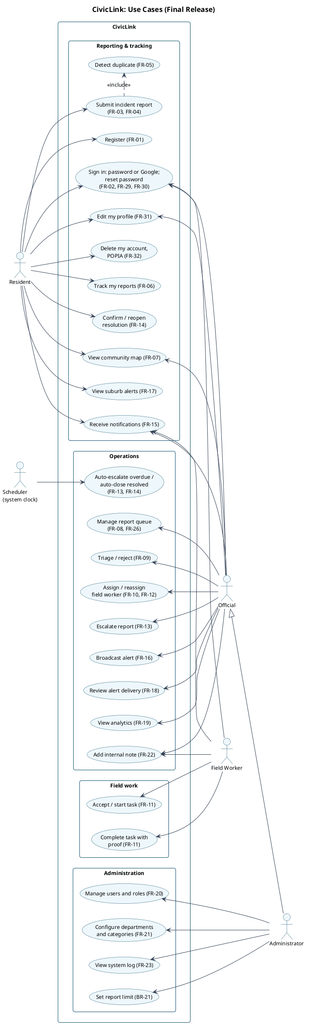
Figure 2: Use-case diagram of the final release

Two end-to-end workflows were selected from the core functionality. Both diagrams for each workflow include the validation, authorisation, conflict and alternative paths, not only the successful path.

Workflow W1: Submit an incident report (FR-03, FR-04, FR-05)
A resident completes the three-step form, and client validation gives immediate feedback. Photos are compressed in the browser (≤ 1280 px, ≤ 700 KB) and sent with the request. The submitReport command checks the caller's role and the input, verifies each photo's real type from its first bytes, and runs transaction TX-1, which also writes the photos as binary documents. TX-1 checks that the category is active, searches for open reports of the same category within 100 m, allocates the next reference, and writes either a new Submitted report (with the public map projection and notifications to the department's officials) or a Duplicate report linked to the original.
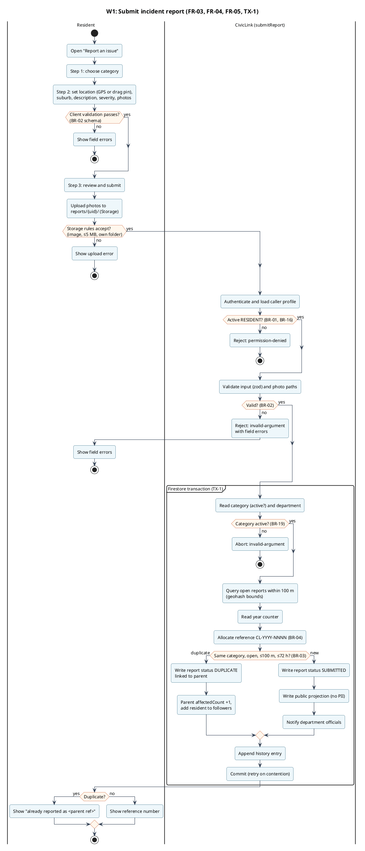
Figure 3: Activity diagram, W1 submit incident report
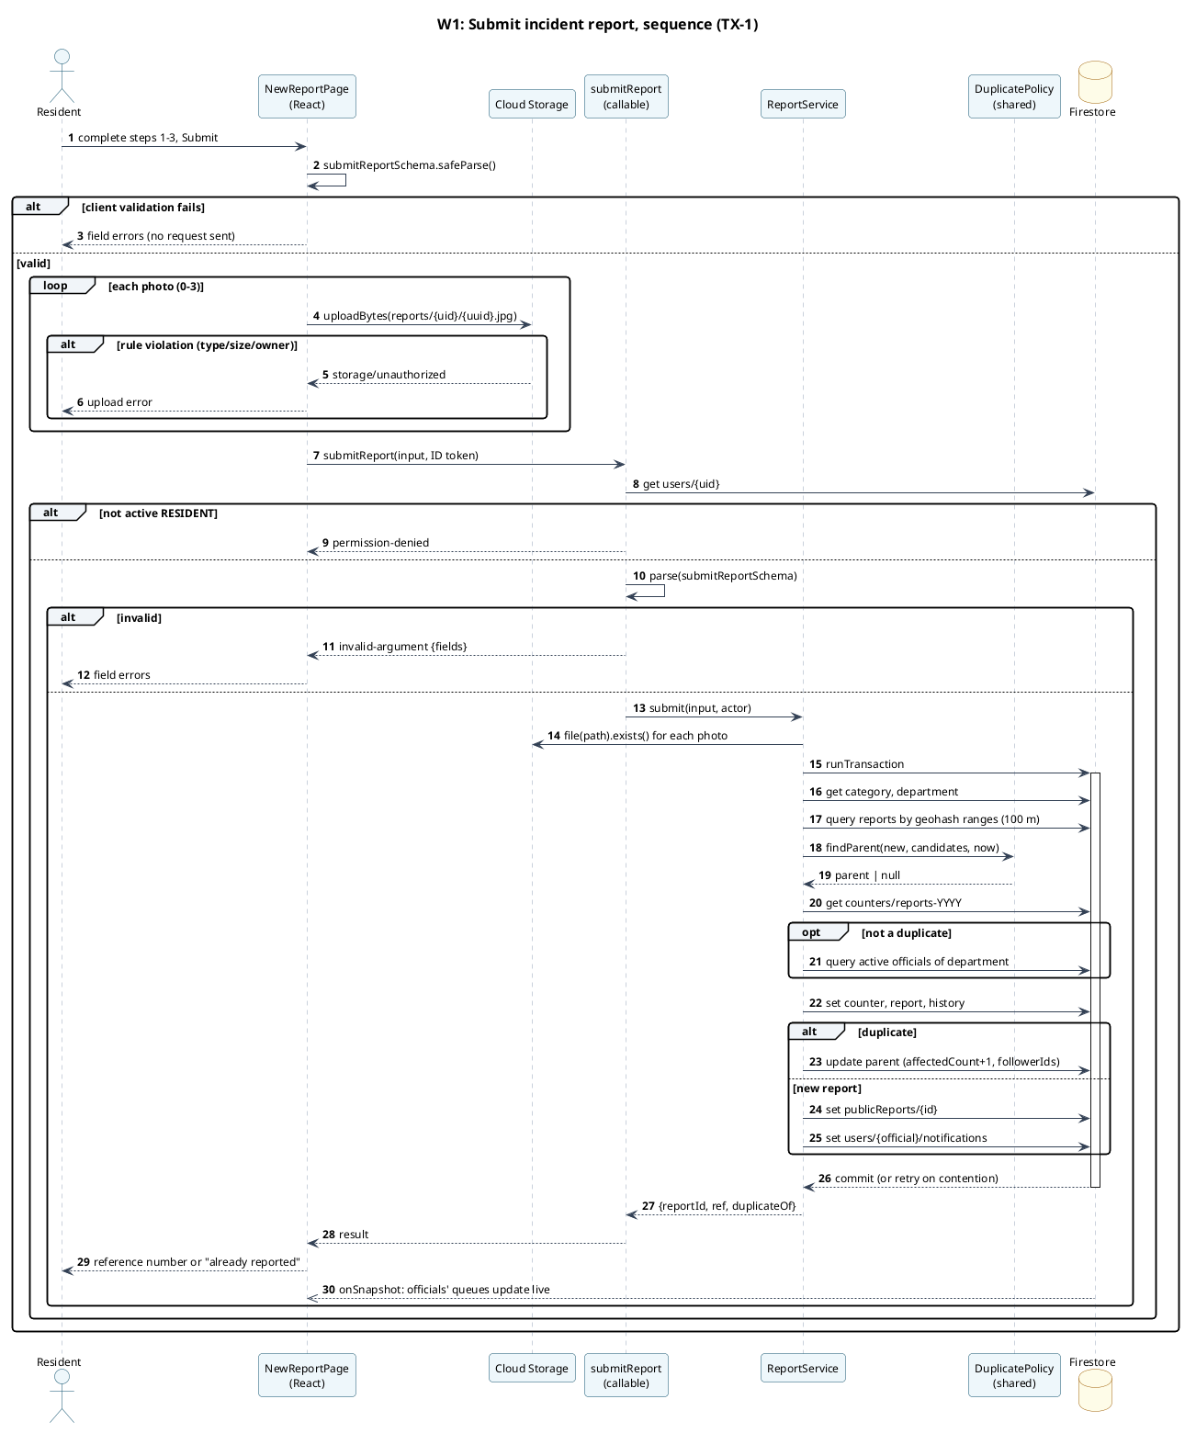
Figure 4: Sequence diagram, W1 submit incident report

Workflow W2: Triage, assign, complete and confirm (FR-09 to FR-14)
An official triages or rejects a report, then assigns it to an eligible field worker in transaction TX-2. The field worker accepts, starts and completes the task, and transaction TX-3 resolves the report. Finally the resident confirms the fix or reopens the report. The alternative and failure paths shown are: rejection; a report that already has an active task; an ineligible worker; skipped task steps; missing completion proof; a task that was reassigned while the worker was on site; and reopening.
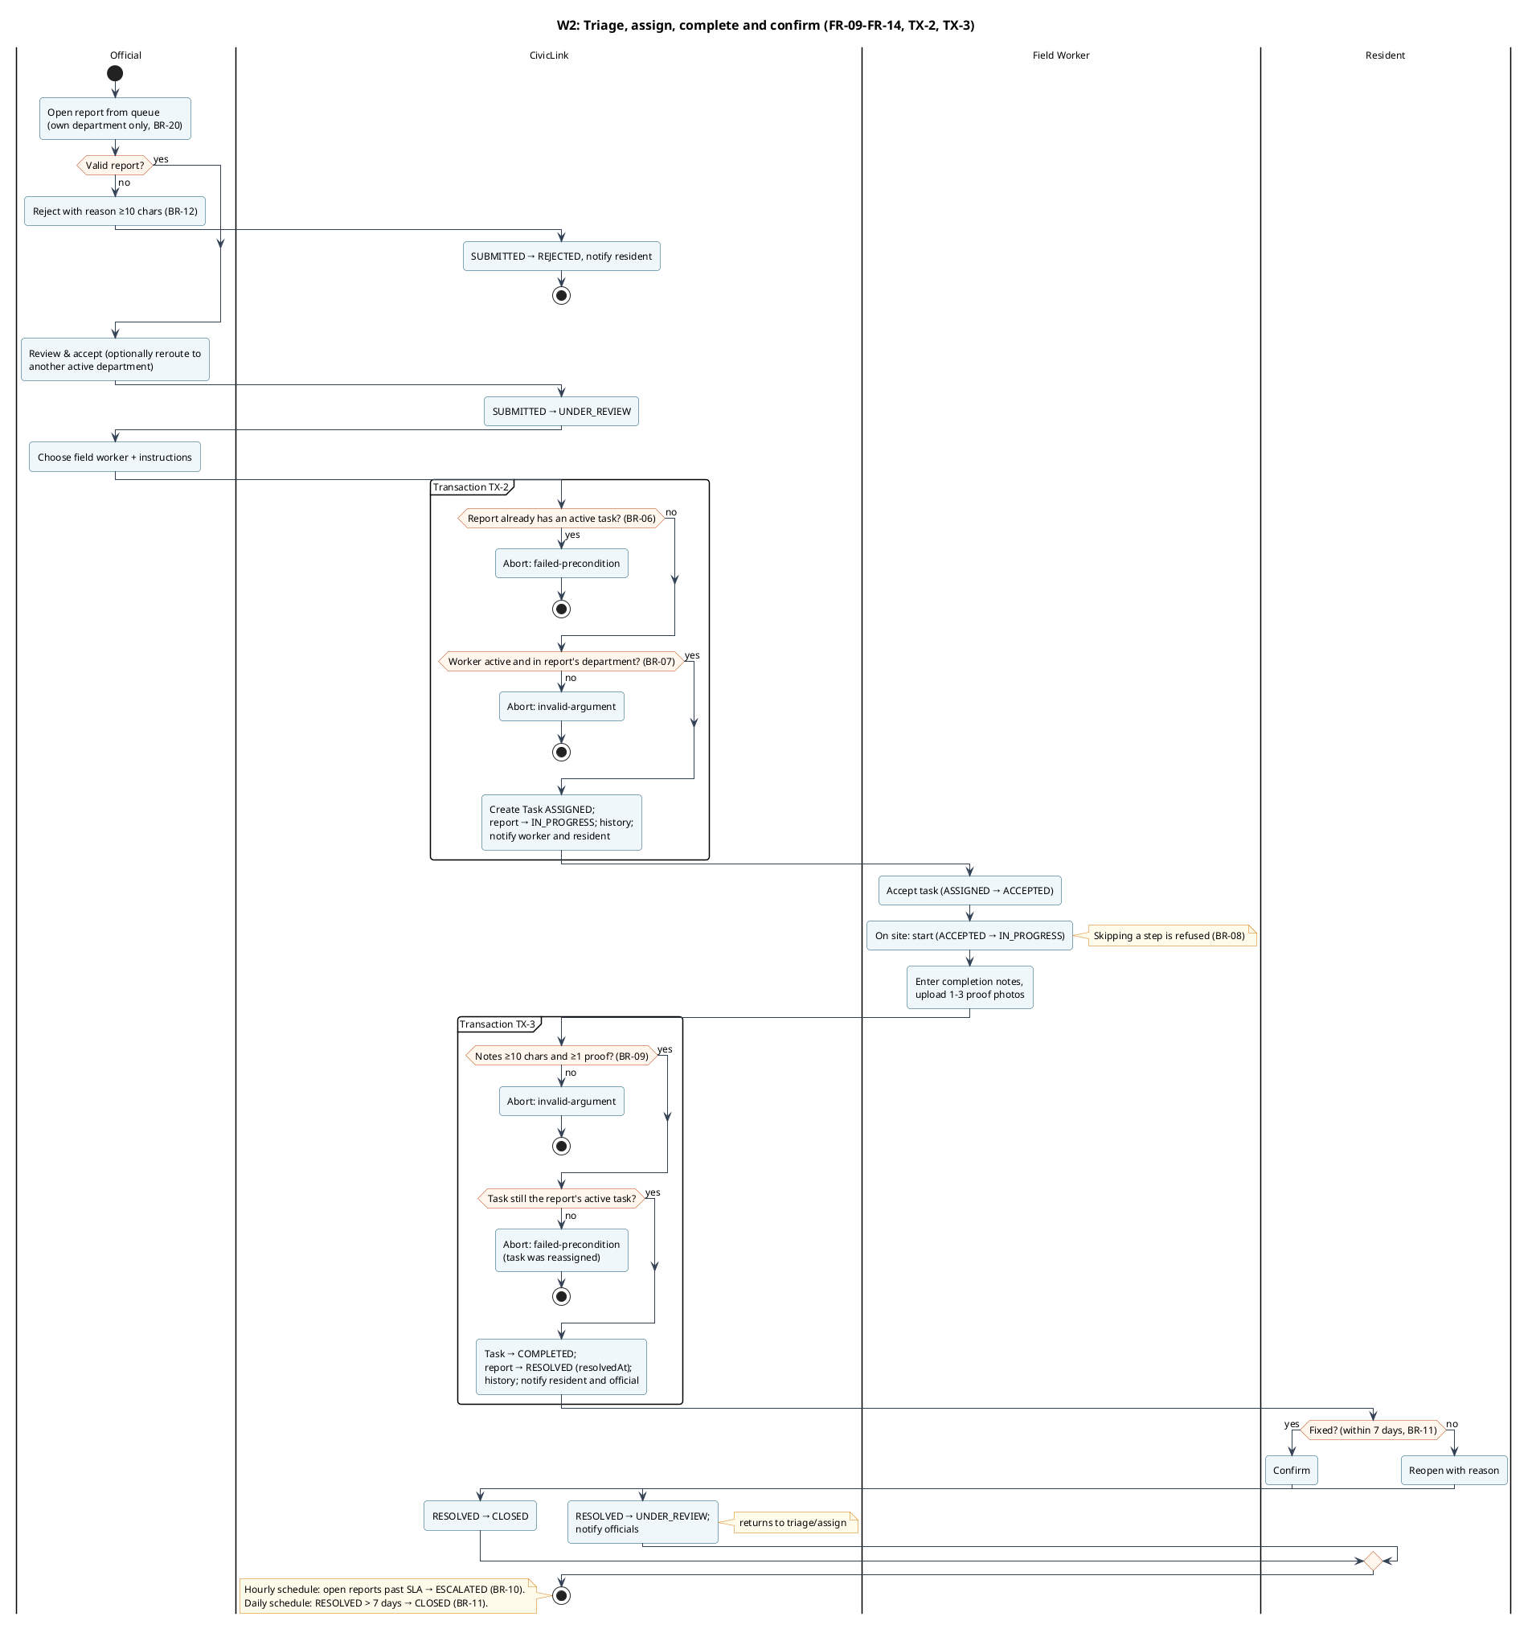
Figure 5: Activity diagram, W2 triage, assign, complete and confirm
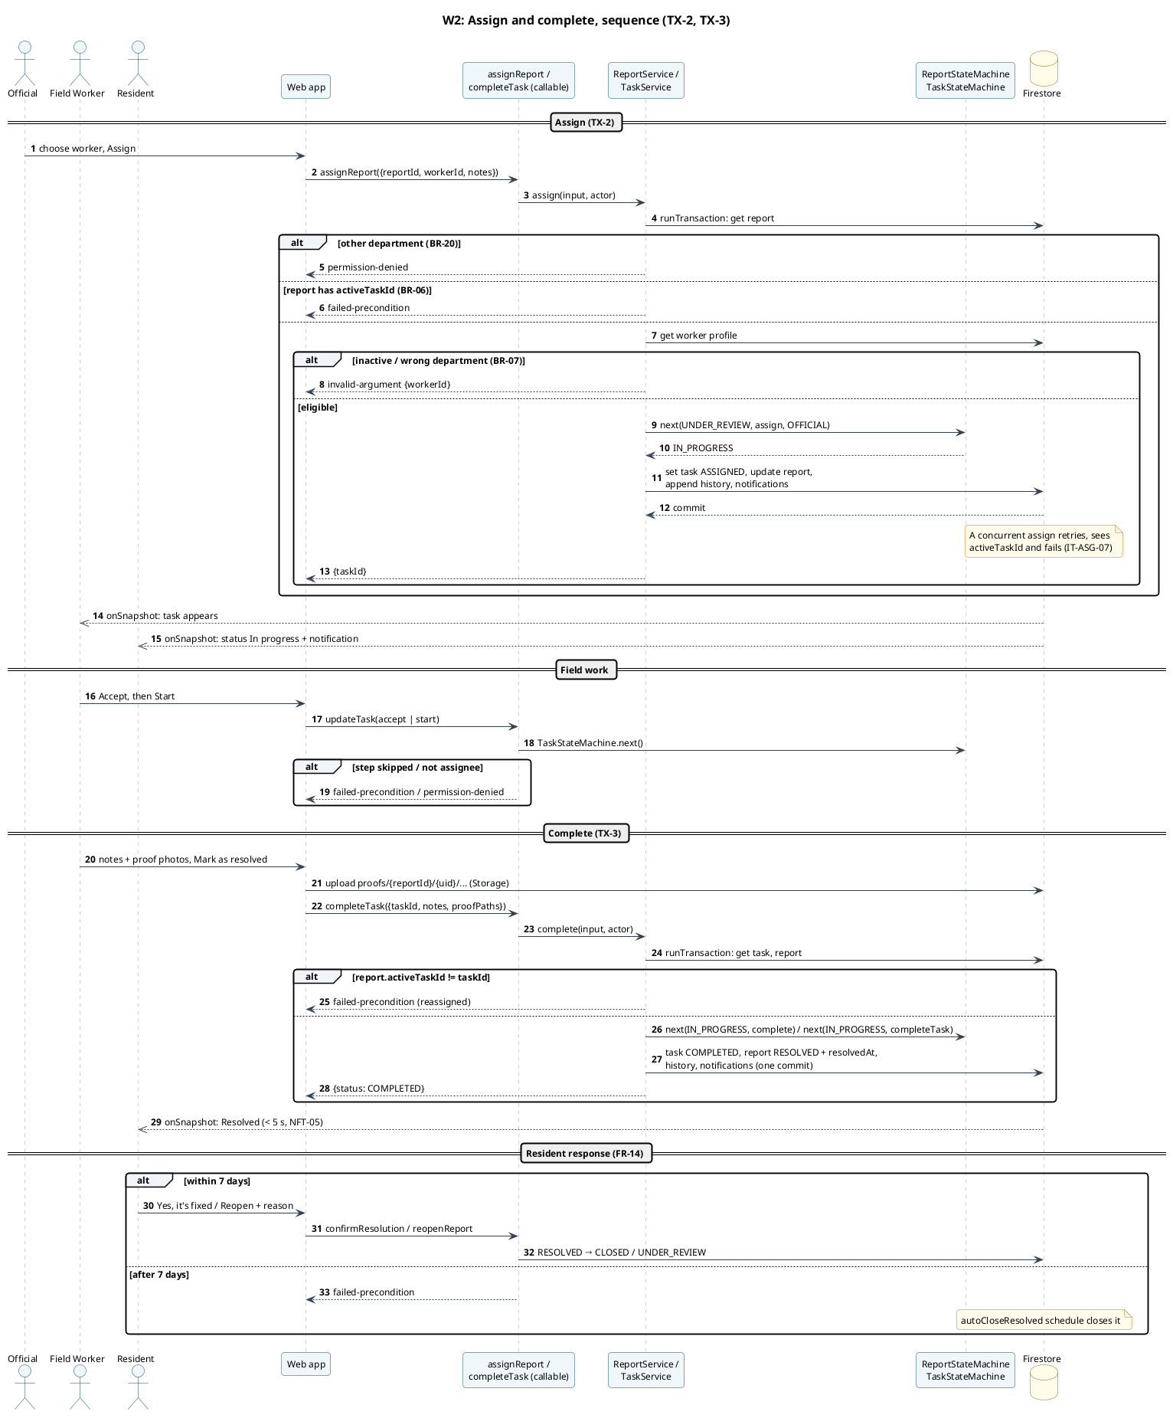
Figure 6: Sequence diagram, W2 assign and complete

Entity lifecycles
The Report has a meaningful lifecycle with eight states (Figure 7), implemented in ReportStateMachine in the shared package. Both the server (to enforce transitions) and the user interface (to offer only valid actions) use it. The Task lifecycle (Figure 8) is implemented in TaskStateMachine.
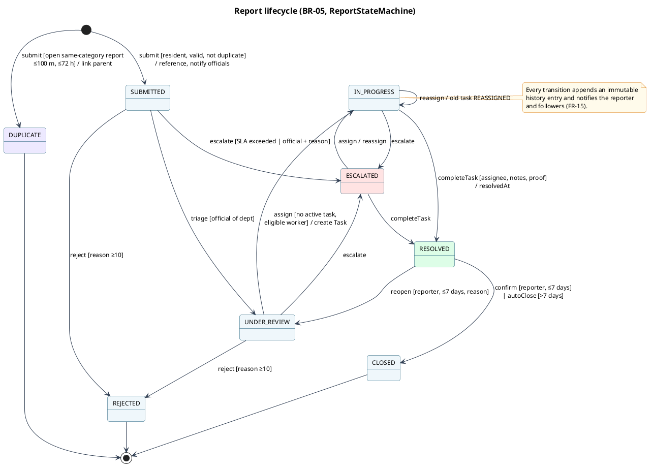
Figure 7: State diagram of the Report entity
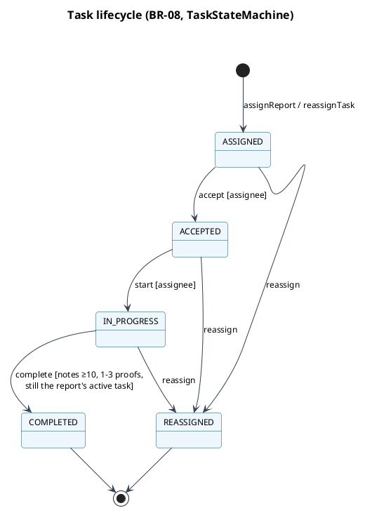
Figure 8: State diagram of the Task entity

System Architecture and Technology Stack
CivicLink follows a command–query separation on a serverless backend (Figure 9).
- Reads are made directly from Firestore through real-time listeners, protected by Security Rules.
- State changes go through callable Cloud Functions. These authenticate the caller, check the role, validate the input with the shared schemas, and run the business logic in Firestore transactions.
- Domain logic (schemas, state machines and policies) lives in a shared TypeScript package used by both the browser and the server.
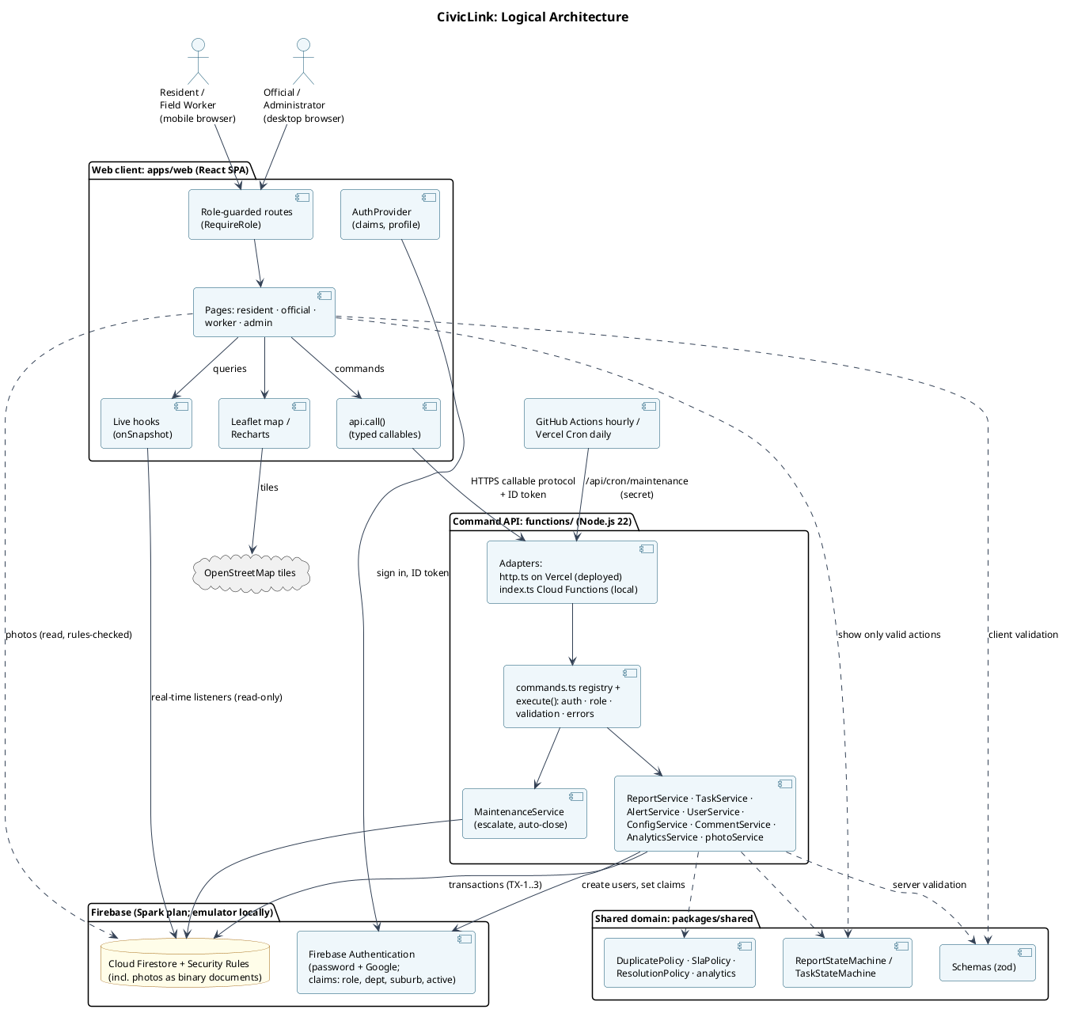
Figure 9: Logical architecture
Table 8: Component responsibilities and technology stack
Component | Technology | Responsibility
Web application | React 19, TypeScript, Vite, React Router, Tailwind CSS | Role-specific user interfaces, client-side validation, real-time views
Maps | Leaflet 1.9 with OpenStreetMap tiles | Location capture (GPS or draggable pin) and incident maps
Charts | Recharts 3 | Analytics visualisation
Command API | Node.js 22 command registry with two adapters: Vercel serverless functions (deployed) and Cloud Functions (local emulator) | Authentication and role checks, validation, business rules, transactions, notifications
Scheduled jobs | GitHub Actions (hourly) and Vercel Cron (daily) calling a secret-protected endpoint; Cloud Functions scheduler locally | SLA escalation, auto-close
Shared domain package | TypeScript, Zod 4 | Schemas, report/task state machines, duplicate, SLA and resolution policies, analytics
Database | Cloud Firestore | Persistent documents, real-time listeners, transactions
Photo storage | Cloud Firestore binary documents (photos) | Report and proof photos, compressed in the browser (decision D3)
Authentication | Firebase Authentication with custom claims | Email/password sign-in, role, department, suburb and active-account claims
Access control | Firestore Security Rules | Server-side enforcement of the permission matrix
Runtime: deployed | Vercel (static site + Node serverless functions, Cape Town region) and Firebase Spark (Auth, Firestore) | Free-tier production configuration (decision D3)
Runtime: local | Firebase Emulator Suite | Local Auth, Firestore and Functions for development, tests and offline demonstration
Testing / CI | Vitest, @firebase/rules-unit-testing, Playwright, axe-core, GitHub Actions, gitleaks | Automated verification

Key Architecture and Design Decisions
D1: All state changes go through server-side commands (ADR-0001).
- Context: the core rules span several documents: allocating a reference, the 100 m duplicate search, one active task per report, and resolving a report when its task completes.
- Options: (a) clients write to Firestore directly, guarded only by Security Rules; (b) callable Cloud Functions running transactions, with rules allowing only reads; (c) a custom Node/Express API with PostgreSQL.
- Decision: (b).
- Rationale: Security Rules cannot express multi-document transactional rules. (b) keeps a single enforcement point and still gets real-time reads from Firestore listeners. (c) would mean rebuilding authentication, real-time updates and storage, and abandoning three phases of design.
- Consequences: clean separation and testable services, and concurrency is handled by Firestore transactions. On the other hand, Firestore has no foreign-key constraints, so integrity depends on transactions and rules (Section 5.6), and deployed functions require Firebase's paid Blaze plan.
D2: React single-page application instead of Next.js (ADR-0002).
- Context: four role-specific interfaces, mobile-first for residents and workers.
- Options: Next.js, React with Vite, Flutter.
- Decision: React + Vite + React Router.
- Rationale: all data comes from the Firebase SDK in the browser, so server rendering adds complexity for no benefit. A static single-page app deploys to Firebase Hosting, and Phase 3 already used React Router conventions.
- Consequences: simple hosting and a fast build. Search-engine indexing is irrelevant for an authenticated application.
D3: Free-tier deployment: Firebase Spark, a Node API on Vercel, and photos stored in Firestore (ADR-0006).
- Context: the system had to be deployable without cost. Cloud Functions and Cloud Storage both require Firebase's paid Blaze plan.
- Options: (a) Blaze with a budget alert; (b) port to Supabase; (c) keep the free Spark plan (Auth, Firestore), serve the command API from a free Node host, and store photos in Firestore.
- Decision: (c). Vercel serverless functions run the API next to the static web app; photos are compressed to ≤ 700 KB and stored as binary documents.
- Rationale: the commands were already transport-independent, so a second adapter reuses every service unchanged and speaks the same callable protocol (the client only switches its URL). Vercel's free functions do not sleep, which matters in a live demonstration. A Supabase port would have meant rewriting the backend and about 90 tests.
- Consequences: two adapters must stay equivalent, so CI runs the complete E2E suite through both. Photo size is bounded by Firestore's 1 MiB document limit, and each photo view is one document read. The hourly SLA job runs from GitHub Actions, because Vercel's free cron is daily. The local emulator configuration remains for development, tests and an offline demonstration.
D4: Leaflet and OpenStreetMap instead of Google Maps (ADR-0004).
- Context: residents must pinpoint incidents, and staff must see them.
- Options: Google Maps with Geocoding, Mapbox, Leaflet with OpenStreetMap.
- Decision: Leaflet with OpenStreetMap.
- Rationale: no API key or billing is needed, and the suburb, which drives alert targeting, is chosen from a list anyway.
- Consequences: there is no reverse geocoding, so officials rely on the pin and the landmark text. Tile usage must follow the OpenStreetMap policy, which suits low volumes.

Application Class Design
Figure 10 shows the implemented classes in two parts. The complete single diagram is docs/diagrams/class.png. The classes fall into three groups:
- Domain entities (packages/shared/src/models.ts), stored as Firestore documents.
- Domain logic (packages/shared/src): ReportStateMachine and TaskStateMachine define the allowed transitions; DuplicatePolicy (100 m, 72 h), SlaPolicy and ResolutionPolicy (7 days) are pure, fully unit-tested rules.
- Application services (functions/src/services), described below.
How the services fit together:
- Entry point: every callable is wrapped by command(), which authenticates the caller, loads their profile (refusing deactivated accounts), checks the role, validates the input and maps errors.
- Report and task services: ReportService implements submission (TX-1), triage, rejection, escalation, assignment (TX-2), reassignment, confirmation and reopening. TaskService implements the field-worker steps and completion (TX-3).
- Single path for status changes: both services use ReportLifecycle.applyTransition, so every status change is validated by the state machine, recorded in the history, reflected in the public projection and notified.
- Other services: AlertService, UserService, ConfigService, CommentService, AnalyticsService and MaintenanceService implement the remaining capabilities.
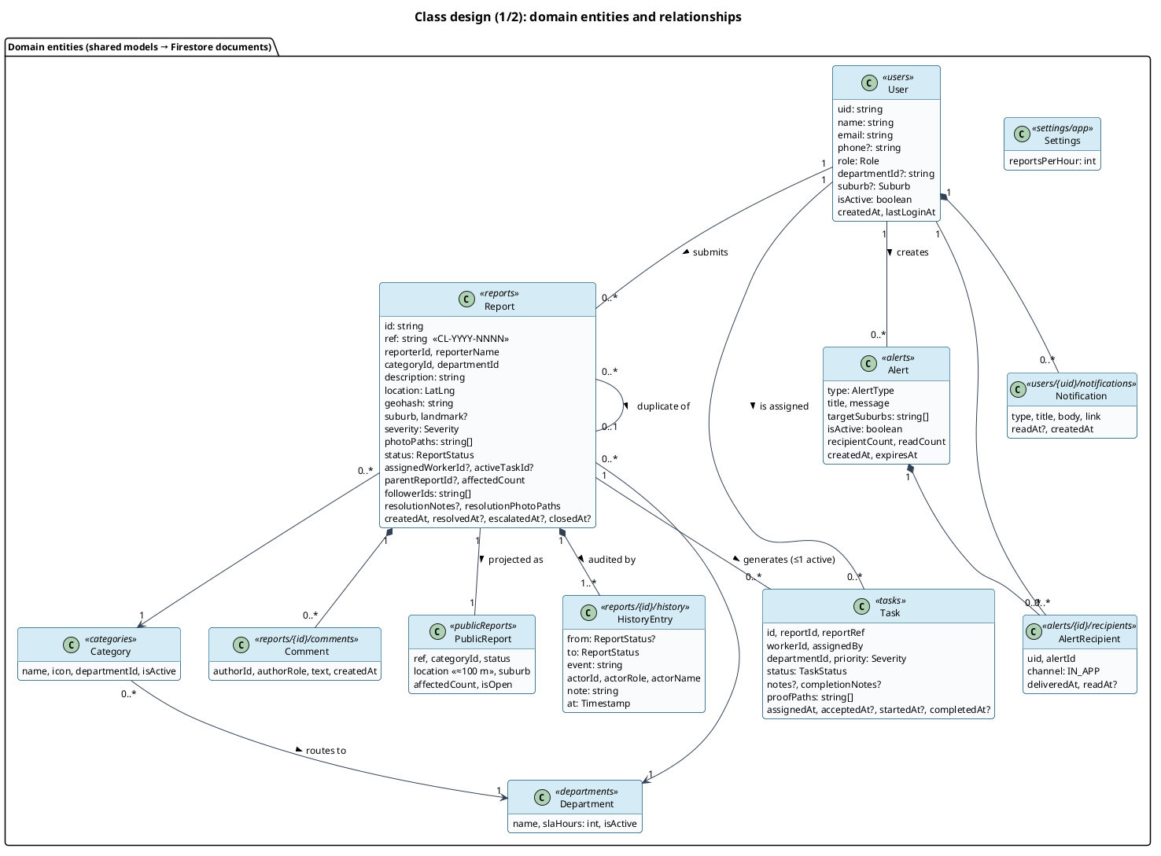
Figure 10a: Class diagram (part 1), domain entities and relationships
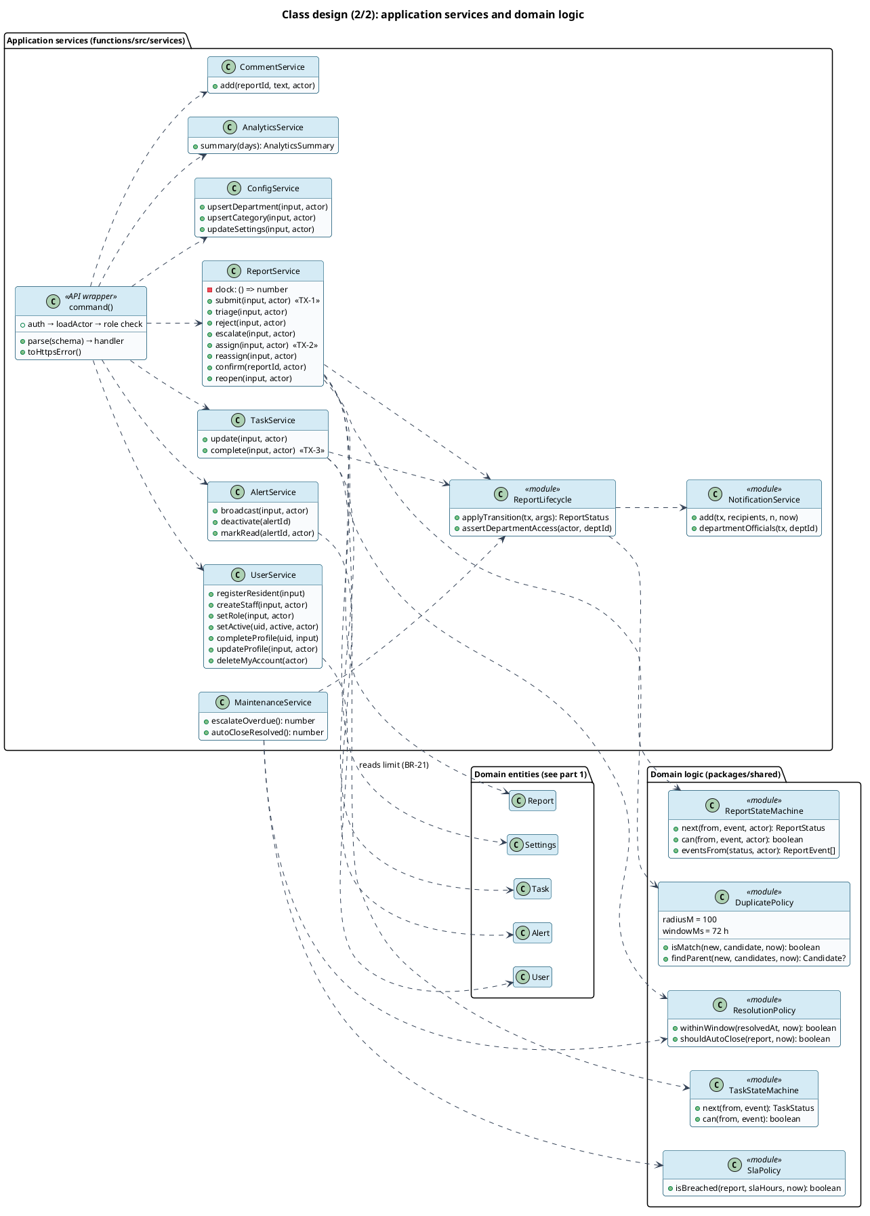
Figure 10b: Class diagram (part 2), application services and domain logic

User Interface and Interaction Design
There are four user roles, each with its own area:
- Residents use a mobile layout with a bottom navigation bar (Home, Map, Report, My reports, Alerts).
- Field workers use the same mobile layout, coloured green and reduced to their task list.
- Officials and administrators use a desktop layout with a sidebar.
Every screen handles loading, empty, error and permission-denied states. The screenshots below were captured from the submitted system with the seeded data (tests/evidence/capture.spec.ts). The photos in them are illustrative sample images.
Table 9: User interface evidence
Figure | User | Purpose and main action | Requirement / workflow
11 | Any | Sign in; demo-account shortcuts in the emulator | FR-02
12 | Resident | Three-step report: details with map pin, suburb, description, severity and photo | FR-03, W1
13 | Resident | Validation errors before submission | BR-02, NFR-03
14 | Resident | Duplicate detected; resident follows the original report | FR-05, W1 alternative path
15 | Official | Department dashboard with KPIs and reports needing action | FR-08
16 | Official | Triage and assignment, with history and internal notes | FR-09, FR-10, W2
17 | Field worker | Task completion with notes and proof photo | FR-11, W2
18 | Resident | Completed state: resolved report with proof, confirm or reopen | FR-06, FR-14
19 | Official | Alert composition with a live resident preview | FR-16
20 | Resident | Suburb alerts feed (strike emergency pinned first) | FR-17
21 | Official | Analytics computed from live data | FR-19
22 | Administrator | User and role management | FR-20
23 | Resident | Permission denied when opening an official page | NFR-01
24 | Official | Empty state in the report queue | FR-08
25 | New resident | First Google sign-in completes the profile | FR-29
26 | Resident | Profile editing and POPIA account deletion | FR-31, FR-32

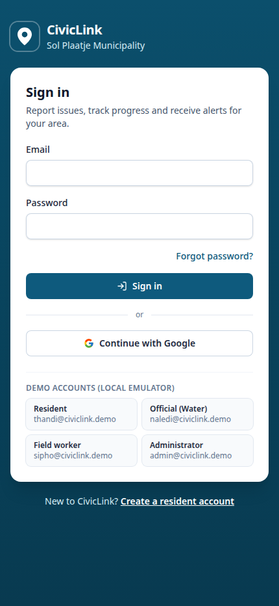 | 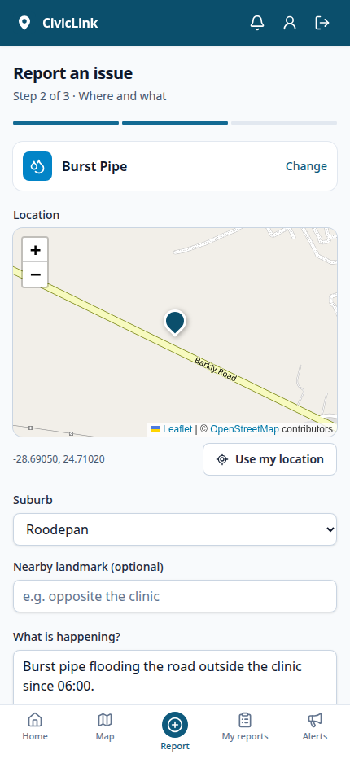 | 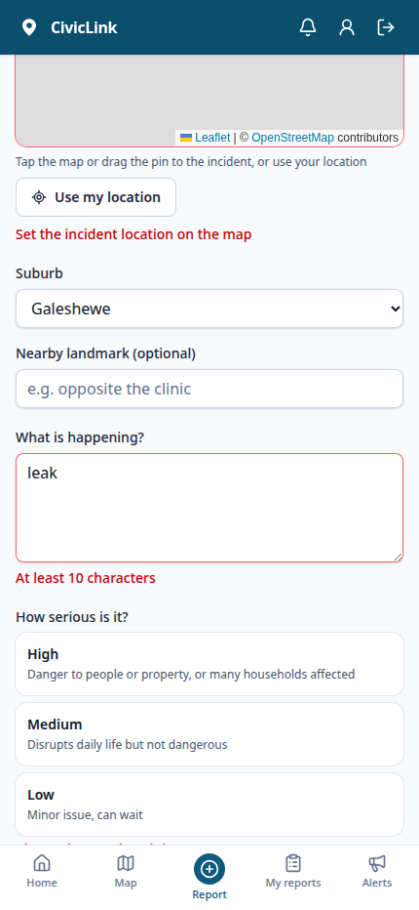
Figure 11: Sign in (all roles) | Figure 12: Resident, report step 2 (location, details and photo) | Figure 13: Resident, validation errors

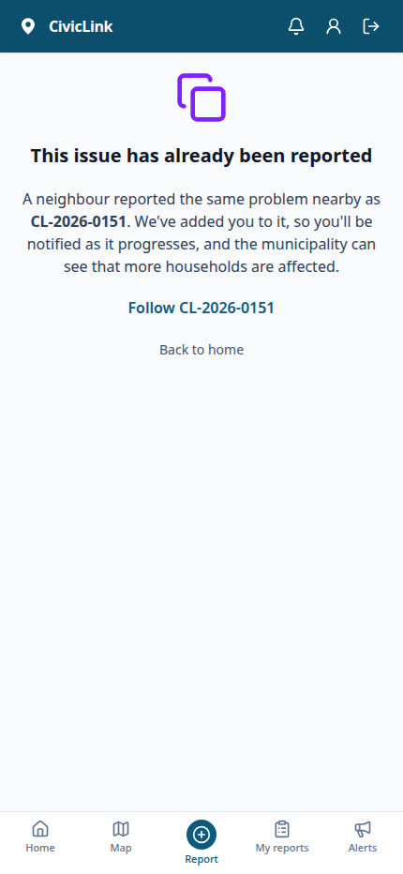
Figure 14: Resident, duplicate report detected

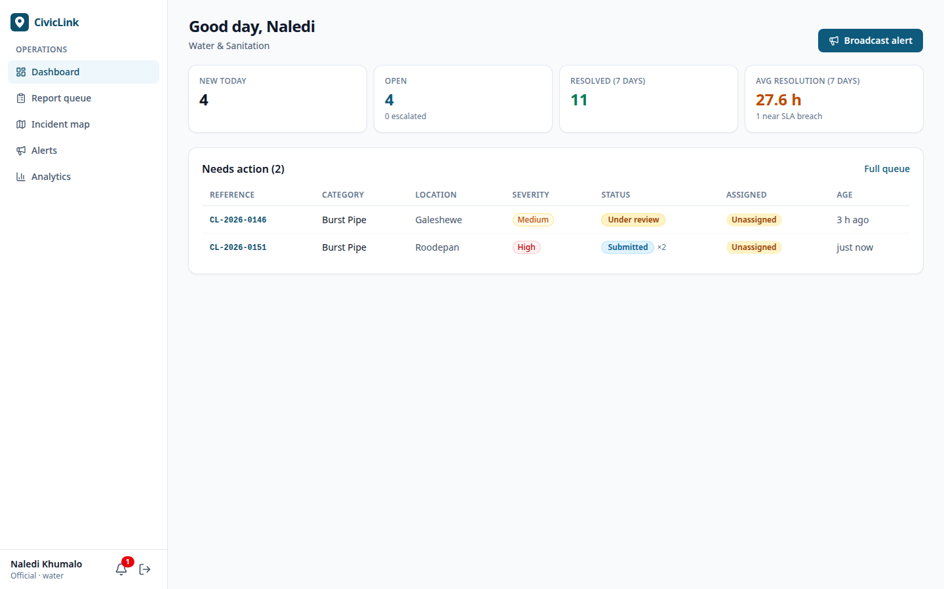
Figure 15: Official dashboard
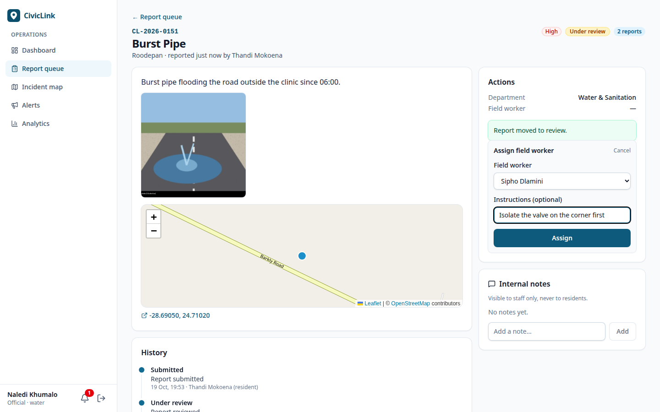
Figure 16: Official, triage and assignment
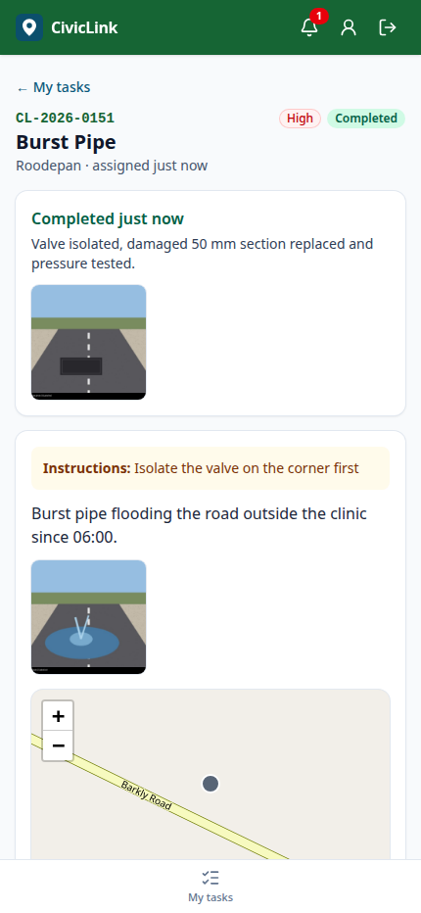 | 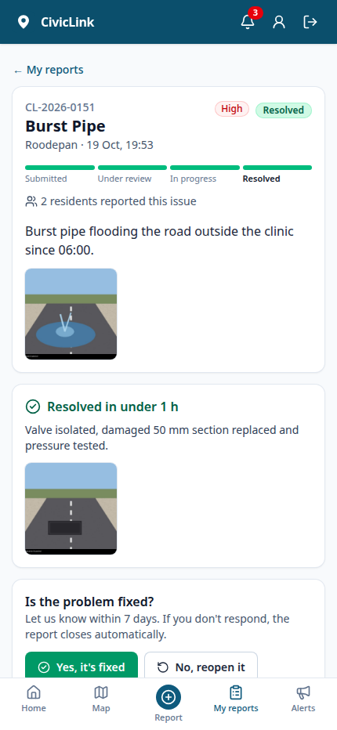
Figure 17: Field worker, completion with proof | Figure 18: Resident, resolved report with proof and confirm/reopen

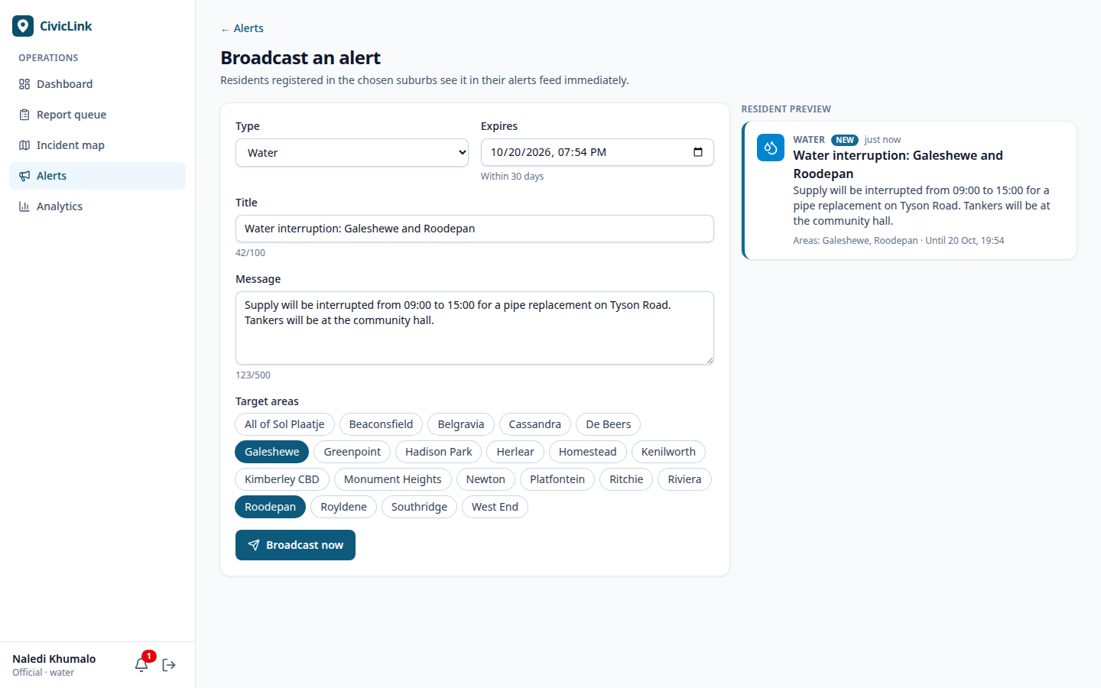
Figure 19: Official, alert composer with preview
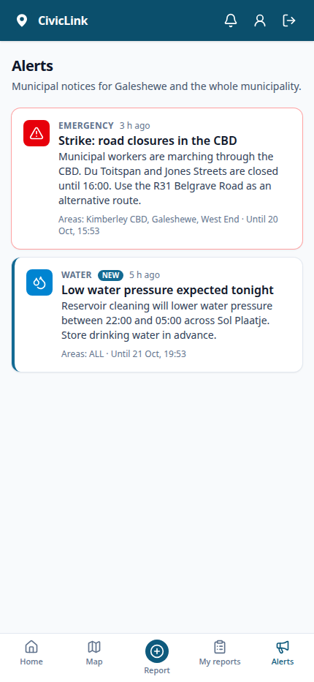
Figure 20: Resident, alerts feed

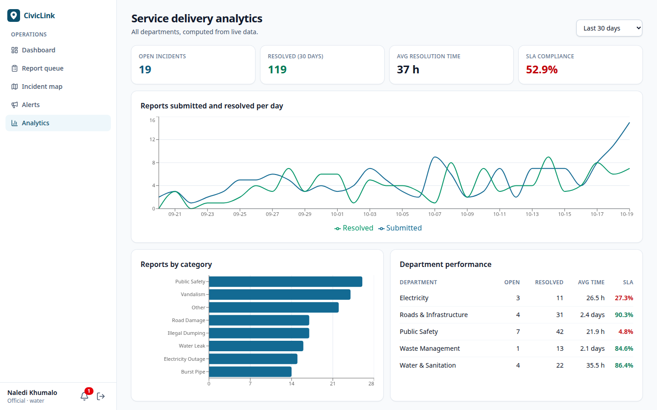
Figure 21: Service-delivery analytics
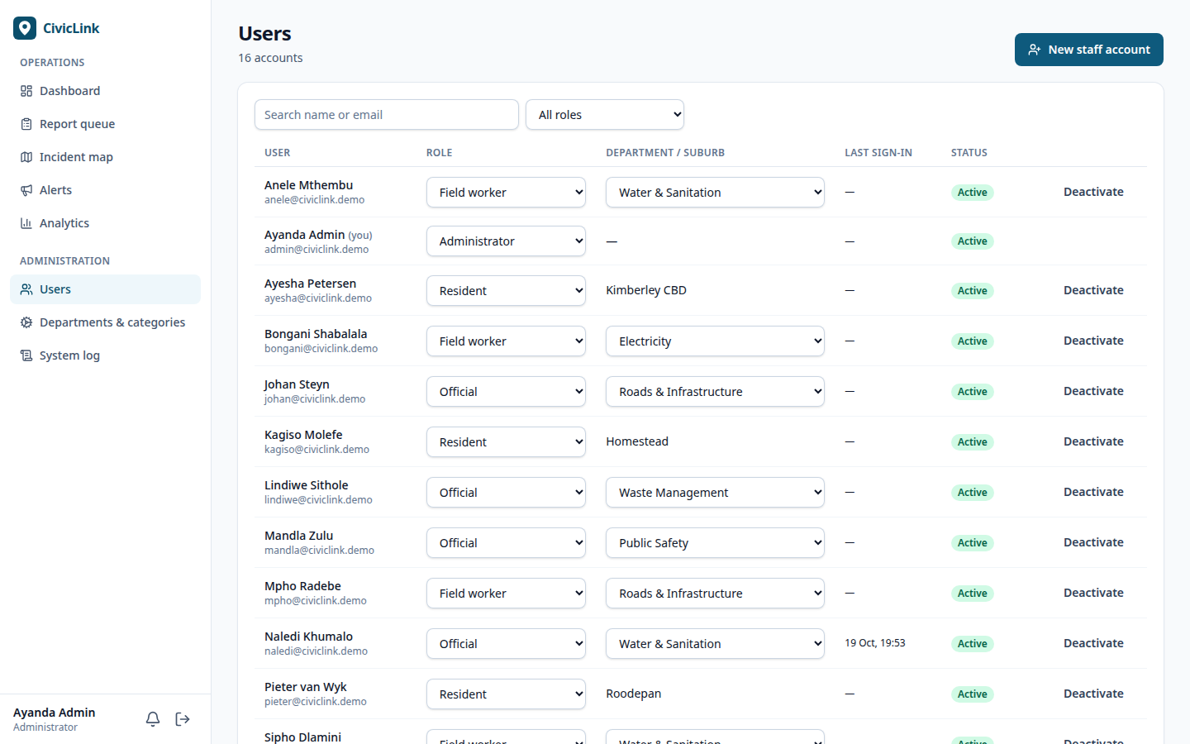
Figure 22: Administrator, user management
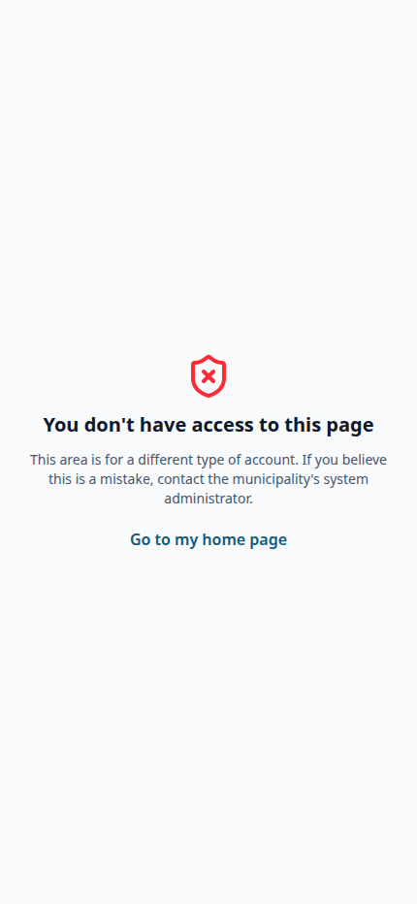
Figure 23: Permission-denied state

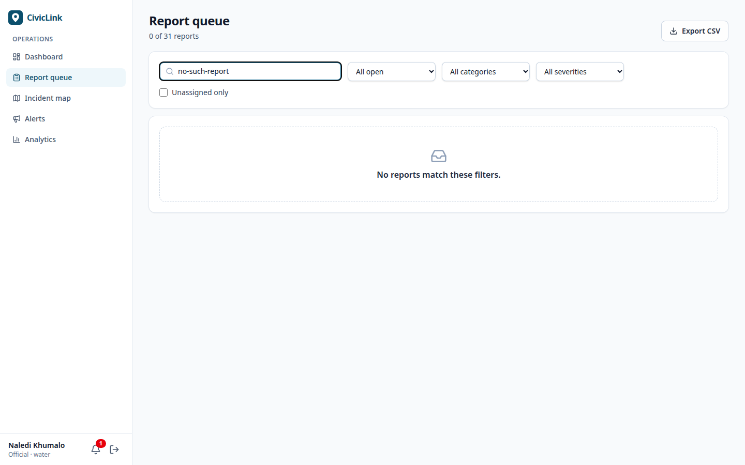
Figure 24: Empty state in the report queue
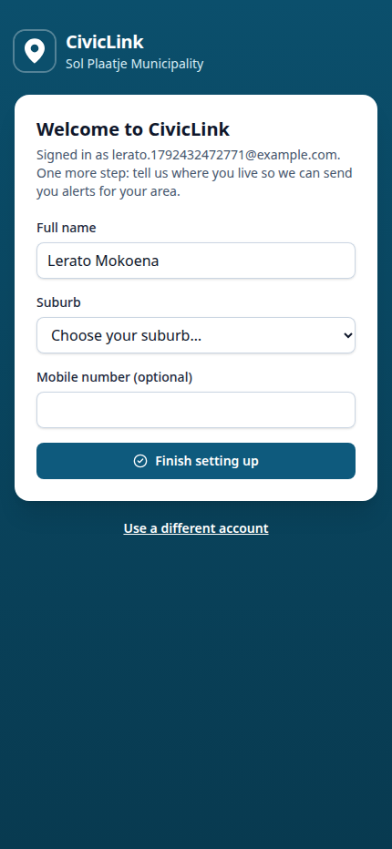 | 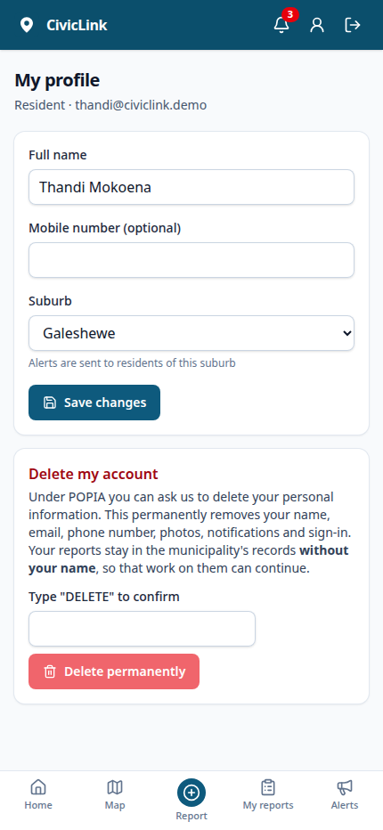
Figure 25: First Google sign-in, profile completion | Figure 26: Resident profile with POPIA account deletion

Data Design
CivicLink stores its persistent data in Cloud Firestore, a document database with real-time listeners and ACID transactions. Photos are stored in Firestore as well, as binary documents in the photos collection (decision D3), so the system needs no separate file store. Figure 27 shows the implemented document model. Collections are shown as entities; references between documents (Firestore has no foreign keys) are shown as relationships with their cardinalities.
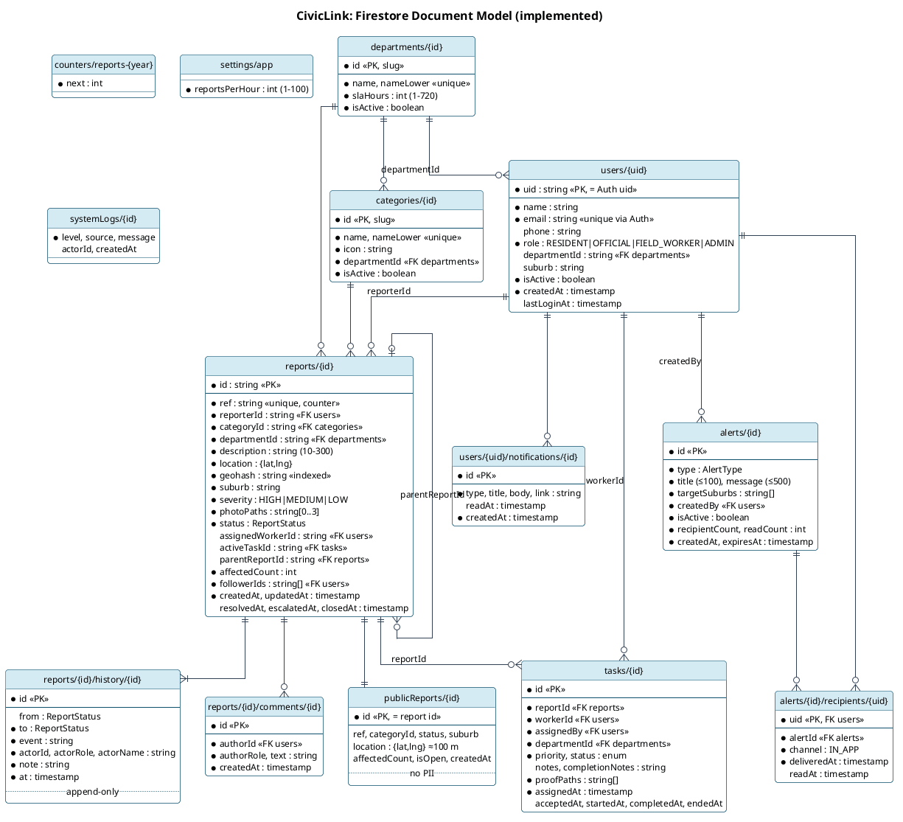
Figure 27: Firestore document model
Table 10: Data dictionary (principal collections)
Collection / field | Type | Key / required | Purpose
users/{uid} |  | uid = Auth user id (PK) | Profile for every account
name, email | string | required | Display name; sign-in email (unique in Firebase Auth)
role | enum RESIDENT, OFFICIAL, FIELD_WORKER, ADMIN | required | Authorisation, mirrored as a custom claim
departmentId | string | FK departments; required for officials and workers | Department scope (BR-20)
suburb | string | required for residents | Alert targeting (BR-14)
isActive | boolean | required | Deactivation (BR-16)
reports/{id} |  | auto id (PK) | Incident report
ref | string | required, unique | CL-YYYY-NNNN (BR-04)
reporterId, reporterName | string | FK users, required | Reporter (staff-only visibility)
categoryId, departmentId | string | FK, required | Routing
description | string (10–300) | required | Resident description
location, geohash | {lat,lng}, string | required | Map position; geohash for the 100 m duplicate query
suburb, landmark | string | suburb required | Human-readable location
severity | enum HIGH, MEDIUM, LOW | required | Priority of the resulting task
photoIds | string[0..3] | required (may be empty) | Ids of evidence photos (photos)
status | enum (8 states) | required | Lifecycle (Figure 7)
assignedWorkerId, activeTaskId | string | FK, optional | Current assignment (BR-06)
parentReportId, followerIds, affectedCount | string, string[], int | optional / required | Duplicate linkage (BR-03)
resolutionNotes, resolutionPhotoPaths | string, string[] | optional | Copied from the completed task
createdAt, updatedAt, resolvedAt, escalatedAt, closedAt | timestamp | createdAt/updatedAt required | Lifecycle times, SLA and analytics
reports/{id}/history/{id} |  | auto id | Append-only audit trail: from, to, event, actorId, actorRole, actorName, note, at
reports/{id}/comments/{id} |  | auto id | Internal notes: authorId, authorRole, text, createdAt
publicReports/{id} |  | id = report id | Privacy-safe projection: ref, category, status, location rounded to about 100 m, suburb, isOpen
tasks/{id} |  | auto id | Assignment: reportId (FK), workerId (FK), assignedBy, departmentId, priority, status, notes, completionNotes, proofPaths, timestamps
alerts/{id} |  | auto id | type, title (≤ 100), message (≤ 500), targetSuburbs[], createdBy (FK), isActive, recipientCount, readCount, createdAt, expiresAt
alerts/{id}/recipients/{uid} |  | uid (PK, FK users) | Delivery record: channel, deliveredAt, readAt
users/{uid}/notifications/{id} |  | auto id | type, title, body, link, readAt, createdAt
departments/{id}, categories/{id} |  | slug id | name (unique), slaHours (1–720) / icon and departmentId (FK), isActive
photos/{id} |  | auto id | reportId (FK), ownerId (FK users), kind EVIDENCE/PROOF, contentType, size, data (bytes ≤ 700 KB), createdAt; readable by whoever can read the report
counters/reports-{year} |  | year | next reference sequence
settings/app |  | fixed id | reportsPerHour (BR-21)
systemLogs/{id} |  | auto id | level, source, message, actorId, createdAt

Integrity mechanisms. Firestore enforces no schema, so integrity is enforced in five ways:
- Server-only writes. Clients cannot write reports, tasks, history, alerts or configuration at all; they may only stamp their own last-login time and mark their own notifications read.
- Shared schema validation. Every command validates its input with the same Zod schemas the forms use.
- Transactions. TX-1 (submission: reference counter, duplicate search, report, history, projection, notifications), TX-2 (assignment: one-active-task check, eligible worker, task, report, history) and TX-3 (completion: task and report resolved together) each commit atomically. Firestore retries a transaction on contention, so of two concurrent assignments only one can succeed (test IT-ASG-07).
- Append-only history. History entries are never updated or deleted.
- Stable references. Departments and categories are deactivated rather than deleted (BR-19), so existing references stay valid.
Data-organisation decisions:
- History, comments, recipients and notifications are subcollections, so their access rules follow the parent document.
- Duplicated fields (names, category names) avoid extra reads in lists, accepting that a renamed user keeps their old name on past records.
- A geohash field supports the 100 m proximity query, and composite indexes are declared in firestore.indexes.json.

Security, Privacy and Access Control
Authentication. Users sign in with email and password through Firebase Authentication. Passwords are never stored by CivicLink. On registration or role change, the server sets signed custom claims (role, dept, suburb, active), which the Security Rules use. Every command also reloads the caller's profile and refuses deactivated accounts. Deactivation additionally disables the Auth account and revokes its sessions. The client refreshes its token when an administrator changes the user's role.
Table 11: Role / permission matrix (✓ allowed; scope in brackets)
Function | Resident | Official | Field Worker | Administrator
Register, sign in (password or Google), reset password, edit own profile | ✓ | ✓ (no registration) | ✓ (no registration) | ✓ (no registration)
Delete own account (POPIA) | ✓ | — | — | —
Submit report; view own reports; confirm/reopen | ✓ | — | — | —
View community map | ✓ | ✓ | — | ✓
View report queue and full report details | — | ✓ (own dept) | ✓ (assigned) | ✓
Triage, reject, assign, reassign, escalate | — | ✓ (own dept) | — | ✓
Accept, start, complete task | — | — | ✓ (own tasks) | —
Internal comments | — | ✓ (own dept) | ✓ (assigned) | ✓
Broadcast / end alert; alert history | — | ✓ | — | ✓
View alerts feed | ✓ (own suburb) | ✓ | — | ✓
Analytics | — | ✓ | — | ✓
Manage users, departments, categories; system log | — | — | — | ✓

Table 12: Security controls
Area | Risk | Implemented control
Authentication | Unauthorised access | Firebase Authentication with email/password (minimum 8 characters) or Google; signed ID tokens on every request; new Google users can only become Residents
Account enumeration | Attackers discover which emails are registered | Password reset and sign-in errors give the same message whether or not an account exists
Abuse | Flooding the queue with fake reports | Configurable per-resident hourly limit enforced inside the submission transaction (BR-21)
Authorisation | A user reaches another role's data or functions | Firestore Security Rules per the matrix (photos inherit their report's access); role and department checks in every command; client route guards for usability only
Account lifecycle | A deactivated user keeps access | Auth account disabled, refresh tokens revoked, profile check on every command
Input | Malicious or invalid data | Zod schemas on the server; geographic bounds; length limits; photo size limit and real-type check from magic bytes, so renamed or script-bearing files (e.g. SVG) are refused; request body limited to 4 MB
Integrity | Race conditions or partial updates | Firestore transactions TX-1 to TX-3; append-only history; no client writes
File uploads | Malicious or oversized files | Photos accepted only through commands, re-checked server-side (type sniffing, ≤ 700 KB); never served as HTML; displayed from bytes with an explicit image content type
Sensitive data (POPIA) | Exposure or indefinite retention of residents' identity, location or photos | Reports readable only by the reporter, followers and staff; public map uses an anonymised projection with location rounded to about 100 m; minimal data collected; processing region africa-south1; residents can erase their personal data (FR-32), leaving anonymised service records (BR-22)
Secrets | API key or credential exposure | Service-account key and cron secret only in Vercel's encrypted environment; none in the repository (.env.example lists names only); gitleaks scan in CI; the cron endpoint compares the secret in constant time
Error handling | Leaking internals | Unexpected errors return a generic message and are written to the system log
Logging and audit | Unaccountable actions | Immutable status history with actor; administrator actions and errors in the system log

Data classification.
Data | Class | Visible to
Names, emails, phone numbers | Personal | Owner, staff
Report photos and exact locations | Personal (may identify a home) | Reporter, staff
Report category, status and approximate location | Public | All signed-in users
Passwords | Secret | Firebase Auth only

Deployment and Runtime Design
CivicLink has two runtime configurations built from the same code (Figure 28):
- Deployed (free tier): the static web app and the Node command API run on Vercel (serverless functions in the Cape Town region). Authentication and Firestore run on Firebase's free Spark plan. The API uses a service-account key held in Vercel's encrypted environment. A GitHub Actions schedule calls the protected maintenance endpoint hourly, and Vercel Cron calls it daily. The deployed URL is given in Appendix 11.2.
- Local: the web app runs on Vite. Auth, Firestore and Cloud Functions run in the Firebase Emulator Suite on one machine, with the same command registry served by the Cloud Functions adapter. This configuration is used for development, all automated tests and an offline demonstration.
In both configurations the browser loads map tiles from OpenStreetMap over HTTPS.
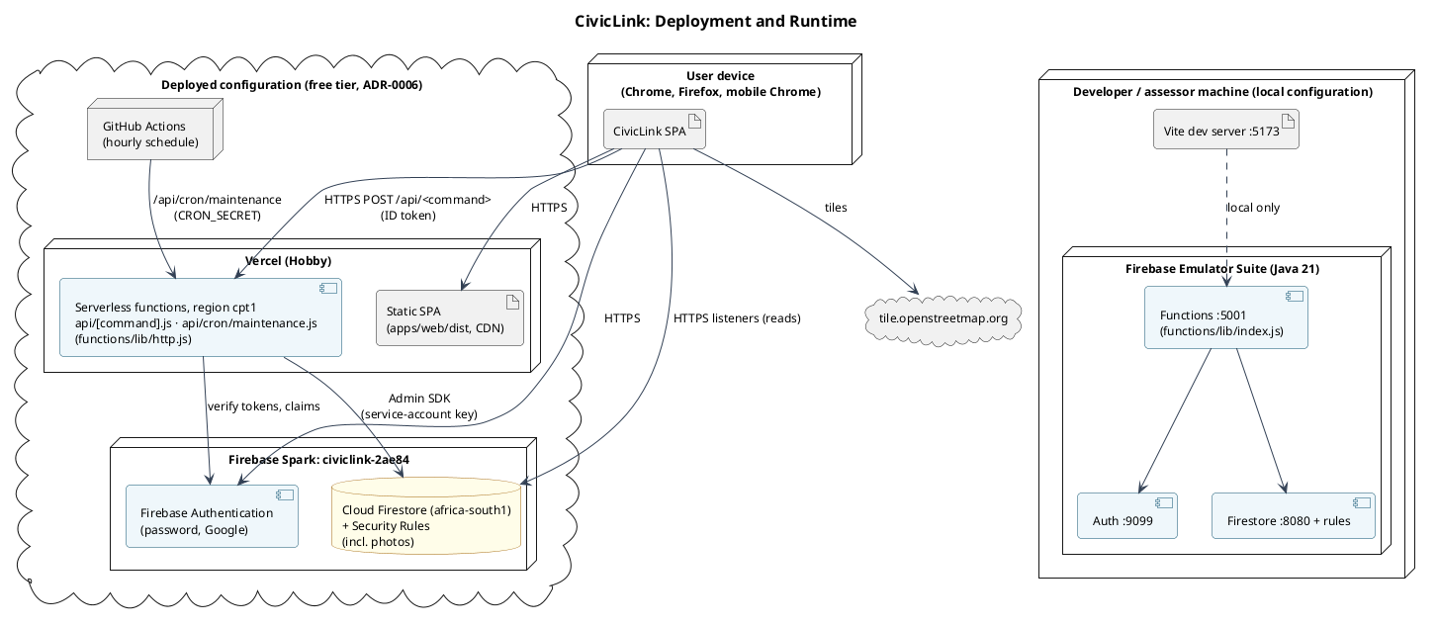
Figure 28: Deployment diagram

SYSTEM IMPLEMENTATION

Codebase and Repository Structure
The repository is an npm-workspaces monorepo. Each top-level folder corresponds to one component of the architecture in Figure 9.
Table 13: Repository structure
Path | Architecture component | Contents
apps/web/ | Web application | src/pages/{auth,resident,official,worker,admin,common}, src/components (UI kit, maps, timeline, notification bell), src/auth (AuthProvider, RequireRole), src/lib (Firebase setup, typed API client, live hooks, uploads)
functions/ | Command API and schedules | src/index.ts (callable and scheduled exports), src/lib/command.ts (auth/role/validation wrapper), src/services/* (business services), test/ (integration tests)
packages/shared/ | Shared domain package | src/schemas.ts, stateMachines.ts, policies.ts, analytics.ts, models.ts, constants.ts; test/ (unit tests)
firestore.rules, firestore.indexes.json | Access control and indexes | Security Rules and composite indexes
api/, vercel.json, functions/src/http.ts, functions/src/commands.ts | Deployed API | Vercel entry points; Node HTTP adapter; the single command registry shared with Cloud Functions
scripts/seed.ts | Data initialisation | Deterministic demonstration data
tests/rules, tests/e2e, tests/evidence, tests/support | Verification | Rules tests, Playwright tests, screenshot capture, emulator harness
docs/ | Documentation | Baseline SRS, change log, ADRs, diagrams (source and rendered), traceability matrix, test catalogue, defect log, evidence, report

The principal dependency and build files are the root package.json (workspaces, scripts), the per-workspace package.json files, package-lock.json, firebase.json (emulators, hosting, functions), tsconfig.base.json, vitest.config.ts, playwright.config.ts, eslint.config.js and .github/workflows/ci.yml. Cloud Functions are bundled with esbuild, so the shared package is included in the deployable artefact.

Implementation of Core Capabilities
Table 14: Capability implementation
Capability | Requirement(s) | Main implementation components
Register and sign in | FR-01, FR-02 | RegisterPage, LoginPage, AuthProvider, RequireRole; registerResident → UserService; command()/loadActor; users, Auth claims
Submit report with duplicate detection | FR-03–FR-05 | NewReportPage, LocationPicker, upload.ts; submitReport → ReportService.submit (TX-1), DuplicatePolicy, formatReference; reports, history, publicReports, counters, photos (photoService: decode, size, type sniffing)
Track reports | FR-06, FR-15 | MyReportsPage, ResidentReportPage, Timeline, NotificationBell, useLiveQuery/useLiveDoc listeners; reports, history, notifications
Triage and dispatch | FR-08–FR-10, FR-12, FR-13 | ReportQueuePage, OfficialReportPage; ReportService.triage/reject/assign (TX-2)/reassign/escalate; applyTransition; tasks, reports, history
Field completion | FR-11 | WorkerHome, TaskPage; updateTask, completeTask → TaskService (TX-3), TaskStateMachine; tasks, reports, photos
Confirm, reopen, SLA | FR-13, FR-14 | ResidentReportPage; ReportService.confirm/reopen; MaintenanceService with escalateOverdue and autoCloseResolved schedules and admin runMaintenance
Alerts | FR-16–FR-18 | NewAlertPage, AlertsAdminPage, AlertsFeedPage, useResidentAlerts; AlertService; alerts, recipients
Accounts | FR-01, FR-02, FR-29–FR-32 | LoginPage, RegisterPage, WelcomePage, ProfilePage, AuthProvider (Google popup, password reset); registerResident, completeProfile, updateProfile, deleteMyAccount → UserService; users, Auth claims, photos
Insight and administration | FR-19–FR-23, FR-26 | AnalyticsPage → AnalyticsService → computeAnalytics; UsersPage → UserService; ConfigPage → ConfigService; LogsPage, logService; CommentService; toCsv

Validation. Forms validate on the client with the same Zod schemas the server uses, and show field-level messages that clear as the user corrects them. The command() wrapper validates every request again and returns invalid-argument with a fields map, which the client displays against the matching inputs.
Business-rule enforcement. Status changes go through a single function, applyTransition. It calls ReportStateMachine.next(from, event, actor), which throws for invalid transitions or actors. It then updates the report, appends a history entry, updates the public projection and creates notifications, all within the caller's transaction. Rules that need a database read are re-checked inside the transaction, so a concurrent change causes a retry rather than a violation. Examples are BR-06 (activeTaskId), BR-07 (worker eligibility) and BR-03 (duplicate candidates).
Duplicate detection (BR-03). Each report stores a geohash. Submission queries the geohash ranges covering a 100 m radius (geofire-common) inside the transaction. The candidates are filtered by DuplicatePolicy (same category, open status, at most 72 hours old, exact haversine distance at most 100 m), and the closest match is chosen.
Error handling. Expected failures are raised as typed DomainErrors or state-machine errors and mapped to callable error codes (invalid-argument, failed-precondition, permission-denied, not-found, already-exists). Unexpected errors are logged and returned as a generic message. The client maps network and timeout errors to friendly messages, and every page has loading, empty, error and access-denied states.

APIs, Integrations and External Dependencies
Command API. The command API is a set of HTTPS callable functions, invoked with the user's ID token. Reads are not exposed as functions; clients read Firestore directly under the Security Rules.
Table 15: Callable command API
Command | Roles | Purpose | Notable errors
registerResident | public | Create resident account | already-exists, invalid-argument
completeProfile | signed in, no profile yet | Finish first Google sign-in as a Resident | already-exists
updateProfile | any role | Own name, phone; residents' suburb | invalid-argument, permission-denied
deleteMyAccount | Resident | POPIA erasure with anonymisation | invalid-argument (confirmation)
submitReport | Resident | TX-1 submission | invalid-argument, permission-denied
triageReport, rejectReport, escalateReport | Official, Admin | Lifecycle actions | failed-precondition, permission-denied
assignReport, reassignTask | Official, Admin | TX-2 dispatch | failed-precondition, invalid-argument
updateTask, completeTask | Field Worker | Task steps, TX-3 completion | failed-precondition, permission-denied
confirmResolution, reopenReport | Resident | Respond to resolution | failed-precondition
addComment | Staff | Internal note | permission-denied
broadcastAlert, deactivateAlert | Official, Admin | Alerts | invalid-argument
markAlertRead | Resident | Read receipt | not-found
createStaffUser, setUserRole, setUserActive | Admin | Accounts | permission-denied (self)
upsertDepartment, upsertCategory, updateSettings | Admin | Configuration, report limit | invalid-argument
getAnalytics | Official, Admin | Metrics | —
runMaintenance | Admin | Run SLA/auto-close on demand | —

External integrations.
- OpenStreetMap tiles are fetched by the browser over HTTPS. If tiles are unavailable, the map shows a blank background but still works: the pin, map clicks and coordinates function, and the report form, lists and timelines do not depend on tiles.
- Browser geolocation is optional. If permission is denied, or the position is outside the municipality, the user is told to drag the pin instead.
Two adapters, one API. functions/src/commands.ts defines all 26 commands once. index.ts exposes them as Cloud Functions (local emulator), and http.ts exposes them as a plain Node handler (Vercel). The Node adapter verifies the Firebase ID token (rejecting revoked sessions), limits the request size, and returns errors in the callable protocol. The client therefore uses httpsCallableFromURL with no other changes. In the local configuration, Firebase services come from the official Emulator Suite. No integration is mocked in the application code.

AI / Machine-Learning Component
Not applicable. CivicLink contains no AI or machine-learning component. Duplicate detection, SLA escalation and analytics are deterministic, rule-based functions that are fully specified in Section 4.3 and unit-tested.

VERIFICATION AND TESTING

Test Approach
Verification combines four automated levels and a set of non-functional checks. All of them run on every push in GitHub Actions (.github/workflows/ci.yml). Each test's identifier appears in its name, so every row in this section can be found in the code (for example, grep -r "IT-ASG-07").
Table 16: Test levels
Level | Tool | Scope | Count
Unit | Vitest | Shared domain: schemas, state machines, duplicate/SLA/resolution policies, location helpers, image sniffing, references, analytics, CSV (≈ 98% line coverage) | 30
Security rules | @firebase/rules-unit-testing on the emulator | Allow and deny case for every permission-matrix cell, including photos | 19
API integration | Vitest + Firebase client SDK against the emulators | Every command: success, validation, boundary, authorisation, state conflict and concurrency; the Node HTTP adapter | 74
End-to-end | Playwright (Chromium and Firefox; 360 px mobile) | Full lifecycle across three browser sessions, duplicates, alerts, access control, validation, out-of-area GPS, Google sign-in, password reset, profile and account deletion | 10 + 3 non-functional (run through both API adapters)
Non-functional | Playwright timing, axe-core, gitleaks, ESLint, TypeScript | NFR-04 to NFR-09, NFR-12 | —

Everything except visual review was tested automatically. Manual testing consisted of exploratory sessions in each role and a review of every screenshot in Section 5.5, including mobile layouts. Seeded data (scripts/seed.ts) gives every test run the same starting state.

Functional and Business-Rule Verification
The table below lists the principal test cases. The complete list of 136 automated tests, with their results, is produced by CI for the submitted commit (Appendix 11.3). All tests listed passed. "As expected" means the actual result matched the expected result exactly.
Table 17: Functional and business-rule test results
Test ID | Requirement / rule | Test scenario | Type | Expected result | Actual result | Status
E2E-01 | SC-01, FR-03–FR-14 | Resident submits → official triages and assigns → worker accepts, starts, completes with proof → resident sees Resolved and confirms | End-to-end | Report Closed; full timeline; updates live | As expected | Pass
IT-RPT-01 | FR-03, FR-04 | Valid submission with photo | Integration | Submitted, CL- reference | As expected | Pass
IT-RPT-02 | BR-02 | Short description and unknown suburb | Validation | invalid-argument with both field errors; nothing written | As expected | Pass
IT-RPT-03 | BR-02 | Location in Johannesburg | Boundary | Refused | As expected | Pass
IT-RPT-04 | BR-02 | Photo path of another user / missing file | Authorisation | Refused | As expected | Pass
IT-RPT-06 | BR-01 | Official, worker and anonymous submit | Authorisation | permission-denied / unauthenticated | As expected | Pass
IT-RPT-08 | BR-04, NFR-10 | 12 concurrent submissions | Concurrency | 12 unique, consecutive references | As expected | Pass
UT-DUP-01..04 | BR-03 | 99/100/101 m; 71/72/73 h; other category; closed original | Boundary | Duplicate only within 100 m, 72 h, same category, open | As expected | Pass
IT-RPT-09, E2E-02 | FR-05 | Second resident reports the same issue 33–60 m away | Integration / E2E | Linked as duplicate; original count 2; follower added | As expected | Pass
UT-RSM-01..03 | BR-05 | Every allowed and every disallowed (status, event, actor) | Unit | Only the transitions of Figure 7 succeed | As expected | Pass
IT-TRI-02 | BR-05 | Triage an already-reviewed report | State conflict | failed-precondition | As expected | Pass
IT-TRI-03 | BR-12 | Reject with a 2-character reason | Validation | Refused; valid reason → Rejected | As expected | Pass
IT-TRI-04 | BR-20 | Roads official triages a water report | Authorisation | permission-denied | As expected | Pass
IT-ASG-02, -03 | BR-07 | Assign to a roads worker / deactivated worker | Validation | Refused | As expected | Pass
IT-ASG-04 | BR-06 | Assign a report with an active task | State conflict | failed-precondition | As expected | Pass
IT-ASG-07 | NFR-10 | Two officials assign the same report simultaneously | Concurrency | Exactly one succeeds; one task exists | As expected | Pass
IT-ASG-08 | FR-12 | Reassign | Integration | Old task Reassigned, new task Assigned | As expected | Pass
IT-TSK-02 | BR-08 | Another worker accepts the task | Authorisation | permission-denied | As expected | Pass
IT-TSK-03 | BR-08 | Start before accept; complete before start | State conflict | failed-precondition | As expected | Pass
IT-TSK-04 | BR-09 | Complete with 2-character notes and no photo | Validation | invalid-argument | As expected | Pass
IT-TSK-06 | BR-09, NFR-10 | Complete a task reassigned while on site | Failure | Refused; report unchanged | As expected | Pass
IT-ESC-01 | BR-10 | Run schedule with clock 49 h after creation (SLA 48 h); run again | Boundary | Escalated once; second run no change | As expected | Pass
IT-RES-02 | FR-14 | Reporter reopens with a reason | Integration | Under Review; officials notified | As expected | Pass
IT-RES-03 | BR-11 | Respond 8 days after resolution; run schedule | Boundary | Refused; report auto-closed | As expected | Pass
IT-RES-04 | BR-11 | Another resident confirms | Authorisation | permission-denied | As expected | Pass
IT-ALR-01 | FR-16, BR-14 | Broadcast to Galeshewe | Integration | Delivery record only for the active Galeshewe resident | As expected | Pass
IT-ALR-03 | BR-13 | Title 101 chars; no suburbs; past expiry; expiry 31 days | Boundary | All refused | As expected | Pass
E2E-03 | FR-17, BR-14 | Galeshewe and Roodepan residents open alerts | End-to-end | Visible to Galeshewe only | As expected | Pass
IT-AUTH-02 | FR-01 | Duplicate email; 5-character password | Validation | already-exists / invalid-argument | As expected | Pass
IT-AUTH-03 | BR-16 | Admin deactivates a signed-in resident who then submits / signs in | Authorisation | Command refused; sign-in refused | As expected | Pass
IT-ADM-04 | BR-15 | Admin demotes or deactivates own account | Authorisation | permission-denied | As expected | Pass
IT-CFG-01 | FR-21 | SLA hours 0 / 721 / 96 | Boundary | 0 and 721 refused; 96 saved | As expected | Pass
IT-CFG-03 | BR-19 | Deactivate category, then submit with it | Integration | Refused | As expected | Pass
IT-ANL-01, UT-ANL-01 | FR-19, SC-05 | Metrics on fixture and after a new report | Integration | Counts, averages and SLA % exact; no NaN on empty data | As expected | Pass
E2E-04 | NFR-01 | Each role opens other roles' pages | End-to-end | Access-denied page; anonymous → login | As expected | Pass
E2E-05 | BR-02 | Submit report with short text, no location and no severity | Validation | Three field messages; cannot proceed | As expected | Pass
E2E-07 | FR-03, BR-02 | Device GPS reports Johannesburg | Boundary | Distance explained; no location set; tapping the map sets the pin and suburb | As expected | Pass
IT-RPT-11 | BR-21 | Limit set to 2; resident submits 3 reports | Boundary | Third refused (resource-exhausted) | As expected | Pass
IT-AUTH-04, E2E-08 | FR-29, BR-16 | First Google sign-in; client sends role ADMIN | Authorisation | Profile step required; account is a Resident; second completion refused | As expected | Pass
E2E-09 | FR-30 | Reset for a registered and an unregistered email | Security | Identical confirmation for both | As expected | Pass
IT-DEL-01, E2E-10 | FR-32, BR-22 | Resident deletes account (wrong confirmation, then DELETE) | Integration | Refused, then reports anonymised; photos, profile, receipts and Auth account removed; sign-in fails | As expected | Pass
IT-DEL-02 | BR-22 | Staff self-delete; triage an anonymised report | Authorisation | Refused; anonymised report progresses without notifications | As expected | Pass

Non-Functional and Security Verification
Table 18: Non-functional verification results
NFR | Test | Result | Status
NFR-01 Authorisation | RT-* (20 tests: every matrix cell, e.g. a resident cannot read another's report or list all reports, a roads official cannot read water reports, no client can write reports/tasks/history) and API authorisation tests | All denied cases denied; all allowed cases allowed | Pass
NFR-02 Authentication | RT-USR-02 (users cannot change their own role, department or active flag); review: no password fields in Firestore | Pass | Pass
NFR-03 Validation | IT-RPT-02, IT-TRI-03, IT-ALR-03, IT-CFG-01, E2E-05 | Field-level errors, no data written | Pass
NFR-04 Secrets | gitleaks over the full git history in CI | 0 findings | Pass
NFR-05 Propagation | NFT-05 inside E2E-01 | Submit → official queue 0.09 s; completion → resident screen 2.47 s (target 5 s) | Pass
NFR-06 Responsiveness | NFT-06 | Dashboard 1.10 s, queue 0.92 s, alerts 0.92 s (target 3 s); p95 of 50 commands 28 ms (target 2 s) | Pass
NFR-07 Mobile | NFT-07 at 360×640 on resident and worker screens; report form has 3 steps | No horizontal overflow | Pass
NFR-08 Accessibility | NFT-08 axe-core WCAG 2.1 A/AA on login, report form, my reports, queue | 0 violations (after DEF-03) | Pass
NFR-09 Compatibility | E2E suite on Chromium and Firefox in CI | All pass | Pass
NFR-10 Integrity | IT-RPT-08, IT-ASG-07, IT-TSK-06 | Atomic, exactly-once outcomes | Pass
NFR-11 Privacy | RT-RPT-03, RT-PUB-01, RT-PHO-01, RT-PHO-02, UT-PRV-01, IT-RPT-07 | No PII in public data; photos restricted | Pass
NFR-12 Maintainability | CI: ESLint, TypeScript strict, coverage threshold | 0 lint errors; 97.9% line coverage of the domain package | Pass

Timings were measured on the development laptop running the emulators, Vite and the browsers at the same time, which is the assessed configuration.

Defects and Known Issues
Table 19: Significant defects found and resolved
ID | Found by | Description | Resolution
DEF-01 | IT-CFG-02 | Creating a department whose name produced an existing identifier silently overwrote that department | Creation now refuses existing identifiers; updates require an existing record
DEF-02 | E2E-01 | Submissions with an empty optional field were rejected, because the callable protocol sends undefined as null | The command wrapper treats top-level nulls as absent; regression test IT-RPT-10
DEF-03 | NFT-08 | Three text styles were below the WCAG AA contrast ratio | Darker text colours
DEF-05 | E2E-10 | The profile form opened with an empty name, because it read the profile before it had loaded | The form is rendered only after the profile loads
DEF-04 | CI on a clean checkout | An over-broad lib/ ignore rule had kept two source folders out of the repository | Ignore rule narrowed to the build output; CI now builds from a clean clone on every push

There are no unresolved defects. The limitations of included functionality are listed in Section 3.4.

SYSTEM SETUP AND OPERATION
Prerequisites. Node.js 22, Java 21 or later (required by the Firebase emulators) and Git. No Firebase account, API keys or .env file are needed: by default the application connects to the local emulators with a demonstration project ID (demo-civiclink).
Install and run.
git clone https://github.com/altechemist/civiclink.git
cd civiclink
git checkout v1.0.0
npx -y npm@11.6.2 ci
npm run dev
npm run dev builds the Cloud Functions, starts the Auth, Firestore and Functions emulators, initialises the database with the deterministic seed (departments, categories, 15 accounts, 150 reports with valid histories, and alerts), and starts the web application. Open http://127.0.0.1:5173. The emulator data browser is at http://127.0.0.1:4000. Restarting the command resets the database to the same seed. npm 11 is used because npm 10 has a known workspace-resolution defect.
Demo accounts. All accounts use the password CivicLink#2026. The login page offers one-click shortcuts for the main four.
Table 20: Demo accounts
Role | Email | Notes
Resident | thandi@civiclink.demo | Galeshewe; reports in every state
Resident | pieter@civiclink.demo | Roodepan
Official | naledi@civiclink.demo | Water & Sanitation (also thabo@ Electricity, johan@ Roads)
Field worker | sipho@civiclink.demo | Water & Sanitation (also bongani@ Electricity, mpho@ Roads)
Administrator | admin@civiclink.demo | All official and administrative functions

Tests. npm run test:unit, npm run test:emulator (rules and API integration), and npm run test:e2e (run npx playwright install chromium once beforehand).
Deployed configuration (free tier). The full runbook is in docs/deploy.md. In summary:
- In the Firebase console, enable Email/Password and Google sign-in and create the Firestore database (location africa-south1).
- Deploy the rules and indexes with npx firebase deploy --only firestore --project prod.
- Import the GitHub repository into Vercel, which reads the build settings from vercel.json.
- Set the environment variables listed in .env.example: Firebase web config, VITE_API_BASE=/api, VITE_USE_EMULATORS=false, FIREBASE_SERVICE_ACCOUNT and CRON_SECRET.
- Set the same CRON_SECRET and the APP_URL in the GitHub repository for the hourly schedule.
- Seed the deployed project with npm run seed:prod.
Alternative cloud deployment (Blaze plan).
- Copy .env.example to apps/web/.env.local and enter the web configuration of a Firebase project on the Blaze plan.
- Set VITE_USE_EMULATORS=false and leave VITE_API_BASE empty.
- Run npm run build followed by npx firebase deploy --project prod.
The same code also runs entirely on Firebase.

SOLUTION EVALUATION
Table 21: Evaluation against the success criteria
Success criterion | Outcome | Evidence
SC-01: The complete incident lifecycle runs end to end | Achieved | E2E-01 passes in Chromium and Firefox across three independent browser sessions (resident, official, field worker); Figures 12–18
SC-02: Key business rules are enforced server-side | Achieved | BR-03 to BR-11 each have unit and integration tests that bypass the user interface and call the API directly (UT-DUP, UT-RSM, IT-ASG-04/07, IT-TSK-03/06, IT-ESC-01, IT-RES-03); all pass
SC-03: Role-based access control holds | Achieved | 20 Security Rule tests covering every cell of the permission matrix, plus authorisation cases for every command and E2E-04; all pass
SC-04: Residents receive timely, targeted information | Achieved | NFT-05: report visible to the official in 0.09 s and the resolution visible to the resident in 2.47 s (target 5 s); E2E-03 shows suburb targeting
SC-05: Officials have operational visibility from live data | Achieved | UT-ANL-01 and IT-ANL-01 reproduce the expected metrics; Figure 21

The final system meets its purpose for the scope that was set. A smaller set of capabilities was delivered completely, rather than the large and partly simulated scope of the Phase 3 prototype. Every included requirement is implemented on a real backend and verified automatically.
The main remaining gap for a production rollout is reaching residents who do not open the app. Push notifications and SMS (FR-24, FR-25) are the most valuable next step, followed by offline drafting (FR-27) for areas with poor coverage, and a pilot with one department to validate the SLA targets.

REFERENCES
TO VERIFY BEFORE SUBMISSION: Confirm each URL, edition and access date below before submission, and add any further sources you cite in Section 2.
Auditor-General South Africa. (2024). Consolidated general report on local government audit outcomes: MFMA 2022-23. https://www.agsa.co.za
Firebase. (2026). Cloud Firestore documentation. Google. https://firebase.google.com/docs/firestore
Firebase. (2026). Cloud Functions for Firebase documentation. Google. https://firebase.google.com/docs/functions
Firebase. (2026). Firebase Security Rules documentation. Google. https://firebase.google.com/docs/rules
Firebase. (2026). Firebase Local Emulator Suite. Google. https://firebase.google.com/docs/emulator-suite
Leaflet. (2023). Leaflet: An open-source JavaScript library for interactive maps (Version 1.9.4) [Computer software]. https://leafletjs.com
Meta Platforms. (2026). React (Version 19) [Computer software]. https://react.dev
Microsoft. (2026). Playwright (Version 1.63) [Computer software]. https://playwright.dev
OpenStreetMap contributors. (2026). OpenStreetMap [Data set]. OpenStreetMap Foundation. https://www.openstreetmap.org
Protection of Personal Information Act 4 of 2013. (2013). Government Gazette, 581(37067). Republic of South Africa.
Sol Plaatje Local Municipality. (2022). Integrated development plan 2022–2027. Sol Plaatje Local Municipality.
Statistics South Africa. (2023). Census 2022: Municipal fact sheet. Statistics South Africa. https://census.statssa.gov.za
W3C. (2018). Web Content Accessibility Guidelines (WCAG) 2.1. World Wide Web Consortium. https://www.w3.org/TR/WCAG21/
Zod. (2026). Zod: TypeScript-first schema validation (Version 4) [Computer software]. https://zod.dev

APPENDICES

GitHub Repository
Repository: https://github.com/altechemist/civiclink (private; access granted to the lecturer).
Submitted version: tag v1.0.0, commit bb32d75a137417a9fb6437cad15cd95094fdedcf.

Deployed System
URL: (deployed URL pending) (Vercel + Firebase Spark, decision D3). Demo accounts are listed in Section 8. The local emulator configuration in Section 8 reproduces the same system offline.
TO VERIFY BEFORE SUBMISSION: Confirm the deployed URL works and the demo accounts exist in the deployed project before submission.

Additional Supporting Material
- Complete automated test results: the GitHub Actions run for commit bb32d75a137417a9fb6437cad15cd95094fdedcf (tab "Actions"). It includes the Playwright HTML report and the coverage report as downloadable artefacts.
- Traceability matrix (requirement → rule → screen → code → data → test): docs/trackers/traceability-matrix.md.
- Full test catalogue: docs/trackers/test-catalog.md; defect log: docs/trackers/defect-log.md.
- Baseline change log reconciling Phases 1–3 (CR-01 to CR-28): docs/baseline/change-log.md.
- Architecture decision records: docs/adr/README.md.
- Diagram sources (PlantUML): docs/diagrams/src/; all 31 UI screenshots: docs/evidence/.

