S.I.G.T.
INGLES
TESTING DUMMIES
Rol | Apellido | Nombre | C.I | Email | Tel/Cel.
Coordinador | Torterolo | Alejo | 5549974-9 | alejotorterolo.com@gmail.com | 097 301 357
Sub-Coordinador | Franca de Lima | Matías | 5472569-0 | matiasfdlv@gmail.com | 094 153 894
Integrante 1 | Olsztyn | Mario | 5537713-5 | olsztyn322@gmail.com | 095 937 863
Integrante 2 | Cabrera | Santiago | 5547462-4 | sgcr987@gmail.com | 095 032 337
Docente: Reggio Laxalde, Cecilia Helena

Fecha de culminación
24/07/2023

Primera entrega

Testing Dummies
Montevideo, 24 de 07 de 2023

Reggio Laxalde Cecilia Helena
Asignatura: Inglés
Instituto Superior Brazo Oriental

Presente.
A continuación, los alumnos de 3BG del turno matutino del Instituto Superior Brazo Oriental nos presentamos ante usted, con el fin de informar la creación del grupo
“Testing Dummies”. Los correspondientes integrantes con sus roles son los siguientes:

A continuación, se detalla dicha integración y roles del grupo:

ROL | C.I | APELLIDO | NOMBRE | E-MAIL | TEL/CEL
Coordinador | 55499749 | Torterolo | Alejo | alejotorterolo.com@gmail.com | 097301357
Subcoordinador | 54725690 | Franca de Lima | Matías | matiasfdlv@gmail.com | 094153894
Integrante 1 | 55377135 | Olsztyn | Mario | olsztyn322@gmail.com | 095937863
Integrante 2 | 55474624 | Cabrera | Santiago | sgrc987@gmail.com | 095032337

Por contacto al correo: testingdummies0@gmail.com
Firmas:

______________________ ______________________
COORDINADOR SUBCOORDINADOR

______________________ ______________________
INTEGRANTE 1 INTEGRANTE 2

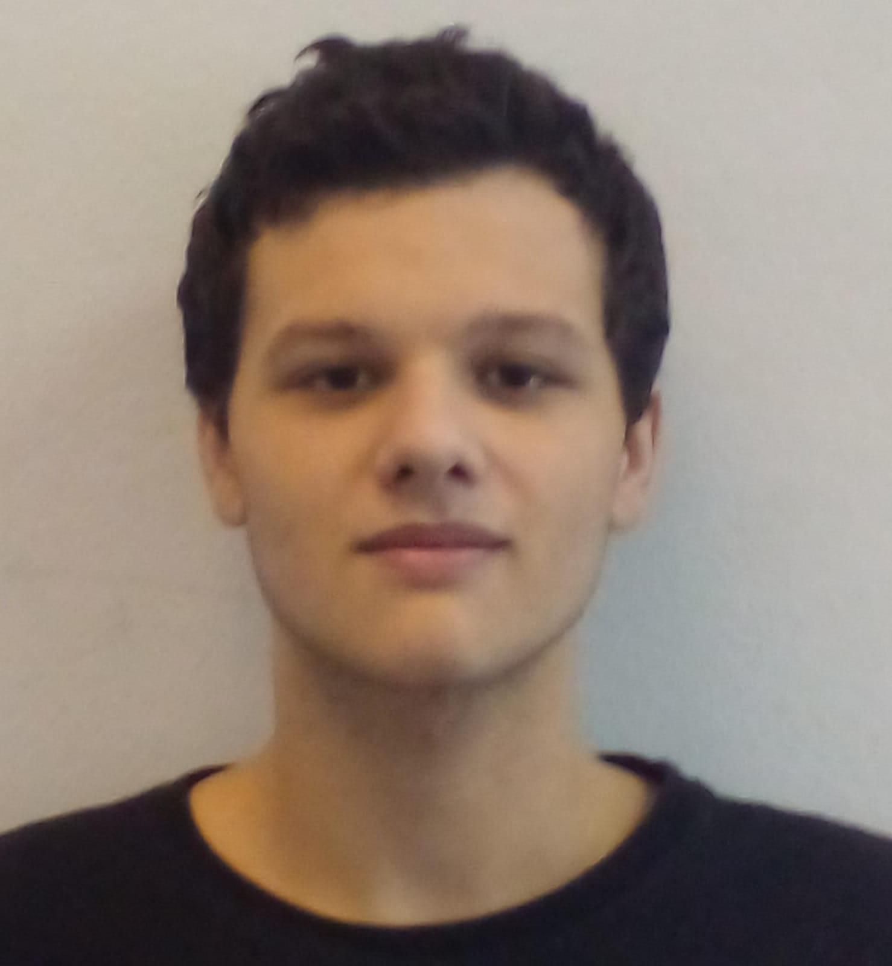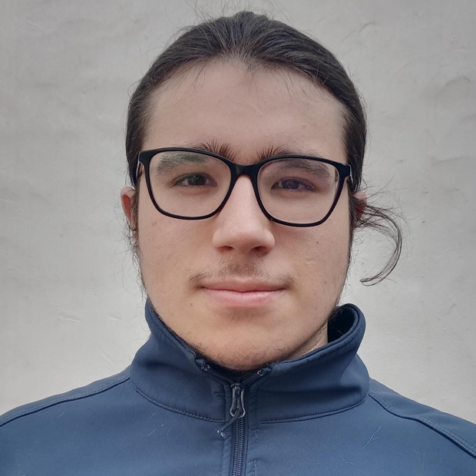
Torterolo, Alejo Franca de Lima, Matías
______________________ ______________________
COORDINADOR SUBCOORDINADOR

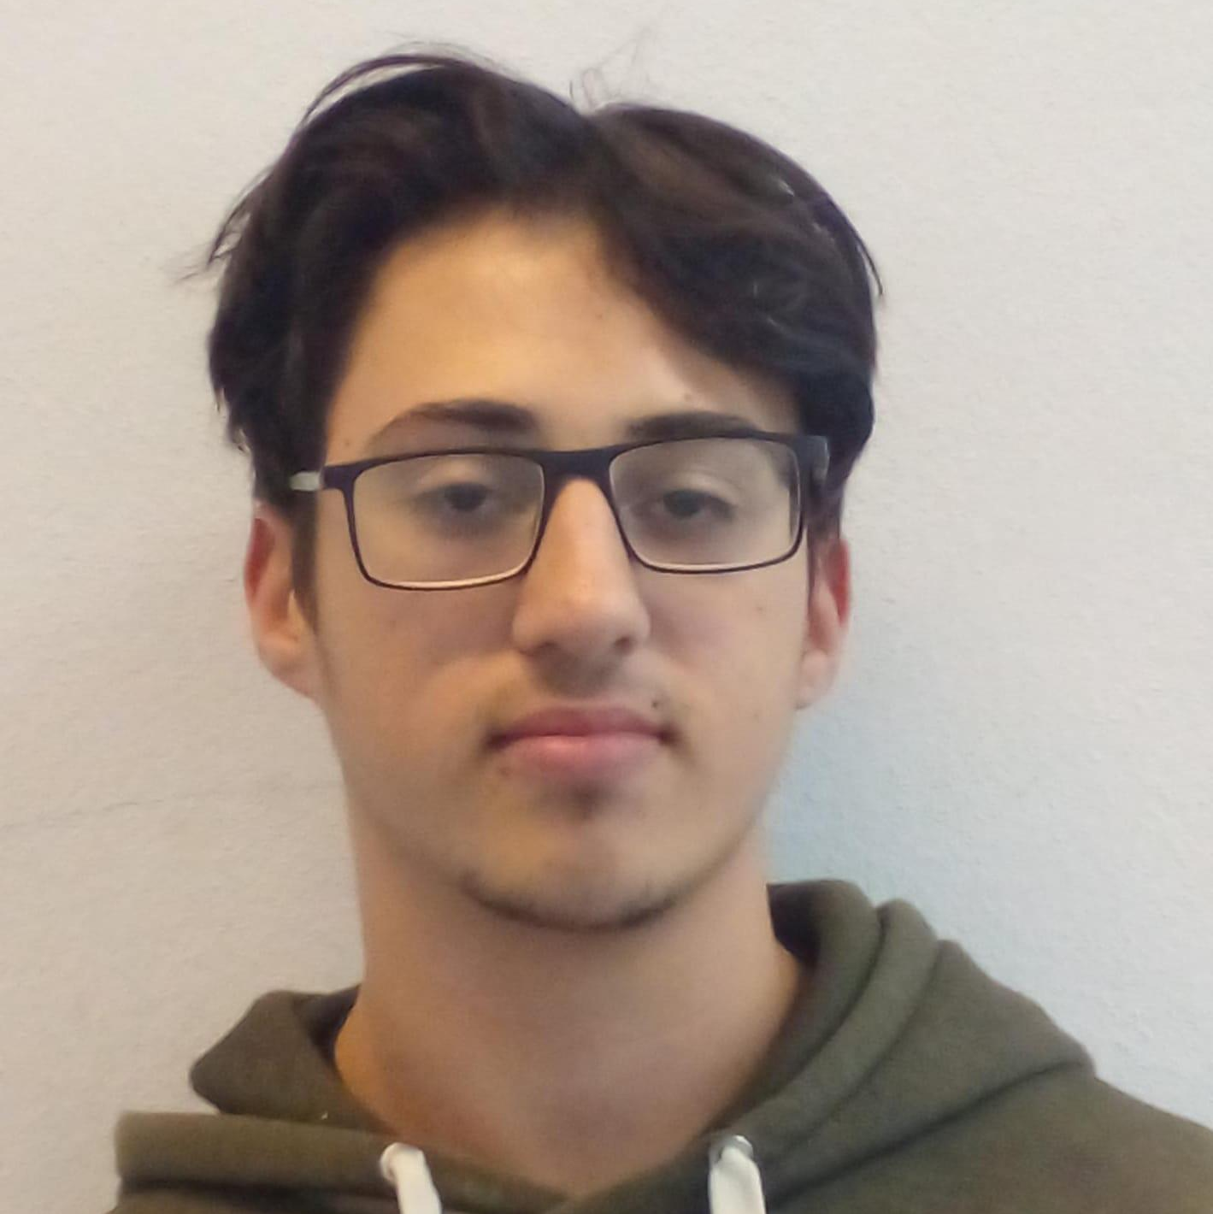
Olsztyn, Mario Cabrera, Santiago
______________________ ______________________
INTEGRANTE 1 INTEGRANTE 2

Indice
Abstract 5

Abstract

Introduction: This Project is about a web page for the CUK( Confederación Uruguaya de Karate) specifically for kata tournaments.

Purposes:
- This web page This web page will serve to make the kata tournaments more dinamic and simple. It will be usefull to the judges when scoring and voting, also it will be usefull to the spectators and competitors because it will be easier to understand the tournament..
- We will create a data base to save efficiently the necessary information for the tournament..
- We will create a lottery system for the keys of the tournament. Also so that the tournament administrator can facilitate the visualization of the results on the screen, making it automatic.

Methods:

Materials:
To this project we will use those next languages: HTML, CSS, PHP, SQL, and for these we will use applications like Visual Studio Code(for HTML, CSS, PHP), CMD for user management, and MYSQL (for SQL).
All of this with te equipment(computers) provided by the institution, and our own equipment.

Working Hours:
We estimated the numbers of hours we will need for this project will be 1288 houers. Calculating that we would work 8 hours a day.

Results: Pending

Conclusions: Pending

