SMARTALYZE: AN AI-ASSISTED DATA VISUALIZATION AND ANALYSIS PLATFORM


DAVAO DEL NORTE STATE COLLEGE

Institute of Computing

New Visayas, Panabo City

A Capstone Project Presented by:

ALTERADO, MAY ANTONETTE A.
ERAN, DONNA MEG S.
RAZ, GEAN

JUNE 2026

CHAPTER 1
INTRODUCTION

Background of Study
The rapid growth of digital information has made data literacy and proper data management increasingly important in academic, business, and organizational settings. Many individuals and organizations now rely on data to support decision-making; however, transforming raw information into meaningful insights remains challenging, especially for users with limited programming and technical experience [1]. Data preparation activities, including collecting, organizing, transforming, and correcting data, may consume a significant portion of data-related work, highlighting the need for tools that can simplify and automate repetitive preprocessing tasks [2]. This challenge has contributed to the development of data democratization, which promotes broader access to data and analytical tools rather than restricting these resources to information technology specialists alone [1].
Data cleaning and preprocessing are fundamental stages of the data analysis process because they directly influence the quality, consistency, and reliability of analytical results [3]. Conventional preprocessing workflows often involve repetitive and time-consuming tasks, particularly when datasets contain missing values, duplicate records, inconsistent formats, and other data-quality issues that require manual correction [4]. These challenges have encouraged the development of automated data cleaning and preprocessing tools that simplify data preparation while making transformation processes more transparent and understandable to users [5].
Automated preprocessing systems have been developed to reduce the time and effort required to prepare structured datasets for analysis. Auto-Prep, for instance, supports common preprocessing tasks such as identifying data types, handling missing values, encoding categorial variables, scaling features, selecting relevant attributes, and preparing data for machine-learning models [6]. However, automated cleaning may still require human judgement, especially when the system cannot confidently determine the correct treatment for a data-quality issue. Cleenex addresses this concern by involving users in an iterative cleaning process where they can review and validate proposed corrections [7]. More recent frameworks such as AutoMind have explored the use of large language and model agents to support different stages of automated data science through expert knowledge, solution exploration, and coding strategies that adapt to the complexity of a task [8]. These developments show that automation can make data preparation and analysis more manageable, while human review remains important for maintaining accuracy and reliability.
The United Kingdom has promoted the wider and more responsible use of data through its National Data Strategy. The strategy focuses on improving access to data, strengthening data-related skills, supporting innovation, and making better use of data in government and public services [9]. Similarly, Singapore’s National AI Strategy 2.0 encourages the responsible adoption of artificial intelligence to improve public services, strengthen the economy, and empower people and businesses [10]. These initiatives show how governments are investing in data access, digital capabilities, and responsible technology use to support better services and decision-making. This direction is relevant to Smartalyze because the proposed platform will provide non-technical users with guided tools for preparing, analyzing, and interpreting structured datasets.
In the Philippines, the Philippine Development Plan 2023-2028 emphasizes digital transformation, innovation, and the development of skills needed for Filipinos to participate in an increasingly technology-driven economy [11]. The DOST Harmonized National Research and Development Agenda 2022-2028 also guides the country’s research priorities and promotes the development of science- and technology-based solutions that respond to national and sectoral needs [12]. In addition, the E-Governance Act institutionalizes the transition of government services and processes toward a more integrated digital environment and strengthens programs for ICT literacy and competency development [13]. These national directions are relevant to Smartalyze because the proposed system will provide students, researchers, educators, and small business owners with accessible tools for preparing, analyzing, visualizing, and interpreting structured data.
At Davao del Norte State College, research activities involve the collection, organization, and analysis of data across various academic disciplines. The College has published research in information technology and other fields that use data-oriented methods, including data mining, geographic information systems, sentiment analysis, and information systems [14]. It also continues to support and evaluate research and extension initiatives, including projects under the Information Technology and Systems cluster [15]. These activities demonstrate the growing importance of effective data management and analysis within the institution. In this context, Smartalyze will provide students, researchers, educators, and other non-technical users with an accessible and guided platform for cleaning, analyzing, visualizing, and interpreting structured datasets.
This study will contribute to Sustainable Development Goal 4, which promotes inclusive and equitable quality education and lifelong learning opportunities, by providing students, researchers, educators, and other users with guided tools for developing practical skills in data preparation, analysis, and interpretation [16]. It will also support Sustainable Development Goal 9, which emphasizes innovation and technological capability, through the development of Smartalyze as an accessible AI-assisted platform for cleaning, analyzing, visualizing, and interpreting structured datasets [17]. Moreover, the proposed system will be consistent with the Davao del Norte State College Research, Development, and Extension Agenda for 2026-2030, which guides the College’s research priorities and extension initiatives [18]. As a project developed by students from the Institute of Computing, Smartalyze will provide a locally relevant technological solution intended to make common data-preparation and basic analysis tasks more accessible and understandable within the DNSC community.
To address these challenges, Smartalyze will be developed as an AI-assisted, web-based data-cleaning and basic analysis platform designed to help users prepare, analyze, visualize, and interpret structured datasets through guided recommendations, rule-based preprocessing, and basic machine-learning techniques. The system will support common data-preparation tasks and apply appropriate basic methods for trend identification and anomaly detection. It will also provide interactive visualizations and understandable explanations to assist students, researchers, educators, and small business owners with limited programming or data-analysis experience. Through these features, Smartalyze will make data preparation and basic analytical activities more accessible while allowing users to review and interpret the generated results.

Objectives of the Study
The main objective of this study is to develop Smartalyze, an AI-assisted, web-based data-cleaning and basic analysis platform that simplifies data preparation, visualization, and insight generation for users with limited technical expertise.
Specifically, this study aims to:
- Develop a web-based data ingestion module that enable users to upload structured datasets in CSV, Excel, and JSON formats, as well as image-based documents containing tabular data (e.g., PNG and JPG) for automated data extraction.
- Implement an automated data-cleaning engine that utilizes rule-based techniques to detect and address common data-quality issues by:
  - Imputing or removing missing values;
  - Identifying and removing duplicate records; and
  - Standardizing inconsistent data types.
- Implement basic machine-learning techniques that provide intelligent recommendations for data structuring, grouping, summarization, and trend identification.
- Design an interactive visualization dashboard that generates summarized insights and enables users to interpret data trends and patterns through graphical representations.
- Develop a data export module that allows users to download cleaned and processed datasets in CSV, Excel, and JSON formats for academic, research, and business applications.
Significance of the Study
This study will develop Smartalyze, an AI-assisted, web-based data-cleaning and basic analysis platform designed to simplify the preparation, visualization, and interpretation of structured datasets for users with limited technical expertise. By automating common data-preparation tasks and providing guided recommendations, interactive visualizations, and basic analytical features, the platform will help users better understand their data while reducing the time and effort required for manual data processing. The following are the primary beneficiaries of this study:
Students. Smartalyze will enable students to efficiently prepare, clean, visualize, and analyze datasets for academic requirements and research activities. The platform will reduce manual preprocessing tasks while helping them understand data patterns and trends without requiring advanced programming or data analytics skills.
Small Business Owners. Smartalyze will allow small business owners to upload operational datasets, such as sales, inventory, and financial records, to obtain summarized insight, visualizations, and guided recommendations. This will assist them in better understanding business information and support more informed planning and decision-making.
Researchers and Educators. Smartalyze will serve as a practical tool for teaching and learning data preparation and basic data analysis. Researchers will be able to organize and preprocess datasets more efficiently, while educators can use the platform to demonstrate data-cleaning techniques, visualization, and fundamental data analysis concepts in an accessible and interactive manner.
Future Developers and Researchers. This study will provide a foundation for the continued development of intelligent and user-friendly data-analysis platforms. Future developers and researchers may enhance Smartalyze by integrating more advanced analytical methods, predictive models, additional data-processing techniques, and expanded visualization capabilities to address broader academic research, and industry applications.

Scope and Limitation
This study will focus on the development and evaluation of Smartalyze, an AI-assisted, web-based platform for data cleaning, visualization, and basic analysis. It is intended for users who have limited technical knowledge and need a simpler way to prepare, examine, and understand structured datasets. The platform will support multiple registered users, with each user having a separate account for managing uploaded files and saved work.
Smartalyze will accept structured data in CSV, Microsoft Excel (.xlsx and xls), and JSON formats. It will also allow users to upload PNG and JPG images containing tabular information through Optical Character Recognition. Before processing begins, the system will check whether the uploaded file is readable and arranged in a suitable table format.
The platform will include basic file dataset management functions. Users will be able to upload, rename, edit, organize, and delete datasets. They may also save unfinished work as a draft and continue editing it later. During data preparation, users will be allowed to add, rename, or remove columns as needed.
For data cleaning, the system will detect common issues such as missing values, duplicated records, and inconsistent data types using rule-based methods. It will also provide suggested values when relationships among fields can be identified. For instance, if a city is already indicated in the dataset, the system may suggest a corresponding ZIP code for a missing field. These suggestions will not be applied automatically and will still require user confirmation.
After the dataset has been prepared, Smartalyze will provide basic analytical functions such as descriptive statistics, grouping, summarization, linear regression for identifying trends, and interquartile range-based detection of possible anomalies.The system will also generate charts, tables, and AI-assisted explanations to help users understand the results. A progress indicator will be shown while data is being processed. Users will also be able to download cleaned datasets and selected analytical outputs in the formats supported by the platform.
The study will be limited to structured datasets and images that contain readable tabular information. The system will not be designed to process handwritten content, audio, video, unstructured documents, or large collections of free-form text. The quality of OCR results will depend on factors such as image clarity, lighting, and the readability of the source material.
Suggestions for missing values will depend on the information already available in the dataset and the relationships that can be identified among its fields. Because of this, the suggested values may not always be correct and should be reviewed by the user. Likewise, the explanations and analytical outputs produced by the system will only serve as support for interpretation and will not replace professional statistical analysis or expert judgement.
The visualization features will also be limited to the chart and table types included in the platform. Smartalyze will not provide advanced business intelligence dashboards, real-time analytics, or predictive analysis beyond the methods implemented in the system. Uploaded files will also be subject to the file-size limit set by the platform to maintain reliable performance and efficient processing.

Review of Related Literature and Works

Related Literature
The increasing volume and complexity of digital data have increased the need for reliable methods of preparing datasets before analysis. Data preprocessing plays an important role in addressing common issues such as missing values, inconsistencies, noise, and incompatible data formats, which may affect the reliability of analytical results [19]. Recent studies have also explored automated and domain-specific machine-learning platforms that reduce the amount of manual work and specialized expertise required when preparing and analyzing data [20]. This section reviews the concepts, existing systems, and research gaps relevant to the development of Smartalyze.

1. Data Analytics and Data-Driven Decision Making
Data analytics supports academic institutions, business, and other organizations by transforming collected data into information that can guide planning, evaluation, and decision-making. For data to support meaningful action, it must be placed in an appropriate context and made available to the individuals who need it [21]. However, preparing, analyzing, and interpreting datasets may require technical knowledge and familiarity with specialized analytical tools, which can limit accessibility for users with little programming or data-analysis experience.
Data democratization has been introduced as an approach for broadening access to data and analytical resources among technical and non-technical users [22]. It involves reducing barriers that prevent users from finding, accessing, analyzing, and sharing organizational data [23]. Related literature also emphasizes the importance of self-service analytics and data literacy in helping users understand data and participate more effectively in data-informed activities [22]. These concepts are relevant to Smartalyze, which will provide guided data cleaning, basic analysis, and visualization features intended to help students, researchers, educators, and small business owners prepare and interpret structured datasets without requiring advanced programming skills.

2. Data Cleaning and Data Preprocessing
Data cleaning and preprocessing are necessary steps before a dataset can be used for analysis. Raw data often contain missing entries, duplicate records, inconsistent formats, incorrect data types, and other issues that may affect the reliability of the results. A recent benchmark of data-cleaning and preprocessing tools found that available solutions vary in terms of accuracy, processing time, memory consumption, usability, and their ability to handle increasing volumes of data [24]. This shows that the selection and design of cleaning methods can influence both the quality of the processed dataset and the efficiency of the workflow.
Previous studies have also explored ways of combining automation with user-guided data correction. BoostClean proposes different combinations of error-detection and repair methods to improve the quality of data used in machine-learning models [25]. ActiveClean uses an iterative process in which data cleaning and statistical model training are performed together, allowing users to gradually improve the dataset while observing how corrections affect the model [26].
These studies demonstrate that automation can reduce repetitive cleaning work, but user involvement remains important when corrections depend on the meaning and context of the dataset. Smartalyze will follow this approach by identifying common data-quality issues such as missing values, duplicate records, inconsistent data types, unnecessary white spaces, capitalization differences, and invalid date formats. Recommended corrections will be shown to users for review before any change is applied.
3. Missing Data Handling Techniques
Missing values are among the most common problems found in structured datasets. Incomplete entries may affect summaries, visualizations, statistical calculations, and the interpretation of analytical results. Existing research explains that data cleaning may involve different detection and repair methods, including rules, statistical procedures, and machine-learning techniques [27]. The appropriate method depends on the type of variable, the amount of missing information, and the relationships present among the available attributes.
Automated methods have also been developed for specific types of datasets. The cleanTS tool, for example, was designed to automate the cleaning of univariate time-series datasets. It integrates procedures for handling missing values, detecting unusual observations, and presenting time-series information at different levels of detail [28]. However, because it is intended for a specific type of dataset, its techniques may not be suitable for all forms of structured data.
For Smartalyze, missing-data handling will follow a guided process. The system will identify incomplete fields and may provide possible values when recurring relationships among existing attributes are detected within the uploaded dataset. For example, if records that belong to the same category consistently contain a particular related value, Smartalyze may recommend that value for an incomplete entry. The recommendation will be presented for user review and will require confirmation before any change is applied.
4. Automated Data Structuring and Summarization
Preparing a dataset involves more than correcting individual errors. Data must also be organized in a consistent and understandable form before grouping, summarization, visualization, or further analysis can be performed. Wang and Strong explained that data quality should not be evaluated through accuracy alone because its usefulness also depends on factors such as relevance, completeness, understandability, appropriate presentation, and accessibility [29]. This indicates that users who understand the purpose and context of a dataset should remain involved in reviewing how the data are prepared.
Holistic data-cleaning research likewise suggests that data-quality issues should be examined in relation to surrounding records, rules, and dependencies rather than being treated as isolated errors [30]. This approach is relevant to Smartalyze’s relationship-based recommendations because a value in one field may be associated with information contained in another attribute or record.
Smartalyze will apply these ideas by allowing users to review and edit cell values, organize columns, and generate summaries from the processed data. Recommendations produced during cleaning will be presented for user review before they are applied. The platform will also present the processed information through tables, visualizations, and AI-assisted explanations so that users with limited technical experience can examine the results without relying on programming or complex analytical software.
Overall, the reviewed literature shows that automated cleaning and structuring methods can make data preparation more efficient. However, the reliability of the results still depends on the quality of the original dataset and the involvement of users who understand its meaning. Smartalyze will therefore combine automated issue detection and recommendations with user review, dataset editing, basic analysis, and visualization in a single web-based platform.
5. Optical Character Recognition (OCR) for Data Extraction
Optical Character Recognition (OCR) is a technology that converts printed or handwritten text from scanned documents and digital images into machine-readable data. It has become an important tool in data management because it reduces the need for manual encoding and allows information stored in physical documents to be processed electronically. As OCR techniques continue to improve, they have become more capable of recognizing text from documents with different layouts, fonts, and image qualities, making them useful in education, healthcare, business, and government applications [31].
Recent studies have expanded the use of OCR beyond simple text recognition by incorporating document layout analysis and table structure detection. These improvements enable OCR systems to identify rows, columns, and relationships among cells before extracting their contents. A study on scanned laboratory reports demonstrated that combining modern table-detection algorithms with deep learning-based OCR models significantly improved the accuracy of extracting tabular information from document images, reducing errors caused by complex layouts and poor scan quality [32].
Modern OCR frameworks have also become more comprehensive for real-world applications. PaddleOCR, for example, integrates text detection, text recognition, layout analysis, and table recognition within a single framework, allowing developers to process structured documents more efficiently. This capability makes OCR suitable not only for digitizing text but also for converting tabular information into formats that can be edited, searched, and analyzed [33].
The capability of extracting structured information from images is relevant to Smartalyze because users may possess datasets that exist only as photographs or scanned tables instead of editable spreadsheet files. Smartalyze will use OCR to detect text from supported PNG and JPG images and organize the extracted content into an editable dataset when a recognizable tabular arrangement is present. Since OCR accuracy may still be affected by image quality, document orientation, text size, and complex table layouts, users will be able to verify and edit the extracted data before proceeding with data cleaning, preprocessing, visualization, and basic analysis.
6. Descriptive Statistics and Data Visualization
Descriptive statistics summarize the main characteristics of a dataset and provide an overview of its distribution before more advanced analyses are performed. Common descriptive measures include the mean, median, mode, frequency, minimum, maximum, and standard deviation, which help users understand the central tendency and variability of numerical data. These summaries allow users to identify general patterns, compare values, and recognize unusual observations within a dataset [34].
Data visualization complements descriptive statistics by presenting information in a graphical form that is easier to understand. Instead of relying only on numerical summaries, charts, graphs, and dashboards allow users to recognize trends, compare values, and identify relationships more efficiently. A recent systematic mapping study emphasized that visualization-driven data exploration helps non-expert users understand complex datasets more effectively when visualizations are designed with usability and user engagement in mind [35].
The usefulness of a visualization also depends on selecting an appropriate presentation for the type of data being analyzed. Recent studies suggest that dashboards should present information in a clear and organized manner, using text, charts, and interactive elements together to guide users toward meaningful interpretation instead of displaying large amounts of information without context [36].
Interactive dashboards and visual analytics have likewise been recognized as valuable tools for improving data interpretation among users with limited technical backgrounds. Studies indicate that users are better able to understand and apply analytical results when visualizations are simple, relevant to their tasks, and designed according to their information needs rather than technical complexity [37].
These concepts are reflected in Smartalyze through the generation of descriptive statistical summaries and visual representations after the data-cleaning process has been completed. The system will generate summary statistics and present the processed information through charts and tables, allowing users to examine their datasets more efficiently. By presenting analytical results in a structured and understandable format, Smartalyze will help users interpret their data without requiring advanced statistical or programming knowledge.
7. Linear Regression for Trend Analysis
Linear regression is a statistical method used to examine the relationship between an outcome variable and one or more predictor variables. In simple linear regression, a straight line is fitted to the observed values to show how changes in one variable are associated with changes in another. The slope indicates the direction and rate of the relationship, while the intercept represents the expected value of the outcome when the predictor is zero. The coefficient of determination, commonly written as $R²,$ may also be used to describe how much of the variation in the outcome is explained by the fitted model [38].
Linear regression is widely used because its results are relatively easy to present and interpret. A positive slope may suggest that the outcome tends to increase as the predictor increases, while a negative slope may indicate a decreasing pattern. However, regression results should be interpreted carefully because a statistical relationship does not automatically establish cause and effect.
The method is most appropriate when the relationship between selected numerical variables is reasonably linear. Its reliability also depends on assumptions concerning the independence of observations, the distribution and behavior of residuals, and the consistency of variance. Extreme values, unsuitable variable selection, or the use of a linear model for a nonlinear pattern may produce misleading results. Predictions made beyond the range of the original observations should likewise be treated cautiously [39].
Smartalyze will use linear regression as a basic analytical feature for examining trends and relationships between selected numerical attributes. The system will present a fitted trend line and related statistical values to help users observe whether the selected variables appear to move in the same or opposite direction. The output will serve as an analytical aid rather than proof of causation or a guaranteed prediction. Users will still need to consider the quality, scope, and context of their dataset when interpreting the output.
8. Interquartile Range (IQR) for Anomaly Detection
Anomaly detection is an important part of data preprocessing because unusual or extreme values may affect statistical calculations and the interpretation of analytical results. One commonly used method is the Interquartile Range (IQR), which measures the spread of the middle 50 percent of a dataset by subtracting the first quartile (Q1) from the third quartile (Q3). Values below Q₁ − 1.5(IQR) or above Q₃ + 1.5(IQR) may be identified as potential outliers [40].
Because the IQR is based on quartiles rather than the mean, it is less affected by extremely high or low observations. This makes it useful for identifying possible anomalies in numerical datasets, particularly when the data are unevenly distributed. However, the results may vary depending on the characteristics and distribution of the dataset, so detected values should still be reviewed within their proper context.

Despite its usefulness, the IQR method cannot determine whether an identified value is truly incorrect. Some values classified as potential outliers may represent valid but uncommon observations that should remain in the dataset. Outlier detection should therefore be treated as a guide for reviewing the data rather than as a basis for automatically removing records. The final decision should consider the purpose, source, and context of the dataset.

Smartalyze will apply the IQR method to identify potential outliers in selected numerical attributes. Instead of automatically deleting detected values, the system will highlight them for user review. Users will then decide whether each value should be retained, corrected, or removed. This approach will support anomaly detection while allowing users to maintain control over the final dataset.

9. Artificial Intelligence-Assisted Explanations in Data Analysis
Artificial intelligence has increasingly been used in data-analysis systems to assist users in understanding analytical outputs and presenting results in a more accessible form. Rather than replacing human judgment, human-centered AI systems are intended to support users by providing clear information and allowing them to review system-generated outputs before taking action [41].
Transparency and user control are also important in AI-assisted systems. Users should be informed about the basis and limitations of system-generated outputs instead of receiving recommendations without sufficient context. Human-centered AI therefore emphasizes that users should remain responsible for reviewing, interpreting, and deciding whether to act on the information presented by the system [42].
Although AI-assisted explanations may make analytical outputs easier to understand, they should not be treated as absolute conclusions. Their usefulness depends on the quality of the uploaded dataset and the analytical procedures applied by the system. They should therefore be considered supporting information that complements human interpretation rather than replacing professional or contextual judgment.
Smartalyze will apply these principles through its AI-assisted explanation feature. After data cleaning and basic analysis, the system will present concise descriptions of selected summaries, trends, and detected anomalies. These explanations will be intended to help users understand the available outputs more easily, but they will not replace the user’s interpretation of the dataset. Users will remain responsible for reviewing the explanations and deciding how the results should be understood or used.
To determine a suitable large language model (LLM) provider for generating these explanations, Smartalyze's AI-assisted explanation feature was designed to support three candidate providers: Ollama, Groq, and Google Gemini. Ollama (running the llama3.2:3b model) was adopted as the default provider because it executes locally on the server, allowing the system to generate explanations without depending on an external network connection or incurring per-request API costs an important consideration for a system intended to remain accessible to students and small business owners with limited resources. Groq (using the llama-3.3-70b-versatile model) and Google Gemini (using the gemini-1.5-flash model) were integrated as optional cloud-based alternatives, offering faster response time and lower cost, at the cost of requiring an active internet connection and, for sustained use, provider API charges. The system determines the active provider through a single configuration setting, allowing the AI-assisted explanation feature to switch between providers without requiring changes to the underlying analysis or explanation logic.

10. Relationship-Based Recommendations in Data Cleaning
The quality of a dataset depends not only on the correctness of individual values but also on the consistency of relationships among related attributes. During data preparation, information contained in one field may help verify or suggest a value in another field. Data-cleaning research has shown that identifying dependencies and recurring associations among attributes can support the detection of inconsistent or incomplete records [43].
Contextual data-cleaning approaches also examine records, rules, and attribute dependencies together instead of treating each value as an isolated entry. By considering the surrounding information in a dataset, a system may identify whether a value appears inconsistent with recurring patterns found in related records [30].
Although relationship-based recommendations may assist users during data preparation, they should not replace human judgment. Their usefulness depends on the completeness, consistency, and accuracy of the existing dataset. Recommendations should therefore be presented as supporting information that users can evaluate before deciding whether to apply them [27].
Smartalyze will apply these principles through a feature referred to in the system as Relationship-Based Recommendations. The system will examine recurring associations among values in related columns within the uploaded dataset and may suggest a possible value when a sufficiently consistent pattern is detected. For example, if records belonging to the same category repeatedly contain the same related value, Smartalyze may present that value as a recommendation for an incomplete entry. Each recommendation will remain editable and will require user confirmation before it is applied.

Related Works
Several existing tools and studies have introduced different methods for improving data cleaning, transformation, and preparation. These works were selected because they include functions that are related to Smartalyze, such as processing structured datasets, identifying data-quality problems, correcting inconsistent values, and assisting users during data preparation. However, they differ in their intended users, deployment method, analytical capabilities, and overall workflow. This section discusses Tale of Data, OpenRefine, and the automated data-cleaning approach of Yasin and Khorsheed to determine the gap that Smartalyze will address.
Feature / System | Smartalyze (Proposed) | Tale of Data | Open Refine | ML Data Cleaning Review (Yasin & Khorsheed)
End-user data-preparation | ✔️ | ✔️ | ✔️
Hosted web-based access | ✔️ | ✔️
CSV file support | ✔️ | ✔️ | ✔️
Excel file support | ✔️ | ✔️ | ✔️
JSON file support | ✔️ | ✔️
OCR image-to-table extraction | ✔️
Automated detection of data quality issues | ✔️ | ✔️ |  | ✔️
Missing-value handling | ✔️ | ✔️ |  | ✔️
Duplicate-record detection | ✔️ | ✔️ | ✔️ | ✔️
Data-format or data-type standardization | ✔️ | ✔️ | ✔️ | ✔️
User review before suggested changes are applied | ✔️ | ✔️ | ✔️
Relationship-based recommendations | ✔️
Descriptive statistical summaries | ✔️
Linear-regression analysis | ✔️
IQR-based outlier detection | ✔️
Charts or visual representations | ✔️ | ✔️
AI-assisted explanations | ✔️
Export of processed datasets | ✔️ | ✔️ | ✔️
Suitable for users with limited programming experience | ✔️ | ✔️
Integrated cleaning and basic-analysis workflow | ✔️
Table 1. Comparison table of existing system vs. the proposed system.

Discussion of Related Works

Tale of Data (Data Cleansing Automation Tool)
Tale of Data is a web-based platform designed for data preparation, data-quality management, and organizational data governance. It supports structured files such as CSV, Excel, JSON, XML, and other formats stored locally, within organizational systems, or through cloud-based services. The platform also provides tools for examining datasets, applying business rules, standardizing information, and managing data-quality processes [44].
Tale of Data is related to Smartalyze because both platforms aim to reduce the technical effort involved in preparing structured datasets. Users can upload data, inspect its contents, and perform cleaning or transformation activities through a graphical interface rather than relying entirely on manually written scripts.
Despite these similarities, Tale of Data is mainly intended for organizations that manage multiple data sources, repositories, and enterprise data products. Its services focus on broader data governance, certification, integration, and organizational data-quality management. Smartalyze, in comparison, will concentrate on a smaller and more guided workflow for students, researchers, educators, small business owners, and other users who need to clean and examine individual datasets.
Smartalyze will also combine OCR-based extraction, descriptive statistics, linear-regression analysis, IQR-based anomaly detection, relationship-based recommendations, visualizations, and AI-assisted explanations within one platform. OCR-based image-to-table extraction was not identified as a standard feature in the reviewed Tale of Data documentation. Tale of Data therefore provides broader enterprise-level services, while Smartalyze will focus on guided cleaning and basic analysis for users with limited technical experience.

OpenRefine
OpenRefine is a free and open-source tool for cleaning, transforming, reconciling, and extending structured datasets. It supports several input formats, including CSV, TSV, JSON, XML, OpenDocument spreadsheets, and Excel files. Users can create projects from imported datasets, perform transformations, reconcile records with external data sources, and export the processed information into supported formats [45].
The application provides tools for filtering, faceting, clustering similar text values, changing formats, splitting or combining columns, and applying customized expressions. Its reconciliation feature allows records from an uploaded dataset to be compared with an external data source. This process may involve entity matching, field matching, and duplicate-record identification.
OpenRefine is related to Smartalyze because both systems allow users to inspect and correct structured datasets without developing an entire data-cleaning application. Both also preserve user involvement because proposed changes or possible matches must still be reviewed before they are accepted.
However, OpenRefine is mainly operated on the user’s local computer. Although its interface opens through a web browser, the application, project files, and data-processing activities remain on the local machine. Advanced transformations may also require users to understand facets, clustering procedures, and the General Refine Expression Language.
Smartalyze will provide a more guided workflow that begins with file or image upload and continues through issue detection, correction, analysis, visualization, and export. It will also include OCR extraction, descriptive summaries, linear regression, IQR-based potential-outlier identification, and AI-assisted explanations. OpenRefine provides more detailed tools for data transformation and reconciliation, while Smartalyze will emphasize accessibility and integration for users with limited programming knowledge.

Automated Data Cleaning in Large Databases Using Machine Learning Methods (Yasin & Khorsheed)
Yasin and Khorsheed examined the use of machine-learning methods for improving data cleaning in large database environments. Their work discusses how supervised and unsupervised approaches may help identify errors, incomplete values, duplicate records, and inconsistencies. It also emphasizes that automated methods may reduce the time required for manual data preparation and improve the scalability of data-cleaning processes [46].
The study is related to Smartalyze because both approaches recognize that manual data cleaning can be repetitive, time-consuming, and prone to inconsistent corrections. Both also consider the use of automated techniques to assist users in detecting data-quality concerns.
However, the work of Yasin and Khorsheed mainly presents and evaluates methods for large databases and machine-learning workflows. It does not describe a complete public platform through which non-technical users can directly upload CSV, Excel, JSON, or image files, inspect individual recommendations, generate visualizations, and export a reviewed dataset.
Smartalyze will apply automation in a more user-oriented setting. Instead of developing a large-database cleaning framework, it will provide a web-based application intended for users who may have limited programming experience. Detected issues, potential outliers, OCR results, and relationship-based recommendations will be presented for review. Users will remain responsible for deciding whether the proposed changes should be accepted.

Synthesis and Justification for Smartalyze
The reviewed works show that data preparation can be supported through different tools and technical approaches. Tale of Data provides enterprise-oriented functions for data quality, governance, remediation, and monitoring. OpenRefine offers detailed tools for cleaning, transforming, clustering, reconciling, and exporting structured datasets. The work of Yasin and Khorsheed focuses on the use of machine-learning methods to improve automated cleaning in large database environments.
Although these works provide useful capabilities, none fully match the intended users and workflow of Smartalyze. Tale of Data is mainly designed for organizational and enterprise data management. OpenRefine provides powerful transformation features but operates locally and may require users to understand specialized expressions and data-manipulation procedures. The approach of Yasin and Khorsheed focuses on automated cleaning methods for large databases rather than a complete self-service application intended for non-technical users.
Smartalyze will address this gap by combining structured-file upload, OCR-based image-to-table extraction, automated detection of common data-quality issues, user-reviewed corrections, relationship-based recommendations, descriptive statistics, linear-regression analysis, IQR-based potential-outlier detection, visualizations, AI-assisted explanations, and processed-data export within one web-based platform.
The contribution of Smartalyze will not be based on claiming that each method is entirely new. Data cleaning, OCR, statistical analysis, anomaly detection, and visualization already exist in previous tools and studies. Its contribution will instead come from integrating these functions into a guided workflow designed for students, researchers, educators, small business owners, and other users with limited programming knowledge.
User involvement will remain important throughout the process. Suggested corrections, OCR-extracted values, missing-data recommendations, and potential outliers will be shown for review before they affect the final dataset. This approach will allow Smartalyze to assist users while keeping the final cleaning and interpretation decisions under their control.
Through this integrated workflow, Smartalyze will provide an alternative between manual spreadsheet preparation and more complex data-cleaning or analytical platforms. It will help users move from raw files or images to a structured, reviewed, visualized, and exportable dataset without requiring advanced technical knowledge.

Definition of Terms
AI-Assisted Explanations. In this study, AI-assisted explanations refer to concise, system-generated descriptions of selected summaries, trends, and potential data-quality issues. These explanations are intended to support user understanding and do not replace the user’s interpretation or judgment
Anomaly Detection. In this study, anomaly detection refers to the process of identifying numerical values that may differ considerably from the general distribution of an uploaded dataset. Smartalyze will use the Interquartile Range method to flag potential outliers for user review rather than automatically treating them as errors.
Data Cleaning. As used in this project, data cleaning refers to the guided process of detecting and addressing missing values, duplicate records, inconsistent formats, unnecessary white spaces, capitalization differences, invalid dates, and other common data-quality issues. Suggested corrections will be presented to users for review before they are applied.
Data Preprocessing. In this study, data preprocessing refers to the preparation of raw data before analysis. It includes data cleaning, data-type conversion, organization of columns, sorting, grouping, and other transformations needed to make a dataset more consistent, understandable, and suitable for visualization or basic statistical analysis.
Descriptive Statistics. In this study, descriptive statistics refer to numerical summaries used to describe the main characteristics of a dataset. These may include frequency, mean, median, mode, minimum, maximum, and standard deviation.
Interquartile Range. In this study, the Interquartile Range refers to a statistical method used by Smartalyze to identify potential outliers in selected numerical attributes. Values falling below the lower threshold or above the upper threshold will be highlighted for user review and will not be removed automatically.
Linear Regression. In this study, linear regression refers to a basic statistical method used by Smartalyze to examine the relationship between selected numerical attributes. The system will present a fitted trend line and related outputs to help users observe patterns, but the results will not be treated as proof of causation or guaranteed prediction.
Machine Learning. For this study, machine learning refers to computational methods that may assist Smartalyze in recognizing recurring relationships or patterns within uploaded datasets. These methods will support recommendations and basic analysis, while users will remain responsible for reviewing and confirming system-generated outputs.
Missing-Value Recommendation. In this study, a missing-value recommendation refers to a possible replacement value suggested by Smartalyze when recurring relationships are detected among related records or attributes in the uploaded dataset. The recommendation will remain editable and will require user confirmation before being applied.
Optical Character Recognition. In this study, Optical Character Recognition refers to the process of detecting text and recognizable table structures from supported PNG and JPG images. The extracted information will be converted into an editable dataset that users can verify before continuing with cleaning and analysis
Relationship-Based Recommendations. In this study, Relationship-Based Recommendations refer to suggestions generated by Smartalyze after examining recurring associations among values in related columns. These recommendations will serve as supporting information and will require user review and confirmation before they affect the dataset.
Rule-Based Preprocessing. In this study, rule-based preprocessing refers to the use of predefined conditions and operations for detecting common data-quality issues. These rules may identify missing values, duplicate rows, inconsistent data types, unnecessary spaces, capitalization differences, and invalid date formats without depending entirely on learned patterns.
Smartalyze. Smartalyze refers to the AI-assisted, web-based platform developed in this capstone project for data cleaning, preprocessing, visualization, and basic analysis. The name combines the words “smart” and “analyze” and reflects the system’s goal of providing a guided and accessible workflow for users with limited programming experience.
Structured Dataset. In this study, a structured dataset refers to information organized according to defined fields or attributes. It commonly appears in tabular form, where rows represent individual records and columns represent variables, and may be uploaded through supported CSV, Excel, or JSON files.
Trend Analysis. In this study, trend analysis refers to the examination of the direction or relationship between selected numerical attributes using linear regression and visual representations. It helps users observe whether values appear to increase, decrease, or move together, but it does not establish causation.
User Confirmation. In this study, user confirmation refers to the action of reviewing and approving a recommendation before Smartalyze applies it to the dataset. It ensures that users retain control over suggested corrections, missing-value recommendations, OCR-extracted values, and other system-generated outputs.
Visualization. In this study, visualization refers to the graphical or tabular presentation of processed data through charts and tables. These outputs will help users examine distributions, comparisons, relationships, trends, and potential anomalies more clearly.
Web-Based System. In this study, a web-based system refers to an application accessed through a web browser rather than through a separately installed desktop program. Smartalyze will allow users to access its data-cleaning and analysis functions through an internet-connected device.

CHAPTER 2

METHODOLOGY
The development of Smartalyze follows the Iterative Software Development Model, a practical and widely used approach to system development in which software is built and improved through repeated cycles. As illustrated in Figure 1, each iteration involves structured, continuous phases: planning, analysis, design, implementation, testing, and evaluation, allowing for the strategic refinement of features based on incremental testing metrics and direct user feedback.
This methodology is highly suitable for Smartalyze because the system involves evolving components, such as data preprocessing rules, visualization outputs, and machine-learning-based anomaly detection. Since these features require continuous improvement and validation using different datasets, an iterative approach ensures flexibility and gradual enhancement of system performance and usability.
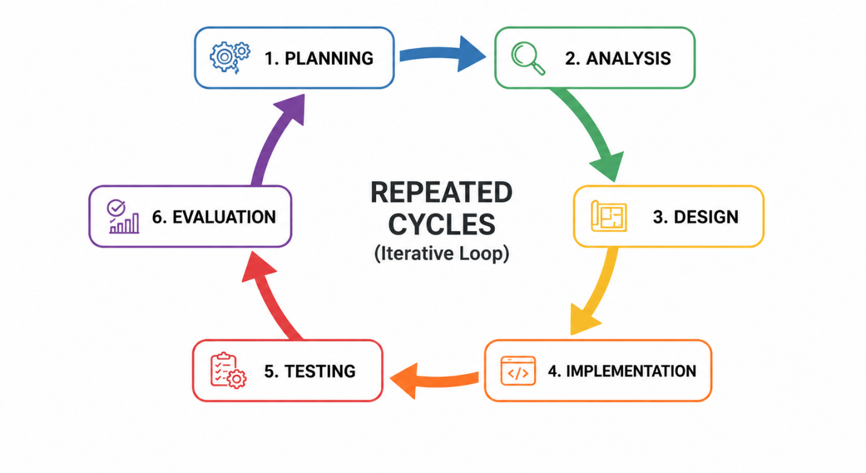
Each iteration of development produces a functional version of the system, starting with basic dataset upload and cleaning and gradually expanding to include advanced features such as automated data analysis, anomaly detection, and exportable insights, as outlined in the cyclic framework of Figure 1.

Figure 1. Iterative Software Development Lifecycle

Iteration Planning
The conceptualization of Smartalyze stemmed from the observation of a critical gap in data literacy and management within the local academic and business communities at Davao del Norte State College. While data-driven decision-making is increasingly necessary, many students, researchers, and small business owners lack the programming expertise required to process structured datasets efficiently [32]. Traditional manual data preprocessing is repetitive, time-consuming, and error-prone, often consuming a significant portion of the analytical workflow [33]. Recognizing this challenge, the project was proposed to bridge the technical divide by automating routine data cleaning and basic data analysis tasks.
Under the Iterative Software Development Model, the planning process is conducted at the beginning of each development cycle. Instead of defining all requirements at once, the system is developed incrementally, allowing features to evolve based on testing results and user feedback [34]. In the initial iteration, the primary objective was established: to develop an AI-assisted web-based system that integrates rule-based preprocessing with basic machine learning techniques for trend analysis and anomaly detection [35].
The system's scope was defined to handle structured datasets in formats such as CSV, Excel, and JSON. Additionally, feasibility considerations were evaluated, including the use of Python-based data processing pipelines, web-based system architecture, and resource allocation for development [36]. Recent evaluations of modular web architectures confirm that Python-based frameworks are highly effective at democratizing data science by enabling the seamless integration of automated cleaning libraries into user-friendly interfaces [37]. A flexible development timeline was also established, allowing iterative refinement of system components, including data cleaning, analysis, and visualization modules, throughout successive development cycles.
Project Team Organization

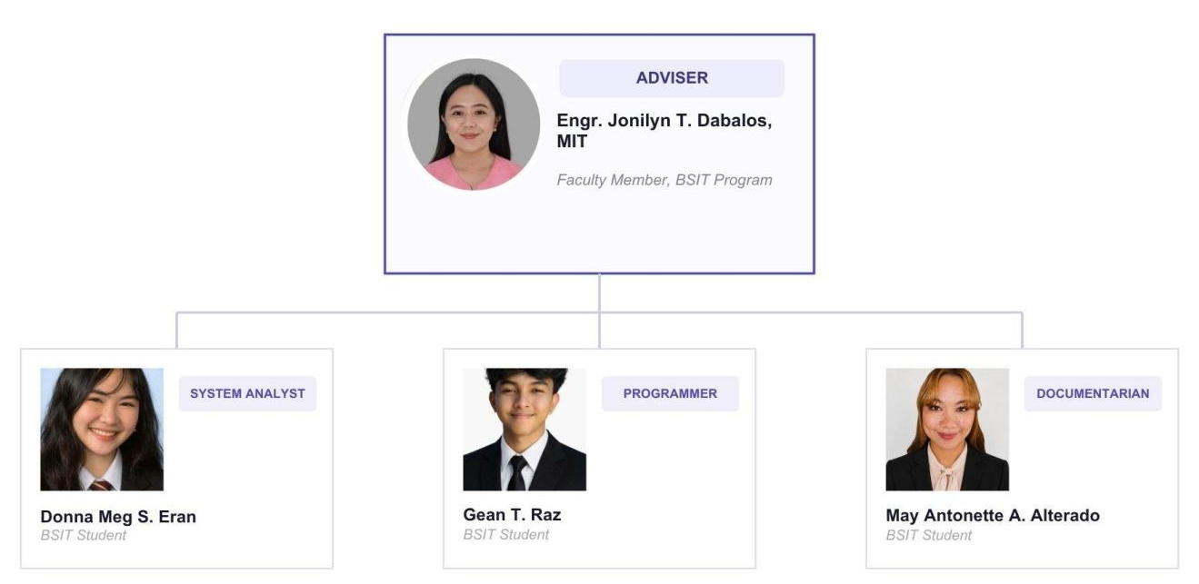
The organizational structure is designed to allocate specific responsibilities essential for the successful development and deployment of Smartalyze. The team follows a collaborative hierarchy in which technical execution is balanced with rigorous analysis and documentation, all guided by academic expertise.

Project Adviser
The Project Adviser provides expert guidance and supervision throughout the development of the Capstone Project. She ensures that the project aligns with academic standards and technical requirements. The adviser reviews the system design, validates methodologies, and provides recommendations to enhance the system's overall quality and reliability.
Systems Analyst
The Systems Analyst, Donna Meg S. Eran, is responsible for analyzing system requirements and ensuring that all system components align with the project objectives. She evaluates user needs, defines system functionalities, and ensures consistency across all modules. The Systems Analyst also coordinates with the development team to ensure that the system design is properly implemented and meets the specific demands of non-technical stakeholders.
System Programmer
The System Programmer, Gean T. Raz, is responsible for the actual development and implementation of the system. He translates system designs into functional code, develops system features, integrates modules, and performs debugging and testing. He ensures that the system operates efficiently, handles various data formats accurately, and meets the required technical specifications established during the planning phase.
Documentarian / Technical Writer
The Documentarian, May Antonette Alterado, is responsible for preparing and organizing all project documentation. This includes the system documentation, research manuscript, and technical reports. She ensures that all documents are accurate, well-structured, and aligned with academic and technical standards. This role is vital for maintaining a clear record of the development lifecycle and providing a comprehensive guide for future system maintenance.
Work Breakdown Structure (WBS)
The project activities for Smartalyze are organized according to the Iterative Software Development Model, in which the system is developed through incremental cycles. Each iteration consists of planning, analysis, design, implementation, and testing, allowing continuous refinement of system features.
Iteration 1 – Core System Setup: Focuses on foundational project planning, requirements gathering for basic dataset formats (CSV, Excel, JSON), designing the client-server architecture, and implementing the core web features for file uploading and database viewing.
Iteration 2 – Data Cleaning Module: Centers on analyzing common data anomalies (such as missing values, duplicates, and faulty data types) and building the rule-based backend preprocessing engine to detect these issues and offer automated fix suggestions to the user.
Iteration 3 – Analysis and Intelligence Layer: Integrates machine learning capabilities into the application to automatically identify deeper data patterns, detect anomalies, and generate trend insights from the uploaded datasets.
Iteration 4 – Visualization and Reporting: Focuses on the user experience by building minimalist chart layouts, graphical elements, and data summaries, as well as implementing reporting features that allow users to export their refined data.
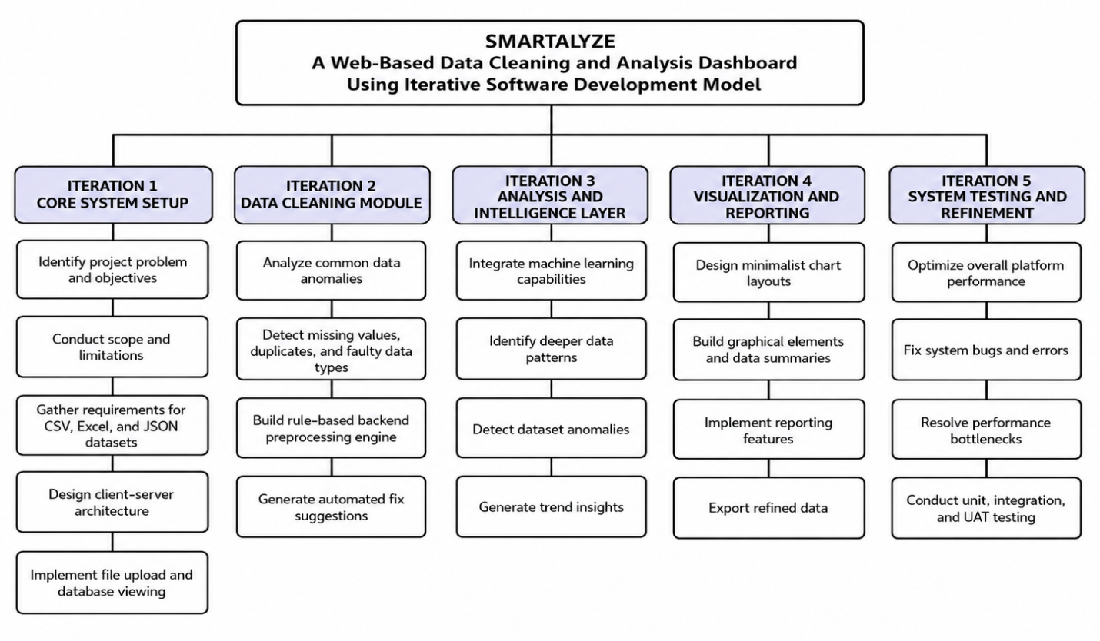
Iteration 5 – System Testing and Refinement: Dedicates final efforts to overall platform optimization, bug fixing, performance bottleneck resolution, and comprehensive quality assurance via unit, integration, and user acceptance testing (UAT).

Figure 2. Work Breakdown Structure (WBS)
Gantt Chart

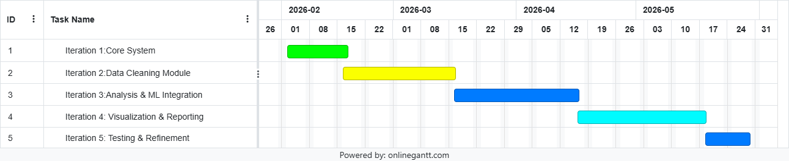
The project schedule and operational timeline for the tasks defined in the Work Breakdown Structure (WBS) are mapped out chronologically in Figure 3. This timeline illustrates the sequential progression of the iterative development phases across their respective calendar weeks, leading to the targeted completion in May 2026. As shown in the visual breakdown of Figure 3, each system module transitions dynamically into the next to ensure milestone accountability throughout the project lifecycle.

Figure 3. Gantt Chart

System Analysis
This section presents the analysis of the Smartalyze system, focusing on how user requirements are translated into system functionality. It defines the conceptual framework, identifies system requirements, and illustrates the logical flow of data as users interact with the platform. The goal of this phase is to ensure that raw structured datasets can be efficiently transformed into meaningful insights for non-technical users.
In alignment with the Iterative Software Development Model, system analysis is continuously refined across development cycles to improve data processing, analysis accuracy, and user interaction.

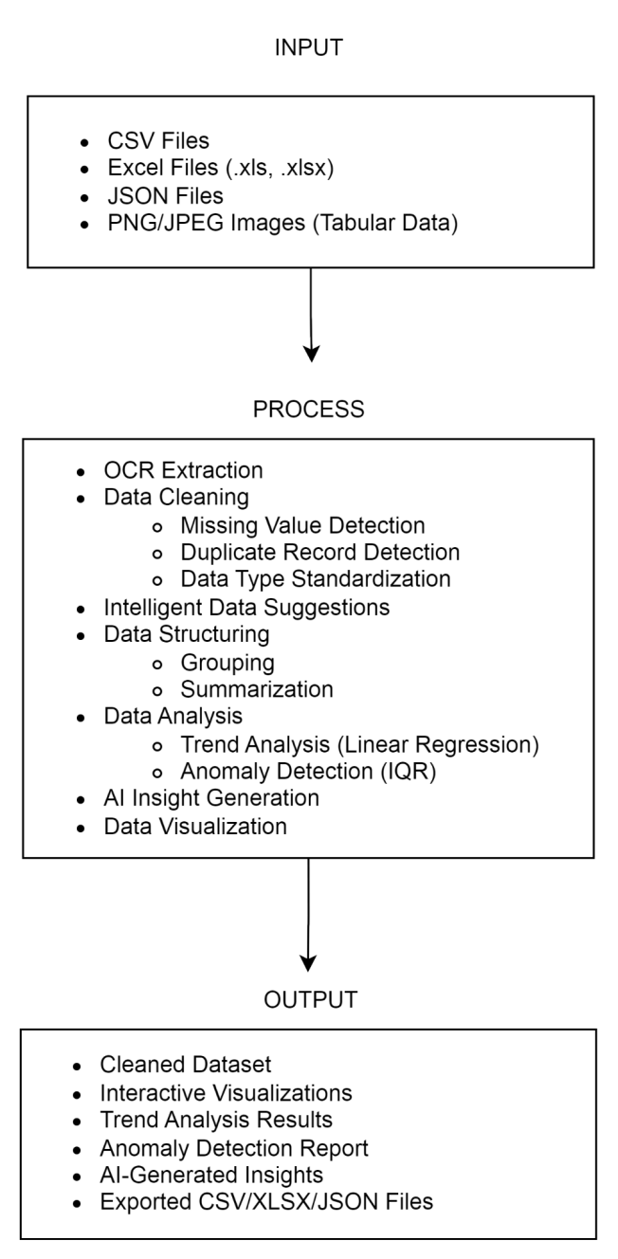
Conceptual Framework

Figure 4. Conceptual Framework

The conceptual framework of Smartalyze will use the Input-Process-Output (IPO) Model to show how upload datasets will move through the system and be converted into organized and understandable analytical outputs.
The input stage will include structured datasets submitted by users in CSV, XLS, XLSX, and JSON formats. The system will also accept PNG and JPG images containing tabular information. For image-based inputs, the Optical Character Recognition module will extract the visible text and convert it into a structured dataset that can be reviewed and processed within the platform.
During the process stage, Smartalyze will validate and manage uploaded files before carrying out data preparation and analysis. Users will be able to edit datasets, add or remove columns, rename headers, save unfinished work as drafts, and continue editing them later. The system will then identify common data-quality issues such as missing values, duplicate records, inconsistent data types, unnecessary spaces, inconsistent capitalization, and invalid date formats. It will also provide relationship-based recommendations when related fields can be used to suggest possible values for incomplete entries. These recommendations will remain subject to user review and confirmation.
Once the dataset has been prepared, the system will perform basic analytical tasks, including descriptive statistics, grouping, summarization, trend analysis using linear regression, and anomaly detection through the Interquartile Range method. It will also generate compatible visualizations and AI-assisted explanations to help users understand the results. A progress indicator will be displayed during operations that require additional processing time.
The output stage will produce cleaned and edited datasets, descriptive statistical results, grouped and summarized information, interactive visualizations, trend analysis results, anomaly detection results, relation-based recommendations, and AI Insights. Users will also be able to download supported datasets and selected analytical outputs in the available export formats.
Through the IPO Model, the framework will present how Smartalyze will transform raw and incomplete data into clearer and more useful information. The generated AI Insights will serve as explanations and recommendations that may assist users in interpreting their datasets, but they will not replace professional statistical analysis, expert judgement, or final user decisions.

System Architecture
Smartalyze follows a web-based client-server architecture, enabling users to access the system through a standard web browser without requiring local installation. This architecture supports scalability, accessibility, and centralized data processing.
The system is composed of the following components:

Hardware Components
The system operates on a centralized server environment that handles data processing, storage, and computation. End users access the platform through client devices such as desktop computers or laptops with internet connectivity. This architecture enables centralized management of datasets, analysis processes, and system resources while ensuring accessibility through a web browser.

Software Components
The frontend is implemented as a browser-based user interface designed for intuitive interaction, allowing users to upload datasets, view results, and perform operations without coding knowledge.
The backend uses Python-based data processing libraries to perform rule-based data cleaning and apply basic machine learning algorithms for trend analysis and anomaly detection.

Data Components
The system processes structured datasets provided by users in formats such as CSV, Excel, and JSON. These datasets undergo validation, preprocessing, analysis, and transformation within the system pipeline.

Processing Components
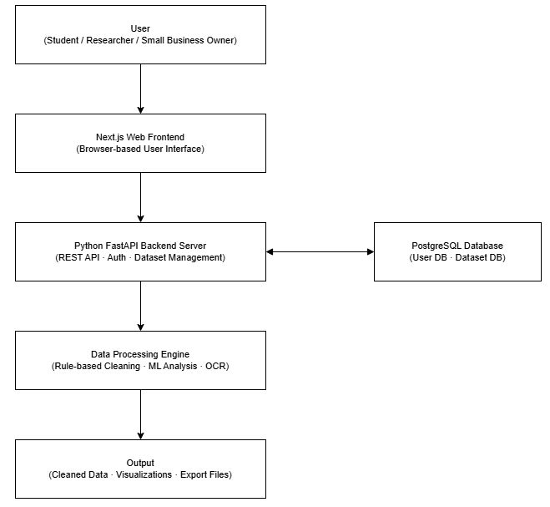
The Data Processing Engine serves as the core analytical layer of the system. It performs OCR extraction, data cleaning, machine learning-assisted trend analysis, anomaly detection, and visualization preparation before generating outputs for the user.

Figure 5. Smartalyze System Architecture

As shown in Figure 5, Smartalyze follows a web-based client-server architecture. Users interact with the system through a browser-based frontend, while requests are processed by the FastAPI backend. The backend communicates with the PostgreSQL database and the Data Processing Engine, which performs OCR extraction, data cleaning, trend analysis, anomaly detection, and visualization preparation before generating outputs for the user.

Functional and Non-Functional Requirements

Functional Requirements
The Smartalyze system shall provide the following functional requirements to support automated data preparation, visualization, and baisc analysis for its intended users:

FR-1. User Authentication and Account Management
The system shall allow users to register, log in, log out, and securely manage their accounts. It shall support multiple authenticated users while ensuring that each user can only access, modify, and manage datasets associated with their own account.

FR-2. Dataset Upload and File Management
The system shall allow users to upload structured datasets in CSV, XLS, XLSX, and JSON formats. It shall accept PNG and JPG images containing tabular data for Optical Character Recognition (OCR)-based extraction. Uploaded files shall be validated before processing and shall comply with the maximum upload size supported by the system. The system shall allow users to rename, organize, and delete uploaded datasets with their own personal workspace.

FR-3. OCR Processing
The system shall extract tabular information from uploaded PNG and JPG images using Optical Character Recognition (OCR) and convert the extracted content into editable structured datasets for further processing.

FR-4. Dataset Editing
The system shall allow users to modify uploaded datasets by editing cell values, adding new columns, deleting unnecessary columns, renaming column headers, and uploading dataset contents. Users shall also be able to save unfinished work as drafts and continue editing in future sessions.

FR-5. Data Cleaning
The system shall identify common data-quality issues, including missing values, duplicate records, inconsistent data types, unnecessary white spaces, inconsistent capitalization, and invalid date formats. The system shall provide cleaning recommendations that users may review and confirm before they are applied.

FR-6. Relationship-Based Data Recommendations
The system shall generate recommendations for missing values by identifying relationships among existing dataset attributes. These recommendations shall require user confirmation before being applied to the dataset.

FR-7. Data Analysis
The system shall generate descriptive statistics, grouping and summarization results, trend analysis using Linear Regression, anomaly detection using the Interquartile Range (IQR) method, and AI-assisted explanations to help users interpret analytical results.

FR-8. Data Visualization
The system shall generate visualizations, including bar charts, line charts, pie charts, area charts, histograms, and frequency distribution charts. Visualizations shall be generated only for compatible numeric categorial, Boolean, and date/time attributes supported by the system.

FR-9. Progress Monitoring
The system shall display a progress indicator during dataset uploading, OCR extraction, data cleaning, analysis, visualization generation, and data export to keep users informed of the current processing status.

FR-10. Data Export
The system shall allow users to download cleaned datasets and selected analytical outputs in supported export formats.

FR-11. Dataset Version Management
The system shall maintain previous versions of edited datasets and allow users to restore an earlier version when necessary.

Non-Functional Requirements
The Smartalyze system shall satisfy the following non-functional requirements to ensure its quality, reliability, security, and usability and overall performance.

NFR-1. Performance
The system shall process supported datasets efficiently while displaying a progress indicator during time-consuming operations such as uploading, OCR extraction, data cleaning, analysis, visualization, and exporting. The system shall accept uploaded files of up to 20 MB and shall reject files exceeding this limit with an appropriate notification to maintain stable performance and efficient resource utilization.

NFR-2. Reliability
The system shall preserve the integrity of user data throughout dataset uploading, editing, cleaning, analysis, visualization, version management, and exporting processes. Saved datasets and draft files shall remain accessible until they are modified or deleted by the user.

NFR-3. Security
The system shall require authenticated user accounts before granting access to datasets and analytical features. User passwords shall be securely encrypted before storage, and each user’s data shall remain isolated to ensure that only authorized users can access, modify, or manage their own datasets.

NFR-4. Usability
The system shall provide a simple and user-friendly interface that can be easily used by individuals with limited technical knowledge. Clear instructions, validation messages, progress indicators, and informative error messages shall be provided throughout the data preparation and analysis process.

NFR-5. Maintainability
The system shall adopt a modular architecture that facilitates future enhancements, including improvements to supported file formats,visualization techniques,data-cleaning method, and analytical features, without requiring major modifications to the overall system architecture.

NFR-6. Scalability
The system shall support multiple authenticated users increasing numbers of datasets while maintaining acceptable performance under normal operating conditions.

NFR-7. Compatibility

The system shall be accessible through modern web browsers, including Google Chrome, Microsoft Edge, Mozilla Firefox, and Safari, without requiring additional software installation.

NFR-8. Availability
The system shall be accessible through an internet connection whenever the application server is operational, allowing authorized users to securely access their datasets and analytical tools.

NFR-9. Accuracy
The system shall generate OCR extraction results, descriptive analysis, trend analysis, anomaly detection results, relationship-based recommendations, and AI-assisted explanations based on the quality and completeness of the uploaded dataset. The generated recommendations and explanations are intended to assist users in interpreting data and shall require user review before they are applied or used in decision-making.

Use Case Diagram
The functional interactions between the user and the platform components are modeled in Figure 6, which outlines how the system boundaries respond to different behavioral actions.
- Primary Actor: Non-technical User (Student, Researcher, Small Business Owner).
- As mapped within the system boundary in Figure 6, the primary actor initiates core behaviors, including Register, Login, Upload Dataset, View Dataset, List Datasets, Apply Cleaning Operations, Detect Data Quality Issues, Save Result, Export Dataset/Result, and Delete Dataset. These functional entry points allow the user to manage their data preparation workflow seamlessly without manual coding.
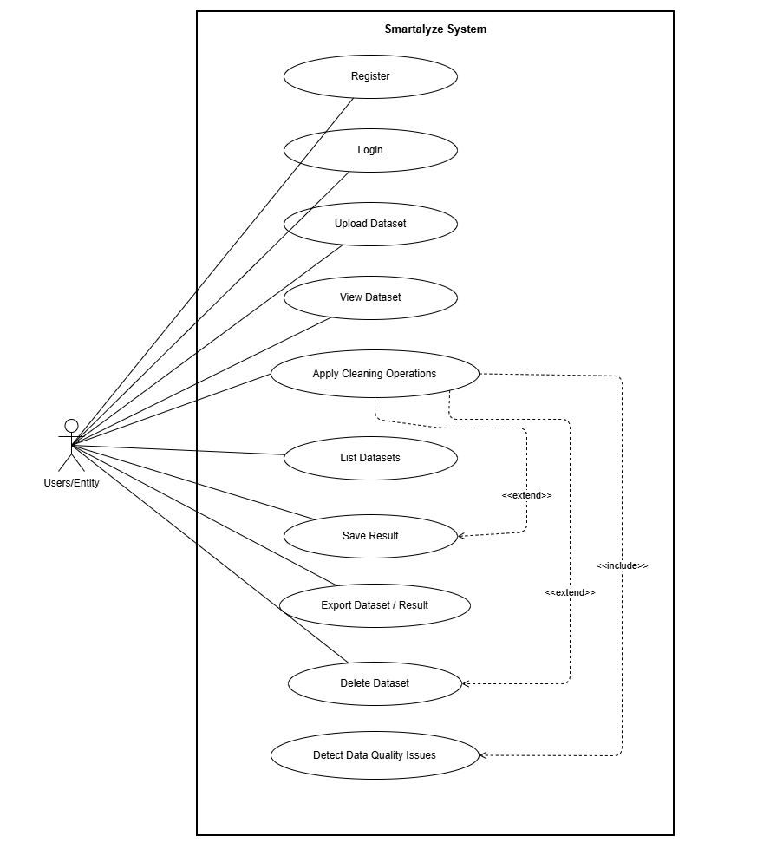

Figure 6. Use Case Diagram

Context Flow Diagram

Following the Gane and Sarson method, the Level 0 DFD mapped in Figure 7 illustrates the logical flow of business actions between the user and the entire Smartalyze system as a single process.

External Entities: User, LLM Provider
Process 0: Smartalyze: An AI-Assisted Data Visualization and Analysis Platform
Data Inflow (User to System): Login Credentials / Registration; Dataset Files (CSV, Excel, JSON, PNG/JPG); Cleaning / Apply Requests; Analysis Requests / AI Questions / Export Requests
Data Outflow (System to user): Authentication Token / Status; Dataset Preview / Health Summary; Cleaning Results / Analysis Results / Charts; AI Suggestions / Chat Reply / Exported File
Data Inflow (LLM Provider to system): Cleaning Plans / Chat Responses
Data Outflow (System to LLM Provider): Dataset Context (schema + issue summary)

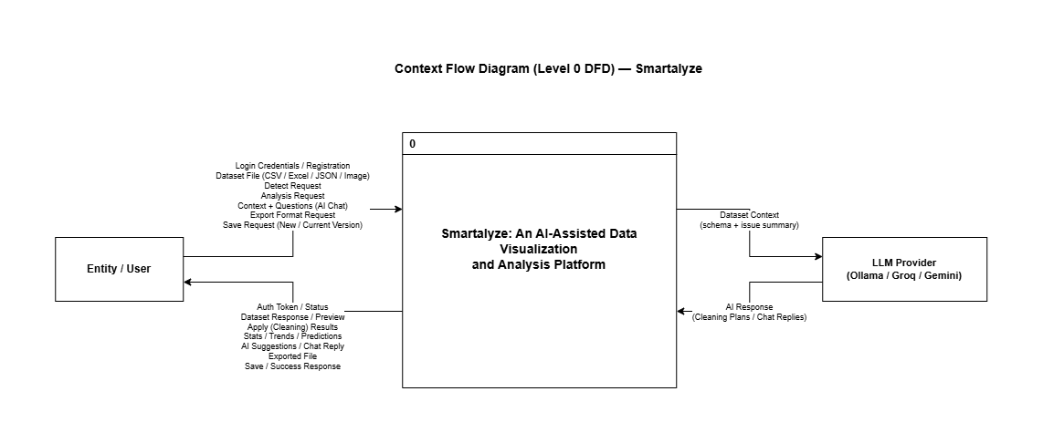

Figure 7. Level 0 (Context Flow Diagram)

Level 1 Data Flow Diagram
The Level 1 Data Flow Diagram (DFD) presents a detailed decomposition of the Smartalyze system, expanding the single process shown in the Level 0 diagram into multiple interconnected sub-processes. This representation follows the Gane and Sarson method and illustrates how data moves through the system — from user input to system outputs — while interacting with the system's data stores.
The diagram highlights the interaction between the user, the Smartalyze sub-processes, and the primary data stores: the User Database (accounts and sessions) and the Dataset Database (datasets, snapshot versions, and action logs). An external LLM Provider (Ollama / Groq / Gemini) is also integrated to support the AI Advisory process. Smartalyze stores dataset contents as versioned JSON snapshots and returns cleaning results, analysis outputs, and export files based on the current snapshot or a user-provided one.
Processes:
1.0 User Authentication: Manages user registration, login verification, and secure session management by validating credentials and issuing authentication tokens.
2.0 Dataset Management: Handles the uploading, structural validation, previewing, listing, and deletion of structured dataset files in CSV, Excel, JSON, and image-based formats (PNG/JPG) processed through the OCR pipeline.
3.0 Data Cleaning (Detect and Apply): Executes rule-based anomaly detection covering missing values, duplicate records, and inconsistent data types on a dataset snapshot, and applies on-the-fly fixes without immediately overwriting the permanent database.
4.0 Export Dataset/Result: Generates and serves a downloadable file (CSV, XLSX, or JSON) from either a permanently stored dataset snapshot or an unsaved, active cleaning workspace result.
5.0 Save Result: Commits cleaned data snapshots to permanent storage, allowing the user to either version-control and overwrite the existing file or save the output as an entirely new dataset.
6.0 Analysis and Prediction: Processes analysis requests from the user by reading the current dataset snapshot from the Dataset Database and returning statistical summaries, trend directions, anomaly detection reports, and linear regression-based predictions on numeric columns.
7.0 AI Advisory: Receives user context and questions, constructs a compact dataset summary from the current snapshot and metadata stored in the Dataset Database, forwards it to the external LLM Provider, and returns AI-generated suggestions or chat replies to guide the user through data cleaning and interpretation.
Data Stores (Referenced in the Level 1 DFD):
D1 User Database: Accommodates account profiles, credential hashes, active session states, and security token validations.
D2 Dataset Database: Maintains the core data architecture by storing dataset metadata, file contents across versioned snapshots, and comprehensive audit trails and action logs.

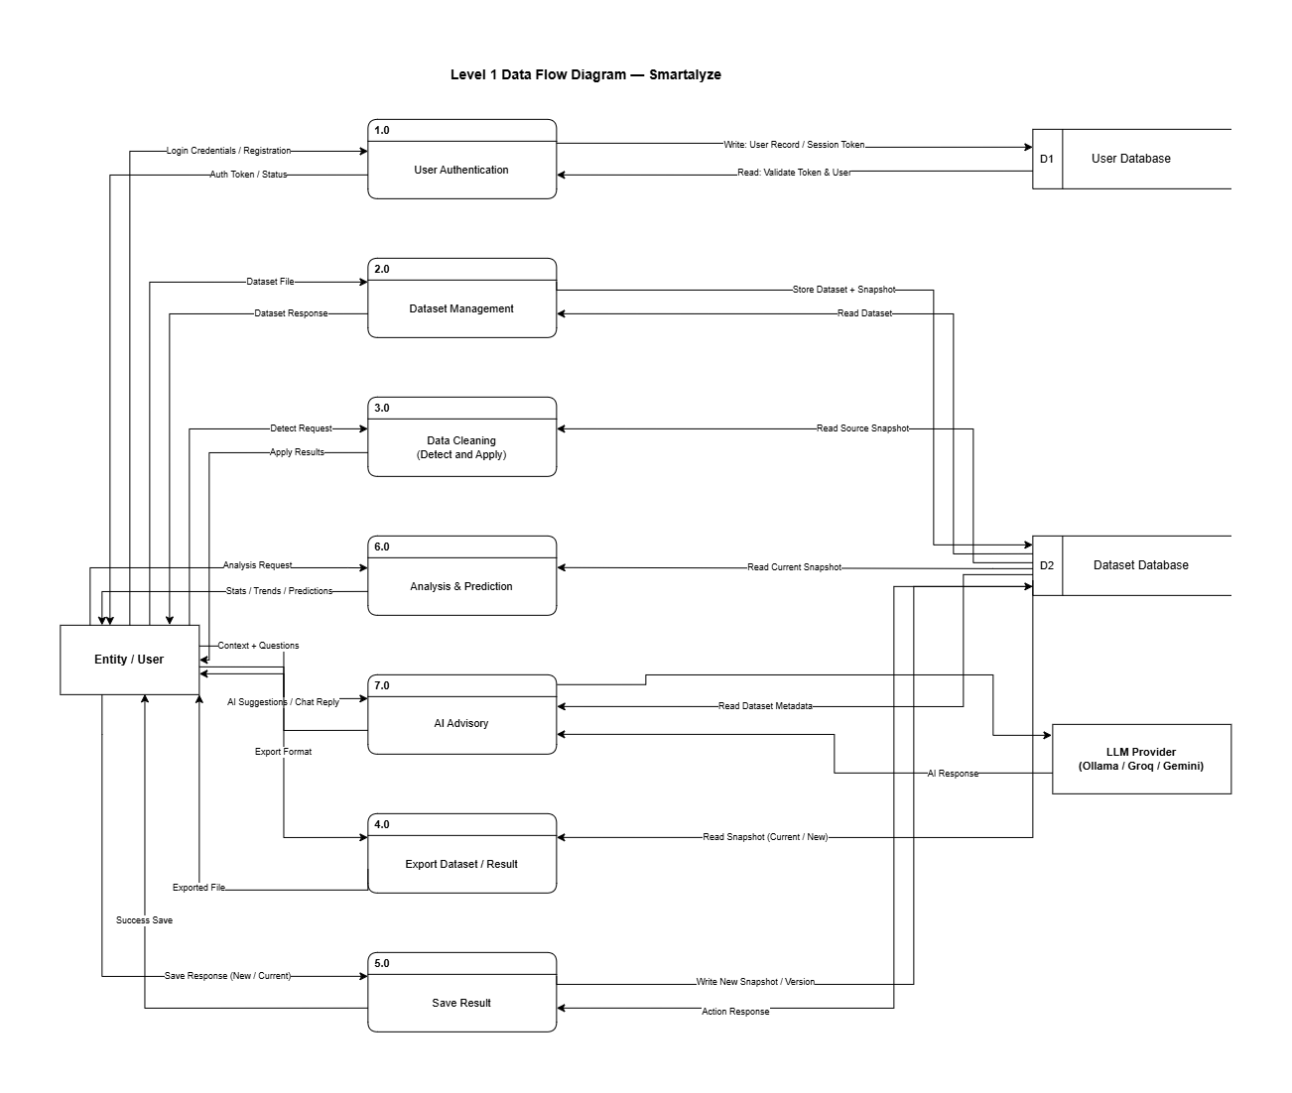
Figure 8. Level 1 (Data Flow Diagram)
System Design

This section presents the structural design artifacts that define Smartalyze's database schema, relationships, and technical blueprint. These components ensure that the data model supports all functional requirements identified during the analysis phase.

Entity Relationship Diagram (ERD)

The Entity-Relationship Diagram depicts the logical structure of the database, showing the entities in the Smartalyze system and the relationships between them. It maps out how datasets, users, preprocessing sessions, and analysis results are interconnected.
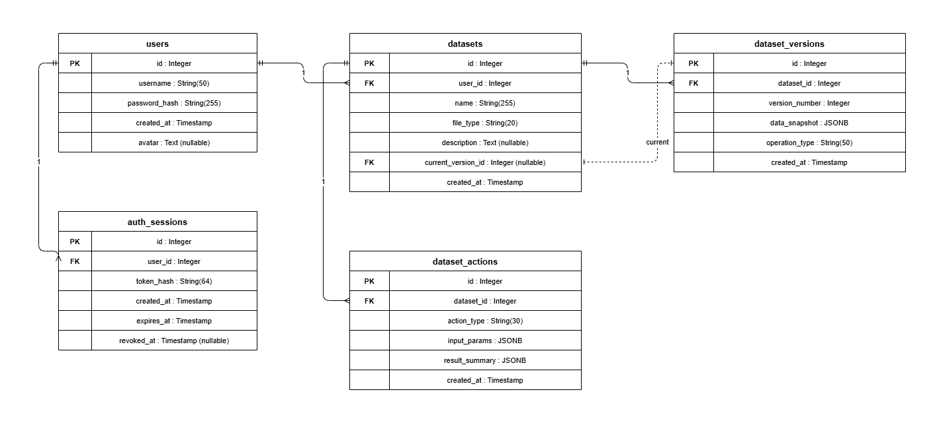Figure 9. ERD (Entity-Relationship Diagram)

Data Dictionary
The Data Dictionary provides a structured reference of all data elements used within the Smartalyze system. It defines the attributes, data types, key types, and descriptions of each data entity stored in the database. This ensures consistency in data handling and supports efficient system development and maintenance.
Table 2. Users
Attribute | Data Type | Key Type | Description
user_id | Integer | Primary Key | Unique identifier for each user
username | Varchar | — | Username used for login
password_hash | Varchar | Unique | Hashed password for auth
created_at | Timestamp | — | Date and time the user account was created

Table 3. AuthSessions
Attribute | Data Type | Key Type | Description
user_id | Integer | Foreign Key | References the user who owns the session
token_hash | Varchar | unique | Hashed authentication token (Bearer token stored securely)
created_at | Timestamp | — | Date and time the session is created
expires_at | Timestamp | — | Date and time the session expires
revoked_at | Timestamp | — | Date and time the session was revoked (null if active)

Table 4. Datasets
Attribute | Data Type | Key Type | Description
id | Integer | Primary Key | Unique identifier for each dataset
user_id | Integer | Foreign Key | References the user who owns the dataset
name | varchar | — | Dataset name
file_type | varchar | — | Dataset format
description | text | — | Optional user dataset desc
current_version_id | integer | Foreign Key | Reference to the current dataset snapshot
created_at | Timestamp | — | Date and time the dataset was created/uploaded

Table 5. Dataset Versions
Attribute | Data Type | Key Type | Description
id | Integer | Primary Key | Unique identifier for each dataset snapshot/version
dataset_id | Integer | Foreign Key | References the dataset this snapshot belongs to
version_number | integer | — | Version sequence number within a dataset like 1 2 3
operation_type | varchar | — | Label for how the snapshot was created (e.g., upload, cleaning, result)
data_snapshot | JSONB | — | Full stored snapshot of the dataset content, including records/preview/summary
created_at | Timestamp | — | Date and time the snapshot was created

Table 6. Dataset_Actions
Attribute | Data Type | Key Type | Description
id | Integer | Primary Key | Unique identifier for each dataset action event
dataset_id | Integer | Foreign Key | References the dataset affected by the action (datasets.id)
action_type | varchar | — | Type of action performed (e.g., upload, result, delete)
input_params | JSONB | — | Input parameters used for the action (stored as JSON)
result_summary | JSONB | — | Summary of outputs/results for the action (stored as JSON)
created_at | Timestamp | — | Date and time the action was recorded

Technologies, Concepts, and Theories

This section discusses the core models, algorithms, and emerging technologies that underpin the Smartalyze system. It covers the complete data pipeline from collection through analysis and provides an overview of the technologies used during development.

Data Collection
Data collection in Smartalyze is entirely user-driven. The system does not gather data from external APIs or third-party sources. Instead, users upload their own structured datasets through the web interface.

Supported File Types
- CSV (Comma-Separated Values)
- Excel (.xlsx, .xls)
- JSON (JavaScript Object Notation)
- Image files (PNG, JPG) containing printed or scanned tabular data

Dataset Validation
Upon upload, Smartalyze performs structural validation to ensure that:
- The file is readable.
- The file is properly formatted.
- Rows and columns follow a consistent tabular structure.
- Required schema elements are present.

OCR-Based Data Extraction
For image uploads, Smartalyze utilizes an Optical Character Recognition (OCR) pipeline before validation.
OCR converts visual text from images into machine-readable data. The system uses:
- EasyOCR – Extracts text from images.
- img2table – Detects table structures and cell boundaries.
Together, these tools:
- Detect table regions within images.
- Extract cell contents.
- Identify column headers.
- Reconstruct the table into a structured DataFrame.
This feature enables users to digitize printed or scanned documents without manually re-entering data.

Dataset Storage
After validation:
- Dataset contents are serialized into a JSONB snapshot.
- The snapshot is stored in PostgreSQL.
- The uploaded dataset becomes Version 1 of the dataset.
This snapshot-based approach preserves the original dataset regardless of future cleaning or transformation operations.

Data Pre-processing
Data preprocessing is the most critical stage of the Smartalyze pipeline. Uploaded datasets often contain quality issues that can negatively impact analytical accuracy.
Smartalyze uses a rule-based preprocessing engine implemented in Python with the pandas library.

Missing Value Detection and Handling
The system identifies:
- Null values
- Empty cells
- Pseudo-null values such as:
  - "N/A"
  - "none"
  - "-"
  - "unknown"

Information Provided to Users
- Missing value count per column
- Missing value percentage
- Severity indicators

Resolution Strategies
Users may choose to:
- Fill with column mean (numeric data)
- Fill with column median (skewed numeric data)
- Fill with column mode (categorical data)
- Remove affected rows
For numeric imputation, Smartalyze preserves the existing decimal precision of the column.

Duplicate Record Detection and Removal
The system identifies rows where all column values are identical.

Benefits
- Prevents inflated counts
- Reduces analytical bias
- Improves dataset reliability
Users can remove detected duplicates through a single operation.

Data Type Standardization
Smartalyze automatically infers column types and compares them with stored values.

Supported Data Types
- Numeric
- Datetime
- Categorical
- Boolean
- Text

Examples
A column containing values such as:
₱1,500
₱2,000
₱3,250
may be stored as text but inferred as numeric.

Supported Conversions
- Currency symbols
- Thousands separators
- Date format variations
- Boolean representations:
  - Yes/No
  - True/False
  - 1/0

Additional Preprocessing Operations
Smartalyze also supports:
- Whitespace trimming
- Lowercase conversion
- Date standardization
- Category value mapping
- Derived column creation
- Outlier nullification using IQR
- Pattern-based value imputation

Execution Order
Operations are executed in a deterministic sequence:
- Type conversions
- Missing value filling
- Row removals
- Sorting operations
This prevents order-dependent processing errors.

Feature Extraction
Feature extraction transforms cleaned data into meaningful attributes and statistical summaries that support analysis.

Column Type Identification
After preprocessing, each column is classified as:
- Numeric
- Datetime
- Boolean
- Categorical
- Text
- Unknown
The classification determines applicable analyses and visualizations.

Statistical Feature Computation
For each numeric column, Smartalyze computes:
- Count
- Missing value count
- Missing value percentage
- Unique value count
- Mean
- Median
- Standard deviation
- Minimum value
- Maximum value
- First Quartile (Q1)
- Third Quartile (Q3)
These statistics are displayed in the Column Analysis view.

Aggregation and Grouping
Users can group data by categorical attributes and perform aggregations on numeric values.

Supported Aggregations
- Sum
- Count
- Mean
- Minimum
- Maximum

Example Applications
- Total sales per region
- Average grades per department
- Monthly transaction summaries

Distribution Analysis

Numeric Columns
The system generates equal-width histogram bins to visualize value distributions.

Categorical Columns
- Counts top 20 most frequent categories.
- Displays frequency distributions.

Datetime Columns
Data is grouped by:
- Year
- Year-Month
depending on the dataset time span.

Classification and Analysis
Smartalyze applies machine learning and statistical techniques to identify patterns, trends, and anomalies.

Trend Analysis (Linear Regression)
Smartalyze uses Scikit-learn's LinearRegression model.

Model Inputs
- Independent Variable:
  - Row index
  - Time dimension (if available)
- Dependent Variable:
  - Numeric column values

Interpretation
Condition | Interpretation
Positive slope | Increasing trend
Negative slope | Decreasing trend
Near-zero slope | Stable trend
R² < 0.1 | Volatile pattern

R-Squared (R²)
R² measures how well the regression line explains variability in the data and serves as a confidence indicator for the detected trend.

Anomaly Detection (IQR Method)
For each numeric column, Smartalyze computes:
IQR=Q3−Q1IQR = Q_3 - Q_1IQR=Q3​−Q1​
Values are classified as anomalies when they fall outside:
- Lower Bound:
  - Q1 − 1.5 × IQR
- Upper Bound:
  - Q3 + 1.5 × IQR

Advantages
- Resistant to skewed distributions
- Does not require normally distributed data
- Suitable for domain-independent datasets

Prediction (Linear Regression Forecasting)
Building on trend analysis, Smartalyze can forecast future values.

Features
- User-defined forecast horizon
- 1–20 future prediction steps
- Confidence bands based on regression residual error

Outputs
- Predicted future values
- Trend visualization
- Confidence intervals
Technologies Used in Development
The development of Smartalyze utilizes modern web, database, machine learning, and OCR technologies to support automated data cleaning, analysis, visualization, and export functionalities. These technologies were selected based on their compatibility, scalability, and suitability for developing a user-friendly platform for non-technical users.

Frontend Technologies

Next.js 16 (App Router)
Purpose: Frontend Framework
Used For:
- Application routing
- Page rendering
- Dashboard interface
- Dataset workspace
- Authentication pages

React 19
Purpose: User Interface Library
Used For:
- Data tables
- Cleaning operation queues
- Charts and visualizations
- AI advisory components

TypeScript 5
Purpose: Statically Typed JavaScript
Benefits:
- Type safety
- Improved maintainability
- Better developer experience

Tailwind CSS 4
Purpose: Utility-First CSS Framework
Used For:
- Layout design
- Typography
- Responsive interfaces
- Consistent styling

Recharts 3
Purpose: Data Visualization Library
Used For:
- Bar charts
- Line charts
- Pie charts
- Area charts

Backend Technologies

Python 3.12
Purpose: Core Backend Language
Used For:
- Data processing
- Machine learning
- API development
- Dataset management

FastAPI 0.135
Purpose: Backend API Framework
Used For:
- Authentication endpoints
- Dataset operations
- Cleaning services
- Analysis services
- Export functionality

pandas 3
Purpose: Data Processing Library
Used For:
- Data cleaning
- Type inference
- Missing value handling
- Statistical computation
- Dataset transformations

scikit-learn 1.8
Purpose: Machine Learning Library
Used For:
- Linear regression
- Trend analysis
- Forecasting

Database Technologies

PostgreSQL
Purpose: Primary Database Management System
Features Used:
- JSONB storage
- Dataset snapshots
- Structured and semi-structured data storage

SQLAlchemy 2 (Async)
Purpose: ORM and Database Toolkit
Benefits:
- Asynchronous database operations
- Non-blocking API performance
- Simplified database interaction

OCR Technologies

EasyOCR
Purpose: Text Extraction
Capabilities:
- Multi-language OCR
- Printed text recognition
- Table cell text extraction

img2table
Purpose: Table Detection
Capabilities:
- Detects table boundaries
- Identifies rows and columns
- Reconstructs tabular layouts
Together, EasyOCR and img2table form Smartalyze's OCR pipeline.

Artificial Intelligence Technologies

Ollama
Purpose: Local LLM Inference
Benefits:
- Offline deployment
- Enhanced privacy
- Open-source model support

Groq
Purpose: Cloud-Based LLM Inference
Benefits:
- High-speed responses
- Cloud-hosted processing

Gemini
Purpose: Cloud-Based Large Language Model
Benefits:
- Advanced natural language understanding
- AI advisory functionality

Privacy Protection
Only summarized dataset metadata is transmitted to the LLM, including:
- Column names
- Column types
- Dataset statistics
- Issue counts
Raw dataset rows are never transmitted, helping protect user privacy and sensitive information.

System Testing and Implementation
This section describes the testing procedures and implementation plan that will be used to evaluate the functionality, performance, reliability, and usability of the Smartalyze system. Testing will be conducted to ensure that the system satisfies the functional and non-functional requirements identified during the analysis and design phases. The testing process will focus on validating the accuracy of data cleaning operations, machine learning-assisted analysis, visualization generation, and dataset export functionalities.

System Test Plan
The Smartalyze system will undergo several testing procedures to verify that each component performs according to its intended purpose. The testing activities will include unit testing, integration testing, usability testing, and user acceptance testing.
Test Area | Test Objective | Expected Result
User Authentication | Verify user registration and login functionality. | Users will successfully access their accounts using valid credentials .
Dataset Upload | Verify uploading of CSV, Excel, and JSON files | Uploaded datasets will be accepted and displayed correctly
OCR Extraction | Verify extraction of text from image-based documents | Text will be extracted and converted into a usable dataset format
Missing Value Detection | Verify identification of incomplete records | Missing values will be detected and highlighted
Duplicate Detection | Verify identification of repeated records | Duplicate entries will be detected and reported
Data Type Validation | Verify consistency of data formats | Incorrect data types will be identified and flagged
Data Cleaning Operations | Verify cleaning functions | Selected cleaning operations will be successfully applied
Trend Analysis | Verify generation of trends and summaries | Relevant patterns and summaries will be generated
Anomaly Detection | Verify identification of unusual data points | Anomalies and outliers will be detected and reported
Data Visualization | Verify chart and dashboard generation | Visual representations will be displayed correctly
Data Export | Verify exporting of processed datasets | Cleaned datasets will be downloaded in the selected format

Table 7. System Test Plan

Testing Approach

Unit Testing
Unit testing will be conducted on individual modules of the Smartalyze system to verify that each component performs its intended function independently. The testing will focus on file upload processing, OCR extraction, missing value handling, duplicate detection, data type validation, trend analysis, anomaly detection, visualization generation, and export functionalities.

Integration Testing
Integration testing will be performed to ensure that all modules interact correctly with one another. This testing phase will validate the complete workflow of the system, beginning from dataset upload and ending with visualization generation and dataset export.

Usability Testing
Usability testing will be conducted with selected students, researchers, and small business owners to evaluate the ease of use, navigation, interface design, and overall user experience of the system. Feedback gathered during this phase will be used to improve system accessibility and usability.

User Acceptance Testing (UAT)
User Acceptance Testing (UAT) will be conducted to determine whether the Smartalyze system satisfies the requirements and expectations of its intended users. The evaluation will focus on functionality, reliability, efficiency, and user satisfaction.

Summary of Findings
After testing has been completed, the results will be summarized and presented using a tabular format.
Test Area | Number of Test Cases | Passed | Failed | Success Rate
User Authentication | TBD | TBD | TBD | TBD
Dataset Upload | TBD | TBD | TBD | TBD
OCR Extraction | TBD | TBD | TBD | TBD
Missing Value Detection | TBD | TBD | TBD | TBD
Duplicate Detection | TBD | TBD | TBD | TBD
Data Type Validation | TBD | TBD | TBD | TBD
Data Cleaning Operations | TBD | TBD | TBD | TBD
Trend Analysis | TBD | TBD | TBD | TBD
Anomaly Detection | TBD | TBD | TBD | TBD
Data Visualization | TBD | TBD | TBD | TBD
Data Export | TBD | TBD | TBD | TBD
Table 8. Summary of Testing Results
Note: Actual testing results will be presented during the implementation and evaluation phase of the project.

System Implementation Plan
The implementation of Smartalyze will be carried out in phases to ensure proper deployment, testing, and evaluation of the system.
Phase | Activity | Description
Phase 1 | System Preparation | Prepare the development environment, database, backend services, and frontend interface
Phase 2 | Module Integration | Integrate the upload, OCR, cleaning, analysis, visualization, and export modules
Phase 3 | Internal Testing | Conduct unit and integration testing to identify and correct errors
Phase 4 | Pilot Testing | Allow selected users to evaluate the system and provide feedback
Phase 5 | User Feedback Collection | Gather comments and recommendations from pilot users
Phase 6 | System Refinement | Apply improvements based on testing results and user feedback
Phase 7 | Final Deployment | Deploy the completed system for presentation and evaluation
Table 9. System Implementation Plan
The implementation process will ensure that Smartalyze is systematically tested, refined, and prepared for deployment. The results of the testing activities will serve as the basis for future enhancements and system improvements.

System Maintenance
This section describes the maintenance activities that will be performed to ensure the continued reliability, security, usability, and performance of the Smartalyze system after deployment. Since the project has not yet reached the implementation and maintenance stages, all activities are presented in future tense.

System Security Plan
The Smartalyze system will implement security measures to protect user accounts, uploaded datasets, and processed results from unauthorized access and misuse.

User Authentication and Access Control

The system will require users to register and log in before accessing its functionalities. User authentication will be implemented to ensure that only authorized individuals can upload, process, analyze, and export datasets. Access control mechanisms will be applied so that users can only access and manage their own data.

Password Security
User passwords will not be stored in plain text. Passwords will be encrypted using secure hashing algorithms before being stored in the database. This approach will reduce the risk of unauthorized access in the event of a database compromise.

File Upload Security
The system will validate uploaded files to ensure that only supported file formats such as CSV, Excel, JSON, PNG, and JPG are accepted. Invalid or potentially harmful files will be rejected automatically to prevent security risks.

Data Protection
Uploaded datasets and generated results will be stored securely within the system database. Access to stored information will be restricted to authenticated users and authorized system administrators.

Backup and Recovery
Regular database backup procedures will be established to prevent data loss caused by hardware failures, software errors, or unexpected system interruptions. Backup copies will be maintained to support data recovery when necessary.

System Maintenance Plan
The Smartalyze system will undergo regular maintenance activities to ensure continuous functionality, reliability, and usability.

Corrective Maintenance
Corrective maintenance will be performed whenever software defects, bugs, or operational errors are identified. Issues reported by users during system operation will be investigated and resolved promptly.

Adaptive Maintenance
Adaptive maintenance will be conducted whenever modifications are needed to accommodate changes in software environments, web technologies, browser updates, or operating system requirements.

Perfective Maintenance
Perfective maintenance will focus on improving system performance, user interface design, processing speed, and overall user experience. User feedback and evaluation results will be considered when implementing enhancements.

Preventive Maintenance
Preventive maintenance will be performed regularly to minimize the possibility of future system failures. This will include database optimization, performance monitoring, software updates, and periodic review of security mechanisms.

Model and Rule Updates
The rule-based preprocessing engine and machine learning components will be reviewed and updated periodically to improve anomaly detection, trend analysis, and data quality assessment capabilities. Future enhancements may incorporate additional analytical techniques based on user requirements and technological advancements.

System Monitoring
The proponents will regularly monitor system performance indicators such as processing time, storage utilization, and system responsiveness. Monitoring activities will help identify potential bottlenecks and support continuous improvement of the platform.

REFERENCES
[1] S. Samarasinghe and S. Lokuge, “Exploring the Critical Success Factors for Data Democratization,” arXiv preprint arXiv:2212.03059, 2022, doi: 10.48550/arXiv.2212.03059.
[2] T. Petricek, G. J. J. van den Burg, A. Nazábal, T. Ceritli, E. Jiménez-Ruiz, and C. K. I. Williams, “AI Assistants: A Framework for Semi-Automated Data Wrangling,” arXiv preprint arXiv:2211.00192, 2022.
[3] M. Guo et al., "Normal Workflow and Key Strategies for Data Cleaning Toward Real-World Data: Viewpoint," Interact. J. Med. Res., vol. 12, p. e44310, 2023. [Online]. Available: https://doi.org/10.2196/44310 Cited by: 76
[4] R. Nasfi, G. de Tré, and A. Bronselaer, "Improving Data Cleaning by Learning From Unstructured Textual Data," IEEE Access, vol. 13, pp. 36470–36491, 2025. [Online]. Available: https://doi.org/10.1109/access.2025.3543953 Cited by: 12
[5] S. Strasser and M. Klettke, "Transparent Data Preprocessing for Machine Learning," in Proc. Workshop Human-In-the-Loop Data Anal. (HILDA), 2024, pp. 1–6, doi: 10.1145/3665939.3665960.
[6] M. Bilal et al., "Auto-Prep: Efficient and Automated Data Preprocessing Pipeline," IEEE Access, vol. 10, pp. 107764–107784, 2022, doi: 10.1109/access.2022.3198662.
[7] J. L. M. Pereira, M. J. Fonseca, A. Lopes, and H. Galhardas, “Cleenex: Support for User Involvement During an Iterative Data Cleaning Process,” ACM Journal of Data and Information Quality, vol. 16, no. 1, Art. no. 6, 2024, doi: 10.1145/3648476.
[8] Y. Ou, Y. Luo, J. Zheng, L. Wei, S. Qiao, J. Zhang, D. Zheng, H. Chen, and N. Zhang, “AutoMind: Adaptive Knowledgeable Agent for Automated Data Science,” arXiv preprint arXiv:2506.10974, 2025, doi: 10.48550/arXiv.2506.10974.
[9] Department for Digital, Culture, Media & Sport, “UK National Data Strategy,” UK Government, Sep. 9, 2020, updated Dec. 9, 2020. [Online]. Available:https://www.gov.uk/government/publications/uk-national-data-strategy
[10] Smart Nation and Digital Government Office, Singapore National AI Strategy 2.0, Government of Singapore, 2023. [Online]. Available: https://www.smartnation.gov.sg/publications/frameworks-and-blueprints/
[11] National Economic and Development Authority, Philippine Development Plan 2023–2028, Government of the Philippines, 2023. [Online]. Available: https://pdp.depdev.gov.ph/philippine-development-plan-2023-2028/
[12] Department of Science and Technology, Harmonized National Research and Development Agenda 2022–2028, Government of the Philippines, 2022. [Online]. Available: https://www.dost.gov.ph/knowledge-resources/downloads/file/5669-harmonized-national-r-d-agenda-2022-2028.html
[13] Republic Act No. 12254, “E-Governance Act,” Sept. 5, 2025. [Online]. Available: https://www.lawphil.net/statutes/repacts/ra2025/ra_12254_2025.html
[14] Davao del Norte State College, Book of Abstracts. [Online]. Available: https://dnsc.edu.ph/book-of-abstract/
[15] Davao del Norte State College, “DNSC Facilitates 2026 In-House Review of Research and Extension Projects,” Apr. 13, 2026. [Online]. Available: https://dnsc.edu.ph/dnsc-facilitates-2026-in-house-review-of-research-extension-projects/
[16] United Nations, “Goal 4: Ensure inclusive and equitable quality education and promote lifelong learning opportunities for all,” Sustainable Development Goals. [Online]. Available: https://sdgs.un.org/goals/goal4
[17] United Nations, “Goal 9: Build resilient infrastructure, promote inclusive and sustainable industrialization and foster innovation,” Sustainable Development Goals. [Online]. Available: https://sdgs.un.org/goals/goal9
[18] Davao del Norte State College, “DNSC Hosts CHED Commissioner Apag, Board Members for 125th BOT Meeting,” Mar. 24, 2026. [Online]. Available: https://dnsc.edu.ph/dnsc-hosts-ched-commissioner-apag-board-members-for-125th-bot-meeting/
[19] H. Wu, “A Brief Introduction to Data Preprocessing,” in Proc. 2nd Int. Conf. Eng. Manage., Inf. Technol. Intell. (EMITI 2025), 2025, pp. 216–221, doi: 10.5220/0014325400004718.
[20] Y. Tian, W. Shao, and Z. Deng, “Marketing-AutoM3L: Domain-aware automated machine learning for financial customer analytics,” Frontiers in Artificial Intelligence, vol. 9, Art. no. 1726900, Jan. 2026, doi: 10.3389/frai.2026.1726900.
[21] K. Wulff and H. Finnestrand, “Data-driven information for action,” Gruppe. Interaktion. Organisation. Zeitschrift für Angewandte Organisationspsychologie, vol. 54, no. 1, pp. 65–77, 2023, doi: 10.1007/s11612-023-00666-9.
[22] R. Murugan and S. Sekhar, “A literature review on data democratization, self-service business intelligence, and data literacy,” International Journal of Business Analytics, vol. 12, no. 1, pp. 1–12, 2025, doi: 10.4018/IJBAN.398838.
[23] S. Samarasinghe and S. Lokuge, “Exploring the critical success factors for data democratization,” in Proc. 33rd Australasian Conference on Information Systems, Melbourne, Australia, 2022, doi: 10.48550/arXiv.2212.03059.
[24] JP. Martins, F. Cardoso, P. Váz, J. Silva, and M. Abbasi, “Performance and scalability of data cleaning and preprocessing tools: A benchmark on large real-world datasets,” Data, vol. 10, no. 5, Art. no. 68, 2025, doi: 10.3390/data10050068.
[25] S. Krishnan, M. J. Franklin, K. Goldberg, and E. Wu, “BoostClean: Automated error detection and repair for machine learning,” arXiv preprint arXiv:1711.01299, 2017.
[26] S. Krishnan, J. Wang, E. Wu, M. J. Franklin, and K. Goldberg, “ActiveClean: Interactive data cleaning for statistical modeling,” Proceedings of the VLDB Endowment, vol. 9, no. 12, pp. 948–959, 2016, doi: 10.14778/2994509.2994514.
[27] X. Chu, I. F. Ilyas, S. Krishnan, and J. Wang, “Data cleaning: Overview and emerging challenges,” in Proceedings of the 2016 International Conference on Management of Data, 2016, pp. 2201–2206, doi: 10.1145/2882903.2912574.
[28] M. K. Shende, L. Feijoo-Lorenzo, and N. D. Bokde, “cleanTS: An R package for comprehensive and automated time-series data cleaning,” PeerJ Computer Science, vol. 10, Art. no. e1796, 2024, doi: 10.7717/peerj-cs.1796.
[29] R. Y. Wang and D. M. Strong, “Beyond accuracy: What data quality means to data consumers,” Journal of Management Information Systems, vol. 12, no. 4, pp. 5–33, 1996.
[30] X. Chu, I. F. Ilyas, and P. Papotti, “Holistic data cleaning: Putting violations into context,” in Proceedings of the 29th IEEE International Conference on Data Engineering, 2013, doi: 10.1109/ICDE.2013.6544847.
[31] A. Abdallah, D. Eberharter, Z. Pfister, and A. Jatowt, “A survey of recent approaches to form understanding in scanned documents,” Artificial Intelligence Review, vol. 57, Art. no. 342, 2024, doi: 10.1007/s10462-024-11000-0.
[32] Y. Li, Q. Wei, X. Chen, J. Li, C. Tao, and H. Xu, "Improving Tabular Data Extraction in Scanned Laboratory Reports Using Deep Learning Models," Journal of Biomedical Informatics, vol. 159, Art. 104735, 2024, doi:10.1016/j.jbi.2024.104735.
[33] C. Cui, T. Sun, M. Lin, et al., "PaddleOCR 3.0 Technical Report," arXiv preprint arXiv:2507.05595, 2025.
[34] G. M. Gaddis and M. L. Gaddis, “Introduction to biostatistics: Part 2, descriptive statistics,” Annals of Emergency Medicine, vol. 19, no. 3, pp. 309–315, Mar. 1990, doi: 10.1016/S0196-0644(05)82052-9.
[35] N. Tylosky, A. Knutas, and A. Wolff, "Design practices in visualization-driven data exploration for non-expert audiences," Computer Science Review, vol. 56, Art. no. 100731, 2025, doi: 10.1016/j.cosrev.2025.100731.
[36] N. Sultanum and V. Setlur, “From instruction to insight: Exploring the functional and semantic roles of text in interactive dashboards,” IEEE Transactions on Visualization and Computer Graphics, vol. 31, no. 1, pp. 382–392, Jan. 2025, doi: 10.1109/TVCG.2024.3456601.
[37] K. Wojciechowska and N. Messmore, "Engaging End-Users to Understand the Usefulness and Applicability of Data Visualization Tools: A Systematic Review," Proceedings of the Indiana Medical and Public Health Research Symposium, 2022.
[38] N. Roustaei, “Application and interpretation of linear-regression analysis,” Medical Hypothesis, Discovery & Innovation in Ophthalmology, vol. 13, no. 3, pp. 151–159, 2024, doi: 10.51329/mehdiophthal1506.
[39] K. Baždarić, D. Šverko, I. Salarić, A. Martinović, and M. Lucijanić, “The ABC of linear regression analysis: What every author and editor should know,” European Science Editing, vol. 47, Art. no. e63780, 2021, doi: 10.3897/ese.2021.e63780.
[40] National Institute of Standards and Technology, “Box plot,” NIST/SEMATECH e-Handbook of Statistical Methods. [Online]. Available: https://www.itl.nist.gov/div898/handbook/eda/section3/boxplot.htm.
[41] M. Amershi, D. Weld, M. Vorvoreanu, et al., "Guidelines for Human-AI Interaction," Proceedings of the 2019 CHI Conference on Human Factors in Computing Systems, pp. 1–13, 2019, doi: 10.1145/3290605.3300233.
[42] National Institute of Standards and Technology (NIST), Artificial Intelligence Risk Management Framework (AI RMF 1.0), Gaithersburg, MD, USA, Jan. 2023.
[43] Z. Abedjan, X. Chu, D. Deng, R. Fernandez, I. F. Ilyas, M. Ouzzani, P. Papotti, M. Stonebraker, and N. Tang, “Detecting Data Errors: Where Are We and What Needs to Be Done?,” Proceedings of the VLDB Endowment, vol. 9, no. 12, pp. 993–1004, 2016, doi: 10.14778/2994509.2994518.
[44] Tale of Data, “Data cleansing and data-quality platform,” Tale of Data. [Online]. Available: https://www.taleofdata.com/product/data-cleansing.
[45] OpenRefine, “OpenRefine user manual,” OpenRefine. [Online]. Available: https://openrefine.org/docs.
[46] H. M. Yasin and A. K. Khorsheed, “Automated data cleaning in large databases using machine learning methods,” Asian Journal of Research in Computer Science, vol. 18, no. 5, pp. 364–386, 2025, doi: 10.9734/ajrcos/2025/v18i5661.

