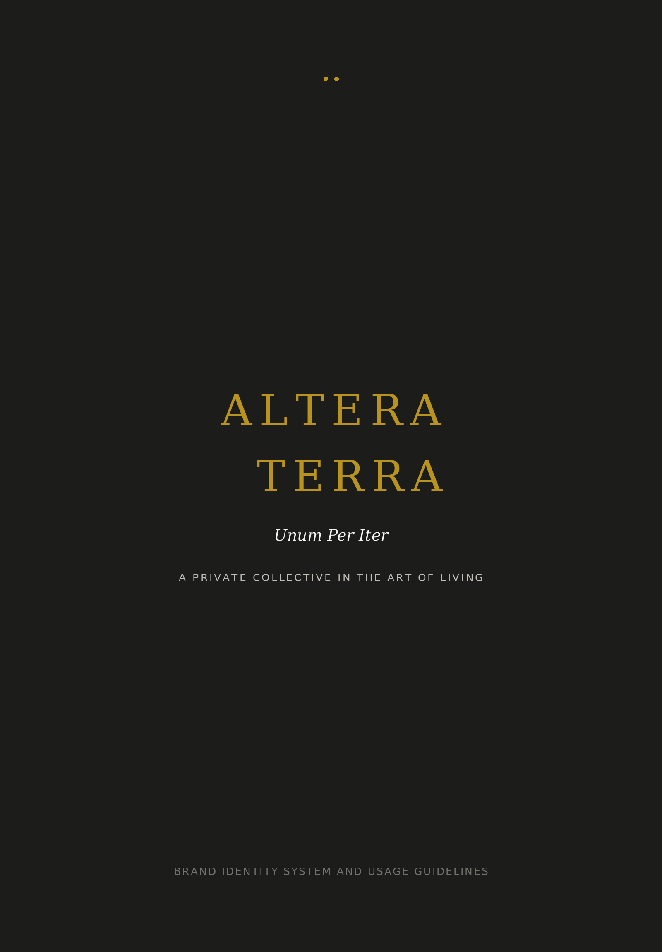

BRAND BOOK
The Standard Before the Surface
The identity is not decoration. It is the visible discipline of a collective that knows when, where, and why something belongs.
OPERATING PRINCIPLE

Altera Terra exists in the space between a person and a place. Its work is not to assemble options. Its work is to recognise the match, make the introduction, and protect the standard that makes the match meaningful.
This book defines how that standard becomes visible. It is written for designers, writers, curators, partners, and anyone entrusted with carrying the name into the world.
The system is built around one idea: the art of the right introduction. Every rule below should make that idea more precise. If a decision does not serve that idea, it should not survive the room.

BRAND ESSENCE
The art of the right introduction.
PUBLIC LINE
Unum Per Iter. One through the journey.
SECONDARY LINE
We know the room. We know you. Let us introduce you.

DOCUMENT MAP
Contents
SECTION | NAME | PURPOSE
01 | Brand Identity System | Logotype, monogram, lockups, co-branding, texture.
02 | Colour System | Palette, values, ratios, approved combinations, accessibility.
03 | Typography System | Typeface roles, hierarchy, scale, usage examples.
04 | Voice and Tone | Principles, vocabulary, copy patterns, channel calibration.
05 | Digital Applications | Website, Instagram, email, documents, favicon and icon.
06 | Print Applications | Stationery, business card, collateral, packaging, signage.
07 | Partner and Co-branding | Hierarchy, partner placement, joint content, refusals.
08 | Brand Governance | Usage authority, approvals, curator rules, review cadence.
09 | Do and Do Not | A practical reference card for daily decisions.

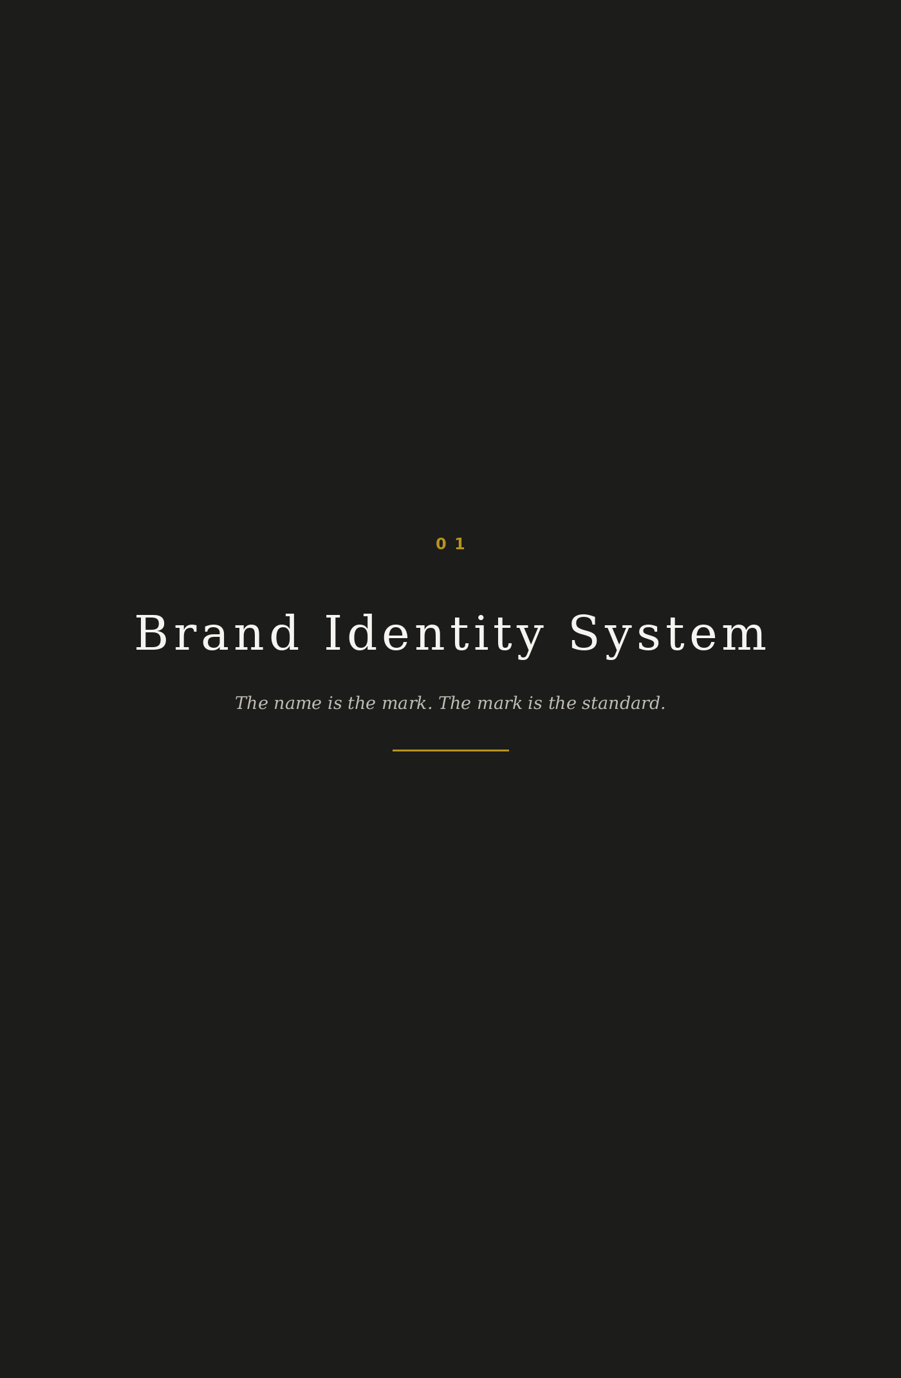
01
Brand Identity System
Principle
The Altera Terra identity must feel like an introduction made by someone with the authority to make it. It does not shout. It creates the conditions for attention.
The logotype carries the full weight of the system. Any symbol is secondary. The name is not accompanied by an emblem because the name already behaves like one.
Primary logotype
Two stacked words: ALTERA above TERRA. TERRA is optically offset to the right by approximately the width of one capital A. This offset creates the core visual tension of the brand: two entities held in relation, not collapsed into sameness.
ELEMENT | SPECIFICATION | RATIONALE
Structure | ALTERA stacked above TERRA. TERRA offset right. | Reflects the act of introduction: two sides brought into relation.
Letterform | All caps Roman serif. High contrast. Wide spacing. | Authority without ornament. The private press, not the hotel lobby.
Tracking | Very wide at display scale. Moderate at small scale. | Distance creates composure. The name is allowed to breathe.
Clear space | Minimum clear space equals the height of the capital A on all sides. | The identity is never crowded. The room around it is part of the mark.
Minimum size | 24 pt in print. 80 px wide in digital. | Below this, the letter spacing and authority begin to degrade.

Tagline lockup
The primary lockup pairs the logotype with Unum Per Iter. The line sits beneath and slightly to the right of TERRA. It should read as an afterthought in the best sense: a quieter layer of meaning, not a slogan pasted under a logo.
• Use the lockup on covers, proposals, formal documents, invitations, and partner introductions.
• Use the standalone logotype when the surrounding context already carries the brand idea.
• Italicise Unum Per Iter in running text and tagline contexts.
Monogram
The monogram is optional. It exists only for constrained spaces where the full name cannot be reproduced: favicon, app icon, seal, envelope closure, and small social avatar.
VERSION | USE | RULE
AT interlock | Digital icon, seal, small imprint. | A and T should feel cut from the same stone, never decorative.
Single T path mark | Reserved application for travel documents or itinerary markers. | Used only as a navigation device, never as a replacement logo.
Wordmark initial | Formal stationery and document folios. | A single capital A in Oro may mark a section or page opening.

Colour versions
VERSION | APPLICATION | NOTES
Oro on Nero | Primary. Covers, digital hero states, formal presentations. | The default expression. Warm, quiet, exact.
Nero on Nebbia | Light print applications, letters, partner proposals. | A more administrative expression without losing character.
Nebbia on Nero | Dark applications where Oro would become too ornamental. | Useful for editorial spreads and understated digital states.
Single colour black | Legal, fax, invoices, low-fidelity reproduction. | Allowed only when production requires it.

Prohibited treatments
• Do not stretch, condense, outline, shadow, glow, emboss, bevel, animate, recolour, or place the logotype over busy photography.
• Do not place the mark in a container unless the container is part of a formal seal system.
• Do not use the monogram as a decorative repeat at small scale. Pattern is allowed only when it behaves like material texture.
• Do not pair the logotype with partner marks without the clear space rules defined in section seven.
Brand texture
A background texture may be derived from the negative space between the A and T forms. It must be abstract, almost invisible, and used at large scale only. It should feel like grain in paper or shadow on plaster. It should never announce itself as a pattern.
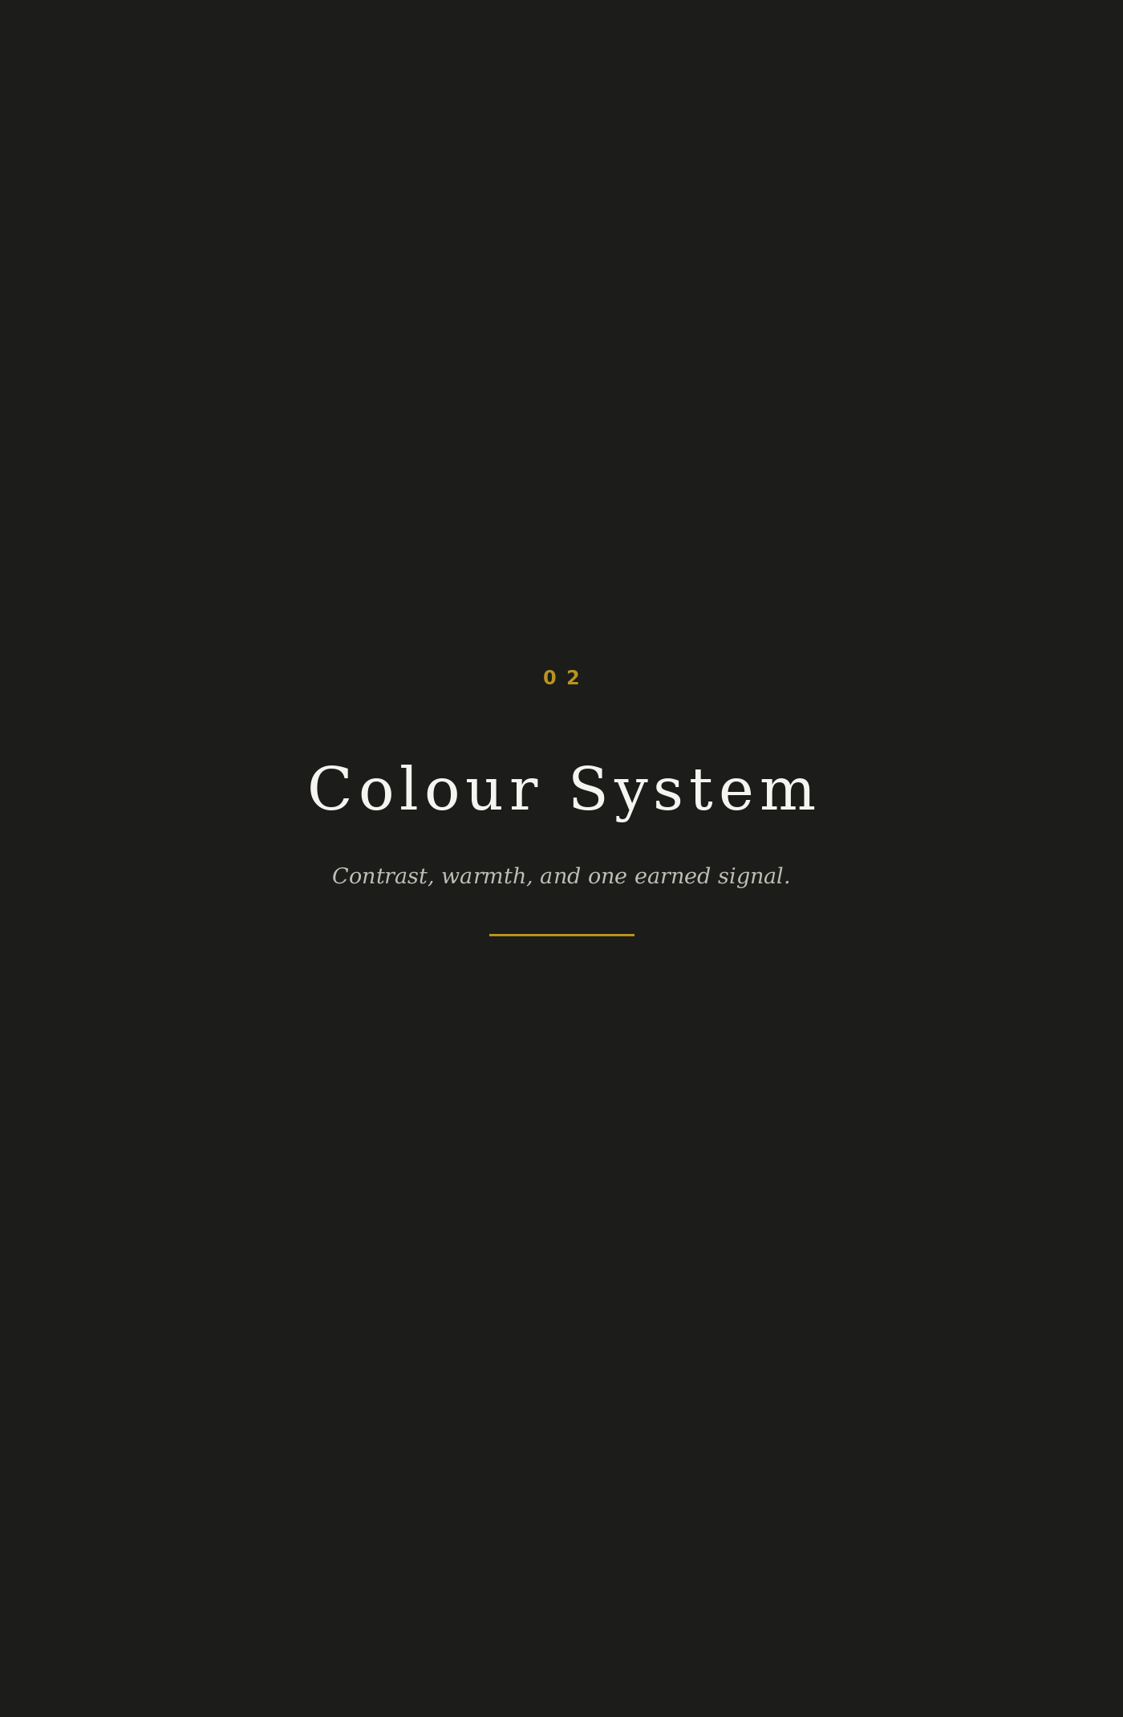
02
Colour System
Principle
The palette is an architecture of restraint. Nero creates depth. Nebbia creates air. Oro appears only when the brand needs to signal significance. The colour system should feel less like styling and more like control.
SWATCH | NAME | HEX | RGB | CMYK | USE
 | Nero | #1C1C1A | 28, 28, 26 | 0, 0, 7, 89 | Primary ground and heavy typography.
 | Oro | #B8941E | 184, 148, 30 | 0, 20, 84, 28 | Accent line, initial, divider, never broad fill.
 | Pietra | #3D3D3A | 61, 61, 58 | 0, 0, 5, 76 | Secondary ground, supporting surfaces.
 | Nebbia | #F5F4F0 | 245, 244, 240 | 0, 0, 2, 4 | Light backgrounds and printed paper surfaces.
 | Cenere | #73726C | 115, 114, 108 | 0, 1, 6, 55 | Captions, metadata, secondary navigation.

Usage ratios
COLOUR | TARGET PRESENCE | BEHAVIOUR
Nero | 60 percent | The default atmospheric ground. It creates the room.
Nebbia | 30 percent | The page surface. It gives the system enough air to stay human.
Oro | 5 percent | The signal. Use as line, detail, initial, or mark. Never as decoration.
Pietra and Cenere | 5 percent | Support, captions, interface states, low hierarchy content.

Approved pairings
PAIRING | USE | AVOID
Oro on Nero | Primary expression, covers, formal hero moments. | Do not use too much Oro. It becomes costume jewelry quickly.
Nero on Nebbia | Letters, proposals, print collateral, long reading. | Do not allow the layout to become plain office stationery.
Nebbia on Nero | Reversed editorial moments and dark UI. | Do not combine with light gray text for core information.
Cenere on Nebbia | Captions and metadata only. | Do not use for body text that must be read with effort.

Accessibility notes
Nero and Nebbia provide strong contrast and should carry all essential text. Oro is not a body text colour. It should be used for accents, section numbers, rules, and rare emphasis. Where a digital interface requires colour-coded information, colour must be paired with a text label or icon.
• Primary readable combination: Nero text on Nebbia.
• Primary reversed combination: Nebbia text on Nero.
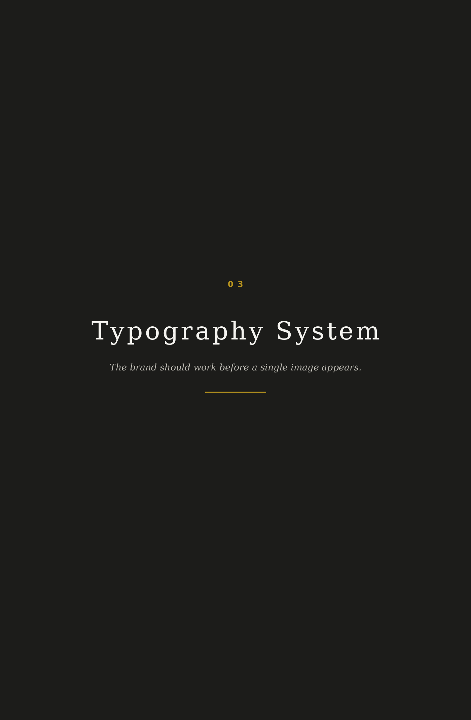
03
Typography System
Principle
Typography is the main material of Altera Terra. It must carry intelligence, silence, and hierarchy without leaning on decoration. A page set only in type should still feel complete.
Typeface architecture
ROLE | RECOMMENDED DIRECTION | USE
Display | Classical Roman serif. High contrast. Wide spacing. Cormorant Garamond, Trajan, EB Garamond Display, or custom lettercut. | Logotype, chapter titles, cover headlines, short formal statements.
Body | Refined serif with warmth and legibility. Spectral, Garamond Premier Pro, Freight Text, or equivalent. | Editorial copy, proposals, correspondence, long-form reading.
Functional | Quiet humanist or geometric sans. Suisse Int'l, Neue Haas Grotesk, Matter, or equivalent. | Captions, labels, navigation, metadata, UI, folios.

Type scale
LEVEL | SIZE | LEADING | TRACKING | USE
Display XL | 56 to 72 pt | 0.95 to 1.05 | +60 to +120 | Covers, hero statements, formal openers.
Display L | 34 to 48 pt | 1.00 to 1.08 | +40 to +90 | Section openings, campaign headlines.
Headline | 24 to 30 pt | 1.08 to 1.16 | +20 to +40 | Document pages and editorial spreads.
Body | 10.5 to 12 pt | 1.25 to 1.45 | 0 | Long-form copy and correspondence.
Caption | 7.5 to 8.5 pt | 1.15 to 1.25 | +20 to +60 | Footnotes, meta labels, image credits.

Hierarchy rules
• Use no more than three visible hierarchy levels in a single layout.
• Do not use bold in running copy. Use placement, size, and silence instead.
• Never centre-align body text. Centre alignment is reserved for lockups, invitations, and ceremonial lines.
• Italics are reserved for Latin phrases, guest voices, and titles of referenced works.
• Numbers are spelled out up to ten in body copy. Use numerals for prices, dates, and data.
Typographic examples
USE CASE | EXAMPLE | NOTE
Headline | The room had already understood you. | A statement, not a claim.
Subhead | A private introduction to places that deserve the person arriving. | Explains without selling too loudly.
Caption | Villa library, dusk. Lake light on walnut. | Precise, sensory, restrained.
Pull quote | Not open. Waiting. | Short enough to feel remembered.
CTA | Request an introduction. | The action matches the brand idea.

Language-specific guidance
Foreign place names and family names must be handled with accuracy. Do not Anglicise unless the client or property uses that form publicly. Unum Per Iter is always italicised. Currency symbols are set close to numerals, with no additional flourish: £34K, €12,000, $8,500.
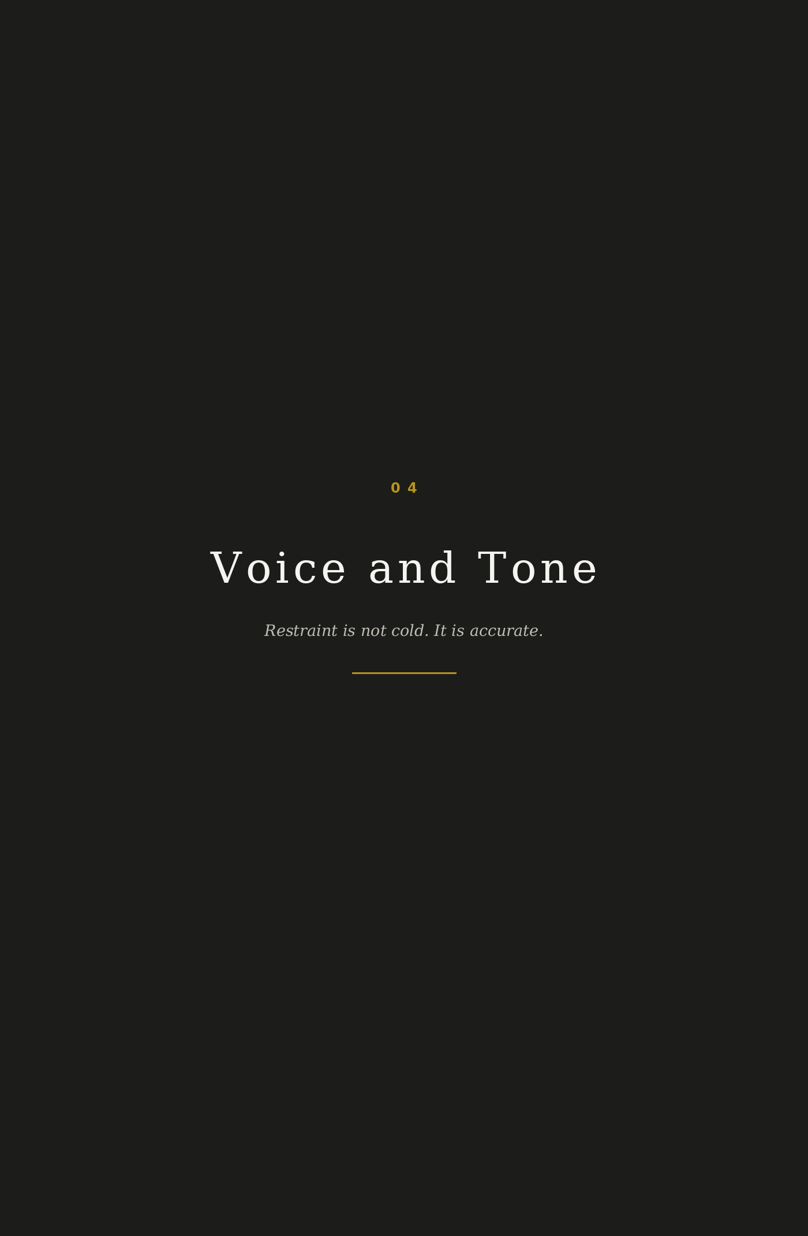
04
Voice and Tone
Principle
The voice of Altera Terra speaks with the calm of someone who knows the room. It does not decorate meaning with adjectives. It earns trust through precision, economy, and intimacy.
GOVERNING PRINCIPLE | MEANING | BEHAVIOUR
Economy | Say only what carries weight. | Short sentences. Clean syntax. No brochure fog.
Restraint | Let proof and context do the work. | Avoid inflated claims. Do not chase applause.
Intimacy | Address one person, never an audience. | The reader should feel recognised, not processed.

Vocabulary that belongs
APPROVED VOCABULARY
introduction, recognition, room, place, standard, practice, discretion, house, arrival, meaning, relationship, judgement, care, quiet, belong, deserve, timing, trust, threshold, rare

Vocabulary that does not belong
PROHIBITED OR TIRED LANGUAGE
curated, bespoke, tailored, world-class, unparalleled, exclusive, luxury as an adjective, opulent, sumptuous, discerning, prestigious, premium, bucket list, once in a lifetime, VIP, hidden gem, dream escape

Sentence structure
• Prefer short declarative sentences. Let one idea stand at a time.
• Use active voice. The collective introduces. The room receives. The place answers.
• No hedging. Do not write may, might, could, or perhaps unless uncertainty is the point.
• No exclamation marks. The brand does not raise its voice.
• No em dashes. Use full stops, colons, or sentence restructuring.
Before and after copy
WEAK COPY | ALTERA TERRA COPY
We curate bespoke luxury travel experiences for discerning clients. | We introduce people to places that deserve them.
Enjoy unparalleled access to the world's most exclusive hotels. | Access is not the point. Recognition is.
Our tailored itineraries are designed around your unique lifestyle. | The journey begins with what we know about you.
A once-in-a-lifetime escape awaits. | Some places are not waiting for everyone.
We offer VIP treatment at prestigious properties. | We know the house. The house knows why you are arriving.
Let us plan your dream vacation. | Let us make the right introduction.
Travel like never before. | Arrive where meaning has not been diluted.
The ultimate luxury concierge service. | Not a concierge. A collective with a standard.
Unlock hidden gems around the world. | Not hidden. Simply not for everyone.
Your perfect trip, tailor-made. | A place chosen because it could only have been this one.

Channel calibration
CHANNEL | TONE | EXAMPLE
Email | Personal, exact, almost letter-like. | I thought of you when this room became available.
Social | Sparse, atmospheric, more caption than campaign. | Morning light on old stone. Some houses speak before they are entered.
Pitch deck | Clear, controlled, proof-led. | Commission from properties. Never from clients. Alignment is not a claim. It is the model.
Partner proposal | Respectful and selective. | We introduce only when the guest and the house can rise together.

Persona-specific voice
PERSONA | NEED | VOICE POSTURE
The Visionary | Relief from abundance that feels numb. | Speak to recognition, certainty, and being understood without performance.
The House | Guests matched to the soul of the property. | Speak as a peer who understands standards, not as a reseller.
The Collective | A standard that remains uncompromised. | Speak as governance. Calm, firm, almost institutional.

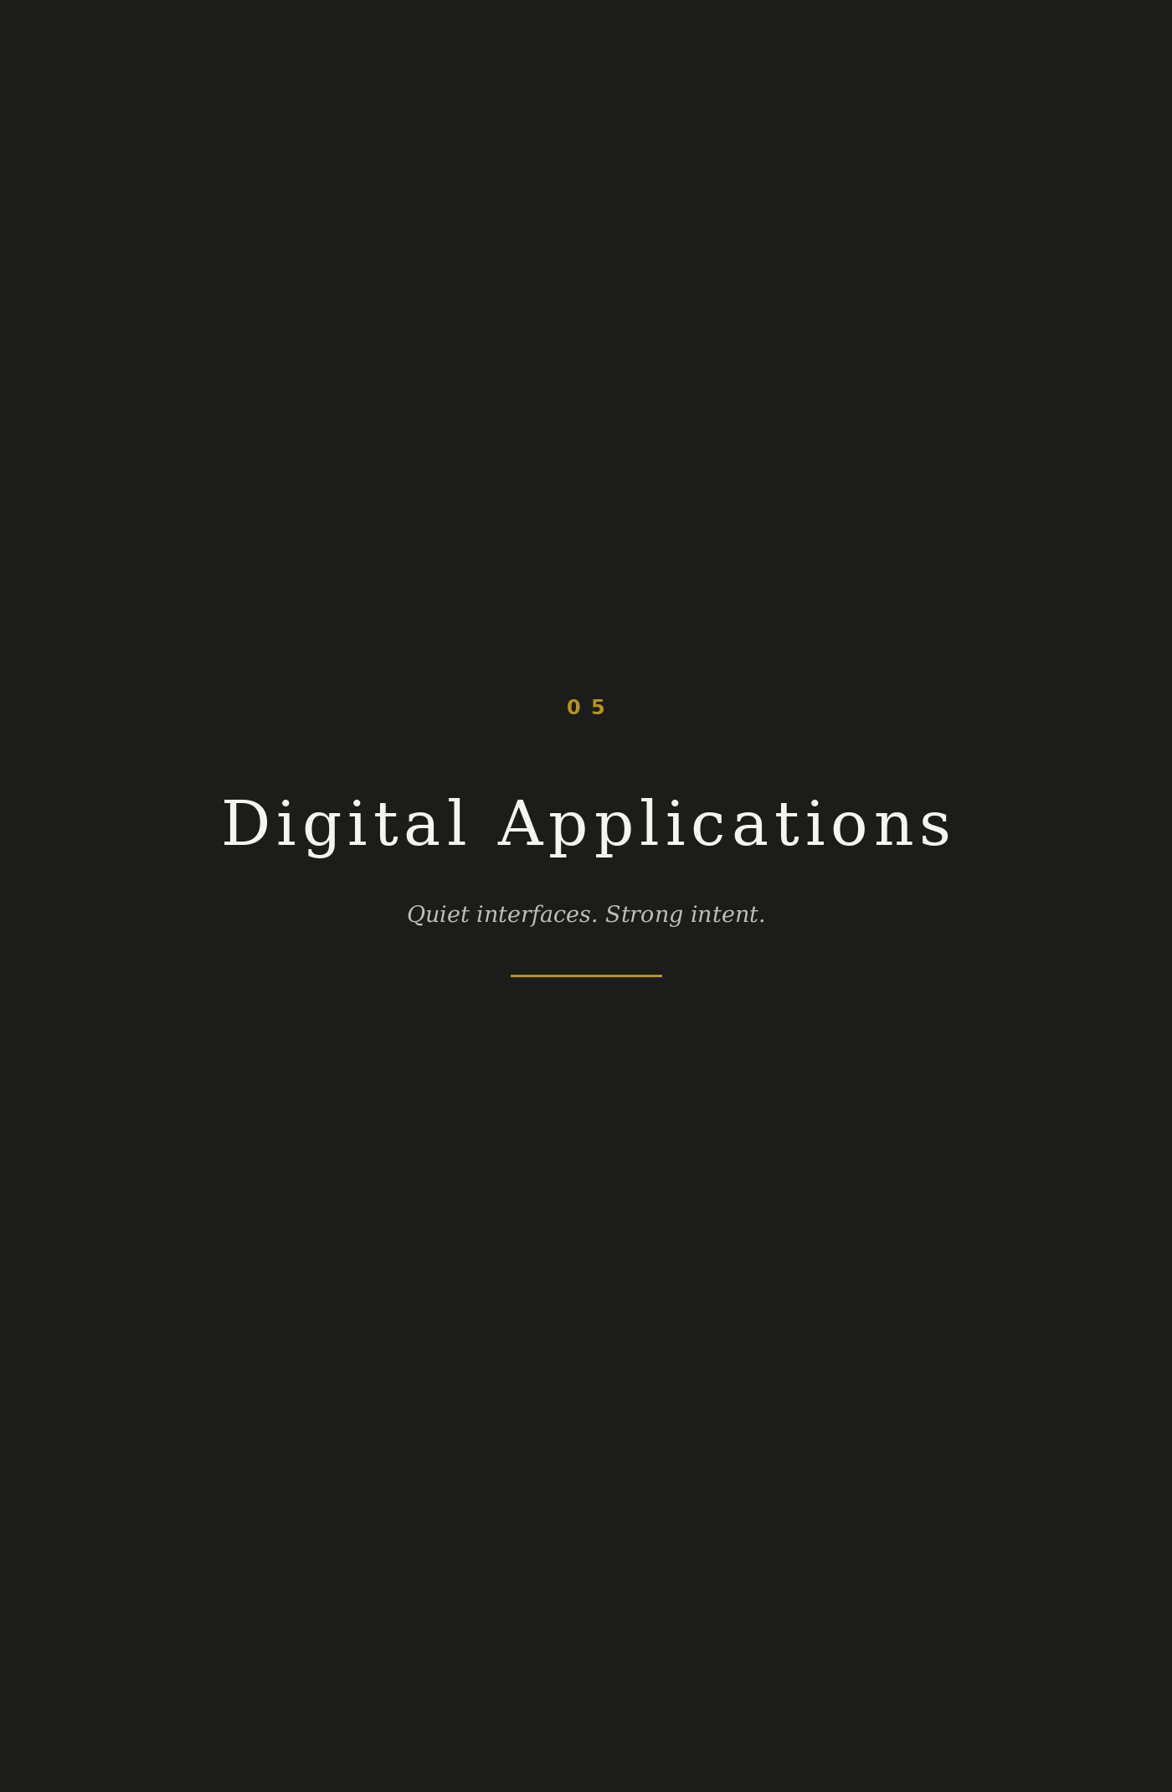
05
Digital Applications
Website
The website should feel closer to a private editorial dossier than a travel marketplace. No search box. No inventory grid. No visual rush. The visitor should understand that Altera Terra is not asking them to browse. It is asking whether they are ready to be known.
AREA | RULE | REASON
Homepage | One opening statement, one atmosphere image, one controlled action. | The brand does not compete for attention. It earns it.
Navigation | About, The Collective, Houses, Journal, Request an Introduction. | Clear, spare, not transactional.
CTA language | Request an introduction. Begin a conversation. Enter the room. | Action language must carry the brand idea.
Image treatment | Large margins, grain overlay, no faces, no busy hero composites. | Discretion is a visual behaviour.
Motion | Slow fade and small vertical movement. No bounce. No snap. | The interface moves at the pace of entry.

Website structure recommendation
1. Opening: The art of the right introduction.
2. Recognition: how the collective knows the person and the place.
3. The houses: partner philosophy without listing inventory.
4. The model: We earn from the places that deserve you.
5. The standard: how admission, discretion, and governance work.
6. Journal: essays on place, taste, arrival, and the art of living.
7. Request: a quiet form that begins with intent, not budget alone.
Instagram
Instagram is not a growth channel in the usual sense. It is a room with the door partly open. The grid should feel like a sequence of fragments from a private archive.
FORMAT | RULE | EXAMPLE
Grid post | Single image or restrained typographic card. No carousels unless each page earns its place. | A doorframe at dawn. Caption: Some houses do not need to announce themselves.
Story | One frame at a time. Caption in small Nebbia or Nero. No stickers. | A plate placed before service. Text: Before arrival.
Highlight cover | Monogram or single letter on Nero. No icons from template libraries. | A, T, House, Journal, Notes.
Bio | One sentence. One invitation. No service list. | A private collective in the art of living. Request an introduction.

Email
• Header: small wordmark, never a banner graphic.
• Body: letter-like, narrow column, generous line height.
• Subject lines: calm and specific. Example: An introduction in Umbria. Avoid urgency mechanics.
• Signature: name, role if needed, Altera Terra, Unum Per Iter. No badges, quotes, or logos stacking under the name.
Digital documents
Pitch decks and proposals use the same editorial discipline: title, proof, implication. Do not overload slides with explanations. The speaker can carry nuance. The page carries the standard.
Favicon and app icon
Use the AT monogram in Oro on Nero. At the smallest scale, remove fine interlock detail and preserve the silhouette. The favicon must feel like a seal, not a social avatar trying to be noticed.
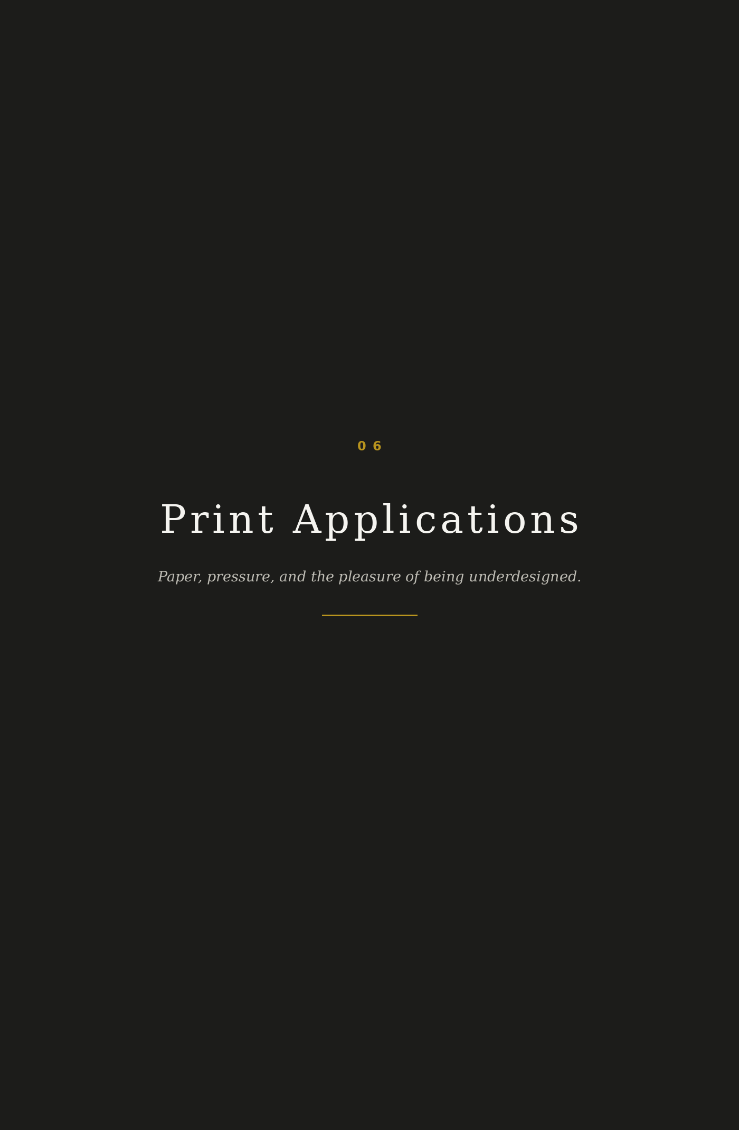
06
Print Applications
Principle
Print is where Altera Terra becomes tangible. The system should feel handled, not manufactured. Material choice matters because the brand is not selling speed. It is protecting attention.
Stationery suite
ITEM | SPECIFICATION | NOTES
Letterhead | Nebbia stock, Nero wordmark top left, Oro hairline rule, generous margins. | No footer clutter. Contact details may sit on the second page or back.
Compliments card | A6 or 105 x 148 mm. Oro wordmark on Nero or Nero on Nebbia. | Used for personal notes and property introductions.
Envelope | Nebbia outer, Nero lining optional. Wordmark small on flap. | The opening experience should feel private.
Seal | AT monogram in Oro. Blind emboss or Oro foil only. | Used sparingly. A seal is not a sticker habit.

Business card
The business card should behave like a quiet object. One side carries the wordmark. The other carries the person, with only the information needed to continue the conversation.
DETAIL | SPECIFICATION
Size | 85 x 55 mm or 90 x 50 mm, depending on print partner.
Stock | Uncoated 600 gsm, warm white or black duplex.
Front | Oro on Nero wordmark, centred or optically high.
Back | Name, role, email, phone, web. No QR code unless context requires it.
Finish | Blind emboss preferred. Oro foil allowed only for mark or rule.

Collateral
• Gift card: written as an introduction, never as a voucher.
• Property card: one image detail, one paragraph, one reason the house belongs in the collective.
• Welcome letter: personal, brief, signed. The first sentence must show recognition, not protocol.
• Itinerary folio: chaptered by rhythm, not just dates. Morning, threshold, arrival, dinner, return.
Signage and partner contexts
Altera Terra should not dominate property environments. When present at a partner property, the identity appears as an introduction mark on printed materials, welcome notes, private menus, or small directional cards. It does not become environmental branding unless the event is produced by Altera Terra.

Packaging
Packaging is a quiet extension of the arrival ritual. Nothing should feel like merchandise. Every material choice should feel useful, tactile, and controlled.
ELEMENT | RULE
Tissue | Nebbia or Nero. No printed repeat unless reduced to near-texture.
Ribbon | Nero cotton or silk. Oro not used for ribbon unless exceptionally narrow.
Envelope | Heavy uncoated stock, soft tooth, no gloss lamination.
Box | If needed, plain exterior, marked only with the monogram.

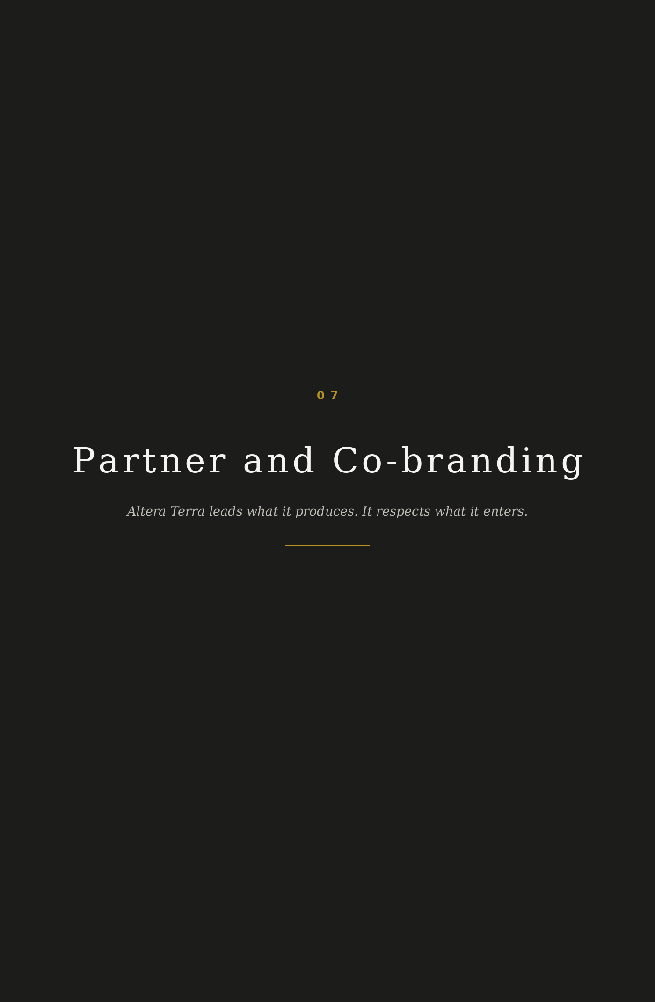
07
Partner and Co-branding
Principle
Co-branding should express mutual respect, not shared noise. Altera Terra must never appear as a sub-brand, affiliate badge, or booking channel. It is the introducing authority.
Hierarchy rules
CONTEXT | HIERARCHY | RULE
Altera Terra produced collateral | Altera Terra leads. | Partner mark may appear in a secondary zone with equal dignity but lower hierarchy.
Partner produced collateral | Partner leads. | Altera Terra appears only if the context is a specific introduction or joint event.
Joint invitation | Shared presence. | Marks sit apart with clear space. No lockup that visually fuses both identities.
Press or editorial | Context decides. | Use written relationship language before stacking logos.

Partner logo placement
• Keep at least two capital A heights between marks.
• Never place partner marks inside the Altera Terra clear space.
• When marks differ in visual weight, align optically, not mathematically.
• Avoid logo walls. If more than three partners must appear, use a written acknowledgements page.
Joint content language
WEAK | CORRECT
In partnership with Hotel X, we offer exclusive access. | An introduction between Altera Terra and Hotel X.
Book Hotel X through Altera Terra. | Arrive at Hotel X through the Altera Terra standard.
Our preferred partner property. | A house we trust with the right guest.

What the collective will not do
• Appear as a discount partner.
• Use partner marks to borrow status.
• Accept co-branded templates that weaken the Altera Terra identity.
• Publish partner content that feels like inventory promotion.
• Allow a property to describe the collective as a reseller or affiliate.
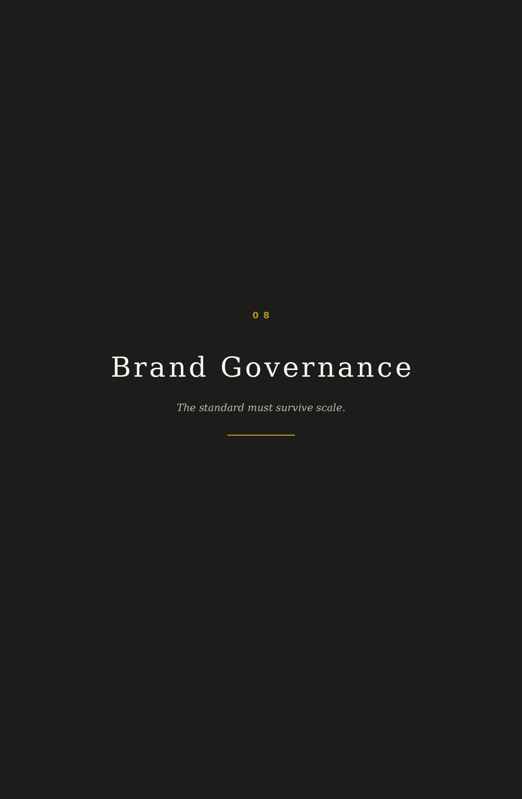
08
Brand Governance
Principle
The brand is the organism, not the individuals within it. Governance exists so that the collective can expand without becoming diluted. Growth is not the measure. Integrity is.
Usage authorisation
Only the core team and admitted curators may use the Altera Terra identity. Use is not a right granted by proximity. It is permission earned through understanding and maintained through conduct.
USER TYPE | MAY USE | MAY NOT USE
Core team | All master identity assets, proposals, partner documents, public channels. | Depart from the system without review.
Admitted curator | Approved templates, email signature, introduction documents, limited social assets. | Create new marks, alter typography, publish unapproved partner materials.
Partner | Approved co-branded assets for agreed context. | Use Altera Terra identity as an affiliate or booking badge.
External vendor | Production files relevant to assigned work only. | Retain, repurpose, or modify assets beyond scope.

Approval process
1. Prepare the application using an approved template or documented layout rule.
2. Check the identity against the five quality criteria: essence, specificity, voice, recognition, scale.
3. Submit to the core team before publication or production.
4. Record approved deviations so the system learns without drifting.
5. Archive final files in the master asset library with date, owner, and context.
Curator guidelines
• A curator may write introductions, not promotional claims.
• A curator may describe houses, not advertise inventory.
• A curator may speak with personal warmth, but never place personal fame above the collective standard.
• A curator must protect client discretion in every image, caption, document, and message.
Review cadence
All public assets, templates, pitch documents, partner materials, and digital surfaces should be reviewed annually. Any material that feels fashionable, over-explained, or visually loud should be retired. The system should age like a house with good bones.
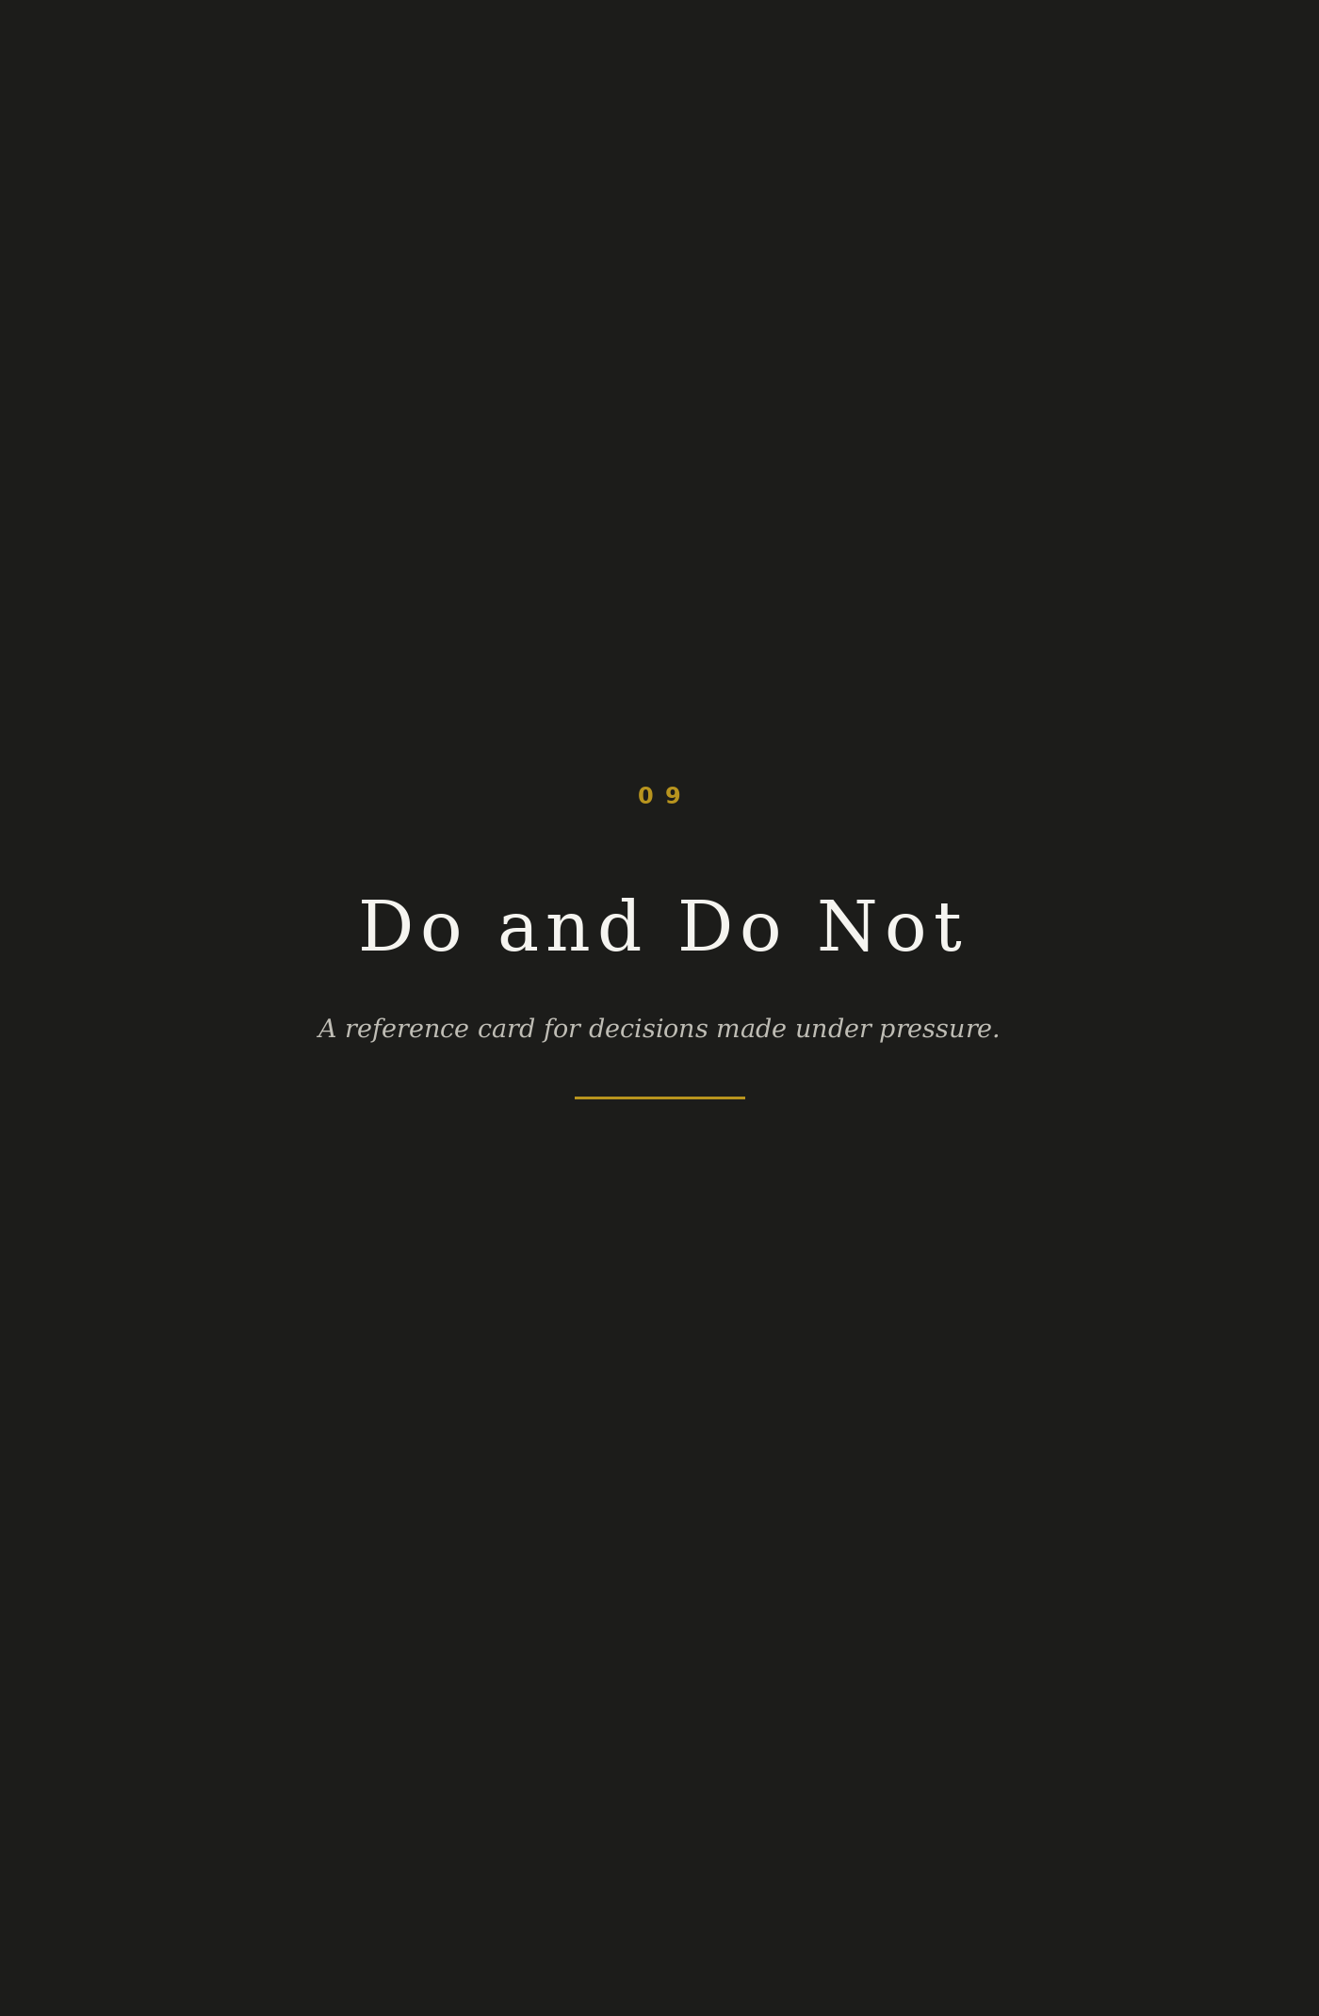
09
Do and Do Not
This section exists for speed. When in doubt, choose the action that protects recognition, discretion, and the standard.
DO | DO NOT
Let silence carry meaning. Space is a decision. | Fill every surface because the page feels empty.
State the standard. Let proof speak. | Describe the standard with inflated adjectives.
Address one person at a time. | Write for a crowd.
Use Oro as a signal. | Use gold as decoration.
Show the detail that tells the story. | Show the obvious landmark from the obvious angle.
Use typography as the primary design material. | Depend on images to rescue weak hierarchy.
Protect client discretion. | Show faces or identifiable private moments.
Write with precision. | Write like a travel brochure wearing a tuxedo.
Use the full logotype when space allows. | Overuse the monogram because it looks neat.
Commission from places that deserve the guest. | Charge clients in a way that creates doubt about alignment.
Make introductions. | Sell bookings.
Use restrained motion. | Animate like a notification app.
Use one strong image. | Build visual collages.
Use no more than two typefaces in an application. | Collect fonts like souvenirs.
Use Nebbia for breathing space. | Use pure white that feels clinical.
Review all new applications before release. | Let every curator improvise the brand.
Let the house keep its dignity. | Turn partner properties into product cards.
Use short, declarative copy. | Stack clauses until the sentence needs a travel pillow.
Retire assets that feel loud or fashionable. | Keep assets because they were expensive to make.
Aim to become indispensable. | Aim to become vast.

LAUNCH READINESS
Implementation Checklist
Before Altera Terra appears in market, the following decisions should be completed. These are not decorative refinements. They are the working conditions of the brand.
1. Approve final logotype construction and spacing in vector format.
2. Build the AT monogram in small, medium, and seal-specific versions.
3. Confirm production typefaces and licensing for digital and print use.
4. Create master templates for proposal, itinerary, partner introduction, and welcome letter.
5. Define photography editing preset: desaturation, grain, shadow warmth, highlight restraint.
6. Create the first image library with no faces, no obvious landmarks, no stock imagery.
7. Build website wireframes around introduction, recognition, houses, model, standard, journal, request.
8. Write core copy library: homepage, about, collective model, partner model, request flow, email signature.
9. Prepare co-branding templates for top partner contexts.
10. Create governance folder: master assets, usage rules, approval log, annual review archive.
Final governing line
Altera Terra does not need to become vast. It needs to become indispensable within the circle where recognition still matters.
GOVERNING AMBITION

This is the measure. Not reach. Not noise. Not the visible size of the room. The measure is whether the right person, the right house, and the right moment meet with enough care that all three are changed by the introduction.

