Homework Submission Template 4

Problem 1 Part c) Screenshot of array containing pH values in console.

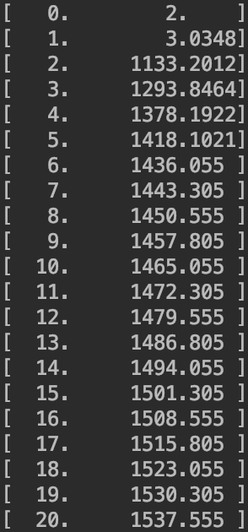

Problem 1 Part d) Screenshot of opened data file.

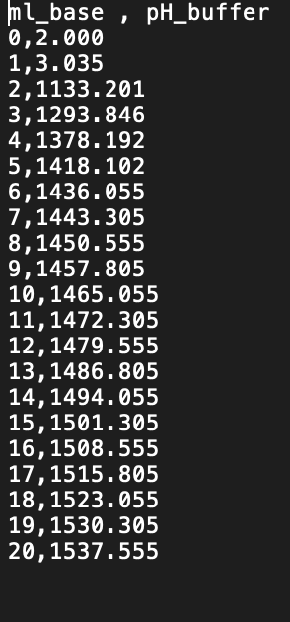

Problem 1 Part e) Plot for Buffer

Problem 2 Part c) Graph of average Bacteria Growth

Problem 3 a) Graph A = 5

Problem 3 b) Graph of A = 2 4 6 8

Problem 3 c) Graph with drought.