Design and development
Java is a general-purpose computer-programming language that is concurrent, class-based, object-oriented, and specifically designed to have as few implementation dependencies as possible. It is intended to let application developers "write once, run anywhere" (WORA), meaning that compiled Java code can run on all platforms that support Java without the need for recompilation. [1] https://en.wikipedia.org/wiki/Java_(programming_language)
The image below shows the model, represented in a class diagram for the AmstrongGPSurgery program, designed in UML (Unified Modelling Language). The Unified Modelling Language (UML) is a general-purpose, developmental, modelling language in the field of software engineering that is intended to provide a standard way to visualize the design of a system.[2] https://en.wikipedia.org/wiki/Unified_Modeling_Language
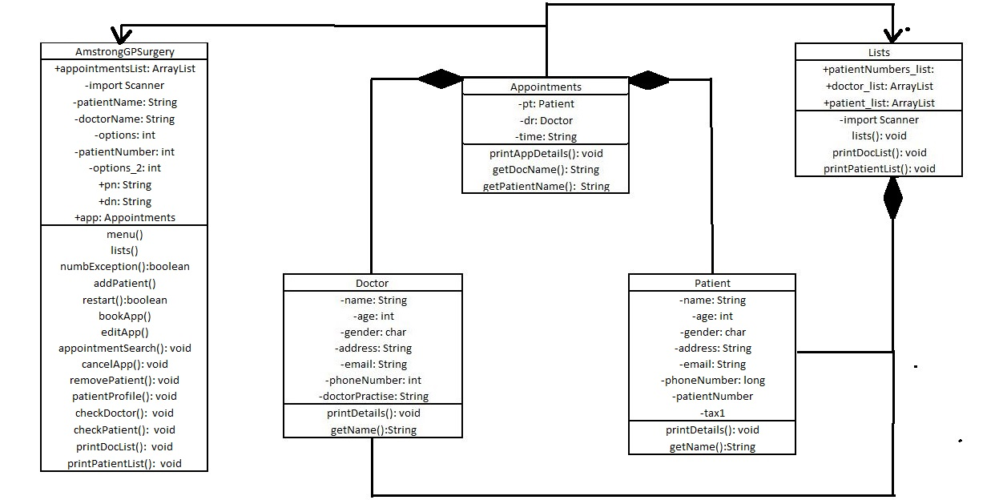
Picture 1
Picture 1 consists of five classes. Each class represented with variables and methods.

Lists Class
The ArrayList class extends AbstractList and implements the List interface. ArrayList supports dynamic arrays that can grow as needed.
Standard Java arrays are of a fixed length. After arrays are created, they cannot grow or shrink, which means that you must know in advance how many elements an array will hold.
Array lists are created with an initial size. When this size is exceeded, the collection is automatically enlarged. When objects are removed, the array may be shrunk. [3]
https://www.tutorialspoint.com/java/java_arraylist_class.htm
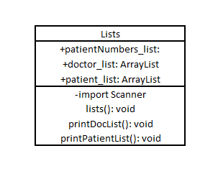
Picture 2
The purpose of the class is to create ArrayLists and print information from that list. In the example we can see objects Doctor from 1 to 5 with declaring their ptoperties as name, age , gender etc. Variables used for them are as folows: String, int, char, String …etc.
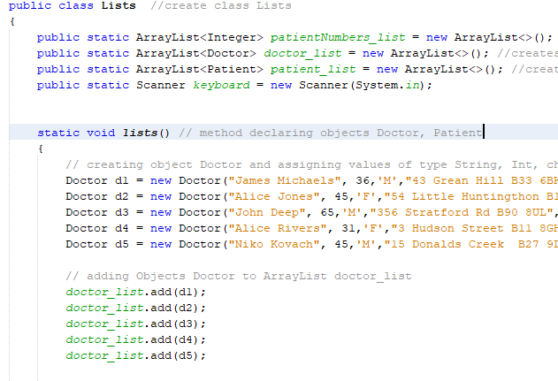
Picture 3
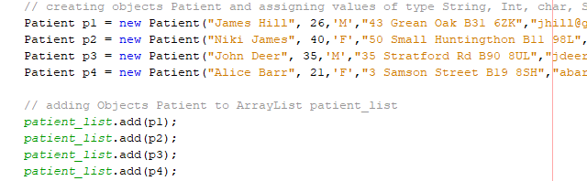 Picture 4
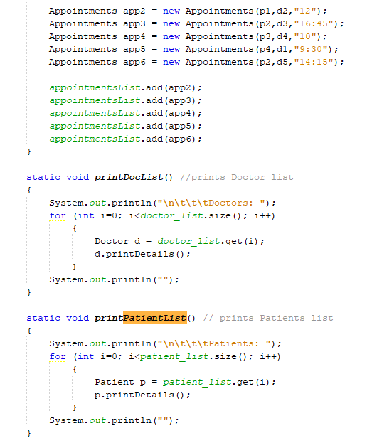
Picture 5
Picture 3-4-5 provides of the source code of the Lists class variables declared global as one of the requirements is to capture and store some patient and appointment details (e.g. name, age, address, …).
Also on picture 5 we can see print methods for Patients and Doctors. Using “for loop” to go trough the lists and take the value of every position in the ArrayLists we can print the details stored in that position.
For that purpose, we need a constructor, a constructor needs to be defined to collect values.
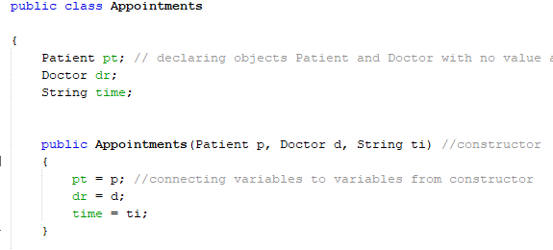
Picture 4
The variables are encapsulated, therefore, getter methods must be established to access the attributes values.
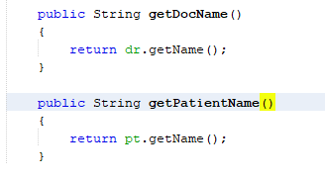

Picture 6

2 Patient Class
In Java, a constructor is a block of codes similar to the method. It is called when an instance of the object is created, and memory is allocated for the object.
It is a special type of method which is used to initialize the object. [4]
https://www.javatpoint.com/java-constructor

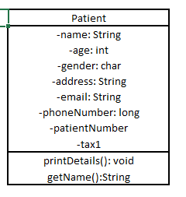
Figure 7
Patient class contains the constructor that needs to be used for creating each patient to meet the requirements of the system, respectively name of the patient, gender, etc.
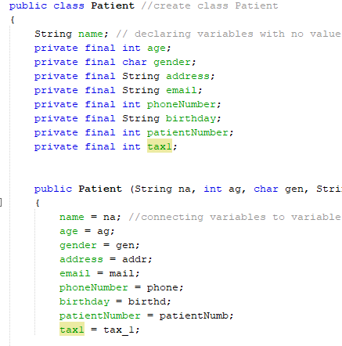
Figure 8

3 AmstrongGPSurgery Class
The AmstrongGPSurgery class has the purpose to display the menu as well as to perform actions from the classes presented above to give the correct output to the user. Also in AmstrongGPSurgery class is the main as it has the main method, having the purpose to run the application.
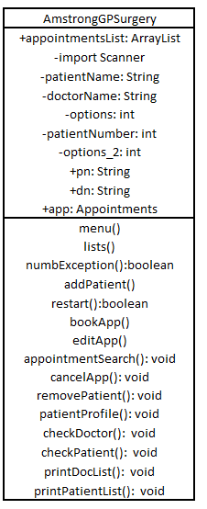
Figure 9
The patient has unique number to be able to be distinguish one patient from another. One way to achieve this is to generate it together with all details required from the user in this class.

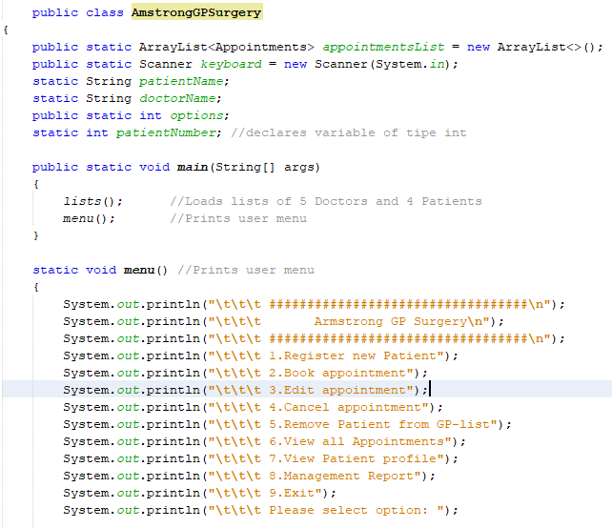 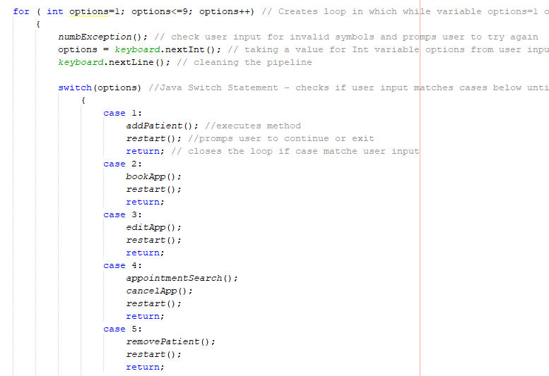 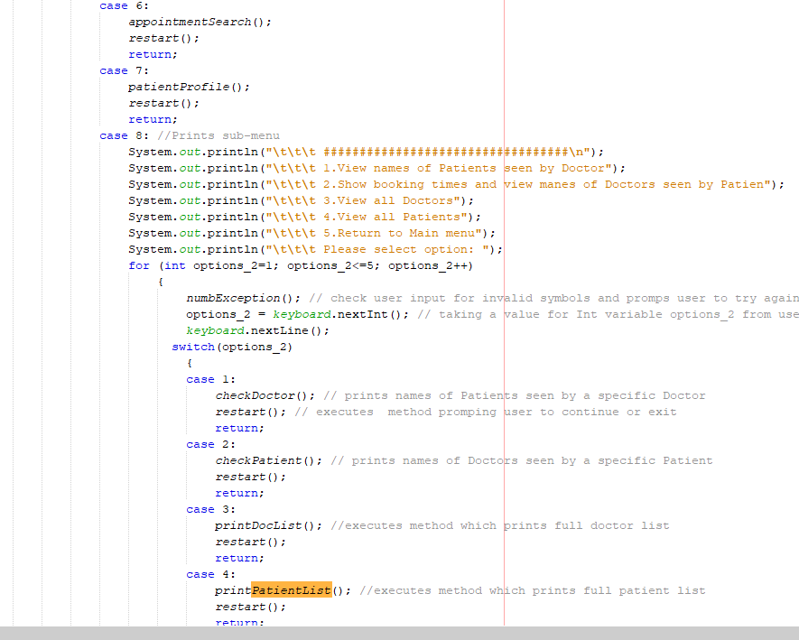 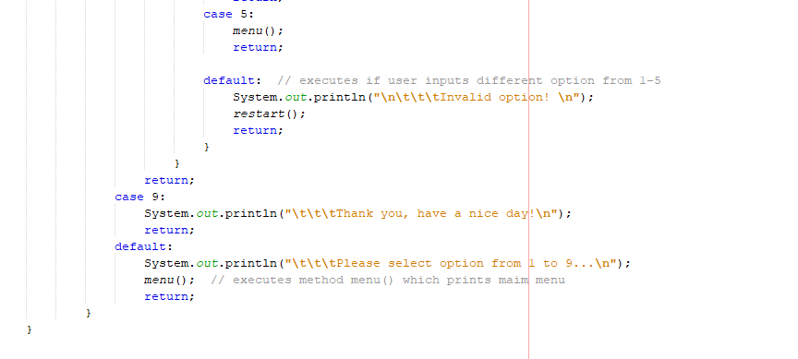 Figure 10

Here, the application prompts user to select option from a list printed on the screen.
In order to display the right option correctly, user is informed if the input is incorrect, in the test table could be seen a test case in which wrong input was tested.
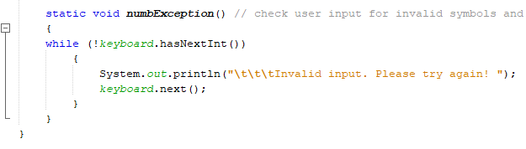 Figure 10

Test

4.1 Initial test
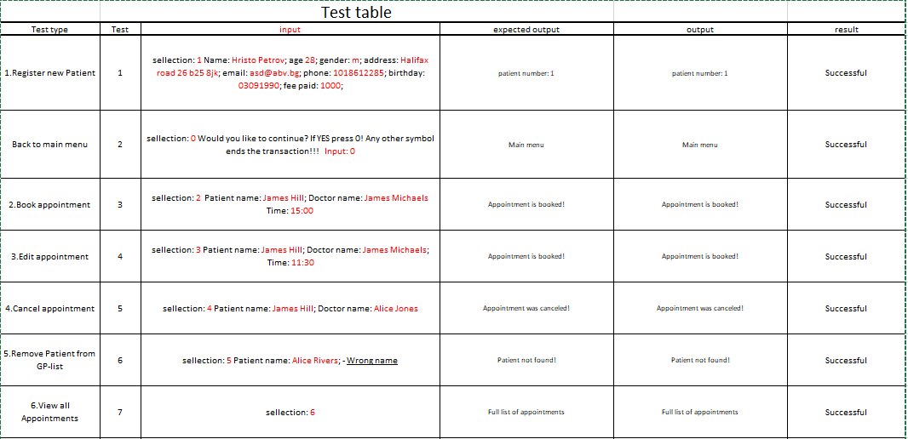
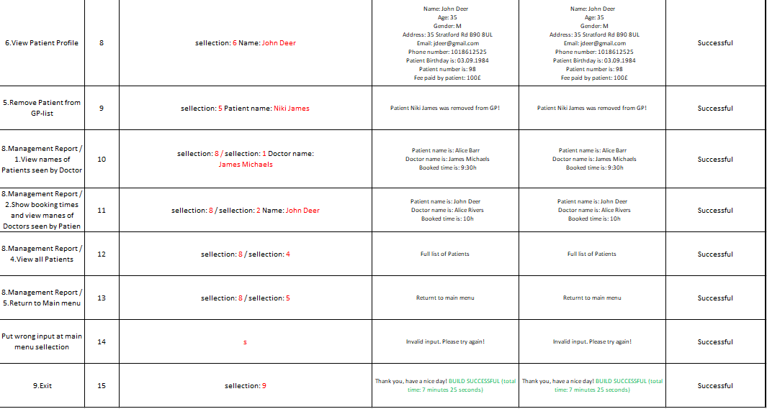

5 References
Wikipedia Java Programing [1] https://en.wikipedia.org/wiki/Java_(programming_language)( Accessed: 30/03/2019).
Wikipedia UML Diagrams [2] https://en.wikipedia.org/wiki/Unified_Modeling_Language (Accessed: 30/03/2019).
Tutorials point Java array lists [3]
https://www.tutorialspoint.com/java/java_arraylist_class.htm (Accessed: 30/03/2019).

Javatpoint Java constructor [4]
https://www.javatpoint.com/java-constructor
(Accessed: 30/03/2019).

Appendices

