- Introduction
In days of advanced technology as todays, databases are very useful “tool” to be able to do various actions.
What is a Database?
Database is a collection of data or information organised in a way to allow very fast search and retrieval by user using a computer. Databases are created in order to be able to safe storage space, to be easy to access specific information, to change and delete date when necessary. To be able to operate the Database we need a special system known as Database Management System – DBMS. DBMS is hardware, information that manages the data and computer software. System is centralized which means it uses standard format and data is easy to share, consistency is preserved and redundancy is taken to minimum. Due to accessibility of DBMS querying is available. DBMS has all the latest security measures available to protect the data. Aldo the cost of hardware and software developed for the DBMS is not a small one.
(https://en.wikipedia.org/wiki/Database 2019)
What is File Management System?
File Management System is system through which user is able to access a single file in particular moment of time. A file management system is not a file system, file system manages all files and data in an operating system, or a database management system (DBMS), which has relational database capabilities and includes a programming language for data managing. Using File Management System could be very unreliable if user managing the files want to change an address or other type of data but do not change all the instances in which the date is stored. If that occurs data is inconsistent. That type of system is lacking security and a data isolation can occur because of the various file formats.
(https://www.webopedia.com/TERM/F/file_management_system.html 2019)
What is RDBMS?
RDBMS (relational database management system) is variety of programs which allows user to manage and interact with relational database. RDBMS use Structured Query Language (SQL) to be able to access the database.
(https://www.tutorialspoint.com/sql/sql-rdbms-concepts 2019)
RDBMS vs. DBMS
Databases hold variety of data, which could be queried for use in applications. A database management system could support the development, administration and management of database applications.
An RDBMS is a type of DBMS in which data elements are connected if they are related, also RDBMS includes functions maintaining security, provide integrity and consistency as well as accuracy of the data. That type of DBMS has data dictionaries and metadata collections which are used for data manipulations.
Comparing characteristics of Hierarchical, network and relational database models:
Hierarchical Model
In this model data is structured in structure which is tree like, single root which is connected to all other data. Hierarchy starts from root and expands adding child nodes to parents notes like a tree. Child node can have only one parent node. One-to-many relationship is used in this model, relationship between two different types of data, for example, one airport can have many departure flights, many arrival flights and many passengers.
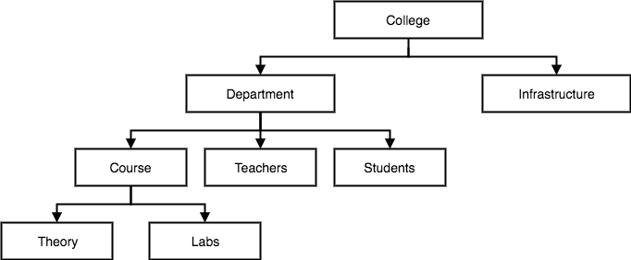

Network Model
This model is a continuation of Hierarchical model in which data is structured like a graph, child is allowed to have more than one parent node. Data has more established relationships in this database model, hence data accessing is easier and fast. Network Model is mapping many-to-many data relationship.
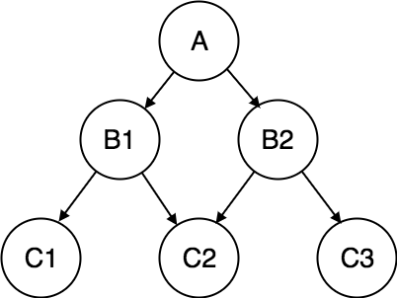

Relational Model
In Relational model, relationship is maintained by storing a common field. The basic structure of data in the relational model is tables. All the information related to a particular type is stored in rows of that table. Hence, tables are also known as relations in relational model.
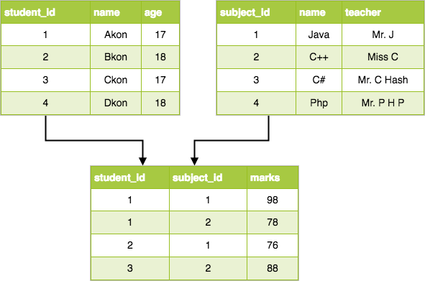

- Conceptual Modelling
- Possible entities based on the scenario:
- Aircrafts
- Airports
- Arrival
- Bookings
- Cancelations
- Departure
- Employees
- Flights
- Passengers
- Payments
- Timetable
Conceptual Data Model for Jet Airlines

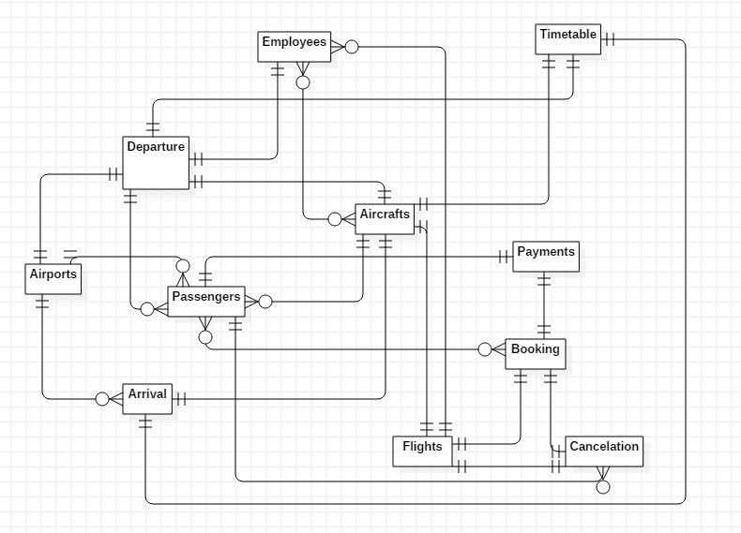

- Logical Modelling

Using Normalization design technique, entities are split in to smaller tables and link all together with the appropriate relationship.
All entities are listed in the UNF (Unnormalized Form).
Converting them to 1NF (First Normalized Form): each entity by its attributes,
data should be atomic (each cell only contains a single value),
relationship using primary key (the unique identifier with no NULL value),
foreign key (referencing to the primary key of another table).
For repeating entities from 1NF create separate table in the 2NF and identified them with unique primary key, using foreign key to relate them to the other tables.
Creating 3NF: The information displayed in my 2NF has no transitive functional dependencies.

UNF | 1NF | 2NF | 3NF | Entities
Aircrafts |  |  |  | Aircrafts
Airports | AircraftID(PK) | AircraftID(PK) | AircraftID(PK)
Arrival | AircraftType | AircraftType | AircraftType
Bookings | PassengerCapacity | PassengerCapacity | PassengerCapacity
Cancelations | FuelCapacity | FuelCapacity | FuelCapacity
Departure | CrueSize | CrueSize | CrueSize
Employees | Manifacturer | Manifacturer | Manifacturer
Flights
Passengers |  |  |  | Airports
Payments | AirportID(PK) | AirportID(PK) | AirportID(PK)
Time | AirportName | AirportName | AirportName
 | AirportCountry | AirportCountry | AirportCountry
 |  |  |  | Arrival
 | ArrivalID(PK) | ArrivalID(PK) | ArrivalID(PK)
 | ArrivalTime | ArrivalTime | AircfarfID(FK)
 | FlightID(FK) | FlightID(FK) | FlightID(FK)
 | AircraftType(FK) | AircraftType(FK) | AirportID(FK)
 | AirportID(FK) | AirportID(FK)
 | AirportName | CrueSize
 | PassengerCapacity
 | PassengerList
 | CrueSize
 |  |  |  | Bookings
 | BookingID(PK) | BookingID(PK) | BookingID(PK)
 | AirportID(FK) | AirportID(FK) | AirportID(FK)
 | AirportName | PassangerID(FK) | PassangerID(FK)
 | PassengerName | DepartureSlotID(FK) | DepartureSlotID(FK)
 | DepartureSlotID(FK)
 | DepartureTime
 |  |  |  | Cancelations
 | Cancelation(ID) | Cancelation(ID) | Cancelation(ID)
 | BookingID(FK) | BookingID(FK) | BookingID(FK)
 | AirportID(FK) | AirportID(FK) | AirportID(FK)
 | AirportName | PassengerID(FK) | PassengerID(FK)
 | PassengerID(FK)
 | PassengerName
 | Time
 | Date
 | DepartureID(PK) | DepartureID(PK) | DepartureID(PK) | Departure
 | AircraftID(FK) | AircraftID(FK) | AircraftID(FK)
 | AircraftType | AirportID(FK) | AirportID(FK)
 | AirportID(FK) | BookingID(PK) | BookingID(PK)
 | AirportName
 | PassengerCapacity
 | PassengerList
 | Date
 | DepartureTime
 | EmployeeCount
 |  |  |  | Employees
 | EmployeeID(PK) | EmployeeID(PK) | EmployeeID(PK)
 | EmployeeType | EmployeeType | EmployeeType
 | EmployeeCount | EmployeeCount | EmployeeCount
 |  |  |  | Flights
 | FlightID(PK) | FlightID(PK) | FlightID(PK)
 | PassengerList | BookingID(PK) | BookingID(PK)
 | PassengerCapacity
 | EmployeeCount
 | Time
 |  |  |  | Passengers
 | PassangerID(PK) | PassangerID(PK) | PassangerID(PK)
 | PassengersName | PassengersName | PassengerName
 | PassengerAddress | PassengerAddress | PassengerAddress
 | PassengerAge | PassengerAge | PassengerAge
 | PassengerGender | PassengerGender | PassengerGender
 |  |  |  | Payments
 | PaymentsID(PK) | PaymentsID(PK) | PaymentsID(PK)
 | PassengerID(FK) | PassengerID(FK) | PassengerID(FK)
 | FlightID(FK) | FlightID(FK) | FlightID(FK)
 | PassengersName | AirportID(FK) | AirportID(FK)
 | AirportID(FK) | AirportID(FK)
 | AirportName
 |  |  |  | Time
 | TimeSlotID(PK) | TimeSlotID(PK) | TimeSlotID(PK)
 | Time | Time | Time

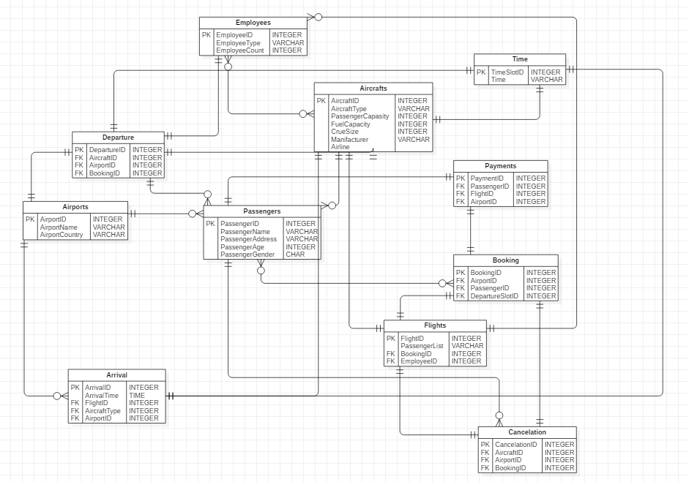
EDR with all attributes and their data types Made in Star UML (https://docs.staruml.io/working-with-diagrams/entity-relationship-diagram 2019)
- SQL and database implementation
Structured query language or SQL is a specifically designed language for interacting with a database. The SQL command used to interact with relational databases are categorized into three major groups namely; DDL (Data Definition Language) that include CREATE, ALTER and DROP; DML (Data Manipulation language) that include SELECT, INSERT, UPDATE and DELETE and DCL (Data control language) that has GRANT and REVOKE. (w3schools.com/sql/ 2019)

Create Aircrafts Table:

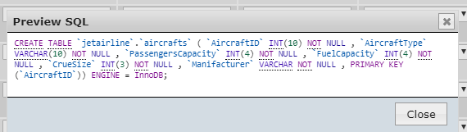

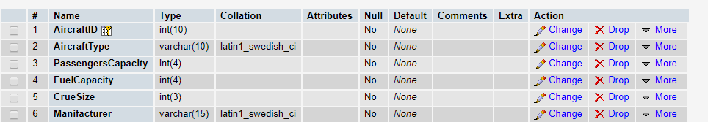

Insert info
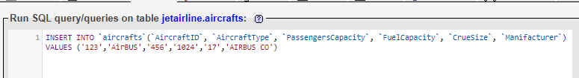

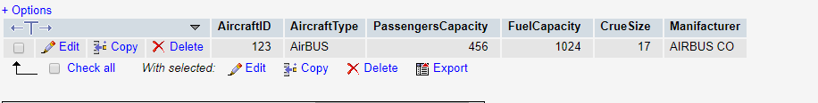

Create Airports Table
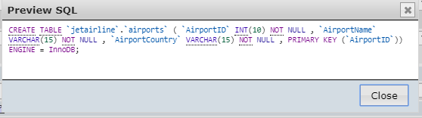

Insert Info
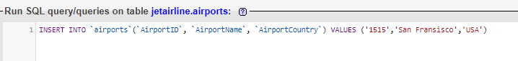

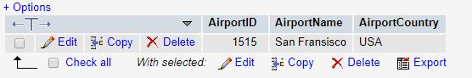

Create Arrival Table:
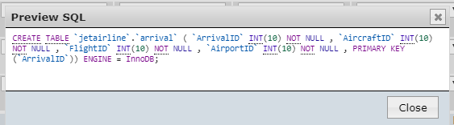

Insert info:
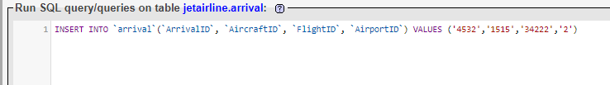
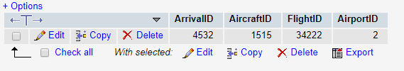
Create Booking Table:

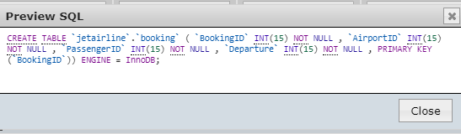

Insert Info:
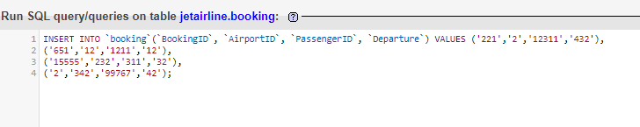
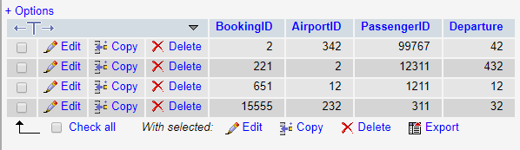

Create Cancelations Tables:
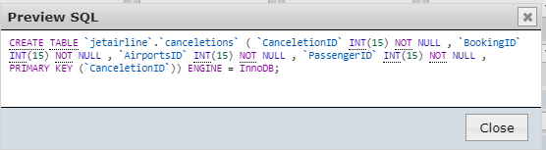

Insert Info:
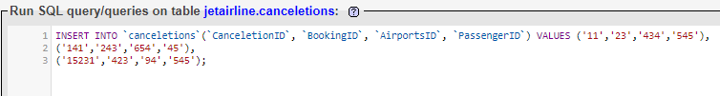
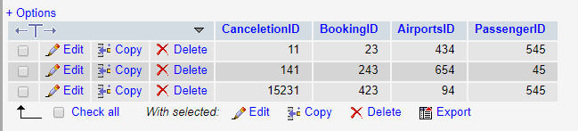

Create Departure Table:
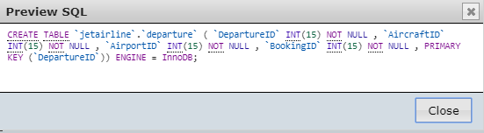

Insert Info:

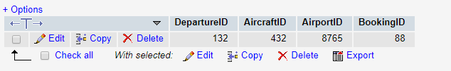

Create Employees Table:

Insert Info:
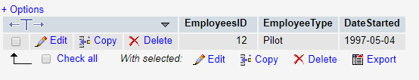

Create Flights Table:
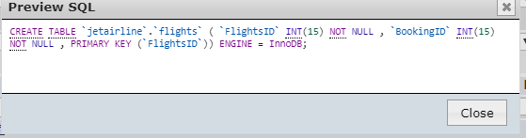

Insert info:
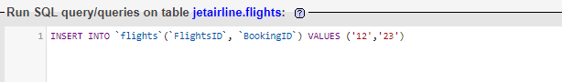
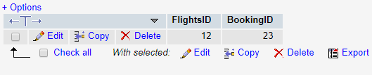

Create Passengers Table:
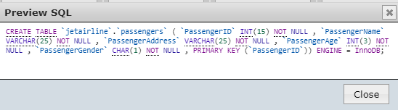

Insert Info:
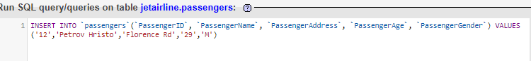

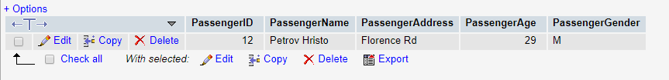

Create Payments Table:
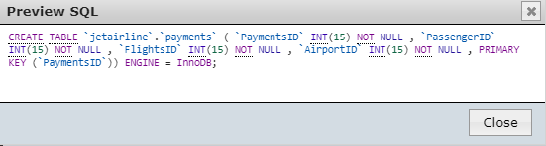

Insert Info:

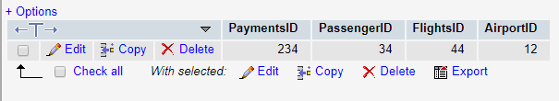

Create Table Time:

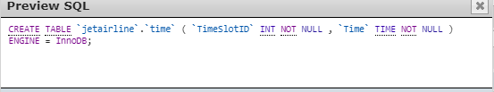

Insert Info:
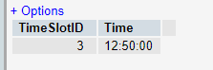

Jet Airline Database:

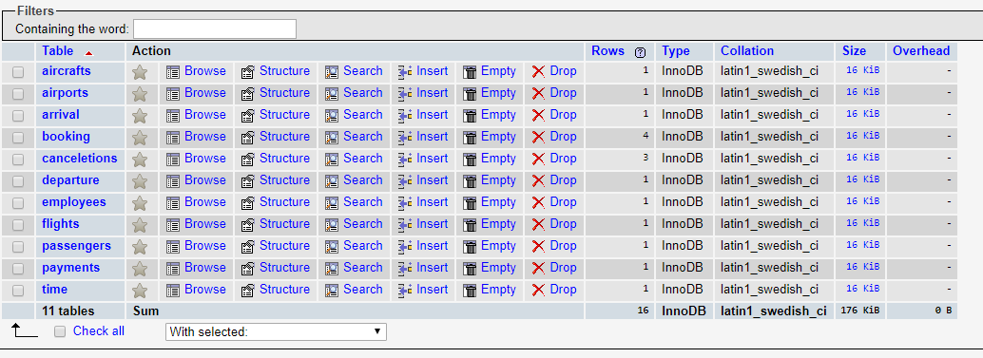

Query:
SELECT `BookingID`, `AirportID`, `PassengerID`, `Departure` FROM `booking` WHERE `BookingID` =2

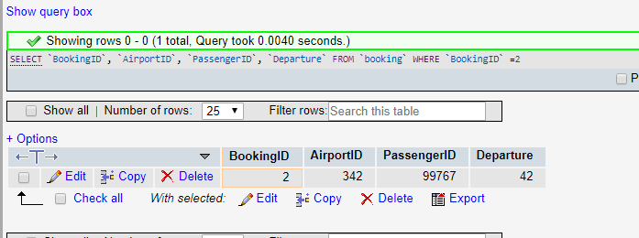

- References:
- SQL Available at:
https://www.w3schools.com/sql/ (Accessed: 21 July 2019)
- EDR STAR UML Available at:
https://docs.staruml.io/working-with-diagrams/entity-relationship-diagram (Accessed: 21 July 2019)
- Database Available at:
https://en.wikipedia.org/wiki/Database (Accessed: 21 July 2019)
- File Management System Available at:
https://www.webopedia.com/TERM/F/file_management_system.html (Accessed: 21 July 2019)
- RDBMS Available at:
https://www.tutorialspoint.com/sql/sql-rdbms-concepts (Accessed: 21 July 2019)

