

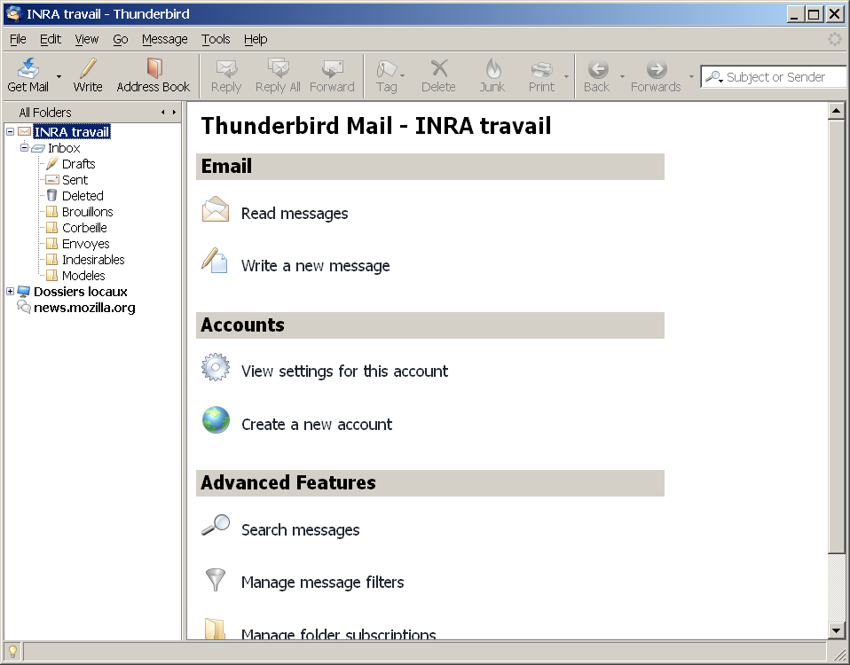
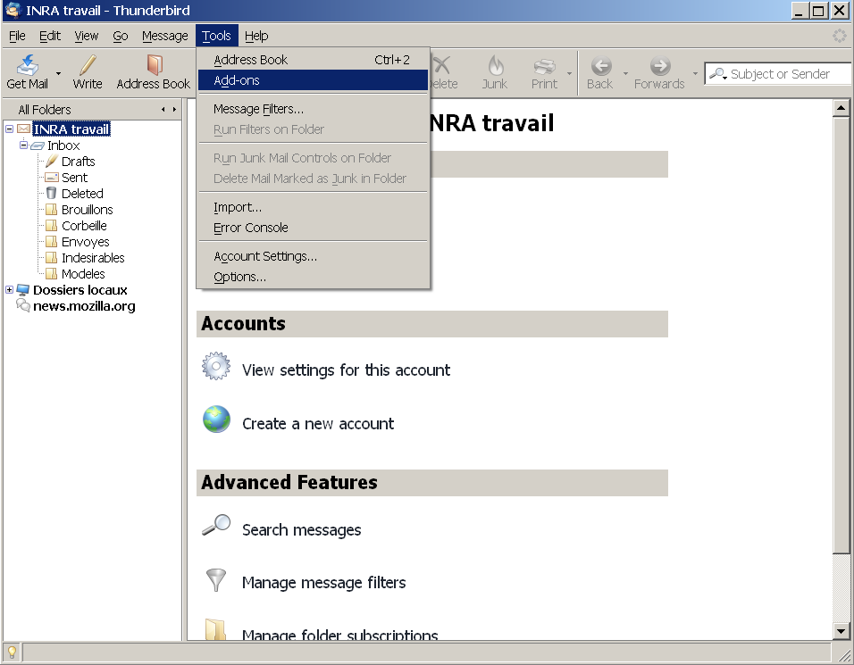
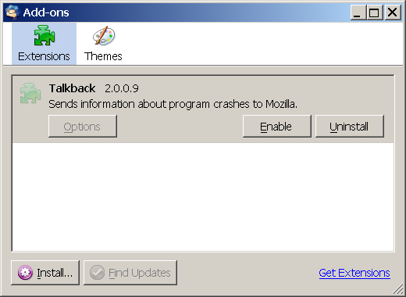
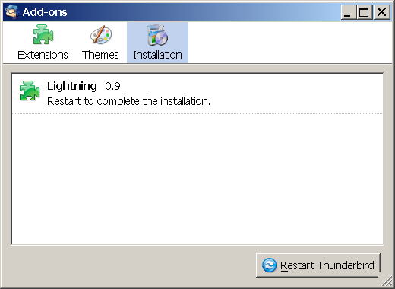
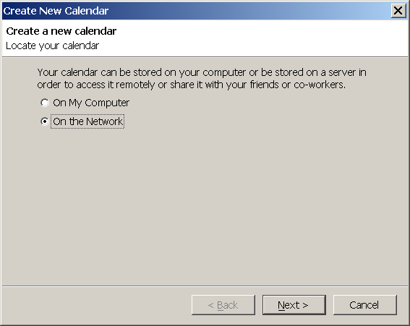
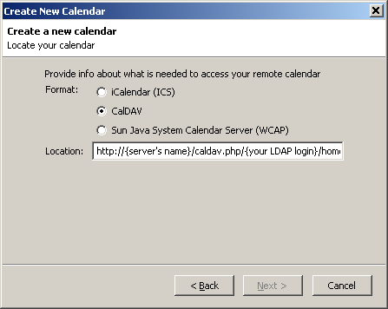
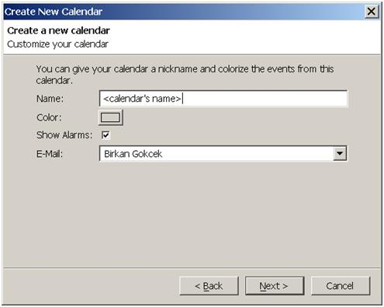
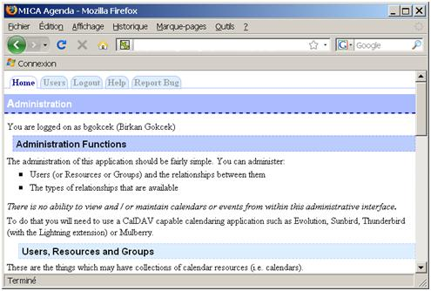
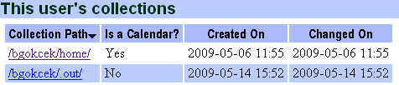
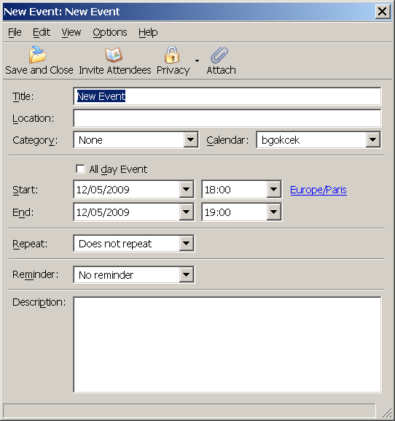


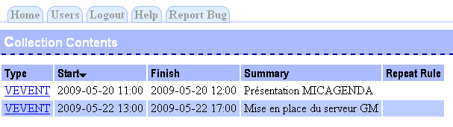
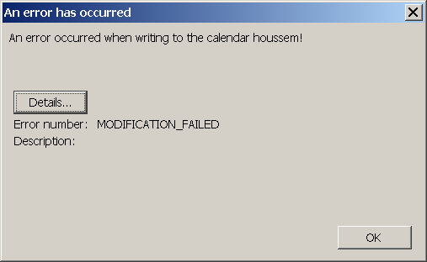
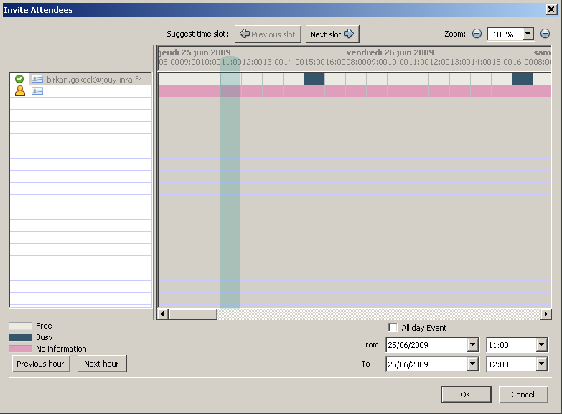

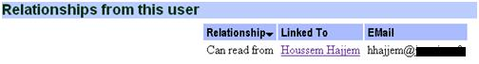
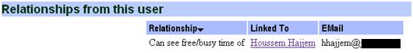
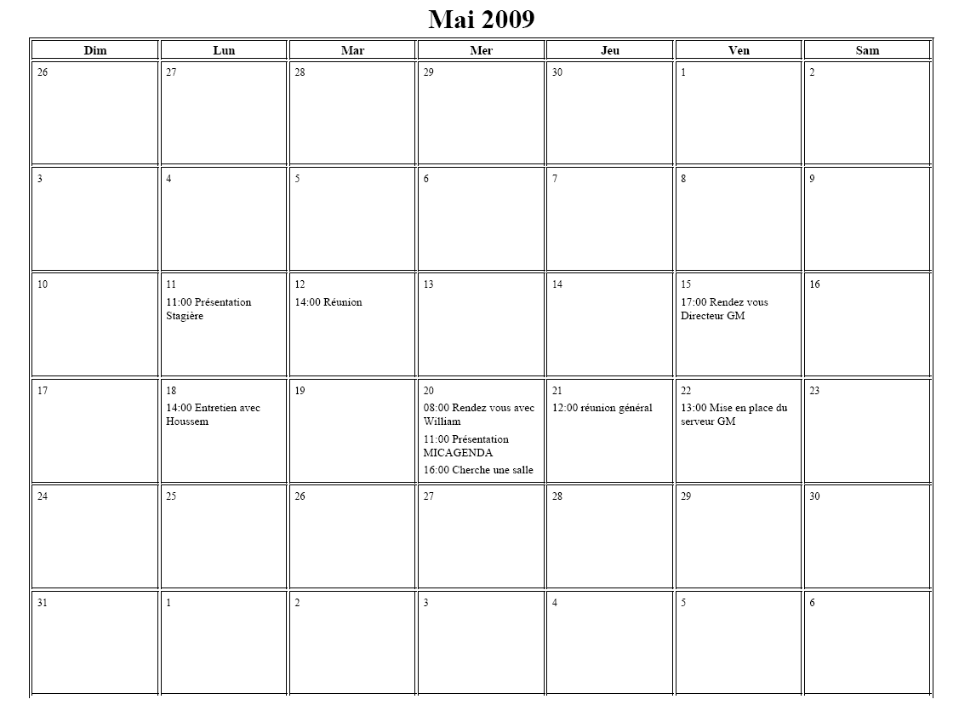
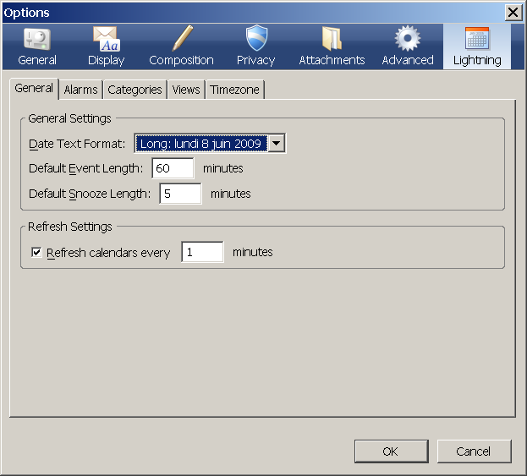

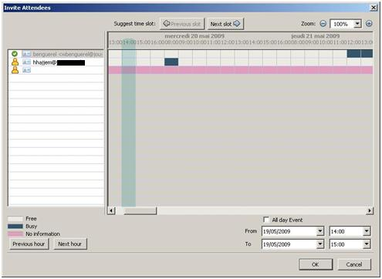
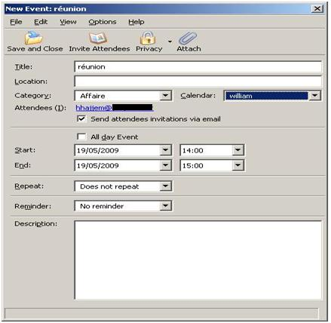
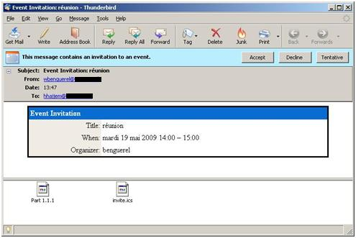
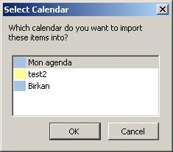
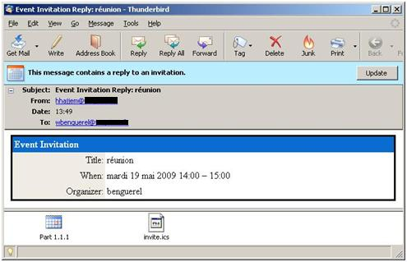
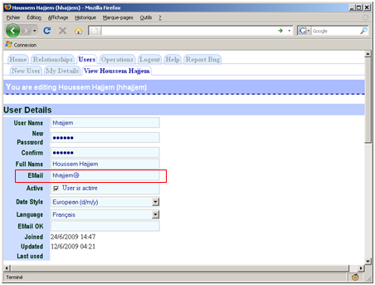

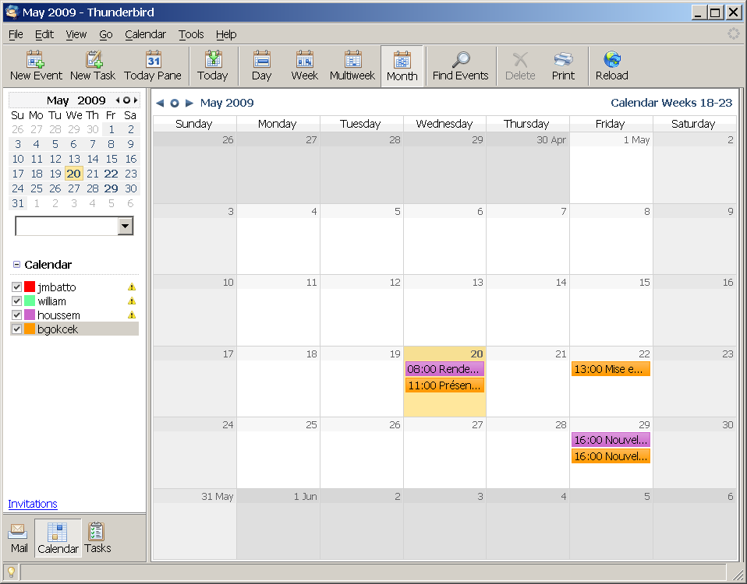
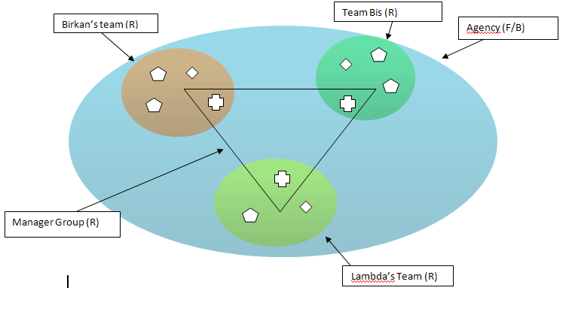
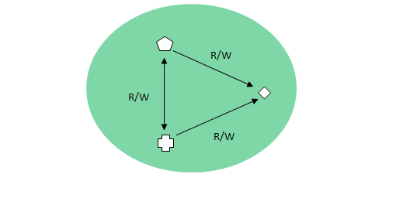
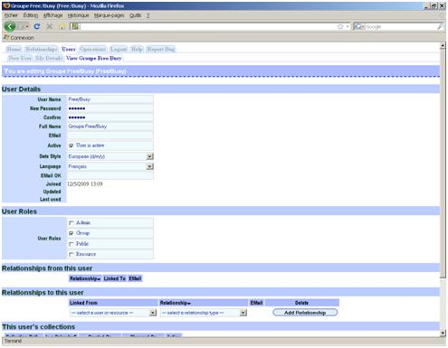
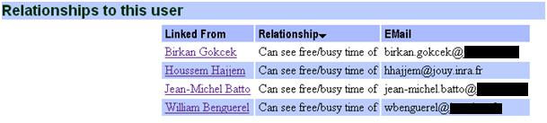
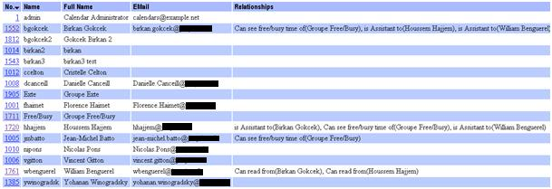
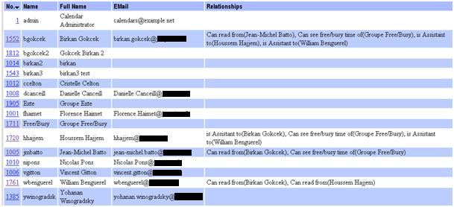
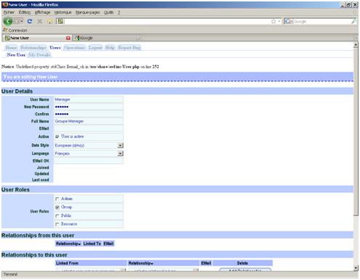

Thunderbird/Lightning and DAVICAL server

User’s Guide

By Birkan GOKCEK

Scholarship training at Génétique Microbienne, UR895
French National Institute for Agricultural Research

Table of contents
Thunderbird/Lightning and DAVICAL server 1
User’s Guide 1
By Birkan GOKCEK 1
Table of contents 1
Introduction 3
I – Thunderbird/Lightning installation 4
II – User’s guide 6
A – Create/add a new calendar 6
B – Create/modify an event 8
C – Free/Busy vision 10
D – Reduce the time of updating for Lightning 11
III – Use scenario 12
A – Basic case N°1: Suggest a public meeting... 12
B – Basic case N°2: “Secretary” rights 13
C – Basic case n°3 : Free/Busy vision 15
D – An example of an agency 16
IV – Useful Links 19

Introduction

The document constitutes the user’s guide of the application Thunderbird / Lightning coupled with the server Davical.
The objective of the guide is to guide you through the installation and introduce you to the use of the calendar.
The system is accessible with any computer, the minimum requirement being to have a LDAP identifier.

In this guide, we use version 2.0.0.21 of Thunderbird, version 0.9 of Lightning and version 0.9.6.3 of Davical.

I – Thunderbird/Lightning installation

Before continue, you must check which version of Thunderbird is installed on your computer. If you have version 2.0.0.21, go directly to step n°2. Otherwise, please do as described below.

Step n°1: Thunderbird installation
Start to download Thunderbird version 2.0.0.21 here, then launch the install file and follow the procedure.

You can set-up your email after this step.

Step n°2: Lightning installation
Start to download Lightning here. Verify that it is the last version to date (Version 0.9 at present).

Once downloaded, follow this step to install Lightning in Thunderbird:
- In Mozilla Thunderbird, open Add-ons from the Tools menu.
- Click the Install button, locate/select the file you downloaded and click "OK".

To complete the procedure, restart Thunderbird.

Note about other possible software:
It is possible to have the same features as Lightning with the other software, but generally, they are less stable and they have more bugs, it’s for this reason that we chose to present only Lightning is in this guide.

II – User’s guide

A – Create/add a new calendar

First at all, to begin to use your calendar, it’s necessary to create it in Lightning. Therefore, click on the Calendar tab, then on New calendar.

If an error message appears to the screen, verify that you correctly entered the address of the calendar and your LDAP login. If the problem persists, contact the administrator of the centre.

To add the calendar of a colleague, you just have to follow the procedure described for the creation of a calendar, adapting the calendar address as follows:
http://{server’s name} /caldav.php/{colleague’s login}/home

To be sure that the calendar was created properly, you can check on the server Davical via the Web interface.
For this purpose, open an internet browser and enter the web server address.
Identify yourself using your LDAP login.

Click on the tab “Users “then on your name. At the bottom of the screen you should see a listing including the calendar that you created:

We also recommend, when you want to add on your computer a colleague’s calendar, that you check beforehand on the Davical server whether it already exists, proceeding as described above.

B – Create/modify an event

Once your calendar is created, you can create your own events in your calendar.

In summary:
- Invite Attendees : Invite persons for your event (You have access to the available funds of your participants if you have the necessary right )
- Privacy : Create a public or private event
- Attach: Join a file, a link to a Web site etc…
- Title : Event’s name
- Calendar : List of the calendars to which you have access and in which you can add events

Once the various fields informed, click to Save and Close.

If you want to delete an event, right click on the event and choose Delete Event
To move an event, click on your event and drag it anywhere.
Finally, to modify an event, double click on it and modify the various fields.

Make sure you have the necessary rights before making trying the modifications listed above.
To do this, open an internet browser and type the web server address.
Then, identify yourself using your LDAP login.
Click on the “Users” tab, click on the name of the person for whom you wish to modify an event. If you have the necessary rights to modify that person’s agenda, you will see the following:

Once you have checked the rights, you can verify if that the event was created. In the “Users” tab, click on your calendar on the bottom of the page, and you will see this:
The screen shows the start date, the end date and the summary of your event.

During the creation if an error message appears, the main reason is that you don’t have the necessary rights to create or modify an event. If this happens, you should contact the administrator.

C – Free/Busy vision
The Free/busy information is accessible only to the person(s) who have need granted the necessary rights.
In the Invite Attendees tab, register the e-mail address of the persons you want to invite to an event.
It is necessary to make sure that you possess Free/Busy rights for the persons you want to invite.
Open an internet browser and type the web server address. You will see one of the following :
Or
Or

One interesting function for the secretarial department is the edition of an overview of the schedule. For this, press on CTRL+P.

Three options are offered:
- List
- Monthly Grid
- Weekly Planner

The most interesting might be the Monthly Grid, which gives a large overview and let us save some paper.

Print preview:

D – Reduce the time of updating for Lightning

It is possible render automatic updates of Lightning each minute.
Click on Tools/Options, then Lightning tab and finally General tab.

It's better to update the calendar manually by clicking on the button “Reload” on the general interface.
There is a bug in the application which doesn’t update correctly the calendar; in that case, you just have to restart Thunderbird.

III – Use scenario

The various actors:
- Managers : Birkan, Martin
- Assistant : Jean-Michel
- Colleague: William, ...
- External person: Houssem, ...

A – Basic case N°1: Suggest a public meeting...

Birkan’s team and Martin’s team (William is a part of this team for this example) wish to organise a public meeting …
Follow this step:
- Create a Free/Busy group
- All the personnel has to point to this group with Free/Busy right

The right attached to the free/busy group (Administrator vision)

Free/Busy vision in Lightning
Create an event, with different options. It is possible to send invitations by e-mail.
Houssem will receive in Lightning an e-mail requesting that he confirms (or refuses) the invitation. Houssem can import the event in the calendar he chooses (among the calendars he created or added to Lightning).

William receives an e-mail to update his calendar according to the answers to his invitation.

Files automatically attached to the mail allow Lightning to update his calendar.
The procedure may be done manually by importing the file " invite.ics " (In case either not press on the button " Update ")
If William wants to create a private event, he has to change the option "Confidentiality" when he invites Houssem.
Make sure that you have correctly entered e-mails addresses of the user in DAVICAL website. If you don’t, edit each user in DAVICAL and complete email’s field or inform users so that they complete their e-mail address.

B – Basic case N°2: “Secretary” rights

Birkan wants to see the calendar of Jean-Michel, William and Houssem. The secretarial department has to have the possibility of entering events in his/her calendar, but also has to manage the calendar of the team in which he/she works.
Stage to be followed:
- Birkan has to have the right “Assistant” for Jean-Michel, William and Houssem
- Jean-Michel has to be granted the right “Assistant” for Birkan, William and Houssem

* Right R/W : Read and write right on public event
* Right R : Only read right

The rights granted to Birkan (Administrator vision)

A view of Birkan’s calendar , he can access (writing and reading) Jean-Michel’, Houssem’ and William’s calendars.

C – Basic case n°3 : Free/Busy vision

Jean-Michel looks for availability in the calendars of his team, furthermore, he wants to have the possibility of creating printouts of the calendar he can access.

For print-outs, there are 3 options: (Cf II – C)
- List
- Monthly Grid
- Weekly Planner
We suggest the Monthly Grid, for a large overview while saving paper!

Print preview:

D – An example of an agency

In this part, you will have a simple outline of the organization’s agency. Here are the various standards:
- The agency contains managers, co-workers and secretaries. They have Free/Busy right between them, and the possibility to consult each other’s availability.
- Each team, supervised by a manager, is composed of a secretary and co-workers.
  - The manager (Birkan) possesses the right "Assistant" for all members of his team, he may suggest meetings, but also move or delete them.
  - The secretary ( Houssem) possesses the same rights as the manager, that is the right "Assistant", he may in his absence, perform the same tasks.
  - The co-workers (William etc.) possess right "Read", they have the possibility of making an appointment with other team members. Furthermore, they have a sight "not hidden" from calendar of the team.
- The managers all belong to the same group. They can read each others calendars. For that, they granted each other the right to "Read" between them.

General organisation:
Legend:
Manager
Secretaries
Co - worker

Team’s organisation:
Legend:
Manager
Secretaries
Co - worker

Step n°1 : Free/Busy right
All the staff can consult the availability of each co-workers, if he possess "Free / Busy" right. In step 1, we will not address the rights within each team. These will be dealt with in step 2. .

Create a Free/Busy group :

Free/Busy rights between each person:

It is possible to define on the Davical server, a user type at the time of creation of the new user account. So each time a new user is added, he/she will have automatically Free/Busy right in his/her group group.

Step n°2 : Team’s right

That what you have in every team:

Step n°3 : Manager’s right

Each manager has an access to read the calendar of the other managers, but they can’t modify the events.

For that, you have to affect bidirectional rights " Read " between managers.

If there are many managers, you can create a managers’ group and affect “Read” right between the managers in the group.

IV – Useful Links

You will find in this part useful links on the documentation of Thunderbird/Lightning (it’s similar between Sunbird and Lightning) and about DAVICAL.

Lightning/Sunbird documentation:
http://www.mozilla.org/projects/calendar/ (Lightning/Sunbird home page)

DAVICAL useful links:
http://wiki.davical.org/ (Wiki)
http://www.davical.org/ (Davical website)
http://sourceforge.net/projects/rscds/ (Davical on SourceForge)
Questions related to this guide can be send to gokcek.birkan[at.]gmail.com

