WEBSITE DEVELOPMENT
PROJECT REPORT



Althea Rahmania Fitri
5025251134

INFORMATICS ENGINEERING STUDY PROGRAM
FACULTY OF INTELLIGENT ELECTRICAL AND
INFORMATICS TECHNOLOGY (F-ELECTICS)

2026

- Design Concept
The user interface design was created using Canva. The main concept of the design was minimalism, easy to read, and easier to navigate. The overall design was aimed to make information easy to access and unambiguous.

Canva link design: https://canva.link/77uv2m0f5v219v9

Several key features included in the design are:
- Navigation Bar (Navbar): Contains navigation links to the Home, Profile, Hometown, Local Food, and Tourist Place pages.
- An “about me” Button: Directs users to the biodata page.
- Transition links to all tourist places as well as attended schools.
- Structure
a. (Your Domain)/quiz1 for the Homepage

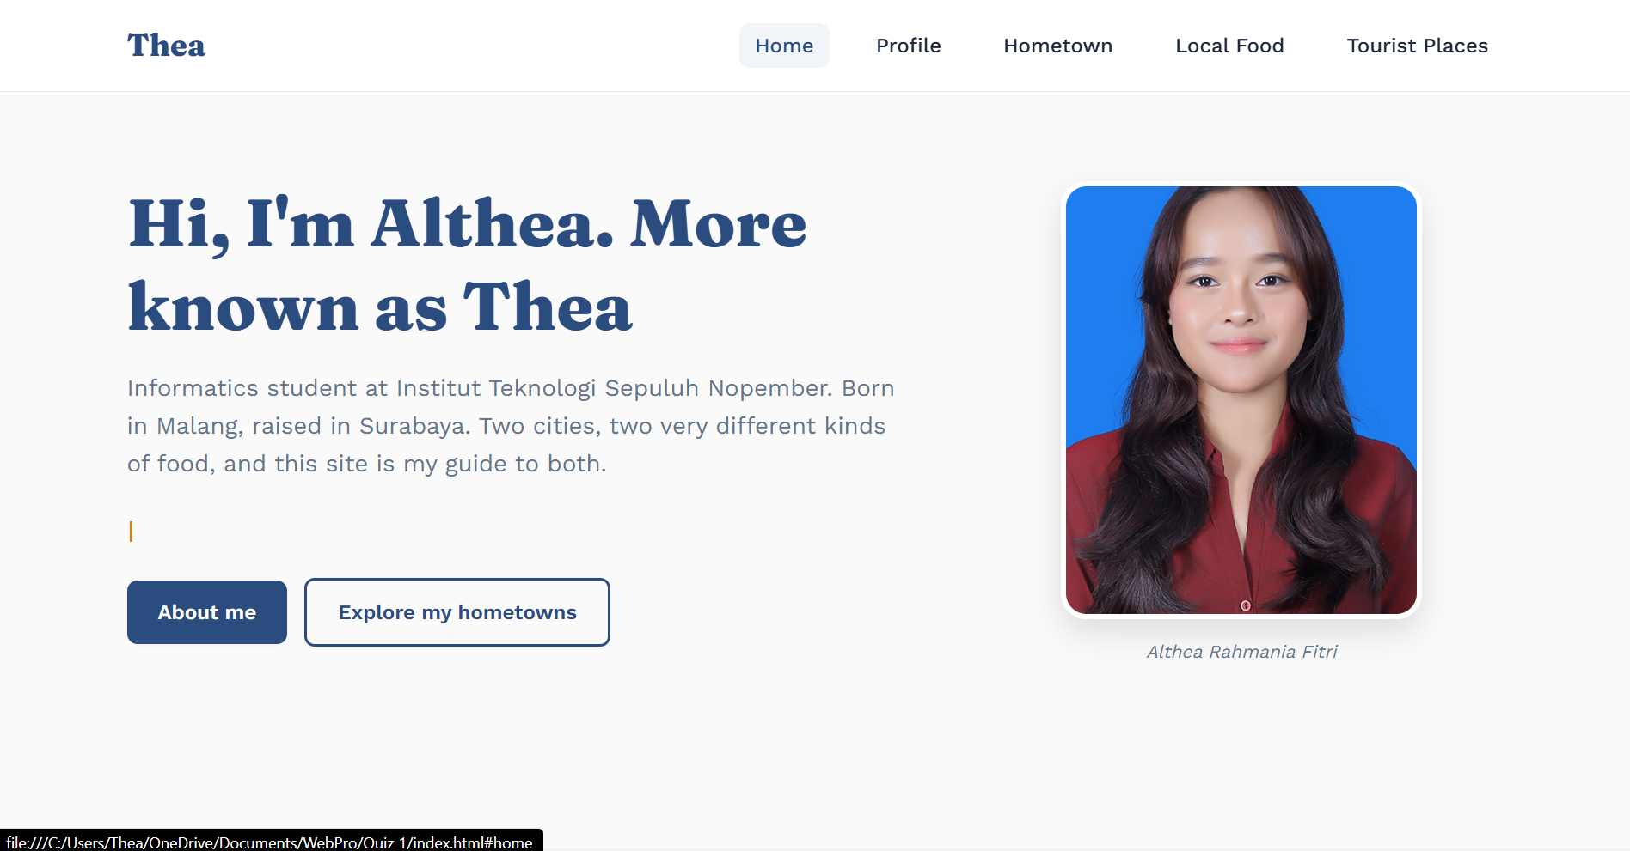
b. (Your Domain)/quiz1/profile for the Profile page
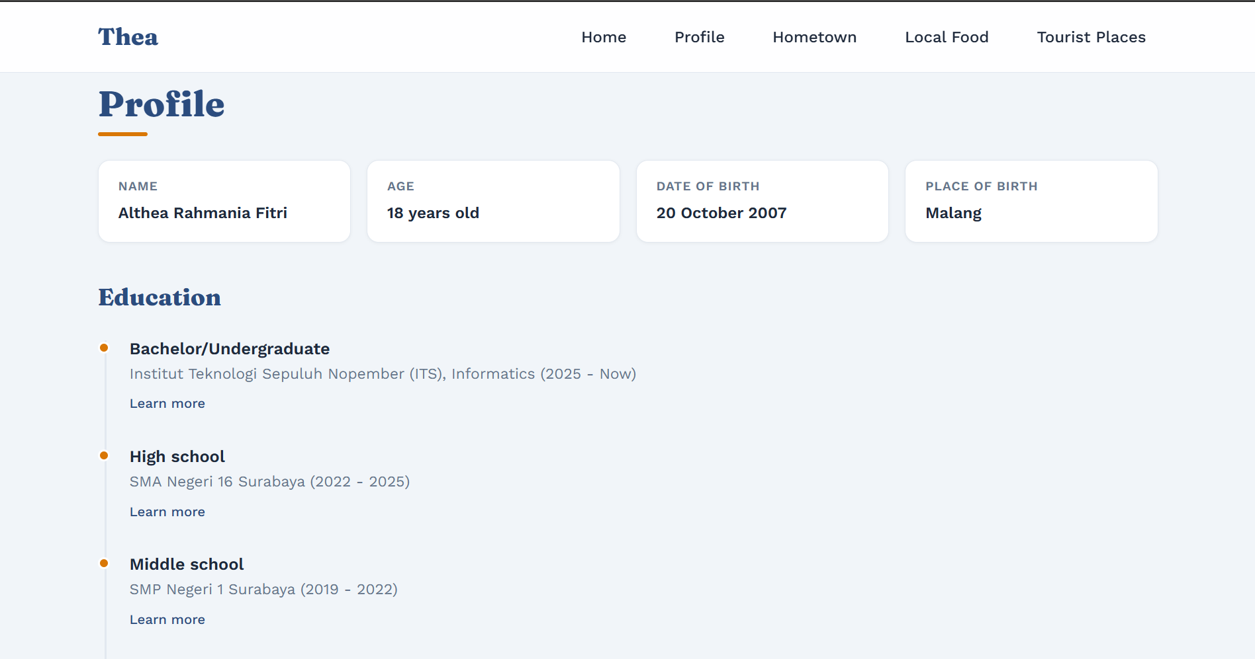
c. (Your Domain)/quiz1/hometown for the Hometown page
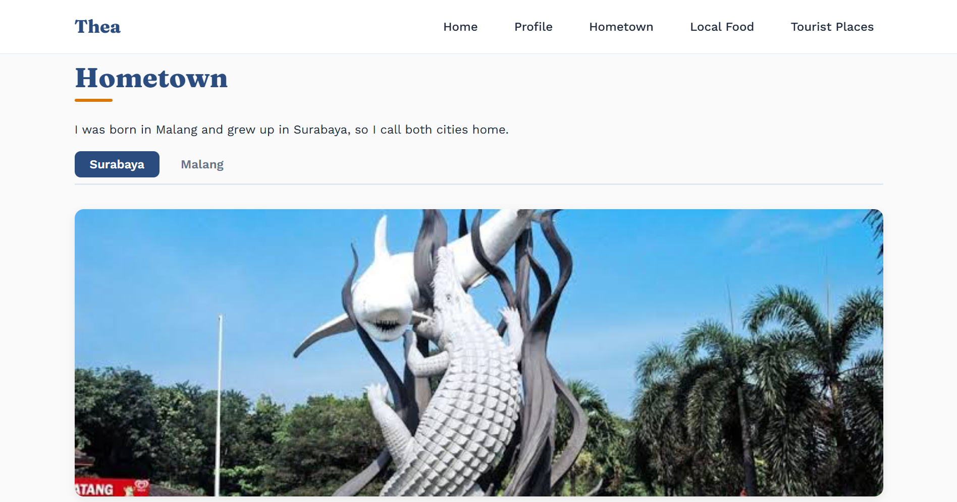
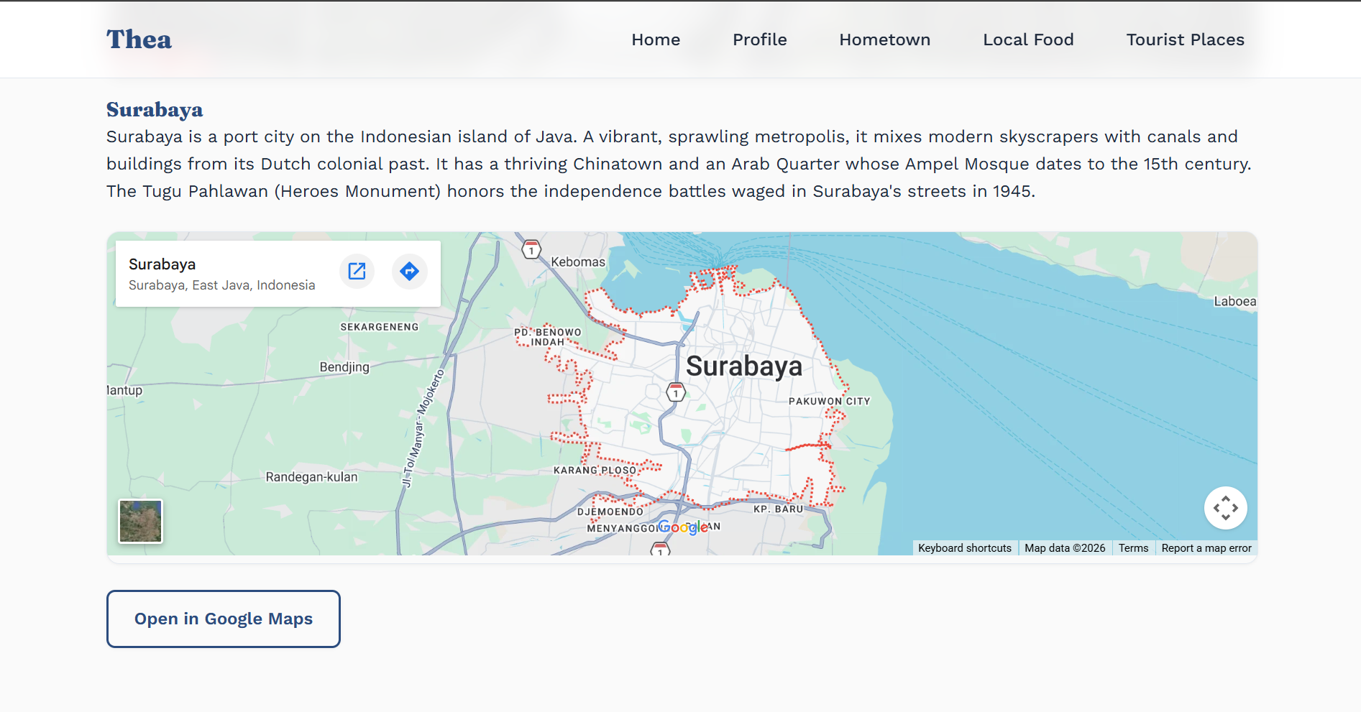
d. (Your Domain)/quiz1/food for the Local Food page
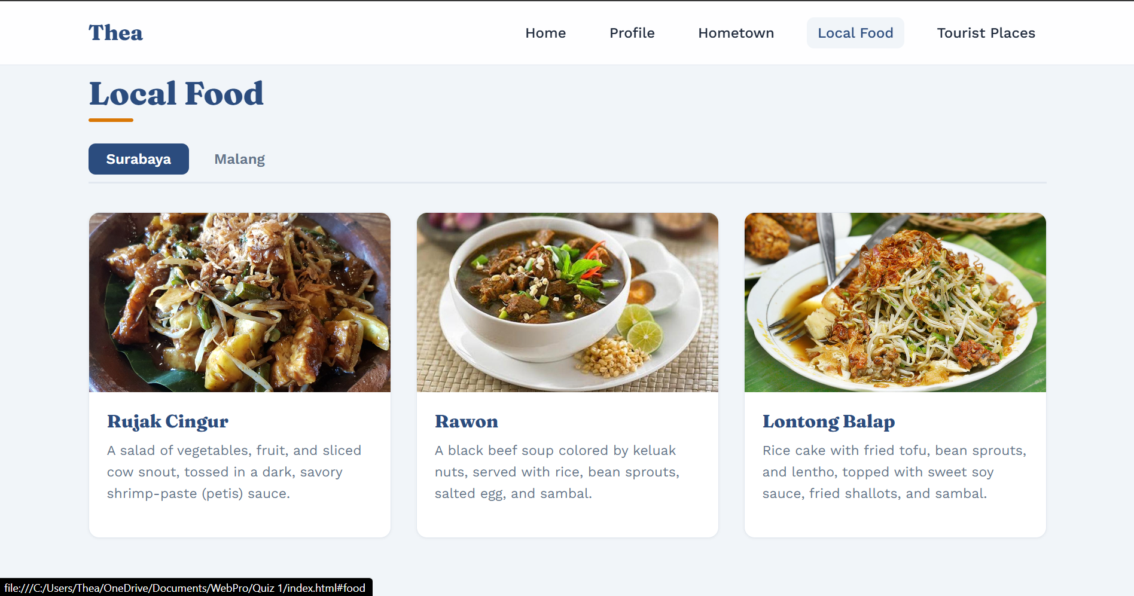
- (Your domain)/quiz1/tourist for the Tourist Places page
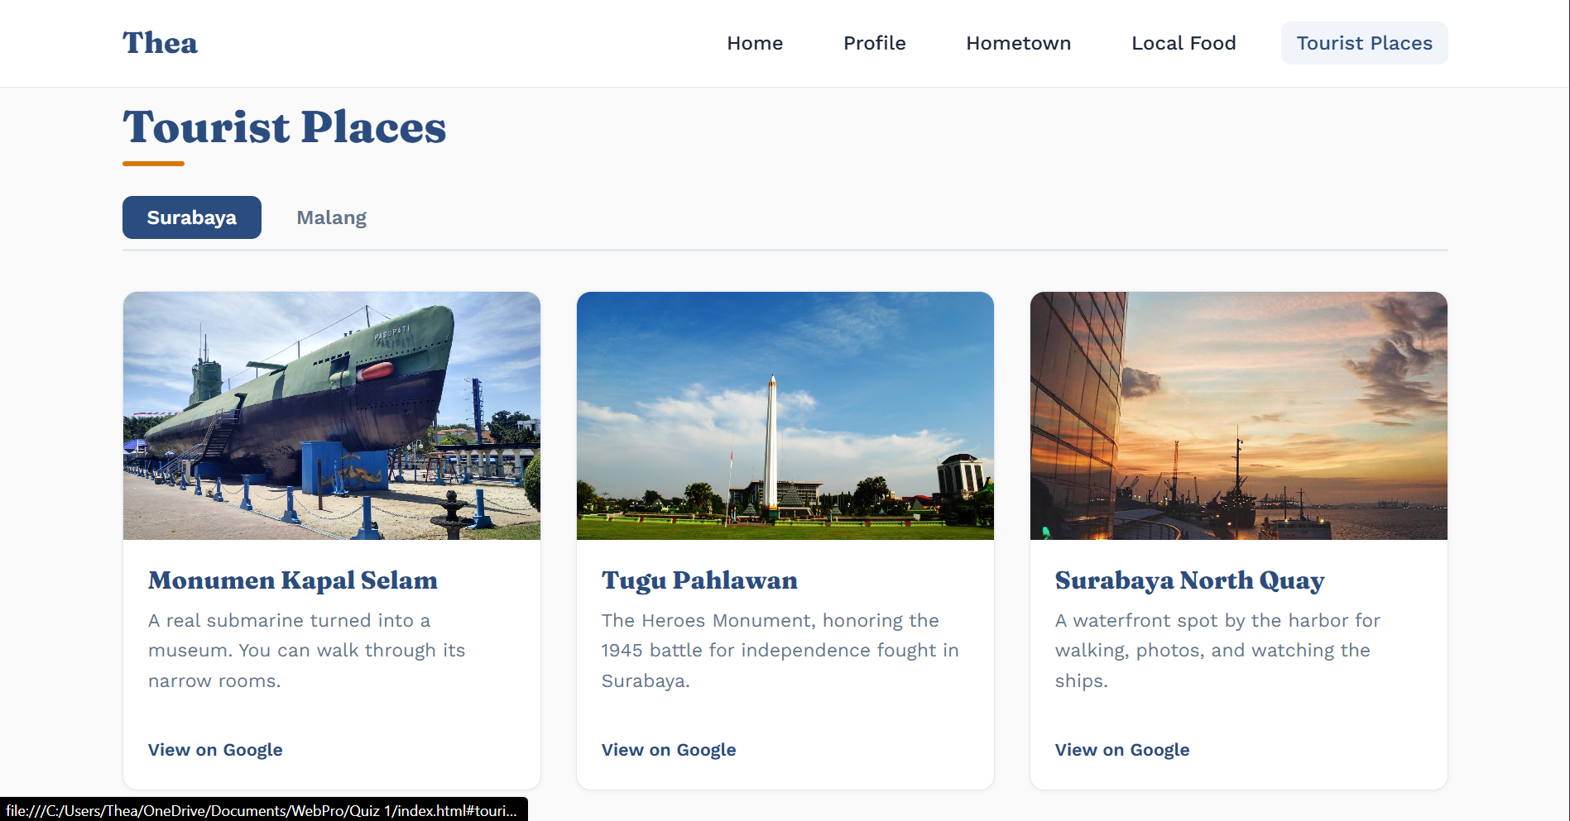
Website link: https://altheaftr.github.io/WebPro-Quiz-1/

- Code Explanation
  - HTML
      - Header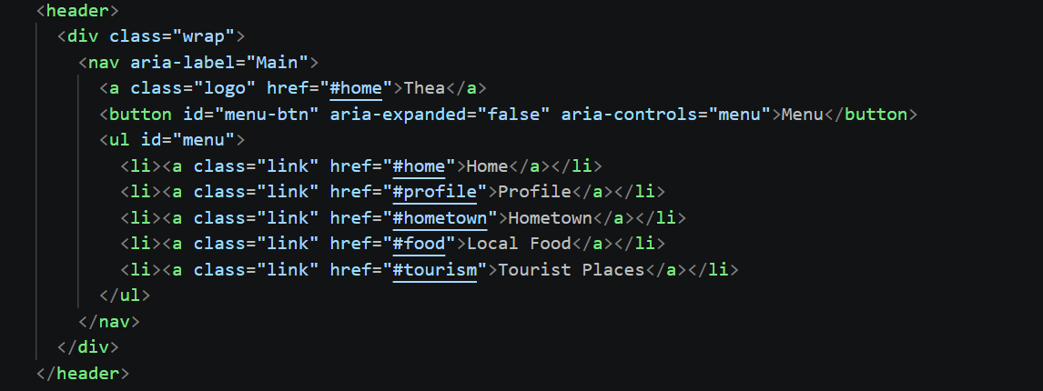The header component utilizes semantic HTML5 elements (<header> and <nav>) to establish the primary navigation bar for the single-page application. It includes a brand logo (<a class="logo">) anchored to the #home section, along with an accessible mobile menu toggle button (#menu-btn) configured with standard accessibility attributes (aria-expanded and aria-controls). The main navigation list (<ul id="menu">) contains anchor links pointing to each corresponding section identifier (#home, #profile, #hometown, #food, and #tourism), enabling smooth internal page routing across all primary views.
      - Home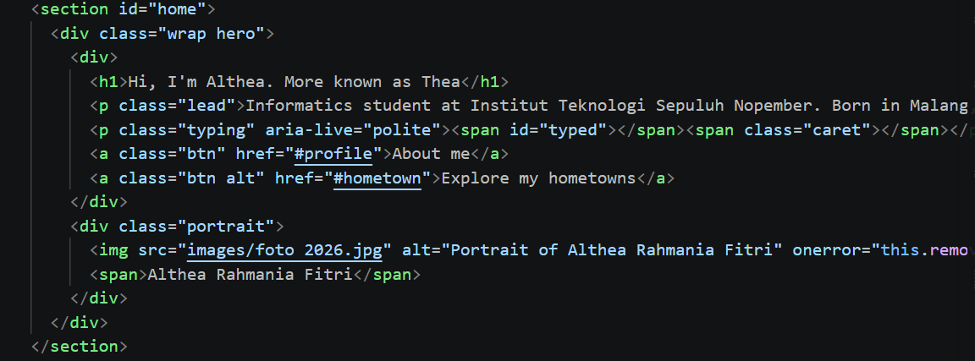The hero section (<section id="home">) serves as the main landing area of the homepage, structured using a two-column layout (.wrap hero) to balance text content and visual elements. The left block introduces the author with a prominent <h1> heading, a brief bio lead paragraph, and an interactive typing effect initialized inside <span id="typed"> with aria-live="polite" for dynamic accessibility announcements. Two call-to-action buttons (.btn and .btn alt) guide users deeper into the website via smooth internal anchors to #profile and #hometown. The right block contains a .portrait container featuring the profile image (foto 2026.jpg) with descriptive alt text, an onerror fallback handler, and a caption displaying the full name.
      - Profile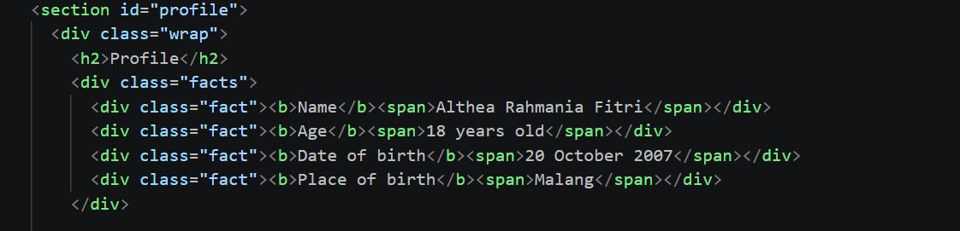The profile section (<section id="profile">) begins with a structured personal details grid enclosed inside a .facts container. It utilizes individual .fact child blocks pairing bold labels (<b>) with corresponding data values (<span>) to clearly present core personal information, including full name, age, date of birth, and place of birth. This key-value layout provides a clean, highly readable summary format that seamlessly integrates with CSS Grid or Flexbox for responsive viewing.
      - Education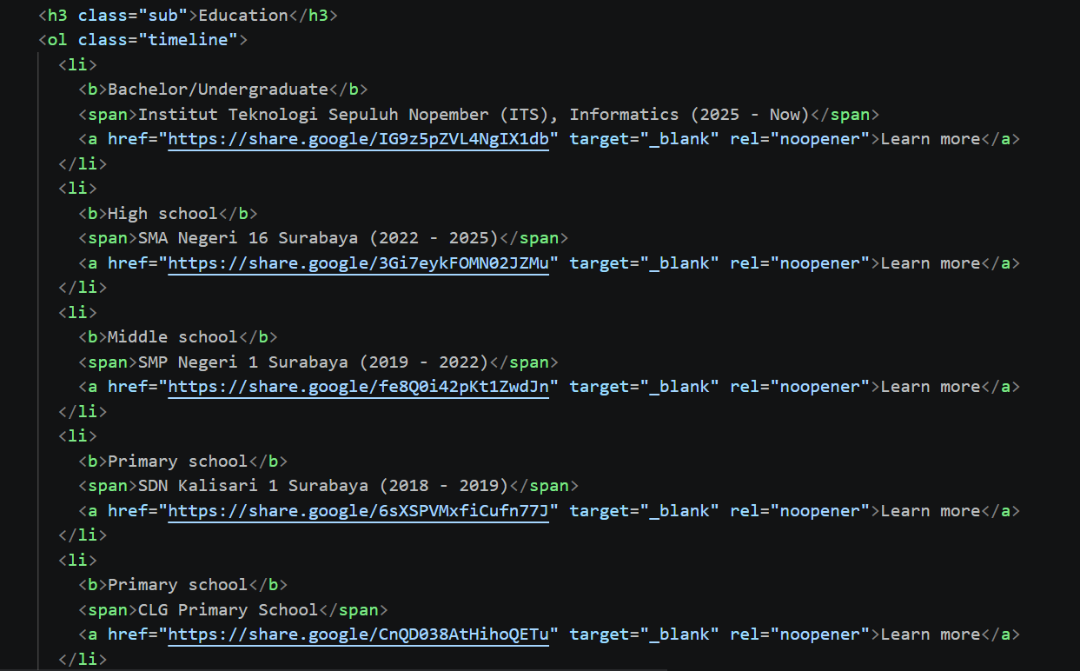The education subsection structures the academic timeline using a semantic ordered list (<ol class="timeline">) under an <h3 class="sub"> heading. Each list item (<li>) represents an educational milestone, containing a bold title (<b>) for the academic level, a <span> for the institution name and years attended, and an external anchor link (<a>) with target="_blank" and rel="noopener" attributes for secure, accessible navigation to external reference pages. This chronological layout cleanly communicates educational background while providing direct links for verification.
      - Hometown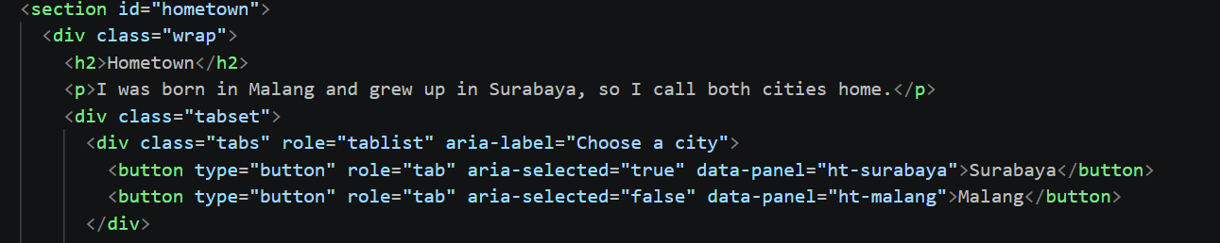The hometown section (<section id="hometown">) introduces the dual-city concept using a clean text lead paragraph followed by an interactive tab control container (.tabset). The navigation tabs are wrapped in a <div class="tabs"> container styled with ARIA accessibility roles (role="tablist" and aria-label="Choose a city"). It contains two action buttons (<button type="button" role="tab">) representing Surabaya and Malang. These buttons utilize aria-selected attributes to signify active/inactive states and data-panel custom attributes (ht-surabaya and ht-malang) to target their corresponding content panels dynamically via JavaScript.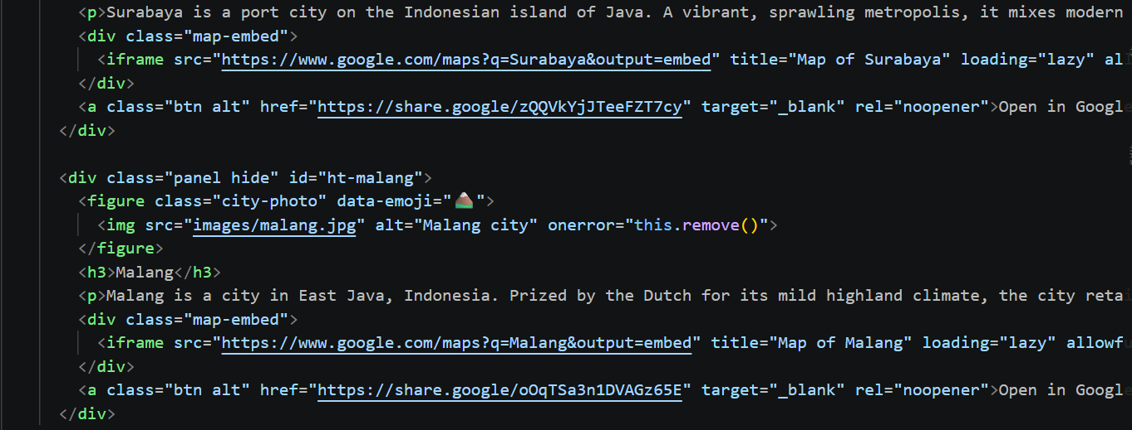The map integration in the hometown section is implemented using embedded HTML <iframe> elements paired with external fallbacks. Responsive Wrapper (<div class="map-embed">). The <iframe> is wrapped inside a dedicated .map-embed container. This allows CSS styling to enforce responsive aspect ratios, ensuring the map resizes dynamically across mobile and desktop screens. The inline frame directly embeds Google Maps by querying city locations (q=Surabaya and q=Malang) with the output=embed parameter: <iframe src="https://www.google.com/maps?q=Surabaya&output=embed" title="Map of Surabaya" loading="lazy" allowfullscreen></iframe>
      - Local Cuisine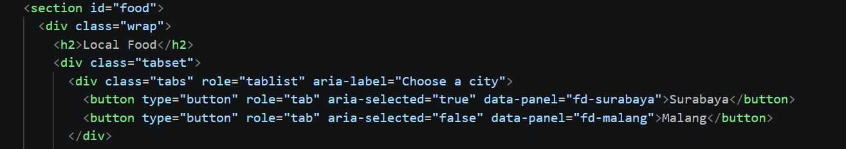The local food section (<section id="food">) uses a similar interactive tab structure inside a .tabset container to separate culinary offerings by city. The navigation bar (<div class="tabs">) features explicit accessibility attributes (role="tablist" and aria-label="Choose a city") and contains two tab buttons for Surabaya and Malang. These buttons toggle selection states via aria-selected attributes and link to their respective food panels using unique data-panel identifiers (fd-surabaya and fd-malang), preventing ID conflicts with other tabbed sections across the page.
      - Tourist Places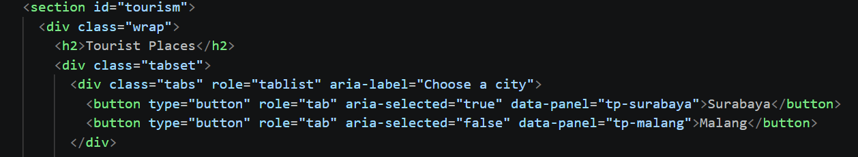The tourist places section (<section id="tourism">) follows the established tabbed interface pattern within a .tabset component to categorize attractions by location. The tab list bar (<div class="tabs">) maintains accessibility compliance using role="tablist" and aria-label="Choose a city". Its interactive buttons (<button type="button" role="tab">) represent Surabaya and Malang, updating state via aria-selected and binding to destination panels through dedicated data-panel attributes (tp-surabaya and tp-malang).
- CSS
The CSS styling architecture relies on CSS Custom Properties (:root) to maintain uniform colour schemes, typography choices, and spacing tokens across the website. Layout structures are built using modern CSS Grid and Flexbox modules, incorporating responsive auto-fitting grids (repeat(auto-fit, minmax(...))) to smoothly adjust card component arrangements across various viewport dimensions. The sticky header uses a glass morphism backdrop blur effect, while interactive components employ smooth hover transitions and CSS transformations. Dynamic panel visibility is enforced via dedicated target rules (.panel.hide { display: none !important; }), and state styling for tab navigation directly binds to dynamic accessibility attributes (aria-selected). Mobile responsiveness is achieved using CSS media queries at 768px breakpoints to collapse navigation lists and re-sequence hero section content.
- JavaScript
The JavaScript implementation manages dynamic tab switching and automated footer content using event delegation and DOM manipulation. Upon DOMContentLoaded, a global click listener intercepts clicks across tab controls using e.target.closest ('.tabs button'). To prevent cross-section side effects, button.closest ('.tabset') isolates tab operations strictly to the parent container. The script updates accessibility attributes by toggling aria-selected across tab buttons and reads the target panel ID from the clicked button's data-panel attribute. It then applies the .hide class to all sibling panels in that tabset before removing .hide from the matching panel element (# + targetId). Lastly, the script queries #year to dynamically populate the footer with the current calendar year.
- Analysis
The website application successfully delivers a modular single-page structure; however, two primary technical issues were identified during testing.
- The inability to open the "Malang" tab across the Hometown, Local Food, and Tourist Places sections stems from a DOM ID conflict and element selection error in JavaScript.
- While CSS media queries exist at the 768px breakpoint, the website currently displays incomplete rendering on smaller screens.
- Conclusion
The developed single-page website successfully fulfills the core architectural objectives of Quiz 1 by combining semantic HTML5 structures, modular CSS3 layouts, and dynamic JavaScript functionality. Through the integration of CSS Grid and Flexbox, the website presents a clean, modern aesthetic equipped with design tokens, a glassmorphism sticky navigation bar, interactive cards, and responsive map embeds for both Surabaya and Malang. The implementation of event delegation in JavaScript provides efficient tab-switching operations while maintaining accessibility standard practices via ARIA roles. Despite current limitations in multi-section tab isolation and mobile menu execution, the project demonstrates a solid foundation in front-end web development principles, user experience design, and structured component engineering.
- Future Work
To enhance the application's functionality, usability, and technical performance in future iterations, the following improvements are planned:
- Bug Resolution for Tab Switching: Refactor the tab navigation logic by enforcing unique namespace IDs across all sections (e.g., #ht-malang, #fd-malang, #tp-malang) or refactoring the script to use index-based sibling querying within each .tabset container to ensure reliable panel toggles.
- Complete Mobile Responsiveness: Implement the missing JavaScript toggle event listener for #menu-btn to expand and collapse the mobile navigation drawer seamlessly on mobile devices.
- Layout Optimization for Small Screens: Convert fixed dimension containers (such as portrait images and map iframe wrappers) to use flexible fluid units (clamp(), max-width: 100%) and enable horizontal scroll containers (overflow-x: auto) for tab buttons on narrow viewports.
- Enhanced Interactive Features: Integrate dynamic content rendering using JavaScript fetch() to load location data dynamically from a JSON file, and implement dark mode theme toggling using CSS variables.

