Project Report

Althof Pandyansa Fajar (9770937)

Introduction:

Abstract

In 2020, a climate analyst developed a new method to analyze the content of O3 in the atmosphere throughout Europe and surrounding areas. There are difficulties with this method, one of which is the processing requirements and time for massive data like the method to analyze O3, which uses NC files. To reduce the processing time, it requires big data analysis to determine processing ways to load the data using the least amount of processing to load the NC file of the O3 data.

Main

This project is an experiment and big data analysis on data provided by the client. The objective of this analysis is to investigate processing methods that minimize the amount of time that is needed to process the data, determine the methods that could minimize processing time. The analysis will be using the techniques being taught throughout the 5011CEM module.

This report will contain a detailed description of the code, the comparison between sequential and parallel processing, the analysis results, the recommendations to be made based on the outcome of the analysis, the conclusion to the whole project and module and the appendix that contains additional, non-essential information for this report.

Code Description:

There are 2 codes that I did before merging them, there are sequential and parallel processing. The files for the code and other details of the project are on the [GitHub repository.](https://github.coventry.ac.uk/althofpana/5011CEM2021)

Sequential Processing

In sequential processing, the code grouped into several parts. The first part of the code consists of the commands to load the required file and loads latitude and longitude. The second part consists of the parameters, which has variables that contain the cluster radius.

The third part encompasses more variables for the starting point and the number of latitudes and longitudes, followed by a for-loop that loops through every hour from 1 to a given number. Once inside the loop, it will set the data layer to one and a for-loop that will load all the data, with layers increased by 1 after each iteration. After all the data a function provided by the customer will prepare for the sequential analysis.

On the sequential analysis, 2 variables will set a timer and it will take place on a for loop that loops from 1 to a given number of data. Within the loop, a function provided by the client will ensemble value and an if statement that will track the time for every 50 locations and prints the result afterwards. 2 end statements will follow to end the if-statement and the for-loop.

After completing the sequential processing it will record the processing time for each hour and end the loop. It will be followed by another end statement and records the overall time for the sequential processing.

Parallel Processing

Parallel Processing contains more parts than sequential one. The first part is started by loading the file similar to that of and detailed parameters are provided. A pre-processing will later take place, it is done by reducing each latitude and longitude by 4 and multiplying each other.

Once the memory has been pre-allocation, it will cycle through hours, it is started by setting the time counter to 0 and will loop through hours. Inside the loop, in the beginning, it is similar to sequential, it loops to load data and preprocessing will occur.

After the data has processed, it will perform the parallel analysis. Instead of one large loop, like sequential analysis, sectioned into multiple variables and loops. It started by creating a parallel pool. a variable containing the pool size and acts as an input into the parallel pool, determining its size. Several variables are later set to pre-process before starting the actual processing.

In the actual processing, it will ensemble the a value into every location that is set. It will take place in a for-loop, that will cycle through each number of data. After each iteration, it will ensemble the value, which consists of the parameters provided, and records the time to process. After the number of data is exceeded, it will end the loop and record the total processing time, followed by ending the hour loop.

Automated Testing Code modifications

For the automated testing version of both codes, few modifications were made to the code. For Parallel Processing, the first modification is 3 new empty arrays that will be able to collect the recorded time from 3 different numbers of data. 2 newly filled arrays are also added, which contains the data sizes and the number of workers requested by the customer. The hour loop is now nestled below the pool size loop, which itself is also nested below the data loop. After the actual processing, an if-statement is added to store the recorded time and pool size, allocating it up to 3 different arrays. After which the elements are plotted into a graph. In the end, break tests are also added to prevent the hours to be a NaN (Not a Number).

For Sequential processing, several modifications were also made to automate it. Like parallel processing, their arrays are empty arrays to record processing time and a plotting code at the end to allow the client to plot the result automatically. Another modification made into it is a for loop, where it iterates through each different data size and the hour loop is nested within the Data loop, where it selects different data sizes from the array and an hour loop is nested bellowed it, it was modified to 3 since the objective for sequential processing is to observe the processing time using 3 different hours.

Sequential and Parallel Processing:

There are two methods used for this analysis, which are sequential and parallel processing. Sequential processing is where the processing took place with one processor, while parallel processing uses multiple numbers of processors.

The number of hours requested to load this data is somewhere under 2.5 hours. At first, the test was done manually by running it one by one and plotting the results, it was later automated due to efficiency and allowing the client to modify and see the error without the user interference.

For the testing of both methods, the amount of data that is used for both processing methods is 80000, 40000 and 10000, to experiment with different sizes to show its consistency.

For sequential processing, each data size is tested with 3 different hours, which is 1,2 and 2.5 hours prospectively. The processing speed is plotted using the script that is also provided (highly modified), Below is the plotted outcome:

With parallel processing, it is tested with different numbers of processors ranging from 1 to 8. Like sequential processing, the result is tested using automated testing.

With different numbers of processors, the time required to load the data will be varied significantly, it is hypothesized that the quickness will peak at some point due to the overhead. The results show that the number of seconds will continuously decrease with the increase of the number of processors, as is plotted below:

Once processing time is recorded, the mean processing time can be calculated. It is done by dividing time by the number of data or expressed as Mean = Processing Time/Number of Data. For example, the time it takes to process 80000 data using 1 processor is 1046, which means we did it by dividing 1046 with 80000. It will form a range that varies differently between processors, with a trend of decreasing.

From this plot, we can see that when processing a bigger number of data, the processing time decreases, although the rate at which the time gets smaller decreases as well. With smaller data like 10000, the overall trend is also decreasing, however, there tends to be a point where it fluctuates and increases a bit, such as the difference between 7 and 8 processors.

Later, the plots are fitted with the line created from the linear extrapolation from the processing time graph and make it as straight as possible to fit the linear. It is done by reducing the number of individual plots within the graph to make the shape of the graph is close to linear. for 80000, the plots that are removed are the plots from 1, 2, 3, and 8 processors, being nearly fitted within. For 40000, since the graph is less linear than 80000, more of the plots must be removed to fit in the linear.

Once the graph has been plotted, we can make predictions by using basic fitting to make predictions for the required processors needed for this project. For this purpose, only 80000 data will be used as a sample for the predicted requirements. The first step is using the linear equation y = mx + c, where x is the number of processors and y is the time required. Based on the linear equation we can calculate the mean time per data by using the formula (mean time = Number of Data x Hours / Total Time) and Time for all data can be calculated by using formula (Total Time = Mean Time Per Data * Total Number of Data * Hours). The overall area of and areas 277000 data, the amount of data that the file has. The total time is 2 hours, hence it would be equal to 7200 seconds. The average is 1/961 data per second. Since the sample used is 80000, it will be multiplied by the sample and meantime is 84.24 seconds.

Once the mean time per data is detected, the linear extrapolation will be used to estimate the number of processors required for the data. The mean time per data is inserted in one of the y-axes and the predicted requirements are x when it goes below or equal to the mean time per data. The results are the following:

Although 12 is close to the average, it is still greater in value compared to it. Hence the predicted requirement for the processing is at least 13 processors.

Once the analysis is done and the results are recorded, a conclusion can be made between each outcome. A table is also being made as a comparison between Sequential and Parallel using different numbers of processor using 1 hour each, for this table only, it is done using manual processing:

|  |  |
| --- | --- |
| 10000 Data | |
| No. of processor | Time |
| Sequential | 187.22 |
| 1 | 120.92 |
| 2 | 64.74 |
| 3 | 43.83 |
| 4 | 35.39 |
| 5 | 32.91 |
| 6 | 33.54 |
| 7 | 31.87 |

|  |  |
| --- | --- |
| 40000 Data | |
| No. of processor | Time |
| Sequential | 750.91 |
| 1 | 497.96 |
| 2 | 246.35 |
| 3 | 177.99 |
| 4 | 144.21 |
| 5 | 143.08 |
| 6 | 134.25 |
| 7 | 120.90 |
| 8 | 119.72 |

|  |  |
| --- | --- |
| 80000 Data | |
| No. of processor | Time |
| Sequential | 1375.48 |
| 1 | 1046.65 |
| 2 | 532.97 |
| 3 | 380.14 |
| 4 | 292.53 |
| 5 | 254.43 |
| 6 | 239.95 |
| 7 | 215.07 |
| 8 | 214.36 |

The chart result in the following graph:

Conclusion and Recommendations:

Based on the experiment, parallel processing is the recommended processing method, due to its capability to process the same amount of data in a shorter time, when a parallel processing method is used using a single processor. With Parallel processing, the recommended number of processors to process the data is at least 13 processors to full fill the required average time.

Since the results have shown that increasing the number of processors continuously reduces the amount of processing time, especially in larger numbers like 227000. Different machines can provide different results, due to different processor specifications and conditions. Additional research with more devices allows more accurate data, due to more results to compare. Since the decrease in time gets slower as the number of processors got bigger, it shows how the trends might defer if a larger number of processors are used such as 60.

References:

Draw.io. (n.d.). *Flowchart Maker & Online Diagram Software*. App.diagrams.net. <https://app.diagrams.net/>

ECMWF *Datasets*. (2018, April 6). ECMWF. <https://www.ecmwf.int/en/forecasts/datasets>

Fajar, A., (2021). *5011CEM2021*. [online] Github Enterprise. https://github.coventry.ac.uk/althofpana/5011CEM2021

FITZPATRICK, J. M., & LÉDECZI, Á. (2015). *COMPUTER PROGRAMMING WITH MATLAB* (pp. 99–101). https://www.cea-wismar.de/pawel/Study/z_Links_and_Sources/2015--ComputerProgrammingWithMATLAB--Textbook-PDF-3rdRevisedEdition-June-2015.pdf

GanttProject. (2019). *GanttProject*. Ganttproject.biz; https://www.ganttproject.biz/

*MATLAB R2020b - MathWorks*. (2021). Mathworks.com. https://www.mathworks.com/products/matlab.html

*MATLAB Online* (n.d) MathWorks <https://matlab.mathworks.com/>

*MATLAB: Programming Fundamentals* (R2021a, Vols. 2–26). (2021). MathWorks. (Original work published 2004) https://www.mathworks.com/help/pdf_doc/matlab/matlab_prog.pdf

Appendix:

Combined Automated Testing Code Description:

There is also a file where both the parallel and sequential processing is combined that allows both processing methods to be compared using the same plot. The hour arrays are removed from the data and several variables are merged, one of which is the array that records the processing speeds. The number of hours is limited to 3 hours due to the client setting the limit for time to be below 2.5.

More into sequential Processing:

Once all steps have been completed, it will end the if statement, followed by the data loop. Once the loop is closed, a variable will record and calculate the total processing time for the hour of the loop. After the results are printed, the hour loop is closed using the end statement, and the total processing time for all hours will be calculated and printed.

Being Tested with a Smaller Data:

When being tested with smaller data, such as 100, 400 and 500 numbers of data with this case, the trends differ significantly in contrast with using larger data, namely above 40000. Instead of continuously declining, the time required to process fluctuates, having its lows at 2 processors for parallel processing.

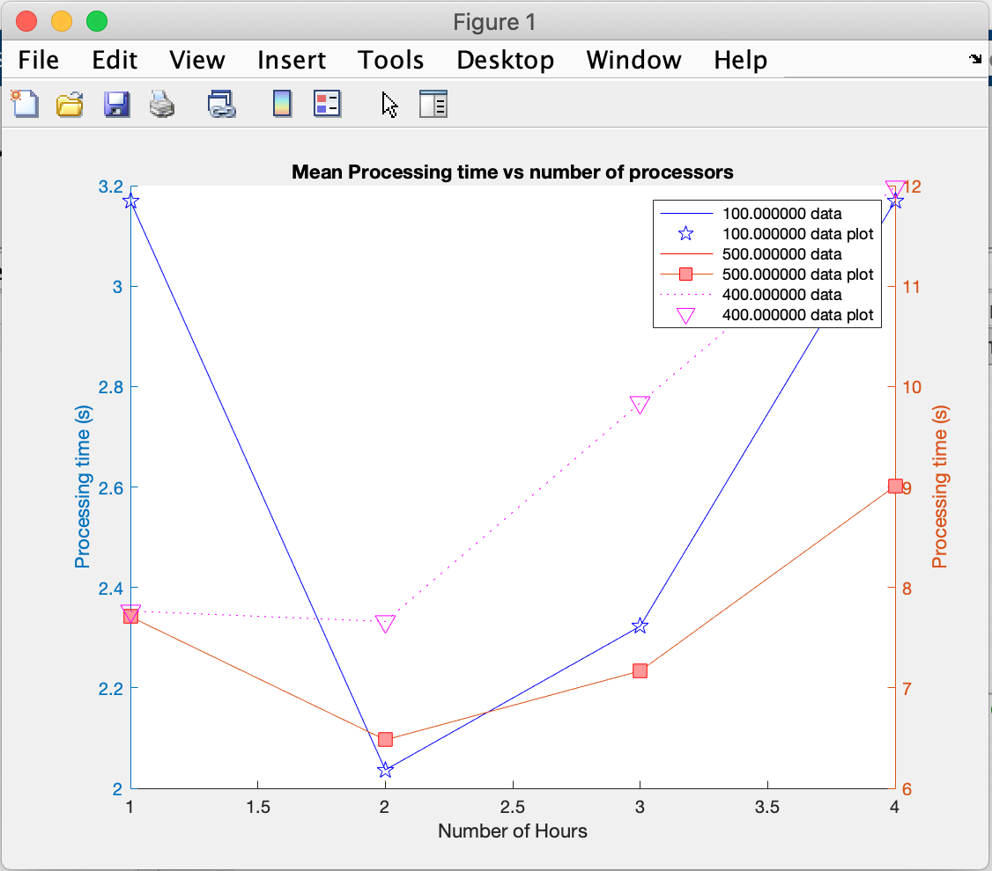

With sequential processing, when being tested by smaller data, the results form a linear plot, with a near consistent rate when increasing, which the increase is less linear with bigger data sizes and changes rate slightly.

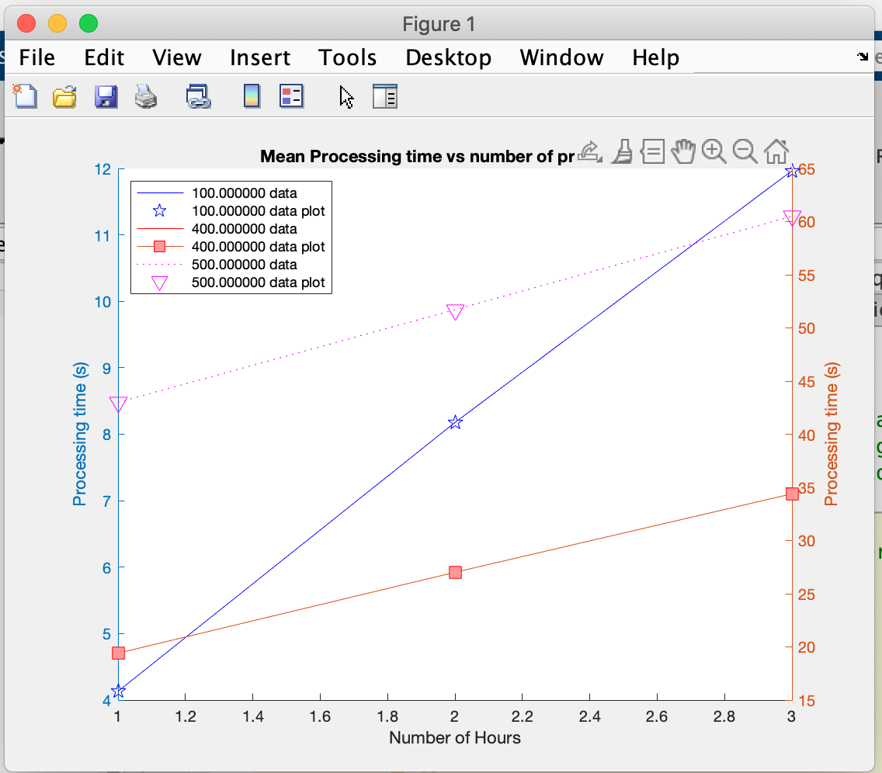

Overall, both plots have shown that smaller data produces a different result than big data, even though the processing is the same. Since this is a big data project, the results of the big data are considered more accurate and relevant.

More into Parallel Processing:

The Parameters provided in parallel processing is more complex than the one that is provided in sequential, it contains the starting point and the numbers latitude and longitude in addition to the 3 parameters that is also provided in sequential.

In Parallel analysis, there are several variables and loops to pre-process before the actual processing. It started with a variable that contains the pool size, which will determine the number of workers that the analysis will use, followed by an if statement that will set the number of workers if the parallel pool is empty or turned off. Once the parallel pool is set, it will be followed by a function that will attach the ensembled value, where it allows all of the processors to access the file. Attaching is done to allow the file to be accessible to individual processors without parsing it each time, followed by a variable to monitor the processing. And then there is a variable that contains the function to create variables within the parallel pool. Later the waiting bar is set to prevent the user from forcefully stopping the processing.

SMART Targets:

SMART target or criteria stands for Smart, Measurable, Achievable, Realistic, and Time-Bound. For this project, five SMART targets are created. The following are the SMART targets, with 3 relating to the code and 2 relating to the project itself.

1. The number of processors that are being tested for parallel processing by the user is around 1,2,3,4,5,6,7, and 8 workers. From the 8 Hours of processors. The client requested 8 processors, so the processors that the customer requested is within that range. After calculating, the number of processors estimated to be required is 13.
2. The number of hours that the customer demands are anywhere below 2.5 hours or around 24 hours in under 2 hours. For Parallel Processing, tests are done within 1 hour and for Sequential Processing, the test is done from 1 to 3 processors.
3. In parallel, the number of Locations is (latitude-4) multiplied by (longitude-4), both of which are set by the customer. The latitude and longitude are 400 and is set to start at 1. So overall, there are 156816 Locations.
4. The hardware or machine that is used for this project is a 2018 MacBook Air and the Operating System is MacOS Catalina version 10.15.6. It has a processor of 1.6 GHz Dual-Core Intel Core i5. It has random overall and is 8 GB and a storage capacity of 121 GB (excluding cloud). The name of the software used for this project is MATLAB, which is developed by MathWorks, and the script used for this analysis is called the MATLAB script. An online version of MATLAB will also be used as a secondary device and provides more accurate results due to being in an ideal condition.
5. The module officially takes place between the 27th of January 2021 from the first lecture, up to the 16th of April 2021, where the Report is originally due. Each week there is a total of one session or meeting, since there are 13 weeks, there are 13 sessions in total. Each session also has 2 hours, which means that there are 36 hours of the overall session. The original target of the module is to spend 150 hours on the subject throughout the semester, however, I spent exactly 272 hours on the module after recorded it on my log book.

Flowchart:

A flowchart is one of the ways that a process (namely codes) or workflow can be planned and represented using graphics and symbols. It represented by different shapes that could mean different processes and the flows are directed by the arrow. For example, the oval represents the beginning and the end, while the parallelogram represents inputs and outputs. The following contains the flowchart for parallel and sequential processing, both containing 2 versions each, the automated and the manual testing.

The following contains the flowchart for the sequential processing, both containing the Manual Testing (left) and the Automated Testing (right).

And below is the flowchart for Parallel Processing for both manual testing (left) and automated testing (right)

For Automated testing, the flowchart is simpler and focused more on the added features from the manual testing.

Gantt Chart:

A Gantt Chart is one of the charts that allow the user to plan on which tasks it will do. It represents the schedule of a project using graphical representations. For this project, the planning has been done by using Gantt chars, created using the Gantt Project software. The following is the Gantt chart that is created to plan the project

LogBook:

In contrast to Gantt Chart, a Logbook will record each activity that is done. It will track the amount of time that the user spends on the task and the progression of the user. Logbooks are created in a table and mostly created with table software such as Microsoft Excel or Google Sheets.

