Mobile Game Development
Kieran Pisani DGD 6.1A
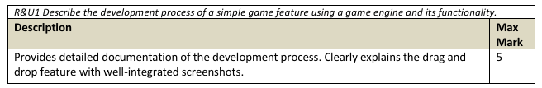

I first started by adding the ‘Selectable’ group on the draggable boxes (they’re TextureButtons for the sake of animations)
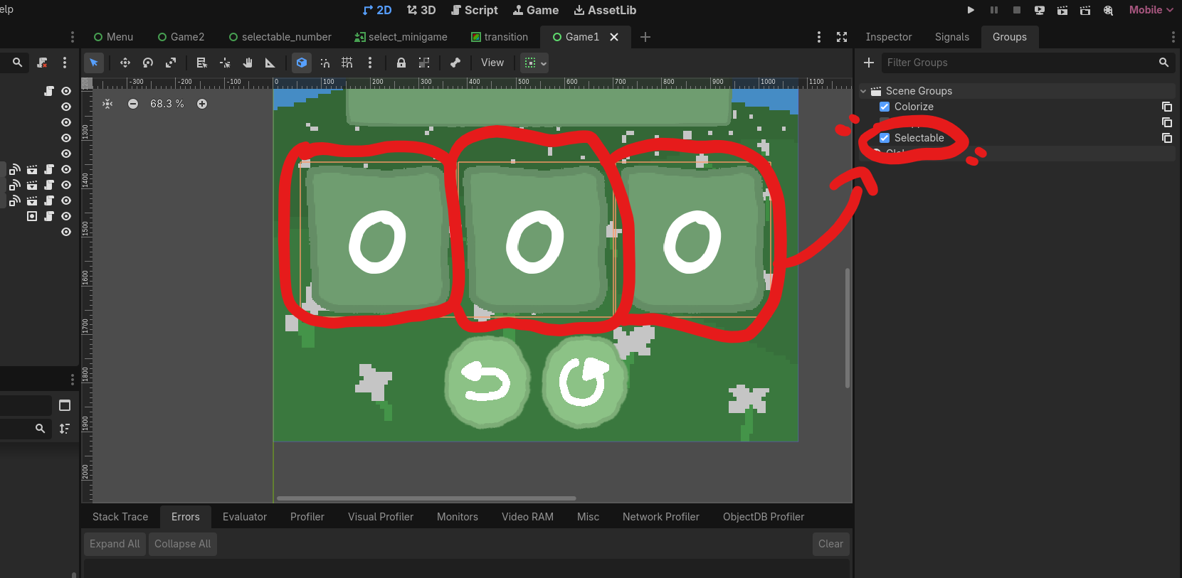
To create the group itself was relatively easy, just click the ‘+’ symbol at the top left of the panel and give it a name.
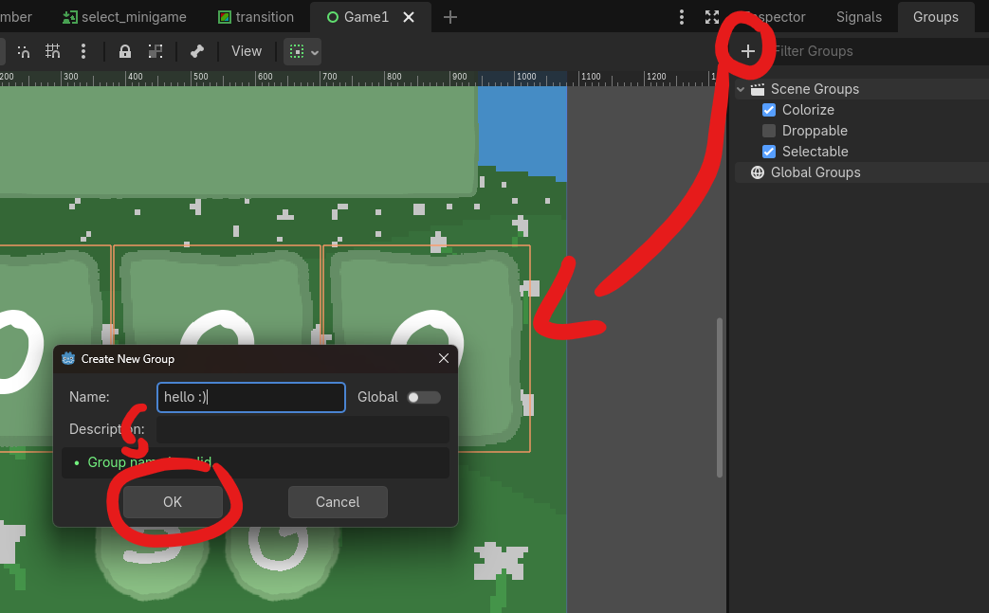

I then added this portion of code to the buttons’ script:
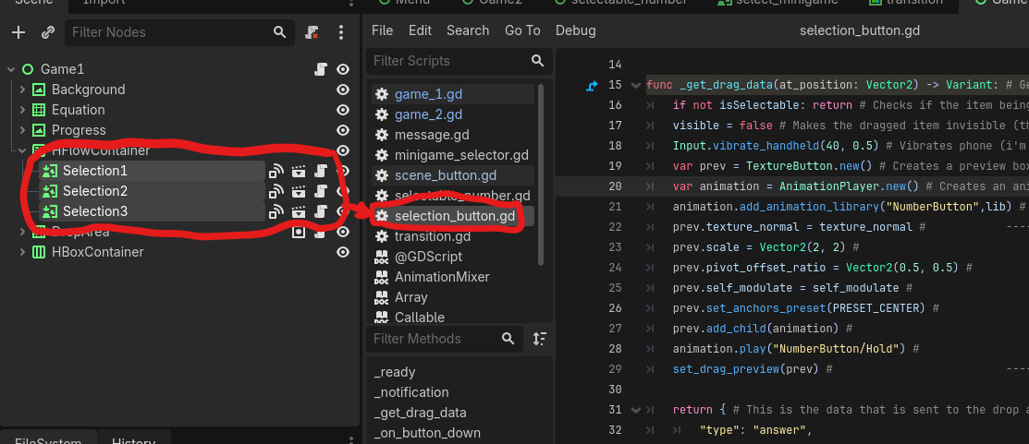
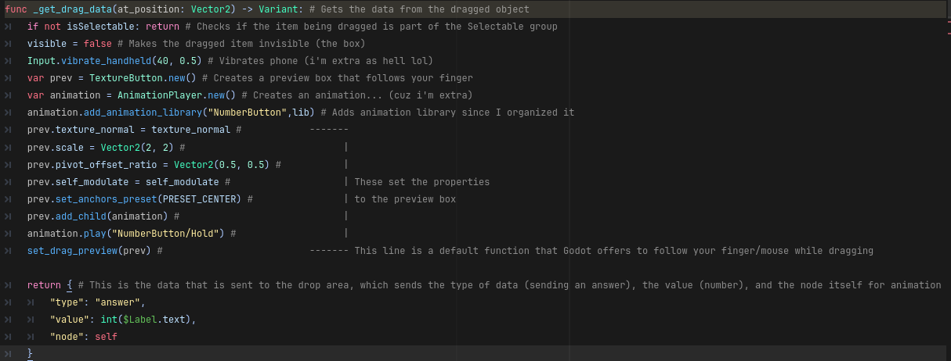
(I just wrote all the instructions/uses in the screenshots.. couldn’t be bothered organizing it here sorry. :[ )

After which, I created the drop box.
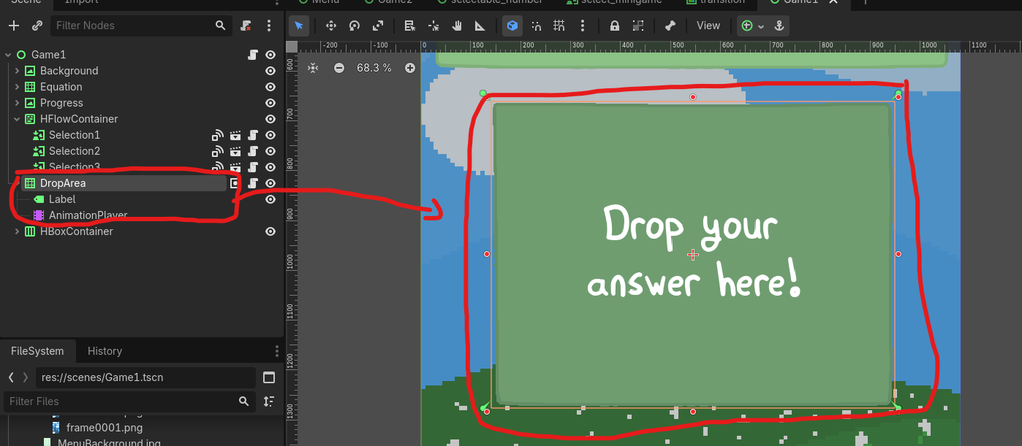
To which I also assigned it’s own group called Droppable

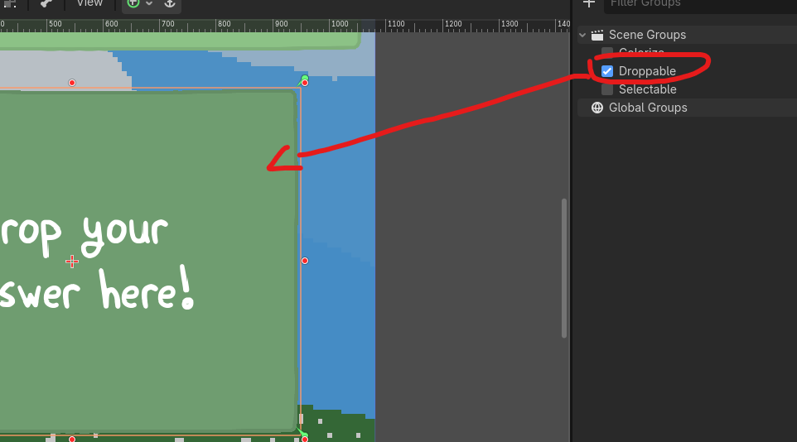
And wrote this script attached to it:
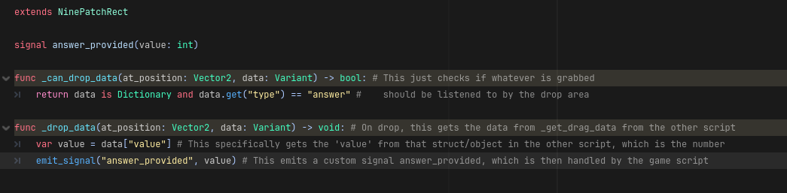
(I used NinePatchRect because I want to make my texture’s borders look pretty)

Inside the main game logic:
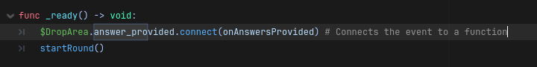
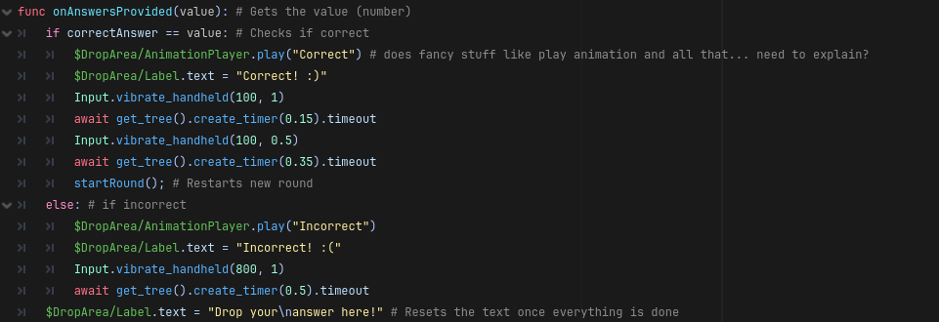
That said, this also answers the question partially:
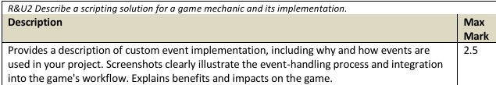
In that particular situation, I used signals so I can just send data from the drop box to the main logic loop without having to cross-reference/possible hard-coding any of the logic, considering how variable answers are anyway.

However, to provide another example:

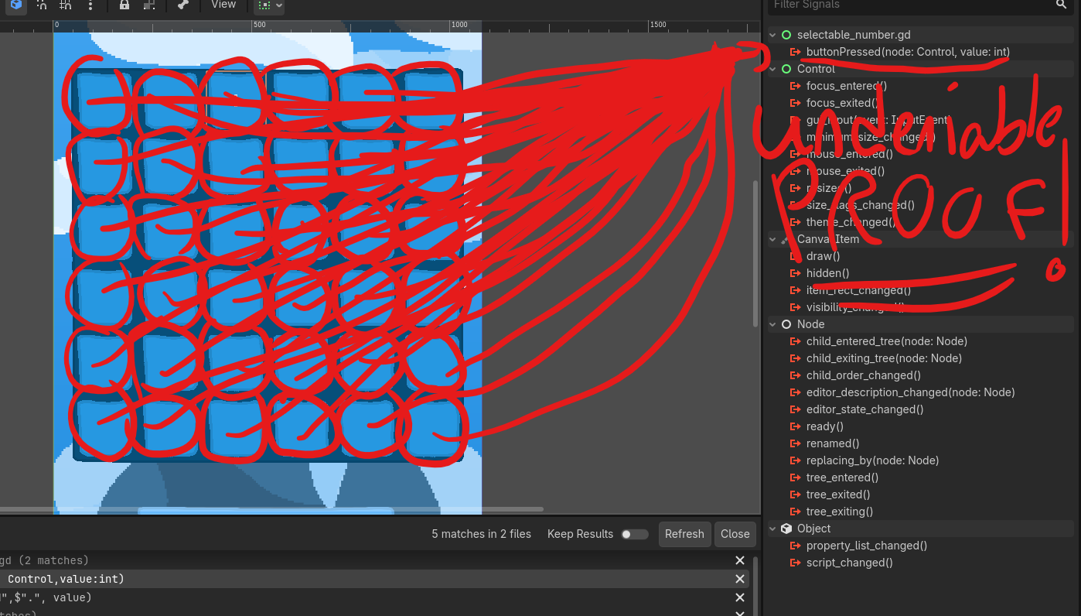
Every box in this grid (that is very evidently marked by red.. all over) emit the signal buttonPressed

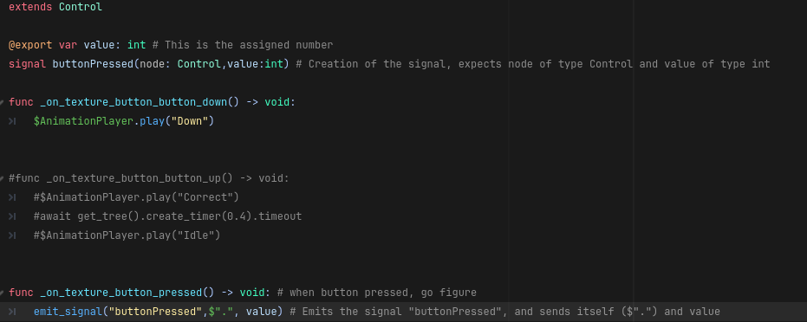
This then sends the data ‘node’ and ‘value’ to the main logic loop of the second game.
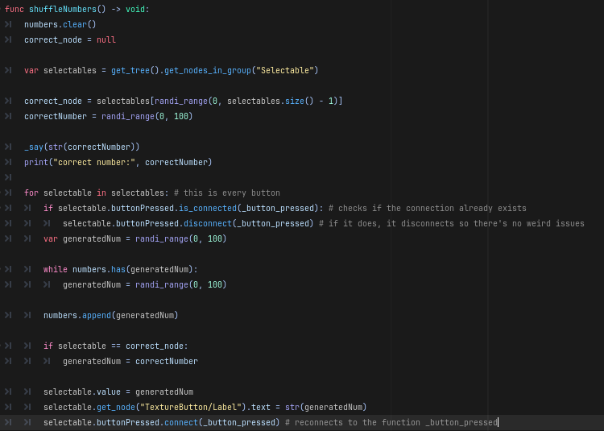
I was having some problems with adding multiple connections, so I checked if there’s an existing connection first and resetted it.

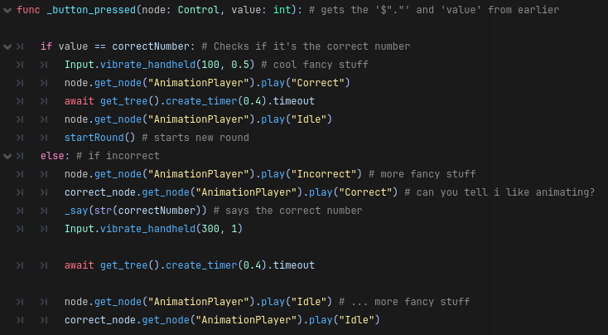
Now that the data from the buttons are passed on the main logic loop, the data of the button can be handled properly without hard-coding!

I’ve also used it because although the value of the button is given in the SAME script, it’s out of scope to be checked if user’s input is correct or not.

Plus the added benefit that you do not have to go through dictionaries of data when the ‘data itself’ just calls instead. It also keeps everything decoupled.

-------------------------------------------------------------------------------------------------------

Moving on to singletons… I have two things: TransitionScreen and MessageScreen.

To preface, the reason why I have these singletons is so I don’t have to import them in every single scene manually when they have the same functionality.

I also use TransitionScreen specifically because I want it to work between.. you guessed it.. transitioning screens. If it wasn’t a singleton, that wouldn’t be possible. It also makes sure that there is only ONE instance of each in the whole game as I don’t need multiple transitions for every level or different message systems every scene, I kept it modular!

TransitionScreen
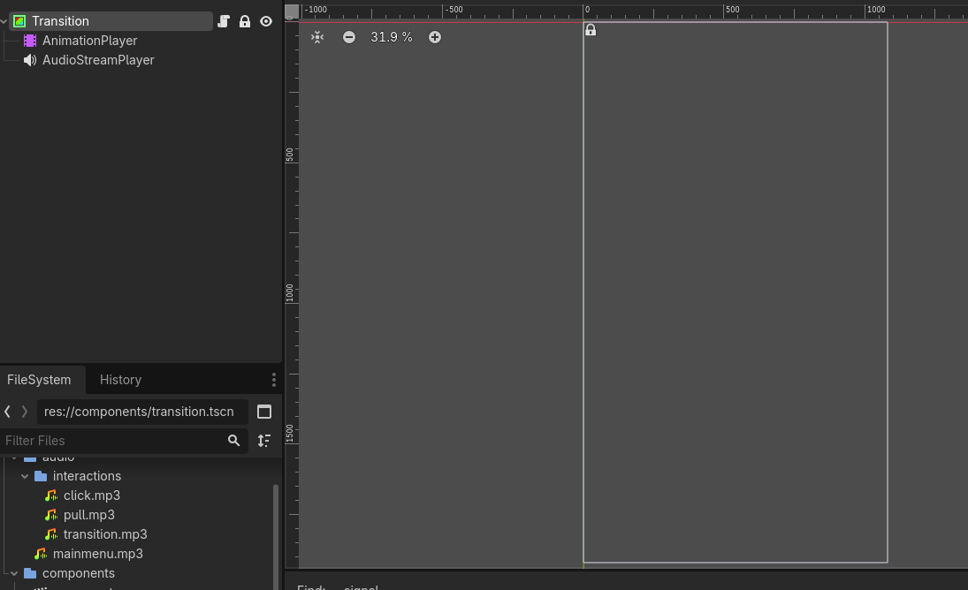
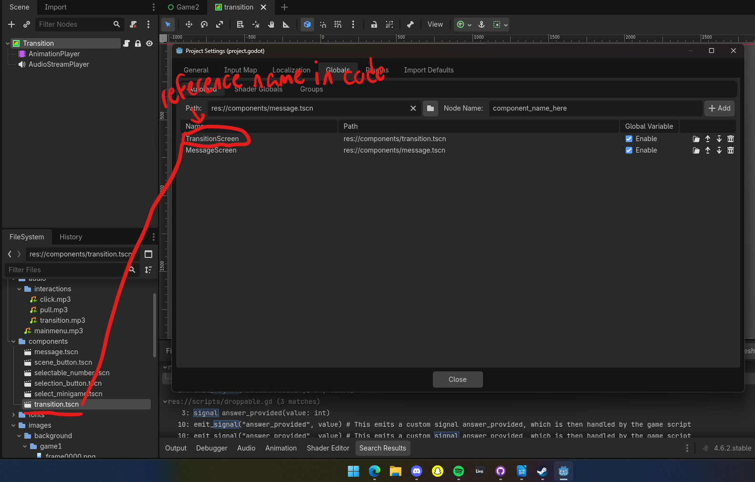
This one is pretty simple, it’s an instance of ‘ColorRect’ and some fancy stuff like Animation and Audio, which fades to white and into another scene when used.
I added the singletons from Project Settings > Globals, imported the components (the singleton files) inside the path and gave them a reference name that is used in code.

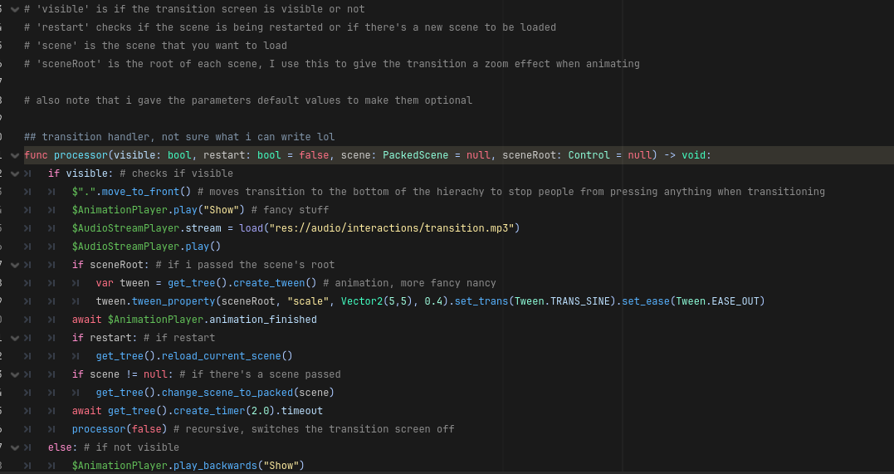
Example use:
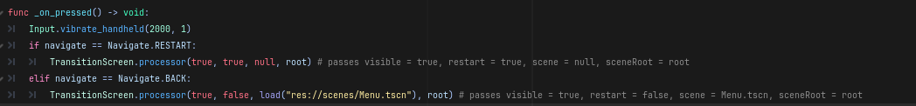
(this script is for the go back to menu and restart button in every level)

And that’s one example of the singletons!

