**GenomeFlow User Manual**

Contents

1 Installation 11

1.1 Quick Start 11

1.2 Basic dependencies 11

1.3 Dependencies and Installation 11

1.3.1 Operating System (OS) 11

1.3.2 Download External Tools 11

1.3.3 Installing External Tools 12

1.4 Create an index for a reference genome 14

1.4.1 Purpose 14

1.4.2 Input 14

1.4.3 Test Data 14

1.4.4 Output 14

1.4.5 Test Data Output 14

1.4.6 Running 15

1.5 Mapping the raw single or pair read FASTQ files 16

1.5.1 Purpose 16

1.5.2 Input 16

1.5.3 Test Data 17

1.5.4 Output 17

1.5.5 Test Data Output 17

1.5.6 Running 18

1.6 Filter a BAM alignment file 21

1.6.1 Purpose 21

1.6.2 Input 21

1.6.3 Test Data 21

1.6.4 Output 22

1.6.5 Test Data Output: 22

1.6.6 Running 22

1.7 Convert a BAM file to a HiC input file format 24

1.7.1 Purpose 24

1.7.2 Input 25

1.7.3 Test Data 25

1.7.4 Output 26

1.7.5 Test Data Output 26

1.7.6 Running 26

1.8 HiC-Express 28

1.8.1 Purpose 28

1.8.2 Input 28

1.8.3 Test Data 28

1.8.4 Output 29

1.8.5 Test Data Output 29

1.8.6 Running 30

2 2D-Functions 33

2.1 Convert mapped Hi-C reads to hic format file 33

2.1.1 Purpose 33

2.1.2 Input file format 33

2.1.3 Output 36

2.1.4 Running 36

2.2 Extract contact matrices from a hic format 38

2.2.1 Purpose 38

2.2.2 Input 38

2.2.3 Output 38

2.2.4 Running 38

2.3 Normalize HiC contact matrices 40

2.3.1 Purpose 40

2.3.2 Input 40

2.3.3 Output 40

2.3.4 Running 40

2.4 Visualizing Dataset in 2D format 41

2.4.1 Purpose 41

2.4.2 Input 41

2.4.3 Output 41

2.4.4 Running 42

2.4.5 Display Controls 42

2.4.6 TAD Annotation 45

2.4.7 Demonstration 46

2.5 Identify TAD 48

2.5.1 Purpose 48

2.5.2 Input 49

2.5.3 Output 49

2.5.4 Running 49

2.6 Check TAD consistency between two TADs from different methods 50

2.6.1 Purpose 50

2.6.2 Input 50

2.6.3 Output 51

2.6.4 Running 51

3 3D-Functions 52

3.1 3D model reconstruction by LorDG 52

3.1.1 Purpose 52

3.1.2 Input 52

3.1.3 Output 52

3.1.4 Running 52

3.2 3D model reconstruction by 3DMax 54

3.2.1 Purpose 54

3.2.2 Input 54

3.2.3 Output 55

3.2.4 Running 55

3.3 Chromatin loop identification 57

3.3.1 Purpose 57

3.3.2 Input 57

3.3.3 Output 57

3.3.4 Running 57

3.4 Model annotation 58

3.4.1 Purpose 58

3.4.2 Input 58

3.4.3 Output 58

3.4.4 Running 58

3.5 Gene expression data visualization (a special case of model annotation) 60

3.5.1 Purpose 60

3.5.2 Input 60

3.5.3 Output 61

3.5.4 Running 61

3.6 Comparing 2 models 62

3.6.1 Purpose 62

3.6.2 Input 62

3.6.3 Output 62

3.6.4 Running 62

**Table of Figures**

Figure 1: Create an index for a reference genome 10

Figure 2: Mapping the raw FASTQ files 13

Figure 3: Filter a BAM alignment file 17

Figure 4: Convert to HiC Input File Format 21

Figure 5: HiC-Express 24

Figure 6: Convert to HiC function 29

Figure 7: Extract Contact Matrices from a hic file 31

Figure 8: Normalize HiC contact matrices 33

Figure 9: Visualize Dataset in 2D Format 34

Figure 10: Demonstration of TAD Annotation on 2D Heatmap 40

Figure 11: Identifying TADs on a contact matrix 41

Figure 12: Comparing two TADs for a consistency check 43

Figure 13: 3D Model reconstruction by LorDG 45

Figure 14: 3D Model reconstruction by 3DMax 47

Figure 15: Chromatin loops 50

Figure 16: Function to annotate 3D models 51

Figure 17: Coordinate of a point in the model 52

Figure 18: Gene expression visualization demonstration 53

Figure 19: Comparing two constructed models 54

List of Tables

Table 1. The description of the input field for indexing GUI 10

Table 2. The description of the input field for mapping GUI 13

Table 3. The description of the input field for filtering GUI 17

Table 4. The description of the input field for formatting GUI 21

Table 5. The description of the input field for HiC Express GUI 24

# Installation

## Quick Start

1. Verify that you have installed the **basic dependencies**.
2. To use the 1D-Function that provides reference genome indexing, alignment of fastq files and filtering of alignment files, follow the instructions here for the dependencies download and installation. **NOTE** **This step is required only for the 1D-Function tools**
3. Download the latest [GenomeFlow Tools jar](https://github.com/jianlin-cheng/GenomeFlow/releases)
4. Run GenomeFlow:
   * Windows OS: double-click the **genomeflow.bat** script
   * Linux/UNIX based OS: execute the script, **genomeflow.sh**

## Basic dependencies

[Java 1.7 or 1.8 JDK](http://www.oracle.com/technetwork/java/javase/downloads/jdk8-downloads-2133151.html). ([Alternative link](http://tecadmin.net/install-oracle-java-8-jdk-8-ubuntu-via-ppa/) for Ubuntu/LinuxMint). Minimum system requirements for running Java can be found at <http://java.com/en/download/help/sysreq.xml> .

These dependencies support only the 2D-Functions and 3D-Functions Tools.

## Dependencies and Installation

### Operating System (OS)

A Linux, UNIX, or Mac OS X environment is required to use the 1D-Functions.

It is strongly recommended to work under a Mac OS X or a Linux/UNIX-based operating system, such as Ubuntu, Centos/Red Hat, Solaris.

If you are using a Windows operating system, install Cygwin first. Cygwin is a free software that provides a UNIX-like environment on Windows. The Cygwin install package can be found at <http://www.cygwin.com/>. Once Cygwin is installed, place your work in the Cygwin directory.

### Download External Tools

* Download BWA (<http://bio-bwa.sourceforge.net/> ) **OR** Bowtie2 ([*http://bowtie-bio.sourceforge.net/index.shtml*](http://bowtie-bio.sourceforge.net/index.shtml)) for indexing and alignment creation.
* Bowtie2 supports multiple OS, download the version for your OS. That is:
  + Download bowtie2- version number-macos-x86_64 for MacOS
  + Download bowtie2- version number- linux-x86_64 for Linux
  + Download bowtie2- version number- mingw-x86_64 for Mingw/Cygwin
* Download Samtools ([*http://samtools.sourceforge.net/*](http://samtools.sourceforge.net/))
* We tested on the following versions for each one of the tools: bwa-0.7.17, bowtie2-2.3.4-*, and samtools-1.6.
* You can also download the installation files for these tools from here: <http://sysbio.rnet.missouri.edu/bdm_download/GenomeFlow/External_Tools/>

### Installing External Tools

#### BWA

* Open a Unix Terminal
* Change directory to the downloaded bwa-* directory. For example:
  + cd bwa-0.7.17
* Type **make** once you are inside the bwa directory. For example:
  + make
* This operation produces a binary file: **bwa** 
  + In Unix based Operating system: **bwa**
  + In Cygwin/Mingw: **bwa.exe**
* Give executable permission to the **binary file**. For example:
  + In Unix based Operating system: chmod +x **bwa**
  + In Cygwin/Mingw:chmod +x **bwa.exe**

#### Bowtie2

* Open a Unix Terminal
* Change directory to the downloaded Bowtie2-* directory. For example:
  + cd bowtie2-2.3.4-linux-x86_64
* Give executable permission to the binary file. For example:
  + In Unix based Operating system/ Cygwin/Mingw: chmod +x **bowtie2\***

#### Samtools

* Open a Unix Terminal
* Change directory to the downloaded samtools-* directory. For example:
  + cd samtools-1.7
* Type **./configure** once you are inside the samtools directory. For example:
  + ./configure
* After configuration is completed, type **make**. For example:
  + make
* This operation produces a binary file: **samtools**
  + In Unix based Operating system: **samtools**
  + In Cygwin/Mingw: **samtools.exe**
* Give executable permission to the **binary file**. For example:
  + In Unix based Operating system: chmod +x **samtools**
  + In Cygwin/Mingw:chmod +x **samtools.exe**

#### Gawk

* Open a Unix Terminal
* Install gawk
* For Linux Users:
  + Type **sudo apt-get install gawk**
* For Max OSX Users:
  + Follow the instructions here: <http://macappstore.org/gawk/>
* For Cygwin/Mingw Users:
  + Open a Unix terminal
  + Download *gawk-4.2.1.tar.gz*
    - *wget* [*https://ftp.gnu.org/gnu/gawk/gawk-4.2.1.tar.gz*](https://ftp.gnu.org/gnu/gawk/gawk-4.2.1.tar.gz)
  + Unzip the *gawk-4.2.1.tar.gz*
    - *tar -xvpzf* *gawk-4.2.1.tar.gz*
  + Change directory to the *gawk-4.2.1 directory*
    - cd *gawk-4.2.1*
  + Type **./configure** once you are inside the *gawk-4.2.1* directory.
    - ./configure
  + After configuration is completed, type **make**. For example:
    - make && make check

## Create an index for a reference genome

### Purpose

* To build an index for the reference genome data. Indexing the reference genome makes querying fast, and can also compress the size of the genome data

### Input

* The reference input FASTA file (usually having extension fa, mfa,.fna or similar). Read more about FASTA files here: <https://en.wikipedia.org/wiki/FASTA> .

### Test Data

* The human hg19 genome data (hg19.fa) can be downloaded from here: <http://sysbio.rnet.missouri.edu/bdm_download/GenomeFlow/hg19_genome/hg19_genome_FASTA/>

### Output

* A list of index files. This varies depending on the tool selected for indexing. BWA output 5 files (NAME.amb, NAME. ann, NAME. bwt, NAME .pac, and NAME.sa), where NAME is a prefix string, and Bowtie2 outputs 6 files (NAME.1.bt2, NAME.2.bt2, NAME.3.bt2, NAME.4.bt2, NAME.rev.1.bt2, and NAME.rev.2.bt2) where NAME is <bt2_base>.

### Test Data Output

* Generated index for the hg19 human genome by bowtie2 and bwa tools can be downloaded from here: <http://sysbio.rnet.missouri.edu/bdm_download/GenomeFlow/hg19_genome/>

### Running

* Access the function from the menu toolbar: 1D-Funcitons/ Build index for reference genome
* Select the appropriate input following the instruction in Table 1.
* Click on the Execute button
  + It will generate a shell script file, **Indexer_script.sh**
* **Linux/Mac OS User**: The indexing operation will start automatically in background.
* **Cygwin/Mingw User**: Manually execute the script
  + Open the Unix terminal
  + Change directory to the directory containing the shell script file. For example:
    - cd path/to/directory
  + Give executable permission to the **script file**. For example:
    - chmod +x *Indexer_script.sh*
  + Execute the shell script: For example:
    - ./Indexer_script.sh

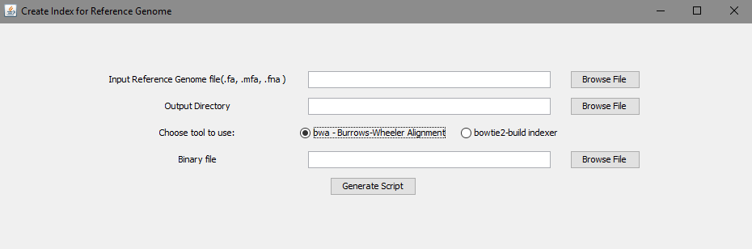

Figure 1: Create an index for a reference genome

Table 1. The description of the input field for indexing GUI

|  |  |  |
| --- | --- | --- |
| **Field** | **Description** | **Default** |
| Input Reference Genome file | A reference genome file having extension. fa, .mfa, .fna or similar. For example, human genome(GRCh37/hg19) | NA |
| Output Directory | The output directory path to output the script | NA |
| Choose tool to use | Two options are made available for indexing. Select [bwa- Burrows-Wheeler alignment](http://bio-bwa.sourceforge.net/bwa.shtml) or [Bowtie2](http://bowtie-bio.sourceforge.net/bowtie2/manual.shtml). | bwa |
| Binary file | Browse and select the binary file for the chosen tool  BWA: Select the **bwa** binary you compiled from the bwa-* directory  Bowtie2: Select the **bowtie2-biuild** binary file from the bowtie2-* directory | NA |
| Number of threads | Specify the number of cores to use for multithreading. This option is available only for the **bowtie2-biuild** indexer. Specify the number of threads to use for this task. More threads means less processing time taken. | 3 |
| Execute | This button generates a shell script (.sh) that is executed automatically for Linux/Mac OS users. |  |

## Mapping the raw single or pair read FASTQ files

### Purpose

To perform alignment of the index and a set of sequencing read files.

### Input

A FASTQ read files usually with extension .fq or .fastq. Read more about FASTA files here: <https://en.wikipedia.org/wiki/FASTQ_format>

### Test Data

Test datasets can be found here:

* MiSeq GM12878 in-situ files: <http://sysbio.rnet.missouri.edu/bdm_download/GenomeFlow/MiSeq_GM12878/MiSeq_GM12878_Data/>
* A karyotypically normal human lymphoblastoid cell line (GM06990) from Aiden et al: <http://sysbio.rnet.missouri.edu/bdm_download/GenomeFlow/GM06990/GM06990_Data/>

### Output

The output will be found in a folder bowtie2_align for bowtie2 and bwa_align for bwa. By default, the output BAM file is named *bwa_mapped.bam* for bwa and named *bowtie2_mapped.bam* for bowtie2.

A BAM binary format (.bam) obtained by converting a SAM file from samtools into a BAM file. Check [http://samtools.sourceforge.net](http://samtools.sourceforge.net/) for the SAM format specification and the tools for post-processing the alignment.

### Test Data Output

The generated bowtie2 and bwa alignment BAM file can be downloaded from the link below for each test data:

* MiSeq GM12878 in-situ files:
  + Bowtie2: <http://sysbio.rnet.missouri.edu/bdm_download/GenomeFlow/MiSeq_GM12878/bowtie2_align_Miseq/>
  + Bwa: <http://sysbio.rnet.missouri.edu/bdm_download/GenomeFlow/MiSeq_GM12878/bwa_align_Miseq/>
* GM06990 Cell line:
  + Bowtie2: <http://sysbio.rnet.missouri.edu/bdm_download/GenomeFlow/GM06990/bowtie2_align/>
  + Bwa:

<http://sysbio.rnet.missouri.edu/bdm_download/GenomeFlow/GM06990/bwa_align/>

### Running

* Access the function from the menu toolbar: 1D-Functions/Map the raw FASTQ files
* Select the appropriate input following the instruction in Table 2.
* Click on the Execute button
  + It will generate a shell script file.
    - **bowtie2 binary:** *Mapper_script_bowtie2.sh*
    - **bwa binary:** *Mapper_script_bwa.sh*
* **Linux/Mac OS User**: The mapping operation will start automatically in background.
* **Cygwin/Mingw User**: Manually execute the script
  + Open the Unix terminal
  + Change directory to the directory containing the shell script file. For example:
    - cd path/to/directory
  + Give executable permission to the **script file**. For example:
    - chmod +x *Mapper_script_bowtie2.sh*
  + Execute the shell script: For example:
    - ./ *Mapper_script_bowtie2.sh*

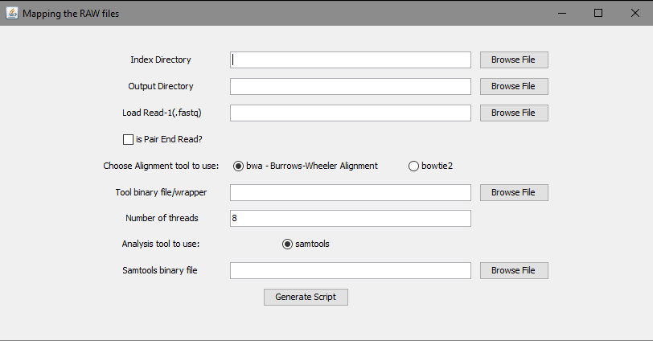

Figure 2: Mapping the raw FASTQ files

Table 2. The description of the input field for mapping GUI

|  |  |  |
| --- | --- | --- |
| **Field** | **Description** | **Default** |
| Index Directory | The file path to the bwa or bowtie2 directory created when you run the Indexer_Script.sh. | NA |
| Output Directory | The output directory path to output the script | NA |
| Load Read-1(.fastq) | The file containing mate 1, or file for a single read e.g HIC003_S2_L001_**R1**_001.fastq | NA |
| Load Read-2(.fastq) | The file containing mate 2 e.g HIC003_S2_L001_**R2**_001.fastq | NA |
| Is Pair-End Read | Check if the data is a pair end read data | unchecked |
| Choose tool to use | Two options are made available for indexing. Select [bwa- Burrows-Wheeler alignment](http://bio-bwa.sourceforge.net/bwa.shtml) or [Bowtie2](http://bowtie-bio.sourceforge.net/bowtie2/manual.shtml).  **Important**: Select the tool which was used to generate the reference genome Index files. *bwa can only be used to map generated bwa index files, and bowtie2 can only be used to map generated bowtie2 index files*. | bwa |
| Binary file | Browse and select the binary file for the chosen tool  BWA: Select the **bwa** binary you compiled from bwa-* directory  Bowtie2: Select the **bowtie2** binary file to align from the bowtie2-* directory | NA |
| Number of threads | Specify the number of cores to use for multithreading. This option is available only for the **bowtie2-biuild** indexer. Specify the number of threads to use for this task. More threads means less processing time taken. | 3 |
| Samtools binary file | [SAMtools](http://samtools.sourceforge.net/) is a collection of tools for manipulating and analyzing SAM and BAM alignment files. This tool allows you to get alignments in SAM format  Browse and select the **samtools** binary file from the **samtools-* directory.** | NA |
| Execute | This button generates a shell script (.sh) that is executed automatically for Linux/Mac OS users. |  |

## Filter a BAM alignment file

### Purpose

To perform filtering of a BAM file to remove low quality map reads and unmapped reads among others.

### Input

The BAM file generated from the mapping step above. For example, by default bwa BAM files is named bwa_mapped.bam and bowtie2 BAM files is named bowtie2_mapped.bam.

### Test Data

The generated bowtie2 alignment BAM file can be downloaded from the link below for each test data:

* MiSeq GM12878 in-situ files:
  + Bowtie2: <http://sysbio.rnet.missouri.edu/bdm_download/GenomeFlow/MiSeq_GM12878/bowtie2_align_Miseq/>
  + Bwa:

<http://sysbio.rnet.missouri.edu/bdm_download/GenomeFlow/MiSeq_GM12878/bwa_align_Miseq/>

* GM06990 Cell line:
  + Bowtie2:

<http://sysbio.rnet.missouri.edu/bdm_download/GenomeFlow/GM06990/bowtie2_align/>

* + Bwa:

<http://sysbio.rnet.missouri.edu/bdm_download/GenomeFlow/GM06990/bwa_align/>

### Output

A BAM binary format (. bam) named *bowtie2_mapped.filtered.bam* for bowtie2 and *bwa_mapped.filtered.bam* for bwa.

### Test Data Output:

The generated filtered bowtie2 and bwa alignment BAM file can be downloaded from the link below for the MiSeq GM12878 in-situ and GM06990 Cell line test datasets.

* MiSeq GM12878 in-situ files:
  + Bowtie2: <http://sysbio.rnet.missouri.edu/bdm_download/GenomeFlow/MiSeq_GM12878/bowtie2_Miseq_mapped.filtered.bam>
  + Bwa:

<http://sysbio.rnet.missouri.edu/bdm_download/GenomeFlow/MiSeq_GM12878/bwa_Miseq_mapped.filtered.bam>

* GM06990 Cell line:
  + Bowtie2:

<http://sysbio.rnet.missouri.edu/bdm_download/GenomeFlow/GM06990/bowtie2_mapped.filtered.bam>

* + Bwa: <http://sysbio.rnet.missouri.edu/bdm_download/GenomeFlow/GM06990/bwa_mapped.filtered.bam>

### Running

* Access the function from the menu toolbar: 1D-Functions/Filter a BAM alignment
* Select the appropriate input following the instruction in Table 3.
* Click on the Execute button
  + It will generate a shell script file, **Filter_script_samtools.sh**
* **Linux/Mac OS User**: The filtering operation will start automatically in background.
* **Cygwin/Mingw User**: Manually execute the script
  + Open the Unix terminal
  + Change directory to the directory containing the shell script file. For example:
    - cd path/to/directory
  + Give executable permission to the **script file**. For example:
    - chmod +x *Filter_script_samtools.sh*
  + Execute the shell script: For example:
    - *./Filter_script_samtools.sh*

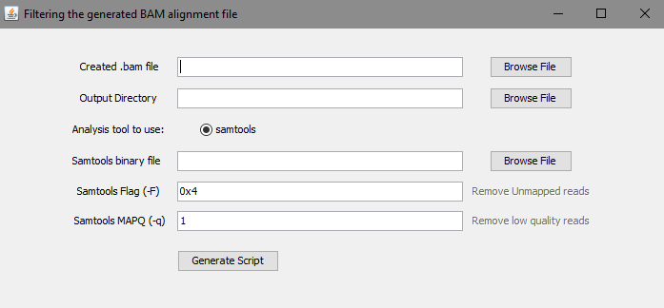

Figure 3: Filter a BAM alignment file

Table 3. The description of the input field for filtering GUI

|  |  |  |
| --- | --- | --- |
| **Field** | **Description** | **Default** |
| Created .bam file | Select the BAM file generated using either BWA or bowtie2. Select the BAM file named bwa_mapped.bam for **bwa** and BAM file named bowtie2_mapped.bam for **bowtie2** | NA |
| Output Directory | The output directory path to output the script | NA |
| Samtools binary file | **samtools** is a collection of tools for manipulating and analyzing SAM and BAM alignment files. This tool allows you to get alignments in SAM format.  Browse and select the **samtools** binary file from the **samtools-* directory.** | NA |
| Samtools Flag (-F) | **samtools**allows you to sort based on certain flags that are specified on [page 5 on the SAM format specification](http://samtools.github.io/hts-specs/SAMv1.pdf) | 0x4 |
| Samtools MAPQ (-q) | An integer value to Skip alignments with MAPQ smaller than INT. The lowest score is a mapping quality of zero, or **mq0** for short. The reads map to multiple places on the genome, and we can't be sure of where the reads originated. To improve the quality of our data, we can remove these low- quality reads. Generally, we select reads with MAPQ > 1. | 1 |
| Execute | This button generates a shell script (.sh) that is executed automatically for Linux/Mac OS users.. This script contains the basic parameters required by each tool for filtering. |  |

## Convert a BAM file to a HiC input file format

### Purpose

To generate a HiC input file format in medium file format – a text file describing mapped Hi-C reads that can be used as input to create a **.***hic* file. A hic format file is a binary file containing contact matrices at different resolutions and normalized by different methods.

### Input

A filtered BAM alignment file. e.g bwa_mapped.filtered.bam.

### Test Data

The generated filtered bowtie2 and bwa alignment BAM file for the MiSeq GM12878 in-situ and GM06990 Cell line test datasets can be downloaded from the link below:

* MiSeq GM12878 in-situ files:
  + Bowtie2: <http://sysbio.rnet.missouri.edu/bdm_download/GenomeFlow/MiSeq_GM12878/bowtie2_Miseq_mapped.filtered.bam>
  + Bwa:

<http://sysbio.rnet.missouri.edu/bdm_download/GenomeFlow/MiSeq_GM12878/bwa_Miseq_mapped.filtered.bam>

* GM06990 Cell line:
  + Bowtie2:

<http://sysbio.rnet.missouri.edu/bdm_download/GenomeFlow/GM06990/bowtie2_mapped.filtered.bam>

* + Bwa: <http://sysbio.rnet.missouri.edu/bdm_download/GenomeFlow/GM06990/bwa_mapped.filtered.bam>

### Output

A medium input file format with 11 columns that can be used to create a .*hic* file This file format is explained in details here: HiC Input Medium File Format.

### Test Data Output

The generated input medium file format file for the input test datasets can be downloaded from the link below:

* MiSeq GM12878 in-situ files:
  + Bowtie2: <http://sysbio.rnet.missouri.edu/bdm_download/GenomeFlow/MiSeq_GM12878/GenomeFlow_Miseq_formatted.bowtie2.input>
  + Bwa:

<http://sysbio.rnet.missouri.edu/bdm_download/GenomeFlow/MiSeq_GM12878/GenomeFlow_Miseq_formatted.bwa.input>

* GM06990 Cell line:
  + Bowtie2:

<http://sysbio.rnet.missouri.edu/bdm_download/GenomeFlow/GM06990/GenomeFlow_formatted.bowtie2.input>

* + Bwa: <http://sysbio.rnet.missouri.edu/bdm_download/GenomeFlow/GM06990/GenomeFlow_formatted.bwa.input>

### Running

* Access the function from the menu toolbar: 1D-Functions/Convert a BAM file to a HiC input file format
* Select the appropriate input following the instruction in Table 4.
* Click on the Execute button
  + It will generate a shell script file, **Format_script_samtools.sh**
* **Linux/Mac OS User**: The formatting operation will start automatically in background.
* **Cygwin/Mingw User**: Manually execute the script
  + Open the Unix terminal
  + Change directory to the directory containing the shell script file. For example:
    - cd path/to/directory
* Give executable permission to the **script file**. For example:
  + chmod +x *Filter_script_samtools.sh*
* Execute the shell script: For example:
  + *./Filter_script_samtools.sh*

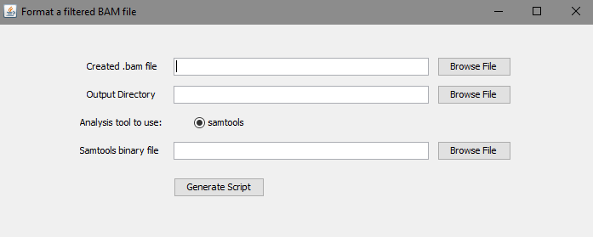

Figure 4: Convert to HiC Input File Format

Table 4. The description of the input field for formatting GUI

|  |  |  |
| --- | --- | --- |
| **Field** | **Description** | **Default** |
| Created .bam file | Select the BAM file generated from the filtering.  By default, **bwa** filtered BAM file is named bwa_mapped.filtered.bam and **bowtie2** filtered BAM file is namedbowtie2_mapped.filtered.bam | NA |
| Output Directory | The output directory path to output the script | NA |
| Samtools binary file | **samtools** is a collection of tools for manipulating and analyzing SAM and BAM alignment files. This tool allows you to get alignments in SAM format  Browse and select the **samtools** binary file from the **samtools-* directory** | NA |
| Execute | This button generates a shell script (.sh) that is executed automatically for Linux/Mac OS users. |  |

## HiC-Express

### Purpose

To generate a HiC input file format in generate a medium file format - a text file describing mapped Hi-C reads that can be used as input to create a **.***hic* file from a raw fastq files derived from a Hi-C experiment. A hic format file is a binary file containing contact matrices at different resolutions and normalized by different methods.

### Input

A FASTQ read files usually with extension, .fq or .fastq. Read more about FASTQ files here: <https://en.wikipedia.org/wiki/FASTQ_format>

### Test Data

Test datasets can be found here:

* MiSeq GM12878 in-situ files: <http://sysbio.rnet.missouri.edu/bdm_download/GenomeFlow/MiSeq_GM12878/MiSeq_GM12878_Data/>
* A karyotypically normal human lymphoblastoid cell line (GM06990) from Aiden et al: <http://sysbio.rnet.missouri.edu/bdm_download/GenomeFlow/GM06990/GM06990_Data/>

### Output

An input medium file format with 11 columns that can be used to create a .*hic* file This file format is explained in details here: HiC Input Medium File Format

### Test Data Output

The generated input medium file format file for the input test datasets can be downloaded from the link below:

* MiSeq GM12878 in-situ files:
  + Bowtie2: <http://sysbio.rnet.missouri.edu/bdm_download/GenomeFlow/MiSeq_GM12878/GenomeFlow_Miseq_formatted.bowtie2.input>
  + Bwa:

<http://sysbio.rnet.missouri.edu/bdm_download/GenomeFlow/MiSeq_GM12878/GenomeFlow_Miseq_formatted.bwa.input>

* GM06990 Cell line:
  + Bowtie2:

<http://sysbio.rnet.missouri.edu/bdm_download/GenomeFlow/GM06990/GenomeFlow_formatted.bowtie2.input>

* + Bwa: <http://sysbio.rnet.missouri.edu/bdm_download/GenomeFlow/GM06990/GenomeFlow_formatted.bwa.input>

### Running

* Access the function from the menu toolbar: 1D-Functions/HiC-Express
* Select the appropriate input following the instruction in Table 5.
* Click on the Execute button
  + It will generate a shell script file, **HiC-Express.sh**
* **Linux/Mac OS User**: The HiC Express operation will start automatically in background.
* **Cygwin/Mingw User**: Manually execute the script
  + Open the Unix terminal
  + Change directory to the directory containing the shell script file. For example:
    - cd path/to/directory
* Give executable permission to the **script file**. For example:
  + chmod +x *HiC-Express.sh*
* Execute the shell script: For example:
  + *./ HiC-Express.sh*

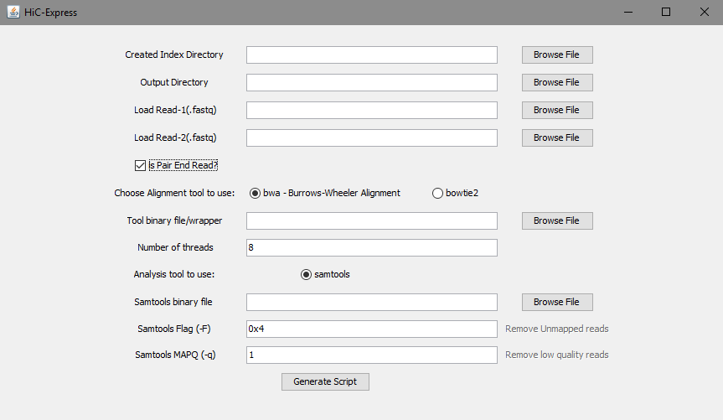

Figure 5: HiC-Express

Table 5. The description of the input field for HiC Express GUI

|  |  |  |
| --- | --- | --- |
| **Field** | **Description** | **Default** |
| Created Index Directory | A path to the index created using bwa or bowtie2 | NA |
| Output Directory | The output directory path to output the script | NA |
| Load Read-1(.fastq) | The file containing mate 1, or file for a single read e.g HIC003_S2_L001_R1_001.fastq | NA |
| Load Read-2(.fastq) | The file containing mate 2 e.g HIC003_S2_L001_R2_001.fastq | NA |
| Is Pair-End Read | Check if the data is a pair end read data | unchecked |
| Choose tool to use | Two options are made available for indexing. Select [bwa- Burrows-Wheeler alignment](http://bio-bwa.sourceforge.net/bwa.shtml) or [Bowtie2](http://bowtie-bio.sourceforge.net/bowtie2/manual.shtml).  **Important**: Select the tool which was used to create the reference genome Index. *bwa can only be used to map bwa index, and bowtie2 can only be used to map bowtie2 index*. | bwa |
| Binary file | Browse and select the binary file for the chosen tool  bwa: Select the **bwa** binary you compiled from bwa-* directory  Bowtie2: Select the **bowtie2** binary file to align from the bowtie2-* directory | NA |
| Number of threads | Specify the number of cores to use for multithreading. This option is available only for the **bowtie2-biuild** indexer, Specify the number of threads to use for this task. More threads means less processing time taken. | 3 |
| Samtools binary file | **samtools** is a collection of tools for manipulating and analyzing SAM and BAM alignment files. This tool allows you to get alignments in SAM format  Browse and select the **samtools** binary file from the **samtools-* directory** | NA |
| Samtools Flag (-F) | **samtools**allows you to sort based on certain flags that are specified on [page 5 on the SAM format specification](http://samtools.github.io/hts-specs/SAMv1.pdf) | 0x4 |
| Samtools MAPQ (-q) | An integer value to skip alignments with MAPQ smaller than INT. The lowest score is a mapping quality of zero, or **mq0** for short. The reads map to multiple places on the genome, and we can't be sure of where the reads originated. To improve the quality of our data, we can remove these low-quality reads. Generally, we select reads with MAPQ > 1. | 1 |
| Execute | This button generates a shell script (.sh) that is executed automatically for Linux/Mac OS users. |  |

# 2D-Functions

## Convert mapped Hi-C reads to hic format file

### Purpose

To create a binary hic format file containing contact matrices at different resolutions and normalized by different methods from a text file describing mapped Hi-C reads.

### Input file format

Five formats are acceptable: short format, short format with score, medium format, long format and 4DN DCIC format. A sample file is: *executable/sample_data/GSM1551688_HIC143_merged_nodups.zip* (unzip it before use).

Another set of test data is the GM06990 cell line data. This can be downloaded from the link below:

* GM06990 Cell line:
  + Bowtie2:
  + <http://sysbio.rnet.missouri.edu/bdm_download/GenomeFlow/GM06990/>
  + Download/Save the GenomeFlow_formatted.bowtie2.input file
  + Bwa
  + <http://sysbio.rnet.missouri.edu/bdm_download/GenomeFlow/GM06990/>
  + Download/Save the GenomeFlow_formatted.bwa.input file

#### Short format

A whitespace separated file that contains, on each line

<str1> <chr1> <pos1> <frag1> <str2> <chr2> <pos2> <frag2>

* str = strand (0 for forward, anything else for reverse)
* chr = chromosome (must be a chromosome in the genome)
* pos = position
* frag = restriction site fragment

If not using the restriction site file option, *frag* will be ignored, but please see above note on dummy values. *readname* and *strand* are also not currently stored within *.hic* files.

#### Short with score format

This format is useful for reading in already processed files, e.g. those that have been already binned and/or normalized. This format can be easily used in conjunction with the -r flag to create a *.hic* file that contains a single resolution.

A whitespace separated file that contains, on each line

<str1> <chr1> <pos1> <frag1> <str2> <chr2> <pos2> <frag2> <score>

* str = strand (0 for forward, anything else for reverse)
* chr = chromosome (must be a chromosome in the genome)
* pos = position
* frag = restriction site fragment
* score = the score imputed to this read

If not using the restriction site file option, *frag* will be ignored, but please see above note on dummy values. *readname* and *strand* are also not currently stored within *.hic* files.

#### Medium format

A whitespace separated file that contains, on each line

<readname> <str1> <chr1> <pos1> <frag1> <str2> <chr2> <pos2> <frag2> <mapq1> <mapq2>

* str = strand (0 for forward, anything else for reverse)
* chr = chromosome (must be a chromosome in the genome)
* pos = position
* frag = restriction site fragment
* mapq = mapping quality score

If not using the restriction site file option, *frag* will be ignored, but please see above note on *dummy values*. If not using mapping quality filter, *mapq* will be ignored. *readname* and *strand* are also not currently stored within .hic files.

#### Long format

The long format is used by [Juicer](https://github.com/theaidenlab/juicer) and takes in directly the *merged_nodups.txt* file.

A whitespace separated file that contains, on each line

<str1> <chr1> <pos1> <frag1> <str2> <chr2> <pos2> <frag2> <mapq1> <cigar1> <sequence1> <mapq2> <cigar2> <sequence2> <readname1> <readname2>

* str = strand (0 for forward, anything else for reverse)
* chr = chromosome (must be a chromosome in the genome)
* pos = position
* frag = restriction site fragment
* mapq = mapping quality score
* cigar = cigar string as reported by aligner
* sequence = DNA sequence

If not using the restriction site file option, frag will be ignored, but please see above note on dummy values. If not using mapping quality filter, mapq will be ignored. readname, strand, cigar, and sequence are also not currently stored within *.hic* files.

#### 4DN DCIC format

A file that follows the 4DN DCIC format specification ([the 4DN DCIC format specification](https://github.com/4dn-dcic/pairix/blob/master/pairs_format_specification.md)).  
See the link for more information. Briefly, there should be a header with the first seven columns reserved:

## pairs format v1.0

#columns: readID chr1 position1 chr2 position2 strand1 strand2

If the columns line contains (in any field after field 7) both *frag1* and *frag2*, those will also be read in; otherwise they will be set as *frag1*=0 and *frag2*=1 by default, so that no reads are discarded. Other fields are ignored.

### Output

A binary .hic file containing contact matrices

### Running

Access the function from the menu toolbar: 2D-Functions/Convert to HiC

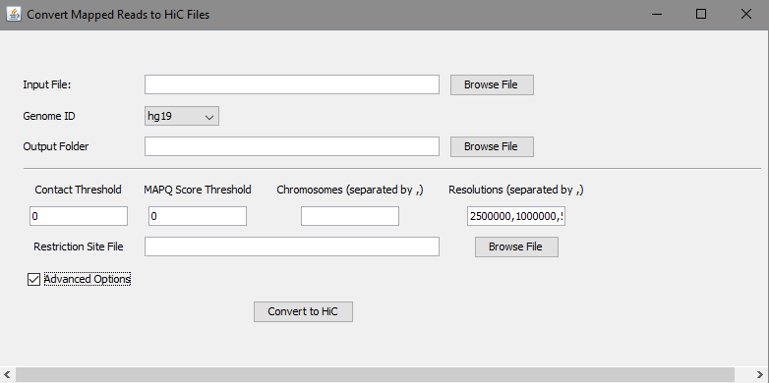

Figure 6: Convert to HiC function

|  |  |  |
| --- | --- | --- |
| **Field** | **Description** | **Default** |
| Input file | A text file that contains the mapped Hi-C reads (format described above) | NA |
| Genome ID | Version genome of Hi-C data | hg19 |
| Output Directory | The output directory path to output the generated hic format file. An example output filename is **GenomeFlow_Convert_1521343280452.hic** | NA |
| Contact Threshold | Number of interaction threshold for contacts to be used in creating contact matrices. | 0 |
| MAPQ Score Threshold | Mapping quality score threshold for reads to be considered in creating contact matrices. | 0 |
| Chromosomes | Chromosomes for which their contact matrices need to be created. When left blank, all chromosomes will be considered. Chromosomes must be separated by a comma (,). | All (when left blank) |
| Resolutions | List of resolutions of contact matrices to be created. Resolutions are separated by a comma (,) | 2500000, 1000000, 500000, 250000, 100000, 50000, 25000,10000,5000 |
| Restriction Site File | Each line starts with a chromosome number followed by positions of restriction sites on that chromosome, in numeric order, and ending with the size of the chromosome. When provided, 8 additional fragment-delimited resolutions are added: 500f, 250f, 100f, 50f, 20f, 5f, 2f, 1f | blank |

## Extract contact matrices from a hic format

### Purpose

To extract a contact matrix from a hic format into a sparse matrix format in a text file

### Input

A local path to a hic format or an online link to a hic format. A link to a hic file: <https://www.encodeproject.org/files/ENCFF219YOB/@@download/ENCFF219YOB.hic>

### Output

A contact matrix in sparse matrix format (each line represents a contact by three numbers separated by whitespaces: <position1> <postion2> <interaction_frequency>

### Running

Access the function from the menu toolbar: 2D-Functions/Extract HiC

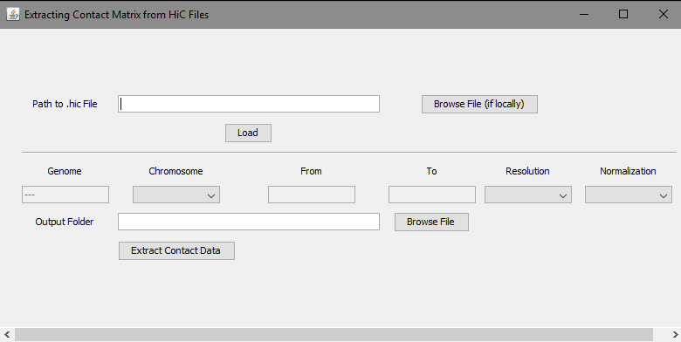

Figure 7: Extract Contact Matrices from a hic file

|  |  |  |
| --- | --- | --- |
| **Field / Button** | **Description** | **Default** |
| Path to .hic File | An online link or local path to a hic format file | NA |
| Load | Click this button to fetch information from the header of the hic file. | NA |
| Genome | Genome version of the hic file | NA |
| Chromosomes | List of resolutions of contact matrices in the hic file | NA |
| From | Start of a fragment (to extract its contact matrix). When From and To are left blank, the whole chromosome is considered. | Blank |
| To | End of a fragment (to extract its contact matrix). When From and To are left blank, the whole chromosome is considered. | Blank |
| Resolution | List of resolutions of contact matrices in the hic file | NA |
| Normalization | List of normalization methods used to normalize contact matrices | NA |
| Output Directory | The output directory path to output the extracted data. An example filename for the generated file is *GenomeFlow_Extract_hg19_chr_1_res_BP_2500000_norm_None.txt* |  |
| Extract Contact Data | Click this button to initiate extracting contact data | NA |

## Normalize HiC contact matrices

### Purpose

To normalize contact matrices in sparse matrix format.

### Input

A contact matrix in sparse matrix format (each line represents a contact by three numbers separated by whitespaces: <position1> <position2> <interaction_frequency>.

### Output

A normalized contact matrix in sparse matrix format. The matrix is normalized by the Iterative Correction and Eigenvector decomposition (ICE) method.

### Running

Access the function from the menu toolbar: 2D-Functions/Normalized HiC Data.

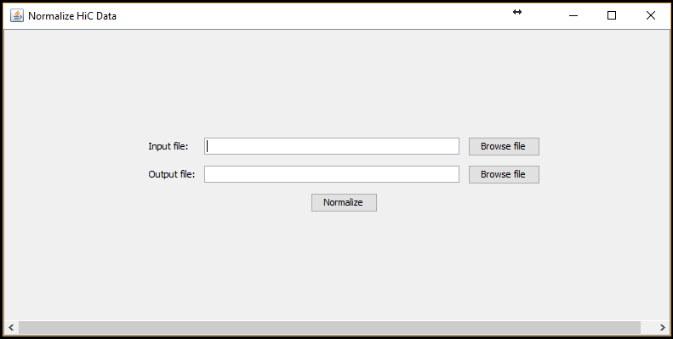

Figure 8: Normalize HiC contact matrices

## Visualizing Dataset in 2D format

### Purpose

To create a two dimensional (2D) graphical representation of a contact matrix from an input file.

### Input

A sparse matrix format (each line represents a contact by three numbers separated by whitespaces: <position1> <postion2> <interaction_frequency> or an input file in square matrix format (a full matrix representing all the contact regions). Mark the *Is Square Matrix?* box if the input is a square matrix.

An example sparse matrix file can be found here:

*/executable/sample_data/ contact_matrices/ chr11_10kb_gm12878_list_125mb_135mb.txt*

Examples of square matrix files can be found here:

*/executable/sample_data/ contact_matrices/square_matrices/*

Note: Resolution for square matrices = 40000

### Output

A heatmap which is a graphical representation of contact data where numeric values in the input contact matrix are represented as colors based according to a selected color gradient.

### Running

Access the function from the menu toolbar: 2D-Functions/Visualize Dataset.

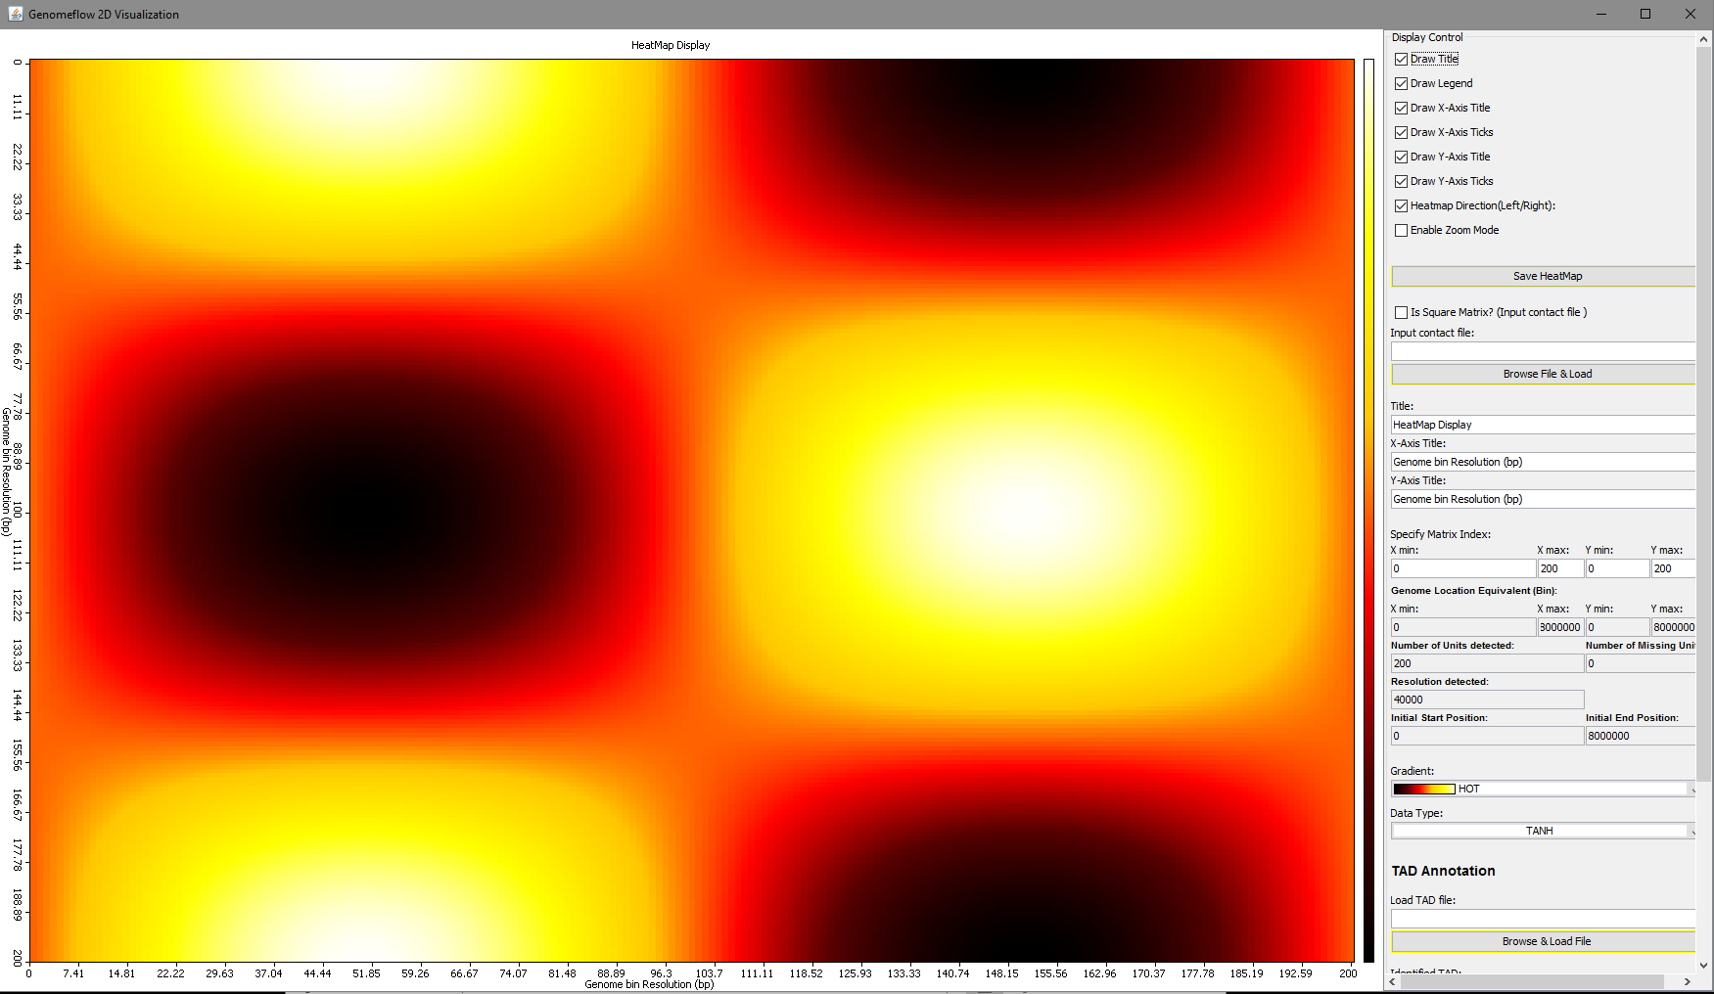

Figure 9: Visualize Dataset in 2D Format

### Display Controls

The description of the display controls on the display window is given below.

|  |  |  |
| --- | --- | --- |
| **Field** | **Description** | **Default** |
| Draw Title | Shows or hides the heatmap title | checked |
| Draw Legend | Shows or hides the color legend | checked |
| Draw X-Axis Title | Shows or hides the X-axis title label on the 2D display window | checked |
| Draw X-Axis Ticks | Shows or hides the X-axis ticks label on the 2D display window | checked |
| Draw Y-Axis Title | Shows or hides the Y-axis title label on the 2D display window | checked |
| Draw Y-Axis Ticks | Shows or hides the Y-axis ticks label on the 2D display window | checked |
| Heatmap Direction(Left/Right) | Changes the Y-axis origin of the heatmap matrix from the Bottom-Left to Top-Left and vice versa | checked |
| Enable Zoom Mode | Allows the user to zoom in/out of the heat map matrix | unchecked |
| Save HeatMap | A Button to save the current State of the HeatMap. Saves in .png format | NA |
| Is Square Matrix?(Input contact file) | Allows the user to specify if the input is a Square matrix (a full matrix) or a sparse matrix. If checked, it displays a textbox for the user to specify the matrix resolution. | unchecked |
| Specify Resolution | Visible only if *Is SquareMatrix?* is checked. It allows user specify resolution for the input matrix. | NA |
| Input contact file | A text file containing a contact matrix in any of the format described above. | NA |
| Title | Allows user to specify the title of the heatmap | Heatmap Display |
| X-Axis Title | Allows user to specify the X-Axis title for the heatmap | Genome bin Resolution (bp) |
| Y-Axis Title | Allows user to specify the Y-Axis title for the heatmap | Genome bin Resolution (bp) |
| X min | Allows the user to specify the minimum X-axis Tick for the heatmap | 0 |
| X max | Allows the user to specify the maximum X-axis Tick for the heatmap | 200 |
| Y min | Allows the user to specify the minimum Y-axis Tick for the heatmap | 0 |
| Y max | Allows the user to specify the maximum Y-axis Tick for the heatmap | 200 |
| X min [Genome Location Equivalent] | Shows the genomic position equivalent for the minimum X-axis tick for the heatmap | 0 |
| X max[Genome Location Equivalent] | Shows the genomic position equivalent for the maximum X-axis tick for the heatmap | 8000000 |
| Y min [Genome Location Equivalent] | Shows the genomic position equivalent for the minimum Y-axis tick for the heatmap | 0 |
| Y [Genome Location Equivalent] | Shows the genomic position equivalent for the maximum Y-axis tick for the heatmap | 8000000 |
| Number of Units detected | Shows the number of regions found in the input matrix | 200 |
| Number of Missing Units | Shows the number of gaps or missing regions noted from the input matrix | 0 |
| Resolution detected | Displays the resolution of the input matrix | 40000 |
| Initial Start Position | Shows the minimum genome position observed from the input matrix | 0 |
| Initial End Position | Shows the maximum genome position observed from the input matrix | 8000000 |
| Gradient | An array of color used as a gradient. One color is used as the bottom gradient and another color is used as the top gradient. Hence, it produces a gradient from one color to the other. The Gradient Colors are explained below | HOT |
| GRADIENT_BLACK_TO_WHITE | Produces a gradient from black (low) to white (high) |  |
| GRADIENT_BLUE_TO_RED | Produces a gradient from blue (low) to red (high) |  |
| GRADIENT_HEAT | Produces a gradient using the colors black, brown, orange, white |  |
| GRADIENT_HOT | Produces a gradient using the colors black, red, orange, and yellow to white |  |
| GRADIENT_MAROON_TO_GOLD | Produces a gradient from maroon (low) to gold (high) |  |
| GRADIENT_RAINBOW | Produces a gradient with the colors violet, blue, green, yellow, orange, and red. |  |
| GRADIENT_RED_TO_GREEN | Produces a gradient from red (low) to green (high) |  |
| GRADIENT_ROY | Produces a gradient through red, orange, yellow |  |
| Data Type | It determines the type of data to be displayed. The types available are the raw input data, a TANH of input data, a Pearson correlation of input data, and a Spearman correlation of the input data. | TANH |

### TAD Annotation

The description of the display controls on the display window for TAD annotation is given below.

|  |  |  |
| --- | --- | --- |
| **Field** | **Description** | **Default** |
| Load TAD file | Browse and Load a .bed format file containing the TADs identified for the input matrix | NA |
| Identified TAD | It shows the TADs in the input file | NA |
| Show TAD on Heatmap | It marks the boundary of the TADs identified on the displayed heatmap |  |
| Display Multiple TADs | Once checked, allows TADs from different method to be overlapped on the same display window. This function is useful for comparing TADs identified by different methods for a dataset. | unchecked |
| Choose Display Color | Choose the color for the TAD boundary marks | Color 1 |

### Demonstration

Figure 5 below shows the TAD annotation for the TADs identified by two TAD identification algorithms (ClusterTAD and DI) for mESC Chromosome 17 from [Ren Lab](http://chromosome.sdsc.edu/mouse/hi-c/download.html).

**Step 1:**

To run this demonstration, load a sample square matrix as the input contact file.

The example file can be found here: */executable/sample_data/* *contact_matrices/square_matrices/mESC_nij.chr17*. Resolution for the square matrix = 40000

Load the contact file as instructed here: Visualizing Dataset in 2D format

**Step 2:**

Modify the highlighted fields on the display window. The table below shows the values set for each field in the display control.

|  |  |
| --- | --- |
| **Field** | **Value** |
| Draw Title | checked |
| Draw Legend | checked |
| Draw X-Axis Title | checked |
| Draw X-Axis Ticks | checked |
| Draw Y-Axis Title | checked |
| Draw Y-Axis Ticks | checked |
| Heatmap Direction(Left/Right) | checked |
| Enable Zoom Mode | unchecked |
| Is SquareMatrix?(Input contact file) | checked |
| Specify Resolution | 40000 |
| Input contact file | Path/to/chr17/inputfile |
| Title | HeatMap Display |
| X-Axis Title | Number of Bins |
| Y-Axis Title | Number of Bins |
| X min | 500 |
| X max | 700 |
| Y min | 500 |
| Y max | 700 |
| X min [Genome Location Equivalent] | 20000000 |
| X max[Genome Location Equivalent] | 28000000 |
| Y min [Genome Location Equivalent] | 20000000 |
| Y [Genome Location Equivalent] | 28000000 |
| Number of Units detected | 2382 |
| Number of Missing Units | 0 |
| Resolution detected | 40000 |
| Initial Start Position | 0 |
| Initial End Position | 95240000 |
| Gradient | HOT |
| Data Type | TANH |

**Step 3:**

* 1. *Browse & Load* the ClusterTAD file found here:

ClusterTAD: /executable/sample_data/TAD_annotation/mESC_TAD_bed/ ClusterTAD /chr17.bed.

* 1. Select a Unique from Color 1 to 4. (Ex: Color 1 for ClusterTAD and Color 2 for DI)
  2. Click the *Show TAD on Heatmap* button.

**Step 4:**

To display multiple TADs on the Heatmap, Mark/Check the *Display Multiple TADs* then Repeat Step 3 with the DI file found here:

DI: */executable/sample_data/TAD_annotation/mESC_TAD_bed/ DI /chr17.bed*

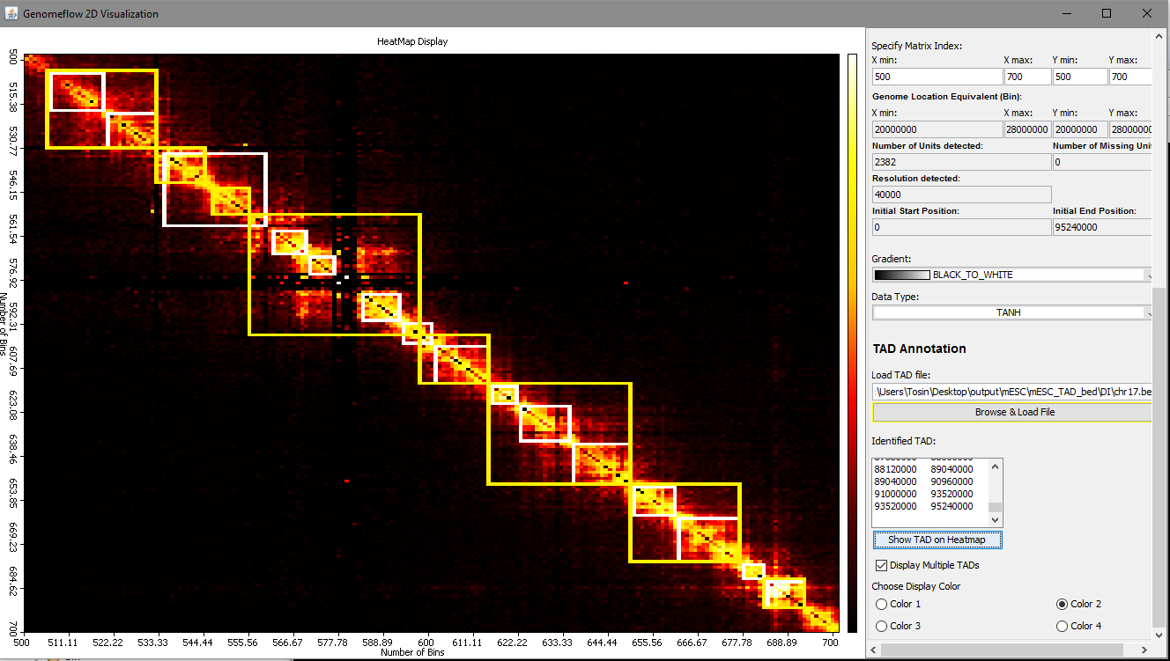

Figure 10: Demonstration of TAD Annotation on 2D Heatmap

## Identify TAD

### Purpose

To identify Topological Associated domains from input contact matrix.

### Input

An input file in square matrix format (a full matrix representing all the contact regions) or a sparse matrix format (each line represents a contact by three numbers separated by whitespaces: <position1> <postion2> <interaction_frequency>.

An example sparse matrix file can be found here:

*/executable/sample_data/ contact_matrices/ chr11_10kb_gm12878_list_125mb_135mb.txt*

### Output

A TAD with the best quality will be generated prefixed with ***BestTAD***_ in *bed* format. This file will be found here: */Selected_output_directory_from_GUI/Output/TADs/.*

### Running

Access the function from the menu toolbar: 2D-Functions/Identify TAD.

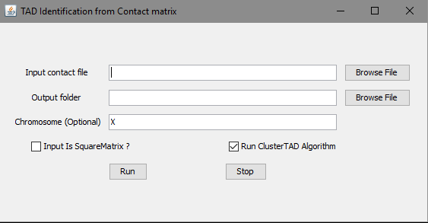

Figure 11: Identifying TADs on a contact matrix

|  |  |  |
| --- | --- | --- |
| **Field** | **Description** | **Default** |
| Input contact file | An input file in any of the format described above | NA |
| Output folder | Directory to output the comparison report | NA |
| Is SquareMatrix?(Input contact file) | Allows the user to specify if the input is a Square matrix (a full matrix) or a sparse matrix. If checked, it displays a textbox for the user to specify the matrix resolution. | unchecked |
| Data Resolution | It is visible only if *Is SquareMatrix?* is checked. It allows user specify resolution for the input matrix. | 40000 |
| Chromosome (optional) | Allows user to specify the chromosome data | X |
| Run ClusterTAD Algorithm | The default algorithm used for TAD identification from the input contact Matrix | checked |
| Run | To start the identification process. A progress bar is displayed to show the steps taken by the TAD identification algorithm. | NA |
| Stop | During the identification, if this button is pressed, the program will stop. | NA |

## Check TAD consistency between two TADs from different methods

### Purpose

To compare two TADs from two different Topological Associated domains identification method.

### Input

A file containing TADs in .bed format. The method whose TADs consistency is to be checked is termed Method-1, and the methods whose TADs is to be compared with is termed Method-2. Choose the same chromosome for different methods. For example, to compare TAD from ClusterTAD with DI for chromosome 17,

Method-1: /*executable/sample_data/TAD_annotation/mESC_TAD_bed/ ClusterTAD* /chr17.bed.

Method-2: */executable/sample_data/TAD_annotation/mESC_TAD_bed/ DI /chr17.bed*

### Output

A report of the consistency of the Method-1 with Method-2. The output reports the following cases:

|  |  |
| --- | --- |
| **Case** | **Description** |
| Case 1 | The number of Exact TADs found in both Method-1 and Method-2 |
| Case 2 | The number of Sub-TADs that exist between Method-1 and Method-2 |
| Case 3 | The number of Conflicting TADs. |
| Case 4 | The number of TADs in Method-1 but not found in Method-2 |

### Running

Access the function from the menu toolbar: 2D-Functions/Check TAD Consistency.

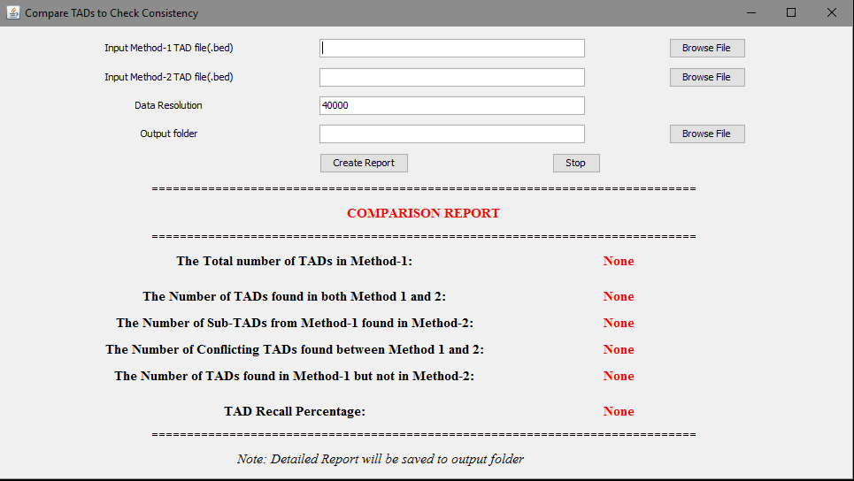

Figure 12: Comparing two TADs for a consistency check

|  |  |  |
| --- | --- | --- |
| **Field** | **Description** | **Default** |
| Input Method-1 TAD file(.bed) | Browse the .bed format file containing the TADs identified by Method-1 | NA |
| Input Method-2 TAD file(.bed) | Browse the .bed format file containing the TADs identified by Method-2 | NA |
| Data Resolution | The Resolution of the dataset the TADs were identified from. | 40000 |
| Output folder | Directory to output the comparison report | NA |
| Create Report | Once this button is pressed, a progress bar is displayed to show the steps taken by the TAD identification algorithm,. | NA |

# 3D-Functions

## 3D model reconstruction by LorDG

### Purpose

To build 3D chromosomes and genome models

### Input

A contact matrix in sparse matrix format

### Output

3D models in. gss format file and .pdb format file

### Running

Access the function from the menu toolbar: 3D-Functions/LorDG-3D Modeler

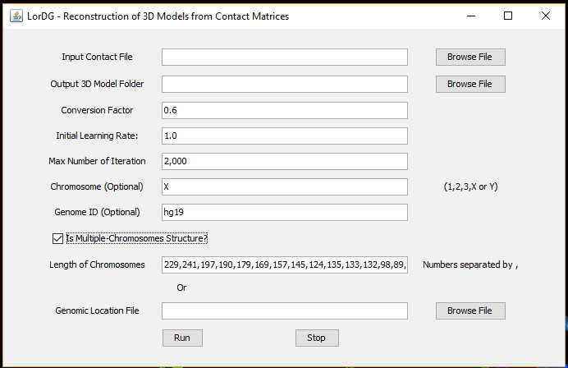

Figure 13: 3D Model reconstruction by LorDG

|  |  |  |
| --- | --- | --- |
| **Field /Button** | **Description** | **Default** |
| Conversion Factor | in the formula , where is interaction frequency between . When the field is left blank, the program will search for the best value in the range [0.1-3.0] with a step size of 0.1. Users can also specify a range to search for by putting two numbers separated by a hyphen (e.g. 0.5-1.0). During the searching, the right-top corner of the main screen displays information about the current value being tested. | 1.0 |
| Initial Learning Rate | Initial learning rate of the optimization. Higher learning rate can speed up the reconstruction process but can cause the process to fail as well | 1.0 |
| Max Number of Iterations | Maximum number of iterations for the optimization | 1000 |
| Chromosome | Chromosome name of the contact matrix in the input. If the input contains contact matrix of the whole genome, leave this field blank. | X |
| Genome ID | Genome version of the contact matrix in the input. | hg19 |
| Is Multiple-Chromosomes Structure? | If the input contains both inter-and intra-chromosomal contacts data, this checkbox should be checked. | unchecked |
| Length of Chromosomes | This field contains a list of lengths of chromosomes in increasing order of chromosome names and separated by commas if “Is Multiple-Chromosomes Structure” is checked. Please note that these lengths should not contain omitted regions (e.g. centromeres) in the input of chromosomes. |  |
| Run | To start the reconstruction process. The main screen displays how new models are being formed from initially random models. The information about the reconstruction is displayed in the top-right corner of the main screen. The conversion factor is being used to build the model and the current value of the objective function (higher is better). After the reconstruction is finished, the score of the model is displayed in the top-right corner of the main screen (the lower the value is, the better the model is). | NA |
| Stop | During the reconstruction, if this button is pressed the program will stop and output the currently best structure. If the program is searching for the best conversion factor, it will stop the searching and use the best-found conversion factor to build models. | NA |

## 3D model reconstruction by 3DMax

### Purpose

To build 3D chromosomes and genome models.

### Input

A contact matrix in sparse matrix format.

### Output

3D models in .gss format file and .pdb format file

### Running

Access the function from the menu toolbar: 3D-Functions/3DMax-3D Modeler

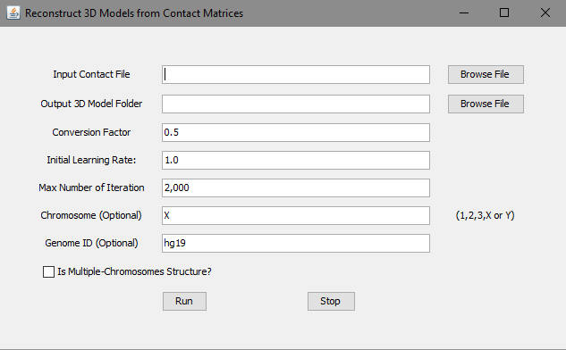

Figure 14: 3D Model reconstruction by 3DMax

|  |  |  |
| --- | --- | --- |
| **Field /Button** | **Description** | **Default** |
| Conversion Factor | in the formula , where is interaction frequency between . When the field is left blank, the program will search for the best value in the range [0.1-2.0] with a step size of 0.1. Users can also specify a range to search for by putting two numbers separated by a hyphen (e.g. 0.5-1.0). During the search, the right-top corner of the main screen displays information about the current value being tested. | 0.5 |
| Initial Learning Rate | Initial learning rate of the optimization. Higher learning rate can speed up the reconstruction process but can cause the process to fail as well | 1.0 |
| Max Number of Iterations | Maximum number of iterations for the optimization | 2000 |
| Chromosome | Chromosome name of the contact matrix in the input. If the input contains contact matrix of the whole genome, leave this field blank. | X |
| Genome ID | Genome version of the contact matrix in the input. | hg19 |
| Is Multiple-Chromosomes Structure? | If the input contains both inter-and intra-chromosomal contacts data, this checkbox should be checked. | unchecked |
| Length of Chromosomes | This field contains a list of lengths of chromosomes in increasing order of chromosome names and separated by commas if “Is Multiple-Chromosomes Structure” is checked. Please note that these lengths should not contain omitted regions (e.g. centromeres) in the input of chromosomes. |  |
| Run | To start the reconstruction process. The main screen displays how new models are being formed from initially random models. The information about the reconstruction is displayed in the top-right corner of the main screen. The conversion factor being used to build the models and the current value of the objective function (higher is better). After the reconstruction is finished, the score of the model is displayed in the top-right corner of the main screen (the lower the value is, the better the model is). | NA |
| Stop | During the reconstruction, if this button is pressed, the program will stop and output the currently best structure. If the program is searching for the best conversion factor, it will stop the searching and use the best-found conversion factor to build models. | NA |

## Chromatin loop identification

### Purpose

To identify chromatin loop in 3D models .

### Input

A 3D model in [.gss format](https://github.com/jianlin-cheng/GenomeFlow/wiki/Data-Format#genome-scale-system-gss-file-format).

### Output

A list of chromatin loops in *a .bed* format file (optional) and highlighted in the 3D model.

### Running

Access the function from the menu toolbar: 3D-Functions/Loop Detection

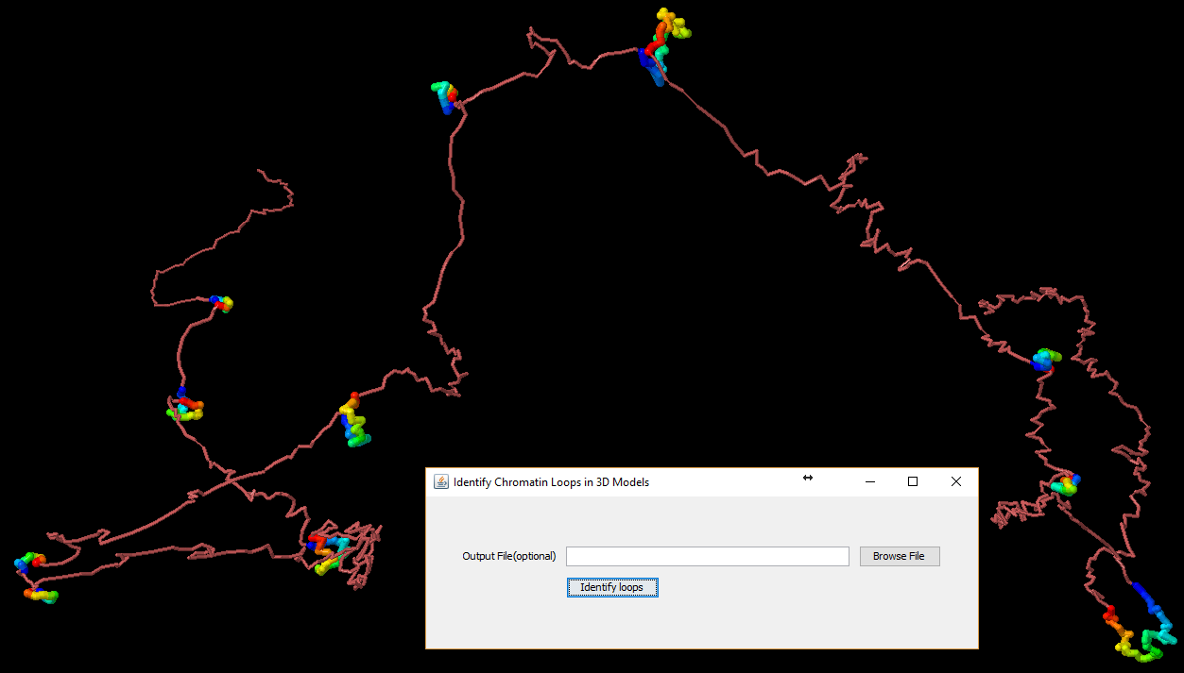

Figure 15: Chromatin loops

The function identifies chromatin loops and highlights them in the 3D model. The loops can also be outputted into a .bed format file located in the *Output folder* field. The top-right corner of the main screen displays the number of chromatin loops identified.

Loops are colored in spectrum (from blue to red). To highlight loops better, color the model by a single color (right-click on the main screen, choose *,*)

## Model annotation

### Purpose

To annotate 3D models with genomic elements.

### Input

A 3D model (e.g. in *executable/sample_data/models*) and genomic elements in *.bed* format files (e.g. in *executable/track_files*).

### Output

3D model is annotated with data from *.bed* format files.

### Running

Access the function from the menu toolbar: 3D-Functions/Model Annotation

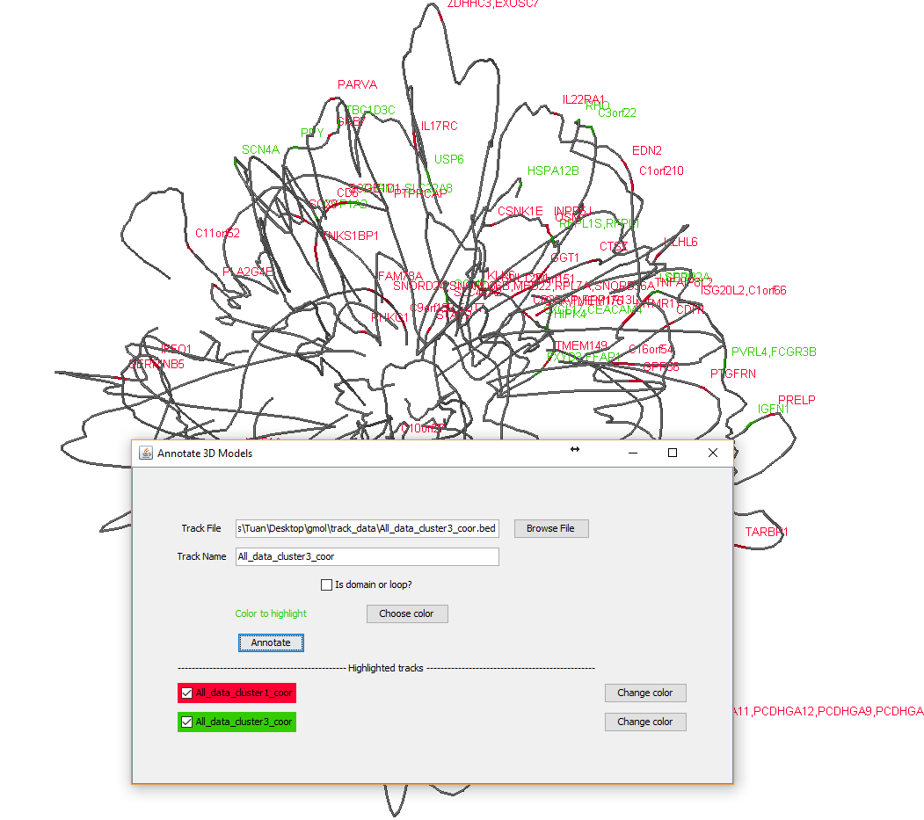

Figure 16: Function to annotate 3D models

To better highlight track data, change the color of the model to a sing color (right-click on the main screen, Color/Structure/Reset). The background can be changed to white to (Color/Background/White)

|  |  |  |
| --- | --- | --- |
| **Field / Button** | **Description** | **Default** |
| Track file | A file in bed format (see executable/track_files for example) to annotate the model | NA |
| Track name | A unique name associated with the above input file | Name of track file |
| Is domain or loop? | Indicate if the track file contains domains or loops. Adjacent domains/loops will be colored in red/blue alternatively. | Unchecked |
| Choose color | To pick a color to label annotation and points overlapped by genomic elements in the track file. | Random |
| Change color | To change color of the corresponding track | NA |
|  | Checking corresponding track names will display or hidden the content of tracks. |  |

To get the genomic coordinate of a point, left-click or mouse-over to the point as shown in **Figure .**

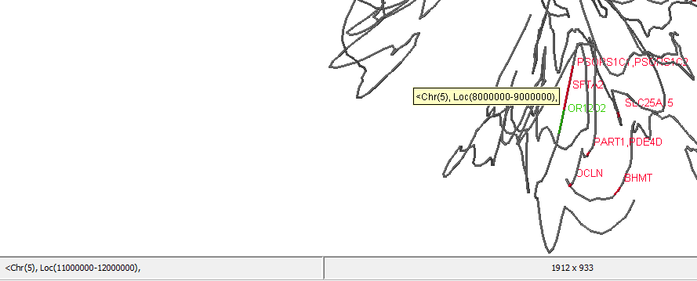

Figure 17: Coordinate of a point in the model

## Gene expression data visualization (a special case of model annotation)

### Purpose

To display gene expression level along a 3D model

### Input

* 1. A 3D model in GSS format (e.g. in executable/sample_data/models/ chr11_10kb_gm12878_list_60mb_70mb_1514493462531.gss) to visualize,
  2. A gene expression data file in GCT format ( <http://software.broadinstitute.org/cancer/software/genepattern/file-formats-guide#GCT> ), an example file is executable/sample_data/gene_expression/allaml.dataset.gct .
  3. And a text file to specify genomic coordinates of probes/genes in the GCT format file (each line consists of 4 elements separated by space or tab, e.g.: probe_or_gene_name chr_number start end). A sample is executable/sample_data/gene_expression/probe_coordinates.txt

These 3 following files are prepared for demo: executable/sample_data/models/ chr11_10kb_gm12878_list_60mb_70mb_1514493462531.gss, executable/sample_data/gene_expression/allaml.dataset.gct and executable/sample_data/gene_expression/ probe_coordinates.txt.

### Output

Expression levels of genes/probes are annotated in the 3D model. Usually, the GCT file contains several samples and therefore, the median value (across all samples) together with minimum and maximum values (in brackets) are displayed next to probe/gene names.

If the 3D model and the gene expression data file have no overlap, no annotation will be added to the 3D model.

### Running

Access the function from the menu toolbar: 3D-Functions/Model Annotation. A GCT file must be filled in the “Track File” field.

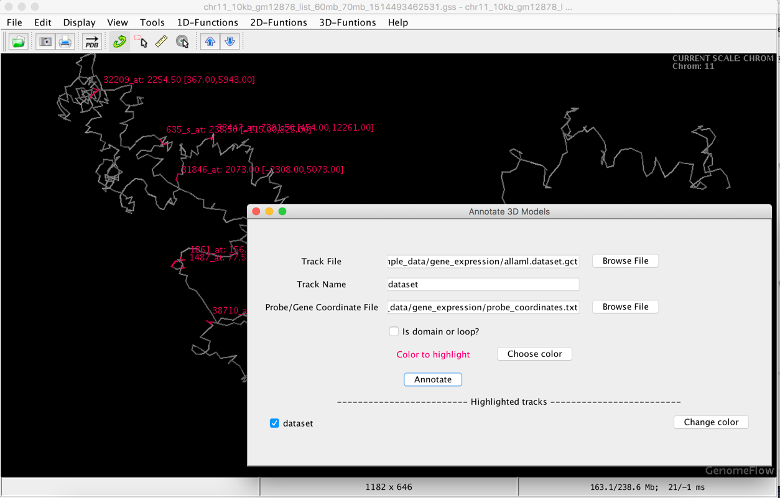

Figure 18: Gene expression visualization demonstration

## Comparing 2 models

### Purpose

To superimpose and compare two 3D-models in GSS format.

### Input

Two chromosome models in GSS format.

### Output

The two models are scaled, superimposed and visualized. Spearman’s correlation and RMSE between pairwise distances of the two models are calculated.

### Running

Access the function from the menu toolbar: 3D-Functions/Compare Models

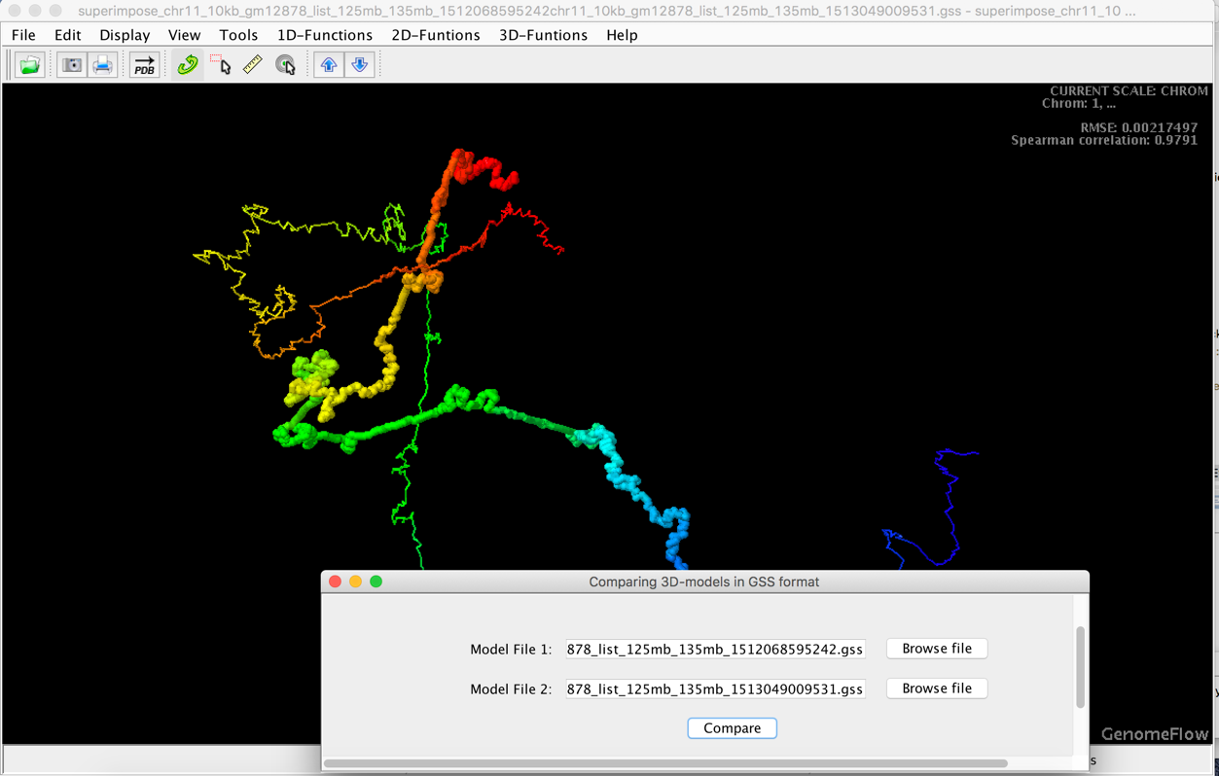

Figure 19: Comparing two constructed models